# PATIENT INFORMATION SHEET

## Research Project Title: Rectal Swabs vs Bulk Faeces PCR testing for the Diagnosis of Enteric Conditions (RecSwabFaeces)

Investigator: Dr. Nicolas Smoll

Site: Sunshine Coast

Metro North HREC B Project Reference ID: 101033

**Introduction**

You are being asked to participate in a research study that is being lead by Dr. Nicolas Smoll, Public Health Senior Medical Officer with Queensland Health. Obtaining a faecal specimen (“poo sample”) is difficult because it cannot be done on demand. We are trialling a much simpler testing process (rectal swabbing) to obtain the valuable information about the health of a person’s gastrointestinal system. In the future, instead of waiting until a person “has to go”, the person can take a swab on their own, on the spot.

You have been asked to be part of this research project because you are being tested as part of your routine medical care for the presence of an enteric organism. An enteric organism is an organism that resides in your gastro-intestinal system and may be causing your disease.

This research is conducted in addition to your regular medical care. The part of this project that is required for your routine medical care is the faecal specimen (the “poo pot” part). This specimen is required to complete your routine medical care. The research part of this project is the provision of a rectal swab. You can decide to return the stool sample (the “poo pot” part) and decide to not participate in the research component (performing the rectal swab) by not returning the rectal swab. You cannot participate in the research component if a rectal swab is not performed and returned with the poo sample (the “poo pot” part).

The aim of this project is to assess the accuracy, measured as sensitivity (proportion of positive faecal samples that return a positive result on the swab) of rectal swabbing in comparison with our traditional method of faecal specimens.

**Benefits of Participation**

There are no direct benefits to participating in this study. However, your participation may help to improve testing methods for future persons. This information should lead to better experiences for future persons, and simpler testing solutions for future patients. There is no guarantee of these benefits.

**Risks of Participation**

The risks of participating in this study are minimal. There is a small risk of bleeding or infection at the site of the swab. There is also a very small risk of an allergic reaction to the swab material which is most commonly made of nylon. Please seek medical advice from your GP if you experience unexpected symptoms or an allergic reaction.

**Confidentiality**

All information collected in this study will be kept confidential, within Queensland Health’s secure servers. Your name will not be used in any reports or publications about the study. Once the study is complete, all names and identifying information will be removed from the data, and the study data will be analysed and presented as grouped, or aggregated data. Only the research team will have access to your data.

**Voluntary Participation**

Your participation in this study is voluntary. You are free to decline to participate or to withdraw from the study at any time. If you decide to withdraw, your data will be deleted from the study records at the end of the study. If you withdraw from the study, this will have no impact on your normal faecal testing (stool sampling). If you decide to withdraw from the study, you do not need to complete the rectal swabbing. It is advisable to continue to provide the faeces sample, as your treating clinician may have ordered this.

**Why are you being asked to participate?**

You are being asked to participate because you have symptoms of a gastrointestinal illness and we would like to know if the rectal swabbing test is as accurate as testing a full faecal sample. We are aiming to include people who are:

* Persons aged 18 and older
* Able to verbally consent to and perform the additional rectal swab test.
* Close contact or person exposed, suspected or confirmed case associated with an outbreak of an enteric organism. E.g. hepatitis A outbreak, foodborne outbreak.
* Chronic carrier of an enteric organism that requires testing.
* Person involved in a clinical encounter where they are, or likely suffering from a disease caused by an enteric organism. (E.g. person presenting to the GP or Emergency Department with diarrhoea or jaundice)

**Data Access:**

In addition to your clinical team, the research team (all Queensland Health Employees) will also have access to your clinical information. However, your data will only be used for the purposes of this study or other studies that will have been approved by an ethics committee, and will not be shared with any other individuals or organizations.

**Storage and Retention:**

The data that you provide will be stored in a secure Queensland Health database according to Department of Health Standards Policy “Retention and disposal of clinical records” (QH-IMP-280-1:2014). This policy is in line with the Public Records Act 2005. After five years, the data will be destroyed.

**What is required?**

We will need you to take 2 samples: one traditional faecal sample (small chunk of poo in a “poo pot”) to be kept in a poo container, and one rectal swab. Please note that the bulk faecal sample is required for your medical care, and the rectal swab is required to participate in the research.

We will ask for you for your name, date of birth, gender and contact information as well as if you are symptomatic, if you or a clinician took the swab, which sample you preferred taking, and if you felt the rectal swab was an appropriate for you in your situation. After performing your test you will receive a follow-up phone call to (1) check that everything went well, (2) if you had an adverse event during or after the testing, and the nature of the event, and (3) we will ask which test you preferred and why. The testing information, as well as the follow-up phone call answers will be stored in a secure database, only accessible to investigators.

If you prefer that a clinician performs the swab, you can request that a person of the same gender perform the swab or have a family member or support person present.

**How is specimen tested?**

The testing is performed in Queensland Pathology laboratory, and both specimens will be tested using the same tests. If there is a pathogen inside the samples, the laboratory may perform whole genome sequencing of the organism. A negative or positive result of the bulk faeces test will be delivered to you by the clinician that initiated or requested the test.

**What will happen with the biospecimens (test samples) and results?**

The bulk faeces specimen and the rectal swab will be tested individually and stored for up to a year, after which both samples will be destroyed. The bulk faeces specimen and the rectal swab will be transported at 4°C and be retained for minimum 1 month. A small sample (aliquot) of the bulk faeces specimen and the rectal swab will be retained for minimum 1 year after submission, or until the end of the project (whichever is later).

The results will be pooled and published in a medical journal. No individuals’ results will be published on their own. The clinician that ordered the test will return the results to you.

**Persons not eligible for the study:**

Persons *unlikely* (as judged by the clinician) to be harbouring an enteric organism.

**Follow-up**

After performing your test you will receive a follow-up phone call to (1) check that everything went well, (2) if you had an adverse event during or after the testing, and the nature of the event, and (3) we will ask which test you preferred and why.

**Who can consent?**

Adults can choose to consent to participate in the study themselves. Participation is completely voluntary, and you can withdraw your consent at any time if you decide you no longer wish to participate.

**Submitting the test kit**

Please return the pack (faeces pot and rectal swab) to a Pathology Queensland Laboratory (any public hospital pathology department). A complete test kit would contain:

(1) bulk faeces pot with poo inside and a closed lid,

(2) a soiled swab inside its container,

(3) completed pathology form

(4) all pieces (1, 2, 3) together inside the sample bag.

The clinician that ordered the test may have further instructions. If there are any questions, or uncertainty, please contact the [Insert Study Site Here] on:

Email: Phone:

**Other Contacts**

This project has been approved by the Metro North Ethics Committee. If you have any questions or concerns about the conduct of this study, please do not hesitate to contact [Site Lead] at [Insert Study Site Email], or:

**Reviewing HREC approving this research and HREC Executive Officer details:**

|  |  |
| --- | --- |
| Reviewing HREC name | Metro North Health HREC B |
| Telephone | 07 3646 5280 |
| Email | [MetroNorthResearch-Ethics@health.qld.gov.au](mailto:MetroNorthResearch-Ethics@health.qld.gov.au) |

**Local HREC Office contact (Single Site -Research Governance Officer)**

|  |  |
| --- | --- |
| Position |  |
| Telephone |  |
| Email |  |

## Verbal Consent Only

*For study investigators only*

Investigator (Research Team) to circle the following choice”

Declined

Consented

Please write email or mailing address below to email or send copy of consent form:

Investigator Name:__________________________ Date:­­­­­­­­­­­­________________

Signature:­­­­­­­­­­­­­­­­­­­­_________________________________

First Test: How to do a rectal swab

**What is a rectal swab? How is the test performed?**

A rectal swab looks similar to a swab used for testing a wound, or used for a COVID-19 test. It is long and slender with cotton at the tip. The person performing the test is ideally the person themselves, as this is meant to be a “self-test”, a trusted family member or friend, or a clinician involved in your care.

The test should always be performed in a well aerated private location such as a bathroom. Please use the provided glove, or clean your hands before performing the test. Insert the swab about 3 to 5 cm (1-2 inches) into the anal canal. Gently turn the swab in a clockwise direction for about 5 - 10 seconds while rubbing the swab against the walls of the rectum. Afterwards, re-insert the swab into the swab container, and then proceed to wash your hands.

If you need to store the swab overnight, please refrigerate.

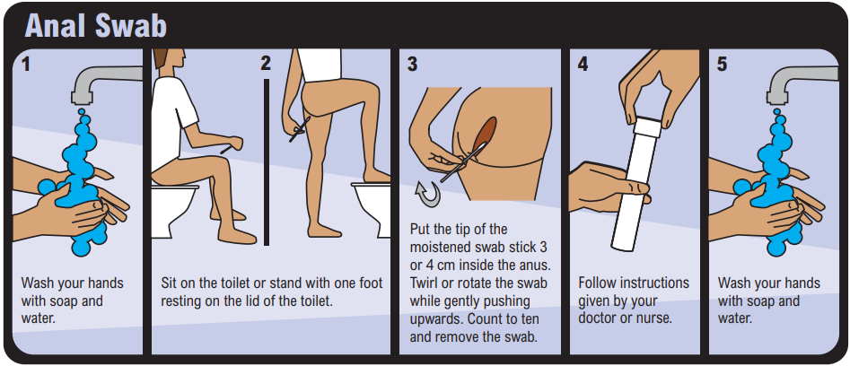

## Please don’t forget to wash your hands immediately after completing your tests!

Second Test: How to obtain a faecal specimen

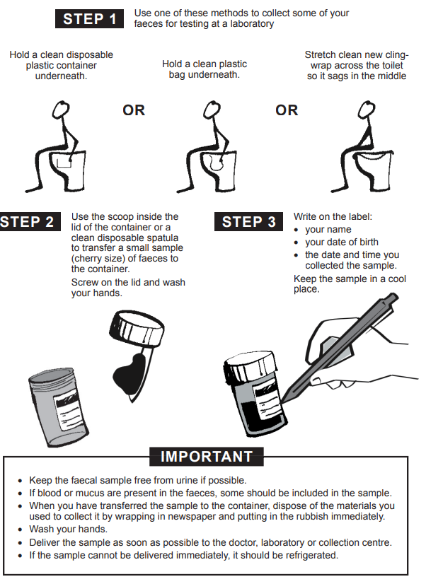

Returning the swab

Please follow your clinician’s instructions about returning the sample kit. Please return the kit to your nearest Pathology Queensland (PQ) Laboratory. A list of PQ laboratories can be found by searching for: “list of pathology queensland laboratories” within the google search engine.

A sample kit to participate in the research project will include:

* the pathology form
* the rectal swab
* the faecal pot

A sample kit for persons declining to participate, but following medical advice for testing will include:

* the pathology form
* the faecal pot

If there are any questions, or uncertainty, please contact the [Insert Study Site Here] on:

Email: Phone:

Withdrawal of Study Form

This form outlines your wish to withdraw from the study. Please fill out this short form and return it to [Insert Study Site Here] on:

Email: Phone:

Mailing Address: [Insert Study Site Mailing Address]

Date of Withdrawal:

Please provide any additional information you would like to share about your withdrawal from this project:

Participant Name:__________________________ Date:­­­­­­­­­­­­________________

Signature:



# Participant Consent and Signature

I have read, or had read to me in my first language, the information presented above (pages 1-4) and I understand its contents.

I believe I understand the purpose, extent and possible risks of my involvement in this project. I voluntarily consent to take part in this research project.

I have had an opportunity to ask questions and I am satisfied with the answers I have received.

I understand that this project has been approved by the Metro North Human Research Ethics Committee B and will be carried out in line with the National Statement on Ethical Conduct in Human Research (2007).

I understand I will receive a copy of this Information Statement.

**OPTIONAL CONSENT**

I consent to the storage of my leftover stool sample and rectal swab for use in future ethically approved research that would include your de-identified data. Please Tick:

I do

I do not

Participant Name:__________________________ Date:­­­­­­­­­­­­________________

Signature:



Witness Name:__________________________ Date:­­­­­­­­­­­­________________

Signature:

