protocol

SENTINEL Study

Sepsis Epidemiology in Paediatric Acute Care International (SENTINEL) Study

.
Protocol Version 1.1 dated 24th October 2023

Document history:

Version Number and Date | Summary of changes

CONFIDENTIAL
This document is confidential and is the property of Murdoch Children’s Research Institute. No part of it may be transmitted, reproduced, published, or used without prior written authorisation from the institution.
Statement of Compliance
This study will be conducted in compliance with all stipulations of this protocol, the conditions of the ethics committee approval, ethical principles that have their origin in the Declaration of Helsinki, all applicable national and local regulations and in the spirit of the standards of Good Clinical Practice (as defined by the International Conference on Harmonisation).

TABLE OF Contents
PROTOCOL SYNOPSIS 4
GLOSSARY OF ABBREVIATIONS 6
INVESTIGATOR AGREEMENT 6
1. ADMINISTRATIVE INFORMATION 8
1.1. Registration of observational research 8
1.2. Sponsor 8
1.3. Expected duration of study 8
2. INTRODUCTION AND BACKGROUND 9
2.1. Background and rationale 9
2.2. Study aim (s) 10
3. STUDY OBJECTIVES AND OUTCOMES 10
3.1. Objectives 10
3.1.1 Primary objective 10
3.1.2 Secondary objectives 10
4. STUDY DESIGN 11
4.1. Overall design 11
4.2. Study population 11
4.3. Inclusion Criteria 11
4.3.1 Aged <18 years; AND 11
4.3.2 Exclusion Criteria 11
4.4. Recruitment of potential participants 11
4.4.1 Recruitment planning 11
4.5. Stages of recruitment 12
4.6. Ethics Approval 12
5. STUDY TIMELINE 13
6. DATA AND INFORMATION MANAGEMENT 13
6.1. Overview 13
6.2. Data management 13
6.2.1. Data overview 13
6.2.2. Data generation (source data) 14
6.2.3. Data collection 14
6.2.4. Use of the data 15
6.2.5. Storage and access 15
6.2.6. Disclosure 16
6.2.7. Data confidentiality 16
6.2.8. Data retention 16
6.2.9. Data sharing 17
7. STUDY OVERSIGHT 17
7.1. Governance structure 17
7.1.1 Central Trial Management 17
7.1.2 Lead Sites for other countries 17
7.1.3 Local Trial Management Group 17
7.1.4 Trial Steering Committee (TSC) 17
7.2. Site Monitoring 18
7.3. Quality management, assurance and control 18
8. STATISTICAL METHODS 19
8.1. Sample Size Estimation 19
8.1.1 Methods of analysis 19
9. ETHICS AND DISSEMINATION 19
9.1. Research Ethics Approval & Local Governance Authorisation 19
9.2. Amendments to the protocol 20
10. PARTICIPANT REIMBURSEMENT 20
11. FINANCIAL DISCLOSURE AND CONFLICTS OF INTEREST 20
12. DISSEMINATION AND TRANSLATION PLAN 20
13. ADDITIONAL CONSIDERATIONS 20
14. REFERENCES 21

PROTOCOL SYNOPSIS

TITLE | Sepsis Epidemiology in Acute Care in Paediatrics International (SENTINEL) Study
STUDY DESCRIPTION | SENTINEL International is a multi-country, multicentre observational study in low and middle income countries and select high income countries outside of Australia and New Zealand to undertake a landscape analysis of children with community-acquired suspected sepsis.
AIM | The aim of the scoping review is to obtain baseline international multi-centre multi-country retrospective observational data required for sepsis landscape analysis and planning of future interventional studies
PRIMARY OBJECTIVE | To create an international sepsis database and collect data for a discreet time period (1 year per site)
SECONDARY OBJECTIVES | To aggregate and analyse sepsis data and describe:  - Sepsis prevalence, severity, and outcomes in children hospitalised with suspected community acquired sepsis.  - The microbiology, resistance patterns, antibiotic use patterns, and antimicrobial stewardship practices in hospitalised children with suspected sepsis  - The management of hospitalised children with suspected sepsis, including adherence to local guidelines and variation in care  - Prevalence, resource utilisation and outcomes in sub-groups of vulnerable children who are at risk of severe sepsis, including those receiving cancer chemotherapy, those identifying as relevant ethnic subgroups, those with chronic disease, and infants or neonates  - Admission and discharge diagnosis of hospitalised children with suspected sepsis  - Features of hospitalised children with discordant (non-septic) admission or discharge diagnosis  - Health economic implications of childhood suspected sepsis for hospitals and healthcare services  - Feasible inclusion criteria and outcomes, and establish feasibility of data collection and transfer, to be used in the design and conduct of future interventional trials in children with suspected sepsis.
STUDY POPULATION | Children aged less than 18 years, with suspected sepsis presenting to the emergency departments of the participating hospitals.
DESCRIPTION OF SITES ENROLLING PARTICIPANTS | Data for the study will be generated from hospitals in Low and Middle income countries and select high income countries outside of Australia and New Zealand only. This data will be entered into the database which is housed at MCRI.  There will be no Australian sites participating in the contribution of data for this study.  MCRI is the single site in Australia- the role of MCRI will be to design the project, house the database and analyse the data.
STUDY DURATION | Expected study duration from HREC approval to publication is approximately 3 years  Each site will collect data for a 1 year period.  Sites will become active post local HREC/RGO approval, therefore will not all commence recruitment together.
PARTICIPANT DURATION | Participants are enrolled in ED during their hospitalisation by the research team.  This is an observational study, all data collection is from the medical records. There is no participant involvement.

GLOSSARY OF ABBREVIATIONS

ABBREVIATION | TERM
AE | Adverse Event
ANOVA | Analysis of Variance
BRF | Biobank Registration Form (MCRI)
CRF / eCRF | Case Report Form / electronic Case Report Form
GCP | Good Clinical Practice
GLP | Good Laboratory Practices
HREA | Human Research Ethics Application
HREC | Human Research Ethics Committee
ICH | International Conference on Harmonisation
MCBC | Melbourne Children's Bioresource Centre
MCRI | Murdoch Children’s Research Institute
MedDRA | Medical Dictionary for Regulatory Activities
NHMRC | National Health and Medical Research Council
PI / CPI | Principal Investigator / Coordinating Principal Investigator
QA | Quality Assurance
QC | Quality Control
RGO | Research Governance Office
RCH | Royal Children’s Hospital (Melbourne)
SAE | Serious Adverse Event
SAP | Statistical Analysis Plan
SoA | Schedule of Assessments
SOP | Standard Operating Procedure

INVESTIGATOR AGREEMENT
I have read the protocol entitled Sepsis Epidemiology in Paediatric Acute Care International (SENTINEL) Study
By signing this protocol, I agree to conduct the study, after approval by a Human Research Ethics Committee or Institutional Review Board (as appropriate), in accordance with the protocol and:
- the principles of the Declaration of Helsinki
- the NHMRC National Statement on Ethical Conduct in Human Research (2007 and all updates)
- the Australian Codefor the Responsible Conduct of Research (NHMRC, 2007 and all updates)
- and in the spirit of the good clinical practice guidelines adopted by the TGA [Integrated Addendum to ICH E6 (R1): Guideline for Good Clinical Practice E6 (R2), dated 9 November 2016 annotated with TGA comments].
Changes to the protocol will only be implemented after written approval is received from the Human Research Ethics Committee or Institutional Review Board (as appropriate), with the exception of medical emergencies.
I will ensure that study staff fully understand and follow the protocol and evidence of their training is documented on the study training log.
Name | Role | Signature and date
A/Prof Elliot Long, RCH, MCRI, UoM | Coordinating Principal Investigator
Prof Franz Babl, RCH, MCRI, UoM | Principal Investigator
Amanda Williams, MCRI | Principal Investigator
Adriana Yock, Hospital Nacional de Niños, Costa Rica | Site Principal Investigator
Stephen Hearps, MCRI | Senior statistician, Associate Investigator
Shane George, Gold Coast University Hospital | Associate Investigator
Chris Blythe, Perth Children’s Hospital | Associate Investigator

ADMINISTRATIVE INFORMATION

Registration of observational research
SENTINEL International will be registered with the Australian and New Zealand Clinical Trials Registry prior to participant enrolment.

Sponsor
On behalf of the Sponsor, MCRI, the Coordinating Principal Investigator (A/Prof Elliot Long) will undertake and/or oversee those Sponsor responsibilities delegated by the Sponsor.
The Coordinating PI will also ensure that each Investigator at the participating sites conducts the study in compliance with the protocol, relevant approvals and regulatory requirements.

Study Sponsor | Murdoch Children’s Research Institute
Contact name | A/Prof Elliot Long
Address | Emergency Research  Murdoch Children’s Research Institute  Royal Children’s Hospital  Flemington Road  Parkville  Victoria 3052, Australia
Email | Elliot.long@rch.org.au

Expected duration of study

Trial preparation- HREC and site governance approval | June 2023 to March 2025
Education and training for site investigators and research assistants | January 2024 to June 2025
Data collection | January 2024 to June 2026
Data cleaning and analysis | June 2025 to December 2026
Publication | 2027

INTRODUCTION AND BACKGROUND

Background and rationale
Sepsis is a global health issue. 25.2 million children per year worldwide suffer from sepsis, resulting in 3.4 million deaths, the majority in children under 5 years of age(1). The hospitalisation cost per patient with sepsis is estimated at $26,592 USD, resulting in an annual expenditure of $7.31 billion, 18.1% of nation-wide paediatric hospitalisation costs in the US in 2019(2). Reliable early identification of sepsis is vital if lives are to be saved, as early identification and treatment of sepsis is the single biggest predictors of survival(3, 4). The World Health Organisation (WHO) has recommended the development of criteria for the early identification of sepsis to reduce its burden through early treatment(5).
Despite advances in public health, prevention, and treatment of many infectious diseases, invasive infections and sepsis remain leading causes of preventable childhood death worldwide(6). Mortality from sepsis remains high, particularly in low and middle-income counties (LMIC)(7). Any reduction in sepsis mortality mirrors that of children hospitalised for non-infectious causes, suggesting improved survival is due to improved routine hospital-based care and not improvement in sepsis-related therapies(8). This may in be part due to an increasing number of patients with high-risk conditions, such as extreme prematurity, acquired or innate immunodeficiency, or the presence of indwelling vascular catheters(9). Nevertheless, trials evaluating novel therapies, such as activated protein C, have not improved sepsis outcomes(10). Trials evaluating existing therapies, such as fluid resuscitation, have had variable and sometimes conflicting effects on sepsis outcomes(11, 12, 13). Trials evaluating other existing therapies, such as corticosteroids, are limited by small size, inconsistent findings, and methodological concerns(14). As a result, guidelines for the management of sepsis in children can provide only weak treatment recommendations based on low quality evidence for many sepsis therapies in children(15). As a result, current care for children with sepsis may be variable, outcomes, when stratified by disease severity, may be variable, and estimates of sepsis incidence, severity, and outcomes may be variable depending on what case definition is used. International data are needed on sepsis epidemiology, current care, and cost.
Effective early antimicrobial therapy is an important predictor of survival from paediatric sepsis(3, 4), yet empiric treatment for sepsis is one of the most common reasons for antibiotic prescribing in children(16) and linked to antibiotic resistant bacteria and adverse long-term outcomes(17, 18). International data are needed on the microbiology, resistance patterns, and antimicrobial prescribing practice in paediatric sepsis to better target guidelines and policy.
In a collaboration between emergency physicians, paediatricians, and intensivists, this study will provide a landscape analysis of community-acquired childhood sepsis in LMIC and select high income countries (HIC) outside of Australia and New Zealand (ANZ). We will describe sepsis prevalence, severity, outcome, and cost. We will report antimicrobial use and stewardship. The study will provide the critical understanding of children at risk of severe disease and poor outcome as well as the epidemiology of children with suspected sepsis as a basis for future interventional trials and international guideline development.

Study aim (s)
The aim of this study is to obtain baseline observational data required to answer fundamental aspects of sepsis epidemiology and care for children and to plan future interventional studies.

STUDY OBJECTIVES AND OUTCOMES

Objectives

Primary objective
The primary objective of this study is to create an international sepsis database and collect data for a discrete time period (1 year per site).

Secondary objectives
The secondary objectives of this study are to analyse the study data and describe:
- The defining characteristics, incidence, severity, outcomes, and cost in hospitalised children with suspected sepsis.
- The microbiology, resistance patterns, antibiotic use patterns, and antimicrobial stewardship practices in hospitalised children with sepsis
- The management of hospitalised children with sepsis, including organ support therapies and length of stay
- Prevalence, resource utilisation and outcomes in sub-groups of vulnerable children who are at high risk of severe sepsis, including those receiving cancer chemotherapy, those with chronic disease, and neonates
- Admission and discharge diagnosis of children hospitalised with suspected sepsis
- Features of hospitalised children with discordant (non-septic) admission or discharge diagnosis
- Health economic implications of suspected childhood sepsis for hospitals
- Feasible inclusion criteria and outcomes, in addition to feasibility of data collection and transfer, to be used in the design and conduct of future interventional sepsis trials.

STUDY DESIGN

Overall design
The SENTINEL Study is an international multi-centre, multi-country observational study in low- and middle-income countries and select high income countries outside of ANZ in children with suspected community acquired sepsis

Study population
Patients aged 0 to less than 18 years presenting to the emergency department and requiring hospitalisation for the treatment of suspected sepsis.

Inclusion Criteria

Aged <18 years; AND
- Admission to hospital; AND
- Treatment with intravenous (IV)/ intramuscular (IM)/ intraosseous (IO) antibiotics pre-hospital or in ED; AND
- Circulatory support (fluid bolus or inotropic support) pre-hospital or in ED
OR
Admission diagnosis of suspected sepsis, septicaemia or septic shock

Fluid bolus defined as ≥5ml/kg or 500mls administered over ≤30 minutes to treat impaired perfusion (not dehydration)
Inotropic support defined as intravenous infusion of inotrope/vasopressor

Exclusion Criteria
- Patients not initially seen in the Emergency Department (i.e. transferred directly to the ward including ICU)
- Patients presenting with trauma
- Patients transferred from another hospital if > 24 hours since presentation

Recruitment of potential participants

Recruitment planning
- Identification of potentially eligible patients will be undertaken by the research team in each participating centre by a review of local ED attendance record for patients meeting inclusion criteria (Figure 1)
- Patients identified through screening will be assessed for inclusion in the study
- Patients meeting inclusion criteria and no exclusion criteria will be enrolled
- All enrolled patients will have a retrospective chart review
- Each site will outline their individual consent process in line with national regulation requirements and the National Statement
Figure 1: SENTINEL Enrolment pathway
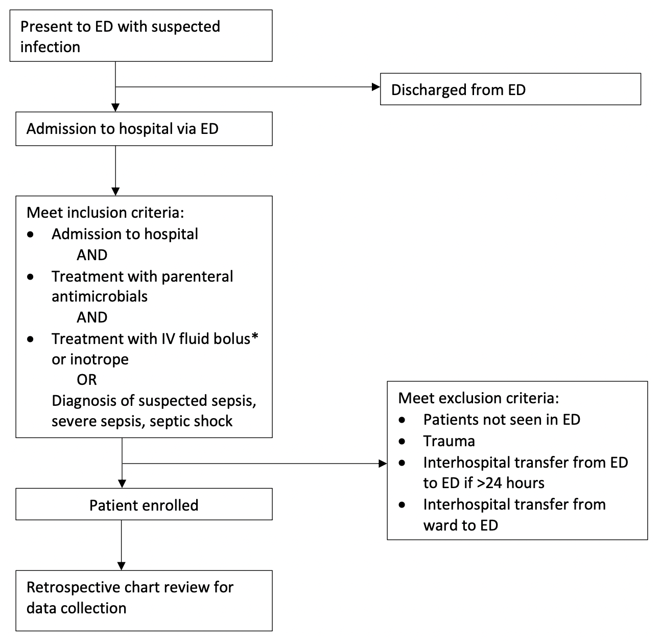

Stages of recruitment
Participants will be enrolled by research staff through screening of ED admission logs.
Retrospective enrolment
- Research staff will conduct a review of ED admission/attendance lists for eligible participants who meet inclusion criteria and no exclusion criteria.
- Participants meting inclusion criteria and no exclusion criteria will be enrolled.
- Enrolled participant details will be stored in a secure, password protected excel file and their identifying details replaced with a unique study number (REDCap ID)
- Enrolled participants will have detailed medical record review for retrospective data collection, including: demographics and history, clinical findings, investigations, interventions and details of hospitalisations.

Ethics Approval
As this study is a multi-country observational study, each country will require a separate HREC approval and will have different permission processes to access and extract data from medical records.

STUDY TIMELINE
TIMELINE | 2023-2024 | 2025-2026 | 2027
Protocol development
Central ethics approval
International site ethics and governance approval
Data collection
Data cleaning and analysis
Manuscript preparation and publication

DATA AND INFORMATION MANAGEMENT

Overview
The Principal Investigator at each site is responsible for storing essential study documents relevant to data management and maintaining a site-specific record of the location(s) of the site’s data management-related Essential Documents.
The Principal Investigator is responsible for maintaining adequate and accurate source documents that include all key observations on all participants at their site. Source data will be attributable, legible (including any changes or corrections), contemporaneous, original, accurate, complete, consistent, enduring and available. Changes to source data (hardcopy and electronic) must be traceable, must not obscure the original entry, and must be explained where this is necessary. A site-specific Source Document Plan will be maintained to indicate the location(s) of source documents.
Any person delegated to collect data, perform data entry or sign for data completeness will be recorded on a delegation log and will be trained to perform these study-related duties and functions.

Data management

Data overview
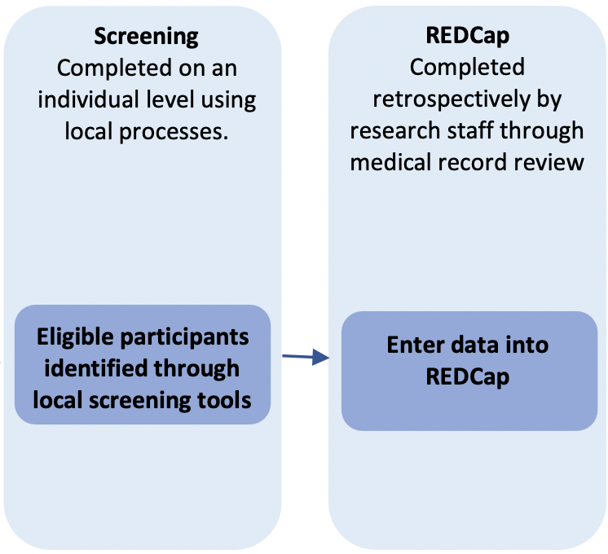
Data for this study will be collected and entered using electronic data collection forms, which will be completed by the research team. Retrospective data will be extracted from the medical records (Figure 2).
Figure 2: Study flow of data collection

Data generation (source data)
Source documents for this study include:
- Hospital medical records: data items sourced from medical records may include: past medical history, triage and hospital admission times, weight, microbiology and laboratory results, medication and fluid records, hospital discharge times and diagnosis.
Source Document Plan
The source documents for this study include the participants medical record, recorded data from automated instruments, and laboratory reports. Each site participating in the study will maintain a site-specific Source Document Plan that will document the source, i.e. original recording, for each data discrete item/ category of items collected for the study. This Source Document Plan, signed and dated by the Principal Investigator, will be prepared prior to recruitment of the first participant and will be filed in the site’s Investigator Site File.

Data collection
Data to be collected is outlined in Table 3.
Table 3. Data to be collected by all participating EDs as identified by time points
Initial ED attendance:
Detailed demographics (age, sex, Ethnicity, comorbidities)
Triage category
Vital signs (e.g.^{β}HR, MBP, SBP, RR, SpO2, RR, GCS score, CRT)
Pathology tests (e.g. ^{χ}VBG, FBC, UEC, LFT, coagulation profile, troponin)
Therapies administered (antibiotics, oxygen, fluids – bolus / maintenance, steroids, organ support)
Admission diagnosis
During hospital stay
Disposition (hospital ward, ICU)
Vital signs (first and worst in ED)
Pathology tests (first and worst in ED) (e.g. ^{χ}VBG, FBC, UEC, LFT, coagulation profile, troponin)
Therapies administered (duration of hospitalisation censored at 30 days)
Intensive care unit and hospital length of stay (censored at 30 days)
Discharge diagnosis
Results of all microbiological tests
In-hospital mortality (censored at 30 days)
^{β}HR=heart rate, MBP=mean blood pressure, SBP=systolic blood pressure, GCS=Glasgow Coma Scale score, CRT=capillary refill time; RR=respiratory rate; ^{χ}VBG=venous blood gas, FBC=full blood count, UEC=urea electrolytes creatinine, LFT=liver function test
Electronic CRF (REDCap)
Study data will be extracted from the participant’s Medical Record by the research team. The data will be entered using electronic data collection forms which will be completed by the researchers. The data entered will only contain de-identified study information.
Study data will be entered into a study REDCap database, with individual sites only having access to the data from their sites. The trial CPI and the trial coordinator will be responsible for overseeing data collection, and will have access to the complete study database, but will only have access to the de-identified data. If there is a need to re-identify data for clarification, this will be done by the principal investigator or research nurse at the site in question.

Use of the data
The data will be used for the analyses specified in the protocol.
Following the completion and analysis of the study, the de-identified data will be retained by site staff based on the mandatory archive period as specified in each institution / country.

Storage and access
Hard copy data will be stored by the Site in a locked cabinet in a secure location, accessible to the research team only (where applicable).
Electronic data will be securely stored in MCRI’s REDCap database system and in files stored in MCRI’s network file servers, which are backed up nightly. Data entry will be conducted at each site by the local research team. Only members of the study team will have access to the study database.
Files containing private or confidential data will be stored only in site locations accessible only by appropriate designated members of the site research team (where applicable).
REDCap is hosted on MCRI infrastructure and is subject to the same security and backup regimen as other systems (e.g. the network file servers). Data is backed up nightly to a local backup server, with a monthly backup taken to tape and stored offsite. REDCap maintains an audit trail of data create/update/delete events that is accessible to project users who are granted permission to view it. Access to REDCap will be provided via an MCRI user account or (for external collaborators) via a REDCap user account created by the MCRI system administrator. The permissions granted to each user within each REDCap project will be controlled by, and will be the responsibility of, the study team delegated this task by the Principal Investigator. REDCap has functionality that makes adding and removing users and managing user permissions straightforward. All data transmissions between users and the REDCap server are encrypted. The instructions for data entry to REDCap must be read and the training log signed prior to personnel commencing data entry on REDCap.
Authorised representatives of the sponsoring institution as well as representatives from the HREC, Research Governance Office and regulatory agencies may inspect all documents and records required to be maintained by the Investigator for the participants in this study. The study site will permit access to such records.

Disclosure
The study protocol, documentation, data and all other information generated will be held in strict confidence. No information concerning the study or the data will be released to any unauthorised third party, without prior written approval of the sponsoring institution. Clinical information will not be released without written permission of the participant, except as necessary for monitoring by the HREC, Research Governance Office or regulatory agencies.

Data confidentiality
Participant confidentiality is strictly held in trust by the Site Principal Investigator, participating investigators, research staff, and the sponsoring institution and their agents.
To preserve confidentiality and reduce the risk of identification during collection, analysis and storage of data and information, the following will be undertaken:
- The number of private/confidential variables collected for each individual has been minimised. The data collected will be limited to that required to address the primary and secondary objectives
- Participant identifiers will be stored separately to the data collected at local sites only; documents with identifiers will be stored separately to participant data. Participant data and samples will be identified through use of a unique participant trial number/code assigned to the trial participant (“re-identifiable”). The Site Principal Investigator is responsible for the storage of a master-file of names and other identifiable data with the participant ID; access to this document will be restricted to the site trial team and authorised persons as listed previously. The master file should be stored securely, and separately, from trial data in locked/ password-protected databases with passwords kept separately
- Separation of the roles responsible for management of identifiers and those responsible for analysing content. The data will be analysed by the study statistician, who will be provided with anonymised data identified only by the unique participant trial ID

Data retention and disposal
Information will be stored for more than the minimum time required
- All research – in general at least 5 years from publication (The Australian Code for the Responsible Conduct of Research 2007)
Destruction
At the end of the 5 year data retention period, the data and documents will be securely destroyed using irreversible methods to ensure that the data is no longer usable. Electronic data will be deleted and hardcopies will be disposed of via a confidential shredding process.

Data sharing
On the completion of the study, the data will be the responsibility of A/Prof Elliot Long and Prof Babl. Each participating site can apply to the group of co-investigators, via the principal investigators, for analysis of the data for specific ancillary studies.
Public availability of the study data: the de-identified data will not be made publicly available due to the multi-country nature of the data set involving many different jurisdictions and regulatory regimens.

STUDY OVERSIGHT

Governance structure
Appropriate oversight of trial conduct, protocol compliance, safety and data integrity will be the responsibility of the site PI. Any issues will be reported to the central coordinating team.

Central Trial Management
Central study coordination will be provided by the MCRI study team and will comprise: Chief Principal Investigator (CPI), central study coordinator, data manager and administration support. They will be responsible for study oversight and the revision of the centralised data. Meetings will be minute with attendees listed, pertinent emails retained, and phone calls documented.

Lead Sites for other countries
As this study is a multi-country study, a lead site from each country will be identified (if applicable). This site will be responsible for HREC submission, approval and management. A lead Principal Investigator will also be identified (if applicable).

Local Trial Management Group
The Site PI is responsible for supervising any individual or party to whom they have delegated tasks at the study site. They must provide continuous supervision and documentation of their oversight. To meet this Good Clinical Practice requirement, a small group will be responsible for the day-to-day management of the study and will include at a minimum the Site PI and project manager/research nurse/study coordinator. The group will closely review all aspects of the conduct and progress of the study, ensuring that there is a forum for identifying and addressing issues. Meetings must be minuted with attendees listed, pertinent emails retained and phone calls documented.

Trial Steering Committee (TSC)
The study will be overseen by a TSC to provide expert advice and overall supervision, and ensure that the study is conducted to the required standards. The membership includes the coordinating Principal Investigator, at least 2 further CIs and the trial coordinator. The role of the TSC will be to monitor and supervise progress of the study.

Site Monitoring
Study site monitoring is conducted to ensure that the rights and well-being of the study participants are protected, that the reported study data are accurate, complete and verifiable, and that the conduct of the study is in compliance with the currently approved protocol and amendment(s), good clinical practice and applicable regulatory requirements.
Full details of the study monitoring are documented in the Clinical Monitoring Plan (CMP). The CMP will outline in detail who will conduct the monitoring, at what frequency monitoring will be done, at what level of detail monitoring will be performed, and the distribution of monitoring reports.
Monitoring for this study will be performed by the CPI and study coordinator from MCRI remotely. Site monitoring will be conducted once during the study period and will review the following:
- trial eligibility data and data related to key outcomes (primary pathogen causing sepsis, discharge diagnosis, ICU admission, organ support therapies, mortality)
Participating sites will provide direct access to all study related sites, source data/documents, and reports for the purpose of monitoring and auditing by the CPI and central study coordinator, in accordance with good clinical practice guidelines. Participating sites will also facilitate inspection by local and regulatory authorities.

Quality management, assurance and control
To standardise the collection of data by local investigator teams, training of the site PI and RA will be undertaken by the central coordinating team from MCRI. The CPI/Central Coordinator will develop a Standard Operating Procedure (SOP) manual that will identify, evaluate and control risk for all aspects of the trial. It will include:
- Study design
- Source data management
- Training
- Eligibility
The CPI/Central Coordinator will also implement quality control (QC) procedures, which will include the data entry system and data QC checks. Any missing data or data anomalies will be communicated to the site(s) for clarification/resolution.
Quality Management is the overall process of establishing and ensuring the quality of processes, data, and documentation associated with clinical research activities. It encompasses both quality control (QC), and quality assurance (QA) activities. Both the Sponsor-Investigator and Site Investigator have responsibilities in relation to quality management.
As outlined in the previous section (Site Monitoring), the trial monitors will verify that the clinical trial is conducted and data are generated, biological specimens are collected, documented (recorded), and reported in compliance with the protocol, good clinical practice and applicable regulatory requirements.
In addition, each clinical site will perform internal quality management of trial conduct, data collection, documentation and completion. An individualised quality management plan will be developed to describe a site’s quality management.

Local site PIs and site RAs will conduct training and education for the local investigator team. Training and education will include all aspects of study conduct and procedures, as outlined in the study protocol. Training material will be provided to local site PIs by the central coordinating team.

STATISTICAL METHODS

Sample Size Estimation
Sample size will be determined by the number of children presenting who meet inclusion criteria over the study period. We will limit data collection to 1 year..

Methods of analysis
Data analysis for primary and secondary outcomes will be performed once all data have been collected with no plan for an interim analysis.
Descriptive statistics will be calculated for key epidemiological variables, using mean and standard deviation for normally distributed data, and median and inter-quartile ranges for skewed data.
Comparisons of proportions will be performed using chi squared tests, and comparisons of continuous data using t-tests, or Mann Whitney U tests for non-normal data.

Logistic regression may be applied based on initial evaluation of data.

The economic evaluation of this study will take a societal perspective, with both acute-care and long-term time horizons. Acute-care costs associated with ED presentation, investigations, and ongoing clinical care will be calculated using administrative hospital costing data. Longer-term healthcare costs and out-of-pocket expenses following sepsis admission will be estimated using ANZ SENTINEL parent questionnaire data.

ETHICS AND DISSEMINATION

Research Ethics Approval & Local Governance Authorisation
This protocol and any subsequent amendments will be reviewed and approved by the central human research ethics committee (HREC) at The Royal Children’s Hospital prior to commencing the research. A letter of protocol approval by HREC will be obtained prior to the commencement of the study.
Each country of participating institutions will also obtain HREC approval in addition to institutional governance authorisation (where applicable) for the research and associated HREC-approved documents. A letter of authorisation will be obtained from the local HREC and or research governance officer prior to the commencement of the research at that institution. Institutional governance authorisation for any subsequent HREC-approved amendments will be obtained prior to implementation at each site.
Each country will have slightly different protocols, accounting for local consent and logistical differences. All protocols will be approved by local HREC prior to study commencement at that institution.
As an observational study there are no significant risks to the participant. The study is expected to add to the body of knowledge on the assessment of children with sepsis in an ED setting and thus contribute to advances in management for children presenting with similar conditions in the future.

Amendments to the protocol
This study will be conducted in compliance with the current version of the protocol. Any change to the protocol document that affects the scientific intent, study design, or may affect a participants willingness to continue participation in the study is considered an amendment, and therefore will be written and filed as an amendment to this protocol and/or informed consent form. All such amendments will be submitted to the HREC, for approval prior to being implemented.

PARTICIPANT REIMBURSEMENT
No payment, reimbursement, gifts, or compensation of any kind will be provided to subjects/families for participation in this study.

FINANCIAL DISCLOSURE AND CONFLICTS OF INTEREST
There are no financial conflicts of interest at any participating trial site.

DISSEMINATION AND TRANSLATION PLAN
Only de-identified aggregated data will be submitted for presentation and/or publication following appropriate peer review

ADDITIONAL CONSIDERATIONS
Nil

REFERENCES
1. Fleischmann C, Scherag A, Adhikari NK, Hartog CS, Tsaganos T, Schlattmann P, et al. Assessment of Global Incidence and Mortality of Hospital-treated Sepsis. Current Estimates and Limitations. Am J Respir Crit Care Med. 2016;193(3):259-72.
2. Carlton EF, Barbaro RP, Iwashyna TJ, Prescott HC. Cost of Pediatric Severe Sepsis Hospitalizations. JAMA pediatrics. 2019;173(10):986-7.
3. Kumar A, Roberts D, Wood KE, Light B, Parrillo JE, Sharma S, et al. Duration of hypotension before initiation of effective antimicrobial therapy is the critical determinant of survival in human septic shock. Crit Care Med. 2006;34(6):1589-96.
4. Weiss SL, Fitzgerald JC, Balamuth F, Alpern ER, Lavelle J, Chilutti M, et al. Delayed antimicrobial therapy increases mortality and organ dysfunction duration in pediatric sepsis. Crit Care Med. 2014;42(11):2409-17.
5. Reinhart K, Daniels R, Kissoon N, Machado FR, Schachter RD, Finfer S. Recognizing Sepsis as a Global Health Priority - A WHO Resolution. N Engl J Med. 2017;377(5):414-7.
6. Liu L, Johnson HL, Cousens S, Perin J, Scott S, Lawn JE, et al. Global, regional, and national causes of child mortality: an updated systematic analysis for 2010 with time trends since 2000. Lancet. 2012;379(9832):2151-61.
7. Weiss SL, Fitzgerald JC, Pappachan J, Wheeler D, Jaramillo-Bustamante JC, Salloo A, et al. Global epidemiology of pediatric severe sepsis: the sepsis prevalence, outcomes, and therapies study. Am J Respir Crit Care Med. 2015;191(10):1147-57.
8. Schlapbach LJ, Straney L, Alexander J, MacLaren G, Festa M, Schibler A, et al. Mortality related to invasive infections, sepsis, and septic shock in critically ill children in Australia and New Zealand, 2002-13: a multicentre retrospective cohort study. The Lancet Infectious diseases. 2015;15(1):46-54.
9. Hartman ME, Linde-Zwirble WT, Angus DC, Watson RS. Trends in the epidemiology of pediatric severe sepsis*. Pediatr Crit Care Med. 2013;14(7):686-93.
10. For sepsis, the drugs don't work. The Lancet Infectious diseases. 2012;12(2):89.
11. Maitland K, Kiguli S, Opoka RO, Engoru C, Olupot-Olupot P, Akech SO, et al. Mortality after fluid bolus in African children with severe infection. New England Journal of Medicine. 2011;364(26):2483-95.
12. Han YY, Carcillo JA, Dragotta MA, Bills DM, Watson RS, Westerman ME, et al. Early reversal of pediatric-neonatal septic shock by community physicians is associated with improved outcome. Pediatrics. 2003;112(4):793-9.
13. Carcillo JA, Davis AL, Zaritsky A. Role of early fluid resuscitation in pediatric septic shock. Jama. 1991;266(9):1242-5.
14. Annane D, Bellissant E, Bollaert PE, Briegel J, Keh D, Kupfer Y, et al. Corticosteroids for treating sepsis in children and adults. Cochrane Database Syst Rev. 2019;12(12):CD002243.
15. Weiss SL, Peters MJ, Alhazzani W, Agus MSD, Flori HR, Inwald DP, et al. Surviving Sepsis Campaign International Guidelines for the Management of Septic Shock and Sepsis-Associated Organ Dysfunction in Children. Pediatr Crit Care Med. 2020;21(2):e52-e106.
16. McMullan BJ, Hall L, James R, Mostaghim M, Jones CA, Konecny P, et al. Antibiotic appropriateness and guideline adherence in hospitalized children: results of a nationwide study. J Antimicrob Chemother. 2020;75(3):738-46.
17. Duong QA, Pittet LF, Curtis N, Zimmermann P. Antibiotic exposure and adverse long-term health outcomes in children: A systematic review and meta-analysis. J Infect. 2022;85(3):213-300.
18. Antimicrobial Resistance C. Global burden of bacterial antimicrobial resistance in 2019: a systematic analysis. Lancet. 2022;399(10325):629-55.

