**Invitation to participate in**

**female specific brain injury research:**

**Hormones and concussion in females.**

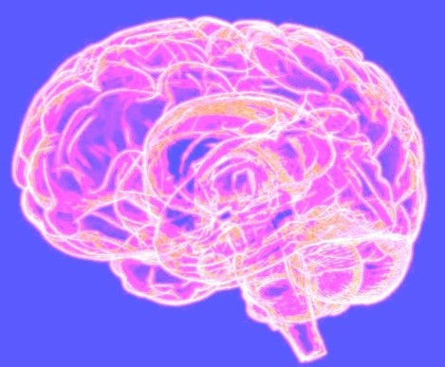

**WHY ARE WE CONDUCTING THIS STUDY AND WHAT IS THE AIM?**

There may be markers present in saliva that can show if a person has had a concussion. There are differences in the way that males and females experience concussion.

Females seem to suffer more severe symptoms that can last longer than males and there is a need to understand why that happens.

The aim of this study is to see how levels of hormones and markers measured in saliva may be related to symptoms and length of recovery after concussion in females.

**WHAT IS INVOLVED IN THE STUDY?**

The study will include collecting some additional research measures at your initial clinical assessment and during your recovery:

1. Provide two saliva (spit) samples
2. short online questionnaires about your menstrual cycle, previous injuries and your concussion symptoms

**WHO CAN PARTICIPATE?**

**Females 16-50 years old who have sustained a concussion.**

**If you are interested, please let the reception staff or clinical team know and we will organise everything you need.**

Thank you for considering participating in this study. If you have any queries, please contact:   
Natalie Hardaker m: 027 898 9023 e: [natalie.hardaker@aut.ac.nz](mailto:natalie.hardaker@aut.ac.nz)

Approved by HDEC (reference #2021 EXP 11655)

Data collected in this study will contribute to Natalie Hardaker’s PhD at Auckland University of Technology.