Title

Outcome of induction of labour comparing double and single balloon catheters and PGE 2 Gel; an Open-label Trial.

Objective

To compare the efficacy of double and single balloon catheters and Prostaglandin E2 Gel in induction of labour.

Introduction

Induction of labour (IOL) is the initiation of labour pain by artificial stimulation of the uterus before the onset of spontaneous labour [1]. The frequency of IOL is on the rise, in the United States of America, it has increased from 9.5% in 1990 to 31.4 % in 2020 [2]. In the United Kingdom, it’s around 20% while in Africa it’s approximately 4.4% [3,4].

Induction of labour is indicated when the benefits of initiating labour overweigh the risk of continuing the pregnancy [5]. One such indication is pregnancy beyond 41 weeks, as continuing it increases the chances of operative delivery, neonatal intensive care admission and stillbirths [6]. Bishop’s score plays an important role in predicting the success of IOL, a score of less than 6 is considered poor while more than this is favourable [7]. For cervical ripening broadly there are two types of methods, mechanical and pharmacological [8,9].

Pharmacological agents like Prostaglandin E2 ( PGE2) and E1 are usually preferred over mechanical methods like balloon catheters when the bishop score is poor [6], however considering the safety of mechanical methods in terms of less risk of hyperstimulation of the uterus and fetal distress, cost-effectiveness and easy storage mechanical methods are now equally favored, especially in developing countries [8].

Balloon catheters (both single and double) are approved by the World Health Organization for use in the induction of labour [5], and double-balloon catheter (Atad or Cook) is approved by the United States Food and Drug Administration (USFDA) [10]. A balloon catheter stretches the lower segment of the uterus and strips the membranes from the cervix, which results in a release of prostaglandins and also promotes neuroendocrine reflex which promotes the onset of contractions and cervical ripening [11].

Considering the increase in the frequency of induction of labour and associated caesarean sections for failed induction and fetal distress, exploring any method with a good safety profile can prove really beneficial to patients as well as for countries with low resources, the results can help us formulate new guidelines and change in clinical practices. Literature review shows no such study has been conducted before, so our study will be the 1st to assess the efficacy and safety of standard treatment i.e PGE2 with double-balloon using two foleys catheters, single-balloon ( foleys catheter) devices and a combination of single balloon and PGE2 among women who underwent labour induction for postdate pregnancy.

Methodology

This study will be conducted in the Department of Obstetrics and Gynaecology at MTI LRH after the approval of the Hospital's ethical review board. Pregnant patients, aged 18-35 years with a single fetus between 37-42 weeks who need induction of labour for maternal or fetal reasons other than mentioned in exclusion criteria, with BMI 20-35 Kg/m2, cephalic presentation, intact membrane, and reassuring CTG will be included in this study, the period of gestation will be calculated from either a dating scan or the last menstrual period. Patients with meconium stained liqor, low-lying placenta defined as placental edge less than 2 cm from the internal os as measured by ultrasonography, pre-labour rupture of membrane, pre-eclampsia, growth-restricted fetus, previously scarred uterus, estimated fetal weight of more than 4kg on ultrasound, uterine anomaly, intrauterine fetal demise, cephalopelvic disproportion and liquor abnormalities will be excluded from the study.

All the participants will be given information about the labour induction by all methods used prior to the study and well-informed written consent will be obtained from all patients fulfilling the inclusion criteria. This will be Open-label trial, computer generated randomization will be used for randomization. Group one (single foleys catheter), group two (double foleys catheter), group 3 Prostaglandin E2 gel (maximum 3 doses 6 hours apart), and Group 4 will be those in whom PGE2 gel (maximum 2 doses, 6 hours apart) will be used 12 hours after insertion of foleys catheter. Relevant medical and obstetric history followed by general, abdominal and vaginal examination will be carried out, pre-insertion bishop score will be noted, and fetal wellbeing will be ensured by pre-induction Cardiotocography (CTG).

The patient will be put in a dorsal position, Vagina will be cleaned with normal saline, a Sims speculum will be inserted, and an 18-Fr Foley catheter will be inserted above the internal os. The catheter bulb will be inflated with 60 ml of normal saline. After inflation, the catheter will be pulled back until the balloon is against the internal cervical os. The catheter was then strapped to the inner aspect of one leg. In the case of group two, two foleys catheter will be tied to each other and inserted together, one bulb will be extra amniotic, above the internal os, inflated with 60ml saline, 2nd the bulb will be placed in the cervix, inflated with 30ml saline. Pain during the insertion of the catheter will be noticed using a visual analogue scale. In Group 3 no catheter will be inserted and only Prostaglandin E2 gel will be used, pessary will be placed in the posterior fornix, 6 hours apart, maximum three doses unless regular uterine contractions are commenced. In group 4, a single bulb Foley catheter will be placed above the internal os, inflated with 60 ml of normal saline, after 12 hours PGE2 pessary will be placed in the posterior fornix ((maximum 2 doses, 6 hours apart).

The induction of labour will be considered as failed if, with a particular method, the patient doesn’t develop regular uterine contractions ( 3 per 10 minutes, each lasting for at least 20 min) leading to cervical dilation of 4cm or more within 24 hours of initiation of the method.

Catheters will be removed if they are not expelled within 24 hours, they will be removed by deflating the balloon. CTG will be done if reassuring then Either induction will be continued with Prostaglandin E2 or c-section will be performed as per maternal wish and consent. If the catheter is expelled in 24 hours, and the patient goes into labour, it will be monitored according to intrapartum care guidelines (NICE). In case the patient expels the catheter within 24 hours but the bishop score is still less than 7, prostaglandin E2 gel will be considered (maximum two doses 6 hours apart). Oxytocin augmentation will be considered with any method if the bishop score is more than 8, an hour after the artificial rupture of the membrane.

The sample size was calculated using, Open Epi, Version 3, open-source calculator-as 122 patients in each group (488 total), keeping the power of study as 80%, Two-sided significance level (1-alpha):95, the ratio of exposed to unexposed as 1, per cent of unexposed with outcome 15, per cent of exposed with the outcome as 30 (12).

The primary outcome will be the rate of cesarean section, secondary outcomes include indication of cesarean section, mode of delivery, failed induction, the Time duration between insertion and expulsion of catheters, pain score on insertion, bishop score before and after expulsion, time from insertion to delivery. Adverse effects recorded will be hyperstimulation, rupture uterus, Postpartum haemorrhage (within 24 hours) fever during or within 24 hours of delivery will be recorded on proforma.

Data will be analysed using SPSS version 22. Mean and standard deviation will be calculated for quantitative variables like age, BMI, duration of insertion to the expulsion of the catheter, and duration of insertion of a catheter to delivery, and bishop score comparison between all groups will be analyzed by the ANOVA test. While qualitative data like rate of failed induction, mode of delivery, and indication of cesarean section will be expressed in frequency and percentages.

References

1. Managing complications in pregnancy and childbirth: a guide for midwives and doctors. Second edition. Geneva Switzerland Who 2017. [http://reprolineplus.org/system/files/resources/mcpc_guide_eng.pdf. Accessed 02 Jan 2018](http://reprolineplus.org/system/files/resources/mcpc_guide_eng.pdf.%20Accessed%2002%20Jan%202018).
2. Osterman, M. J., Hamilton, B. E., Martin, J. A., Driscoll, A. K., & Valenzuela, C. P. (2022). Births: final data for 2020.
3. Battista, L., Chung, J. H., Lagrew, D. C., & Wing, D. A. (2007). Complications of labor induction among multiparous women in a community-based hospital system. *American journal of obstetrics and gynecology*, *197*(3), 241-e1.

<https://doi.org/10.1016/j.ajog.2006.12.027>[Get rights and content](https://s100.copyright.com/AppDispatchServlet?publisherName=ELS&contentID=S0002937806024690&orderBeanReset=true)

1. Vogel, J. P., Souza, J. P., & Gülmezoglu, A. M. (2013). Patterns and outcomes of induction of labour in Africa and Asia: a secondary analysis of the WHO Global Survey on Maternal and Neonatal Health. *PloS one*, *8*(6), e65612.

<https://doi.org/10.1371/journal.pone.0065612>

1. World Health Organization. (2011). *WHO recommendations for induction of labour*. World Health Organization.
2. Guideline, N. I. C. E. (2008). Induction of Labour. *National Collabourating Centre for Women’s and Children’s Health. National Institute for Health and Clinical Excellence*.
3. Cocks, D. P. (1955). Significance of initial condition of cervix uteri to subsequent course of labour. *British Medical Journal*, *1*(4909), 327. doi: [10.1136/bmj.1.4909.327](https://doi.org/10.1136%2Fbmj.1.4909.327)
4. Jozwiak, M., Bloemenkamp, K. W., Kelly, A. J., Mol, B. W. J., Irion, O., & Boulvain, M. (2012). Mechanical methods for induction of labour. *Cochrane Database of Systematic Reviews*, (3). ACOG Practice Bulletin No. 107: induction of labor. Obstet Gynecol 2009, 114(2 Pt 1):386–397.<https://doi.org/10.1002/14651858.CD001233.pub2>
5. ACOG Practice Bulletin No. 107: induction of labor. Obstet Gynecol 2009, 114(2 Pt 1):386–397.
6. Cook Medical*,* Cervical Ripening Balloon Instructions for Use. <https://www.cookmedical.com/data/IFU_PDF/T_J-CCRB_REV2.PDF>. Accessed 02 Jan 2018.
7. Keirse MJ, Thiery M, Parewijck W, Mitchell MD. Chronic stimulation of uterine prostaglandin synthesis during cervical ripening before the onset of labor. Prostaglandins. 1983;25(5):671–82.
8. Pennell CE, Henderson JJ, O’Neill MJ, McCleery S, Doherty DA, Dickinson JE. Induction of labour in nulliparous women with an unfavourable cervix: a randomised controlled trial comparing double and single balloon catheters and PGE2 gel. BJOG: an international journal of obstetrics & gynaecology. 2009 Oct;116(11):1443-52.
9. Krammer J, O'Brien WF. Mechanical methods of cervical ripening. Clin Obstet Gynecol. 1995;38(2):280–6

PROFORMA serial no -------

MR number ------------------ DOA ---------------- AGE -----------------

BMI ---------------- days of hospital stay -----------------

Single foleys catheter ------------ Double foleys catheter -----------------

PGE2 ----------- Catheter + PGE2 --------------------

Time of insertion of catheter ------------- Time of expulsion of catheter --------

Duration of insertion to expulsion ----------- bishop score before induction --------

Pain encountered during insertion -------------- 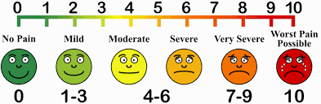

Bishop score after expulsion of catheter ----------- 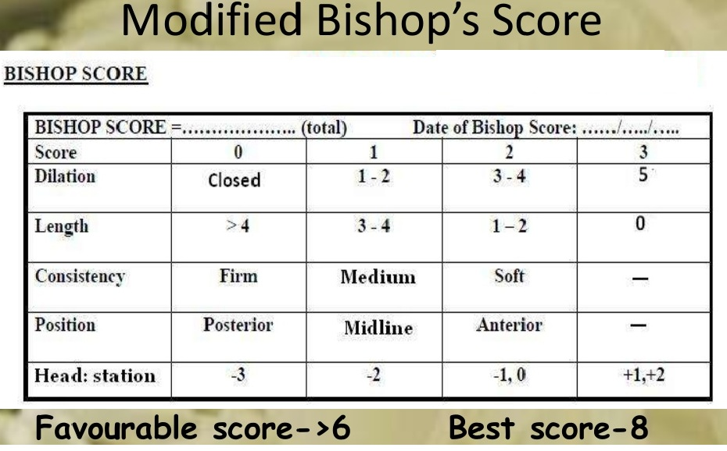

Time/ date of delivery ------------------ Duration of insertion to delivery ----------

Amount of oxytocin (units) used ----------- prostaglandin used ------------

Mode of delivery, NVD ------- Instrumental delivery ------------ CS -------

IF CS, write indication ------------------------------------------------------------------------------

Hyperstimulation YES ------ NO ----- Fever within 24 hr of delivery YES --- NO –

PPH YES -------- NO ------------ Rupture Uterus