# Information Statement – Engaging Men in Crisis Support

Centre for Youth Mental Health

Faculty of Medicine, Dentistry and Health Sciences

The University of Melbourne

## *Project Title:* A randomised controlled trial evaluating the effectiveness of the *Engaging Men in Crisis Support* training program for Crisis Supporters at Lifeline Australia

**Responsible Researcher:** Professor Jane Pirkis

Tel: +61 3 [8344 0647](mailto:8344%200647) Email: [j.pirkis@unimelb.edu.au](mailto:j.pirkis@unimelb.edu.au)

**Project Contact:** Tara Hunt

**Email:** Tara.Hunt@lifeline.org.au

### Introduction

Thank you for your interest in participating in this research project. The following few pages will provide you with further information about the project, so that you can decide if you would like to take part. Please take the time to read this information carefully. Feel free to seek clarification from the project contact listed above about anything you don’t understand or want to know more about.

Your participation is voluntary. If you don’t wish to take part, you don’t have to. If you begin participating, you can also stop at any time. You can email the Project Contact should you wish to withdraw later on.

This project has been approved by The University of Melbourne, Medicine, Dentistry and Health Sciences Human Ethics Sub-Committee (26011). This project is funded the Australian Government Medical Research Future Fund.

### What is this project about?

This project represents a partnership between the Lifeline Research Office, Lifeline Australia and the Centre for Mental Health, The University of Melbourne.

Men represent approximately 40% of callers to Lifeline, however they account for 75% of suicide deaths in Australia. Past research has highlighted that many men struggle to engage with mental health services such as helplines due to the influence of traditional masculine norms, such as the expectation that men be self-reliant and in control of their emotions. These norms also influence the way men experience mental distress, making them more likely to experience anger, irritability, substance misuse, and risk-taking. In interviews with Lifeline Crisis Supporters, we found that Crisis Supporters felt they would benefit from further training around understanding male presentations of distress, and how to engage with callers to Lifeline.

Applying this, Lifeline have partnered with The University of Melbourne’s Centre for Mental health to develop a world-first training program Crisis Supporters, called *Engaging Men in Crisis Support*. The development of this training was guided by lived/living experience interviews with Crisis Supporters and male consumers of helplines, subject matter experts, and best-practice guidelines. This training aims to inform Crisis Supporters regarding common presentations among male-identifying help-seekers and provide the skills to effectively engage and support these help-seekers. This training is designed to be an enhancement to CARE and therefore skills learned will be embedded within the CARE model. It is not designed to be a replacement for any components of CARE. This study aims to investigate the impact of the training on male caller outcomes at Lifeline.

**Who can participate?**

You will be eligible to participate if you are a Crisis Supporter at Lifeline currently completing paid shifts. You must be currently completing a minimum of one four-hour paid rostered shift a fortnight at a participating Lifeline centre.

You must also be able to commit to completing an additional weekday (Monday-Friday) paid shift on top of your normal crisis support shift in the 4-week training period to complete the professional development training required for the study. This will be coordinated with your Centre’s workforce management team and will be between [insert dates].

As the training and surveys are delivered online you must have access to a computer and internet to be able to participate.

Please note that if you took part in a research interview or focus group between April-June 2022 for the study entitled *Optimising telephone crisis helplines: exploring the needs of male help-seekers (22987)* you will be ineligible to partake in this phase of the project. We thank you for already taking the time to contribute to our research.

If you have previously completed the *Men in Mind* training program (Seidler, Wilson, Owen, et al., 2021) or the *Male-Friendly Counselling: Enhancing Therapy Work with Men* training program, you will also be unable to participate in the research. Additionally, if you have previously accessed the *Engaging Men in Crisis Support* training module, you will not be eligible to participate in the research. If you are unsure about your eligibility to participate, please contact the Tara Hunt via email [Tara.Hunt@lifeline.org.au](mailto:Tara.Hunt@lifeline.org.au).

We especially welcome and encourage participation from Aboriginal and Torres Strait Islander people, culturally and linguistically diverse people, LGBTIQA+ people (including individuals identifying as transgender or gender diverse), and people with a disability.

### What will I be asked to do?

*Summary*

This trial involves completing an online training module followed by completing your regular shifts at Lifeline for a period of up to 18 months. During that time, we will collect data from callers to Lifeline to evaluate the effectiveness of the training module.

If you agree to take part, you will be asked to complete two short online surveys over the trial period. Each survey is expected to take about 10 minutes to complete. You will be randomised to either group A or group B and will be asked to complete an online training module via Lifeline’s LMS which will take a maximum of three hours to complete. Once you have completed the training, you will continue to complete your regular rostered shifts at Lifeline during the trial period. We will collect data from callers that you speak with via a post-call survey embedded in the interactive voice response (IVR) system that we will use to evaluate the effectiveness of the *Engaging Men in Crisis Support* training module.

The tasks required and study timeline are outlined in detail below.

***Phase 1:***

First you will be asked to complete an online survey which involves some demographic questions, some questions about your role at Lifeline, some questions about your experiences supporting male callers at Lifeline, and current skills and confidence in engaging male callers at Lifeline.

Following completion of this survey, you will be allocated either **group A** or **group B**. Which group you are allocated to is determined at random (like flipping a coin). Each group will be given access to a different e-learning module via Lifeline’s LMS platform. You will have 4 weeks to complete your allocated module. **Regardless of which group you are allocated to you will definitely get access to the *Engaging Men in Crisis Support* module at some point.**

**If you are in group A**, you will be asked to complete the *Engaging Men in Crisis Support* online training package. This training is a self-paced e-learning involving 3 modules and is expected to take 3 hours to complete. You will be rostered on to complete an additional paid shift during the training period for you to complete your allocated training. You will have access to the training for the duration of the trial should you wish to revisit it.

**If you are in group B**, you will be asked complete a short online module called *Child Safety and Crisis Support*: a self-paced e-learning focused on identifying and responding to child safety concerns during interactions with help-seekers. This module is a self-paced e-learning and is expected to take 2 hours to complete. You will be rostered on to complete an additional paid shift during the training period for you to complete your allocated training. You will have access to the training for the duration of the trial should you wish to revisit it. **You will be also provided access to the *Engaging Men in Crisis Support* module after the trial ends.**

Following completion of your allocated module, you will be asked to complete another brief online survey. This will include questions about your experiences supporting male callers and feedback questions about completing the training.

***Phase 2:***

Once you have completed your allocated module and the post-training survey, you will continue supporting callers through attendance of regular rostered shifts. While the trial is running, callers will be invited to participate in a post-call survey administered via the IVR where they will answer a few short questions about their experience of the call. We will use this data to evaluate the effectiveness of the module. It is expected that we will collect data from callers for up to 18 months. If you don’t complete the training module assigned to you in Phase 1, we won’t include caller survey data from your calls in our analyses.

As part of your participation, you’ll need to verbally invite callers at the end of a call to complete the post-call survey. As part of your training, we’ll provide instructions and guidance on how to invite and transfer callers to the post-call survey (including answers to FAQs from callers).

During this period, you will have ongoing access to the training material and accompanying resources if you require a refresher on the content. During the trial period, you will complete your shifts as you normally would, drawing upon the knowledge and skills you gained from the training module as you see fit.

**Data collected from callers and in all of the surveys is anonymous and is not intended to test or assess your ability as a Crisis Supporter.** Rather, it enables us to determine how useful the training is and will help us identify areas for future improvement.

**We also ask that you do not disclose your group allocation or discuss the training content with any other Crisis Supporters, as this may impact the findings of the study.** If you have questions about the training content, you can contact the research team via the contact details provided above.

Access to all activities in this study will be facilitated via a link sent to your email. The training is hosted on Moodle and you will be able to access it through using your Lifeline Moodle e-learning account. Completing your allocated module will involve reading content, engaging with videos and audio scenarios, and completing self-reflection tasks.

**The total time commitment involved in phase 1 is expected to be around 4 hours (a maximum of 3 hours completing the module and an additional maximum of an hour completing the research surveys). You will not be required to complete any tasks outside of your shifts at Lifeline. In phase 2 you will be asked to complete your regular shifts at Lifeline, and you may also spend additional time revisiting the module content.**

The diagram below summarises everything involved in this study.

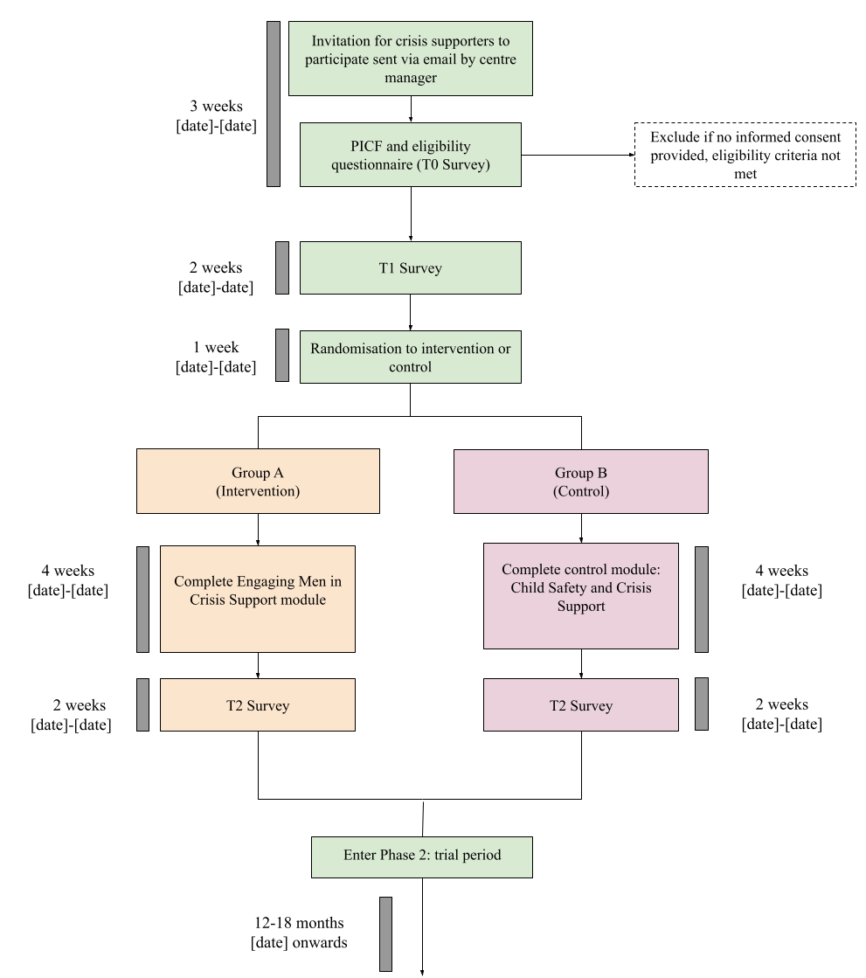

### When will I be contacted?

If you agree to take part by completing this form, you will be contacted by the research team via email with access to the first online survey, which you will have two weeks to complete. We will send you a maximum of two emails reminding you to complete the survey, if you have not already done so. Following survey completion, you will be enrolled into your allocated module and informed of this via email. Four weeks after you are enrolled, you will be emailed a link to the second survey, which you will have two weeks to complete. We will send you a maximum of two emails reminding you to complete the survey, if you have not already done so.

### What are the possible benefits?

The *Engaging Men in Crisis Support*module is designed to improve Crisis Supporters’ confidence and skills in engaging with and supporting male-identifying help-seekers. Your participation helps us understand the effectiveness of the module, such that it can be scaled up and rolled out to all Lifeline Crisis Supporters. Your contribution to the study is vital to ensuring the training will have maximum impact on helping Crisis Supporters, and therefore helping improve male experiences when contacting Lifeline. Aside from receiving the training program, and any learning or skill development you experience, no direct benefits of participation are anticipated for you.

### What are the possible risks?

The main risk for you is inconvenience due to the time commitment involved in the study (approximately 4 hours in phase 1, and completion of regular rostered shifts in phase 2).

An additional risk involves the sensitive nature of the content of the course provided to Group A. The content of these modules may be distressing and includes discussion of suicide and managing challenging presentations such as anger. We encourage you to ensure you have adequate self-care strategies in place prior to and following completion of these modules. You will be reminded to contact your ISS or Centre supervisor for debriefing if you are concerned about anything that comes up when completing the modules. The Project Contact details are also provided at the top of this form should you require direction to further support. We have also listed a number of support services at the end of this form, should you need them.

### Will I be reimbursed?

You will be able to claim the time spent on the modules as Professional Development hours by completing the reflection form found on the LMS website. You will be paid to complete the additional training shift at your standard rate.

### Do I have to take part?

No. Participation in any research project is totally voluntary. If you do not wish to take part, you are not obliged to. If you do take part and decide later you would like to withdraw your research information, you are welcome to do so. If you choose to withdraw from the trial, we will not use data from your completed surveys, nor will we collect any further data from your callers. It is expected that the trial will run for up to 18 months. While we hope that you are able to complete on average one 4-hour shift per fortnight for this period, we understand that things may change, and you may need to withdraw or take a break from your role at Lifeline. If you leave your role at Lifeline during the trial period, we will use data from your completed surveys (unless you request to withdraw this data) and from your callers up until the point that you leave. If you withdraw from the study, we will retain data from caller IVR responses.

### How confidential is the information I provide?

All information you provide when completing surveys will be stored securely on password protected servers by Logicly, an external data management organisation. Logicly will have access to your name and email address in order to send you emails that link to the surveys, and reminders to complete the training. The Lifeline Learning & Design team will also have access to your name and email in order to enrol you into the training modules. The Lifeline Workflow Management team will also be aware of your participation in the trial in order to monitor shift completion over the course of the trial. Your Lifeline centre manager will be aware that CSs in their centre may be taking part in the study but will not be aware of your participation in particular. Your contact details will never be stored together with your study data (i.e., data from training surveys).

All data you provide as part of this study will be stored by Logicly against a study identifier (ID) that is unique to you, so will be completely confidential. You will be provided with a unique link via email to access all tasks involved in this study, and each participant will have their own link.

Your deidentified study data will be transferred to a secure data platform hosted by Lifeline Australia in order to complete data analysis for the trial.

Caller data collected via the post-call survey will be linked with your Crisis Supporter ID. This will be stored in deidentified format at Lifeline for the purpose of identifying whether callers were allocated to Crisis Supporters in Group A or Group B.

At the conclusion of the study, all data collected by the research team will be securely transferred to the research team at The University of Melbourne and stored indefinitely on password-protected servers, to which only the research team will have access.

In addition to this, while you are completing the training, we will collect data on the completion status of your training. This will be stored securely by Logicly. This information will be transferred to a secure data platform hosted by Lifeline Australia in order to complete data analysis for the trial. This information will eventually be downloaded to secure, password-protected servers at The University of Melbourne for storage.

### What will happen to information about me?

Personal information that you give us as part of your participation in the project won’t be passed on to anyone outside the research team without your permission, subject to any legal reporting requirements. The Lifeline Workflow Management Team, designated members of the Lifeline Learning & Design team, and the study Research Manager (Tara Hunt) will be aware of your participation in the study for e-learning enrolment and shift monitoring purposes but will not have access to any data related to the study. Also, any research data may be subject to monitoring or auditing to ensure procedures are in compliance with regulations. This may be undertaken by the approving ethics committee, or the sponsor of the study (University of Melbourne).

At the conclusion of the study, your anonymous data will be analysed along with other participants, and likely published in a scientific journal alongside internal and external reports. In any publication, information or data will be provided in such a way that you cannot be identified (i.e., no names or contact information will ever be published). Anonymous aggregate data may be provided to Lifeline for reporting purposes and future training development.

Researchers from other universities or organisations may request to use the data from this study for their own research. If we agreed to pass on the data, the data we would provide would never include your personal details, such as your name and contact details. The data we would provide would only be the responses to the questionnaires and caller outcome data. There would be no way to identify you through this data. We would approve or reject researchers’ written requests to use this data on a case-by-case basis. Only research that has gained ethics approval from a human research ethics committee, as needed, would be considered.

Your anonymous research information will be kept indefinitely for use in this research project. All data will be kept securely on password-protected computer- or cloud-based servers. We will use your email address to provide you with updates about the project including results.

### Can I access information about me?

When analysing study data, we will be compiling all participants together, so it won’t be possible to provide individual results to any participant.

### How will I be informed of the final results of this research project?

Once the project has been completed, a summary of findings will be disseminated to participants via email.

### Where can I get further information?

If you would like more information about the project or have any questions or concerns, please contact Tara Hunt ([Tara.Hunt@Lifeline.org.au](mailto:Tara.Hunt@Lifeline.org.au)).

This research project has been approved by the Human Research Ethics Committee of The University of Melbourne. If you have any concerns or complaints about the conduct of this research project, which you do not wish to discuss with the research team, you should contact the Manager, Human Research Ethics, Research Ethics and Integrity, University of Melbourne, VIC 3010. Tel: +61 3 8344 2073 or Email: humanethics-complaints@unimelb.edu.au. All complaints will be treated confidentially. In any correspondence, please provide the name of the research team or the name or ethics ID number of the research project (26011).

**Who is funding this project?**

This study is part of a larger project ‘The Buoy Project: Preventing suicide in boys and men’ funded through a grant supplied by the Australian Government’s Medical Research Future Fund (MRFF).

**What if I need support?**

If you need support for your own mental health, you can book in for a reflexive debriefing session with one of the in-shift supervisors at Lifeline. You can also contact one of the services below:

* [MensLine Australia](http://www.mensline.org.au/Home.html) on 1300 789 978
* [Suicide Call Back Service](http://www.suicidecallbackservice.org.au/) on 1300 659 467
* [Beyond Blue](https://www.beyondblue.org.au/) on 1300 224 636
* [Headspace](https://headspace.org.au/) on 1800 650 890
* [ReachOut](https://au.reachout.com/) at [au.reachout.com](https://au.reachout.com/)
* [QLife](https://qlife.org.au/) on 1800 184 527
* [13YARN](https://www.13yarn.org.au/) on 13 92 76

If you need further assistance with direction to appropriate support services, please contact Tara Hunt ([Tara.Hunt@Lifeline.org.au](mailto:Tara.Hunt@Lifeline.org.au)).

# Consent form

If you agree to take part in this study, you are agreeing to the following:

* Complete a total of two online surveys at different time points over the trial period (including one on the next page, should you consent).
* Complete an additional paid shift where you will complete your allocated training.
* Complete your standard Lifeline shifts for the foreseeable future and invite callers to complete the post-call survey.
* Your anonymous study data will be kept for research purposes. You won’t be identifiable as your contact details will be stored separately from study data.

If you agree with all of the information described here, please indicate your consent to take part in the study by responding below:

|  |
| --- |
| **☐ YES, I consent to take part in this study.** |
| **☐ NO, I do not consent to take part in this study.** |