# Title: TRialHub tELetriAge pilot studY

# Acronym: RELAY

## Version number: Version 3 30th August 2022

# Project Team Roles & Responsibilities

|  |  |  |  |
| --- | --- | --- | --- |
| **Name** | **Affiliations** | **Position** | **Responsibilities** |
| Associate Professor Victoria Mar | Alfred Health and School of Public Health and Preventive Medicine, Monash University | Director, Victorian Melanoma Service | Principal Investigator: Overall responsibility for the project including ensuring compliance to protocol, informing HREC of any amendments to protocol and serious adverse events, and ensuring regulatory requirements are met throughout the conduct of the study. |
| Associate Professor Chris McCormack | Peter MacCallum Cancer Centre | Dermatologist | Consultant dermatologist responsible for remote assessment and diagnosis of lesions of concern, including recommendations for treatment plan if applicable. |
| Dr Michelle Goh | Peter MacCallum Cancer Centre | Dermatologist | Remote assessment and diagnosis of lesions of concern, including recommendations for treatment plan if applicable. |
| Dr Ryan Toholka | Peter MacCallum Cancer Centre | Dermatologist | Remote assessment and diagnosis of lesions of concern, including recommendations for treatment plan if applicable. |
| Associate Professor Dennis O’Connor | Bendigo Primary Care Centre | General Practitioner | Lead Practitioner at the recruiting practice, overseeing participant recruitment and referral to the Regional Care Navigator |
| Ms Amy Clark | Bendigo Health | Regional Care Navigator | These Regional Care Navigators will establish and enhance links between the hospital and general practices, working with their local Primary Health Network and specialists involved in skin cancer management.  They will be linked in with multidisciplinary meetings at Peter MacCallum and/or Alfred Health so that they are up to date with staging, management protocols and eligibility criteria for available trials. They will be the key local contact for referring doctors and will assist with the triage of patients requiring diagnosis or who have recently had a confirmed diagnosis of melanoma and other skin cancers into the relevant multidisciplinary services and trials.  These positions will be supported centrally by established melanoma and skin cancer care coordinators as well as dermatologists and oncologists at Alfred Health and Peter MacCallum Cancer Centre. Upskilling will be provided via workshops and visits to Alfred Health and/ or Peter MacCallum clinics and site visits to Bendigo Health during the establishment phase. |
| Ms Narelle McPhee | Bendigo Health | Cancer Research Manager | Working with the Regional Care Navigator at Bendigo Health |
| Professor Rory Wolfe | School of Public Health and Preventive Medicine, Monash University | Biostatistician | Biostatistics advice and data analysis |
| Professor Monika Janda | Faculty of Medicine, University of Queensland | Director, Centre for Health Services Research | Planning, execution, analysis and manuscript revision. |
| Dr Maithili Sashindranath | ACRF Australian Centre for Excellence in Melanoma Imaging and Diagnosis, Monash University | Victoria Project Manager | Plan, coordinate and execute the project.  Lead research team to complete projects within allotted timelines and budgets.  Oversee the development and enforcement of research policies and procedures.  Act as primary contact for client communications.  Monitor project progress and reporting.  Collection and analysis of data, preparation of manuscripts.  Co-supervising PhD student Ayooluwatomiwa Oloruntoba. |
| Ayooluwatomiwa Oloruntoba | School of Public Health and Preventive Medicine, Monash Medical AI Group, Monash University | PhD candidate | Project planning, organising upskilling sessions, collection and analysis of data, preparation of manuscripts. |
| Dr Ken Ip | Alfred Health | Dermatology registrar, Victorian Melanoma Service | Plan, coordinate and execute the project.  Oversee the development and enforcement of research policies and procedures.  Collection and analysis of data, preparation of manuscripts. |

# Resources

## 2.1. Resources necessary for the project to be conducted:

* Teledermatology referral, triage and reporting system. Experience from other studies is that most reviews are very quick and do not add a lot of additional work.
* DermEngine™ by MetaOptima Technology Inc. will be the teledermatology platform used.
* Recruiting GPs to recruit patients, and to submit referrals containing clinical and photographic information which teledermatology assessments will be based upon. Bendigo Primary Care Centre will be the sole recruiting practice for this pilot feasibility study.
* Dermatologists to complete remote assessments of skin lesions. This will be supported by the Department of Dermatology at Peter MacCallum Cancer Centre.
* Regional Care Navigator (RCN) to coordinate the study including contacting patients for obtained consent, undertaking initial triaging of skin cancer referrals, arranging face-to-face photography appointments at Bendigo health if required, communicate teledermatology report to GP and to facilitate referrals as needed based on teledermatologists' recommendation.

## 2.2. Funding Support:

The Australian Government is providing $24.6 million Commonwealth funding through the Community Health and Hospitals Program to support the establishment of the Australian Clinical Trials Network’s TrialHub, administered via Alfred Health, so Australians with cancer and rare diseases have access to clinical trials no matter where they live including regional and remote Victoria. As initial foci of investments, TrialHub is developing flagship programs in regions (outer metro, regional and rural) and diseases of high need, particularly melanoma and prostate cancer, to enable TrialHub to develop processes and approaches that will be rolled out nationally. Funding has been secured from TrialHub to implement this study.

# Background

## 3.1. Literature review

Melanoma is Australia’s national cancer, with Australians experiencing 12 times the global average incidence.1 Currently, almost 17,000 Australians are diagnosed with invasive melanoma each year; it is the most common cancer in Australians aged 15-39 years, and the third most commonly diagnosed cancer in both males and females.2 The incidence and mortality rates for melanoma continue to increase. The number of melanoma-related hospitalisations increased by 63% during 2002-2014, with an age standardised hospitalisation rate of 9.2 hospitalisations per 10,000.3 In addition, people living in regional or remote Australia are often disadvantaged in their access to primary healthcare and diagnostic services, which may adversely affect disease outcomes and mortality.4,5 In the absence of substantial specialist care in rural and regional areas, there is an increasing strain on health care systems from treating people with late stage melanomas.

Teledermatology has led to increased access to specialist care and improved clinical outcomes as well as timely dermatology diagnosis and treatment.6 Teledermatology also improves patient access to care and clinical efficiency while maintaining a high level of diagnostic accuracy6. It is also well-accepted from the patient perspective, as it is a valuable way to access specialist dermatology care in areas where no expert dermatologists are available.7 However, there is a need for further studies to explore the potential of teledermatology to improve care pathways for people living in regional areas.

Concurrently, several studies of artificial intelligence (AI) algorithms suggest that they can improve diagnostic accuracy of skin cancer.8-12 Our recent SMARTI study (NCT04040114) assessed an AI algorithm in the specialist clinical setting, which shows accuracy on par with experienced teledermatologists and face-to-face clinician assessment (manuscript under review).

In this pilot study we will use an existing commercially available teledermatology platform, DermEngine™ developed by MetaOptima Technology Inc., to streamline skin cancer referrals and use this technology to upskill the regional workforce. The study will evaluate the feasibility, acceptability and impacts of the teletriage service on skin cancer management and referral pathways in the Bendigo Health catchment area. The study will also determine the feasibility and what sort of uptake this service would have and whether the workload is sustainable for the teledermatologists. Data will also be captured relating to patient access to multidisciplinary management and clinical trials for the 6 months prior to study commencement (baseline) and during the pilot study period.

## 3.2. Rationale/Justification

Access to specialist care and clinical trial enrolments is very limited in rural and regional Australia. Bendigo Health undertook a skin cancer review of 1182 patients for Safer Care Victoria during 2020/2021, which highlighted the limited skin cancer referral pathways for General Practitioners (GP), and the lack of availability of Dermatologists and Plastic Surgeons in rural areas for referrals. Additionally, the limited number of GPs with specialist skin cancer interest/qualifications across the Loddon Mallee Region and the paucity of options for patients to receive care close to home are further areas that need to be addressed. To support local doctors in timely skin cancer diagnosis and lesion management, we propose a trial of image enabled tele-triage using novel technologies.

The Australian Government is providing $24.6 million Commonwealth funding through the Community Health and Hospitals Program to support the establishment of the Australian Clinical Trials Network’s TrialHub, so Australians with cancer and rare diseases have access to clinical trials no matter where they live including regional and remote Victoria. As initial foci of investments, TrialHub is developing flagship programs in regions (outer metro, regional and rural) and diseases of high need, particularly melanoma and prostate cancer, to enable TrialHub to develop processes and approaches that will be rolled out nationally.

This pilot study will take place in Bendigo, leveraging on the 3D imaging equipment which will be installed at Bendigo Health as part of the Australian Centre of Excellence for Melanoma Imaging and Diagnosis (ACEMID) research program. Successful implementation of a teledermatology referral, triage and reporting system is anticipated to provide proof of concept for improvement of cancer care pathways in rural and regional settings through:

* **Increased early detection of skin cancer**: The availability of expert analysis by teledermatology could result in earlier diagnosis and more appropriate management, and improved patient outcomes by avoidance of costly surgery and medical therapy associated with malignancies that are detected at later stages.
* **Better use of limited resources**: The provision of rapid-access teledermatology opinion, may result in more appropriate referrals for face-to-face appointments, improving specialist physician allocation of time and clinical resources.
* **Upskilling clinical staff in rural and regional settings**: The study will incorporate upskilling of a Regional Care Navigator and integration of staff from Bendigo Health, Loddon Mallee Integrated Cancer Services and local GPs and GP Registrars to enhance melanoma and skin cancer diagnosis and management skills.
* **Improving clinical trial recruitment and participation**: It is anticipated that provision of access to teledermatologist and multidisciplinary care, in conjunction with a Regional Care Navigator, will enhance clinical trial recruitment and uptake in the Bendigo region.
* **Improving sustainability**: It is expected that promoting Regional Care Navigator roles will lead to increased referrals to the regional nodes and thereby increase demand for trial activity locally, which will in turn provide sustainability for these roles in the longer term.
* **Future access for vulnerable populations**: Future integration of AI diagnostic aids in the triage process may further improve efficiency and sustainability of the model by reducing burden on the limited workforce and assisting to upskill regional staff.

## 3.3. Research questions/aims/objectives/hypothesis

### 3.3.1. Aim

This is a pilot study aimed at improving teledermatology referral and triage pathways into melanoma treatment, clinical trials and research projects at Bendigo Health

### 3.3.2. Objectives

To improve access to melanoma and skin cancer specialist care and participation in clinical trials for patients in regional and rural centres through implementation of a teledermatology triage service and upskilling of local affiliated healthcare professionals:

The primary objectives are to:

* + - Determine the feasibility of implementing a teledermatology referral, triage and reporting service for melanomas and keratinocyte cancers
    - Upskill a Regional Care Navigator (see below) to facilitate teledermatology referrals, and improve recruitment of eligible patients to melanoma and keratinocyte cancer trials
    - Promote telehealth referrals in regional and rural centres, including through engagement with GPs and delivery of training workshops
    - Evaluate the impacts of a teledermatology service on timely access to definitive management of skin cancers for people living in regional and rural centres
    - Evaluate acceptability, barriers and enablers from the perspective of the Regional Care Navigator, clinicians and patients of a teledermatology service

The secondary objectives are to:

* + - Evaluate the utility of an AI algorithm as an upskilling tool for the regional workforce in evaluating and triaging melanoma and skin cancer
    - Evaluate the agreement between the AI-assisted Regional Care Navigator triage plan and that of the teledermatologist
    - For participants who also provide consent to participate in the ACEMID cohort study, evaluate the impact of 3D total body imaging on detection of additional incidental synchronous melanoma and/or keratinocyte cancers which may not have been identified by the GP

Establishment of Regional Care Navigators:

It is unknown what proportion of patients in regional and rural centres are currently referred for multidisciplinary care and are potentially eligible for participation in trials. The perceived requirement for travel if referred to a metropolitan centre is a barrier. In order to remove this barrier and better understand the needs of consumers in regional areas, including trial eligibility and demand, bolster capacity and improve access to both trials and multidisciplinary care locally, we propose a regionally based tumour stream navigator (Regional Care Navigator).

The Regional Care Navigator will establish and enhance links between the hospital and general practices, working with their local Primary Health Network and specialists involved in skin cancer management. They will be linked in with multidisciplinary meetings at Peter MacCallum and/or Alfred Health so that they are up to date with staging, management protocols and eligibility criteria for available trials. They will be the key local contact for referring doctors and will assist with the triage of patients requiring diagnosis or who have recently had a confirmed diagnosis of melanoma and other skin cancers into the relevant multidisciplinary services and trials.

These positions will be supported centrally by established melanoma and skin cancer care-coordinators as well as dermatologists and oncologists at Alfred Health and Peter MacCallum Cancer Centre. Upskilling will be provided during the establishment phase. The teledermatologists, RCN and the GPs will be provided upskilling in the use of DermEngine by representatives from MetaOptima. The RCN will receive further upskilling in the use of the custom-designed RELAY REDCap database by the Alfred Health study team. The RCN will also receive further dermoscopy (photography) training from the Alfred and Peter MacCallum dermatologists. The GPs will be offered to attend biopsy workshop(s) conducted by Peter MacCallum clinical staff where hands-on training for diagnosis and biopsy of skin lesions will be provided.

### 3.3.3. Hypotheses

* An integrated teledermatology referral, triage and reporting system will enhance timely access to dermatologist reviews and management decisions for patients in regional and rural centre
* An integrated teledermatology referral, triage and reporting system will be acceptable to both patients and referring healthcare practitioners.
* Developing regional care coordination will improve recruitment of eligible patients to melanoma and keratinocyte cancer trials
* The AI decision support algorithm will be useful in upskilling the Regional Care Navigator
* The AI algorithm will be acceptable, in the context of upskilling, to referring healthcare practitioners

### 3.4. Expected Outcomes

* It is feasible to identify and train a Regional Care Navigator to facilitate a teledermatology triage service
* It is feasible to integrate a teledermatology referral, triage and reporting service in a regional setting, which will ultimately enhance timely access to definitive skin cancer management for patients in regional and rural centres
* An integrated teledermatology referral, triage and reporting system will be acceptable to both patients and referring healthcare practitioners.
* Developing regional care coordination will improve recruitment of eligible patients to melanoma and keratinocyte cancer trials
* The AI algorithm will be useful, in the context of upskilling, to the Regional Care Navigator
* The Regional Care Navigator’s AI-assisted triage plan will be comparable to a teledermatologist’s triage plan. Provisionally, ‘comparable’ will require >95% concordance with the teledermatologist for malignant lesions that require further biopsy/excision or treatment, and >80% concordance with the teledermatologist for benign lesions. This will provide insight into the feasibility of using AI-assistance to triage skin lesions safely (including ensuring malignant lesions acted on appropriately) and accurately (including the recognition of benign lesions that do not require surgery)

# Project Design

## Research project setting (physical sites, online forums and alternatives)

This pilot study will take place at Bendigo Health, the School of Public Health and Preventative Medicine, Monash University and the Peter MacCallum Cancer Centre with 1 referring GP clinic initially - Bendigo Primary Care Centre. Dermatologists from Peter MacCallum Cancer Centre will provide teledermatology support and will be rostered as ‘on-call’ for teledermatology assessments. Peter MacCallum has an agreement in place with Bendigo Health and runs a monthly dermatology clinic at the hospital.

## Methodological approach

### Rationale for choices of method/s (tied to project aims/objectives)

Consecutive patients will be recruited with the aim of maximising participant number in this pilot study, in order to demonstrate the feasibility of implementing a teledermatology referral, triage and reporting service for melanomas and keratinocyte cancers in a regional centre.

Acceptability of teledermatology to GPs, Regional Care Navigator, teledermatologists and patients will be evaluated using a modified version of the validated Technology Acceptance Model which assesses seven domains; perceived usefulness, perceived ease of use, attitude and intention, compatibility, facilitator, subjective norms and trust (Appendix 1-4).14-15

### Rationale for the choice of any control arm

There is no control arm for this pilot feasibility study. Data from the recruiting GP practice in the 6 months leading up to active participant recruitment will be used as a comparator for any changes effected.

## Participants

### 4.3.1 Description and number

Adult patients attending local GP clinics within the Bendigo Health catchment area, who require skin cancer assessment. Approximately 100 patients will be enrolled.

### 4.3.2 Inclusion and exclusion criteria

Patients are eligible to be included in the study if they meet ALL of the following criteria:

* Patient must have at least 1 lesion of concern to the patient or to the treating doctor.
* Patient is willing to undergo clinical photography for skin lesion(s) of concern.
* Patient is aged 18 years or older.
* Ability to understand information written in English and capacity to provide informed consent
* Patient must hold a valid Medicare card

Patients are ineligible for enrolment in the study if they meet ANY of the following criteria:

* Patient has a known past or current diagnosis of cognitive impairment.
* Patient is unable to stand for photography.

### Unable to read and complete PICF and/or surveys4.3.3 Sample size and statistical or power issues

In this feasibility study, we will collect baseline data for the number of referrals for skin lesion assessment and benign:malignant excision ratios prior to implementation of a teledermatology triage platform. We will measure uptake of the platform and any improvements in the care pathway overseen by the Regional Care Navigator.

One clinic has reported approximately 150 referrals over a 6-month period. Recruitment of a similar number of patients over a 6-month period would enable us to demonstrate feasibility and acceptability of the platform.

## Participant recruitment strategies and timeframes (as required in addition to that outlined in the HREA)

Participants will be recruited on a consecutive basis from routine GP clinic attendance at the recruiting GP practice. Recruitment period is projected as 6 months from date of first participant enrolment.

Duration of study per participant is determined by time taken from consent, screening and clinical imaging to the time of study exit after submission of teledermatology report and completion of patient survey.

In addition to consent withdrawal, participants exit the study after completion of the patient acceptability survey.

Lesions entered into the study that undergo excisional biopsy during the study period either as the initial recommended management, or on subsequent recommendation following monitoring, will have pathology information entered into the study database.

## Approach/es to provision of information to participants and/or consent (as required in addition to that outlined in the HREA)

## Recruiting GPs obtain verbal consent for participation and sharing of images via the teledermatology platform, and for the Regional Care Navigator to contact them. They are given a printed copy of the patient information and consent form. The GP will share photos, clinical information and patient contact details with the RCN via the DermEngine platform. After referral for teledermatology assessment has been submitted, the Regional Care Navigator contacts the participant directly (within 24 hrs) to discuss the study and obtain consent in full detail, then for signing either electronically on REDCap, or posting a physically signed consent form in prepaid envelope back to the Regional Care Navigator. If the participant has not had sufficient time to read the PICF when the RCN contacts them, the RCN will give them more time (up to 72hrs) to read the PICF, ask questions and provide consent. Participants will be supported in understanding the consent form and requirements of participation in the GP appointment, they will be able to consider these details in the time between the initial appointment and contact by the Regional Care Navigator. Any concerns/issues will be addressed when the Regional Care Navigator contacts the participants ahead of obtaining informed written consent.

## Research Activities: What you are going to do?

*Training of the Regional Care Navigator*

A Regional Care Navigator will be employed via Bendigo Health and will be trained in basic dermatoscopy, skin cancer diagnosis and management via a combination of face-to-face and online workshops and meetings. . Training will be provided alongside GPs by dermatologists from Peter MacCallum Cancer Centre who also undertake dermatology clinics at Bendigo Health. Training will also be provided on use of the teledermatology platform

*Collection of baseline data*

Data relating to skin cancer diagnoses, biopsies, excisions and referrals will be collected from both participating practices retrospectively for the 6 months leading up to active participant recruitment for this pilot study. No identifying data (patient name, date of birth, address) will be collected. Some of this data is already collected by GPs in the practice for the purpose of self-audit. Consent will be obtained from each doctor within the practice for a researcher (Ibukun Oloruntoba) to collect re-identifiable data from practice medical records as a baseline for comparison. This will be entered into the study database. Doctors not wishing to participate will be able to opt all of their patients out of the study. Baseline data will be collected at times when COVID restrictions do not preclude this activity.

*Participant recruitment and referral*

Patients presenting with a lesion of concern that requires referral for either diagnostic second opinion and/or management will be included in the study. These patients will be referred directly to the Regional Care Navigator at Bendigo Health via an integrated teledermatology platform (DermEngine™ platform developed by MetaOptima Technology Inc.). The referral will include the usual information including demographics and clinical history as well as a macroscopic and/or dermatoscopic image of the lesion of concern (Figure 1). Participants will provide verbal consent for the referral proforma and photos to be shared by the GP with the Regional Care Navigator and teledermatologist, and for the Regional Care Navigator to contact them to undertake a formal consent process (see Appendix 5 - GP Script). A copy of the Patient Information and Consent Form will be provided to the patient by the GP.

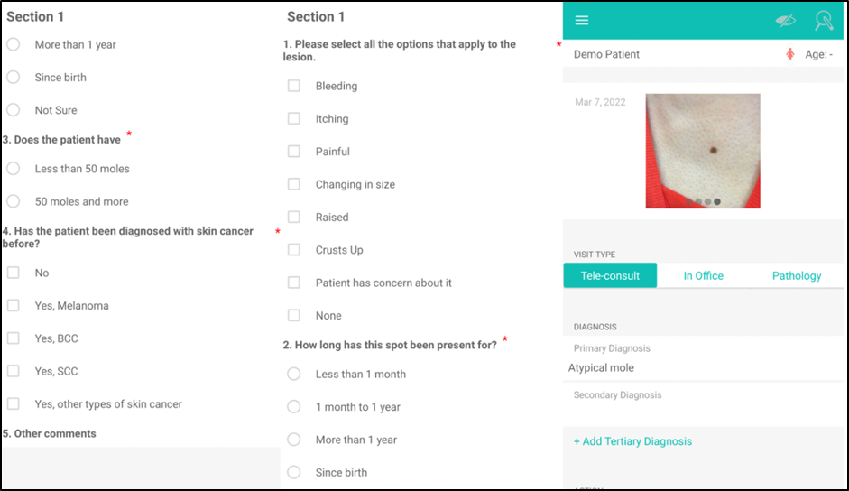

**Figure 1: Referral template for teledermatology assessment on the DermEngine™ platform**

Clinical and/or dermatoscopic photos submitted by the referring GP will be reviewed by the Regional Care Navigator to assess quality on a scale (1-5). If re-imaging is required due to poor quality or insufficient images, the Regional Care Navigator will contact the participant to arrange a face-to-face appointment at Bendigo Health during which clinical and polarised dermatoscopic photos of the lesion(s) of concern will be taken.

All patients referred via the teledermatology platform will be contacted by the Regional Care Navigator to confirm consent to use referral data and images for research purposes and request a signed copy of the Patient Information and Consent Form, either emailed via the RELAY REDCap database survey function, or scanned and returned as an attachment by email. Those who do not wish to consent to the study will be triaged with teledermatology input and will receive standard care, but will not contribute any data (including images) to the RELAY REDCap study database.

All patients will also be invited to attend Bendigo Health in person to participate in the ACEMID cohort study (optional), which enables use of the VECTRA machine for 3D Total Body Photography to be taken. Once patients have provided consent, the RCN will ask them if they would like information relating to the ACEMID cohort study. If they are interested, they will be sent the ACEMID PICF to read, and will be offered an appointment for the ACEMID cohort study baseline visit. For patients consenting to partake in 3D Total Body Photography, any additional synchronous skin cancers diagnosed, which would otherwise not have been detected, will be recorded. The DEXITM score for the lesion referred will also be recorded. These lesions will not be managed under the RELAY protocol. ACEMID dermatologists will provide a report (either via telehealth or face-to-face assessment) to the treating doctor directly as per the ACEMID Cohort Study protocol. This would not involve the DermEngine platform.

*Lesion assessment by Regional Care Navigator*

To assess the ability of the AI to assist with upskilling, on receipt of the tele-triage referral, the Regional Care Navigator will assess the images themselves, and document their primary diagnosis and triage plan within one of the following categories:

1. Re-image (poor quality photo).
2. Reassure
3. GP to monitor
4. GP to excise / biopsy
5. GP to treat (non-surgical)
6. Dermatology clinic review (urgent).
7. Dermatology clinic review (non-urgent).
8. Surgical referral for excision.

The regional care navigator will then apply an AI algorithm to the images and a diagnostic category (benign / malignant) will be provided (Figure 2). The Regional Care Navigator will record their AI-assisted diagnosis and management plan. Both the AI assessment and AI-assisted diagnosis and management plan will remain concealed from the teledermatologist to ensure the AI does not influence clinical care.

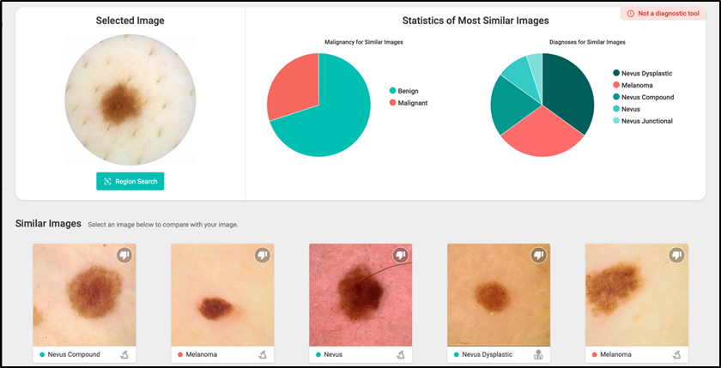

**Figure 2: Example of an AI report generated by the DermEngine™ platform on the probabilities of a diagnostic category (benign or malignant) and a diagnosis based on image analysis**

*Teledermatology assessment*

If images are of reasonable quality, the Regional Care Navigator will forward the referral and images immediately to the teledermatologist for assessment via the online Dermengine™ platform.

The teledermatologist will provide the Regional Care Navigator and the referring GP with an assessment within 48 hours, including the preferred diagnosis and management plan, via the teledermatology platform (Figure 3).

The teledermatologist will provide the Regional Care Navigator and the referring GP with an assessment within 48 hours, including the preferred diagnosis and management plan, via the integrated teledermatology platform (Figure 3).

For lesions where the teledermatology recommendation is specialist-directed management (ie. via an appointment at dermatology or surgical clinics) the Regional Care Navigator will assist to facilitate this appointment and will advise the patient of this plan. Outcomes of appointments will be followed up and histology reports will be requested by the Regional Care Navigator.

For lesions where the recommendation is GP-directed management, the referring GP is responsible for contacting the patient and actioning the recommendation and arranging follow-up. Free text can be provided in the report by the teledermatologist for specific instructions.

. The Regional Care Navigator will also compare the teledermatology assessment against the AI assessment. As a safety measure, if there is discordance between the teledermatologist and AI assessment (i.e. in cases where the AI ascribed a malignancy probability of >50%), a second review by the reporting teledermatologist plus a second teledermatologist review will be triggered. The teledermatologist’s diagnosis will be the gold standard for RCN upskilling.

In the clinical setting there is always the risk that a malignancy may be missed. Our aim is always to minimise this. Most algorithms are set to err on the side of caution. A missed diagnosis is still possible if both the dermatologist and the algorithm provide falsely reassuring recommendations. Participants will be advised that if they continue to be concerned about a lesion (diagnosed as benign), that they should return to their GP for review.

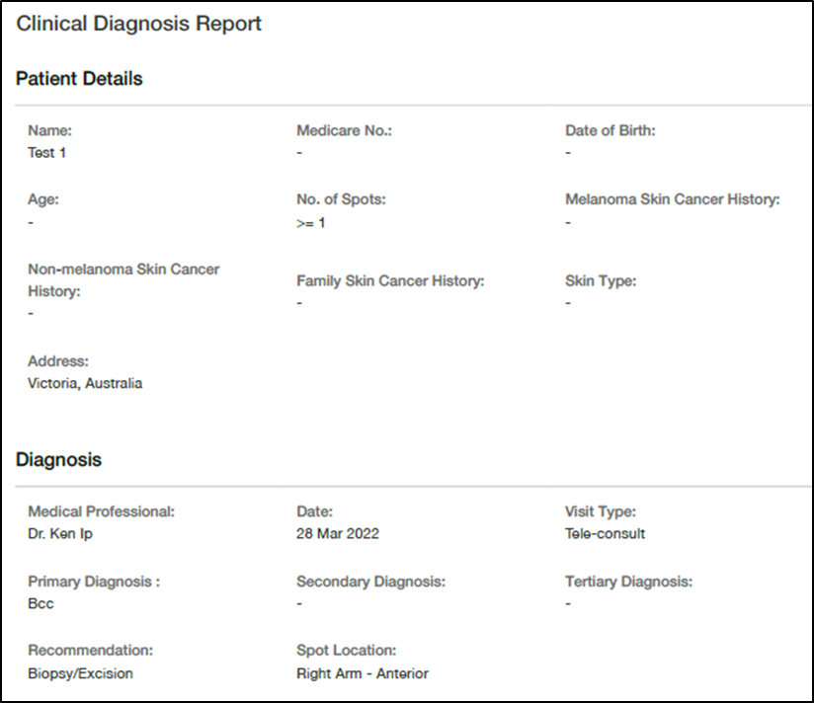

**Figure 3: Teledermatology report template using the DermEngine™ platform**

*Acceptability assessment*

Participants will be asked to complete an acceptability survey within 4 weeks of their imaging appointment and provision of their teledermatology assessment. All recruiting GPs, the Regional Care Navigator and teledermatologists will also complete an acceptability survey 3 months after recruitment has begun.

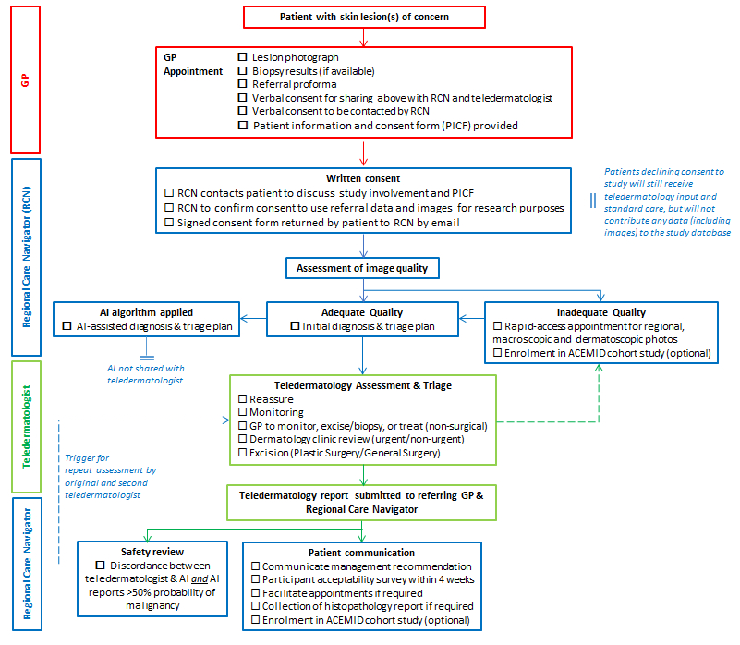

**Figure 4: Study Flow Chart**

## Participant commitment

It is anticipated that the primary commitment from patients from participating in this study is completion of the patient acceptability survey which is estimated to take up to 10 minutes. The information required to refer for teledermatology assessment, including clinical information and photographs, are obtained as part of routine clinical care and thus does not require additional commitment from participants. Only in cases where the referred lesion photographs are of insufficient quality, will participating patients be asked to attend a face-to-face photography appointment at Bendigo Health, with each appointment estimated up to 30 minutes in duration.

The acceptability surveys will be completed by:

* Participants: within 4 weeks of completion of imaging appointment and communication of the dermatologists’ recommendation (Appendix 1)
* Recruiting GPs: 3 months after recruiting period has begun (Appendix 2)
* Regional Care Navigator: 3 months after recruiting period has begun (Appendix 3)
* Teledermatologists: 3 months after the recruiting period has begun (Appendix 4).

## Project duration

Upon completion of all data collection pertaining to study visits, including voluntary completion of patient acceptability survey and histopathology results of lesions for which biopsy and/or excision was recommended, participation is considered complete. If enrolled patients present at future routine clinical visits or follow-up monitoring visits with additional lesions of concern that may meet criteria for study inclusion, the patient may re-enter the study on the same basis as newly identified potential participants. Recruitment is anticipated to be completed by January 2023, subject to further funding review from TrialHub.

### ***Participant follow-up***

The Regional Care Navigator will be responsible for communicating management recommendations made by the teledermatologist to the patients, and facilitating any appointments that may be required. If excision of a skin lesion has been recommended, the histopathology result will also be reviewed and recorded.

# Data Collection/Gathering: What information are you going to collect/gather? (as required in addition to that outlined in the HREA)

## Data collection/gathering techniques: How will you collect/gather the information?

Information on demographics, skin cancer risk factors and clinical history will be entered by the GP directly into a referral proforma on the DermEngine™ platform (see below). The DermEngine™ platform will be integrated with the GP’s Practice Management software so that all data entered into the platform will be automatically transferred and stored within the patients’ clinical notes.

Time intervals from referral to submission of the teledermatology report will be recorded, as will referral for multidisciplinary care, clinical trials and other research projects for comparison with baseline data. Where a recommendation for biopsy has been made, reports and relevant details of participants’ diagnoses from medical officers, pathology laboratories and hospitals will be requested. Biopsy results and reports from pathology laboratories will only be stored in REDCap. The only exception to this is where GPs have already biopsied a skin lesion prior to referring for teledermatology assessment, and is submitting a referral of the skin lesion with both images and histology report for management advice. Acceptability of the teledermatology pathway will be collected via surveys sent to participants by email via REDCap.

## Impact of and response to participant withdrawal

Participation in this study is voluntary; patients are able to withdraw at any time without penalty. Patients contacted by the Regional Care Navigator who do not wish to consent to use of their data for research purposes will still be triaged with teledermatology support to avoid unnecessary delays in management. Their data will not be entered into the study database.

If a participant withdraws their consent during the research project, the study doctor and relevant study staff will not collect additional personal information from them, although personal information already collected will be retained to ensure that the results of the research project can be measured properly and to comply with law. Participants will be made aware that data collected by the sponsor up to the time they withdraw will form part of the research project results and will be retained in the study database. If they do not want them to do this, they will be asked to notify the study team before they withdraw. If further photography is required or a biopsy is recommended, withdrawal of consent prior to these being taken will exclude them from input into the database as part of the research project.

# Data Management: How will you store, provide access to, disclose, use/re-use, transfer, destroy or archive the information that you collect/gather? (as required in addition to that outlined in the HREA)

Identifiable information is retained in DermEngine for forwarding to the teledermatologist, and in turn for reporting back to the GP, to ensure integrity of clinical records. Only the referring GP, Regional Care Navigator (RCN), research team and tele-dermatologists will have access to this. MetaOptima may access patient data to provide IT support if needed, provided they have permission to do so. Only the referring GP, Regional Care Navigator (RCN), research team and tele-dermatologists will have access to data within DermEngine. MetOptima will not have access to data or study images without our permission. They will not impose any restrictions on results, publications or authorship. They may access patient data to provide IT support if needed, provided they have permission to do so. At the end of the study, the data collected within DermEngine will be exported and stored in the REDCap database and then all the data within DermEngine will be deleted within 6 months.

All study data will be recorded on the REDCap system, a secure study database software built by Vanderbilt University and hosted by Monash University, Melbourne (https://redcap.helix.monash.edu).

Participant data will be handled with utmost confidentiality. Following patient consent, a data entry will be created in REDCap and an automatically generated ID number will be allocated to each participant. Referral data, images, questionnaires, forms and medical reports will be entered into REDCap by the Regional Care Navigator under the participant’s ID number to protect privacy. The participant log will only be accessible to the study investigators, and will be password protected. All electronic study documents will be stored password protected and all hardcopy documents will be stored in locked cabinets.

Bendigo Health will retain all hard copy source data and PICFs in a locked storeroom where all patient files are kept. Access is via swipe card to research staff only. After the study they will be archived at Grace information Management at 13 Baldock Court Eaglehawk VIC 3556.

Data will not be shared with other researchers or organisations within Australia or overseas unless ethics approval is sought and approved for further research. There is no sharing of information with third parties unless the participant agrees to optional consent for use of their deidentified clinical and dermatoscopic images for potential future research. Close up re-identifiable images may be included in publications. Participants will be asked if they give optional consent for the use of their re-identifiable images (individual macroscopic and dermatoscopic images of skin lesions and/or histopathology) for publications and presentations in the study; and future studies. Participants are not obliged to consent for future use of their images, and choosing not to give consent will not impact their inclusion in the study.

At completion of the study all essential documents will be archived for 15 years as per GCP guidelines, after which, electronic files will be deleted and paper files will be shredded.

# Data Analysis: How will you measure, manipulate and/or analyse the information that you collect/gather?

Descriptive statistical analyses will be used to summarise proportion of skin cancer referrals via the teledermatology triage platform, participant demographics, proportions of referred clinical images of acceptable quality, interval between referral and photography appointment (if needed), time to provision of teledermatology report, skin lesion diagnoses, clinicopathologic features of melanomas, total numbers of patients referred to melanoma multidisciplinary meetings and referred for clinical trial participation, and frequency of incidental skin cancers detected through 3D total body photography for participants also participating in the ACEMID cohort study.

Patients attending the two GP clinics for a skin cancer assessment in the 6 months prior to active recruitment, will be used as a comparator for clinical outcomes.

Acceptability of teledermatology to GPs, Regional Care Navigator, teledermatologists and patients will be evaluated using a modified version of the Technology Acceptance Model which assesses seven domains; perceived usefulness, perceived ease of use, attitude and intention, compatibility, facilitator, subjective norms and trust (Appendix 1-4).14-15

The AI-assisted Regional Care Navigator triage plan will be compared to teledermatologist triage plan using Kappa statistics to examine agreement between triage categorisations.

# Data Linkage: What linkages are planned or anticipated?

No data linkage is planned or anticipated. Data analysis will be undertaken using only re-identifiable information entered into the RELAY REDCap database.

# Outcome measures

We expect to provide evidence that implementation of a teledermatology referral, triage and reporting system in a Regional setting is feasible. The establishment of this integrated teledermatology system will allow us to explore how teledermatology can be used to upskill the regional workforce, optimise patient access to early and appropriate melanoma and keratinocyte cancer management in regional and rural centres where dermatology services may otherwise not be available, as well as facilitate participation in relevant multidisciplinary care and eligible clinical trials.

*Primary Outcome Measure*

The primary outcome measure of this pilot feasibility study is the uptake of the teledermatology triage platform at the recruiting GP clinic, measured as the proportion of all skin cancer referrals sent via the platform and facilitated by the Regional Care Navigator.

*Secondary Outcome Measures*

*Clinical Outcomes*

* Proportion of teledermatology reports received by Regional Care Navigator within 48 hours
* Number of participants recruited into clinical trials and cohort studies by the Regional Care Navigator
* Reduction in the ratio of benign to malignant skin excisions undertaken
* Increase in proportion of biopsy-proven referrals for head and neck skin malignancies
* Increase in proportion of people appropriately managed in primary care without a hospital visit
* Reduction in unnecessary hospital clinic visits for patients referred for skin cancer management. An unnecessary hospital visit is defined as either:
  + A visit to a hospital clinic (including dermatology, plastics, general surgery) for a diagnostic biopsy which could have been performed in primary care
  + A visit to a hospital clinic which resulted in reassurance for a benign lesion
  + Reduction in time from referral to definitive management. Date of definitive management is defined as date of excision procedure or commencement of appropriate non-surgical management of a malignant lesion, or decision to reassure or monitor in the case of benign lesions compared to routinely collected Bendigo Health administrative data from patients referred from non-participating GP clinics.

*Imaging outcomes*

Imaging data will be used to understand quality of clinical and dermoscopic photos submitted by referring GPs in a real-world setting, and frequency that these need to be re-captured. For participants opting to attend a face-to-face imaging visit and/or participate in the ACEMID Cohort study, quality of images for GP-captured images will be compared to melanographer-captured images. The frequency of incidental skin cancers detected through use of 3D total body photography, in lieu of full skin examination, will also be described.

*AI outcomes*

Agreement of the Regional Care Navigator’s AI-assisted diagnosis and triage decision with that of the teledermatologist will be assessed.

*Acceptability of Teledermatology*

Regional Care Navigator, GPs’ and dermatologists’ preferences, perceptions of the acceptability, relevance and comprehensibility of the online platform as a triage tool will be assessed via a study-specific modified Technology Acceptability survey instrument, based on similar measures used in previous research (Appendix 1-4).14-15

# For research involving an investigational drug or device as part of a clinical trial: What is/are the drug(s) and/or device(s):

**Teledermatology platform & AI algorithm**

The DermEngine™ platform developed by MetaOptima Technology Inc. is a programme that facilitates imaging, documentation and teledermatology assessment of skin cancers. It is widely used in Australia, with over 2000 active monthly users. Photography of skin lesions is taken with the clinician’s preferred device, including optional use of the MoleScopeTM dermatoscope attached to smartphones, which is included in the Australian Register of Therapeutic Goods (ARTG) by the Therapeutic Goods Administration (TGA).

Clinical information alongside photographs of skin lesions can be stored and submitted for teledermatology review, during which the data is stored securely on Amazon Web Services cloud computing platform (Australia) in adherence to the Health Insurance Portability and Accountability Act (HIPAA), General Data Protection Regulation (GDPR), Health Level 7 (HL7), together with SOC2 compliance to ensure data protection and security. A diagnostic and assessment report can then be generated by a different user within the same platform. This information in turn is automatically integrated into Practice Management Software such that data entered into the platform will be automatically transferred into the patients’ medical records.

The incorporated AI algorithm has been developed as an educational tool, whereby the photographed lesion is analysed using deep learning techniques and compared against a visual search through a database of thousands of pathology-labelled images. Decision support is provided in the form of two pie-charts; one showing the likelihood of classification as benign or malignant, and another, the statistics for top diagnoses generated through the visual search (Figure 2).

*Intended Use*

Clinical information and images will be submitted by referring GPs to the Regional Care Navigator using the DermEngine™ platform. The Regional Care Navigator records their initial assessment and diagnosis, and in turn, forwards the information and images to the teledermatologist. The teledermatologist will record their final diagnosis and management recommendations on the platform with an automated report returned to both the Regional Care Navigator and the referring GP.

The AI algorithm has FDA breakthrough device designation status, but is not currently TGA approved and will be evaluated separately so as not to impact on clinical care. Only the Regional Care Navigator will have access to AI algorithm assessment, in order to record an additional AI-assisted diagnosis and management plan. Its utility as an educational and upskilling tool will be assessed. As a safety measure, if there is discordance between the teledermatologist and AI assessment, a second review by the reporting teledermatologist and a second teledermatologist review will be triggered in cases where the AI ascribed a malignancy probability of >50%.

# Results, Outcomes and Future Plans

### ***Plans for return of results of research to participants***

Patients will be made aware that research results including any publications arising from the research, will be available from their GP at the conclusion of the study.

### ***Plans for dissemination and publication of project outcomes***

The Principal Investigator will be responsible for decisions regarding presentations and publications arising from this study.

Authorship credit should be based on the Vancouver statement by the International Committee of Medical Journal Editors, i.e. substantial contribution to all three of the following criteria:

- Conception and design OR analysis and interpretation

- Drafting article OR critically revising it for intellectual content

- Final approval of version to be published

### ***Other potential uses of the data at the end of the project***

Successful implementation of a teledermatology referral, triage and reporting system is anticipated to provide proof of concept for improvement of cancer care in rural and regional settings, which can thereafter be expanded beyond the sole recruiting GP practice in this pilot feasibility study.

### ***Project closure processes***

At completion of the study all essential documents will be archived for 15 years as per GCP guidelines, after which, electronic files will be deleted and paper files will be shredded.

### ***Plans for sharing and/or future use of data and/or follow-up research***

### Participants will be asked if they give optional consent for the use of their re-identifiable images (individual macroscopic and dermatoscopic images of skin lesions and/or histopathology) for future studies.

# References

1. KPMG on behalf of Melanoma Patients Australia. Advanced melanoma - the real cost of Australia's national cancer. KPMG; 2014 17 July 2019. 56.
2. Australian Institute of Health and Welfare. Cancer in Australia 2017. Cat no. 100 ed. Vol. 2017. Canberra, ACT: AIHW; 2017. 204 p. p. 108-09 (vol. 03 Feb 2017). <http://www.aihw.gov.au/acim->books/.
3. Australian Institute of Health and Welfare. Skin cancer in Australia. Cat no. 96 ed. Vol. 2016. Canberra, ACT: AIHW; 2016. 204 p. [http://www.aihw.gov.au/acim-books/.](http://www.aihw.gov.au/acim-books/)
4. Cramb, S. M., Mengersen, K. L., & Baade, P. D. (2011). Developing the atlas of cancer in Queensland: methodological issues. *International Journal of Health Geographics*, *10*(1), 1-11.
5. Cramb, S. M., Moraga, P., Mengersen, K. L., & Baade, P. D. (2017). Spatial variation in cancer incidence and survival over time across Queensland, Australia. *Spatial and Spatio-temporal Epidemiology*, *23*, 59-67.
6. Zakaria, A., Miclau, T. A., Maurer, T., Leslie, K. S., & Amerson, E. (2021). Cost minimization analysis of a teledermatology triage system in a managed care setting. *JAMA dermatology*, *157*(1), 52-58.
7. Asabor EN, Bunick CG, Cohen JM, Perkins SH. Patient and physician perspectives on teledermatology at an academic dermatology department amid the COVID-19 pandemic. *J Am Acad Dermatol*. 2021;84(1):158-161.
8. Esteva A, Kuprel B, Novoa RA, Ko J, Swetter SM, Blau HM, et al. (2017). Dermatologist-level classification of skin cancer with deep neural networks. Nature, 2017;542(7639):115-8.
9. Fujisawa Y, Otomo Y, Ogata Y, Nakamura Y, Fujita R, Ishitsuka Y, et al. Deep-learning-based, computer-aided classifier developed with a small dataset of clinical images surpasses board-certified dermatologists in skin tumour diagnosis. Br J Dermatol. 2019;180(2):373-81.
10. Han SS, Kim MS, Lim W, Park GH, Park I, Chang SE. Classification of the Clinical Images for Benign and Malignant Cutaneous Tumors Using a Deep Learning Algorithm. Journal of Investigative Dermatology. 2018;138(7):1529-38.
11. Tschandl P, Rosendahl C, Akay BN, Argenziano G, Blum A, Braun RP, et al. Expert-Level Diagnosis of Nonpigmented Skin Cancer by Combined Convolutional Neural Networks. JAMA Dermatol. 2019;155(1):58-65.
12. Haenssle HA, Fink C, Schneiderbauer R, Toberer F, Buhl T, Blum A, et al. Man against machine: diagnostic performance of a deep learning convolutional neural network for dermoscopic melanoma recognition in comparison to 58 dermatologists. Ann Oncol. 2018;29(8):1836-42.
13. Fabbrocini, G., De Vita, V., Pastore, F., D'Arco, V., Mazzella, C., Annunziata, M. C., ... & Monfrecola, A. (2011). Teledermatology: from prevention to diagnosis of nonmelanoma and melanoma skin cancer. *International journal of telemedicine and applications*, *2011*.
14. Orruño, E., Gagnon, M. P., Asua, J., & Abdeljelil, A. B. (2011). Evaluation of teledermatology adoption by health-care professionals using a modified Technology Acceptance Model. *Journal of telemedicine and telecare*, *17*(6), 303-307.
15. Horsham, C., Snoswell, C., Vagenas, D., Loescher, L. J., Gillespie, N., Soyer, H. P., & Janda, M. (2020). Is teledermoscopy ready to replace face-to-face examinations for the early detection of skin cancer? Consumer views, technology acceptance, and satisfaction with care. *Dermatology*, *236*(2), 90-96.