The INFORMED Sepsis study: Improving Information Comprehension and Recall Metrics in the Emergency Department

Short title: The INFORMED Sepsis study

PROTOCOL

Based on the WA Health Research Protocol Template for Clinical Trials v1.2 October 2019
Table of Contents
1 Trial Details 3
Trial Summary 3
2 Background 3
3 Trial Aims 5
4 Trial Design 5
Study Outcomes 5
Study Design 5
Component 1 – Public Awareness of Sepsis 5
Component 2 – Consent for Research 5
Intervention 6
Bias 7
Trial Schedule 7
Data identification 7
5 Source and Selection of Participants 8
Source of Participants 8
Participant inclusion criteria 8
Participant exclusion criteria 8
Participant withdrawal criteria 8
6 Data Management, Statistical Analysis and Record Keeping 8
Statistics and Interim Analysis 8
Sample Size, Study Power and Significance 8
Selection of participants for analyses: 9
Data management 9
7 Monitoring / Audit 9
Monitoring, Audit and Regulatory Inspections Statement 9
Procedures for monitoring and auditing 9
8 Ethics 10
9 Budget and Financing 12
10 Publication 12
11 References 12
12 Appendices 14

Trial Details
Protocol/Clinical Trial Title: | The INFORMED Sepsis study: Improving Information Comprehension and Recall Metrics in the Emergency Department
Protocol Number (Version and Date): | Version 1 27th August 2021
Amendment
(Number and Date):
Trial Start Date: |  | Trial Finish Date:
Coordinating Principal Investigator Name: | Jonathon Burcham (RN)
Coordinating Principal Investigator Contact Details: | Centre for Clinical Research in Emergency Medicine  (08) 9224 1915  Jonathon.Burcham@health.wa.gov.au

Trial Summary

Sepsis is a life-threatening condition that arises when the body’s response to an infection injures its own tissues and organs. Globally, sepsis kills more people each year than any other condition except cardiovascular disease, yet few Australian’s know what it is. This study asks, 'what is the baseline awareness of sepsis in Emergency Department patients and what is the best way to educate them about it?' To answer that question participants will undergo a short test to measure their knowledge of sepsis. Then they will be split evenly into two groups at random (like tossing a coin), one group will receive a one-page paper handout that tells them what they need to know about sepsis while the other group will watch a video that presents the same information. One month after receiving the sepsis education the participant will receive a follow-up phone call and be asked to take the short sepsis test again to measure how much they have learned and retained about sepsis. By comparing the difference between the average test scores in each group we will learn which education method (paper handout or video) is most effective at teaching participants about sepsis.

Embedded within the process of signing up to this study will be another study component focused on different ways to present consent information for research. People who are interested in participating will be split evenly into two groups. One group will receive information about the study in paper form, the other electronically. Those who consent to participate will be followed up one month later and asked what they recall of the consent process. Recall of study and consent details will be compared between the group receiving the paper study information and the group receiving the electronic version. This is how we will show which method of presenting information results in better understanding and recollection.

Background

The INFORMED Sepsis study consists of two components.

Component 1 – Public Awareness of Sepsis
This part of the study asks 'what is the baseline awareness of sepsis in Emergency Department patients and what is the best way to educate them about it?'

Component 2 – Consent for Research
Embedded within the consent process is the second part of the study that seeks to answer the question, 'does eConsent improve comprehension and recall for research participants compared with paper consent forms in the Emergency Department?'

Public Awareness of Sepsis

Background: Sepsis is a life-threatening condition that arises when the body’s response to an infection injures its own tissues and organs (Singer et al., 2016). The true global burden of sepsis-related mortality and morbidity is only now starting to emerge. In 2017, an estimated 48.9 million cases and 11 million deaths were attributed to sepsis-related causes. This accounted for 19.7% of global deaths in that year, second only to cardiovascular diseases (31.8%) (Rudd et al., 2020). Up to 50% of sepsis survivors experience permanent disability or other long-term health complications (Prescott & Angus, 2018).

Despite growing evidence of the significant death and disability caused by sepsis, population-level awareness remains low. A recent survey conducted by the Australian Sepsis Network (ASN) found that only 59% of respondents had heard of sepsis, and only a small proportion (14%) could identify a related symptom (YouGov, 2020). Early recognition and treatment for sepsis are key factors in preventing mortality and morbidity (Rhodes et al., 2017). This has prompted efforts by the World Health Organisation (Reinhart et al., 2017) and the ASN National Sepsis Action Plan (ASN, 2017) to call for public awareness campaigns to address the current deficit in public awareness on sepsis and when to seek help.

Consent for Research

Background: Respect for human autonomy is at the heart of ethical conduct in clinical research and underpins the global and national guidance in this space from the Nuremberg Code, the Declaration of Helsinki and the National Statement on Ethical Conduct in Human Research (Furyk et al., 2018; Tam et al., 2015). A key part of consent for research is that potential participants are truly informed about all aspects of the study, including an explanation of the study procedures, potential risks and benefits, the alternatives available, randomisation, how privacy will be maintained, the voluntary nature or participation, how the results will be reported and how to withdraw from the study among many other things (NHMRC, 2018; Tam et al., 2015).

Traditionally, consent for clinical research has been in the form of a paper-based participant information and consent form (PICF). Due to the ethics and governance requirements to disclose a significant amount of detail, these PICF’s can be expansive (for example the NHMRC standard template for non-interventional trials is 17 pages long before any content is added) (Zeps, Northcott, & Weekes, 2020). For a patient sitting in an Emergency Department trolley, to be asked to read, understand and sign this form can be overwhelming and burdensome; some patients will decline to be involved solely for this reason and for those that do consent to participate, some may not completely understand or recall all of the information presented to them (Fatovich, Finn, Webb, & Macdonald, 2020; Furyk, Lawton, Ting, & McD Taylor, 2017).

A further challenge of paper based PICF’s is the potential risk of transmission of communicable disease from the participant to the researcher during their interaction with the form. This has been highlighted during the COVID-19 pandemic, and the NHMRC released COVID-19 guidance during the initial peak of the pandemic for institutions, HRECs, researchers and sponsors that included the promotion of electronic consent (NHMRC, 2020).

Electronic consent, or eConsent, is gaining popularity as a credible and effective method of obtaining informed consent in clinical research. Benefits such as improved comprehension and interaction with the information presented by using dynamic methods for communicating complex ideas (video, interactive multimedia), being more accessible to current generations, reducing the risk of transmission from communicable disease and improving the workflow for research teams have been reported (Zeps et al., 2020). However, potential risks associated with eConsent have also been noted, including attribution, validity, digital security, privacy and access to technology (Lawrence et al., 2020). To date, there is limited evidence comparing the efficacy of paper based consent with eConsent in clinical research (Chen et al., 2020; Skelton, Drey, Rutherford, Ayers, & Malamateniou, 2020).

Trial Aims

Public Awareness of Sepsis

Aim: This study component aims to measure the baseline understanding of sepsis in patients who access an inner-city Emergency Department (ED) and compare two methods of informing ED patients about sepsis.

Consent for Research

Aim: This study component seeks to evaluate the participant’s comprehension and recall of the consent information and describe the user experience, comparing traditional paper based consent with an interactive eConsent process.

Trial Design

Study Outcomes

Public awareness of sepsis:
Primary Outcome: Difference between sepsis awareness survey score of key sepsis information at 1 month follow-up between paper and video education groups.
Secondary Outcome: Median baseline public knowledge of sepsis information as measured by a score out of 10 in sepsis awareness survey

Consent for Research
Primary Outcome: Difference between recollections of key consent information scored at 1 month follow-up.
Secondary Outcomes: Number of participants who consent vs do not consent.
Qualitative description of consent process

Study Design

The INFORMED Sepsis study consists of two components.

Component 1 – Public Awareness of Sepsis

Component 2 – Consent for Research

This study will utilise a randomised control trial study design for both the public awareness of sepsis and consent for research parts. Participants will be blinded to the consent for research part of the study (see figure 1 below).

Figure 1: INFORMED Sepsis Study Design
Participant screened against inclusion / exclusion criteria

Exclude
CONSENT FOR RESEARCH
Randomisation
eConsent process
Paper consent process
Participant Consents to Participate
Participant declines to participate
Exclude
AWARENESS OF SEPSIS
Randomisation
Electronic sepsis education
Paper sepsis education
Baseline sepsis awareness Assessment
1 Month Follow-up
CONSENT FOR RESEARCH
AWARENESS OF SEPSIS
Measure recollection of consent information
Record qualitative consent experience
Measure recollection of sepsis information
Disclose consent for research arm of trial
Not eligible
Eligible

Intervention

Participants will be randomised to receive either standard education via a one-page hardcopy information sheet (control) or to watch an informative sepsis video (intervention).

Bias

Randomisation will be used to reduce bias. The randomisation module will be setup on the study RedCAP database prior to the study being open for enrolment.

Trial Schedule

31st August 2021  31st August 2021  15th September 2021  1st June 2021  30th June 2021  31st November 2022  1st December 2022  14th December 2022  6th February 2022  4th March 2022  18th March 2022 | Submit to RPH HREC for ethics pre-review  Submit to EMHS RGO for governance review  HREC meeting  Begin enrolment (pending approvals and recruitment)  Begin 30-day phone call follow-up  Close Enrolment  Complete 30-day phone call follow-up  Lock database and extract data  Complete statistical analysis  Complete manuscript drafting  Manuscript submission

Data identification

We intend to collect the data including non-identifiable demographic information and patient journey metrics including discharge diagnosis from the medical record and from EDIS. Study specific measures such as the sepsis knowledge assessment tool (appendix 3) and consent recall assessment will also be conducted.

Source and Selection of Participants

Source of Participants

Participants will be sourced from patients in the RPH Emergency Department.

Participant inclusion criteria

Patients attending the RPH ED (for any condition)
Competent to prospectively consent (as assessed by their treating doctor)

Participant exclusion criteria

<18 years
Clinical acuity precludes participation
Unable to be reliably followed up in 4 weeks

Participant withdrawal criteria

Participants may withdraw at any time without reason by contacting the chief investigator or during contact with research staff. When withdrawing, participants can choose to have their data removed from the study or to have the data already collected stay in but cease to participate further. De-identified, aggregate data will not be able to be withdrawn from publications or presentations if they have already been published.

Data Management, Statistical Analysis and Record Keeping

Statistics and Interim Analysis

Statistical analysis will not begin prior to completing data collection, checking the data through an audit and closing the database. Once the data is available this will be read into a software package.
The primary outcome will be measured by calculating the difference of two means (paper vs video).
The baseline knowledge of all participants will be presented descriptively.
A description of test results between groups for each question in the quiz will be displayed and if there is sufficient power the significance of the difference of proportions (of correct answers) will be analysed utilising a chi squared test.
A qualitative and descriptive analysis of responses to questions regarding consent experience will occur.

Sample Size, Study Power and Significance

We aim to enrol 600 participants. This accounts for 250 in each arm of the study with full data allowing for 20% loss to follow up in each arm. The sample size has been chosen to be able to detect a difference (p=0.05) between means of at least 0.5021 with 80% power. The standard deviation between baseline and one month follow up for both groups is estimated to be 2 in these calculations. The standard deviation is not known because the sepsis knowledge assessment tool has not been used in previous studies but is likely to be low given that this is a repeated measure on the same participant. These estimates have been informed by consultation with a biostatistician.

Selection of participants for analyses:

All participants with complete data will be used to analyse the primary outcome.
All enrolled participants will be included in the baseline sepsis knowledge descriptive analysis and qualitative consent experience analysis.

Data management

Paper study documentation will only be handled by CCREM staff and be kept on-site in the swipe card restricted CCREM research offices within a code-locked storeroom that is only accessible by CCREM staff.
Electronic copies of study documents will be contained on the WA Health network in a study specific folder with user level access for CCREM staff access only.
Electronic data will be entered into a study specific, user level access-controlled RedCAP database, maintained on Department of Health servers.
Data will be retained for period of 7 years from completion of the trial and then destroyed as per policy at that time.

Monitoring / Audit

Monitoring, Audit and Regulatory Inspections Statement

The trial investigators will permit trial-related monitoring, audits, and regulatory inspections, providing direct access to source data/documents. This may include, but not limited to, review by the Human Research Ethics Committee and institutional governance review bodies.

Procedures for monitoring and auditing

Internal audits will be conducted at 10% and 50% enrolment by a CCREM research assistant and will include data accuracy and validity within RedCAP as well as appropriate compliance with consent and data management procedures.

The trial will be conducted in compliance with the protocol, Good Clinical Practice and the application regulatory requirements.

Ethics
Consent
After CCREM research staff screen the patient as eligible for the study they will randomise them to receive the consent documentation in either electronic or paper form. This essential part of the protocol will be conducted without disclosing that there are two options to receive the consent documentation. This will be disclosed to the participant during the follow-up phone call where they will be asked to comment on their experience and recollection of the consent process. Please see below declarations specifically addressing sections 2.3.1 and 2.3.2 of the National Statement regarding limited disclosure.
CCREM research staff will approach the research candidate to explain the trial and provide those interested with the participant information and consent form (PICF) in either electronic or paper form as described above. Research candidates will prospectively consent to participate by signing the PICF and returning it to the CCREM research staff.
Limited Disclosure
The request for limited disclosure in consent is limited only to the parts of this study that involve the consent process itself (highlighted in the orange boxes in figure 1, page 6 of this protocol).
The following section addresses the justification for limited disclosure as per the national statement.
2.3.1 (a) We believe that there are no suitable alternatives involving fuller disclosure by which the aims of the research can be achieved
(b) the potential benefits of the research are sufficient to justify both the limited disclosure to participants and any risk to the community’s trust in research and researchers
(c) the research involves very low risk to participants and the limited disclosure is unlikely to affect participants adversely
(d) The request for limited disclosure of consent is limited only to the parts of this study that involve the consent process itself (highlighted in the orange boxes in figure 1, page 6 of this protocol)
(e) The consent part of this study will be (i) disclosed to the participant during the follow-up phone call where they will be asked to comment on their experience and recollection of the consent process. (ii) the participant may withdraw at any time as described in section 5 page 8 of this protocol under heading ‘Participant withdrawal criteria’.
2.3.2 (a) participants will not be exposed to an increased risk of harm as a result of the limited concealment of the consent part of this study.
(b) The consent part of this study will be (i) disclosed to the participant during the follow-up phone call where they will be asked to comment on their experience and recollection of the consent process
(c) there is no known or likely reason for thinking that participants would not have consented if they had been fully aware of what the research involved.

Ethics Approval
As the Royal Perth Hospital (RPH) Human Research Ethics Committee (HREC) is the reviewing HREC for this project, three members of the Committee declared a conflict of interest. These members were Jonathon Burcham as the Coordinating Principal Investigator for this study, Stephen Macdonald as an Associate Investigator and Xavier Fiorilla, Manager of the RPH Research Foundation, one of the organisations that awarded the grant.
This conflict of interest was managed during the ethics review process with Jonathon, Stephen and Xavier being absent from the meeting room during the discussion and decision regarding this project. This action has been recorded in the HREC meeting minutes. For the purposes of transparency and completeness, the Committee have requested that this conflict of interest also be documented in the study protocol.
The RPH HREC approved this study on the 15th September 2021.

Budget and Financing
This trial has been generously supported by the Doreen McCarthy Nursing Research Grant (2020) as awarded to chief investigator Mr Jonathon Burcham. The Doreen McCarthy Nursing Research Grant is jointly funded by the Royal Perth Hospital Nursing Research Foundation and the Royal Perth Hospital Research Foundation.

Publication
Publication will be way of a peer reviewed journal article. The results may also be disseminated by way of conference presentation or poster, presentation at another public event or in an alternate form. No identifying data will be published or disseminated. This study will be registered on the Australian New Zealand Clinical Trials Registry (ANZCTR) prior to enrolment of the first participant.

References
ASN. (2017). Stopping sepsis: a national action plan. Retrieved from https://www.georgeinstitute.org.au/sites/default/files/documents/stopping-sepsis-national-action-plan.pdf
Chen, C., Lee, P.-I., Pain, K. J., Delgado, D., Cole, C. L., & Campion, T. R., Jr. (2020). Replacing Paper Informed Consent with Electronic Informed Consent for Research in Academic Medical Centers: A Scoping Review. AMIA Joint Summits on Translational Science proceedings. AMIA Joint Summits on Translational Science, 2020, 80-88.
Fatovich, D., Finn, J., Webb, S., & Macdonald, S. (2020). The challenges of obtaining consent in emergency care research. Tasman Medical Journal, 2(1), 11-14.
Furyk, J., Franklin, R., Watt, K., Emeto, T., Dalziel, S., McBain‐Rigg, K., . . . Babl, F. (2018). Community attitudes to emergency research without prospective informed consent: A survey of the general population. Emergency Medicine Australasia, 30(4), 547-555.
Furyk, J., Lawton, L., Ting, J., & McD Taylor, D. (2017). Informed consent in emergency care research: An oxymoron? Emergency Medicine Australasia, 29(1), 110-112. doi:10.1111/1742-6723.12642
GSA. (2020a). Global sepsis alliance - what is sepsis? Retrieved from https://www.global-sepsis-alliance.org/sepsis
GSA. (2020b). Sepsis fact sheet. Retrieved from https://www.global-sepsis-alliance.org/news/2020/5/12/updated-sepsis-fact-sheet-now-available-for-download?rq=fact*20sheet
Lawrence, C. E., Dunkel, L., McEver, M., Israel, T., Taylor, R., Chiriboga, G., . . . Roberson, E. D. (2020). A REDCap-based model for electronic consent (eConsent): Moving toward a more personalized consent. Journal of Clinical and Translational Science, 4(4), 345-353.
NHMRC. (2018). National statement on ethical conduct in human research (2007) - updated 2018. In. Retrieved from https://www.nhmrc.gov.au/about-us/publications/national-statement-ethical-conduct-human-research-2007-updated-2018
NHMRC. (2020). COVID-19: Guidance on clinical trials for institutions, HRECs, researchers and sponsors Retrieved from https://www.nhmrc.gov.au/research-policy/COVID-19-impacts
Prescott, H. C., & Angus, D. C. (2018). Enhancing Recovery From Sepsis: A Review. JAMA, 319(1), 62-75. doi:10.1001/jama.2017.17687
Reinhart, K., Daniels, R., Kissoon, N., Machado, F. R., Schachter, R. D., & Finfer, S. (2017). Recognizing Sepsis as a Global Health Priority — A WHO Resolution. New England Journal of Medicine, 377(5), 414-417. doi:10.1056/NEJMp1707170
Rhodes, A., Evans, L. E., Alhazzani, W., Levy, M. M., Antonelli, M., Ferrer, R., . . . Dellinger, R. P. (2017). Surviving Sepsis Campaign: International Guidelines for Management of Sepsis and Septic Shock: 2016. Critical Care Medicine, 45(3), 486-552. doi:10.1097/ccm.0000000000002255
Singer, M., Deutschman, C. S., Seymour, C. W., Shankar-Hari, M., Annane, D., Bauer, M., . . . Angus, D. C. (2016). The Third International Consensus Definitions for Sepsis and Septic Shock (Sepsis-3). JAMA, 315(8), 801-810. doi:10.1001/jama.2016.0287
Skelton, E., Drey, N., Rutherford, M., Ayers, S., & Malamateniou, C. (2020). Electronic consenting for conducting research remotely: A review of current practice and key recommendations for using e-consenting. International Journal of Medical Informatics, 143, 104271. doi:https://doi.org/10.1016/j.ijmedinf.2020.104271
Tam, N. T., Huy, N. T., Thoa, L. T. B., Long, N. P., Trang, N. T. H., Hirayama, K., & Karbwang, J. (2015). Participants’ understanding of informed consent in clinical trials over three decades: systematic review and meta-analysis. Bulletin of the World Health Organization, 93, 186-198H.
YouGov. (2020). The George Institute for Global Health - Sepsis Study. Retrieved from https://www.australiansepsisnetwork.net.au/wp-content/uploads/2020/09/ASN-National-Sepsis-Awareness-Survey-Report-July-2020.pdf
Zeps, N., Northcott, N., & Weekes, L. (2020). Opportunities for eConsent to enhance consumer engagement in clinical trials. The Medical Journal of Australia, 213(6), 260-262. e261.

Appendices

Appendix 1: Interventions (Sepsis handout and educational video)

Both the educational video and handout are provided by the Global Sepsis Alliance / World Sepsis Day.
The video entitled What is Sepsis? Sepsis explained in 3 minutes (In English – 2020 version) can be viewed here: https://youtu.be/NsPDjOX8QHA
The double sided handout utilises the infographics from Sepsis Campaign | Australian Commission on Safety and Quality in Health Care and is provided on the following pages of this document.

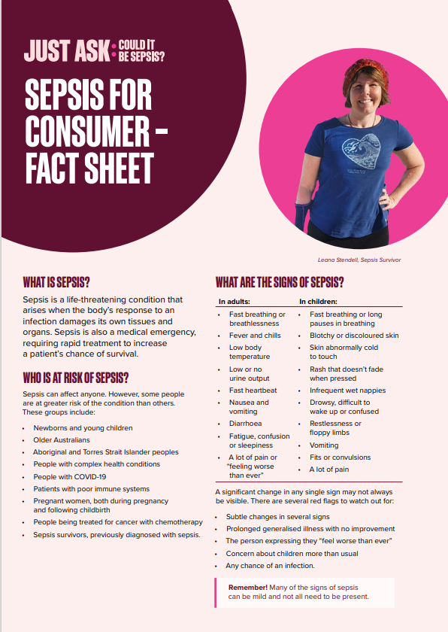
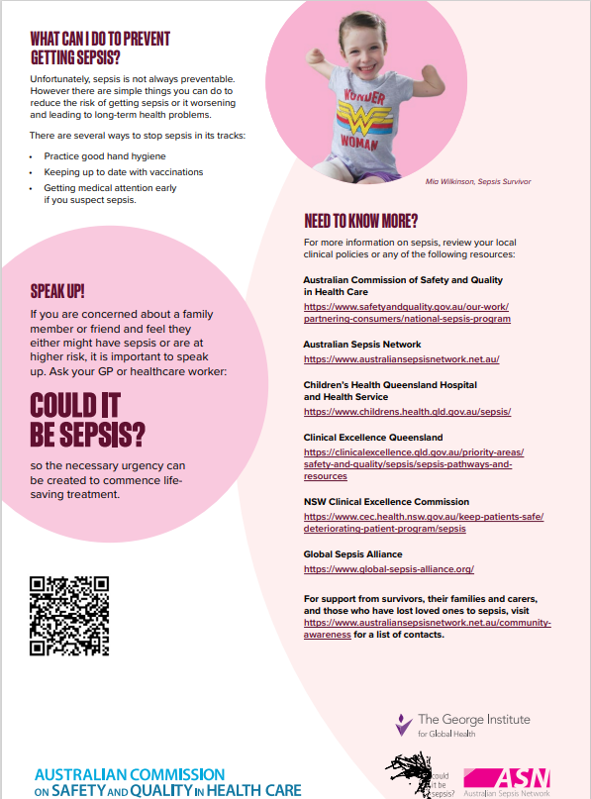
Appendix 2: Sepsis Knowledge Assessment Tool
The following table is a copy of the Sepsis Knowledge Assessment Tool designed for this study.
Question | Multi-choice Answers
What is the definition of sepsis? | 1, Sepsis occurs when the immune system is not strong enough to fight infection  2, Sepsis is a life-threatening condition that arises when the body's response to an infection injures its own tissues and organs  3, Sepsis is another word for blood poisoning  4, All of the above
Which of the following health problems can cause sepsis? | 1, Viral infections including COVID-19  2, Diabetes, heart attack, stroke  3, Pneumonia, Meningitis and other bacterial infections  4, Options 1 and 3 are correct
Anyone can get sepsis, but which of the following groups of people are at higher risk? | 1, Older adults , newborns and young children  2, Those with complex health conditions  3, People being treated for cancer with chemotherapy  4, All of the above
How can sepsis be prevented? | 1, Vaccination and hand washing  2, Going to the toilet regularly  3, Wearing sunscreen  4, All of the above
Identify the signs and symptoms that may indicate sepsis in adults? | 1, Slurred speech or confusion  2, Extreme shivering or muscle pain / fever  3, Passing no urine all day  4, Severe breathlessness  5, It feels like you're going to die  6, Skin mottled or discoloured  7, All of the above
Care giver concern about children more than usual can be a significant red flag for sepsis | 1, False  2, True
Why is it important to use the word ‘sepsis’? | 1, It’s not, sepsis and infection are the same thing  2, Because the word sepsis is actually French, meaning “bugs”  3, so the necessary urgency can be created to commence lifesaving treatment  4, To sound like you know what you’re talking about
All patients who have sepsis get a fever | 1, True  2, False
Is sepsis a medical emergency? | 1, yes  2, no
Where can I get more information about sepsis? | 1, All of the below  2, Global Sepsis Alliance  3, Participate in World Sepsis Day  4, Ask my doctor

Appendix 3: Consent Recall Assessment
The following table is a copy of the Consent Recall Assessment Tool designed for this study.
From what you remember about consenting to participate in this study: | Multi-choice Answers (choose one)
Your involvement in the study included | 1, Finding out more about sepsis in one of two ways, either in paper form or in electronic form  2, Taking a quiz to find out what you knew about sepsis to start with  3, Being contacted after a month to be asked about sepsis again  4, All of the above
There was a risk that you | 1, Wouldn’t have access to the information about sepsis  2, Had to give up your time  3, Could get sepsis by taking part in the study  4, Would have to stay in the hospital longer
One of the possible benefits of participating was | 1, To help raise funds for the hospital  2, To access education and awareness of sepsis  3, To get a follow-up on recovery in 30 days  4, There was no benefit presented
Randomisation is | 1, A cause of sepsis and septic shock  2, A computer program that helps with data collection  3, Splitting the groups of participants evenly between groups  4, None of the above
Information about you would be kept private by | 1, Linking your details to a study number  2, Keeping your paperwork locked up  3, Using secure software for collecting data  4, All of the above
Withdrawing from the study | 1, Is not allowed  2, Can only happen in the first 24 hours after signing the form  3, Can only happen in the first 72 hours after signing the form  4, Can be done at any time
The results of this study are planned to be reported | 1, to participants as a score out of 10  2, via a video call to all participants in 2024  3, in a peer-reviewed scientific journal  4, None of the above
This project was approved by | 1, The WA minister for medical research  2, The Royal Perth Hospital Human Research Ethics Committee  3, The Royal Sepsis Administration  4, The study investigator team
This project was funded by | 1, a nursing research grant  3, it wasn’t funded, the investigators are paying for it themselves  4, a local pharmaceutical company  5, fundraising from 2010-2015
Participants could ask questions about the research | 1, By talking to their doctor or nurse  2, By Emailing the East Metropolitan Health Service research governance officer  3, By calling the principle investigator  4, All of the above

