|  |
| --- |
| HRECS No 2021.260  **UTN: U1111-1278-3123**  protocol |
| A randomized control trial regarding the efficacy of an app series based on EMDR for PTSD symptoms. |
|  |
| Mark Grant MA, Jeff DiNardo, Phd.  **Sponsor/s:**  none |
|  |
|  |
|  |

Table of Contents

1. Glossary of Abbreviations & Terms 6

2. Study Sites 6

2.1 Study Location/s 6

3. Introduction/Background Information 6

3.1 Lay Summary 6

3.2 Introduction 7

3.3 Background information 7

4. Study Objectives 10

4.1 Hypothesis 10

4.2 Study Aims 10

4.3 Outcome Measures 10

5. Study Design 11

5.1 Study Type & Design & Schedule 11

5.2 Standard Care and Additional to Standard Care Procedures 12

5.3 Randomisation 13

5.4 Study methodology 13

6. Study Population 16

6.1 Recruitment Procedure 16

6.2 Inclusion Criteria 16

6.3 Exclusion Criteria 17

6.4 Consent 17

7. Participant Safety and Withdrawal 17

7.1 Risk Management and Safety 17

7.2 Handling of Withdrawals 18

7.3 Replacements 18

8. Statistical Methods 18

8.1 Sample Size Estimation & Justification 18

8.2 Power Calculations 18

8.3 Statistical Methods To Be Undertaken 18

9. Storage of Blood and Tissue Samples 19

9.1 Details of where samples will be stored, and the type of consent for future use of samples 19

10. Data Security & Handling 19

10.1 Details of where records will be kept & How long will they be stored 19

10.2 Confidentiality and Security 19

10.3 Ancillary data 20

11. Appendix 21

PCL-C checklist 21

4DSQ 22

12. References 25

Health app usage among adults in the United States as of November 2019, by demographics. https://www.statista.com/statistics/1193612/health-app-user-demographics-us/ 25

Provide brief information

|  |  |
| --- | --- |
| Title: | A randomized control trial regarding the efficacy of an app series based on EMDR for PTSD symptoms |
| Short Title: | RCT for of Healing Trauma App series |
| Design: | RCT |
| Study Centers: | online |
| Hospital: | n/a |
| Study Question: | Can apps help PTSD sufferers experience reduced PTSD symptoms |
| Study Objectives: | To assess the efficacy of a series of apps designed to address the four main symptoms of PTSD; anxiety, medically unexplained pain, insomnia, and negative effects on self-confidence. |
| Primary Objectives: | Ascertain whether use of ‘Healing trauma’ App series reduces symptom levels of PTSD. |
| Secondary Objectives | Ascertain whether use of ‘Healing Trauma’ app series reduces medically unexplained symptoms. A third objective would be to see if there are any potential risks associated with self-use of apps to manage PTSD symptoms. |
| Inclusion Criteria: | Diagnosis of PTSD, or symptoms consistent with PTSD as measured by PCL-C and over age 18.  May be receiving individual treatment or not. |
| Exclusion Criteria: | (1) Lack of access to mobile apps; (2) on-going self-harm/suidical or homidical ideation, (3) diagnosis of psychotic or bipolar disorder (4) non-English speakers; (5) diagnosis of dissociative disorder (6) organic mental disorder (7) substance abuse and (8) significant cognitive impairment (eg; severe intellectual disability, dementia). |
| Number of Planned Subjects: | 200 |
| Investigational product: | Healing traumatic stress app series;   1. Anxiety Release App 2. Overcomingpain App 3. Sleep Restore App 4. Calm and Confident App |
| Safety considerations: | Access to therapist in event of adverse reaction |
| Statistical Methods: | SPSS statistical software |
| Subgroups: |  |

# Glossary of Abbreviations & Terms

|  |  |
| --- | --- |
| **Abbreviation** | **Description (using lay language)** |
| EMDR | Eye Movement Desensitization and Reprocessing |
| app | Computer or mobile phone application |
| PTSD | Post-traumatic Stress Disorder |
| MUS | Medically Unexplained Symptoms |
| RCT | Randomized Control Trial |

# Study Sites

### Study Location/s

|  |  |  |  |  |
| --- | --- | --- | --- | --- |
| **Site** | **Address** | **Contact Person** | **Phone** | **Email** |
| online | online | Mark Grant |  | Markgra@ozemail.com.au |
|  |  |  |  |  |
|  |  |  |  |  |
|  |  |  |  |  |

# Introduction/Background Information

### Lay Summary

The purpose of this study is to evaluate whether a series of mobile apps based on Eye Movement Desensitization and Reprocessing (EMDR) can stimulate reduced symptom levels in individuals experiencing symptoms of PTSD and whether those changes are long-lasting. Although mobile health apps are widely used, there is very little research regarding their efficacy. Participants will be given four mobile apps (for anxiety, medically unexplained symptoms, insomnia and negative effects on self-confidence) together with instructions in how to use them to learn to manage the problems each one addresses. A minimum time commitment of 15 minutes per day will be expected for using one or more of the apps, for one month, with no upper daily time limit.

### Introduction

Mobile apps are increasingly being used as an adjunct to psychological treatment or a stand-alone self-help resource. Despite PTSD involving multiple symptoms, most PTSD apps are designed as stand-alone resources. The Healing Traumatic Stress app series was developed to help PTSD sufferers cope with four of the most common PTSD symptoms; anxiety, medically unexplained symptoms, insomnia and negative effects on identity. Based on EMDR, each app incorporates a number of tracks comprising guided and unguided bilateral stimulation (BLS), ego-strengthening affirmations, emotional integration exercises and targeted suggestions for symptom management. BLS is a core treatment element of EMDR which has been found to stimulate decreased physiological arousal, relaxation and improved access to positive memories as part of client resourcing (Eloffson 2007, Armano 2019). The latest independent research indicates that BLS is superior at stimulating neuronal pathways involved in fear extinction (Baek *et al*, 2019). This study will seek to determine whether PTSD sufferers can achieve symptom reduction by using these apps and how enduring that reduction is. Participants will be recruited through therapist referral via advertising in professional journals. There is very little research regarding the efficacy of apps for PTSD, let alone their systemic use.

### Background information

Post-traumatic stress disorder (PTSD) is a mental health condition which can develop after experiencing or witnessing threatening or horrific events such as childhood sexual or physical abuse and adult trauma such as terrorism, domestic violence, rape and assault. Survivors of workplace bullying, life-threatening health problems and medical mishaps (including birth trauma), are also more likely to develop symptoms of PTSD (Deatrich et al, 2016, Fishbain et al, 2017, . The symptoms of PTSD include increased physiological arousal (difficulty relaxing), hypervigilance (feeling anxious and “on-edge”), re-experiencing (nightmares and flashbacks) and avoidance of reminders the traumatic event. PTSD is often associated with problems such as insomnia, anxiety, depression and medically unexplained symptoms (Kuhn & Owen, 2020, Wright et al, 2021, Fishbain *et al*, 2017, Gupta, 2013). Medically unexplained symptoms are one of the most common-comorbid problems with PTSD symptoms preceding pain in 66.5% of cases (Hauser, 2013). PTSD is associated with possibly the highest frequency of ill-defined medical symptoms among all psychiatric disorders (Andreski *et al*., 1998). The relationship between co-morbid problems and PTSD is thought to be bidirectional; e.g.; anxiety disrupts sleep, poor sleep contributes to somatic problems; somatic problems increase the sense of powerlessness and defectiveness that PTSD sufferers feel and so on. Insomnia is thought to be most responsible for MUS associated with PTSD (Wright *et al*, 2021)

PTSD is usually treated via face-to-face psychotherapy in the form of trauma-focused CBT, exposure therapy and EMDR (WHO, 2013, Watkins et al, 2018). However, treatment is also often supplemented by self-help strategies in the form of books, audio relaxation (Redding et al, 2008) and now mobile apps (Kuhn & Owen, 2020, Wasil *et al,* 2021). The term m-health is used to refer to “medical and public health practice supported by mobile devices, such as mobile phones, patient monitoring devices … and other wireless devices (WHO, 2011). Mobile apps are thought to offer access to convenient, inexpensive, in-the-moment interventions for symptom management, particularly for those unable to access treatment, and augment outcomes for clients already in treatment (Kuhn & Owen, 2020, Goreis *et al,* 2020).

According to a recent estimate there are over 325,000 health apps, approximately 10,000 of which are for mental health (Kuhn & Owen, 2020, Wasil *et al,* 2021). Usage of health apps is growing with a recent study finding that 25% of adults in the US reported having used a health app (Statistica, 2019). Like self-help books and audio recordings, Mobile apps constitute a therapeutic resource for individuals who may not be able to afford or access treatment, or to supplement treatment for individuals already receiving therapy (Shen et al, 2015, Cernvall et al 2018). A recent research review identified 555 mobiles apps for PTSD, predominantly based on Cognitive Behavior Therapy. Most of these apps focus on affect and mood regulation through mindfulness meditation, breathing exercises, and behavioral activation (Sanders et al, 2020). Other elements include psycho-education, problem-solving skills and symptom-tracking. Many of the apps are designed to be used in conjunction with treatment. There were 25 apps based on EMDR (Marotta-Walters et al, 2018). The key features of apps based on EMDR are the incorporation of bilateral stimulation (BLS), psychoeducation about trauma, EMDR, and the AIP model, and emotional regulation strategies (Marotta-Walters et al, 2018, Grant, 2014). BLS is a defining element of EMDR which has been found to stimulate decreased physiological arousal, relaxation and improved access to positive memories as part of client resourcing (Eloffson 2007, Armano 2019). The latest independent research indicates that BLS is superior at stimulating neuronal pathways involved in fear extinction (Baek et al, 2019). Most of the EMDR apps are designed to be used as an adjunct to EMDR therapy, but the Healing Trauma App series are designed to be suitable for symptom management. In a review of EMDR apps that was written before the series had been published in its entirety, Anxiety Release was found to be suitable for symptom management (Marotta-Walters et al, 2018).

In terms of their application to the most common symptoms of PTSD, most CBT apps focus on anxiety management, two address PTSD-related insomnia, (insomnia coach and CBT-I) but none address MUS associated with PTSD. Anxiety is a common symptom of PTSD (Ref ); sleep disturbance is a part of hypervigilance (Ref ); medically unexplained symptoms are a well-documented consequence trauma exposure (Roelofs & Spinhoven, 2007); negative alterations in cognition and their impact of identity and self confidence are also well-documented symptoms of PTSD (Wright et al, 2021,)

As of 2019 there were only four RCT studies of PTSD apps, three involving PTSD coach (Kuhn & Owen, 2020). The results showed modest effects, not necessarily maintained at follow-up (Kuhn *et al*, 2017). Goreis et al (2020) metanalysis found a PTSD app produced small to moderate effect size for reduction of PTSD and depressive symptoms in a sample of 209 PTSD sufferers. Although many apps were found to be of high quality, most lacked scientific research. Individual apps for insomnia, chronic pain or anxiety, fail to recognize the overlap between these problems and PTSD.

With the exception of the Healing traumatic stress app series, all of the EMDR apps are designed as an adjunct to EMDR therapy.

The Healing PTSD series consists of four apps which address four of the most common symptoms associated with PTSD, anxiety, medically unexplained symptoms, insomnia and negative effects on identity. This series consists of; Anxiety Release, Overcoming Pain, Sleep Restore and Calm and Confident. These apps were developed by Mark Grant with no outside funding. While depression and dissociation are also strongly correlated with PTSD (van der Kolk et al, 1996, Flory & Yehuda, 2015, Carlson et al, 2012), it was felt that having more than four apps would be cumbersome and that these issues could be addressed indirectly through the emotional regulation and self-awareness exercises incorporated in the existing four apps. These apps were designed to be used outside of treatment and hypothesized to have tangible benefits, but not to act as a substitute for face-to-face treatment. Apart from a single case-study report regarding the use *of Anxiety Release based on EMDR* to resolve Carpal Tunnel Syndrome, there is no research regarding the efficacy of EMDR-based apps (Grant 2014). Based on EMDR, each app incorporates a number of tracks comprising guided and unguided bilateral stimulation (BLS), ego-strengthening affirmations, emotional integration exercises and targeted suggestions for symptom management. The inclusion of BLS and the coupling of that with cognitive and sensory stimulus (accessing positive memories, positive affirmations, music) and sensory monitoring forms the rational for defining these apps as based on EMDR.

This study seeks to investigate whether a series of apps which separately target four of the main symptoms associated with PTSD, based on EMDR, can help PTSD sufferers experience reduced symptoms and whether these reductions can be enduring.

The target audience of this research are PTSD sufferers in the community who are not be receiving out-patient treatment. This study will help answer the question of whether a targeted series of mobile apps a) help PTSD sufferers achieve reduced levels of symptoms and b) how enduring any reductions achieved are.

# Study Objectives

### Hypothesis

That mobile apps based on EMDR can help reduce symptoms of anxiety and MUS in persons suffering from PTSD symptoms.

### Study Aims

This study aims to evaluate whether a series of apps, which target four of the key effects of PTSD, can reduce overall PTSD symptoms. Secondary outcomes will be to evaluate any changes in MUS following use of these apps. An additional aim is to evaluate any potential risks associated with self-management of symptoms using apps in this population.

### Outcome Measures

The primary outcome being measured is PTSD symptoms, as measured by the PCL-5 (Blevins et al, 2015). The PCL-5 is a 20-item questionnaire, corresponding to the *DSM-5* symptom criteria for PTSD. With the exception of MUS the PCL-5 captures DSM-5 levels of PTSD symptomatology such as anxiety, sleep disturbance, (Cluster E) and general well-being (cluster D).

Secondary outcomes are MUS as measured by the PHQ-15 (Kocalevent et al, 2013). High levels of somatization have been found in PTSD sufferers (Wright et al, 2021). The PHQ-15 is a self-report questionnaire comprising 15 items. Each of the fifteen items on the PHQ-15 is rated on a 3-point Likert scale ranging from ‘not bothered at all’ to ‘bothered a lot’ (Kroenke et al, 2002). The total score is continuous and can range from 0 to 30, it can also provide a categorical measure of somatic symptom severity. A total score of 0–4 indicates minimal somatic symptom severity, 5–9 indicates low, 10–14 indicates medium, and 15–30 indicates high symptom severity. The PHQ-15 is well validated and has a sensitivity of 78% and a specificity of 71% for a DSM-IV diagnosis of somatoform disorder in a primary care setting using a cutoff of 3 or more severe somatic symptoms over the preceding 4 weeks (van Ravesteijn et al, 2009). Furthermore, internal consistency is good (Cronbach’s alpha = 0.80).

cales; distress, anxiety, depression and somatization. The items are worded as questions similar to those that can be asked in everyday primary care practice. The reference period is "the past week". For example, item 26 reads "During the past week, did you feel easily irritated?". The 4DSQ does not contain any positive affect questions, nor any other "reversed" worded questions. The response categories are also worded as normal answers to clinical questions: "no", "sometimes", "regularly", "often", "very often or constantly". In order to arrive at scale scores, the responses are scored as 0 for "no", 1 for "sometimes" and 2 for the other response categories, and the item scores are summated to scale scores. The Distress scale contains 16 items and has a score range of 0–32, the Depression scale contains 6 items and has a range of 0–12, the Anxiety scale contains 12 items and has a range of 0–24, and the Somatization scale contains 16 items and has a range of 0–32

# Study Design

### Study Type & Design & Schedule

This controlled, two-arm, randomized (1:1) trial will evaluate the efficacy of the healing effects of PTSD series to reduce PTSD symptoms in a community sample of trauma survivors with PTSD (adults aged 18 or above). After completing an eligibility online screen, individuals who score 35 or above on the PTSD Checklist (PCL-5) and consent will complete a baseline assessment and then be randomized to group 1: using a series of PTSD app condition, or group B: a waitlist control group. Each individual will be reassessed at post-intervention (1 month) and a follow-up (3 months later, or 6 months after completing baseline) by completing the same set of online assessments to measure PTSD symptoms across all stages. Self-reported PTSD symptoms in the form of non-identifiable data will be collected via online questionnaires provided to participants. All data collection, treatment and assessment procedures will be conducted through online questionnaires, managed and stored electronically for a period of 5 years post study closure (see section 11). The investigators predict that those using the healing effects of PTSD app series will demonstrate improved symptom management and a significant and sustained reduction in PTSD symptoms, compared to the waitlist control group.

**STUDY TABLE**

|  |  |  |  |  |  |
| --- | --- | --- | --- | --- | --- |
| Procedures | **Assessment/** **Procedure** | **Screening** | **Post-intervention**  **(3 months)** | **Follow-up**  **(6**  **months)** | **Follow-up**  **(12 months)** |
| **Informed Consent** | **x** |  |  |  |
| **Demographic Information** | **x** |  |  |  |
| **PCL-C questionnaire** | **x** | **x** | **x** | **x** |
|  | **4DSQ** | **x** | **x** | **x** | **x** |

### Standard Care and Additional to Standard Care Procedures

|  |  |  |  |  |  |  |
| --- | --- | --- | --- | --- | --- | --- |
| **Standard Care Procedures** | | |  | **Additional To Standard Care** | | |
| **Procedure** | **Time/Visit** | **Dosage/**  **Volume** |  | **Procedure** | **Time/Visit** | **Dosage/**  **Volume** |
| Anxiety Release App | Daily | - |  | - | - | - |
| Overcomingpain App | Daily | - |  |  |  |  |
| Sleep Restore App | Daily | - |  |  |  |  |
| Calm and Confident App | Daily | - |  |  |  |  |

### Randomisation

This research will employ the Study Randomiser software (www.studyrandomizer.com) wherein both the researcher and study coordinator can create, and utilise, one account to send out weblinks to the respective study participants. Both the researcher and study coordinator would update the online questionnaires into the software by filling out a form, with details regarding the research. As such, the aforementioned software will automatically randomise the participants into the distinct categories, whilst maintaining their privacy by allocating each candidate a numerical participant ID which prevents selection bias and insures against accidental bias- during the analysis phase of this research. Nevertheless, the researchers can still access data regarding the number of participants enrolled in the study through the “dashboard” feature, and the groups they are allocated to.

### Study methodology

The design of the present study is a parallel-group randomized controlled trial comprised of: (1) a 4-week mobile app treatment arm and (2) a 4-week control group (no treatment) arm. Participants will be randomly allocated by the computer program (see section 6.3) to ensure blindness of the investigators. Half of the participants to be allocated to the treatment group and the other half to the control group with no provision of the treatment apps. The proposed intervention (4 mobile apps) is available on Apple app store for iPhone devices and Google Play Services for android devices. Users will be directed to use contents of all apps at least once a day, for example before bed and whilst they sleep.

Screening will be conducted after consent as the process may involve the collection of sensitive data such as information about being on worker’s compensation and/or having sleep apnea and the use of psychotropic medication.

The screening process will include the materials used in baseline, during and follow-up assessment on participants’ PTSD symptoms and sleep quality (see section “assessment measures” below), delivered in the format of online questionnaires. Those who meet criteria will proceed to be invited to participate in the experiment trial. They will be given one month to decide. Self-report measures of sleep quality, sleep behaviours, PTSD symptoms and medication use will be obtained in all participants at baseline, immediate post-intervention, 3 months post-intervention and 6 months post-intervention. Participants allocated to the waitlist control group will be provided the full version of sleep restore app and treatment materials upon completion of the study. All data collection, treatment and assessment procedures will be conducted through online surveys and managed electronically.

**Assessment measures**

All assessment material will be provided in the form of online questionnaires that require an internet browser which can be used/found on any device. These questionnaires aim to assess PTSD symptoms and stress factors that are affecting sleep and whether or not the user might be suffering from a medical sleep disorder such as sleep apnea or restless leg syndrome. Subjects will be advised to seek professional help through email if they report positive in the above conditions.

**PTSD Checklist**

The PCL-5 is a validated self-report scale for the assessment of PTSD symptoms, with a total of 20 items on a 5-point scale correspond to DSM-5 symptoms of PTSD. Checklist scores range from 0 to 80, with a score of 31-33 being the cut-off indicative of probable a diagnosis of PTSD and higher scores indicating a higher severity of PTSD symptoms. (Blevins et al, 2015, Bovins et al, 2015, Wortman et al, 2016).

**Four-Dimensional Symptom Questionnaire (4DSQ)**

The 4DSQ is a self-report questionnaire to assess distress, depression, anxiety and somatization. The questionnaire aims to differentiate between normal distress and psychiatric disorders.

**Treatment conditions**

**Anxiety Release App**

The Anxiety Release App incorporates brain training exercises, guided anxiety management sessions and bilateral stimulation material in audio and video formats. The purpose is to stimulate the brain with bilateral stimulation (alternating audio and/or visual stimuli), which captures attention processes and diverts emotional resources. It is predicted that the exercises would help release anxiety using sensory and auditory bilateral stimulation.

**Overcomingpain App**

The Overcomingpain app is designed to decrease medically unexplained pain associated with trauma. This app comprises 20 sessions incorporating a mix of BLS, pain-relieving imagery and suggestions and behavioral exercises divided into three playlists targeting mental and emotional dimensions of chronic pain;

1. Mental Healing strategies,

2. Sensory Healing strategies and

3. Stress Management. created by the author before the era or mobile apps.

This app is based on a CD called ‘Pain Control based on EMDR’, created by the author before the era of mobile apps.

**Sleep Restore App**

The Sleep Restore app was developed to specifically address the effects of traumatic stress which lead to insomnia, namely: trouble falling asleep, night-waking, hypervigilance, worry, nightmares and feelings of lack of safety. Based on the response collected from each participant in the online assessment, the Sleep Restore app will automatically generate a unique meditation playlist from 18 sessions of pre-installed guided EMDR-based treatment materials including: BLS (natural sounds, music and story reading), individually designed to address the different effects of stress. Materials will be available immediately after completion of baseline assessments. Participants will be instructed to utilize these materials whenever they experience trouble falling asleep. They will also be encouraged to revisit the app more often in order to unlock extra treatment materials.

**Calm and Confident App**

The Calm and Confident app incorporates guided meditations. BLS and ego-enhancing suggestions to stimulate decreased tension, relaxation and increased confidence. In addition to decreasing stress, this app aims to facilitate a relaxed state of well-being in the listener. The 10 tracks include session targeting stress and anxiety relief, emotional integration and self-worth. This app is based on a CD of the same name, created by the author before the era or mobile apps.

**Waitlist control condition**

The waitlist control condition will consist of only monitoring PTSD symptoms and anxiety, MUS, sleep and self-confidence using the assessment measures during assessment periods at baseline, immediate post-intervention, 3- and 6-months post-study. Participants will not be provided any treatment materials or feedback until the end of study.

**Treatment condition summary**

|  |  |  |
| --- | --- | --- |
|  | Sleep Restore (bilateral stimulation) | Waitlist control |
| Treatment content | Anxiety Release App  Overcomingpain App  Sleep Restore App  Calm and Confident App | N/A [advised that full treatment would be provided upon completion] |
| Duration | (Minimum of) 8 weeks | N/A |
| Delivery context | Online mobile app | N/A |
| Assessment content | PTSD checklist + Sleep questionnaire at:   * Baseline * Follow-up * 3 months post-treatment * 6 months post-treatment | PTSD checklist + Sleep questionnaire at:   * Baseline * Follow-up * 3 months post-treatment * 6 months post-treatment |

# Study Population

### Recruitment Procedure

Study participants will be recruited through internet postings (i.e. Facebook, email call-outs to trauma therapists) and promotion online on a voluntary participation basis. Context of the study, inclusion criteria and exclusion criteria will be provided in the recruitment material for reference. Study participants (both treatment and control group) will include individuals who have been diagnosed with PTSD and complain of symptoms of PTSD such as anxiety, MUS and insomnia based on responses to the screening questionnaires.

### Inclusion Criteria

Study participants will be recruited through online postings and promotion to the general public within Australia and internationally. Study participants will include individuals who; (1) have clinical levels of symptoms of PTSD at the time of self-report screening based on responses to the PCL-5 checklist and/or; (2) Experience of sleeping problems (e.g. trouble falling asleep, night-waking, lack of restorative sleep) as evaluated the Sleep condition indicator (SCI) criteria for Insomnia; (3) English-speaking male or female PTSD sufferers above the age of 18. The study is open to people of all races and gender.

### Exclusion Criteria

Exclusion criteria will be: (1) Lack of access to mobile apps; (2) on-going self-harm/suidical or homidical ideation, (3) diagnosis of psychotic or bipolar disorder (4) non-English speakers; (5) diagnosis of dissociative disorder (6) organic mental disorder (7) substance abuse and (8) significant cognitive impairment (eg; severe intellectual disability, dementia). Diagnosis of sleep apnea will be recorded into medical condition history but the subject will not be excluded from the trial. Participants involved in worker-compensation claims or who are subject to concurrent stressful events will not be excluded, but cases will be noted as a variable given the stressful nature of the circumstance. Children and young individuals (under 18years of age) will be excluded from this research as they do not possess legal authority to give consent to the study, and they most likely require very different treatment approaches compared to emergency workers, which are beyond the scope of this study.

### Consent

Participation is entirely voluntary. Prior to entering into the study, prospective participants

(both patients and therapists) will be informed of their ability to withdraw at any given time, without a reason. The process will be conducted through an online consent form delivered through email, once participants sign up for the study. The online form will include an information sheet regarding the content of the experiment and the participant’s involvement in the study. Respondents will have to click ‘agree’, on the consent page followed by their electronic signature in full name to imply consent, in order to participate. If they click ‘decline’ then they will be thanked for their time and subsequently redirected out of the online form. The Information Sheet will also explain that withdrawal from the study will prevent them from accessing the study material, but that if they withdraw following commencement of the study, they will be allowed to retain the treatment resources (Healing Trauma app series).

# Participant Safety and Withdrawal

### Risk Management and Safety

We do not foresee any specific risks from participation in this study. All participants will be advised to contact the primary investigator and cease use of the apps in the unlikely event they experience any adverse responses. The primary investigator will provide immediate one-to-one assistance and on-going referral if necessary.

### Handling of Withdrawals

Participants will be allowed to withdraw from the study at any time, without a reason. They will be informed of their ability to withdraw prior to entry into the study. Data collected from withdrawn participants will not be included nor used as valid study data, but will be labelled withdrawn and stored and destroyed in accordance to data security and handling strategy (see section 11).

### Replacements

Withdrawn participants will be replaced in the study via the same recruitment process as described in section 7.1.

# Statistical Methods

### Sample Size Estimation & Justification

Data analysis will be carried out under 80% power to detect a medium effect size at P = .05 using SPSS statistical software. These criteria implied a proposed sample size of 80, randomised half to the treatment group and the other half to the waitlist control group.

### Power Calculations

See section 9.1

### Statistical Methods To Be Undertaken

All tests will be run using 2-sided tests of significance, with P < 0.05 considered statistical significance. Repeated-measures ANOVA will be carried out on assessment measures collected at baseline, immediate post-treatment, 3- and 6-months post-treatment for both conditions. Analysis of covariance (to control for baseline score) will be conducted to test differences at baseline and post-treatment. Paired t-tests will be conducted for the treatment group to compare baseline results to post-treatment data.

# Storage of Blood and Tissue Samples

### Details of where samples will be stored, and the type of consent for future use of samples

No blood or tissue samples from participants will be collected nor used for the purpose of this study.

# Data Security & Handling

### Details of where records will be kept & How long will they be stored

All data collection, treatment and assessment procedures will be conducted through online questionnaires, which will be managed, and stored, electronically for a period of 5 years post study closure. Participants' responses on online questionnaires will be numerically coded and analysed as group data.Furthermore, the software *Study Randomiser* is a secured application which stores all data in a protected database that is backed up every day, thus ensuring that no information regarding the study nor the participants are leaked. Access to the data will be provided to: Primary Investigator (Mark Grant) - to monitor process of the study and for analysis purposes; The study co-ordinator (Richard Lau) - monitoring of participation status and administrative purposes such as mail out of survey and data entry.

### Confidentiality and Security

All electronic data will be stored on an online database (Google Drive) secured by user names and passwords accessible only to the primary investigator and co-ordinator (named above) to enable secure and confidential collection, storage and maintenance of the research data for this study. The database is legally owned by Google and located on an online server, registered independently for the research. Participants will not have access to any data until the dissemination of project outcomes. They will be provided their own data together with the disseminated report. This process ensures confidentiality and secure storage of all the research data. Study data will be destroyed by electronically deleting all relevant files on the online database (described above) containing participant information and activities. All participants (including control group) will continue to have access to the trial intervention (the respective apps) for an unlimited time for zero costs as the apps are already developed.

### Ancillary data

Data such as videos, photographs and images (if any collected) will be stored on the online database (Google Drive) mentioned above for a period of 5 years post study closure secured by user names and passwords accessible only to the primary investigator and co-ordinator (named above) to enable secure and confidential collection, storage and maintenance of the research data for this study.

# Appendix

**List of Attachments included:**

|  |  |  |
| --- | --- | --- |
| **Document Name** | **Version Number** | **Date**  (e.g. 18 January 2012) |
| PCL-C checklist – Google form | 1 | 13 July 2021 |
| 4DSQ – online form | 1 | 13 July 2021 |
|  |  |  |

## PCL-C checklist

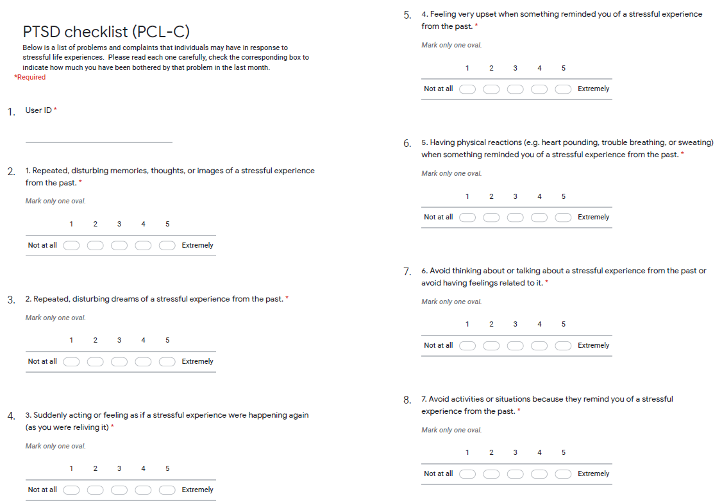

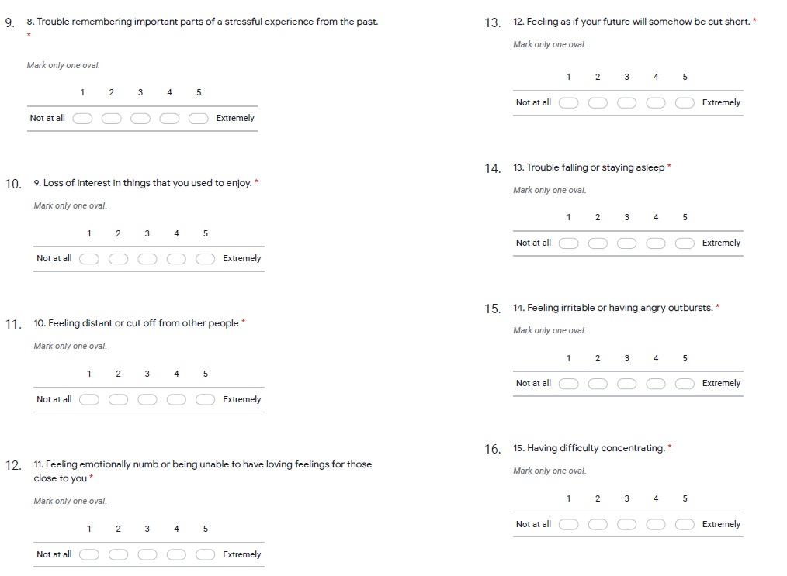

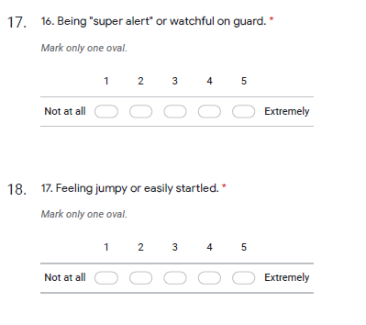

## 4DSQ

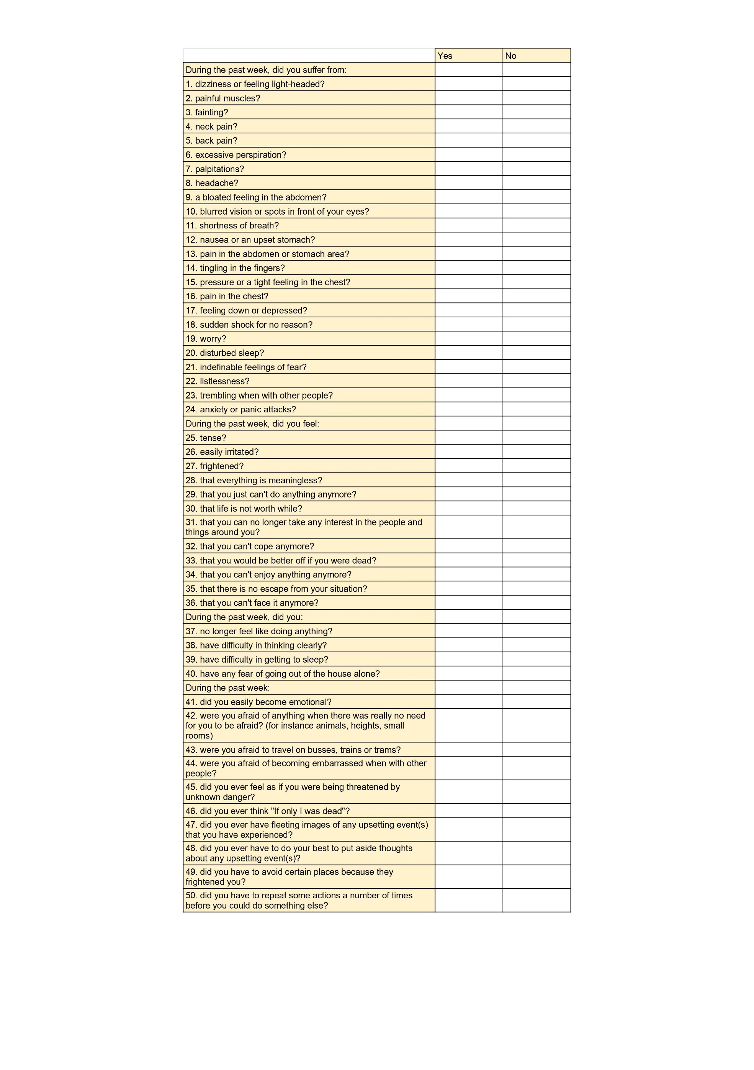

# References

Sander LB, Schorndanner J, Terhorst Y, Spanhel K, Pryss R, Baumeister H, Messner EM (2020). 'Help for trauma from the app stores?' A systematic review and standardised rating of apps for Post-Traumatic Stress Disorder (PTSD). Eur J Psychotraumatol. 2020 Jan 9;11(1):1701788. doi: 10.1080/20008198.2019.1701788. PMID: 32002136; PMCID: PMC6968629.

Armano Tamaki, Toichi Motomi, (2019) The Role of Alternating Bilateral Stimulation in Establishing Positive Cognition in EMDR Therapy: a Multi-channel Near-infrared Spectroscopy Study. PLoS ONE 11(10): e0162735. doi:10.1371/journal. pone.0162735

Baek et al., (2019) Neural circuits underlying a psychotherapeutic regimen for fear disorders, Nature 566, p. 339-343

Blevins, C. A., Weathers, F. W., Davis, M. T., Witte, T. K., & Domino, J. L. (2015). The Posttraumatic Stress Disorder Checklist for *DSM-5* (PCL-5): Development and initial psychometric evaluation. *Journal of Traumatic Stress, 28*, 489-498. doi:10.1002/jts.22059

Bovin, M. J., Marx, B. P., Weathers, F. W., Gallagher, M. W., Rodriguez, P., Schnurr, P. P., & Keane, T. M. (2015). Psychometric properties of the PTSD Checklist for Diagnostic and Statistical Manual of Mental Disorders-Fifth Edition (PCL-5) in Veterans. *Psychological Assessment, 28,* 1379-1391. doi:10.1037/pas0000254

Carlson, E. B., Dalenberg, C., & McDade-Montez, E. (2012). Dissociation in posttraumatic stress disorder part 1: Definitions and review of research. *Psychological Trauma: Theory, Research, Practice, and Policy, 4*(5), 479–489. [https://doi.org/10.1037/a0027748](https://psycnet.apa.org/doi/10.1037/a0027748)

Cernvall, M., Sveen, J., Bergh Johannesson, K., and Arnberg, F. (2018). A pilot study of user satisfaction and perceived helpfulness of the Swedish version of the mobile app PTSD Coach. Eur. J.

Deatrich, Kate, Boyer B., Martin C., Preedy V., Patel V. (2016) Post-traumatic Stress Disorder Related to Surgery: Prevalance and Risk Factors. In; Comprehensive Guide to Post-Traumatic Stress Disorders p 351-366. Springer.

Elofsson UO, von Scheele B, Theorell T, Sondergaard HP. (2007) Physiological correlates of eye movement desensitization and reprocessing. Journal of Anxiety Disorders June 3; [Epub ahead of print].

Fishbain D. A., Pulikal A., Lewis J. E., and Gao J (2017). Chronic pain types differ in their reported prevalence of post-traumatic stress disorder (PTSD) and there is consistent evidence that chronic pain is associated with PTSD: an evidence-based structured systematic review. Pain Medicine 18: 711-735

Flory JD, Yehuda R. Comorbidity between post-traumatic stress disorder and major depressive disorder: alternative explanations and treatment considerations. Dialogues Clin Neurosci. 2015 Jun;17(2):141-50. doi: 10.31887/DCNS.2015.17.2/jflory. PMID: 26246789; PMCID: PMC4518698

Goreis A, Felnhofer A, Kafka JX, Probst T and Kothgassner OD (2020) Efficacy of Self-Management Smartphone-Based Apps for Post-traumatic Stress Disorder Symptoms: A Systematic Review and Meta-Analysis. Front. Neurosci. 14:3. doi: 10.3389/fnins.2020.00003

Grant M (2014) The use of an app to manage carpal tunnel syndrome. OA Behavioral Medicine. 2014. Mar. 20;2(1):3.

Gupta, M.A. (2013) Review of somatic symptoms in post-traumatic stress disorder, International Review of Psychiatry, 25:1, 86-99, DOI: [10.3109/09540261.2012.73636](https://doi.org/10.3109/09540261.2012.736367)

Health app usage among adults in the United States as of November 2019, by demographics. https://www.statista.com/statistics/1193612/health-app-user-demographics-us/

Kocalevent RD, Hinz A, Brähler E. Standardization of a screening instrument (PHQ-15) for somatization syndromes in the general population. BMC Psychiatry. 2013 Mar 20;13:91. doi: 10.1186/1471-244X-13-91. PMID: 23514436; PMCID: PMC3606198.

Kroenke K, Spitzer RL, Williams JB. The PHQ-15: validity of a new measure for evaluating the severity of somatic symptoms. Psychosom Med. 2002 Mar-Apr;64(2):258-66. doi: 10.1097/00006842-200203000-00008. PMID: 11914441.

Kuhn E, Kanuri N, Hoffman JE, Garvert DW, Ruzek JI, Taylor CB (2017). A randomized controlled trial of the PTSD Coach app with community trauma survivors. J Consult Clin Psychol. 2017;85(3):267–73. https://doi.org/10.1037/ccp0000163

Marotta-Walters, S. A., Jain, K., DiNardo, J., Kaur, P., & Kaligounder, S. (2018). A review of mobile applications for facilitating EMDR treatment of complex trauma and its comorbidities. *Journal of EMDR Practice and Research, 12*(1), 2–15. [https://doi.org/10.1891/1933-3196.12.1.2](https://psycnet.apa.org/doi/10.1891/1933-3196.12.1.2)

Redding, R. E., Herbert, J. D., Forman, E. M., & Gaudiano, B. A. (2008). Popular self-help books for anxiety, depression, and trauma: How scientifically grounded and useful are they? *Professional Psychology: Research and Practice, 39*(5), 537–545. [https://doi.org/10.1037/0735-7028.39.5.537](https://psycnet.apa.org/doi/10.1037/0735-7028.39.5.537)

Roelofs K, Spinhoven P. Trauma and medically unexplained symptoms towards an integration of cognitive and neuro-biological accounts. Clin Psychol Rev. 2007 Oct;27(7):798-820. doi: 10.1016/j.cpr.2007.07.004. Epub 2007 Jul 17. PMID: 17728032.

Shen, N., Levitan, M. J., Johnson, A., Bender, J. L., Hamilton-Page, M., Jadad, A. A., & Wiljer, D. (2015). Finding a depression app: A review and content analysis of the depression app marketplace. JMIR mHealth and uHealth, 3(1), e16. http:// dx. doi. org/ 10. 2196/ mhealth. 3713

Tesarz J, Wicking M, Bernady K, Seidler G. (2020). EMDR’s efficacy in the treatment of pain. Journal of EMDR Practice and Research 13 (4):337-344.

Van der Kolk BA, Pelcovitz D, Roth S, et al. Dissociation, somatization, and affect dysregulation: the complexity of adaptation of trauma. Am J Psychiatry. 1996;153(7 suppl):83-93. Review.

van Ravesteijn H, Wittkampf K, Lucassen P, van de Lisdonk E, van den Hoogen H, van Weert H, Huijser J, Schene A, van Weel C, Speckens A. Detecting somatoform disorders in primary care with the PHQ-15. Ann Fam Med. 2009 May-Jun;7(3):232-8. doi: 10.1370/afm.985. PMID: 19433840; PMCID: PMC2682971.

Watkins, L. E., Sprang, K. R., & Rothbaum, B. O. (2018). Treating PTSD: A review of evidence- based psychotherapy interventions. *Frontiers in behavioral neuroscience*, *12*, 258.

Wasil A, Gillespie S, Shingleton R et al. Am J Psychiatry 2020;177:464-5

Wikipedia, Self-help. <https://en.wikipedia.org/wiki/Self-help>.

World Health Organization. mHealth: New Horizons for Health through Mobile Technologies. Glob Obs eHealth Ser. 2011; 3.

World Health Organization. Guidelines for the management of conditions specifically related to stress. Geneva: WHO, 2013.

Wortmann, J. H., Jordan, A. H., Weathers, F. W., Resick, P. A., Dondanville, K. A., Hall-Clark, B., Foa, E. B., Young-McCaughan, S., Yarvis, J., Hembree, E. A., Mintz, J., Peterson, A. L., & Litz, B. T. (2016). Psychometric analysis of the PTSD Checklist-5 (PCL-5) among treatment-seeking military service members. *Psychological Assessment, 28,* 1392-1403. doi:10.1037/pas0000260

Wright Lawrence Astill, Roberts Neill P, Barawa Kali et al (2021) Disturbed sleep connects symptoms of posttraumatic stress disorder and somatization: a network analysis approach.

Astill Wright L, Roberts NP, Lewis C, Simon N, Hyland P, Ho GWK, McElroy E, Bisson JI. High prevalence of somatisation in ICD-11 complex PTSD: A cross sectional cohort study. J Psychosom Res. 2021 Sep;148:110574. doi: 10.1016/j.jpsychores.2021.110574. Epub 2021 Jul 16. PMID: 34298467; PMCID: PMC8359920.