Community Health Navigator (Community Health Worker) assisted transition of care from hospital to community, Stage 2- A Randomised Control Trial
Protocol Number | 2021/ETH1271
Coordinating Principal Investigator | Professor Mark Harris
Signature: | Date: 23rd Nov 2021
Protocol Authors (Co-investigators) | The study is being conducted in this hospital by the following researchers:  - Professor Mark Harris, from the Centre for Primary Health Care and Equity (CPHCE) at the University of New South Wales (UNSW). Professor Harris is the lead investigator.  - Professor Parisa Aslani, The University of Sydney  - Professor Jean-Frederic Levesque, UNSW  - Associate Professor Margo Barr, UNSW  - Dr Anurag Sharma, UNSW  - Associate Professor Benjamin Harris-Roxas, UNSW  - Dr Michael Wright, University of Technology Sydney  - Professor Richard Osborne, Swinburne University  - Ms. Lou-Anne Blunden, Sydney Local Health District (SLHD)  - Dr Brendan Goodger, Central and Eastern Sydney Local Health District (CESPHN)  - Ms. Regina Osten, Agency for Clinical Innovation (ACI)  - Dr Anthony Brown, Health Consumers NSW  - The Program Manager is Ms Mamta Porwal UNSW  Partner investigators:  - Ms Lou-Anne Blunden, Sydney Local Health District  - Dr John Cullen, Sydney Local Health District  - Ms Julie Finch, Sydney Local Health District  - Debra Donnelly, Sydney Local Health District  - Dr Brendan Goodger, Central and Eastern Sydney Local Health District  - Ms Regina Osten, Agency for Clinical Innovation  - Dr Anthony Brown, Health Consumers NSW
Protocol Version Number | Protocol Number: 2021_ ETH1271_V3
Protocol Date | 11th January 2022
Revision Date | 12th April 2022
Sponsor (if applicable) | NHMRC, SLHD, CESPHN
Ethics Statement:

The study will be conducted in accordance with the National Statement on Ethical Conduct in Human Research (2007) (Link to National Statement) , the CPMP/ICH Note for Guidance on Good Clinical Practice (Link to CPMP/ICH ) and consistent with the principles that have their origin in the Declaration of Helsinki. Compliance with these standards provides assurance that the rights, safety, and well-being of trial participants are respected.

CONTENTS
CONTENTS 2
1. BACKGROUND AND INTRODUCTION 5
1.1. DISEASE/PROPOSED INTERVENTION BACKGROUND 5
1.2. RATIONALE FOR PERFORMING THE STUDY 6
2. HYPOTHESES 6
3. STUDY OBJECTIVES / AIMS 8
3.1. PRIMARY OBJECTIVE 8
3.2. SECONDARY OBJECTIVES 8
4. STUDY DESIGN 8
4.1. DESIGN / STUDY TYPE 8
4.2. EXPECTED PARTICIPANT NUMBERS 8
4.3. TIME PERIOD OF THE STUDY 8
4.4. ENDPOINTS 10
4.5. CENTRES 10
5. STUDY PARTICIPANTS 11
5.1 INCLUSION CRITERIA 11
5.2. EXCLUSION CRITERIA 11
5.3 Key Elements of Recruitment 12
5.4 CONFOUNDERS 12
5.5 STUDY LIMITATIONS 13
6. STUDY PROCEDURES 14
6.1. Recruitment flow chart (Figure 3) 14
6.2 INVESTIGATION PLAN 15
6.3. STUDY PROCEDURE RISKS 16
6.4 PARTICIPANT RECRUITMENT AND SCREENING 19
6.5 PARTICIPANT ENROLMENT 20
6.6 INFORMATION AND CONSENT 20
6.7 RANDOMISATION PROCEDURE 20
6.8 END OF STUDY TREATMENT/WITHDRAWAL PROCEDURE 21
7. OUTCOMES 21
7.1 DEFINITION OF OUTCOMES 21
8. DATA COLLECTION 23
8.1. FORMS AND PROCEDURE FOR COLLECTING DATA 23
9. STATISTICAL METHODS 24
9.1. SAMPLE SIZE ESTIMATION 24
9.2. STATISTICAL ANALYSIS PLAN 24
10. QUALITY CONTROL AND ASSURANCE 24
10.1. CONTROL OF DATA CONSISTENCY 24
10.2. AUDITS 25
10.3. PROTOCOL AMENDMENTS 25
11. ETHICS 25
11.1. INVESTIGATOR AUTHORISATION PROCEDURE 25
12. BLINDING AND UNBLINDING 25
13. CONFIDENTIALITY, STORAGE AND ARCHIVING OF STUDY 25
14. TRIAL SPONSORSHIP AND FINANCING 26
15. APPENDICES 26

[if applicable:] Protocol Version Control box
Protocol  Version Number | Date | Summary of Changes
2021_ETH1271_V2_02 | 11/01/2022 | Refer to HREC response, reference:X21-0438 & 2021/ETH12171  Dated 13/12/2021
2021_ETH1271_V2_03 | 12/04/2022 | Protocol updated to reflect the revised recruitment numbers, power calculations and randomisation method

Protocol Title | Community Health Navigator (Community Health Worker) assisted transition of care from hospital to community, Stage 2- A Randomised Control Trial  Abbreviated title: Community Health Navigators (CHNs) transitioning care into  the community
Protocol version | #1
Objectives | The objective of this research study is to evaluate impact of the role of Community Health Worker/Navigator* (CHW/CHN) in assisting patients to transition from hospital to community on their health, experience of health care and health service use (including the cost of care).  *Please note Community Health Worker/ Community Health Navigator is used interchangeably in this document
Study design | This study is a randomised control trial where potential participants are allocated by chance to a control group or an intervention group.
Planned sample size | 400 participants (200 in the intervention group) and (200 in the control group)
Selection criteria | Inclusion criteria  Patients will be identified via the Patient Flow Portal (PFP) contained within the SLHD.  - Aged 40 years and over  - Living within SLHD boundaries  - Admitted for a chronic condition or under the aged care service  - To be discharged to their own home from a SLHD hospital with an Estimated Date of Discharge (EDD) within 2 days  - Speaks English or any of the top five languages (Arabic, Cantonese, Mandarin, Greek or Italian)  Exclusion criteria  - Selected for follow-up by any other chronic care program offered by the SLHD  - Planned discharge to hostel, Residential Aged Care Facilities (RACF), rehabilitation facilities, transferred to another SLHD facility or transferred to another hospital or may be too unwell to participate in the study  - Admitted primarily for COVID-19 diagnosis  - Receiving community palliative care services  - Receiving 7-day post discharge follow up from Mental Health services  - Have severe cognitive impairment (based on Rowland Universal Dementia Assessment Scale (RUDAS) score unless a carer/informant is their primary carer and is available for the interview  - Patient or their primary carer does not have a landline or a mobile phone contact number available
Study Procedure | Potential participants from four public hospital sites (Royal Prince Alfred, Concord, Balmain, and Canterbury) will be identified using the patient flow portal currently used to identify in-patients at risk of re-admission by a member of the patient’s clinical team (defined as a medical officer, nurse or allied health professional who routinely sees the patient as part of their clinical care). “The invitation to participate in the study will be initiated by a member of the potential participants clinical team. Interested patients will be asked whether they agree to be contacted by the research staff, who will then discuss the study in detail with the participant, go through the consent process, and obtain written consent”. Participants will be informed that their participation in this research study is voluntary, and at any stage if they do not want to take part or change their mind, they are free to withdraw. Potential participants will be given a Participant Information and Consent Form to sign and will be given a copy to keep.
Statistical considerations | Sample size calculation  We aim to recruit (n=400) patients and for 266 to remain in the study at the six-month follow-up (based on 3% mortality and 12% loss to follow up). Power calculation based on the primary outcome measure of readmission rate: Assuming a readmission rate of 20% within 60 days (based on pilot and published data) a sample size of 392 or 196 in each group would be required to detect a 50% reduction in readmissions to 10% with 95% confidence intervals and 80% power. Survival analysis of time to readmission would require a similar sample size of 200 in each group.  Analysis plan  The fidelity and tailoring of the intervention to patient needs will be assessed by analysing CHW records and patient interviews. Baseline characteristics of those lost to follow- up will be analysed on an intention-to-treat basis. Demographics of non-participants and reasons for drop-out will be collected to assess bias We will compare the outcomes described in the hypotheses (fewer readmissions, improved medication adherence, more GP care plans, higher quality of life, improved health literacy and patient assessment of chronic illness) between intervention and control groups, using multivariate regression techniques that adjust for age, sex and those independent variables that are significantly different between the two groups, and using multiple imputation for missing values. Sensitivity analyses will assess unmeasured variation. We will also conduct time to event analysis to examine the relationship between seeing a CHW following discharge from the index hospitalisation and reduced re-hospitalisation in the subsequent 60 days and six months. This will be undertaken by first calculating propensity weights to account for differences in characteristics between those who were allocated to the CHW intervention and those in the control group, and then, using Cox proportional hazards regression modelling. Outcomes will be censored at first re-hospitalisation, death or 60 days/six months following index hospitalisation, whichever occurred first.
Time Period of Data Collection | Recruitment and data collection will be contingent upon ethics approval  (approximately May 2022 - December 2023) or unless the recruitment target has been achieved prior to the end date.
Duration of the Study | April 2021-Sep 2024
Funding (if applicable) | NHMRC
Sponsor (if applicable) | NHMRC, SLHD, CESPHN

1. BACKGROUND AND INTRODUCTION

1.1. DISEASE/PROPOSED INTERVENTION BACKGROUND
Preventing hospital admission and readmission are major priorities for national and state governments due to their cost and the potential for adverse outcomes. In NSW between 2009 and 2012, readmission rates within 30 days post-discharge varied between 11% (for ischaemic stroke) and 23% (for cardiac failure) [1]. In a major Sydney hospital in 2012, 22% of admissions resulted in readmission within 60 days [2]. An NSW review of all-cause unplanned readmissions identified strategies to reduce readmission including greater integration and shared care between hospitals and general practitioners (GPs) [3], however, unplanned readmission rates in NSW have improved little.
Care needs can intensify post-hospitalisation resulting in readmission or presentation to the ED [4]. Problems with mobility, food preparation and activities of daily living may only become apparent when patients return home. Patients living with progressively deteriorating conditions require additional support to manage at home when discharged from hospital. Demands on carers can also increase [5]. This is especially the case for older people living with frailty, who are more likely to be readmitted or admitted to residential aged care rather than supported to continue living in the community [6]. There can also be delays in restarting care arrangements previously in place to support patients prior to hospitalisation.
Community Health Workers (CHWs) are defined as “frontline public health workers who are trusted members of and /or have an unusually close understanding of the community served. This trusting relationship enables CHWs to serve as a liaison /link between health/social services and the community to facilitate access to services and improve the quality and cultural competence of service delivery” [7]. In their role as navigators, CHWs have been demonstrated to reduce hospitalisation and re- hospitalisation rates and to improve access to health and social care for disadvantaged groups, especially for Indigenous and culturally and linguistically diverse (CALD) populations [8,9].
There is increasing evidence of the effectiveness of CHWs in assisting patients to navigate their care and the complexities of referral and follow-up [10,11]. A review of 16 randomised controlled trials (RCTs) conducted to 2015, identified variable results, with five studies showing a significant reduction in ED visits (23%-51%) and/or hospitalisations (21%–50%). A recent US trial of a CHW chronic disease intervention demonstrated improved quality of care and reduced hospitalisations at one year by 28% [12]. A larger RCT in veterans evaluated the impact of CHWs providing goal- setting, tailored support, and connection with long-term primary care, finding 8% 30-day readmissions in the intervention arm, compared to 26% in the control group [13]. CHW follow-up improved access to primary care while controlling recurrent readmissions in a high-risk population. It also improved medication adherence post-discharge [8, 14]. Another recent study from the US, showed that patients randomised to a post-discharge visit and telephone follow-up by CHW navigators, had lower health-care costs [15]. The Centre for Medicare and Medicaid Innovation (CMMI) Health Care Innovation awarded grants for the development of 108 innovative health care payment and service delivery models across the US in 2012 [16]. In meta-regression of three-year findings of the six types of innovation components (including health information systems, patient centred medical homes, behavioural health, telemedicine, and workflow redesign), only those innovations that used CHWs had appreciably lower cost of care US$138/patient/quarter). CHW interventions improve medication adherence and reduce errors by triggering health professionals to address inappropriate patterns of use or non-use and potential harm [17,1 8]. Medication adherence assessed at hospital admission, is independently associated with readmission risk in those with poor adherence [19] and improving adherence reduces readmission rates [20].

1.2. RATIONALE FOR PERFORMING THE STUDY

Our proposed study is informed by an evaluation of CHWs providing follow-up care post-discharge for 300 patients with cardiac failure in SLHD, conducted in 2018. Patients were aged between 40 and 100 years, with 27% living alone, 10% without social support, 45% speaking a language other than English and 71% born in a country other than Australia. Patients were discharged on an average of 11 medications. Problems that the CHWs managed well included dealing with medication issues and arranging referrals to other services and facilitating follow-up by the patient’s usual GP. After the intervention, and controlling for age and gender, only speaking a language other than English at home remained an independent predictor of readmission (16%) [21].
The current proposal is developed based on the experience with this program, the literature cited above and a process of codesign involving clinicians, managers, patients, and other stakeholders. This suggests a model of care which focuses on the early identification and referral of patients experiencing problems with medications, self-management of their conditions, social support and navigation to health and social services.

The intervention includes:
- Selection of CHWs from local communities, where possible.
- Training of CHWs for cultural sensitivity, ability to develop relationships and communicate with patients and their carers, to identify problems in patient self-management and medication adherence, help patients to navigate within the health system and working with other health professionals.
- Early contact between CHW and patient while in hospital, to establish a trusting relationship.
- Where possible, matching the language and cultural background of the CHW with that of the patient.
- Collaboration of CHWs with existing community health teams, general practitioners, and referral services, establish supervision for the CHWs and institute a communication pathway for CHWs to relay identified patient problems for prompt action.

2. HYPOTHESES
Primary outcomes:
Our hypothesis in relation to our objective is in comparison with a control group; intervention-group participants will have 50% fewer readmissions (from 20% to 10%), in the first 60 days post discharge (as this is the duration of the CHW intervention).
Secondary outcomes:
In comparison with the control group, post-discharge intervention group participants will, at six months, be more likely to report: -
- Improved self-reported medication adherence (Brief Medication Questionnaire (BMQ) score of 0.5) [14].
- Higher quality of life (measured by the EQ5D-5L instrument [15]).
- Improved health literacy (HLQ domains concerned with self-management and use of health services [16]).
- Improved patient assessment of chronic illness (PACIC short form adapted [17]).

We will also measure the cost of the intervention, health service use in the intervention and control groups over six months following discharge, using individually linked Medicare Benefits Schedule (MBS) (including care plans)*, Pharmaceutical Benefits Scheme (PBS)* and hospital-use data (inpatient and Emergency Department (ED) use). Our hypothesis is that health service use will be more appropriate (higher proportion of Team Care Arrangements, fewer ED presentations) and that the total cost in the intervention group will be less than the control group at six months. * Separate Ethics approval and consent will be obtained for linkage to MBS and PBS.
References:
1. NSW Bureau of Health Information, The Insights Series: Return to acute care following hospitalisation, Insights into readmissions, NSW public hospitals, July 2009 – June 2012. 2015, BMI: Sydney (NSW).
2. Maali, Y., et al., Predicting 7-day, 30-day and 60-day all-cause unplanned readmission: a case study of a Sydney hospital. BMC medical informatics and decision making, 2018. 18(1): p. 1.
3. Forster, A.J., et al., The incidence and severity of adverse events affecting patients after discharge from the hospital. Annals of Internal Medicine, 2003. 138(3): p. 161-167.
4. Rennke, S. and S.R. Ranji, Transitional care strategies from hospital to home: a review for the neurohospitalist. The Neurohospitalist, 2015. 5(1): p. 35-42.
5. Vashi, A.A., et al., Use of hospital-based acute care among patients recently discharged from the hospital. JAMA, 2013. 309(4): p. 364-371.
6. Gallagher, R., M.-L. Luttik, and T. Jaarsma, Social support and self-care in heart failure. Journal of Cardiovascular Nursing, 2011. 26(6): p. 439-445.
7. Audit Office of New South Wales. Managing length of stay and unplanned readmissions in NSW public hospitals. 2017.
8. APHA., Support for Community Health Worker Leadership in Determining Workforce Standards for Training and Credentialing. 2014, American Public Health Association: Washington DC
9. Kangovi, S., et al., Patient-centered community health worker intervention to improve posthospital outcomes: a randomized clinical trial. JAMA Intern Med, 2014. 174(4): p. 535-43
10. Scott, K., et al., What do we know about community-based health worker programs? A systematic review of existing reviews on community health workers. Human resources for health, 2018. 16(1): p. 39.
11. Babamoto, K.S., et al., Improving diabetes care and health measures among hispanics using community health workers: Results from a randomized controlled trial. Health Education & Behavior, 2006. 36(1): p. 113-126.
12. Ali-Faisal, S.F., et al., The effectiveness of patient navigation to improve healthcare utilization outcomes: A meta-analysis of randomized controlled trials. Patient Education and Counseling, 2017. 100(3): p. 436-448.
13. Doolan-Noble, F., et al., Evolution of a health navigator model of care within a primary care setting: a case study. Aust Health Rev, 2013. 37(4): p. 523-8.
14. Kangovi, S., et al., Community Health Worker Support for Disadvantaged Patients With Multiple Chronic Diseases: A Randomized Clinical Trial. American Journal of Public Health, 2017. 107(10): p. 1660-1667.
15. Sharma, K.K., et al., Non-physician health workers for improving adherence to medications and healthy lifestyle following acute coronary syndrome: 24-month follow-up study. Indian Heart Journal, 2016. 68(6): p. 832-840.
16. Galbraith, A.A., et al., Long‐Term Impact of a Post-discharge Community Health Worker Intervention on Health Care Costs in a Safety‐Net System. Health Services Research, 2017. 52(6): p. 2061-2078.
17. Viswanathan, M., et al., Outcomes and costs of community health worker interventions: a systematic review. Med Care, 2010. 48(9): p. 792-808.
18 Newman, P.M., et al., Community health workers improve disease control and medication adherence among patients with diabetes and/or hypertension in Chiapas, Mexico: an observational stepped-wedge study. BMJ global health, 2018. 3(1): p. e000566-e000566.
19. Xavier, D., et al., Community health worker-based intervention for adherence to drugs and lifestyle change after acute coronary syndrome: a multicentre, open, randomised controlled trial. The Lancet Diabetes & Endocrinology, 2016. 4(3): p. 244-253.
20. Rosen, O.Z., et al., Medication adherence as a predictor of 30-day hospital readmissions. Patient preference and adherence, 2017. 11: p. 801.
21. Sydney Local Health District, Xtend program description and evaluation. 2019, Sydney.
22. Agency for Clinical Innovation. A Guide to Build Co-design Capability 2019

3. STUDY OBJECTIVES / AIMS

3.1. PRIMARY OBJECTIVE
To evaluate the implementation and impact of Community Health Navigator follow up of patients post discharge from hospitals model on readmissions.

3.2. SECONDARY OBJECTIVES
- To evaluate the impact of the model on patient health care experience, quality of life, health literacy and medication experience
- To assess the impact of the model on health service use and the cost benefit of this role.
- To assess factors influencing the implementation of the model and its sustainability

4. STUDY DESIGN

4.1. DESIGN / STUDY TYPE
This phase of the study is a pragmatic randomised controlled trial. Randomisation of patients into intervention or control groups will be performed following stratification by hospital type and batching techniques using REDCap or SAS program. The control group patients will receive usual care.

4.2. EXPECTED PARTICIPANT NUMBERS
We aim to recruit 400 patients initially and for 266 to remain in the study at the six-month follow-up (based on 3% mortality and 12% loss to follow up).

4.3. TIME PERIOD OF THE STUDY
Recruitment will continue over a minimum of 10 months to a maximum of 12 months and/or until the recruitment target has been reached from an estimated eligible patient list obtained via the patient flow portal. The study commencement is contingent upon ethics approval. Study time period timeline is shown in Table 1.

Table 1: Timeline for the Community Health Navigator (Community Health Worker) assisted transition of care from hospital to community
 | Months | 1-6 | 7-12 | 13-18 | 19-24 |  | 24-30 |  |  | 31-36 |  | 37-42 |  | 43-48
 |  | Apr 21 | Nov  21 | Apr  22 | Sep  22 |  | Apr  23 |  |  | Sep  23 |  | Apr  24 |  | Sep  24
Phase 1: Codesign
(completed)
Qual analysis in progress
 | Phase 2:
 | Recruitment and training of CHN to be employed by SLHD
 | Research staff to be employed by UNSW
 | Patient recruitment and baseline data collection
 | Intervention visits and contacts
 | 6-month patient interview (Quant and Qual)
 | Hospital, MBS & PBS Data (6-months)
 | Analysis and reporting
 | Phase 3: Dissemination & translation

Consent will be sought to interview approximately from overall (N=20) health care providers’ (clinical staff involved in the discharge processes i.e. Clinical Nurse Consultants, Nursing Unit Managers, specialists, clinicians, social workers, pharmacists), to share their views/reflections on the discharge process when their patient was discharged back into the community. Refer to the Health Care Provider Information Sheet, Health Care Provider Consent Form and Qualitative Interview Guide for Health Care Providers’ for more information.
The aim of the interview will be to gain health care providers’ thoughts and reflections on some of the main issues that were encountered by their patient during and after discharge (e.g., getting to their specialists, general practitioners, or other providers’), continuing, or changing their medicines; issues faced with providing lifestyle changes (e.g., stopping smoking, changing diet, doing more physical activity, reducing alcohol intake). If the patient is allocated to the intervention (i.e., Community Health Navigator) group there may be questions around their contact or experience with CHNs’, and whether the CHNs’ role has been helpful in assisting their patient transition following discharge from the hospital into the community.
Research staff will approach the health care providers at the hospital or via email seeking interest to participate in the interview within the 3 months post commencement of the potential participant’s recruitment into the study. Upon agreement to participant research staff will send the Health Care Provider Information Sheet and Health Care Provider Consent form and arrange a time convenient to contact via MS Teams or Zoom. With the health care providers’ permission, the interview will be audio-recorded for transcription and analysis purposes. All information collected from the health care providers’ will be de-identified and only group data will be reported. At no point will the individual health care provider be identified.

4.4. ENDPOINTS
PRIMARY ENDPOINTS (Figure 1)
- 60-day readmission
- Death and/or loss to follow-up
SECONDARY ENDPOINTS
  - Change in two domains of health literacy (HLQ)[16];
  - Quality of life using the EQ-5D-5L[39];
  - Brief Medication Questionnaire BMQ [14, 40] a validated measure of medication adherence in the past week and focusing on issues regarding medication taking.

The following additional measures will be collected
  - Frequency and quality of visits, phone contact and support provided by the CHN;
  - Self-reported service use: date seen by GP and specialist, care plan, social services;
  - Patient and carer experience (Bureau of Health Information questions and PACIC).
  - Patient consent will also be sought for patient data to be linked to data on hospitalisation, medical claims through Medicare (MBS) and dispensing of medications (PBS).

Figure 1 Patient flow and primary and secondary end points

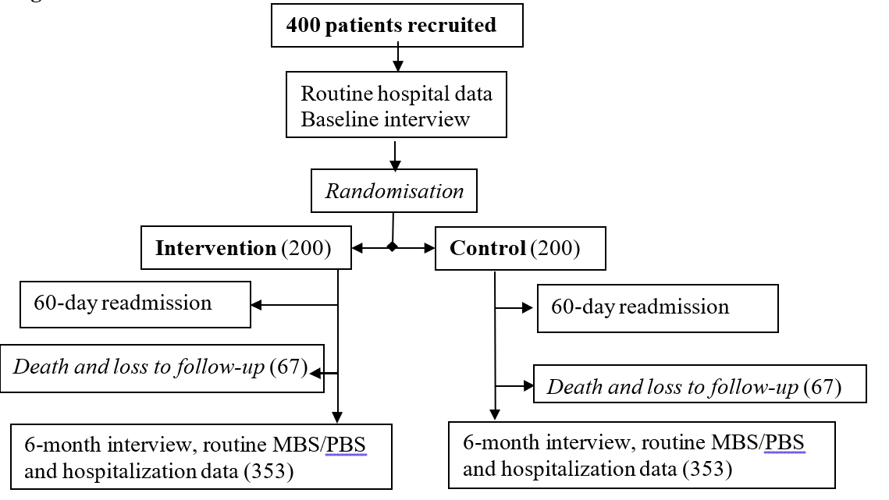

4.5. CENTRES
Potential participants will be identified via the Patient Flow Portal used across NSW Health. Patients will then be recruited at four hospital sites (Royal Prince Alfred Hospital, Balmain Hospital, Concord Hospital, Canterbury Hospital). The intervention will be implemented under the SLHD Aged Health, Chronic Care and Rehabilitation (AHCCR) service.
A presentation was held at Whole of Health Steering Committee on 3rd June 2021 (meeting minutes attached, Appendix). General Managers from the respective sites RPA, Canterbury, Concord, and Balmain were in support of this project. A dedicated staff member will be appointed as a point of contact and liaison for all four sites.

Site Name/s | Sydney Local Health District Aged Health, Chronic Care and Rehabilitation (AHCCR) service
Site Contact/Investigator | Dr John Cullen
Study Procedures | After consent and baseline interview, participants will be randomised to  intervention or control groups. The Control group will receive usual care. The  intervention group will receive a phone follow and a minimum of two home visits  (first visit, within the first 72 hours of participant discharge from the hospital) and  second visit (within two to four weeks from the first visit) from the Community  Health Navigator to review actions and monitor progress from the first visit. There  will be additional two to four contacts as required up to 60 days in accordance with  the action plan to address identified issues at the first home visit. At 3- and 6-  month time points participants in both groups will receive an option to receive a  telephone interview or fill in an online survey administered via SLHD REDCap  Installation.

5. STUDY PARTICIPANTS

5.1 INCLUSION CRITERIA
- Aged 40 years and over
- Living within SLHD boundaries
- Admitted for a chronic condition or under the aged care service
- To be discharged to their own home from a SLHD hospital with an Estimated Date of Discharge (EDD) within 2 days
- Speaks English or any of the top five languages (Arabic, Cantonese, Mandarin, Greek and Italian)

5.2. EXCLUSION CRITERIA
- Selected for follow-up by any other chronic care program offered by the SLHD
- Discharged to hostels, Residential Aged Care Facilities (RACF), rehabilitation facilities, transferred to another SLHD facility or transferred to another hospital or may be too unwell to participate in the study
- Admitted primarily for COVID-19 diagnosis
- Receiving community palliative care services
- Receiving 7-day post discharge follow up from Mental Health services may be allocated follow-up from the other health care teams
- Mild to moderate cognitive impairment (based on Rowland Universal Dementia Assessment Scale (RUDAS) score, able to give verbal assent and has a carer/informant as their primary carer available for an interview. People diagnosed with severe cognitive impairment unable to give verbal assent will be excluded
- Patient or their primary carer does not have a landline or a mobile phone contact number available.

5.3 Key Elements of Recruitment
Patients will be identified via the Patient Flow Portal (PFP) located within the SLHD. “The invitation to participate in the study will be initiated by a member of the potential participants clinical team. Interested patients will be asked whether they agree to be contacted by the research staff, who will then discuss the study in detail with the participant, go through the consent process, and obtain written consent” (Figure 2). The PFP provides access to a suite of modules used by NSW Health Hospital Staff, administration support and executive teams to monitor and manage patient flow and coordinate patient care.
Within the PFP is an Integrated Care module that has an e-enabled Risk of Hospitalisation (RoH) algorithm that identifies people at risk of rehospitalisation within 15 months. The RoH score is calculated based on multiple factors (including no. of inpatient admissions, no. of ED presentations, socio-economic factors). If a patient scores greater than 0.18 the patient is deemed to be at high risk of re-admission. Patients with a RoH score of great than 0.18 are the target group of patients to be followed up by care coordinators/nurses in the Planned Care for Better Health (PCBH) program.
However, due to capacity limitations of PCBH program, not all patients with a high risk of re-admission score will be followed up. This study will therefore identify patients with a score greater than 0.18 who are not allocated to be followed up by PCBH program clinician.
Figure 2- Patient identification workflow
Patient Flow Portal (Inclusion criteria)
- Aged 40 years and over
- Living within SLHD
- Admitted for a chronic condition or under aged care service
- To be discharged to their own home from a SLHD hospital with an Estimated Date of Discharge (EDD) within 2days
- Speaks English or any of the top five languages (Arabic, Cantonese, Mandarin, Greek or Italian)

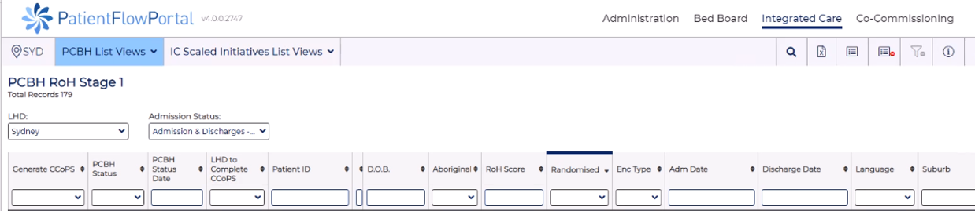

5.4 CONFOUNDERS
Factors such as the length of admission, hospital of admission, age, language spoken at home, socioeconomic status (postcode), health literacy and affiliation with general practice may influence the primary outcome hospital readmission. These will be assessed and any significant differences at baseline between intervention and control groups will be adjusted for in the analysis.

5.5 STUDY LIMITATIONS
The study has some limitations.
- It will be conducted in one inner urban local health district (SLHD) and thus its generalisation to other areas may need to be made with care.
- The study participants and evaluators will not be blinded to allocation, and this may influence some secondary outcomes.
- There may be selection effects as, for example, some patients may self-exclude. We will monitor some limited characteristics (age, gender, language spoken) of those who elect to not participate in order to assess possible selection bias.
- The study is a “real world” trial so participants in both groups may receive other support post discharge.
- Patients may be at highest point in their risk of hospitalisation and thus risk may decrease in both groups. Patient’s risk will be monitored to determine if there are differences between groups at baseline.

6. STUDY PROCEDURES

6.1 Recruitment flow chart (Figure 3) (updated text to reflect changes to randomisation process)

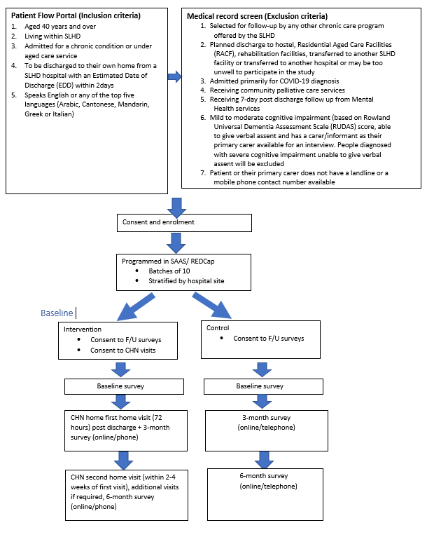

6.2 INVESTIGATION PLAN

Intervention Methodology and Data Collection timepoints
- In the intervention group the first visit will be conducted by the CHN in the patient’s home within 72 hours of discharge to provide support. During this visit, the specific roles of the CHN are likely to include:
  - building patient understanding of their condition and confidence in self-management.
  - identification of problems in the living environment that might impact on the patient’s health and wellbeing, including social isolation.
  - checking of medicines with the discharge summary, assessing if they are safely stored and asking about side effects of medicines (to alert GP or other clinical staff).
  - monitoring self-management.

After the visit the CHW will meet with their supervisor to develop an action plan to address any issues identified and to arrange appointments and transport to the GP and specialist (if required).

- Phone follow up within two weeks will occur to monitor progress with the patient’s action plan and provide support with self-management and in navigating to other services.

- A second home visit will be conducted at two to four weeks to review actions and monitor progress. Patient and carer concerns will be addressed, and support provided for self- management using translated web- or printed- resource. The CHW will communicate by phone or e-mail with the patient’s GP, pharmacist, allied health provider, community health services, aged and/or home care services and other health and/or social care providers. With their supervisor, the CHW will review the need for further follow-up.

- There will be an additional two to four contacts (via phone or visits) as required up to 60 days, in accordance with the action plan, to address identified issues. Follow-up will continue until the patient has been successfully transferred/ integrated to other services as needed.

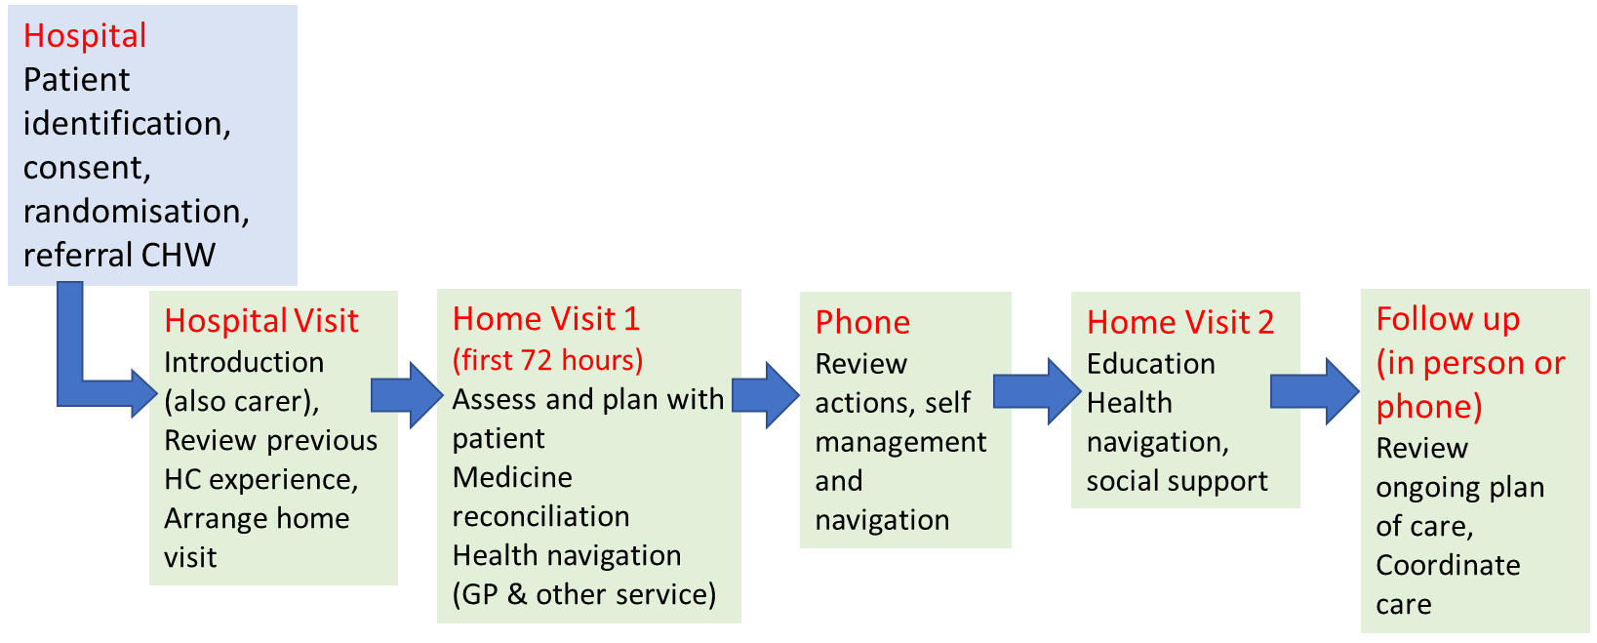
Figure 4 Community Health Navigator (Community Health Worker) visits and contacts

6.3 STUDY PROCEDURE RISKS

6.3.1 Risks to participants:
There are several study steps where participants may be “at risk” from their participation (Table 2):
- At recruitment participants may be unclear about the study intervention or purpose or feel pressured to participate, which may invoke a range of personal feelings including frustration.
- In the interviews during completion of the surveys at baseline, 3- and 6-months participants will be invited to consider issues involved in their transition from hospital to community and their experiences of the CHN visits. It is possible that during these, any negative experiences during their hospital stay and/or discharge may be recalled invoking a range of personal responses including frustration or sadness. In the intervention participants will receive support from CHNs who will be trained to provide non-clinical support. Some patients may feel uncomfortable with the visits and telephone contact.
- An independent data monitoring and safety committee will oversee the project, including 6 months review of adverse events and analysis of outcomes.

Table 2 Risk management and mitigation strategies
Project phase | Description of risk | Risk mitigation strategy
Recruitment phase | Participant feels pressured to be involved and/or concerned about consequences for their own or their family member’s treatment/care of participation or non-participation | Voluntary nature of the project, freedom to choose to participate or not, and freedom to express one’s opinion clearly stated on participant information sheet and consent form.
Recruitment phase | Participant is unclear about the nature of the project and the commitment | Provision of information in easy-to-read format with each component of the process clearly outlined. The research team will respond promptly to queries either by phone or email.
CHN intervention | Participant misses out on receiving care. | CHN are trained not to act as a care coordinator nor substitute for another health care provider. They can only facilitate access to healthcare.
CHN intervention | Consumer/carer partner feels uncomfortable with the CHN | CHNs are trained in communication with patients. At enrolment participants are informed they may withdraw at any time by phone, e-mail, or other contact with the research team
CHN intervention | CHN gives inappropriate advice or information. | CHNs receive training in the limitations of their role including not giving any medical or medication related advice. Advice or support given to participants is recorded in the CHN logbook and reviewed at the regular 2 weekly supervision meetings.
CHN intervention | CHN is in a hazardous or disturbing situation during a home visit | See section 6.3.2
Data collection and storage | Patient becomes upset or distressed during interviews | Participants are informed they may stop at any time. Participants are provided information about who they may seek support from including their own GP or the mental health line.
Data collection and storage | Participant information not kept confidential | All participant information will be stored on secure password protected electronic systems (see later section). All staff and CHNs will be appropriately trained about data handling and storage.

6.3.2 All patients will be screened prior to the home visit for risks according to the Aged, Chronic Care and Rehabilitation (ACC&R) policy, Home Visit Risk Assessment and Management Policy (Attached in Appendices). Section 8.3.1, page 5, of the Policy states prior to a home visit staff are expected, in addition to a Home Visit Risk Assessment Checklist, to notify the manager/coordinator/staff member prior to a home visit, and again following departure from the participant’s home. Details of patients dealing with severe mental illness or at risk of mental health issues are recorded in an electronic form in the Electronic Medical Record (eMR) and system alerts are in place within the eMR. An admission for mental health is an exclusion however patients may have mental health issues as a comorbidity. If they are actively involved with the mental health services, they will not be included in this study.
6.4.3 To ensure the safety of staff and in compliance with SLHD policies and procedures all staff will abide by the NSW Health Policy and Standards for Security Risk Management in NSW Health Agencies, updated Oct 2018 (Attached in Appendices) & ACC&R policy, approved May 2017.
Staff working in the community must:
- Complete a risk assessment of the client and the client’s home prior to any visit.
- Attend a client with a second staff member, or the police, where there is a risk of violence, or the risk is unknown.
- Make an excuse not to enter the premises if the person answering the door gives cause for concern e.g., if they are drunk, if the patient is not in, or if a potentially dangerous relative is present.
- Be familiar with the vehicle they have been allocated and should ensure the vehicle has sufficient fuel to complete the journey.
- Know, to the best of their ability, the area, region, and streets they work in. They should try and identify the address without having to continuously refer to an electronically aligned navigation system or hard copy map since risks can arise from sitting on the side of the road to read a map, or a staff member trying to read a “SatNav” while driving an unfamiliar road.
- Terminate the home visit if there is an obvious increase in numbers of people when the clinician presents, or if there is any other overt or implied threat. The pre attendance risk assessment should show who inhabits the premises on a regular basis.
- Show identity badges.
- Follow the occupant when entering the premises.
- Not search for clients by unnecessarily knocking on doors.
- Ensure any correspondence for a client is pushed firmly under the door or placed in their letterbox.
- Determine whether the client is at home prior to entering the premises if an unfamiliar person opens the door.
- Immediately leave if firearms or other weapons are seen (the presence of weapons should be noted in the client’s file and communicated to police and management). Staff should not return to these premises until the matter is resolved.
- Ensure animals are restrained.
- Remain aware of the environment and potential escape routes in case problems arise.
- Position self when providing treatment so that the patient or others do not block quick access to exit routes.
- Lock their vehicle while driving through areas identified as potentially dangerous.
- Conceal all bags, drugs and equipment when first entering the car so that nothing is visible while travelling, and staff are not seen to be hiding them as they park or prior to leaving the car for the visit.
- On reaching the intended home visit – only take what is necessary for the visit/treatment. Staff working in the community should only carry personal items necessary for the home visit. Consider a second wallet with drivers licence, Health Service Identification, and sufficient money to cater for a meal. Mobile phones should be kept on the person out of view and laptops kept completely out of view.
- Remove navigation systems, personal music storage devices, sunglasses, non- uniform clothes of high-end value are all regarded as opportune theft items. Mobile phones and portable navigation systems offer the owner storage for personal information such as home addresses however if stolen this information is available to a thief provides access to the staff member’s home address and daily routine.
- Drive to the nearest police, fire or petrol station, other populated place, or a pre-determined ‘safe’ venue if they suspect they are being followed.
- Park in a well-lit area as close to the patient’s home as possible.
- Park in a way to allow rapid exit – facing the intended direction of travel if possible.
- Not remain in the parked car for a prolonged period either before or after making the visit and keep doors locked.
- Avoid walking in deserted places, or taking short cuts through secluded alleys or vacant lots.
- Walk in the centre of footpaths away from buildings.
- Observe windows, alcoves, and doorways for loiterers, and be aware of any partly open doors where a person could be concealed.
- Walk around, rather than through groups of people.
- Avoid entering areas of unrest, or where there appears to be trouble in the neighbourhood.
- Check lighting and stairwells when entering a building where no lift is available
- Look before entering a lift and not enter if concerned.
- Stay near to the door and control panel in lifts and be observant of other passengers.
- Cross the street and walk in the opposite direction or into an open business if there is suspicion of being followed by a car.

    - To ensure the safety of staff and in compliance with SLHD policies and procedures the Home Visit Risk Assessment will be completed prior to the first home visit (as below). As outlined in the Working in the Community Home - Visiting Policy, staff must be provided with sufficient information from the patient, the carer or referrer regarding potential risks from patients, other members of the household/ visitors and the environment where the visit will be conducted.

6.4 PARTICIPANT RECRUITMENT AND SCREENING
Will participants be screened? | Yes
If yes, what data will be collected? (NB, if participant is not eligible, will data collected be destroyed or kept?) This should be mentioned in PIS/CF) | Patients will be screened for eligibility using the Patient Flow Portal (PFP). If the participant is not eligible no data will be collected.
Who will make initial contact with participants? | Initial contact will be made by a member of the patient’s clinical team.
Who will perform the consent process? How will this be carried out? | “The invitation to participate in the study will be initiated by a member of the potential participants clinical team. Interested patients will be asked whether they agree to be contacted by the research staff, who will then discuss the study in detail with the participant, go through the consent process, and obtain written consent”.
Will participants be consented verbally/explicitly/using eConsent?  SLHD Research Forms Link | Potential participants from four public hospital sites (Royal Prince Alfred, Concord, Balmain, and Canterbury) will be identified using the patient flow portal currently used to identify in-patients at risk of re-admission by a member of the patient’s clinical team (defined as a medical officer, nurse or allied health professional who routinely sees the patient as part of their clinical care). To reduce the workload on clinical staff written consent will be taken by research staff.  Participants will be explained their participation in this research study is voluntary, at any stage if they do not want to take part or change their mind, they are free to withdraw at any stage. Potential participants will be given Participant Information and Consent Form to sign and will be given a copy to keep.
Will participants be given a specific time period to consider participating? | Yes - They will be given at least 4 hours to consider participation in the study and will be free to withdraw at any time. The short period of time is because patient may be discharged. Study participation will not be offered to very sick or unstable patients, being delayed until close to discharge.
Review of existing databases or databanks (please identify the database/databank and the custodian) | Ministry of Health
Review of clinic files (please include who will be reviewing these files, for example a research coordinator). | Mr Brad Astell
Advertisements (please include where the advertisement will be placed for example, in a newspaper, poster in a clinic or hospital foyer, radio announcements, website etc.) | Nil
Information Letter to Health Care Providers | Yes- Information on the study will be provided to their respective health care providers
Explain how potential participants will be screened for the study | Potential participants will be identified via the Patient Flow Portal and the medical record/s checked for exclusion criteria by a member of the patient’s clinical team.
Any other potential recruitment methods. | The recruitment strategy will be reviewed 3 months post commencement of the trial.

6.5 PARTICIPANT ENROLMENT
Potential participants will be enrolled into the study after the informed consent process has been completed and the participant has been assessed to meet all the inclusion criteria and none of the exclusion criteria. Participation in the study will be voluntary participant’s will be free to withdraw at any time. Study participants will receive a Participant ID, and this will be documented in all study documents.

6.6 INFORMATION AND CONSENT

All patients are provided with information about the study both verbally when considering participation and in writing when they are provided with the participants information and consent form.

The hard copy consent forms will be stored onsite at HERDU. The potential participants will be assisted by LHD/ research staff to complete a brief questionnaire asking questions about their overall health and care received during the last six months. The questions will cover a broad range of topics including their mobility, personal care, day to day activities, medicines, and pain levels. The baseline questionnaire will take approximately 10-15 minutes to complete. If at any time they feel unwell or change their mind they will be free to ask the staff to stop the questions.

6.7 RANDOMISATION PROCEDURE

After recruitment and consent patients will be randomly allocated to intervention or control groups following stratification by hospital type and batching using SAS or REDCap program The control group patients will receive usual care.

6.8 END OF STUDY TREATMENT/WITHDRAWAL PROCEDURE
Participation in this study is entirely voluntary. Participants will be informed they do not have to take part if they wish not to and will be free to withdraw at any time by informing Professor Mark Harris by email (m.f.harris@unsw.edu.au) or phone (02-9385 8384). If a participant withdraws, we will not collect any further information however we will not be able to remove any de-identified information already provided. Whatever the participant decides they will be assured their relationship with the SLHD, CESPHN, ACI, Health Consumers NSW, the University of New South Wales, The University of Sydney, University of Technology Sydney, or Swinburne University will not be affected.
Participants will be informed all the information collected from the study will be treated confidentially, and only the research team will have access to it. Data will only be stored in the SLHD database (REDCap Instance) and Centre for Primary Health Care (CPHCE) at the University of New South Wales, Sydney. Data will be de-identified and stored for 7 years after completion of the study. Patient identity on the surveys/questionnaires will be replaced by a number. The study results may be presented at a conference or in a scientific publication, but individual participants will not be identifiable in such a presentation. Participants will be informed de-identified data may be provided on request to the NHMRC or medical publications in order to verify report/s of the findings.

7. OUTCOMES

This study will provide evidence of the impact of CHW follow-up of patients in the community post-hospitalisation in the Australian context. The findings will inform the case for funding CHWs in this role. Agency for Clinical Innovation (ACI) has a leadership role in health system change especially in NSW through service redesign, health care innovation, developing and promoting guidelines and models of care, and supporting local health districts to implement health care improvements. It also has roles in developing capacity and supporting networks of clinicians and managers. ACI works with clinicians, consumers, and managers to design and promote better healthcare for NSW. It has a strong record of translation of evidence in practice and health care innovation in hospitals and the community that has led to better outcomes for patients with stroke, myocardial infarction, heart failure, and trauma. Apart from implementation in their own services and programs, the Partner Investigators have senior roles in their organisations and have expertise in engaging with policy makers at state and national levels on relevant topics such as aged care, chronic disease management, integrated care, workforce development, health care innovation and improvement.
This study also has strong potential for translation into practice through standards and clinical pathways, health professional education and programs, both in Australia and overseas to prevent hospital readmission.

7.1 DEFINITION OF OUTCOMES

Primary outcomes:
Our hypothesis in relation to our objective is in comparison with a control group; intervention-group participants will have 50% fewer readmissions (from 20% to 10%), in the first 60 days post discharge (as this is the duration of the CHW intervention).
Secondary outcomes:
In comparison with the control group, post-discharge intervention group participants will, at six months, be more likely to report: -
- Improved self-reported medication adherence (Brief Medication Questionnaire (BMQ) score of 0.5)
- Higher quality of life (measured by the EQ5D-5L instrument
- Improved health literacy (HLQ domains concerned with self-management and use of health services
- Improved patient assessment of chronic illness (PACIC short form adapted)

We will also measure the cost of the intervention, health service use in the intervention and control groups over six months following discharge, using individually linked Medicare Benefits Schedule (MBS) (including care plans), Pharmaceutical Benefits Scheme (PBS) and hospital-use data (inpatient and Emergency Department (ED) use). Our hypothesis is that health service use will be more appropriate (higher proportion of Team Care Arrangements, fewer ED presentations) and that the total cost in the intervention group will be less than the control group at six months.
The outcomes of this phase of the study will be:

- A publication/report that will identify key issues for patients with long-term conditions transitioning from hospital to the community and a model of transitional care by Community Health Navigator (Community Health Worker).
- A detailed plan for evaluating the CHW model of care including recruitment, evaluation, and translation of findings into practice and policy.

8. DATA COLLECTION

8.1. FORMS AND PROCEDURE FOR COLLECTING DATA

 |  | Control and Intervention group
Data variables | Data source | Baseline | 3 months | 6 months
Demographic data  Age (in years), gender, main language spoken at home  Country of birth  Admission data  Length of stay, admission and discharge date, reason for admission, Disease Related Groups (DRG), elective/urgency category, time to readmission within 60 days, reason for readmission (under same or different specialty) and medications on discharge | eMR (Electronic Medical Record)/ Patient Flow Portal | 
Living arrangements and carer status (if unavailable in eMR) | eMR | 
 |  |  | Online participant survey administered via SLHD REDCap installation OR telephone interview
Quality of life (measured by the EQ5D-5L) instrument | Participant survey |  |  | 
Self-reported medication adherence (Brief Medication Questionnaire (BMQ) | Participant survey |  |  | `
Improved health literacy (HLQ domains concerned with self-management and use of health services (6 domains) | Participant survey |  | 
Patient assessment of chronic illness (PACIC short form) | Participant survey |  |  | 
Bureau of Health Information questionnaire | Participant survey |  | 
Refer to the Data Collection form for multiple source data collection/ Data Dictionary (Excel
sheet attached)

9. STATISTICAL METHODS

9.1. SAMPLE SIZE ESTIMATION
We aim to recruit (n=400) patients and for 266 to remain in the study at the six-month follow-up (based on 3% mortality and 12% loss to follow up). Power calculation based on the primary outcome measure of readmission rate: Assuming a readmission rate of 20% within 60 days (based on pilot and published data) a sample size of 392 or 196 in each group would be required to detect a 50% reduction in readmissions to 10% with 95% confidence intervals and 80% power. Survival analysis of time to readmission would require a similar sample size of 200 in each group.

9.2. STATISTICAL ANALYSIS PLAN
The fidelity and tailoring of the intervention to patient needs will be assessed by analysing CHW records and patient interviews. Baseline characteristics of those lost to follow- up will be analysed on an intention-to-treat basis. Demographics of non-participants and reasons for drop-out will be collected to assess bias. We will compare the outcomes described in the hypotheses (fewer readmissions, improved medication adherence, more GP care plans, higher quality of life, improved health literacy and patient assessment of chronic illness) between intervention and control groups, using multivariate regression techniques that adjust for age, sex and those independent variables that are significantly different between the two groups, and using multiple imputation for missing values. Sensitivity analyses will assess unmeasured variation. We will also conduct time to event analysis to examine the relationship between seeing a CHW following discharge from the index hospitalisation and reduced re-hospitalisation in the subsequent 60 days and six months. This will be undertaken by first calculating propensity weights to account for differences in characteristics between those who were allocated to the CHW intervention and those in the control group, and then, using Cox proportional hazards regression modelling. Outcomes will be censored at first re-hospitalisation, death or 60 days/six months following index hospitalisation, whichever occurred first.

10. QUALITY CONTROL AND ASSURANCE

10.1. CONTROL OF DATA CONSISTENCY
All questionnaire data will be entered into the SLHD REDCap Installation. Data fields will have rules which only allow entry of data which meets entry criteria (e.g., numeric fields within a range) to reduce errors and improve accuracy*.
* REDCap has a data quality module. The Data Quality module allows discrepancies in the study data to be identified. Data fields can be created with custom rules that REDCap will execute to determine if a specific data value is discrepant or not. This allows for regular audits to be conducted to ensure data accuracy and control. The data quality module can also be activated in real time execution to continually ensure the data integrity of the data collected for the study. Data quality check will be conducted monthly to ensure data quality.

10.2. AUDITS
The study team will be responsible for the following
- Maintain adequate, clear, and accurate records of source data/documents collected
- Manage research data and source materials according to ethical approvals
- Ensure that appropriate research data and source materials are maintained for accurate reporting
Regular audits to ensure data accuracy and control*

10.3. PROTOCOL AMENDMENTS
All protocol amendments will be submitted to ethics for approval.

11. ETHICS

11.1. INVESTIGATOR AUTHORISATION PROCEDURE

Ethics application and documentation including participant information and consent forms must be approved prior to commencing recruitment for the study.

12. BLINDING AND UNBLINDING

Random allocation of the potential participants to the control or the intervention group will be kept separate from the staff involved in participant follow-up data collection. Allocation concealment use of batching via REDCap or the SAS program will ensure the person consenting the participants does not know in advance the allocation of the potential participant (i.e., to control or the intervention group).

13. CONFIDENTIALITY, STORAGE AND ARCHIVING OF STUDY

Non-digital data such as hardcopy consent forms will be stored in a locked secure office within the Health Equity Research and Development Unit (HERDU), SLHD (Table 3). Only the research team members and Principal Investigators will have access to the consent forms. On completion of the study and following publication/s, only the PI and the Head of Department/s will have access to all study material and data stored on SLHD REDCap installation. De-identified data will be available for analysis only on site at SLHD and Centre for Primary Health Care and Equity (CPHCE). Identification codes will be stored separately in a password protected file in CPHCE. De-identified data will be available for analysis only on site at SLHD and CPHCE. De-identified data will be stored in password protected one-drive files as per advice from UNSW IT.
Data will be retained for 7 years after the completion of the study. Hard copy questionnaires will be securely disposed via the confidential documentation disposal bin in accordance with the UNSW Records Disposal policy (https://www.recordkeeping.unsw.edu.au/recordkeeping/research-records).

Table 3 Data Storage, security, and retention period
Data Storage
Data Type | Campus/  Location | Building/Server Name | How is data stored securely | How is access restricted | Data Retention Period
Hard copy consent forms and data collection forms | HERDU, SLHD | SLHD, Level 9 KGV Building, Missenden Road,  Camperdown | Secure locked filing cabinet and offices | Restricted access to the building | 7 years after completion of the study
Electronic data | REDCap Installation, SLHD | SLHD | - REDCap is a secure data capture tool licenced by SLHD IT  - Activated by a two factor-authentication system | Allows to limit user accessibility based on respective authorised roles within the project. | On completion of recruitment and data collection
Electronic data | UNSW Kensington | UNSW OneDrive | Researcher’s computers and OneDrive folders are password protected | Only the research team members have access to the project folders on OneDrive | 7 years after completion of the study

14. TRIAL SPONSORSHIP AND FINANCING

The study is funded by the National Health and Medical Research Council (NHMRC) partnership grant. Sydney Local Health District and Central and Eastern Sydney Primary Health network (CESPHN) are co-sponsors.

15. APPENDICES

- NSW Health Policy and Standards for Security Risk Management in NSW Health Agencies, updated
Oct 2018
- Aged, Chronic Care and Rehabilitation (ACC&R) policy, Home Visit Risk Assessment and Management Policy, approved May 2017.
- Sydney Local Health District (SLHD), Whole of Health Steering Committee Minutes, 3rd June 2021.

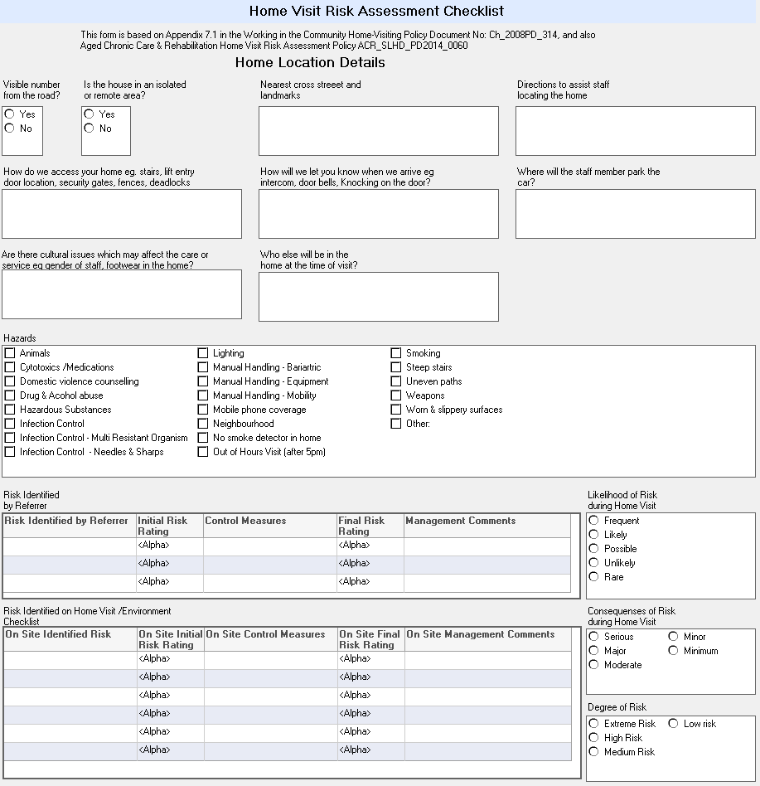
Aged Chronic Care and Rehabilitation (ACC&R) policy, Home Visit Risk Assessment and Management Policy, approved May 2017,
Home Visit Risk Assessment Checklist.

