**Do you have**

**kidney disease?**

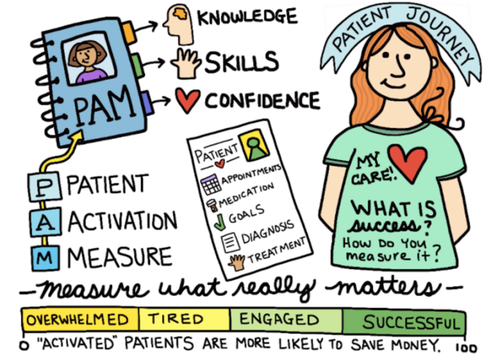

**How involved are you in your health care?**

**This study aims to assess your knowledge, skills, and confidence you have in taking care of your kidney disease.**

**To prevent your kidney function getting worse and improve your quality of life, it is essential for you to have an active role in your health care.**

**Our study consists of 2 simple short survey’s and will take less than 15 minutes of your time.**

**If you are interested in participating, please let your kidney nurse know or contact Laura Lunardi, Nephrology Nurse Practitioner, on 08 - 70745441 or** [**laura.lunardi@sa.gov.au**](mailto:laura.lunardi@sa.gov.au)

**Central Northern Adelaide Renal and Transplantation Service**

Recruitment Flyer; Version 2; 2-3-2022