*Metro South Hospital and Health Service*

**Participant Information Sheet/Consent Form**

**Interventional Study** -*Adult providing own consent*

|  |  |
| --- | --- |
| **Title** | *Laparoscopic fundoplication versus laparoscopic Roux-en-Y gastric bypass for gastro-oesophageal reflux disease in obese patients; a randomised, controlled trial* |
| **Short Title** | *An RCT of LF vs. LRYGB for GORD in obese patients* |
| **Protocol Number** | HREC/2022/QMS/84188 |
| **Project Sponsor** | *Dr Adam Frankel (MSHHS)* |
| **Coordinating Principal Investigator/ Principal Investigator** | *Dr Adam Frankel* |
| **Associate Investigator(s)**  *(if required by institution)* | *Professor B. Mark Smithers*  *Professor Andrew Barbour*  *Dr Iain Thomson*  *Dr Ben Dodd*  *Dr David Mitchell*  *Dr Chung Won*  *Dr Peita Webb*  *Professor Gerald Holtmann*  *Dr Ayesha Shah*  *Dr Syeda Farah Zahir*  *Professor Chen Chen*  *Dr Lili Huang* |
| **Location** *(where CPI/PI will recruit)* | *Princess Alexandra Hospital*  *Royal Brisbane and Women’s Hospital* |

**Part 1 What does my participation involve?**

**1 Introduction**

You are invited to take part in this research project. This is because you have gastro-oesophageal reflux disease (GORD) and your weight is in the unhealthy range (you have a high body mass index). The standard operation that you would normally be offered is called a laparoscopic fundoplication. The research project is testing an alternative operation for GORD, which is called a laparoscopic Roux-en-Y gastric bypass.

This Participant Information Sheet/Consent Form tells you about the research project. It explains the tests and treatments involved. Knowing what is involved will help you decide if you want to take part in the research.

Please read this information carefully. Ask questions about anything that you don’t understand or want to know more about. Before deciding whether or not to take part, you might want to talk about it with a relative, friend or your local doctor.

Participation in this research is voluntary. If you don’t wish to take part, you don’t have to. You will receive the best possible care whether or not you take part.

If you decide you want to take part in the research project, you will be asked to sign the consent section. By signing it you are telling us that you:

• Understand what you have read

• Consent to take part in the research project

• Consent to have the tests and treatments that are described

• Consent to the use of your personal and health information as described.

You will be given a copy of this Participant Information and Consent Form to keep.

**2 What is the purpose of this research?**

We commonly see patients just like you, who are suffering from gastro-oesophageal reflux disease (GORD) and are carrying excessive weight (obesity). Obesity is one of the underlying causes of GORD. There are two operations that surgeons think are effective at treating GORD in patients like you but we have no evidence to help decide if they are equally effective or if one might be better. One treats the GORD, the other treats the GORD and the obesity (i.e. the underlying cause of the GORD). It is very important that we advance our understanding of how to best treat people with your condition, so we need to study both of these operations in people like you.

Both operations are laparoscopic (‘keyhole’). The traditional operation (laparoscopic fundoplication; LF) involves wrapping the top part of your stomach around the oesophagus (‘food pipe’) to make a one-way valve and prevent acid reflux. The alternative operation (laparoscopic Roux-en-Y gastric bypass; LRYGB) involves separating a small pouch of stomach from the majority of the stomach, then connecting this pouch directly to the small intestine. This operation fixes GORD because the small stomach pouch doesn’t produce any significant amount of acid. In addition, the small pouch and the re-configuration of the small intestine work together to make you feel full quickly, so you eat less and lose weight.

Across the world, Laparoscopic Fundoplication (LF) is the gold standard surgical procedure for the treatment of GORD. Currently, if a patient like you has GORD and you are referred to a public hospital for consideration of surgery to fix it, you would be offered a LF. It is a very effective operation at fixing the GORD, but over the years, particularly if your weight remains too high, your GORD may come back. If it did, many surgeons would offer you a revision (re-do) of the LF. As the years went by, if you still suffered GORD, a Roux-en-Y Gastric Bypass (RYGB) may be offered as a third-line operation. RYGB is an effective anti-reflux operation and has been used for this reason for many decades. However, it also has some additional benefits, such as reducing your weight and improving any weight-related medical issues that you may also suffer (e.g. high blood pressure, obstructive sleep apnoea, osteoarthritis). Indeed, at the moment, laparoscopic RYGB is most commonly used as a bariatric and metabolic operation (i.e. to achieve weight loss and other health benefits in obese patients), rather than an anti-reflux operation.

There is some evidence that LF may not be as effective at treating GORD in obese patients as in non-obese patients. Given LRYGB can achieve control of GORD and induce weight loss, in the obese population suffering from GORD it is an attractive first-line alternative to LF. Put simply, LRYGB treats both an underlying cause of GORD as well as the GORD itself. LRYGB is actually recommended as the first-line operation for GORD in some national and international guidelines, but this is based on opinion. We don’t actually have any high-quality trial data comparing the two procedures. This means LRYGB must be considered an experimental treatment for GORD in obese patients.

The aim of this study is to compare the two operations and identify how good each operation is at treating GORD. In addition, it will help advance the understanding of what changes occur in people suffering from obesity and how those changes contribute to GORD and our ability to cure it with surgery. Finally, this study will also help us better understand the side effects of each operation, so that we can better counsel and treat future patients like you.

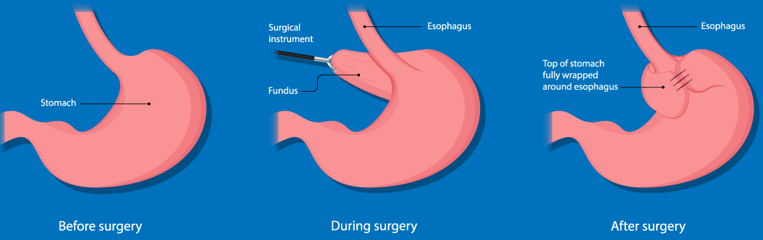

**Laparoscopic fundoplication.**

*Modified from* [*https://www.sages.org/publications/patient-information/patient-information-for-laparoscopic-anti-reflux-gerd-surgery-from-sages/*](https://www.sages.org/publications/patient-information/patient-information-for-laparoscopic-anti-reflux-gerd-surgery-from-sages/) *and used under the educational exemption for copyright.*

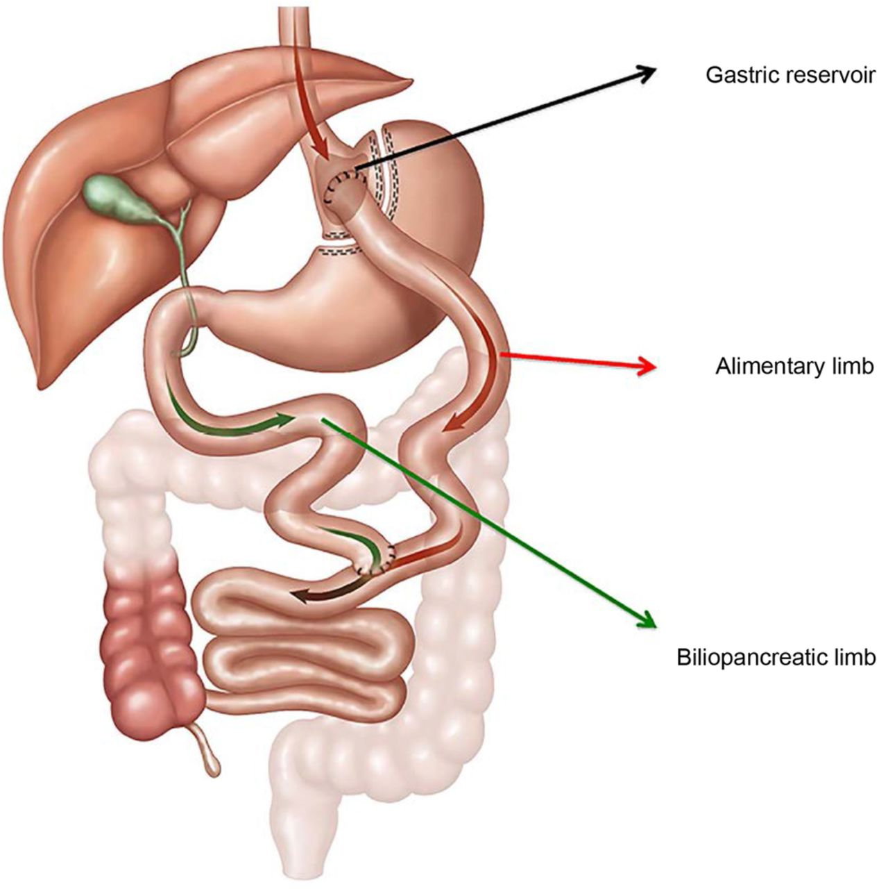

**Laparoscopic Roux-en-Y gastric bypass.**

*Image taken from https://bmjopen.bmj.com/content/7/1/e013574 and used under the educational exemption for copyright.*

This research has been initiated by the study doctor, Dr Adam Frankel.

This research is being conducted by the Princess Alexandra Hospital Department of Upper Gastrointestinal Surgery.

**3 What does participation in this research involve?**

You will be participating in a randomised controlled research project. Sometimes we do not know which treatment is best for treating a condition. To find out we need to compare different treatments. We put people into groups and give each group a different treatment. The results are compared to see if one is better. To try to make sure the groups are the same, each participant is put into a group by chance (random).

You will sign a consent form prior to any study assessments being performed. You will then be asked a number of questions to confirm you are eligible to participate. If you are, and you wish to proceed, you will be referred for a comprehensive set of health checks to confirm the presence of acid reflux, identify any complications of reflux disease and identify any other changes in your oesophagus (food pipe) or stomach. In addition, you will also undergo a comprehensive assessment to find obesity-related health changes that would influence how we care for you.

The pre-operative check-up includes:

- Evaluation of your

experience of GORD (GERD-HRQL questionnaire; 1-2 minutes)

overall gastro-intestinal health (SAGIS questionnaire; 5 minutes)

overall health (SF-6Dv2 questionnaire; 1 minute)

- Global health screening

This will be performed to identify any medical conditions you have, in preparation for surgery. This is routine care and would be done regardless of your participation in this trial. This may include questions about and provision of care for obesity-related conditions such as type 2 diabetes mellitus (blood test), cardiovascular disease (questionnaire, ECG), non-alcoholic fatty liver disease (blood tests +/- abdominal ultrasound), obstructive sleep apnoea (questionnaire +/- sleep physician review +- sleep study) and nutrition (clinical assessment and blood tests)). Even if you need all of these, only a small amount of blood will be required, and the blood tests can all be done at the same time to minimise your discomfort. We will also use some of this blood to check for levels of certain hormones which can be abnormal in patients who are overweight or obese.

- Investigations

You will need to undergo an oesophago-gastro-duodenoscopy (endoscopy). This will be done under sedation which will be provided by a specialist anaesthetist. While you are sedated, the surgeon will take a sample of the lining of your oesophagus. This will not cause any discomfort. A doctor or nurse will also insert a small tube through your urethra and into your bladder to measure the pressure inside your abdomen. If you prefer, this can be done while you are sedated, to minimise any discomfort. Finally, a fine tube will be inserted through your nostril and into your oesophagus and will be left there for 24 hours (24h pH and impedence study), to measure the degree of reflux in your oesophagus. This helps to confirm that the symptoms you are experiencing are actually due to reflux, which improves the chance of anti-reflux surgery improving your quality of life. When you return to have this small tube removed (which is done easily without any sedation and only trivial discomfort), a different tube will be inserted for approximately ten minutes (oesophageal manometry) to allow your doctor to measure the pressure inside your oesophagus, and how it changes between quiet breathing and swallowing. The endoscopy and pH study are routine care for anyone wanting anti-reflux surgery. Manometry is usually only done in selected patients. The bladder measurement is not normally done and is a special feature of this trial. We will also take breath samples to check how well your stomach empties and whether you have any abnormal bacterial growth in your small intestine.

After all of these checks, if your surgeon deems it appropriate and you wish to proceed, you will be offered surgery. Because we don’t know which of two different operations is better (or indeed if they bring the same benefits), you will be randomised to either the laparoscopic fundoplication or the laparoscopic Roux-en-Y gastric bypass. You therefore have a 50% chance (1/2) of receiving the laparoscopic Roux-en-Y gastric bypass (the operation under investigation). You will not know which operation you have had until 2 weeks after the surgery, unless we need to release the information earlier due to an emergency situation.

For the two weeks before your surgery, you will be prescribed a low-calorie diet to shrink your liver and make your surgery easier and safer. This is routine, regardless of whether you participate in this trial. Your surgery will be done in a public hospital. A team made up of a specialist surgeon (who is credentialled to perform the operation you are having) and one (or sometimes two) other training doctors will work together to do your operation. Regardless of which operation you have, you will be allowed clear liquids once you recover from the anaesthetic and will be upgraded to a full liquid diet the following day. If your surgeon thinks it is safe to do so, you will then be discharged (the day after your operation).Under the direction of your surgeon, you will slowly reintroduce pureed and mashed foods, increasing to a normal diet by six weeks. If you had the gastric bypass, you will also take a daily vitamin and mineral supplement. This may need to continue for the rest of your life and will be supervised initially by our dietitian and then in the coming years, by your GP.

In the months and years after your surgery, we need to perform rigorous follow-up to understand how effective the two different operations are, and why. This is extremely important, and if you wish to participate in the trial you will need to commit to the following:

- You will return to the outpatients department two weeks after your surgery and you will repeat the GERD-HRQL, SAGIS and SF6Dv2 questionnaires, be weighed and have blood taken.

- This will be repeated at 3, 6 and 12 months, then yearly to five years

- At 1 and 5 years, in addition to the above, you will have a repeat global health assessment and all of the pre-operative investigations from above

There is no cost for any of the tests or procedures, including the operation, but it does require a time commitment from you. As described above, most of the tests done before the operation are routine. The addition of the oesophageal manometry takes approximately fifteen minutes, while the bladder pressure measurement takes approximately ten minutes. The questionnaires take approximately ten minutes. The breath tests take approximately thirty minutes. Outside of this trial, the post-operative tests we will be asking you to do would normally only be done if there was an abnormal recovery. However, in this trial, we will ask you to commit to a repeat of all the pre-operative tests at 1 and 5 years, which would require two or three additional appointments at the hospital at 1 and 5 years. Aside from some discomfort, there is very little risk to you with these tests. The most significant risk would be a major injury (perforation) to your oesophagus or stomach during endoscopy, which happens in approximately one in 10,000 patients. It would also require approximately 10 minutes of your time each time we repeat the questionnaires.

There will be close, independent oversight of all aspects of the trial, particularly in relation to safety, by Metro South Research.

This research project has been designed to make sure the researchers interpret the results in a fair and appropriate way and avoids study doctors or participants jumping to conclusions.

That is why you will not know which operation you will be getting until two weeks after it has been completed. It is very important that you complete all of the follow-up requirements for the full five years of the trial, and better help patients like you into the future.

There are no additional costs associated with participating in this research project, nor will you be paid. All medication, tests and medical care required as part of the research project will be provided to you free of charge.

At the time of writing, no funding is available, but if it materialises during the study period, you may be reimbursed for any reasonable travel and parking expenses associated with the research project visit.

If you decide to participate in this research project, the study doctor will inform your local doctor.

**4 What do I have to do?**

In addition to the requirements above, you should:

- abstain from heavy lifting (that requires you to strain) or contact sport for at least six weeks

- closely follow the dietary advice given

- take all of your regular medication (unless told by your treating doctor that you should stop)

- avoid falling pregnant within the first year of surgery if you have had a gastric bypass

(although there are no international guidelines to support this recommendation)

We again emphasise the requirement for you to commit to all aspects of the trial to ensure we can answer the important questions we have posed. It is your responsibility to complete the trial requirements in accordance with the instructions provided.

**5 Other relevant information about the research project**

Overall, we will be inviting 182 patients to participate. Many will be from the Princess Alexandra Hospital, but some will take part through other sites, including Logan Hospital, Queen Elizabeth II Jubilee Hospital, and the Royal Brisbane and Women’s Hospital.

As mentioned, there are two different surgical procedures being investigated in this trial, although you will only undergo one of them. You cannot choose which operation you have; you will be randomly allocated. This process ensures we get a true understanding of the risks and benefits of each operation.

This is a new trial and does not follow on from previous work. It represents a collaboration between surgeons, gastroenterologists, endocrinologists, dietitians and statisticians.

**6 Do I have to take part in this research project?**

Participation in any research project is voluntary. If you do not wish to take part, you do not have to. If you decide to take part and later change your mind, you are free to withdraw from the project at any stage.

If you do decide to take part, you will be given this Participant Information and Consent Form to sign and you will be given a copy to keep.

Your decision whether to take part or not to take part, or to take part and then withdraw, will not affect your routine treatment, your relationship with those treating you or your relationship with your hospital.

**7 What are the alternatives to participation?**

You do not have to take part in this research project to receive treatment at this hospital. You can choose to have the standard investigations and surgery (laparoscopic fundoplication) offered by your hospital for your condition. Your study doctor will discuss these options with you before you decide whether or not to take part in this research project. You can also discuss the options with your local doctor.

**8 What are the possible benefits of taking part?**

We cannot guarantee or promise that you will receive any benefits from this research; however, possible benefits may include an improvement in your reflux symptoms, an improvement in your quality of life, and reduced side effects in your gastrointestinal system. We also hope that your participation will help future patients just like you to receive optimal treatment.

**9 What are the possible risks and disadvantages of taking part?**

Surgical treatments often cause side effects. You may have none, some or all of the effects listed below, and they may be mild, moderate or severe. If you have any of these side effects, or are worried about them, talk with your study doctor. Your study doctor will also be looking out for side effects.

There may be side effects that the researchers do not expect or do not know about and that may be serious. Tell your study doctor immediately about any new or unusual symptoms that you get.

Many side effects go away shortly after treatment ends. However, sometimes side effects can be serious, long lasting or permanent. If a severe side effect or reaction occurs, your study doctor may need to stop your treatment. Your study doctor will discuss the best way of managing any side effects with you.

As with any surgery, complications occur despite all due care and a strong desire to avoid them on the part of both the surgeon and the patient. The two operations in this trial have quite different side effect and complication profiles. The contemporary surgical literature has been reviewed and summarised below. Some of the figures quoted for LRYGB may be over-estimates, because the vast majority of data comes from patients undergoing the operation for morbid obesity rather than GORD. Overall, we think that the improvement in GORD is similar between to the two operations, however the LRYGB also causes weight loss. This may improve some of the problems you may suffer due to excess weight, but it also brings some risks that LF does not. Notably, your appearance will change if you lose weight, including developing some loose skin.

If you suffer from a complication, as for any patient presenting with an emergency, you will be treated promptly. Side effects that are intolerable will be addressed within the limitations of what is medically and surgically possible. Treatment will be provided by your operating surgeon or another specialist surgeon or physician depending on the circumstances. Within the public hospital system, there will be no cost to you.

Having blood or a tissue sample taken may cause some discomfort, bruising, minor infection or bleeding. If this happens, it can be easily treated.

|  |  |  |
| --- | --- | --- |
|  | *Laparoscopic fundoplication* | *Laparoscopic Roux-en-Y gastric bypass* |
| **Major differences between the operations** | | |
| Feeling full quickly | 35% | 100% |
| Amount of excess weight lost | 1-5% | 40-60% |
| Improvement in osteoarthritis, high blood pressure, high cholesterol, obstructive sleep apnoea, varicose veins (10 years) | No appreciable change | 80% |
| Nutrient deficiency (e.g. iron, vit B12) | No appreciable change | 30-50% |
| Unable to burp | 30% | Not applicable |
| Gallstones (general population = 2-15%) | No appreciable change | 30-40% |
| Need for gallstone surgery (10 years) | No appreciable change | 15% |
| Complication affecting the small bowel (e.g. leakage, bleeding, blockage, new abdominal pain) | <1% | 5-15% |
| Risk of any complication within 90 days | 4% (1/250) | 35% (1/3) |
| Alcohol or substance misuse | No appreciable change | 7-15% |
| Light-headedness/dizziness and altered bowel habit after eating (dumping syndrome) | No appreciable change | 15% |
| **Minor differences between the operations** | | |
| Improvement in GORD (6 weeks) | 97-100% | 90-100% |
| Improvement in GORD (5 years) | 85-90% | 85-95% |
| Need for anti-acid medication (5 years) | 5% | 5-15% |
| Difficulty swallowing (first months) | 2.5% | 1% |
| Difficulty swallowing (years later) | 1.5% | 1% |
| Bloating | 8% | 10% |
| Excessive flatulence | 10% | 5% |
| Diarrhoea | 10% | 5% |
| Low blood sugar | No appreciable change | 2% |
| Depression and self-harm | No appreciable change | Increased if pre-existing |
| Patient satisfaction rate (5 years) | 95% | 75-85% |
| Reoperation rate (5 years) | 5% | 8% |
| Risk of death within 90 days | 0.2% (1/500) | 0.05% (1/2000) |

The effects of laparoscopic Roux-en-Y gastric bypass on the unborn child and on the newborn baby are not known. Because of this, it is important that research project participants are not pregnant or breast-feeding and do not become pregnant during the first year after surgery if you receive the gastric bypass operation. You must not participate in the research if you are pregnant or trying to become pregnant, or breast-feeding. If you are female and child-bearing is a possibility, you will be required to undergo a pregnancy test prior to commencing the research project.

Female participants are strongly advised to use effective contraception during the course of the research and for a period of twelve months after completion of the research project. You should discuss methods of effective contraception with your study doctor.

If you do become pregnant whilst participating in the research project, you should advise your study doctor immediately. Your study doctor advise on further medical attention should this be necessary and may withdraw you from the research project.

These days, whilst anaesthesia is generally very safe there are some risks associated with anaesthesia. The most common problems associated with anaesthesia are feeling unwell or vomiting, bruising at the site of injections, sore throat or hoarse voice. Most patients do not have these problems. If these problems do happen, they usually get better very quickly. Damage to teeth may occur, but this is rare. The risk of brain damage or death due to anaesthesia is very rare.

The risk of problems from anaesthesia increases for patients who are having more major surgery, those with medical problems and those that require difficult anaesthetic procedures. If you have any concerns about these issues, you should discuss them with the study team.

If you become upset or distressed as a result of your participation in the research, the study doctor will be able to arrange for counselling or other appropriate support. Any counselling or support will be provided by qualified staff who are not members of the research project team. This counselling will be provided free of charge.

**10 What will happen to my test samples?**

Some blood tests done during this trial form part of your routine care (e.g. checking for anaemia, assessing your vitamin and mineral levels, etc.)

You will be asked to provide additional consent for the collection of your blood during the research project. The blood will be processed and stored for future analysis. This will happen once we have enrolled a sufficient number of patients. The blood will be used to test for levels of hormones (chemical messengers). These blood tests are not part of your routine care but will help us understand how these levels change in relation to surgery. You will not get any benefit from this part of the study, but your generosity might help us take better care of patients like you in the future.

**11 What if new information arises during this research project?**

Sometimes during the course of a research project, new information becomes available about the treatment that is being studied. If this happens, your study doctor will tell you about it and discuss with you whether you want to continue in the research project. If you decide to withdraw, your study doctor will make arrangements for your regular health care to continue. If you decide to continue in the research project you will be asked to sign an updated consent form.

Also, on receiving new information, your study doctor might consider it to be in your best interests to withdraw you from the research project. If this happens, he/ she will explain the reasons and arrange for your regular health care to continue.

**12 Can I have other treatments during this research project?**

Whilst you are participating in this research project, you may not be able to take some or all of the medications or treatments you have been taking for your condition or for other reasons. It is important to tell your study doctor and the study staff about any treatments or medications you may be taking, including over-the-counter medications, vitamins or herbal remedies, acupuncture or other alternative treatments. You should also tell your study doctor about any changes to these during your participation in the research project. Your study doctor should also explain to you which treatments or medications need to be stopped for the time you are involved in the research project.

It may also be necessary for you to take medication during or after the research project to address side effects or symptoms that you may have. You may need to pay for these medications and so it is important that you ask your doctor about this possibility.

**13 What if I withdraw from this research project?**

If you decide to withdraw from the project, please notify a member of the research team before you withdraw. This notice will allow that person or the research supervisor to discuss any health risks or special requirements linked to withdrawing.

If you have had a gastric bypass, you will still need to continue follow-up in the long term with your local doctor

If you do withdraw your consent during the research project, the study doctor and relevant study staff will not collect additional personal information from you, although personal information already collected will be retained to ensure that the results of the research project can be measured properly and to comply with law. You should be aware that data collected by the sponsor up to the time you withdraw will form part of the research project results. If you do not want them to do this, you must tell them before you join the research project.

**14 Could this research project be stopped unexpectedly?**

This research project may be stopped unexpectedly for a variety of reasons. These may include reasons such as:

• Unacceptable side effects

• The treatment being shown not to be effective

• The treatment being shown to work and not need further testing

**15 What happens when the research project ends?**

When the research project ends, your care will be handed over to your local doctor. We will then update our routine clinical practice to reflect the findings of the trial. This may mean that future patients like you are only offered one or the other of the two operations under investigation.

We will write to you once the research project is complete to update you on the findings, so that you can update your knowledge and reflect on and appreciate your involvement in the scientific process.

After the trial has concluded, you are still able to access care with us via standard clinical pathways, as for any other patient.

**Part 2 How is the research project being conducted?**

**16 What will happen to information about me?**

By signing the consent form you consent to the study doctor and relevant research staff collecting and using personal information about you for the research project. Any information obtained in connection with this research project that can identify you will remain confidential. Only trial staff will have access to your data. The only identifying details linked to your data during your participation will be your date of birth, gender and hospital number. our information will only be used for the purpose of this research project and it will only be disclosed with your permission, except as required by law.

Information about you may be obtained from your health records held at this and other health services for the purpose of this research. By signing the consent form you agree to the study team accessing health records if they are relevant to your participation in this research project.

Your health records and any information obtained during the research project are subject to inspection (for the purpose of verifying the procedures and the data) by the relevant authorities and authorised representatives of the Sponsor, Dr Adam Frankel, the institution relevant to this Participant Information Sheet, Princess Alexandra Hospital, or as required by law. By signing the Consent Form, you authorise release of, or access to, this confidential information to the relevant study personnel and regulatory authorities as noted above.

It is anticipated that the results of this research project will be published and/or presented in a variety of forums. In any publication and/or presentation, information will be provided in such a way that you cannot be identified. This is because after the trial is closed and data analysis commences, we will further de-identify your information by keeping only your age (in years) and gender, and removing your date of birth and your hospital number.

Information about your participation in this research project will be recorded in your health records.

In accordance with relevant Australian and Queensland privacy and other relevant laws, you have the right to request access to your information collected and stored by the research team. You also have the right to request that any information with which you disagree be corrected. Please contact the study team member named at the end of this document if you would like to access your information.

Any information obtained for the purpose of this research project that can identify you will be treated as confidential and securely stored. It will be disclosed only with your permission, or as required by law.

**17 Complaints and compensation**

If you suffer any injuries or complications as a result of this research project, you should contact the study team as soon as possible and you will be assisted with arranging appropriate medical treatment. If you are eligible for Medicare, you can receive any medical treatment required to treat the injury or complication, free of charge, as a public patient in any Australian public hospital.

There is also a procedure in place through Metro South Research so that if a serious adverse event occurs as a result of your participation in the trial, the trial will be paused or stopped and a thorough review will be initiated by an independent oversight committee.

**18 Who is organising and funding the research?**

This research project is being conducted by Dr Adam Frankel.

By taking part in this research project you agree that samples of your blood or tissue (or data generated from analysis of these materials) may be provided to The University of Queensland. The University of Queensland may directly or indirectly benefit financially from your samples or from knowledge acquired through analysis of your samples.

You will not benefit financially from your involvement in this research project.

In addition, if knowledge acquired through this research leads to discoveries that are of commercial value to The University of Queensland, the study doctors or their institutions, there will be no financial benefit to you or your family from these discoveries.

No member of the research team will receive a personal financial benefit from your involvement in this research project (other than their ordinary wages).

**19 Who has reviewed the research project?**

All research in Australia involving humans is reviewed by an independent group of people called a Human Research Ethics Committee (HREC). The ethical aspects of this research project have been approved by the HREC of Metro South Hospital and Health Service.

This project will be carried out according to the *National Statement on Ethical Conduct in Human Research (2007)*. This statement has been developed to protect the interests of people who agree to participate in human research studies.

**20 Further information and who to contact**

The person you may need to contact will depend on the nature of your query.

If you want any further information concerning this project or if you have any medical problems which may be related to your involvement in the project (for example, any side effects), you can contact the principal study doctor on 07 3176 2111or any of the following people:

**Clinical contact person**

|  |  |
| --- | --- |
| Name | *Dr Adam Frankel* |
| Position | *Consultant Surgeon* |
| Telephone | *3176 2111* |
| Email | *Adam.Frankel@health.qld.gov.au* |

For matters relating to research at the site at which you are participating, the details of the local site complaints person are:

**Complaints contact person**

|  |  |
| --- | --- |
| Name | *Patient Liaison Officer* |
| Position |  |
| Telephone | *3176 5598* |
| Email | *PAH_PLO@health.qld.gov.au* |

If you have any complaints about any aspect of the project, the way it is being conducted or any questions about being a research participant in general, then you may contact:

|  |  |
| --- | --- |
| Reviewing HREC name | *Metro South Hospital and Health Service* |
| HREC Executive Officer | *HREC Co-ordinator* |
| Telephone | *3443 8049* |
| Email | *MSH-Ethics@health.qld.gov.au* |

**Reviewing HREC approving this research** **and HREC Executive Officer details**

**Consent Form -** *Adult providing own consent*

|  |  |
| --- | --- |
| **Title** | *Laparoscopic fundoplication versus laparoscopic Roux-en-Y gastric bypass for gastro-oesophageal reflux disease in obese patients; a randomised, controlled trial* |
| **Short Title** | *An RCT of LF vs. LRYGB for GORD in obese patients* |
| **Protocol Number** | HREC/2022/QMS/84188 |
| **Project Sponsor** | *Dr Adam Frankel (MSHHS)* |
| **Coordinating Principal Investigator/ Principal Investigator** | *Dr Adam Frankel* |
| **Associate Investigator(s)**  *(if required by institution)* | *Professor B. Mark Smithers*  *Professor Andrew Barbour*  *Dr Iain Thomson*  *Dr David Mitchell*  *Dr Ben Dodd*  *Dr Chung Won*  *Dr Peita Webb*  *Professor Gerald Holtmann*  *Dr Ayesha Shah*  *Dr Syeda Farah Zahir*  *Professor Chen Chen*  *Dr Lili Huang* |
| **Location**  *(where CPI/PI will recruit)* | *Princess Alexandra Hospital*  *Royal Brisbane and Women’s Hospital* |

**Declaration by Participant**

I have read the Participant Information Sheet or someone has read it to me in a language that I understand.

I understand the purposes, procedures and risks of the research described in the project.

I give permission for my doctors, other health professionals, hospitals or laboratories outside this hospital to release information to Princess Alexandra Hospitalconcerning my disease and treatment for the purposes of this project. I understand that such information will remain confidential.

I have had an opportunity to ask questions and I am satisfied with the answers I have received.

I freely agree to participate in this research project as described and understand that I am free to withdraw at any time during the study without affecting my future health care.

I understand that I will be given a signed copy of this document to keep.

|  |  |  |  |  |  |  |
| --- | --- | --- | --- | --- | --- | --- |
|  | | | | | | |
|  | Name of Participant (please print) | |  |  |  |  |
|  | | | | | | |
|  | Signature |  | | Date |  |  |
|  | | | | | | |

*Under certain circumstances (see* Note for Guidance on Good Clinical Practice CPMP/ICH/135/95 at 4.8.9*) a witness* to informed consent is required.*

|  |  |  |  |  |  |  |
| --- | --- | --- | --- | --- | --- | --- |
|  | | | | | | |
|  | Name of Witness* to Participant’s Signature (please print) | |  | | |  |
|  | | | | | | |
|  | Signature |  | | Date |  |  |
|  | | | | | | |

* Witness is not to be the investigator, a member of the study team or their delegate. In the event that an interpreter is used, the interpreter may not act as a witness to the consent process. Witness must be 18 years or older.

**Declaration by Study Doctor/Senior Researcher†**

I have given a verbal explanation of the research project, its procedures and risks and I believe that the participant has understood that explanation.

|  |  |  |  |  |  |  |
| --- | --- | --- | --- | --- | --- | --- |
|  | | | | | | |
|  | Name of Study Doctor/  Senior Researcher† (please print) | |  | | |  |
|  | | | | | |  |
|  | Signature |  | | Date |  |  |
|  | | | | | | |

† A senior member of the research team must provide the explanation of, and information concerning, the research project.

Note: All parties signing the consent section must date their own signature.

I understand that, if I decide to discontinue the study treatment, I may be asked to attend follow-up visits to allow collection of information regarding my health status. Alternatively, a member of the research team may request my permission to obtain access to my medical records for collection of follow-up information for the purposes of research and analysis.

I consent to the storage and use of blood and tissue samples taken from me for use, as described in the relevant section of the Participant Information Sheet, for:

• This specific research project

• Other research that is closely related to this research project

• Any future research.

By signing this consent section, I agree to the use of blood or tissue samples obtained previously from my routine biopsy or surgery for the purposes of additional testing.

|  |  |  |  |  |  |  |
| --- | --- | --- | --- | --- | --- | --- |
|  | | | | | | |
|  | Name of Participant (please print) | |  | | |  |
|  | | | | | | |
|  | Signature |  | | Date |  |  |
|  | | | | | | |

|  |  |  |  |  |  |  |
| --- | --- | --- | --- | --- | --- | --- |
|  | | | | | | |
|  | Name of Witness* to Participant’s Signature (please print) | |  | | |  |
|  | | | | | | |
|  | Signature |  | | Date |  |  |
|  | | | | | | |

* Witness is not to be the investigator, a member of the study team or their delegate. In the event that an interpreter is used, the interpreter may not act as a witness to the consent process. Witness must be 18 years or older.

|  |  |  |  |  |  |  |
| --- | --- | --- | --- | --- | --- | --- |
|  | | | | | | |
|  | Name of Study Doctor/  Senior Researcher† (please print) | |  | | |  |
|  | | | | | |  |
|  | Signature |  | | Date |  |  |
|  | | | | | | |

† A senior member of the research team must provide the explanation of and information concerning the research project.

Note: All parties signing the consent section must date their own signature.

**Form for Withdrawal of Participation -** *Adult providing own consent*

|  |  |
| --- | --- |
| **Title** | *Laparoscopic fundoplication versus laparoscopic Roux-en-Y gastric bypass for gastro-oesophageal reflux disease in obese patients; a randomised, controlled trial* |
| **Short Title** | *An RCT of LF vs. LRYGB for GORD in obese patients* |
| **Protocol Number** | HREC/2022/QMS/84188 |
| **Project Sponsor** | *Dr Adam Frankel (MSHHS)* |
| **Coordinating Principal Investigator/ Principal Investigator** | *Dr Adam Frankel* |
| **Associate Investigator(s)**  *(if required by institution)* | *Professor B. Mark Smithers*  *Professor Andrew Barbour*  *Dr Iain Thomson*  *Dr Ben Dodd*  *Dr Chung Won*  *Dr Peita Webb*  *Professor Gerald Holtmann*  *Dr Ayesha Shah*  *Dr Syeda Farah Zahir*  *Professor Chen Chen*  *Dr Lili Huang* |
| **Location**  *(where CPI/PI will recruit)* | *Princess Alexandra Hospital*  *Royal Brisbane and Women’s Hospital* |

**Declaration by Participant**

I wish to withdraw from participation in the above research project and understand that such withdrawal will not affect my routine treatment, my relationship with those treating me or my relationship with Princess Alexandra Hospital.

|  |  |  |  |  |  |  |
| --- | --- | --- | --- | --- | --- | --- |
|  | | | | | | |
|  | Name of Participant (please print) | |  |  |  |  |
|  | | | | | | |
|  | Signature |  | | Date |  |  |
|  | | | | | | |

*In the event that the participant’s decision to withdraw is communicated verbally, the Study Doctor/Senior Researcher will need to provide a description of the circumstances below.*

|  |
| --- |
|  |

**Declaration by Study Doctor/Senior Researcher†**

I have given a verbal explanation of the implications of withdrawal from the research project and I believe that the participant has understood that explanation.

|  |  |  |  |  |  |  |
| --- | --- | --- | --- | --- | --- | --- |
|  | | | | | | |
|  | Name of Study Doctor/  Senior Researcher† (please print) | |  | | |  |
|  | | | | | |  |
|  | Signature |  | | Date |  |  |
|  | | | | | | |

† A senior member of the research team must provide the explanation of and information concerning withdrawal from the research project.

Note: All parties signing the consent section must date their own signature.