Pilot trial of the “Slider” CPAP prongs.

VERSION: 3

DATE: 29th November 2021
PRINCIPAL INVESTIGATOR:
Dr Melissa Weber
Consultant Neonatologist
Department of Paediatrics
Mercy Hospital for Women
163 Studley Rd, Heidelberg VIC 3084

GLOSSARY OF ABBREVIATIONS
Glossary:
CPAP - Continuous Positive Airway Pressure- Mode of respiratory support where a mixture of oxygen and air is delivered at a constant pressure to an infant’s airway.
NICU – Neonatal Intensive Care Unit.
Level 1- Nurseries where a General Practitioner delivers care. (Also known as Well Baby Nurseries) This usually means well newborns that don’t have respiratory problems and are not therefore CPAP users.
Level 2- Nurseries where Paediatricians deliver care. (Also known as Special Care Nurseries).
Level 3-Nurseries where Neonatally trained Paediatricians deliver care. (Also known as NICUs or tertiary level care).
TABLE OF CONTENTS
1. INTRODUCTION AND BACKGROUND 4
2. STUDY OBJECTIVES 8
2.1. Primary objective 8
2.2. Secondary objectives 8
3. STUDY DESIGN 8
3.1. Type of Study 8
3.2. Number of participants 8
3.3. Expected duration 8
3.4. Primary and secondary outcome measures 8
4. STUDY TREATMENTS 9
5. ENROLMENT AND RANDOMISATION 9
5.1. Inclusion criteria 9
5.2. Participant withdrawal 9
6. STUDY ASSESSMENT AND PROCEDURES 9
6.1. At Enrolment 9
6.2. Whilst on CPAP 10
7. ADVERSE EVENT REPORTING 10
7.1 Serious Adverse Event (SAE) 10
7.2. Australian Therapeutic Goods Association (TGA).........................11
8. STATISTICAL METHODS 11
9. DATA MANAGEMENT 11
9.1. Data collection 11
9.2. Data storage 11
9.3. Study record retention 11
10. PUBLICATIONS POLICY 12
11. REFERENCES 13

- INTRODUCTION AND BACKGROUND
CPAP was first reported to be successful in treating newborn infants suffering from respiratory distress syndrome in 1971 by Gregory. ⁽¹⁾ They reported on 20 infants whose survival rate increased from an estimated 25% to 80% once CPAP treatment was implemented.
Since 1971 multiple modalities have been used to deliver CPAP. These include, endotracheal tubes, nasopharyngeal via cut down endotracheal tubes, long narrow binasal prongs, short binasal prongs, nasal masks, face masks, head box with seal and oropharyngeal systems. ⁽²⁾ Both in vitro and in vivo experiments. ^{(3,4)} have clearly shown that short binasal prongs offer the most reliable delivery of pressure to the infant.
CPAP has increased in popularity since the 1987 landmark paper by Avery ⁽⁵⁾ reported that a Neonatal Intensive Care Unit (NICU) in New York (Columbia Presbyterian Medical Center) had the same survival rate as 7 other American NICUs for infants between 700 and 1500gm but approximately a quarter of the rate of Chronic Lung Disease. This unit had a very CPAP focussed method of respiratory support. The “Columbian “system is now the predominant form of CPAP in Australia.
CPAP has overtaken endotracheal ventilation as the most common mode of respiratory support in newborn infants in Australia and New Zealand (ANZ). ⁽⁶⁾ In 1998, 55% of the infants admitted to ANZ NICUs received CPAP, whilst 66% received endotracheal intubation (infants can receive both), by 2018 83% were receiving CPAP, and 35% were being ventilated.
As well as increasing in NICUs, CPAP is now becoming common in non Neonatal Intensive Care settings such as the Special Care Nurseries (SCN) of larger metropolitan and rural hospitals, ⁽⁷⁾ particularly since an Australian publication by Buckmaster ⁽⁸⁾ showed that it could be delivered safely in these settings.

Problems with the current systems*:
There are two main problems with the current CPAP systems in use in Australia today.
- Nasal trauma:

The binasal systems currently available have two short nasal prongs (Fig 1). Each nasal prong enters a nostril and although not designed to touch the nasal columella (skin covered part of the nasal septum) they regularly do and causes damage to the columella and underlying nasal septum, often within hours of such contact occurring.

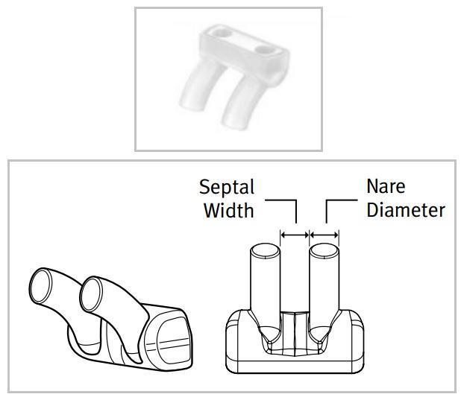⁽¹²⁾

Figure 1: Current CPAP interface

While the complete necrosis of the columella and the lower nasal septum is uncommon (anecdotally estimated as occurring once per unit every 2-3 years) it leads to significant cosmetic injury, which requires plastic surgery. A representative image of the damage that current systems can cause is available in the article by Carlisle. ⁽⁹⁾
Lesser degrees of nasal damage requiring “nasal rest” occurs much more commonly, with rates of up to 60% being reported. ⁽¹⁰⁾ Even minor degrees of nasal damage cause significant clinical issues such as infants requiring more intensive nursing care, a different (and less effective form of CPAP) or even re-intubation-which increases ventilation induced lung damage. ^{(2,5)}
(ii) Head Gear:

To prevent the crossbar from touching the columella, the nasal prongs are fixed to a hat using either safety pins, rubber bands or Velcro shown in figure 2.

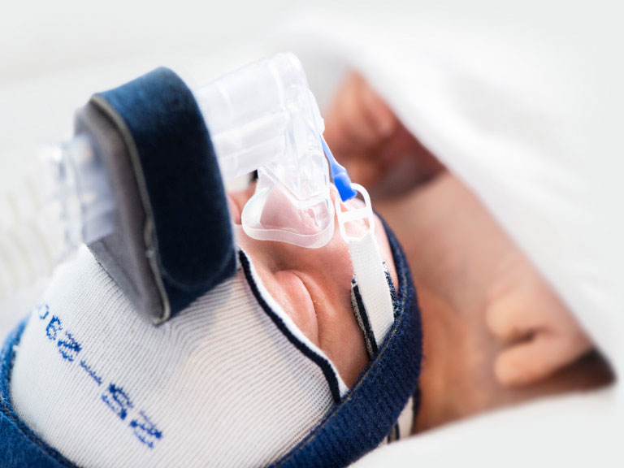
Figure 2: Current CPAP system attached to infant with head gear.⁽¹²⁾

These fixation systems have two main problems. The first is that to achieve good body and head alignment without allowing the prongs or tubing to cause pressure on the infant’s nose, head or face, they require constant nursing attention. The second main issue with the caps is that they can alter the shape of the head as a consequence of pressure on the mobile skull bones. Head shape generally returns to normal once the caps are removed and although the changes are probably not clinically significant, the abnormal shape of the infant’s head can be upsetting for parents.

Advantages with the Slider prongs:
The primary design advantage of the new prongs is the removal of the current inflexible prongs which is the source of pressure on a newborns’ nose. A secondary advantage is improved ease of nursing, as the new system does not require caps or similar fixation devices.
Potentially these changes have clinical advantages:
Reduction of the pressure necrosis of the columella, while this is an advantage on its own, it may also allow infants in which ventilation continues due to fear of columella damage to be extubated earlier.

Reduction in lesser degrees of nasal damage, allowing continued treatment with the most efficient form of CPAP. Thereby, hopefully, reducing chronic lung disease of the newborn and requiring fewer infants to be discharged home on oxygen.

Improved ease of nursing- leading to less handling of CPAP infants, better infant positioning, potentially improving long-term outcomes.

Improved infant access for the parents and better family centred care, as it will make babies easier to move from the incubator for cuddling and feeding.

Potential problems with the Slider prongs:
While pre-clinical testing has shown the prongs deliver CPAP pressure this study is the first time they have been trialled clinically on patients.
Potential problems with the Slider prongs could include issues with fixation to the infant and delivering less CPAP support than expected.STUDY OBJECTIVES

Primary objective
The primary objective of this study is to evaluate use of Slider prongs to deliver effective CPAP to preterm infants in infants requiring CPAP for respiratory distress.

Secondary objectives
The secondary objectives of this study are to determine the impact of the Slider prongs :
- Rates of nasal trauma with slider prongs
- Treatment failure within 72 hours of starting Slider prong CPAP
- Duration and pressures of CPAP required
- Duration of oxygen required
- Changes in respiratory rate / Heart rate / Apnoea and Bradycardia
- Blood gas values
- The length of hospital stay, growth rate, grade of intra-ventricular haemorrhage (IVH), confirmed sepsis, confirmed necrotising enterocolitis (NEC), grade of retinopathy of prematurity (ROP) and death (if any).
- STUDY DESIGN
  - Type of Study
This is a pilot observational study of a new form of CPAP delivery.
  - Number of participants
A total of 30 infants requiring CPAP will be included in the study. Participants will be >28 weeks gestational age.
  - Expected duration
The recruitment period for the study will begin after ethics approval and is expected to take approximately 6 months.
  - Primary and secondary outcome measures
As stated above
Treatment failure:
As this is the first use of Slider prongs on infants, particular care to ensure clinical stability of the infants. Clinical failure of the Slider prongs is based on the failure criteria of the HIPSTER trial (11)
- Sustained fraction of inspired oxygen (FiO2) requirement of 0.2 (20%) above baseline to maintain peripheral oxygen saturation (SpO2) within the units normal limits (86-94%)
- pH 7.20 or lower and pCO2 >60 mm Hg on free-flowing capillary or arterial blood gas sample, taken at least 1 hour after initiation of assigned treatment
- Six or more apnoeas requiring intervention (not self-resolving) within any 6-hour period, or 2 or more apnoeas requiring positive pressure ventilation within any 24-hour period
Treatment failure will also be adjudged to have occurred in any infant requiring urgent intubation and mechanical ventilation (at medical discretion)

- STUDY TREATMENTS

A new type of CPAP delivery device is the only study treatment. It will be offered to infants already receiving CPAP, for the period that CPAP is required.

5. ENROLMENT
The parent/s of eligible infants will be approached to enter the trial by the principal investigator (or associate investigator if principal investigator is clinically involved), if clinically stable on CPAP.
The information sheet will describe the purpose of the study, the procedures to be followed, and the risks and benefits of participation. The investigator will conduct the informed consent discussion and will check that information provided is understood and answer any questions about the study. Consent will be voluntary and free from coercion. A copy of the consent form will be given to the parents and also documented in the infant’s medical record.

5.1 Inclusion criteria
Any infant currently receiving CPAP at the Mercy Hospital for Women is eligible-provided informed consent is given.
  - Participant withdrawal
Parent/s are free to withdraw their infant from the study at any time. The reasons for withdrawal will be recorded (including no reason). Infants who discontinue treatment or are withdrawn from the study will not be replaced. Whenever possible, infants who withdraw from the study permission will be sought to obtain as much data for the follow-up period as the parent/s will permit.

6. STUDY ASSESSMENT AND PROCEDURES
  - At Enrolment
- Current CPAP requirements and clinical parameters (Heart rate, Respiratory rate, CO2, Work of breathing)
- Baseline neonatal clinical and demographic details including birth data, gestational age, birth weight, length and head circumference. Baseline maternal clinical and demographic details including age, type of delivery, antenatal steroids, reason for preterm birth.
  - Whilst on CPAP
- Nasal injury score (Attachment 1)
- Clinical parameters from medical records.
- Blood gas results

- ADVERSE EVENT REPORTING
An adverse event is any untoward medical occurrence in a patient enrolled into this study regardless of its causal relationship to study treatment.
  - Serious Adverse Event (SAE)
A SAE is defined as any adverse event that:
- results in death; or
- is immediately life threatening; or
- requires prolongation of existing hospitalisation; or
- results in persistent or significant disability/incapacity; or
- may jeopardise the infant and may require medical intervention to prevent the occurrence of one of the above listed outcomes.
Important medical events will be considered an SAE when, based upon appropriate medical judgement, they may jeopardize the patient and may require medical or surgical intervention to prevent one of the outcomes listed in this definition.
Serious adverse events that are life-threatening or result in death, should be notified immediately to the principal investigator. Any event that in the opinion of the Principal Investigator may be of immediate or potential concern for an infant’s health or well-being will also be reported as soon as possible (within 24 hours) to the Chair of the HREC.
Serious adverse events likely to be the result of the Slider prongs in the opinion of the principal investigator or the Chair of the HREC will result in the trial being closed immediately.
  - Australian Therapeutic Goods Association (TGA) notification
The Australian TGA requires notification of serious adverse events which are unexpected and deemed to be related to the study treatments. Fatal or life-threatening unexpected adverse events will be notified to the TGA as soon as possible but no later than 7 calendar days after first knowledge by the principal investigator that a case qualifies, followed by as complete a report as possible within 8 additional calendar days. Serious, unexpected adverse events that are not fatal or life-threatening, but deemed related to study treatment shall be filed as soon as possible but no later than 15 calendar days. Serious adverse events that are unrelated to the study treatments shall be included in the end of study report.
- STATISTICAL METHODS
  - Sample size estimation
This is a pilot study to assess the potential utility of new prongs.
A study of 30 infants means that obvious faults will be revealed, while allowing data to be gathered for further appropriately powered studies.
- DATA MANAGEMENT
  - Data collection
Source documents- Infant medical records will be accessed by principal investigator or nominee. Data will be transcribed onto study forms which will then be transferred onto a password protected computer for analysis.
  - Data storage
The study forms will be stored in a locked office in the dept of Paediatrics (MHW) Only research staff directly involved in the study will have access to the information. All electronic data will be on a password protected computer and will only contain de-identified data.
  - Study record retention
Original/copies of study documents will be retained in the dept of Paediatrics (MHW). Documents will be retained for at least 25 years after study completion in line with the data retention schedules for research involving minors. At the completion of this time documentation will be destroyed using confidential document disposal, by shredding with a commercial grade document shredder.
The study electronic data will be deleted at the same time.
.
- PUBLICATIONS POLICY
It is anticipated that the study will result in publication of conference abstracts, posters or presentations; seminars, and journal articles.
- REFERENCES
1.Gregory GA, Kitterman JA, Phibbs RH, Tooley WH, Hamilton WK. Treatment of the idiopathic respiratory distress syndrome with continuous positive airway pressure. N Engl J Med. 1971 Jun 17; 284(24): 1333-40.

2.Morley C. Continuous distending pressure. Arch Dis Child Fetal Neonatal Ed. 1999; 81:F152-156.

3.De Paoli AG, Morley CJ, Davis PG, Lau R, Hingeley E. In vitro comparison of nasal continuous positive airway pressure devices for neonates. Arch Dis Child Fetal Neonatal Ed. 2002 Jul; 87(1): F42-5.

4. Davis P, Davies M, Faber B.A randomised controlled trial of two methods of delivering nasal continuous positive airway pressure after extubation to infants weighing less than 1000 g: binasal (Hudson) versus single nasal prongs. Arch Dis Child Fetal Neonatal Ed. 2001 Sep; 85(2): F82-5.5.Avery ME, Tooley WH, Keller JB, Hurd SS, Bryan MH, Cotton RB, Epstein MF, Fitzhardinge PM, Hansen CB, Hansen TN, et al. Is chronic lung disease in low birth weight infants preventable? A survey of eight centers. Pediatrics. 1987 Jan; 79(1): 26-30.

6. Chow, S.S.W., Creighton, P., Chambers, G.M., Lui, K. 2020. Report of the Australian and New Zealand Neonatal Network 2018. Sydney:

7.Manley BJ, Owen L, Doyle LW, Davis PG. High-flow nasal cannulae and nasal continuous positive airway pressure use in non-tertiary special care nurseries in Australia and New Zealand. Journal of Paediatrics and Child Health.2012; 48:16-21.

8.Buckmaster AG, Arnolda G, Wright IM, Foster JP, Henderson-Smart DJ. Continuous positive airway pressure therapy for infants with respiratory distress in non-tertiary care centers: a randomized, controlled trial. Pediatrics. 2007 Sep; 120(3): 509-18.

9.Carlisle HR, Kamlin CO, Owen LS, Davis PG, Morley CJ. Oral continuous positive airway pressure (CPAP) following nasal injury in a preterm infant. Arch Dis Child Fetal Neonatal Ed. 2010 Mar; 95(2): F142-3.

10 Squires AJ, Hyndman M, Prevention of nasal injuries secondary to NCPAP application in the ELBW infant. Neonatal Netw. 2009;28(1): 13-27.

11 Roberts CT, Owen LS, Manley BJ, Froisland DH, Donath SM, Dalziel KM, Pritchard MA, Cartwright DW, Collins CL, Malhotra A, Davis PG. Nasla High Flow Therapy for Primary Respiratory Support In Preterm Infants. NEngl J Med 2016;375:1142-1151.

12. Fisher and Paykel manufacturers manual. Rx only [Internet]. 2021. Available from: www.fphcare.com/ip

Attachment 1. MHW CPAP damage scoring chart:

* The remarks here are based solely on the problems with short binasal prongs, as these are the predominant (and most effective) mode of delivering CPAP.

