, .

La dy R ea d i n g H ospital



Med i ca l Tea chi ng I nstitu tion

Eth i cal Revi ew Boa r d

Ref : N o.

*6(/ 6* /LR H/ MT\

Dated a*I I I;i,* /2020

Ch a i r ma n

D r. Reh an a Ra h i m

M em be rs TO W H OM IT MAY CON CERN

D r. Za h id aza r Or. aiid Pa rach a Dr . P>..n\\a Bas\t



Or.tt..bdu\ Q.a'/um



Dr. Naveed Haroon

This is to certif y th at Eth i ca l Ap p rova l h as bee n gra nted to D r.Kh awaja Kam ra n W aji d Ped i at r i cs (A) U n it MTl -Lady Read i ng H ospita l, Pesh awa r. for tit\ e "LEVETlRACETA M VERSUS PHENYTOI N FOR NEONATAL SEIZURES:

A RANDOM\ZED CONTROLLED TRIAL"

Dr. Shah Zeb

Dr. Muhammad Usman

Dr.Nosheen Noor Dr. Zaifa Gui

# Dr. Asmatull ah

Or. M. Maji Pa ra ch a Mem ber & ecreta ry E R B LR H/MTI, Pe hawa r

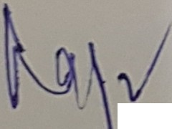

Dr. him

Chai rma n

ER B, LRH/MTI, Pesh awa r

