DIET IN CROHN’S DISEASE STUDY

Principal Investigator
Professor Simon Keely

Associate Investigators:
Doctor Kerith Duncanson
Doctor Emily Hoedt
Doctor Grace Burns
Doctor Michael Potter
Doctor Peter Pockney
Doctor Tom Goodsall
Cheenie Nieva

Sites:
University of Newcastle
John Hunter Hospital
Newcastle Endoscopy Centre

1. OVERVIEW

1.2 Crohn’s Disease
Crohn’s disease (CD) is a type of inflammatory bowel disease (IBD) characterised by chronic inflammation that can affect any part of the gastrointestinal tract, leading to a range of symptoms including abdominal pain, diarrhea, fatigue, reduced appetite, and weight loss (1) with negative impacts on quality of life and work productivity (2). In Australia, an estimated 80, 000 adults and children are living with IBD and this incidence is projected to rise (3). The burden associated with IBD is high, incurring approximately $2.7 billion in financial and economic costs annually (4). While the disorder is known to have a genetic predisposition, epidemiological studies have implicated several environmental factors in the pathogenesis of CD, and diet is considered as one of the major drivers of the disease (5).
Recent surveys have revealed that more than half of IBD patients believe that diet plays an important role in triggering relapse (6). However, despite strong patient interest in diet, the lack of knowledge among healthcare professionals and credible scientific evidence to support dietary recommendations has led patients to seek information from other sources including lay literature and the internet to address their unmet information needs, leading to self-imposed dietary restrictions with consequent adverse effects such as malnutrition and/or exacerbation of symptoms (7). A study found that over half of patients appear to modify their diet after diagnosis of IBD to ameliorate symptoms and prevent relapse (7). However, many proposed diets involve elimination of specific foods or food groups which may be very restrictive and difficult to follow. Popular diets include specific carbohydrate diet (SCD), anti-inflammatory diet (inflammatory bowel disease anti-inflammatory diet (IBD-AID)), paleolithic diet, gluten-free diet (GFD) and low fermentable oligosaccharide, disaccharide, monosaccharide, and polyol (FODMAP) diet (8).
The onset of CD has been strongly associated in observational studies with a ‘Western diet’ pattern, which is typically characterised by a high consumption of animal fats and protein and processed foods, with low intake of fibre from fruits and vegetables. Diets high in fruit and vegetables have been shown to be protective (9). Exclusive enteral nutrition (EEN) or elemental diet, where food whole food is eliminated, and all calories are obtained through a nutritionally complete liquid formula containing only amino acids (no intact protein), has been shown to be equally efficacious as corticosteroids in inducing clinical remission in paediatric patients. As such, EEN is globally considered as a first-line therapy for remission induction in children with CD (60-80%) (10). Although the efficacy of EEN for the induction of remission in adult populations with active CD is not well-established, the findings within paediatric patients suggests that protein antigens in food are linked to the pathogenesis of the disease (11).
A study in which adult patients with active CD had remission induced with an elemental diet, demonstrated that the subsequent use of an exclusion diet based on symptoms (foods re-introduced sequentially and eliminated if caused symptoms) was more effective than corticosteroids, at maintaining remission, with 62% relapsing by 24 months in the dietary arm, compared with 79% in the corticosteroid group (12). The causal foods identified included most commonly cereals (wheat), dairy products and yeast. More recently, an exclusion diet in conjunction with partial enteral nutrition (PEN), eliminating gluten, as well as other proinflammatory foods such as animal fats, sulphites, and emulsifiers, was shown to induce remission in 62% of CD patients in a cohort study of 21 adults and children refractory to biologic therapy with anti-tumour necrosis factor (anti-TNF) agents (13). Levine et al. (14) also reported that when the Crohn’s disease exclusion diet (CDED), which limits or eliminates gluten, dairy products, animal fat, processed meats and products containing emulsifiers, was used in combination with PEN, was effective in inducing remission in children with mild to moderate CD. CDED, when combined with PEN, induced sustained remission in significantly higher proportion of patients than EEN treatment alone and produced changes associated with remission in the faecal microbiome (14). However, EEN is not routinely utilised as a primary therapy in adults outside of Japanese populations (15), and the discrepancies observed regarding the efficacy of this intervention between paediatric and adult populations can be attributed to low tolerability and poor compliance due to unpalatable formula (16).

1.2 Foods likely to trigger relapse in Crohn’s disease
The increasing incidence of CD in previously low-incidence parts of the world, such as Asia and South America (17,18), is paralleled by the Westernisation of dietary habits. Numerous epidemiological and animal studies have demonstrated that changes in diet can induce intestinal inflammation and alterations in the gut microbial composition (19), however, human-based studies are still lacking. Of the Western diet, animal fats, emulsifiers, and wheat (FEW) have been identified as the three major food components that are associated with disease flares in CD, however, despite reaching consensus, the levels of evidence surrounding patient dietary guidance for CD is low and novel approaches are needed (20).

1.3 Animal Fats
Several epidemiological studies have found strong associations between consumption of animal fats, which is a significant component of a Western diet, and the development of CD (9,21). Consumption of a higher ratio of n-3: n-6 polyunsaturated fatty acids (PUFAs), and diets that are higher in total fats, saturated fats, and monounsaturated fatty acids (MUFAs) has been associated with disease relapses in patients with CD (22-24). Mice with ileitis or colitis (induced by genetic manipulation or exposure to chemicals) fed a high-fat diet (HFD) were found to have increased small intestinal or colonic inflammation and barrier dysfunction (25-29). Furthermore, direct supplementation of γ-linolenic and docosahexaenoic acid (DHA) fatty acids, abundantly found in Western-style diets, to differentiated human colon adenocarcinoma cell line (Caco2) monolayers (well-established enterocyte model), enhanced intestinal permeability through stimulation of intracellular signalling pathways (30,31).

1.4 Emulsifiers
The use of food additives, particularly emulsifiers, in processed foods which goes hand-in-hand with Western diet have strong preliminary evidence as causal factors or contributors to the inflammatory state in CD (9). Emulsifiers are widely used to improve texture and extend shelf-life of processed foods, but epidemiological studies show a strong and significant positive correlation between emulsifier consumption/sales with CD incidence (32). It is hypothesised that these detergent-like emulsifying molecules disrupt the multi-layered mucus structures that cover the intestinal surface, thereby disrupting mucus-bacterial interactions that promote diseases associated with gut inflammation. This hypothesis is supported by the results of a study in which low concentrations of two commonly used emulsifiers, carboxymethylcellulose (CMC) and polysorbate-80 (P80), induced low-grade or mild intestinal inflammation and obesity/metabolic syndrome in wild-type hosts and promoted robust colitis in mice predisposed to IBD (33).

1.5 Wheat
Gluten, a component of wheat, have been linked to symptoms in IBD. Aziz et al. (34) performed a cross-sectional study of patients with IBD and compared them to patients with irritable bowel syndrome (IBS) and dyspeptic controls. They reported a prevalence of self-reported wheat sensitivity in the IBD cohort of 27.6%, lower than those with IBS (42.4%) but higher than in dyspeptic controls (17.4%). (p = 0.015). The prevalence was similar for UC, the other major type of IBD, and CD (p = 0.63). Subgroup analysis of the CD cohort revealed that patients with wheat sensitivity were more likely to have structuring (40.9% versus 18.9%, p = 0.046) and more severe disease (CDAI 228.1 versus 133.3, p = 0.002). They also reported that in the clinical work up of patients presenting with self-reported wheat sensitivity, 1.5% were subsequently found to have IBD. These observations are supported by a cross-sectional online questionnaire study of 1647 patients with IBD by Herfarth et al. (35), in which 19% reported previously trying a gluten-free diet, and 8% reporting current adherence to a gluten-free diet for their chronic gastrointestinal symptoms. Of those who attempted a gluten-free diet, 66% reported an improvement in symptoms and 38% report a decrease in flares.

Despite findings suggesting that diet plays a fundamental role in driving symptoms, there is a lack of credible evidence linking laboratory studies to dietary interventions to support dietary modification or restrictions to prevent relapse in CD. A recent systematic review and meta-analysis concluded that the benefits of dietary interventions for the induction and maintenance of remission in IBD remains unclear as the designs of the studies are often flawed, heterogenous and inadequately powered (10). Personalised approaches to food exclusion in IBD are being explored. A novel dietary treatment approach for CD that has reported symptom improvement in an open-label study is an IgG4-guided in which participants with CD had IgG4 titers tested against 16 common food types using enzyme-linked immunosorbent assay (ELISA) (36). The intervention group then excluded the foods with the top four antibody titers (milk, pork, beef, and egg) and the control group excluded the four foods with lowest antibody titers (rice, chicken, tomato, and potato).
The aim of this study is to evaluate whether exclusion of a number of culprit foods (animal fat, emulsifiers, and wheat) from the diet of patients with CD improves their disease course, both in terms of symptom improvement as well as inflammatory activity. This proof-of-concept study, where dietary treatment will be used as an adjunct to standard care, with the hypothesis being that FEW food exclusion will reduce the number of flares and increase the duration of remission and response with usual treatment.

1.6 Funding
This project was initiated by HMRI donors who have a family history of Crohn’s disease and are interested in supporting research to progress the understanding of the role of environmental factors such as diet in Crohn’s disease.

2. HYPOTHESIS AND AIMS

2.1 HYPOTHESIS
Dietary exclusion of specific fats, emulsifiers, and wheat (FEW)-containing foods will reduce the number of flares and increase the duration of remission and response with usual treatment in a cohort of CD patients.

2.2 AIMS
Our hypothesis will be addressed through three specific aims:
- To examine whether CD patients exhibit antibodies or immune cell responses against specific FEW food components that may be predictive of dietary response to exclusion.

- To assess dietary exclusion of FEW foods as an adjunct therapeutic approach to maintain remission in CD using a randomised controlled dietary crossover trial.

- To identify lifestyle and microbiome signatures that may contribute to specific food responsiveness in FEW-responsive patients.

3. PRELIMINARY DATA
We have demonstrated in a large population-based survey in the local Hunter region that patients with IBD self-associated gluten or wheat ingestion with adverse gastrointestinal symptoms. A total of 3542 people randomly selected from the Australian population returned a mail survey (Digestive Health & Wellbeing Survey, response rate = 43%) which contained questions on gastrointestinal (GI) symptoms (presented in the last 3 month), medical and lifestyle factors including a self-reported physician diagnosis of coeliac disease and IBD as previously described. Response bias was minimal. Wheat sensitivity was defined as people without coeliac disease who reported GI symptoms on wheat ingestion. Associations between categorical variables were evaluated using the Pearson chi-square test.
The prevalence of IBD by self-report in our cohort was 2.0% (n = 69, Crohn’s disease = 21, 50% male, mean age 60.3 years). Of those with IBD, 26% reported wheat sensitivity, compared with only 15.5% of the unaffected cohort (OR 1.9, 95% CI 1.1-3.4) There was no significant association between wheat sensitivity in IBD and age (p = 0.28), gender (p = 0.43) or psychological distress (p = 0.11). Symptoms significantly associated with wheat sensitivity in the IBD cohort included epigastric pain, post prandial fullness, and constipation.

4. RESEARCH PLAN
This study will be conducted in three phases corresponding with three different studies.
Study 1: Cross-sectional Study
Study 2: Dietary Trial
Study 3: Microbiome Analysis

5. PARTICIPANTS

5.1 STUDY 1 – Cross-sectional Study
We will access retrospectively collected samples/data (see section 6) of 150 CD patients and 20 age and sex-matched controls from the Digestive Health Biobank (DHB) 2020/ETH01635 (for recruitment) and 2020/ETH03303 (for analysis of samples), who have already consented to their samples/data being used for research purposes.
CD inclusion criteria:
- Adults aged 18 to 50 years
- Males and females
- Crohn’s disease; a new diagnosis (within the last 2 years) of mild to moderate ileal or ileo-colonic disease (Crohn’s Disease Activity Index (CDAI) 150 – 450) and faecal calprotectin (FC)

CD exclusion criteria:
- Pregnancy
- Post-resection surgery
- Smokers
- BMI greater than or equal to 30
- Other autoimmune or atopic conditions
- Other dietary restrictions or modifications that would prevent individual from completing dietary intervention (e.g., coeliac disease)
- Unable to complete the study participation requirements

Healthy control inclusion criteria:
- Adults aged 18 to 50 years
- Males and females
- Presented for investigation of iron deficiency with normal results

Healthy control exclusion criteria:
- BMI greater than or equal to 30
- Diagnosis of GI disease, inflammatory or autoimmune disease, cancer, or metabolic syndrome
- Smokers
- Pregnancy

5.2 STUDY 2 – Dietary Trial
We will aim to recruit 100 patients with CD, meeting the inclusion criteria above, to the dietary trial phase of this study. The majority of participants will be people who have previously donated samples to the DHB and agreed to be contacted for future research projects. Also treating gastroenterologists who see patients at clinic appointment that may be suitable for this study will mention the study and advise the research assistant (RA) if the patient is interested so they can follow up. The RA will contact the potential participant to provide a participant information sheet (PIS) (Attachment A) and explain the study. If participants are interested, they will be provided with a consent form (CF) (Attachment B). Potential participants will be reassured that their decision whether to participate in this research will not influence their current or future treatment.

5.3 STUDY 3 – Microbiome Analysis
Retrospectively collected samples from CD patients and controls, sourced from the DHB (see section 6), will again be used in Study 3. Study 3 will also utilise samples collected during the dietary trial in Study 2.

6. AVAILABLE SAMPLES

The following information and samples for CD and control patients will already be available from the DHB (2020/ETH01635 and 2020/ETH03303) for use in Study 1:
- Demographic and medical information (from a medical interview including a detailed medical history (to include allergies) and other pathologies, medication usage (e.g., UBD biologics), surgical history, family medical history and demographics)

- Gastrointestinal symptoms (from the validated Digestive Health and Wellbeing Survey (DHWS) which assesses gastrointestinal symptoms, anxiety and depression, sleep, smoking and alcohol intake)

- Dietary history (from food frequency questionnaires (FFQ) or 24-hour food recalls)

- Stool samples

- Endoscopic samples
8 biopsy samples from the terminal ileum to the rectosigmoid tract:
- 3 x processed by collagenase digestion to liberate immune cells for in vitro stimulation with specific FEW food components and for local immune cell phenotyping by flow cytometry
- 1 x collected in formalin and processed for histopathological staining and immunohistochemistry (IHC)
- 1 x snap frozen into RNAlater for analysis of specific gene expression
- 1 x collected for quantitative protein analysis

- Blood samples (42 mL)

- Peripheral blood mononuclear cells (PBMCs) isolated for in vitro stimulation with specific FEW food components and for peripheral immune cell phenotyping by flow cytometry.
- Serum and plasma will be analysed for circulating antibody levels and antibody reactivity towards specific FEW food components.
- Whole blood gene expression will be assessed for differences in expression of inflammatory mediators.

7. STUDY 1 – Cross-sectional
We will fully characterise the systemic and gastrointestinal immunological profiles of the CD patients and healthy controls using a combination of flow cytometry, cell culture, histology, immunohistochemistry, microbiota profiling, protein, and gene expression analyses. All experimental techniques proposed are established in our laboratories.
Retrospectively collected samples/data of 150 CD patients and 20 age and sex-matched controls from the DHB (2020/ETH01635 and 2020/ETH03303) will be used in this aim, as outlined in the section 5 above.

7.1 STUDY 1 METHODS
STUDY 1: To examine whether CD patient blood and intestinal biopsies exhibit antibodies or immune cell responses against specific FEW foods that may be predictive of dietary response to exclusion.
STUDY 1.1: To identify whether CD patients’ blood samples exhibit immune responses against specific FEW food components.
Given that CD is an immune-driven disorder, we will independently assess immune phenotypes of the participants to examine whether dietary triggers can be independently predicted in our cohorts. To examine if these group of patients exhibit systemic immune responses against specific FEW food components, blood samples will be analysed using various techniques including flow cytometry, cell stimulation assays and seroreactivity analyses. Blood samples collected from patients were processed by density gradient centrifugation to isolate peripheral mononuclear cells (PBMCs), plasma and serum.
Blood response
- Flow cytometry
PBMCs will be used to examine different cell populations and characterise each patient’s immune cell profile. Unstimulated samples will be used to characterise the general PBMC populations of our groups which will provide a broad overview of T cells, monocytes, natural killer (NK) cells, eosinophils, basophils, and other immune cells. Given that responses to food antigens are driven by adaptive processes to produce antibodies, deep T cell phenotyping will be used on FEW-stimulated and non-stimulated cells to specifically characterise T cells.

- Cell stimulation assay
PBMCs will be resuspended in complete medium (RPMI-1640 media supplemented with foetal calf serum, HEPES, sodium pyruvate, penicillin, streptomycin, and L-Glutamine) and cultured in 24 well-plates (either stimulated or non-stimulated with different FEW food components) for 24 h at 37ºC in a humidified 5% CO₂ atmosphere. Timepoint collection of cultured cells and cultured supernatants will be carried out for (a) detection of cell lineage by flow cytometry; (b) analysis of cytokines/inflammatory mediators by ELISA or cytometric bead array (CBA); and (c) detection of cell lineage-specific gene expression by real time quantitative polymerase chain reaction (qPCR).

- Seroreactivity assay
Patient plasma will be screened for specific immunoglobulins (IgG, IgE, IgA, IgM and IgD subtypes) against FEW food components to assess whether patients exhibit immune responses against specific wheat protein components. Various protein components of wheat (e.g., gluten, gliadin, amalyse trypsin inhibitors (ATIs) etc.), will be separated by gel electrophoresis. Proteins on the gel will be transferred onto a nitrocellulose membrane (blot) and blocked before incubating with patient plasma or serum. The blots will be probed with horseradish peroxidase (HRP)-conjugated anti-human secondary antibodies (IgG, IgE, IgA, IgM and IgD) and proteins on the blot are visualised using a ChemiDoc Imaging System. The presence of patient antibodies bound to specific wheat proteins will be identified, indicative of a systemic response against these wheat constituents.
See Section 10 for Analysis.

STUDY 1.2: To identify whether CD patients’ intestinal mucosa samples exhibit immune responses against specific FEW food components.
To determine whether these groups of CD patients display a local immune response to FEW food components, various techniques will be used including haematoxylin and eosin (H&E) staining, IHC, flow cytometry and cell stimulation assays. Lamina propria mononuclear cells (LPMCs) were isolated from intestinal biopsies by collagenase and DNase II digestion.
Mucosal response
- Histology and IHC
Intestinal biopsies will be formalin fixed and paraffin embedded prior to sectioning and H&E staining to evaluate cell localisation, tissue architecture and histological changes. IHC staining will also be performed for specific targets/markers and immune cells implicated in the immune response of the patients to FEW foods.

- Flow Cytometry
LPMCs will be used to examine different cell populations and characterise each patient’s T cell profiles to characterise the phenotype of the T cell populations involved in the response to FEW components.

- Cell stimulation assay
LPMCs are resuspended in complete medium (RPMI-1640 media supplemented with foetal calf serum, penicillin, streptomycin, and L-Glutamine) and cultured in 24 well-plates (either stimulated or non-stimulated with different FEW food components) for 24 h at 37ºC in a humidified 5% CO₂ atmosphere. Timepoint collection of cultured cells and cultured supernatants will carried out for (a) detection of cell lineage by flow cytometry; (b) analysis of cytokines/inflammatory mediators by ELISA or CBA; and (c) detection of cell lineage-specific gene expression by qPCR.

STUDY 1.3: To understand immune responses against FEW foods in CD patients at a protein and gene level.
To gain an understanding of the immune responses of CD patients against specific FEW food components (as observed from our immunoassays) at the gene and protein level, we will employ techniques such as qPCR and western blot, respectively. We will assess differences in protein and gene expression in these patients and controls, as well as validate our findings from Studies 1.1 and 1.2.
- qPCR
To characterise immune response genes differentially expressed in our cohort of CD patients, RNA will be extracted from biopsy using the Maxwell (Promega Corporation, Australia), an automated nucleic acid purification platform, to be reverse transcribed into complementary DNA (cDNA). Nutritional modulation of gene expression (e.g., NOS3 and DEFB1) will be determined by qPCR.

- Western blot
Protein expression will be determined using western blotting. PBMCs or LPMCs will be enzymatically lysed to release proteins from the cells. Proteins will be separated using gel electrophoresis and then transferred onto a nitrocellulose membrane. Membranes will be incubated in blocking buffer and then probed with primary antibodies against our proteins of interest. The blots will be incubated in HRP-conjugated secondary antibodies and protein bands are detected and visualised using a ChemiDoc Imaging System.

7.2 STUDY 1 ANALYSIS AND PUBLICATION
The data from studies 1.1, 1.2 and 1.3 will be compared with data from studies 2 and 3 once study 2 is unblinded. See Section 10 of protocol for details of analysis. The methods and findings from this study are both novel, with the majority of literature published on this topic relating to animal or epidemiological studies in humans. We plan to submit a methodology and an outcomes manuscript for publication.

8. STUDY 2 - Dietary Trial
Participants identified from the DHB who meet the inclusion criteria as outlined in section 5.2 above will be invited to enter the dietary trial component of the study. We will evaluate, in a proof-of-concept trial, whether exclusion of FEW-containing foods which are commonly reported as triggers in CD is efficacious in maintaining remission in patients. The study design will be a randomised controlled trial of the FEW foods exclusion diet compared to standard IBD dietary management. The primary outcome for this study is the maintenance of remission (time to flare in days). An overview of this process is shown in Figure 1 and Table 1 below.
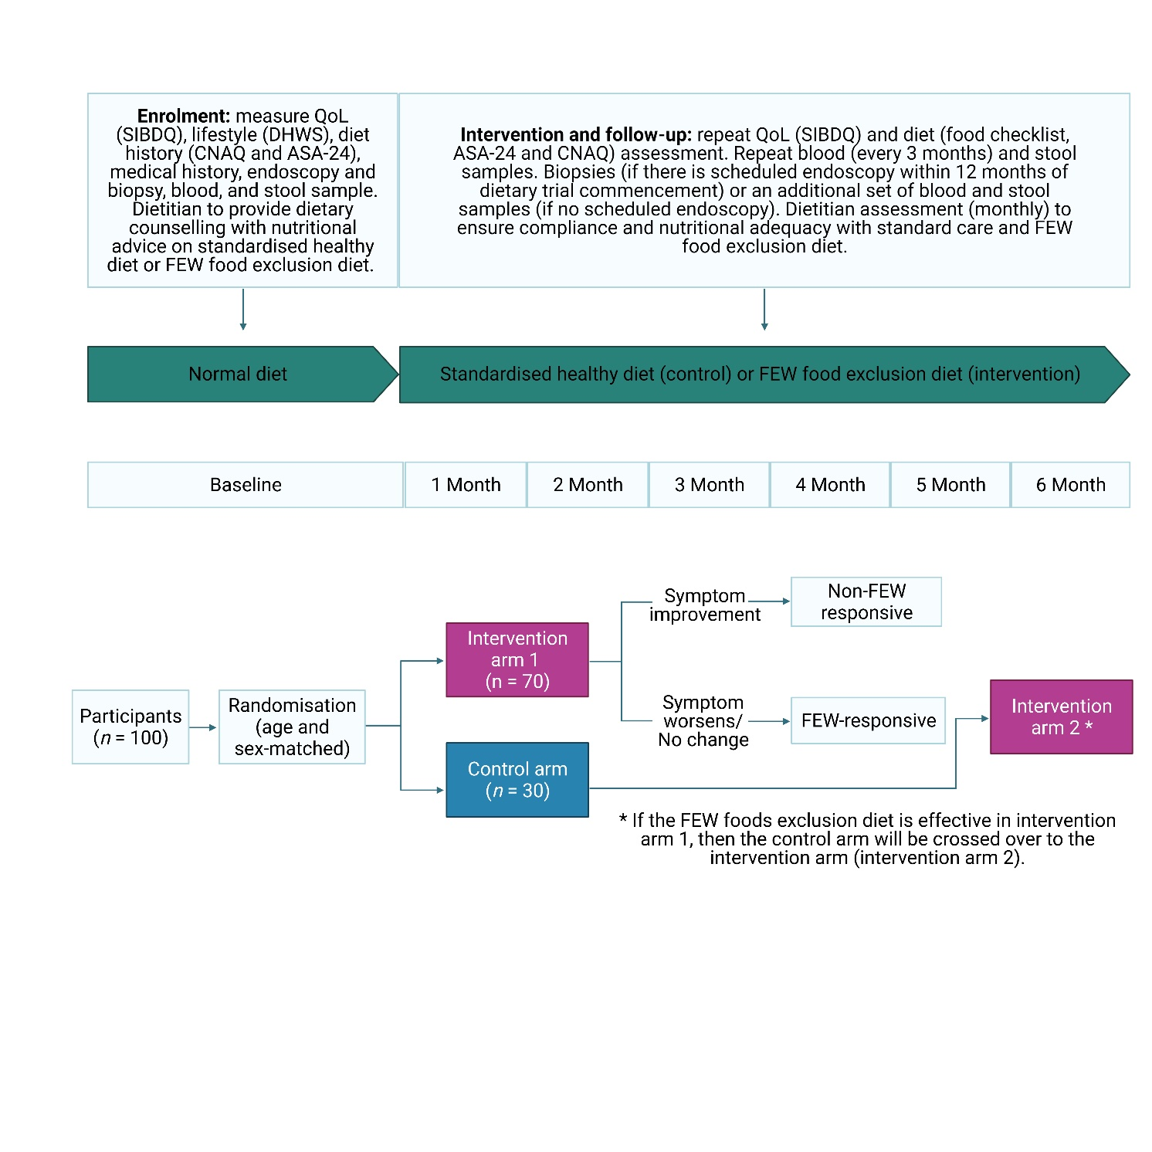
Figure 3. Summary and flow diagram of the FEW foods exclusion dietary trial.

Table 1. Time and events schedule of the FEW foods exclusion dietary trial.
Assessment | How long it should take me? | 0 | Month
 |  |  | 1 | 2 | 3 | 4 | 5 | 6 | 12
Initial appointment | 1 hour
Food frequency questionnaire (CNAQ) | 20 minutes
Daily food checklist | 5 minutes per day, totalling 2.5 hours per month
Weekly 24-hour food recall (ASA-24) | 15 minutes per week, totalling 1 hour per month
Monthly SIBDQ | 5 minutes per month
Monthly  dietitian appointment | 30 minutes
What samples will I be asked to provide? | How long will it take?
Biopsies * | 15 minutes
Blood | 30 minutes
Stool | 10 minutes
Total monthly time commitment |  | 2.5  hours | 4.25  hours | 4.25 hours | 5 hours | 4.25 hours | 4.25 hours | 5  hours | <1  hour
* If the participant is scheduled for a routine endoscopy within 12 months following dietary trial commencement, up to 8 additional tissue biopsies will requested.

8.1 STUDY 2 METHODS
STUDY 2: To assess dietary exclusion of FEW as an adjunct therapeutic approach to maintain remission in CD using a randomised controlled dietary crossover trial.
STUDY 2.1: To assess, in a controlled randomised trial, the dietary exclusion of FEW as an adjunct therapeutic approach to maintain remission in CD patients.
Intervention
The study design is a randomised controlled dietary crossover trial in which participants will be partially blinded to diet for 6 months. Participants (n = 100) will be randomly allocated to either the standard care control arm (n = 30) or the intervention arm (n = 70). The control arm will receive a standardised healthy diet consistent with the Nutrition Education Materials Online (NEMO) IBD guidelines (Attachment C) whereas the intervention arm will be prescribed a diet that excludes FEW-containing foods (Attachment D).

Randomisation
Study participants will be randomised into age (5 or 10-year age bracket) and sex-matched standard care control and intervention arms. Randomisation will be stratified to address the need to control for covariates. This method will be used to achieve balance among groups in terms of participants’ baseline characteristics. Specific covariates that may influence study outcomes include medication regime, time since diagnosis, disease severity. A separate block will be created for each combination of covariates, and participants will be assigned to the appropriate block of covariates. After all participants have been assigned into blocks, simple computer-generated randomisation will be performed within each block.

Blinding
- Participant – partially blinded (whether their diet is standard care or FEW food exclusion)
- Intervention administrator (dietitian) – blinded to lab results but not intervention allocation
- Research assistant – blinded to lab results, unblinded to intervention allocation
- Laboratory staff – blinded to intervention allocation but not lab results
- Data analyst – blinded to lab results and intervention allocation
Follow-up
Nutritional assessment and dietary management are important for all people with IBD. As most individuals with IBD already follow a restricted diet or monitor their diet to a similar extent, this study does not present considerable additional participant burden in this regard. The NEMO guide will be provided to the standard care participants at the first dietetics consult and then referred to throughout the follow-up. The intervention group participants will also be provided with an equivalent resource (FEW-diet information sheet), the only difference will be that the intervention arm will receive additional instructions around the FEW-exclusion diet. Both standard care and intervention arm participants will be provided with dietary advice (as per group allocation) and specific instructions, personalised instructions based on food preferences and to alleviate symptoms or to meet caloric and micronutrient requirements.
All participants will receive a monthly face-to-face or telehealth visit from a dietitian with experience in IBD management, at a time that suits the participants, to check on their progress and ensure compliance. A dietitian consultation also routinely includes assessment of nutritional adequacy as per the Nutrition Care Processes guidelines followed by an Accredited Practising Dietitian.

Questionnaires
Participants will complete the following checklist and questionnaires throughout the duration of the dietary study:
- Daily food checklist (5 minutes) – a daily FEW or NEMO diet checklist (as per group allocation) using a phone application to monitor adherence and ensure regular diet (Attachment E).

- Automated Self-Administered 24-hour (ASA-24) (15 minutes) – a once-weekly 24-hour food recall which takes 15-20 minutes to complete on first administration and 10-15 minutes on subsequent occasions when the participant is familiar with the content. The day of the 24-hour recall will be randomised each week to capture maximum diet diversity, and the participant will receive a text message or email as a reminder to complete the recall. For participants who would prefer, a researcher administered version of the ASA-24 is available and will be conducted by a trained research assistant or dietitian using standard methods (Attachment F).

- Short Inflammatory Bowel Disease Questionnaire (SIBDQ) (5 minutes) – administered monthly during their monthly dietitian visits. This 10-item shortened version of the IBDQ (32-items) has been validated for use in CD patients to assess Health-Related Quality of Life (HRQoL) as measured in bowel symptoms, emotional and social domains (61) (Attachment G).

- Comprehensive Nutrition Assessment Questionnaire (CNAQ) (20 minutes) – a food frequency questionnaire to assess diet will be administered at baseline, at 3 months, and at 6 months (Attachment H).
For people without reliable access to a device with an internet connection, we will provide printed hard copies of the questionnaires which will be kept in the same format as the online version for the participants to complete.

Sample collection
The following information and samples will be collected after the dietary trial commences:
- Blood samples (42 mL at each timepoint)
Participants will be requested to provide blood samples at the 3-month, 6-month, and 12-month timepoints of the dietary trial. Blood draws will be separate from clinic appointments and will be conducted at HMRI, where parking can be arranged for participants at no cost, and times can be scheduled to suit the participant. Early morning and late afternoon appointments will be possible to accommodate fulltime workers. Blood will be collected by a staff trained in venepuncture and a total of 42mL of blood will be collected per scheduled visit.

Bloods will be used to assess the patients’ immune responses to specific food components from the FEW food groups, using the same methods outlined in Section 7.1, at each timepoint. Blood will be collected in five 6 mL lithium heparin tubes and then processed to isolate PBMCs and plasma. PBMCs will be used for in vitro stimulation with specific FEW food components and for peripheral immune cell phenotyping by flow cytometry. Blood will also be collected in one 4 mL serum-separating tube (SST) tube to isolate serum and one 6 mL EDTA tube for DNA/RNA extraction and plasma. Patient plasma and serum will be screened for circulating antibody levels (IgG, IgE, IgA, IgM and IgD subtypes) and antibody reactivity against specific FEW food components using seroreactivity assays. Whole blood gene expression will be assessed for differences in expression of inflammatory mediators.

- Stool samples
Participants will be requested to provide a very small sample of stool every month (at home at their convenience) for 6 months and one final sample at the 12-month timepoint. The participant will collect stool swab using a Microba faecal collection kit with possible second sample collected using a separate collection kit to measure faecal calprotectin. The kit/s will be returned to HMRI for collection by research staff; or returned in a pre-paid mail envelope (will be provided) if a HMRI visit is not scheduled. The faecal collection tubes take a microbial snapshot of a sample while inactivating viruses making samples safe and ready for transport. Samples stored in faecal collection tubes are stable at ambient temperature, can be used to measure faecal calprotectin and can be frozen for longer-term storage.

The kits will be sent for sequencing and laboratory analysis of microbial profile (see Study 3) and the other stool sample will be utilised to detect and monitor disease activity and risk of relapse in patients undergoing the dietary trial using FC testing. FC testing is a non-invasive, clinically employed tool for assessing intestinal inflammation in IBD patients (62). Calprotectin extracted from stool can be detected easily using standard ELISA. Monthly FC test results will be compared to baseline and each subsequent FC test results throughout the dietary trial as a way to monitor each patients’ intestinal inflammatory activity or risk of relapse.

- Endoscopic samples
Opportunistic biopsy samples will be requested if the participant is scheduled for routine endoscopy within the study timeframe (within 12 months following commencement of the dietary trial). Using exactly the same methods as used for CD patients in DHB, up to 8 biopsies from the ileo-colonic region of the digestive tract will be taken during endoscopy. Biopsies will be used to assess mucosal responses to specific food components from the FEW food groups using the same methods as Section 7.1. Where there is active inflammation, 6 biopsies will be taken from inflamed tissue and 2 biopsies from adjacent healthy tissue from each subject (Figure 2). Of these, 3 inflamed tissue biopsies will be processed by collagenase and DNase II digestion to liberate lamina propria mononuclear cells (LPMCs) for flow cytometry and cell stimulation assays. One inflamed tissue biopsy will be collected in formalin and processed for routine histopathology staining and immunohistochemistry (IHC). The remaining inflamed tissue biopsies and matched healthy adjacent tissues will be stored in RNAlater and processed for RNA/Protein (1 x) and microbiome analysis (1 x).
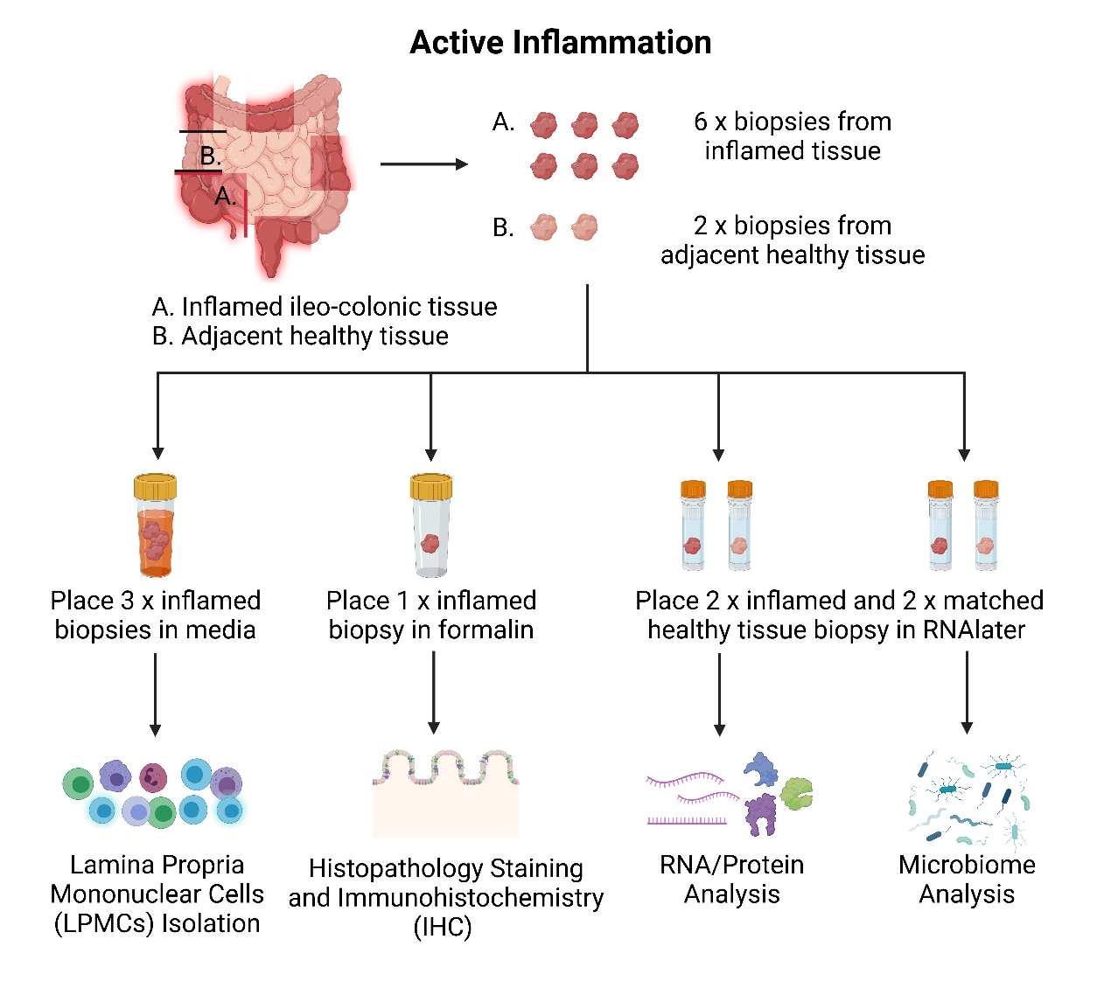

Figure 2. Biopsy collection flowchart if there is active inflammation.
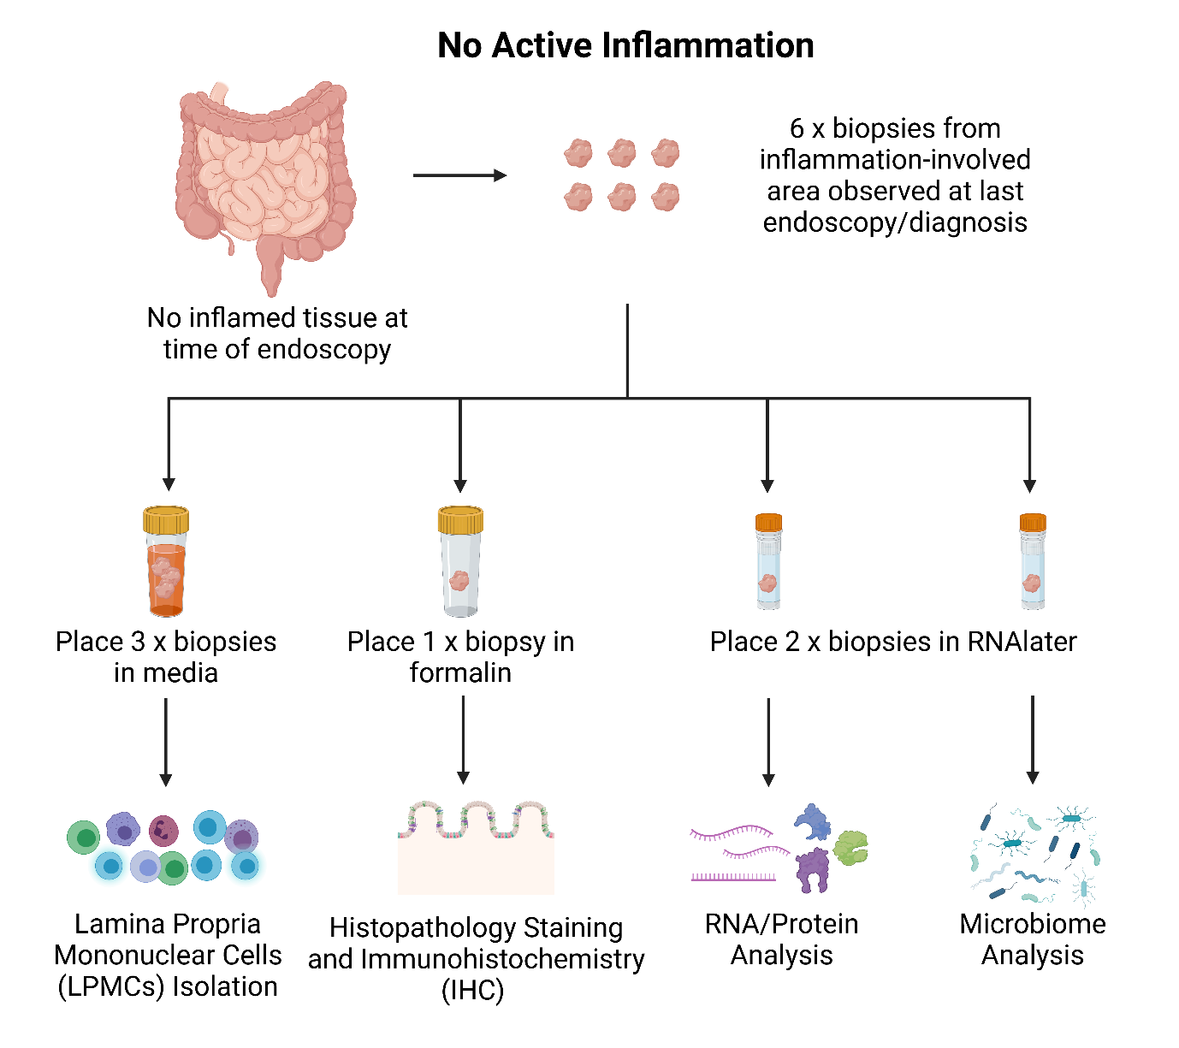
If there is no inflamed tissue at the time of endoscopy, 6 biopsies will be taken from the inflammation-involved area observed at last endoscopy/diagnosis. Of these, 3 biopsies will be processed for LPMCs, 1 biopsy will be processed for each of histopathology, RNA/Protein analysis and microbiome analysis (Figure 3).
Figure 3. Biopsy collection flowchart if there is no active inflammation.

Criteria for research suspension/cessation:
The research will be discontinued or suspended if adverse effects of unexpected type, severity or frequency are encountered during the dietary trial (i.e., if the participants in the intervention group (FEW diet) experience more flares) or if there is evidence that the continuation of the trial would disadvantage some of the participants.
Interim analysis will be conducted each month following the dietitian consultation with the participant to determine relative number of flares in standard care control and intervention groups. If a statistically significant number of flares are reported in the intervention group compared to control for two consecutive months or if FC results demonstrate an elevated calprotectin level indicating the presence of high-level intestinal inflammation, the trial will be suspended. It is highly unlikely that these diets could worsen any symptoms and are more likely going to improve patients quality of life especially since they are having regular meetings with a dietitian to help maintain a healthy diet.

STUDY 2.2: To confirm CD patients’ response to FEW foods in a crossover dietary trial.
Confirmation of FEW food response:
The initial 6-month dietary trial will assess whether 1) dietary reduction of FEW-containing foods are likely to provide better outcomes for CD patients, both in terms of symptom improvement as well as inflammatory activity (as measured by our immunoassays, questionnaires, and faecal calprotectin tests) than standard dietetics counselling; and 2) whether laboratory assays can predict outcomes by assessing immune responses to FEW food antigens. If Study 2.1 results in longer mean remission duration (longer time to flare) or significant improvement in symptoms scores, participants in the control arm will be crossed over to the FEW diets as per the intervention arm. The intervention cohort will be asked to maintain their diet for an additional six months (see Figure 1) but will focus on excluding food antigens identified for each individual patient (from Study 1 laboratory stimulation) to assess whether specific food triggers have been identified. At the conclusion of the additional six-month period (12-month timepoint), participants will be requested to provide a final sample of blood (42 mL) and stool. Opportunistic post-study biopsy sampling will be conducted if clinically indicated, as outlined in Section 2.1. If this is not indicated, blood samples will be used as a proxy measure. Whilst investigation of the localised immune response through immune cell isolation from biopsies (LPMCs) is preferable to generate clinically relevant results, the peripheral immune response can instead be investigated through isolation of immune cells from blood (PBMCs). These PBMCs can be phenotyped by flow cytometry and used in stimulation assays as an alternative to LPMCs and compared to baseline peripheral responses. See Section 10 for Analysis.
We anticipate that the FEW foods exclusion diet will reduce the number of flares and increase the duration of maintaining remission in our intervention cohort. Diet analysis from 24-hour recalls and FFQ will be analysed (nutrients and FEW food components) using existing methods of the study team for associations with CD symptom and clinical outcomes (flares and FC levels) to measure primary study outcome. Dietary responsiveness in Study 2 will be correlated with data from Study 1 and Study 3 (see below) to examine whether these immunoassays can independently predict food triggers and dietary response.

9. STUDY 3 – Microbiome Analysis
We will compare the microbiome in intestinal biopsies and stool samples from CD patients in STUDY 2 standard care control and intervention groups as well as healthy controls to study the relationship between the diversity of microbiome, lifestyle, and dietary composition. Baseline samples for this analysis will be accessed from the DHB as described in section 6.

9.1 STUDY 3 METHODS
STUDY 3: To identify lifestyle and microbiome signatures that may contribute to specific food responsiveness in FEW-responsive patients.
Metagenomic shotgun sequencing (MGS) will be used to characterise the microbial profile from stool and biopsies. Detailed lifestyle information will be obtained from patients using the Digestive Health and Wellbeing Surveys used by the University of Newcastle Centre for Research Excellence (CRE) Digestive Health Biobank. Statistical analysis will assess correlations between lifestyle factors, microbiome profiles, immune response (Study 1) and dietary response (Study 2), to determine whether aetiological factors can be identified.
- Metagenomic shotgun sequencing
Microbial DNA will be extracted from patient stool and biopsy through a combination of bead-beating homogenisation and Maxwell (Promega) automated nucleic purification system, this will ensure adequate lysis of the microbial community and standardised DNA recovery for all samples. MGS will be performed out of house with either Australian Centre of Ecogenomics (ACE) or Microba. Short/long read metagenomic sequencing will be completed on either the Illumina NovoSeq6000 or Nanopore PromethION. MGS will provide microbiome taxonomic composition as well as functional data, with strain level resolution.

- MGS analysis
Bioinformatics workflow will be applied to resulting MGS data, briefly bioinformatics packages (such as HUManN2) will be used to identify taxonomical and functional changes between groups, while R software (i.e., phyloseq and vegan) will be used to determine diversity metrics (both alpha, beta) and investigate correlations between the microbiome, immune responses, diet, and intervention outcomes.

10. DATA ANALYSIS
Datasets will be analysed and graphed using GraphPad Prism 8 software version 8.1 (GraphPad Software Inc., La Jolla, USA). For Study 1, the comparators are healthy controls versus CD patients, and then for Study 2, the comparators are pre- versus post- samples for the CD patients in the dietary trial. Data will be analysed for normality of distribution using the D'Agostino & Pearson test, where p<0.05 indicates data that is not normally distributed. The mean demographic characteristics of the CD patients versus controls (Study 1) and pre- versus post- samples for CD patients in the dietary trial (Study 2) will be analysed by parametric t tests where the data is normally distributed and by the equivalent nonparametric t test where the distribution is not normal. This cohort data will be presented as mean standard deviation (SD) and p<0.05 will be considered significant. Fisher’s exact test will be used to analyse potential effects of co-morbidities and confounders between the comparators in Study 1 and in Study 2, as well as between CD patients identified as sero-positive and those identified as sero-negative. This data will be presented as percentage of total cohort positive for tested variable and p<0.05 will be considered significant. Relationships between the presence or absence of a sero-reactive response between the comparators in Study 1 and Study 2 will be analysed by Chi-square testing. This data will be presented as percentage of total cohort positive for tested variable and p<0.05 will be considered significant. Potential associations between seroreactivity status and other immune parameters will be evaluated by ordinary one-way ANOVA for normally distributed datasets, while nonparametric ANOVA (Kruskal-Wallis test) with Dunn’s multiple comparisons testing will be used for data without a normal distribution. This cohort data will be presented as mean standard error of the mean (SEM) and p<0.05 will be considered significant.

11. DATA MANAGEMENT
All data will be deidentified and names and re-identifiable data will be kept in a separate database accessed only by team members named on the ethics application. All information in this study will be kept strictly confidential and in accordance with NSW privacy laws. All information included from the participants including survey data or medical records will have been consented for use by the participant. Any research projects utilising data collected by the DHB will have been approved by a human research ethics committee.
Biological samples will be stored indefinitely or until they are used in research or until quality checks show they have deteriorated and are no longer suitable for research, in which case the samples will be handled according to human tissue disposal regulations. Associated data will be deleted. The stored biological samples will be coded with a unique number and therefore be re-identifiable. It may be possible for participants to request their samples be destroyed if they wish to withdraw by contacting the DHB manager.
All data collected will be stored in a password-protected program REDCap on a password-protected University of Newcastle computer. Only investigators involved in the project will have access to raw data. Data/information that has consent from participant to be stored in the DHB for future use will be stored under biobank storage protocols. Any other data will be stored in REDCap for five years, then destroyed.

12. SAFETY
Participants in this study will continue to be provided with routine medical care and treatment throughout the trial. Intervention and control group participants will all receive monthly dietetic counselling during the trial to ensure nutritional adequacy while adhering to the FEW-modified food exclusion diet. Participants will receive nutritional advice to follow a standardised healthy dietary pattern which emphasises a balanced intake of fruits, vegetables, and protein, with the intervention group also specifically limiting the consumption of animal-based fats, emulsifier-containing processed foods, and wheat, which are potential triggers of flares in CD patients. All other safety issues relate to routine care, with the study contributing no additional risk.
The plan for adverse event management is as follows:
- Laboratory: Adverse events are not expected because the challenge components relate to tissue and blood samples from human participants, not to the participants themselves. Standard procedures documents are covered under laboratory safety authorisation for all aspects of laboratory work.

- Dietary intervention: Adverse responses to the dietary trial are not expected due to removal of foods suspected to be associated with IBD flare. Nutrition Care processes by Accredited Practising Dietitian will be followed in the event of an adverse event, with referral to medical profession if indicated.

- Colonoscopy: There is a rare (less than one in 10,000 cases) risk of injury to the bowel wall that can require further procedures or even surgery to treat. This risk is slightly increased with an increased number of biopsies for research purposes. The gastroenterologists involved in this study have extensive experience in colonoscopy, but if any adverse events result from the procedure associated with this study, all the indicated clinical care procedures will be followed.

- Dietary trial related adverse events: As standard IBD medical care will be provided in parallel with the trial, the JHH gastroenterology department and treating gastroenterologist will determine if adverse events (blood tests or disease flare) are intervention related.

13. ETHICAL CONSIDERATIONS
Human biospecimens such as biopsies, blood, and stool, will be prospectively collected for research which may inflict burden, inconvenience, or harm upon the participants involved in the study. However, before biospecimens are collected, participants will be sufficiently informed about what their biospecimens will be used for and proper consent will be sought. To ensure the burdens are justified and potential harm is minimised, collection of biospecimens will be conducted by suitably qualified or experienced staff members who will follow current best practice and ensure appropriate processing, storage, distribution and/or use, and disposal of the biospecimens. Furthermore, the burden of biospecimen collection on the participants are justified by the potential benefits of the proposed research. Any laboratory methods/techniques that will be used in this research are not likely to lead to any additional risks.
Patients and ethicists may have concerns regarding the use of biospecimens for genetic testing which may reveal disease susceptibilities and lead to harmful information about the patient and potentially the patient’s family. In the rare event that incidental findings are identified, the researcher will communicate back to DHB. The DHB will refer this on to a genetics specialist who will determine the clinical significance of the findings, including verifying the findings through clinically accredited genetic testing. If a clinical condition is found that is untreatable or preventable, patients can specify on the consent form if they want to be informed about such a finding.
Unrealistic expectations or misconceptions as to the extent of benefits gained from participating in the research will be initially addressed by the gastroenterology research nurse, GP or research staff who will inform the patients that they will not be receiving additional benefits other than standard care. This will be reinforced by the dietitian who will provide patients with monthly follow-up dietary advice and monitor compliance. Our participants will be asked to follow a diet for 6-12 months (whether it is the FEW food exclusion diet or standard care) and will be made aware from the beginning that that they will not be informed of their lab results until the end of the study as a strategy to manage participants’ expectations.
Given that the participants will be required to follow a diet for up to 12 months and frequently monitor their food and symptoms, this may be perceived as inconvenient or costly (especially for the intervention group). However, they may gain benefits by receiving consistent dietary support, follow-up, and diet advice from a dietitian at a higher level than other people with CD receiving usual care. Furthermore, these are recommended guidelines (for control) and possible intervention benefit with very minimal additional health risk (for intervention group). The age cut-off of 50 years was defined to reduce the burden associated with the trial in older adults. Apart from the ethical considerations which stem from the potential drawbacks of the FEW food exclusion diet, we foresee no other ethical consideration associated with this dietary intervention trial.
Information derived from this study has the potential to improve knowledge, insight and understanding of the efficacy of dietary interventions in CD, which thus far has been limited. Based on our findings, this may help prompt researchers to further investigate FEW foods or other foods/food components that have been implicated in CD. Identification of specific food components that can cause a disease flare in CD can assist doctors, dietitians, and other health professionals in guiding patients to avoid food triggers, and therefore, prevent the burdensome trial and error dietary approach for patients and more importantly, disease relapse.

14. IMPACT
This study may result in the reduction of the frequency and/or duration of flares experienced by the participants and the potential identification of certain foods/food components that contribute worse disease outcomes. Characterisation of the systemic and gastrointestinal immunological profiles of CD patients, in parallel with their participation in the dietary trial, may allow for the prediction of each patient’s response against specific food triggers. The significance of this study is that we may be able to help deliver the goal of personalised medicine to identifying individual triggers for patients to avoid burdensome trial and error dietary approaches and potentially contribute to developing dietary guidelines for management of CD. Clinical applications may include conducting a simple blood test to predict immune responses in CD patients against specific foods or food constituents, which would allow health professionals to provide consulting patients with evidence-based dietary recommendations. Furthermore, dietary management of CD may eliminate adverse side-effects and/or long-term health risks associated with biological treatments.
With the rise of coeliac disease incidence, gluten-free foods are readily available in supermarkets and restaurants (37). Similarly, plant-based diets have garnered much interest and popularity in recent years, therefore, if animal fats were to be identified as triggers of flares in CD patients, plant-derived fat alternatives will be a cost-effective and readily available intervention to improve health outcomes (38). Furthermore, with high numbers of people in the general population as well as in IBD populations self-prescribing a gluten-free diet for their gastrointestinal symptoms, it is imperative that this is evaluated in the therapeutic trial so clinicians can advise patients whether or not this is an effective treatment.

15. REFERENCES
1. Ha, F., and Khalil, H. (2015) Crohn’s disease: a clinical update. Therapeutic advances in gastroenterology 8, 352-359
2. Barberio, B., Zamani, M., Black, C. J., Savarino, E. V., and Ford, A. C. (2021) Prevalence of symptoms of anxiety and depression in patients with inflammatory bowel disease: a systematic review and meta-analysis. The Lancet Gastroenterology & Hepatology
3. Australia, P. P. (2013) Improving Inflammatory Bowel Disease care across Australia.
4. (ACCA), A. C. s. a. C. A. (2007) The Economic Costs of Crohn's Disease and Ulcerative Colitis.
5. Lee, D., Albenberg, L., Compher, C., Baldassano, R., Piccoli, D., Lewis, J. D., and Wu, G. D. (2015) Diet in the pathogenesis and treatment of inflammatory bowel diseases. Gastroenterology 148, 1087-1106
6. Holt, D., Strauss, B., and Moore, G. (2017) Patients with inflammatory bowel disease and their treating clinicians have different views regarding diet. Journal of Human Nutrition and Dietetics 30, 66-72
7. Limdi, J. K., Aggarwal, D., and McLaughlin, J. T. (2016) Dietary practices and beliefs in patients with inflammatory bowel disease. Inflammatory bowel diseases 22, 164-170
8. Larussa, T., Suraci, E., Marasco, R., Imeneo, M., Abenavoli, L., and Luzza, F. (2019) Self-prescribed dietary restrictions are common in inflammatory bowel disease patients and are associated with low bone mineralization. Medicina 55, 507
9. Lewis, J. D., and Abreu, M. T. (2017) Diet as a trigger or therapy for inflammatory bowel diseases. Gastroenterology 152, 398-414. e396
10. Limketkai, B. N., Iheozor‐Ejiofor, Z., Gjuladin‐Hellon, T., Parian, A., Matarese, L. E., Bracewell, K., MacDonald, J. K., Gordon, M., and Mullin, G. E. (2019) Dietary interventions for induction and maintenance of remission in inflammatory bowel disease. Cochrane Database of Systematic Reviews
11. Swaminath, A., Feathers, A., Ananthakrishnan, A., Falzon, L., and Li Ferry, S. (2017) Systematic review with meta‐analysis: enteral nutrition therapy for the induction of remission in paediatric Crohn's disease. Alimentary pharmacology & therapeutics 46, 645-656
12. Riordan, A., Hunter, J., Crampton, J., Neale, G., Cowan, R., Davidson, A., Dickinson, R., Dronfield, M., Fellows, I., and Kennedy, H. (1993) Treatment of active Crohn's disease by exclusion diet: East Anglian multicentre controlled trial. The Lancet 342, 1131-1134
13. Sigall Boneh, R., Sarbagili Shabat, C., Yanai, H., Chermesh, I., Ben Avraham, S., Boaz, M., and Levine, A. (2017) Dietary therapy with the Crohn’s disease exclusion diet is a successful strategy for induction of remission in children and adults failing biological therapy. Journal of Crohn's and Colitis 11, 1205-1212
14. Levine, A., Wine, E., Assa, A., Boneh, R. S., Shaoul, R., Kori, M., Cohen, S., Peleg, S., Shamaly, H., and On, A. (2019) Crohn’s disease exclusion diet plus partial enteral nutrition induces sustained remission in a randomized controlled trial. Gastroenterology 157, 440-450. e448
15. Takagi, S., Utsunomiya, K., Kuriyama, S., Yokoyama, H., Takahashi, S., Iwabuchi, M., Takahashi, H., Takahashi, S., Kinouchi, Y., and Hiwatashi, N. (2006) Effectiveness of an ‘half elemental diet’as maintenance therapy for Crohn's disease: a randomized‐controlled trial. Alimentary pharmacology & therapeutics 24, 1333-1340
16. Ashton, J. J., Gavin, J., and Beattie, R. M. (2019) Exclusive enteral nutrition in Crohn's disease: Evidence and practicalities. Clinical nutrition 38, 80-89
17. Ng, S. C., Shi, H. Y., Hamidi, N., Underwood, F. E., Tang, W., Benchimol, E. I., Panaccione, R., Ghosh, S., Wu, J. C., and Chan, F. K. (2017) Worldwide incidence and prevalence of inflammatory bowel disease in the 21st century: a systematic review of population-based studies. The Lancet 390, 2769-2778
18. Cui, G., and Yuan, A. (2018) A systematic review of epidemiology and risk factors associated with Chinese inflammatory bowel disease. Frontiers in medicine 5, 183
19. David, L. A., Maurice, C. F., Carmody, R. N., Gootenberg, D. B., Button, J. E., Wolfe, B. E., Ling, A. V., Devlin, A. S., Varma, Y., and Fischbach, M. A. (2014) Diet rapidly and reproducibly alters the human gut microbiome. Nature 505, 559-563
20. Levine, A., Rhodes, J. M., Lindsay, J. O., Abreu, M. T., Kamm, M. A., Gibson, P. R., Gasche, C., Silverberg, M. S., Mahadevan, U., and Boneh, R. S. (2020) Dietary guidance from the international organization for the study of inflammatory bowel diseases. Clinical Gastroenterology and Hepatology 18, 1381-1392
21. Shoda, R., Matsueda, K., Yamato, S., and Umeda, N. (1996) Epidemiologic analysis of Crohn disease in Japan: increased dietary intake of n-6 polyunsaturated fatty acids and animal protein relates to the increased incidence of Crohn disease in Japan. The American journal of clinical nutrition 63, 741-745
22. Tanaka, M., Iwao, Y., Sasaki, S., Okamoto, S., Ogata, H., Hibi, T., and Kazuma, K. (2007) Moderate dietary temperance effectively prevents relapse of Crohn disease: a prospective study of patients in remission. Gastroenterology Nursing 30, 202-210
23. Guerreiro, C. S., Ferreira, P., Tavares, L., Santos, P. M., Neves, M., Brito, M., and Cravo, M. (2009) Fatty acids, IL6, and TNFα polymorphisms: an example of nutrigenetics in Crohn's disease. American Journal of Gastroenterology 104, 2241-2249
24. Ferreira, P., Cravo, M., Guerreiro, C. S., Tavares, L., Santos, P. M., and Brito, M. (2010) Fat intake interacts with polymorphisms of Caspase9, FasLigand and PPARgamma apoptotic genes in modulating Crohn’s disease activity. Clinical nutrition 29, 819-823
25. Gruber, L., Kisling, S., Lichti, P., Martin, F.-P., May, S., Klingenspor, M., Lichtenegger, M., Rychlik, M., and Haller, D. (2013) High fat diet accelerates pathogenesis of murine Crohn’s disease-like ileitis independently of obesity. PloS one 8, e71661
26. Paik, J., Fierce, Y., Treuting, P. M., Brabb, T., and Maggio-Price, L. (2013) High-fat diet-induced obesity exacerbates inflammatory bowel disease in genetically susceptible Mdr1a−/− male mice. The Journal of nutrition 143, 1240-1247
27. van der Logt, E. M., Blokzijl, T., van der Meer, R., Faber, K. N., and Dijkstra, G. (2013) Westernized high-fat diet accelerates weight loss in dextran sulfate sodium-induced colitis in mice, which is further aggravated by supplementation of heme. The Journal of nutritional biochemistry 24, 1159-1165
28. Ma, X., Torbenson, M., Hamad, A., Soloski, M., and Li, Z. (2008) High‐fat diet modulates non‐CD1d‐restricted natural killer T cells and regulatory T cells in mouse colon and exacerbates experimental colitis. Clinical & Experimental Immunology 151, 130-138
29. Rohr, M. W., Narasimhulu, C. A., Rudeski-Rohr, T. A., and Parthasarathy, S. (2020) Negative effects of a high-fat diet on intestinal permeability: a review. Advances in Nutrition 11, 77-91
30. Usami, M., Komurasaki, T., Hanada, A., Kinoshita, K., and Ohata, A. (2003) Effect of γ-linolenic acid or docosahexaenoic acid on tight junction permeability in intestinal monolayer cells and their mechanism by protein kinase C activation and/or eicosanoid formation. Nutrition 19, 150-156
31. Aspenström-Fagerlund, B., Sundström, B., Tallkvist, J., Ilbäck, N.-G., and Glynn, A. W. (2009) Fatty acids increase paracellular absorption of aluminium across Caco-2 cell monolayers. Chemico-biological interactions 181, 272-278
32. Roberts, C. L., Rushworth, S. L., Richman, E., and Rhodes, J. M. (2013) Hypothesis: Increased consumption of emulsifiers as an explanation for the rising incidence of Crohn's disease. Journal of Crohn's and Colitis 7, 338-341
33. Chassaing, B., Koren, O., Goodrich, J. K., Poole, A. C., Srinivasan, S., Ley, R. E., and Gewirtz, A. T. (2015) Dietary emulsifiers impact the mouse gut microbiota promoting colitis and metabolic syndrome. Nature 519, 92-96
34. Aziz, I., Branchi, F., Pearson, K., Priest, J., and Sanders, D. S. (2015) A study evaluating the bidirectional relationship between inflammatory bowel disease and self-reported non-celiac gluten sensitivity. Inflammatory bowel diseases 21, 847-853
35. Herfarth, H. H., Martin, C. F., Sandler, R. S., Kappelman, M. D., and Long, M. D. (2014) Prevalence of a gluten-free diet and improvement of clinical symptoms in patients with inflammatory bowel diseases. Inflammatory bowel diseases 20, 1194-1197
36. Gunasekeera, V., Mendall, M. A., Chan, D., and Kumar, D. (2016) Treatment of Crohn’s disease with an IgG4-guided exclusion diet: a randomized controlled trial. Digestive diseases and sciences 61, 1148-1157
37. Potter, M. D., Walker, M. M., Jones, M. P., Koloski, N. A., Keely, S., and Talley, N. J. (2018) Wheat intolerance and chronic gastrointestinal symptoms in an Australian population-based study: association between wheat sensitivity, celiac disease and functional gastrointestinal disorders. American Journal of Gastroenterology 113, 1036-1044
38. Tuso, P. J., Ismail, M. H., Ha, B. P., and Bartolotto, C. (2013) Nutritional update for physicians: plant-based diets. The Permanente Journal 17, 61

