**Metro South Health Research Protocol**

NeuroMuscle Research Protocol

Association between acute muscle wasting and functional deficits following severe traumatic brain injury: observational cohort study

**Investigators**

|  |  |
| --- | --- |
| Principal Investigator / Contact Person: | Dr Marc Nickels Senior Critical Care Physiotherapist  Physiotherapy Department  Princess Alexandra Hospital  marc.nickels@health.qld.gov.au  Ph: 3176-2401 |
| Associate Investigators: | Professor Steven McPhailSupervisor InvestigatorClinical Informatics Directorate Metro South Health  Ph: 0402-743-494 |
|  | Dr Matthew GriggStaff SpecialistPrincess Alexandra Hospital Intensive Care Unit [matthew.grigg@health.qld.gov.au](mailto:matthew.grigg@health.qld.gov.au)  Ph: 3176-4650 |
|  | Dr Ra’eesa Doola Team Leader Dietetics  Princess Alexandra Hospital  [raeesa.doola@health.qld.gov.au](mailto:raeesa.doola@health.qld.gov.au)  Ph: 3176-7938 |
|  | Mr Scott King Section Senior – Ultrasound  Princess Alexandra Hospital  [scott.king@health.qld.gov.au](mailto:scott.king@health.qld.gov.au) Ph: 3176-2499 |
|  | Ms Trang Nguyen  Senior Sonographer  Princess Alexandra Hospital  [trang.nguyen2@health.qld.gov.au](mailto:trang.nguyen2@health.qld.gov.au)  Ph: 3176-2363 |
|  | Mrs. Alicia Hadley  Physiotherapist  Princess Alexandra Hospital  [Alicia.hadley@health.qld.gov.au](mailto:Alicia.hadley@health.qld.gov.au)  Ph: 3176-2401 |

# 1. INTRODUCTION

This study aims to observe acute muscle loss in patients with an acute severe TBI over the first 28 days. To date acute muscle loss following the first 7 days following TBI has not been reported. This study will assist to determine if there is an association between acute muscle wasting and functional impairments following a severe TBI. The study will also determine if enteral or parenteral nutritional intake whilst admitted to ICU (energy and protein) is associated with acute muscle wasting.

This observational study is expected to lay the foundation for future interventional studies to assess the effect of exercise or nutrition (or a combination of both) on muscle loss and functional recovery following a severe TBI.

# 2. BACKGROUND

Patients who present to an intensive care unit (ICU) following a severe traumatic brain injury (TBI) may develop multi-organ failure, spend prolonged periods of time bedbound and may not have their nutritional requirements met.1,2

Patients with acute neurological conditions rarely participate exercise interventions prior to being able to follow commands.3 TBI patients admitted to ICU lose muscle mass in hospital and their quadriceps muscle thickness at hospital discharge is associated with a reduction in functional status at 3 months that may impede and prolong rehabilitation from a neurological injury.1,3,4

To date only a one single-centre study has examined the association between TBI, muscle loss and function (Figure 1).1 This study commenced baseline ultrasound assessment at Day 7 following ICU admission and found a persistent reduction in quadriceps muscle thickness until ward transfer where muscle loss plateaued. The key limitation of this study, as acknowledged by its investigators, was that a significant degree of muscle wasting may have already occurred prior to the initial assessment utilised as baseline measurement in their study.1

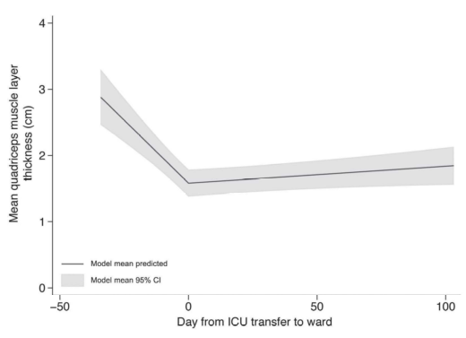

Figure 1. Changes in quadriceps muscle layer thickness, per patient, before and after discharge from ICU

Another study of acute muscle wasting by Puthucheary and colleagues (2013) reports that critically ill patients lost 12.5% of rectus femoris cross sectional area in the first 7 days since study enrolment (1-2 days post ICU admission) (Figure 2).4 This study examined acute muscle wasting in 67 critically ill patients and only 5 of these patients had a severe brain injury (intracranial haemorrhage). There were insufficient patients admitted to ICU following an intracranial haemorrhage to enable a sub-analysis of this cohort. Consequently, the amount of acute muscle wasting that patients experience in the first week following a TBI remains unknown.

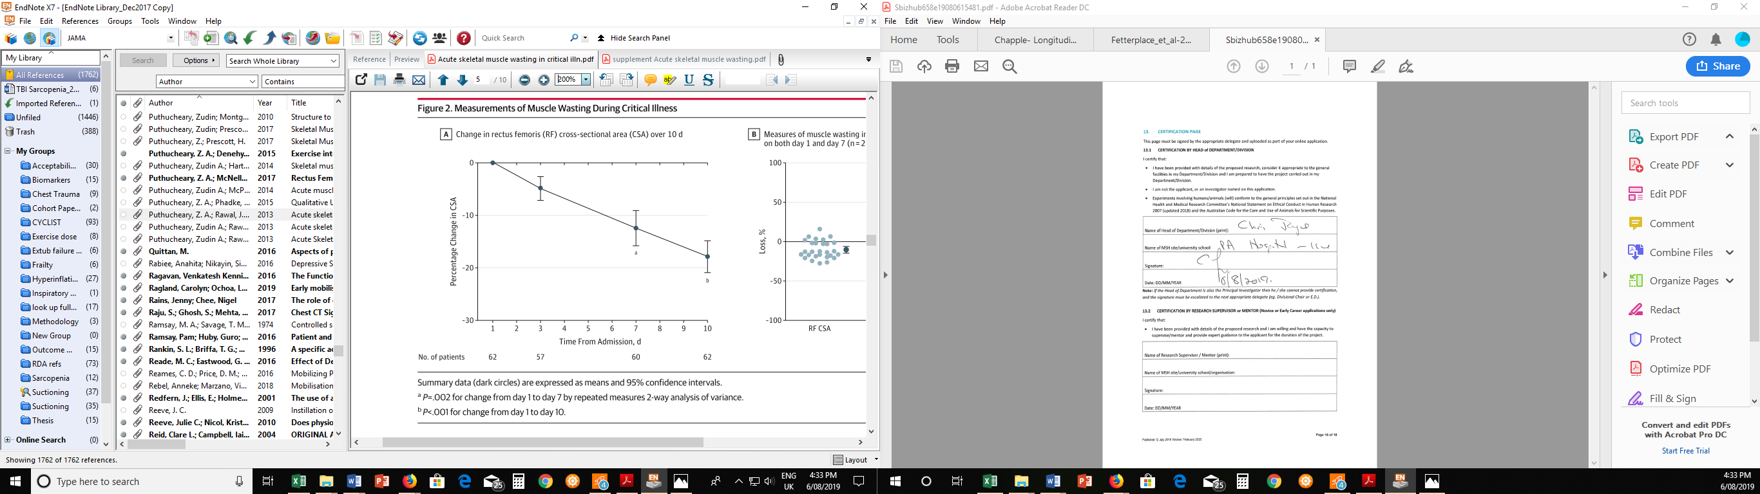

Figure 2. Change in rectus femoris cross sectional area over 10 days

A recent study completed at the Princess Alexandra Hospital (PAH) that included members of the current investigating team determined that participants admitted to ICU lost large amounts of muscle regardless of whether they completed an in-bed cycling exercise intervention (Figure 3)5. There was a group separation in terms of acute muscle wasting. Due to the variability of measurements and the relatively small sample size the results did not reach statistical significance. Patients with TBI presentations were excluded from this study.

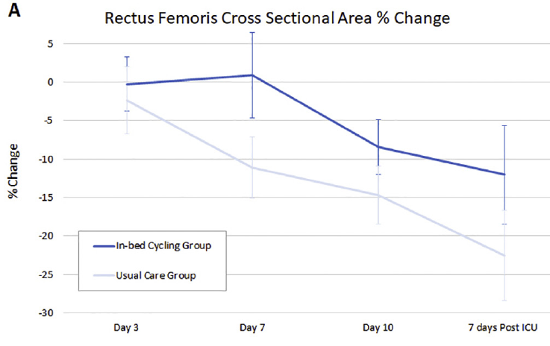

Figure 3. Change in rectus femoris cross sectional area over 10 days

The proposed study aims to add earlier baseline measurements within 1-2 days of ICU admission to the existing preliminary data regarding acute muscle loss following a severe TBI. Consequently, this study is likely to generate new and important findings regarding acute muscle wasting experienced by patients in their first week following a TBI that necessitated an ICU admission.

The information gained from this study is likely to serve as a baseline for future interventional studies to determine what interventions (or combination of interventions) are most effective at reducing acute muscle loss and improving functional outcomes for patients following a severe TBI.

# 3. AIM(S) OF RESEARCH PROJECT

To quantify acute phase muscle wasting in critically ill patients post severe TBI and determine associations with functional outcomes and nutrition provision.

To develop a research program investigating the most effective strategies to attenuate muscle wasting.

# 4. OBJECTIVES

To determine the trajectory of muscle loss from day 1-2 of ICU admission up to 28 days from initial scan.

To determine the feasibility of completing functional outcome measurements with patients following a TBI at either acute hospital discharge / admission to rehabilitation or at 28 days post admission whichever occurs earlier.

To determine if there is an association between acute muscle wasting and functional impairments (ability to transfer and mobilise) following a TBI.

To determine if energy and/ or protein provision from enteral or parenteral nutrition is associated with acute muscle wasting.

1. To determine associations, if any, between acute muscle wasting and glucose control (mean BGL and insulin provision).

# 5. HYPOTHESIS

## 5a. Primary Hypothesis

H0 : Acute muscle wasting following a severe traumatic brain injury is **not** associated with **functional impairments**.

HA : Acute muscle wasting following a severe traumatic brain injury is associated with **functional impairments**.

## 5b. Secondary Hypotheses

H0: Acute muscle wasting following a severe traumatic brain injury is **not** associated with **protein** intake.

HA: Acute muscle wasting following a severe traumatic brain injury is associated with **protein** intake.

H0: Acute muscle wasting following a severe traumatic brain injury is **not** associated with **energy** intake.

HA: Acute muscle wasting following a severe traumatic brain injury is associated with **energy** intake.

H0: Acute muscle wasting following a severe traumatic brain injury is **not** associated with blood glucose levels and/ or insulin requirements.

HA: Acute muscle wasting following a severe traumatic brain injury is associated with blood glucose levels and/ or insulin requirements.

# 6. RESEARCH PROJECT DESIGN

Prospective observational cohort study

Participants will not receive any interventions in addition to usual clinical practice. The cohort of participants presenting with a severe traumatic brain injury admitted to the PAH ICU will be included in this study.

# 7. RESEARCH PROJECT SETTING / LOCATION

Single centre study:

Intensive Care Unit and acute medical and surgical wards, Princess Alexandra Hospital.

# 8. SAMPLE SIZE AND STUDY DURATION

## 30 participants admitted to PAH ICU following a TBI that complete follow-up until Day 28 post baseline ultrasound scan.

## Thirty participants that complete scans up to Day 28 is a sufficient sample size to obtain observational data to determine the pattern and variability of acute muscle loss. It is likely that approximately 40 participants will need to be recruited into the study to enable sufficient repeated weekly ultrasound scans, function, and follow-up data to be collected from 30 participants due to early recovery and discharge, unexpected death or care direction changed to palliation.

## Participant recruit is expected to take approximately 9-months.

# 9. ELIGIBILITY CRITERIA

|  |  |
| --- | --- |
| **Inclusion Criteria** | **Rationale** |
| Able to have a family member or NOK consent on the patient’s behalf. | Ethical research practice. |
| Traumatic brain injury (TBI) requiring an ICU admission.  Injuries may include:  Intracerebral haemorrhage  Epidural haemorrhage  Subdural haemorrhage  Subarachnoid haemorrhage  Intraparenchymal Haemorrhage  Diffuse axonal injury | Traumatic brain injuries are varied and the ability to assess different the types of TBI’s will assist generalisability of results. |

|  |  |
| --- | --- |
| **Exclusion Criteria** | **Rationale** |
| Dire prognosis (i.e. unlikely to survive the current admission) | Potential short acute hospital length of stay reducing ability to complete longitudinal assessments. |
| Spinal cord injury | Outside of the scope of the current study. |
| Acute injuries that prohibit ultrasound assessment of thigh musculature i.e. lacerations or open wounds. | Minimising potential infection control risks. Ultrasound may be performed if the wounds have been sufficiently covered and the medical and nursing clinicians are agreeable that the ultrasound assessment is safe. |
| People who are incarcerated. | Difficulty to complete follow-up assessments |
| Women who are pregnant | This research aims to form the baseline for future interventional search. While all assessments are safe with pregnant women in the present study, the effect of future interventions to reduce muscle wasting have not been assessed including pregnant women. Hence, to create a comparable baseline research for future studies pregnant women will be excluded from the current research study. |
| Participants with significant pre-existing cognitive impairment, intellectual disability or mental illness. | Participants with significant pre-existing cognitive impairment, intellectual disability or mental illness that is likely to prohibit co-operation with future standardised functional assessments of physical function that would reduce the reliability of the assessment findings will be excluded from study recruitment. |
| Previously admitted to ICU this index hospital admission | Excludes patients who may have experienced acute muscle loss following initial hospital admission |

# 10. RESEARCH OUTCOMES

## 10a. Primary Outcome

Acute muscle wasting:

The rate of rectus femoris cross sectional area and thickness muscle loss following at TBI requiring admission to the ICU. Measured bilaterally by ultrasound within 48 hours of ICU admission, day 7 (+/- 1 day), 14, 21, till day 28 or until acute hospital discharge (whichever occurs earlier).

## 10b. Secondary Outcome(s)

Function:

1. 10 metre walk test (day 28 or acute hospital discharge if prior to day 28).
2. Timed up and go (day 28 or acute hospital discharge if prior to day 28).
3. Handgrip strength (day 28 or acute hospital discharge if prior to day 28).
4. ICU Mobility Scale score - Highest level of function in ICU (medical records).
5. Time to achieve functional milestones – sitting on the edge of the bed, SOOB, standing, mobilisation with assistance, independent mobility (medical records).
6. Barthel Index at acute hospital discharge (medical records).

Telephone follow-up at 6 months:

1. Days alive and out of hospital,
2. Health related quality of life (EQ5D-5L),
3. Return to work (if working prior to admission),
4. Independence with ADLs (Barthel Index).

## 10c. Data Variables

Participant characteristics:

Pre-admission Clinical Frailty Score, SARC-F questionnaire, admission injury and illness severity scores (Acute Physiology And Chronic Health Evaluation III (APACHE III), admission Sequential Organ Failure Assessment (SOFA), modified Nutrition Risk Calculation (mNUTRIC) and Glasgow Coma Scale Scores (GCS)), duration of mechanical ventilation (hours), incidence of delirium in ICU (delirium free days) (Cognitive Assessment Measure (CAM ICU)), weight, height, body mass index, adjusted weight, diabetes on admission, nutrition received (name and volume of parental nutrition feed), volume of feed during ICU admission, volume of discarded gastric residual volumes, propofol received, type and volume of carbohydrate infusion, urea level, creatine level, blood glucose levels and units of insulin.

Length of stay – ICU, acute hospital, rehabilitation.

Acute hospital discharge destination (home, rehab, other hospital, died).

# 11. RESEARCH PROJECT PROCEDURES

## 11a. Recruitment of Patients/Participants

## Identification of participants:

## Potential study participants will be admitted to the Princess Alexandra Hospital (PAH) Intensive Care Unit (ICU) following a traumatic brain injury (TBI). Neurology or neurosurgery medical notes will be reviewed and the ICU treating medical team will be consulted to determine if the patient presentation is likely to survive.

## At an appropriate timepoint (as soon as possible) the person responsible for the potential participant will be approached to consider providing (person responsible) informed consent for study inclusion.

## If a person responsible for the potential participant is unable to be contacted within the first 48 hours following ICU admission and early prognostic indicators are favourable baseline ultrasound scans will be taken (a waiver of consent has been granted by Metro South HREC).

## If initial baseline ultrasound scans are taken prior to receiving consent, the person responsible for the participant will be approached to provide consent to continue in the study at the earliest opportunity. No data will be accessed from the patients medical records before informed consent to continue is received.

If baseline scans are performed and informed consent to continue is not received, or if the participant passes away prior to receiving informed consent, the scan data will be discarded following appropriate patient information confidentiality procedures. A record of the number to patients that this affects will be recorded to enable transparent reporting of results and to assist to inform future research.

## Who will obtain consent and issue Participant Information and Consent Forms:

## In most cases the Principal Investigator (Dr Marc Nickels), will be the person to initially approach the person responsible for the participant, explain the study and provide the person responsible for the participant with the Participant Information and Consent Form (PICF). If Dr Nickels is unavailable another member of the research team who has completed their Good Clinical Practice training will explain the study, provide the PICF and request consent.

## How will consent be obtained:

## Whenever possible the initial approach will be in person. If the person responsible for the participant is not able to visit during usual working hours of the investigating team (Monday to Friday 8am-4:30pm) the person responsible for the participant will be contacted by telephone to explain the study and determine if they would like to organise a time to meet in person to further discuss the study (see NeuroMuscle_Intro Telephone Script_V1.0). If the person responsible is happy to provide telephone consent the Investigator will ask another clinician to witness the telephone consent, and will verify from person responsible for the participant that the study has been explained, that the person responsible for the participant is willing for the participant to be included in the study and that the person responsible for the participant is aware that they / or the participant are able to withdraw from the study at any time without affecting future healthcare.

## Note: given the severity of traumatic brain injuries that necessitate an ICU admission the participant either will not be conscious or will have an acute brain injury that will preclude them from being able to understand the consent process and implications of being included in a research study. On the rare occasion some patients recover quickly following a traumatic brain injury and could follow the consent process. However, patients who recover this quickly are unlikely to remain an inpatient in hospital for a sufficient duration to enable adequate research data to be completed (28 days post ultrasound scans) to enable analysis of the research aims of the study. Hence, the initial consent process will be conducted with the person responsible for the participant rather than with the participant themselves.

## How much time to consider participation:

## The person responsible for the participant will be given as much time as they require to read the PICF, discuss consent with other family members / friends that the person responsible for the participant deems appropriate to be included in the consent process and to ask the investigating team any questions that may affect the consent process or the participants participation in the study.

## Extended consent:

## The person responsible for the participant will be asked to consider if data obtained in the current research study can be used for other research with appropriate ethics committee approval/s. A separate tick box and name, signature and date details will be completed by the person responsible for the participant if they consent to allowing data obtained from this study to be used for other ethics approved studies.

## Participants opportunity to confirm consent:

## When a participant regains sufficient cognitive function following their traumatic brain injury to enable them to make informed decisions regarding their involvement in the proposed research study then participants ongoing consent will be formally sought. A verbal and written overview of the study will be provided via a participant ongoing consent PICF. The participants future outcome assessments will be explained. If the participant does consent to continue to be involved in the study, then an ongoing consent form will be completed.

The participant will also be asked if they are willing to provide consent to allowing data obtained from this study to be used for other ethics approved studies. If the participant is agreeable they will be asked to mark the appropriate check box and sign and date the participant ongoing consent PICF to acknowledge that they consent to their de-identified research data being stored on an appropriate research data repository and potentially accessed by other researchers for other approved research studies.

## Withdrawal:

## If a participant or their person responsible elects to withdraw from the study, it will be explicitly re-iterated that the decision to withdraw will not affect the quality of future healthcare provided to the participant.

## In this event that a participant is withdrawn from the study the research team will request consent to use any data that has been collected prior to withdrawal. A relevant tick and signature box is included on the Withdrawal Form for this purpose. Further assessments will not be completed. Data collected prior to the participant’s withdrawal will only be included in the study if consent to use the data collected prior to withdrawal is obtained.

## 11b. Research Project Process

Once enrolled in this study participants will receive weekly bilateral thigh ultrasound measurements at admission (within 48 hours of ICU admission), and subsequently weekly on days 7, 14, 21 and 28 post initial baseline ultrasound, whilst they are inpatients in the PAH ICU, acute wards, or rehabilitation. If a participant is discharged prior to day 28 and could feasibly attend follow-up outcome measurement sessions, they will be asked if they would like to return for follow-up assessments. A $50 gift voucher will be offered to reimburse the participant / carer for the inconvenience of attending an appointment. The costs of parking will be coved with a parking pass to ensure participants or carers are not out of pocket for appointment costs.

At day 28 (post initial baseline ultrasound) or at hospital discharge (whichever occurs earlier) a physiotherapist will assess the participants functional capability. The functional tests are a 10-metre walk test, timed up and go, and a handgrip strength test. These functional tests are common physiotherapy assessments that are routinely assessed in clinical practice by physiotherapists.

Other outcome information will be obtained from the participants medical records. This information includes illness and injury severity scores, modified nutrition risk (mNUTRIC), incidence of delirium (CAM ICU), duration of mechanical ventilation, length of ICU and hospital stay, highest level of function in ICU (ICU Mobility Score), Barthel Index (participant function), discharge destination. Results from CT or MRI scans that have been taken during routine clinical care will also be collected to enable associations between ultrasound results and other scans to be analysed.

At 6 months following hospital admission a follow-up phone call will be made to enquire about quality of life (EQ5D-5L), return to work (if working prior to admission), independence with ADLs (Barthel Index) and any readmissions to enable the number of days alive and out of hospital over 6 months to be calculated. Participants will be given the option to opt in or opt out of being contacted for 6-month follow-up prior to acute hospital discharge (see NeuroMusle_Participant Ongoing Consent_V1.0). If the participant remains in hospital at 6 months the interview will be conducted in person (with the support of the substitute decision maker or person responsible if required). The telephone follow-up or in-person interview should be completed in approximately 10 to 15 minutes. See telephone scripts NeuroMuscle_6M Person Responsible_Telephone Script_V1.0, and NeuroMuscle_6M Participant_Telephone Script_V1.0.

The assessment procedures will be explained to participants in lay language. Participants will have the opportunity to answer questions regarding the assessment procedures. Participants will not be coerced into completing any of the assessment, and retain the right to refuse to participate in the research assessments without adversely affecting their ongoing care. When appropriate family members or close friends will be invited to be involved in any discussions regarding assessment procedures. Family / friends may also decline to allow the participant to participate in the research assessments without adversely affecting the participants ongoing care.

## 11c. Measurement Tools Used

Primary Measure:

Ultrasound Sonography will be the measurement tool used to assess thigh skeletal muscle loss. Qualified sonographers will teach and check the accuracy of the investigators ultrasound measurements prior to study commencement. The intra and inter-rater reliability will be examined and will be reported in the associated manuscript (likely to be supplementary material).

## Ultrasound methodology

The ultrasound measurement point is 2/3 of the distance between the anterior superior iliac spine (ASIS) and the upper pole of the patella. This point will be marked with a surgical marker pen and regularly retraced to optimise the consistency of the same scan point being used during subsequent scans.

The participants leg will be passively positioned into neutral hip rotation, abduction/ adduction, passive knee extension with the back of the bed positioned at 30 degrees elevation. If the participant is awake and following commands they will be instructed to try to relax their thigh muscles as much as possible.

A water-soluble transmission gel will be applied to the ultrasound head to allow acoustic contact without depressing the dermal surface.

This ultrasound protocol is based on the published protocol by Tillquist et. al (2014)6 and utilised by the study investigators during the CYCLIST study7, (Figure 4). Rectus femoris cross sectional area and rectus femoris and vastus intermedius thickness will be recorded.

Duplicate scans will be taken bilaterally and the scan repeated a third time if the first two measures of rectus femoris cross sectional area (of left or right thighs) vary by more than 10% 1. As per current clinical practice the ultrasound scans will be recorded in the participants electronic medical records.

All values will be recorded will be entered into the research database. During data cleaning the result that was clearly different will be discarded and the data from the three scans retained. The average of the 2 retained scans utilised will be the value recorded for that participant for analysis at the relevant timepoint.

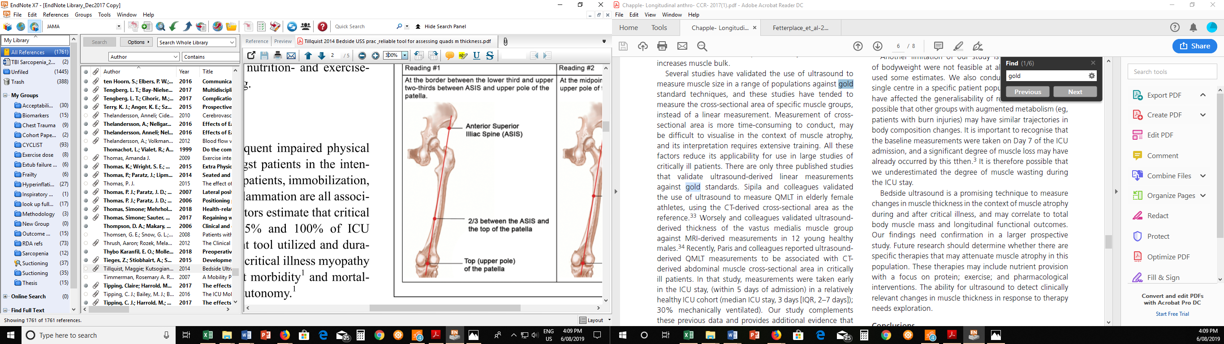

Figure 4. Ultrasound assessment location

Secondary Measures

The ICU Mobility Scale is an eleven-point ordinal scale (0-10) that represents the highest level of function that a participant achieves while in ICU. Higher scores represent higher levels of physical function. This score is routinely documented within patients electronic medical records and hence the study participant will not be required to complete any additional physical assessment at ICU discharge.

At acute hospital discharge (or at a timepoint as close as practical to acute hospital discharge i.e. 48hrs prior to discharge home or 48hrs following inpatient rehabilitation admission), the following physical assessments will be performed.

The 10-metre walk test, timed up and go, and handgrip strength test using a Jamar Dynamometer will be conducted in an appropriate clinical space, such as a physiotherapy gymnasium or unobstructed hospital corridor. The assessment will be conducted by qualified physiotherapists who are familiar with the standardised testing procedure of these tests. It is likely that up to three different physiotherapists may conduct these tests over the duration of the study. A pre-study training and standardisation session will occur to optimise inter-rater reliability. These assessments are routinely completed and the three assessments can be completed in approximately 5-10 minutes with a patient who is reliably following commands.

## 11d. Schedule of enrolment and assessments

|  |  |  |  |  |  |  |  |
| --- | --- | --- | --- | --- | --- | --- | --- |
|  | **Admission to ICU** | **Day 7\*** | **Day 14\*** | **Day 21\*** | **Day 28\*** | **Acute hospital discharge** | **6 months post admission to ICU** |
| **Enrolment and Consent** |  | | | | | | |
| Eligibility Screen | **X** |  |  |  |  |  |  |
| Substitute Decision Maker consent |  |  |  |  |  |  |  |
| Participant ongoing consent |  |  |  |  |  |  |  |
| **Assessments**: |  | | | | | | |
| Clinical Frailty Score | **X** |  |  |  |  |  |  |
| SARC-F questionnaire | **X** |  |  |  |  |  |  |
| Thigh Ultrasound | **X** | **X** | **X** | **X** | **X** |  |  |
| ICU Mobility Scale |  |  |  |  |  | **X**  **(ICU d/c)** |  |
| 10m walk test |  |  |  |  |  | **X** |  |
| Timed up and go |  |  |  |  |  | **X** |  |
| Handgrip Strength |  |  |  |  |  | **X** |  |
| Functional Milestones |  |  |  |  |  |  |  |
| Barthel Index |  |  |  |  |  | **X** | **X** |
| EQ5D-5L |  |  |  |  |  |  | **X** |
| Return to work |  |  |  |  |  |  | **X** |
| Days alive and out of hospital |  |  |  |  |  |  |  |

* Following baseline thigh ultrasound.

## 11e. Safety Considerations Including Patient/Participant Safety

Participant safety will be paramount throughout the study. The assessment of acute muscle wasting will be by ultrasound which is a non-invasive investigation that does not expose the participants to radiation. The assessment will occur at the participants’ bedside and hence risks associated with patient transportation have been eliminated.

The physical outcome assessments will only be conducted if a participant is able to follow commands. A physiotherapist will assess if the participant has sufficient muscle strength and balance to complete the 10-metre walk test and timed up and go. The handgrip test can be completed with a participant sitting up in bed or in a chair, and hence may be completed in isolation if other functional assessments cannot be safely performed.

As an observational study there are low risks of adverse events (including serious adverse events). However, in an adverse event were to occur the treating medical team would be notified, the event documented in the participants electronic medical records, and if indicated appropriate reporting of the adverse event to the governing ethics and governance committees would be completed. Reporting would follow the procedures and definitions of adverse events set by the Metro South Research Ethics and Governance committees.

## 11f. Data Monitoring

Data will be stored on secure password protected Queensland Health computers. The study investigators will have access to the data. Paper records will be minimised. Paper records containing identifiable participant data will be stored in a locked cupboard within a lockable room within the Physiotherapy Department Staff Office or Intensive Care Allied Health Office. Access to ICU or the Physiotherapy Department Staff Office is restricted to staff with proxy access, minimising the risk of accidental data exposure to unauthorised personnel.

The research data will be managed according to legal, statutory, ethical, and funding body requirements.

At the earliest paper and electronic records will be destroyed 7 years after the publication of the primary peer reviewed publication that are expected to be completed as a part of this study.

## 11g. Potential sources of bias and methods to reduce bias

Survivor bias will be addressed by recording zero for the number of days alive and out of hospital to participants who do not survive their acute hospitalisation.

It is likely that approximately 40 participants will need to be recruited into the study to enable sufficient ultrasound, function, and follow-up data to be collected from 30 participants due to early recovery and discharge, unexpected death or care direction changed to palliation.

# 12. STATISTICAL CONSIDERATIONS AND DATA ANALYSIS

## 12a. Sample Size

A sample size of 30 participants is required to obtain observational data to determine the pattern and variability of acute muscle loss. Participants will not be included as contributing to the sample if the three repeated ultrasound scans are unable to be completed (e.g. baseline, day 7 and day 14). It is likely that approximately 40 participants will need to be recruited into the study to enable sufficient ultrasound, function, and follow-up data to be collected from 30 participants due to early recovery and discharge, unexpected death or care direction changed to palliation.

Participant recruit is expected to take approximately 9-months.

## 12b. Statistical Methods

As this is an observational study descriptive statistics will be used to describe the clinical characteristics of the cohort and the participants outcomes. An exploratory analysis will be conducted to examine the:

1. Association between acute muscle wasting and functional decline following a severe TBI.
2. Association between nutritional intake in ICU (protein and energy) and acute muscle wasting at ICU discharge in patients with a severe TBI.
3. Association between acute muscle wasting and blood glucose levels and/ or insulin requirements following a severe TBI.

# 13. RESULTS DISSEMINATION AND AUTHORSHIP

## 13a. Results Dissemination

Results of this study will be presented at local, national, and potentially also at international scientific conferences. Any of the study investigators are able to present results of this study to their potential respective audiences of interest. A peer reviewed publication is expected to be completed and if sufficient funds remain will be published in an open access journal. If possible a local publicly accessible publication in the PA Research Foundation and/ or the PA People newsletter will be completed to assist to disseminate results to the public in lay terms.

Participants and their person responsible will be able to receive results from this study in the form of a lay summary and a copy of the primary peer reviewed publication. A relevant check box has been included to ask participants if they would like a copy of these study results and to confirm their likely postal address following hospital discharge (see NeuroMusle_Participant Ongoing Consent_V1.0).

## 13b. Authorship

Authors should adhere to the practices of their research field and the guidelines of the International Committee of Medical Journal Editors ([ICMJE](http://www.icmje.org/recommendations/browse/roles-and-responsibilities/defining-the-role-of-authors-and-contributors.html)). According to the ICMJE guidelines, all of the following 4 criteria must be met to be considered an author:

* Substantial contributions to the conception or design of the work; or the acquisition, analysis, or interpretation of data for the work; AND
* Drafting the work or revising it critically for important intellectual content; AND
* Final approval of the version to be published; AND
* Agreement to be accountable for all aspects of the work in ensuring that questions related to the accuracy or integrity of any part of the work are appropriately investigated and resolved.

Individuals who participated only in acquisition of funding, collection of data, or general supervision of a research group (i.e. institution leaders who were not actively involved in specific projects), does not justify authorship. These individuals should be included in the Acknowledgements.

The principal publication from the trial will be led by Principal Investigator Dr Marc Nickels, supervising investigator Professor Steven McPhail will be listed as last / supervising author. Full credit will be assigned to all collaborating investigators, with all investigators who provide a meaningful contribution listed as co-authors. Authors will be listed by ordered by contribution; in the event of equal co-author contributions the co-authors will be listed alphabetically by surname.

Funding bodies will be acknowledged in the publication.

# 14. ETHICAL CONSIDERATIONS

The research project will be conducted in full conformance with principles of the “Declaration of Helsinki” 8, Good Clinical Practice (GCP) and within the laws and regulations of Australia. The National Statement on Ethical Conduct in Human Research (NHMRC, 2007) 9 andAustralian Code for the Responsible Conduct of Research 10 will be adhered too. The relevant Metro South Health Human Research Ethics Office/r will be contacted for advice and guidance if required.

There will be a priority of the patient/ participants’ interests over those of science or of society and those interests will be safeguarded with a clear Participant Information and Consent procedure that will include the ability for the participant, their person responsible or other person acting in the participants interests to withdraw the participant from the study without consequence to quality the participants ongoing healthcare.

Information on how informed consent is to be obtained should be included. This ensures that if participants can read and understand the information they need to make an informed decision about their voluntary participation. This can include allowances for special population groups (e.g., Aboriginal and Torres Strait Islander) where applicable.

A study investigator will discuss the study with the person responsible for the participant and provide a Participant Information and Consent Form (PICF). The person responsible will be given the opportunity to read the PICF and consult with other family/ friends regarding the decision to consent to the study. During the consenting process, any relevant cultural considerations will be observed to create an understanding, sensitive and non-authoritative environment to ensure that a voluntary consent process is optimised.

The person responsible or the participant can withdraw from the study at any time without affecting the quality of future healthcare. In this event the research team will ascertain whether research data already collected can be used for research purposes.

# 14. OUTCOMES AND SIGNIFICANCE

The proposed study is a preliminary step in optimising the recovery of patients following a traumatic brain injury. Before the efficacy of early exercise and or nutrition interventions can be assessed the baseline rate of acute muscle loss needs to be examined. Currently the rate of acute muscle loss during the first week following TBI is unknown. This study will assist to substantiate the pattern of both early and late muscle loss (up to 28 days).

An establishment of functional status post TBI following a period of usual care may also assist future studies to compare the future outcomes of patients participating in an intervention study.

# 15. REFERENCES

1. Chapple L-AS, Deane AM, Williams LT, et al. Longitudinal changes in anthropometrics and impact on self-reported physical function after traumatic brain injury. *Crit Care Resusc.* 2017;19(1):29-36.

2. Needham DM. Mobilizing patients in the intensive care unit: improving neuromuscular weakness and physical function. *JAMA.* 2008;300(14):1685-1690.

3. Nickels MR, Aitken LM, Walsham J, Crampton LJ, Barnett AG, McPhail SM. Exercise interventions are delayed in critically ill patients: an historical cohort study in an Australian tertiary intensive care unit. *Physiotherapy.* 2019;10.1016/j.physio.2019.06.011.

4. Puthucheary ZA, Rawal J, McPhail M, et al. Acute skeletal muscle wasting in critical illness. *JAMA.* 2013;310(15):1591-1600.

5. Nickels MR, Aitken LM, Barnett AG, et al. Effect of in-bed cycling on acute muscle wasting in critically ill adults: A randomised clinical trial. *J Crit Care.* 2020;59:86-93.

6. Tillquist M, Kutsogiannis DJ, Wischmeyer PE, et al. Bedside ultrasound is a practical and reliable measurement tool for assessing quadriceps muscle layer thickness. *JPEN J Parenter Enteral Nutr.* 2014;38(7):886-890.

7. Nickels MR, Aitken LM, Walsham J, Barnett AG, McPhail SM. Critical Care Cycling Study (CYCLIST) trial protocol: a randomised controlled trial of usual care plus additional in-bed cycling sessions versus usual care in the critically ill. *BMJ Open.* 2017;7(10):e017393.

1. Declaration of Helsinki World Medical Association Declaration of Helsinki Ethical Principles for Medical Research Involving Human Subjects. Adopted by the 18th WMA General Assembly, Helsinki, Finland, June 1964.
2. National Statement on Ethical Conduct in Human Research 2007 (Updated 2018). The National Health and Medical Research Council, the Australian Research Council and Universities Australia. Commonwealth of Australia, Canberra.
3. Australian Code for the Responsible Conduct of Research 2018. National Health and Medical Research Council, Australian Research Council and Universities Australia. Commonwealth of Australia, Canberra.