**WIRST ARTHRODEIS WITH AND WITHOUT THE CARPOMETACARPAL JOINT STUDY PROTOCOL**

**Contents**

**1. Study title**

**2. Project summary**

**3. Study identification**

**4. Sponsor**

**5. Administering institution (university)**

**6. Investigators and participating institutions**

**7. Rationale and background information**

**8. Study hypothesis**

**9. Aims**

**10. Study design**

**11. Methods**

**12. Safety considerations**

**13. Data management**

**14. Ethical considerations**

**16. Feasibility**

**17. Expected outcomes**

**18. Dissemination of results and publication policy**

**19. Duration of the project**

**20. Anticipated problems**

**21. Project management**

**22. References**

**1. Study title**

Randomized clinical trial of wrist arthrodesis with and without inclusion of the carpometacarpal joint

**2. Project summary**

Total wrist arthrodesis is indicated for end-stage arthritis of the wrist, as well as neurologic, neoplastic and traumatic conditions when motion-preserving procedures are contraindicated. The goal of TWA is to eliminate pain at the expense of wrist motion and thus improve function.

Total wrist arthrodesis has evolved from a procedure with high morbidity, with early reports of cortical bone graft with no fixation and prolonged periods of cast immobilization, to specifically designed low-profile wrist arthrodesis plates than aim to minimize local soft irritation while providing rigid fixation allowing early mobilization. The most recent contoured dorsal plate designs include options that facilitate preserving or crossing the carpometacarpal joint (CMCJ) allowing it to be spared, bridged or included in the fusion mass.

Treatment of the CMCJ remains controversial in wrist arthrodesis. It is generally thought that bridging the CMCJ mandates plate removal because increased stresses on the plate predispose it to failure. Conversely, it is thought that arthrodesis of the CMCJ eliminates the need for a second operation to remove the plates. Nagy and Büchler observed an increased complication rate in wrists with CMCJ arthrodesis and advocated for bridging the CMCJ with subsequent plate removal (Nagy & Büchler, 2002). Conversely, Berling et al., in a similarly designed retrospective study, found a decreased complication rate when the CMCJ was fused (Berling, Kiefhaber, & Stern, 2015).

In an effort to minimize hardware removal and eliminate the need to fuse the CMCJ, non-CMCJ-bridging wrist fusion plates have been developed. Despite their perceived advantages, these plates have not been robustly tested against bridging plates with fusion of the CMCJ. And, to date, small clinical studies have not demonstrated superiority of the non-CMCJ-bridging wrist fusion plate (Köhler et al., 2017).

This randomized clinical trial will compare the outcomes of wrist arthrodesis with CMCJ fusion using a CMCJ spanning plate, to wrist arthrodesis without CMCJ fusion with a non-spanning CMCJ plate. It is hoped all upper limb surgeons in the Australian Capital Territory (ACT) will participate in this study.

This study will primarily assess union rates, complications and requirement for hardware removal. Secondary outcomes that will be assess will include pain (0-10 worst, Visual Analogue Scale) and function (Disabilities of Arm, Shoulder, Hand (DASH) and Patient Rated Wrist Evaluation (PRWE).

This study will provide the highest grade of evidence that will inform surgeons of the best approach with regard to the treatment of the CMCJ in arthrodesis of the wrist. This study will benefit patients by determining which approach to wrist arthrodesis results in a reduced requirement for a secondary operation; it will also reduce resource utilization and cost.

3. Study identification

This trial is will be registered with:

World Health Organisation Universal Trail Number (WHO UTN): U1111-1262-6523

Date Submitted: 12/12/20

Date Registered: 12/12/20

Australian and New Zealand Clinical Trails Registry (ANZCTR):

Web address:

Registered by: David Owen

Email: David.owen@anu.edu.au

4. Sponsor

Trauma and Orthopaedic Unit (TORU), Canberra Hospital Garran ACT 2605

Australian National University, Acton, ACT 0200

5. Administering Institution

Canberra Hospital and Health Services

6. Investigators and participating institutions

Dr David Owen Trauma and Orthopaedic Unit /Australian National University

Email: David.owen@anu.edu.au

A/Prof Christopher Roberts Trauma and Orthopaedic Unit /Australian National University

Dr Dianna Perriman Trauma and Orthopaedic Unit /Australian National University

Prof Paul Smith Trauma and Orthopaedic Unit /Australian National University

7. Rationale and background information

Epidemiology: Total wrist arthrodesis is indicated for inflammatory and non-inflammatory arthritis of the wrist, post traumatic conditions, neurological conditions, tumour and as a salvage procedure for operations such as partial wrist fusion and total wrist arthroplasty. Indications for total wrist arthrodesis have been narrowed by increasing use of total wrist arthroplasty which is suitable for older, lower demand patients and recognition of the role partial carpal fusion. Increased potency of autoimmune disease modifying agents has led fewer patients with advanced inflammatory wrist arthritis requiring TWA. The majority of recent wrist arthrodesis series now include patients with isolated disease of the wrist, typically originating from injuries such as scapholunate ligament rupture, scaphoid non-union or post traumatic arthritis.

Current practice: Treatment of the carpometacarpal joint in wrist arthrodesis remains controversial. Early series described corticocancellous bone grafts from either the ilium or tibia that locked into the metacarpals and radius in a suitably shaped trough(Butler, 1949). Arthrodesis of the wrist with pins, rods and nails, describe penetration through CMCJ or introduction of the fixation device between the metacarpals(Millender & Nalebuff, 1973). Since that introduction of dorsal plate for wrist arthrodesis inclusion of the CMCJ has been variable reported(Bolano & Green, 1993; Clendenin & Green, 1981; Larsson, 1974).

Problems at the CMCJ in wrist arthrodesis has been identified by a number of authors (Berling et al., 2015; Hastings et al., 1996; Houshian & SchrØder, 2001; Nagy & Büchler, 2002; Rancy, Ek, Paul, Hotchkiss, & Wolfe, 2018).

Nagy retrospectively analysed CMCJ pain in patients that had wrist arthrodesis with and without the CMCJ fused and concluded that due to the high rate of non-union and ensuing problems, that the joint should not be fused, instead recommending that all plates be removed(Nagy & Büchler, 2002). Berling undertook a similar study and disagreed, suggesting that CMCJ arthrodesis should be performed, recommending against plate removal and thus avoiding a second operation(Berling et al., 2015).

There has been no systematic review or meta-analysis of the wrist arthrodesis literature to suggest whether or not fusion of the CMCJ is superior. Review articles and product manuals state that fusion of the CMCJ is optional. Upper limb surgeons in Canberra where this study is to be completely, similarly disagree on the management of the CMCJ in wrist arthrodesis but acknowledge neither option is superior.

Justification: Currently there exists no high-quality study which informs us about optimal management of the CMCJ in wrist arthrodesis. Answering this question will lead to improved patient outcomes by determining which approach to the CMCJ minimizes complications. This information will lead to reduced costs via fewer revision procedures. The results of this trial will be relevant here in Australia and internationally.

8. Study hypothesis

Primary hypothesis:

Patients undergoing wrist arthrodesis with a non-bridging plate and without CMCJ fusion, will have reduced complications and improved union* rates (measured on CT) at 12 months compared to those managed with bridging plates and CMCJ arthrodesis.

* Union will be defined differently in each study population. In the non-bridging plate condition fusion will be required at both the radiocarpal and midcarpal joints; in the bridging plate condition union will be required at the radiocarpal midcarpal joints and CMCJ.

Secondary hypothesis:

Patients undergoing wrist arthrodesis with a non-bridging plate and without CMCJ fusion, will have improved patient reported outcome measures and grip strength at 12 months compared to those managed with bridging plates and CMCJ arthrodesis.

9. Aims

Primary aim: is to determine whether wrist arthrodesis with CMCJ sparing plates are superior to wrist arthrodesis with CMCJ bridging plates and CMCJ fusion, in terms of complication and union rates at 12 months.

Secondary aims: is to determine whether wrist arthrodesis with CMCJ sparing plates are superior to wrist arthrodesis with CMCJ bridging plates and CMCJ fusion in terms of patient reported outcomes (DASH and PRWE) at 12 months.

10. Study design

We will conduct a double-blinded randomized clinical trial of patients undergoing total wrist fusion with and without CMCJ fusion. All patients will be followed up accord to the same protocol and assessed using the same outcome measures. Participants will be blinded to the treatment that they receive.

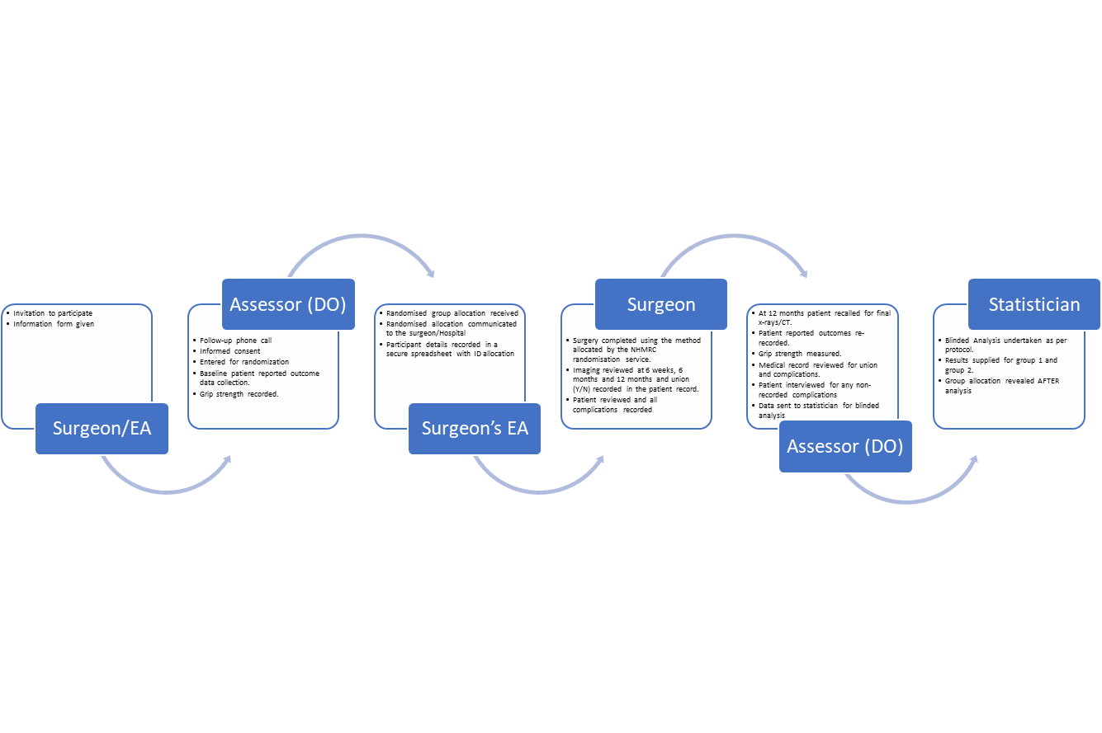Figure 1: Roles of each member of the research team to ensure that the trial is triple blinded.

11. Methods

Setting

All upper limb orthopaedic surgeons practicing in the Australian Capital Territory will be informed about this trial but only those with equipoise regarding the efficacy of the two surgical options will be invited to be involved as treating surgeons. The surgery will be undertaken at Canberra hospital, John James Memorial Hospital and National Capital Hospital.

Only fellowship trained, subspecialist upper limb surgeons with experience in total wrist arthrodesis will be involved in this study. The addition of carpometacarpal joint fusion is not complex procedure and surgeon who do not currently fuse it in wrist arthrodesis will have experience in fusion of this joint for other indications. The use of an alternate plate – either the Synthes bridging or Medartis non-bridging plate will represent a minor deviation from the surgeons preferred prior practice.

Population

All adults > 18 years of age scheduled for total wrist arthrodesis that meet the inclusion and exclusion criteria will be invited to participate in this study.

Inclusion criteria

This study will include English speaking adults aged > 18 years who have been scheduled for total wrist arthrodesis by their surgeon. The conditions which are likely to be included are:

SNAC (Scaphoid non-union advanced collapse)

SLAC (Scapholunate ligament advanced collapse)

Keinbock’s disease/Lunate avascular necrosis

Preiser’s disease/Scaphoid avascular necrosis

Wrist osteoarthritis

Post traumatic arthritis

Failed partial fusion

Failed proximal row carpectomy

Failed ligament repairs

Exclusion criteria

Patients will be excluded from this study if they:

Lack ability to provide informed consent for participation (cognitive capacity or English proficiency)

Have an inflammatory arthropathy (e.g., Rheumatoid arthritis)

Have coexisting debilitating other upper limb disorder e.g., rotator cuff tear arthropathy with inability to raise arm above head.

Neurological dysfunction affecting the limb of interest (CVA, plexus injury, peripheral nerve injury, spasm or contracture)

Tumour of the wrist (giant cell or other)

Wrist arthroplasty that will be revised to arthrodesis

Planned to undergo or have undergone bilateral wrist arthrodesis

Recruitment

Potential participants will be screened by the treating surgeon and those deemed eligible invited by their treating surgeon to participate. These patients will be provided with a patient information pack and given the opportunity to ask questions prior to consenting to participate.

Randomization and treatment allocation

Randomization will occur after consent for participation is obtained. Stratified permuted block randomisation will be used to mitigate potential bias and allow for datat analysis to be completed if insufficient participants are recruited. Robust Randomisation App (RRApp) software(Tu & Benn, 2017) be used, and allocation will be returned to the primary surgeon’s assistant who will ensure that the patient is allocated to the appropriate treatment.

Blinding

This is a triple blinded trial – patient, assessor and statistician. As the treatment arms will be similar in terms of surgical approach, length of wound and scar, blinding of the patient and assessor will be possible. The surgeons providing the treatment will not be able to be blinded. Because the assessor will be able to determine group allocation by viewing the imaging for each patient to assess union and complications, the surgeon will be required to document union.

The researcher administering the patient reported outcomes (DASH, PRWE) and analysing the data will be blinded to the treatment received by the patient.

The statistician will undertake all of the analyses according to a predetermined plan. Group allocation will be blinded.

Surgery

Surgery will be performed under general anaesthesia, with block and arm high tourniquet. An incision of equal length (treatment and comparison arm) will be used to facilitate blinding of the patient. A dorsal approach using the interval between the third and fourth compartments will be used. A posterior interosseous nerve neurectomy will be performed. In all wrists the radioscaphoid, radiolunate, scapholunate, scaphocapitate and lunocapitate joints will be decorticated. Other intercarpal joints in the wrist will be fused depending on the presence of arthritis and the discretion of the surgeon (See Figure 1). Only bone originating from these bones will be used as bone graft.



Figure 1. The third CMCJ will be fused with a plate in the control arm and spared in the treatment arm.

Intervention group (CMCJ sparing)

The CMCJ will be identified and carefully preserved in the CMCJ sparing treatment arm. After preparing the carpals as described above, while carefully preserving CMCJ joint and its capsule, a non-spanning wrist fusion plate will be implanted according the manufactures description (Medartis AG, Switzerland) (Figure 2).

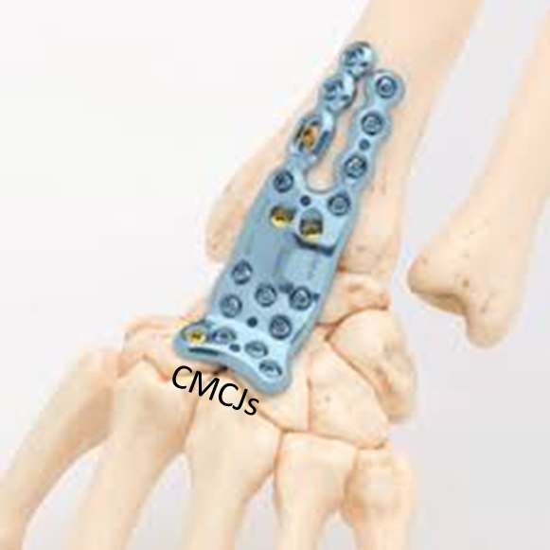

Figure 2. Manufacturers diagram of the Medartis non-bridging plate that spares the CMCJ

Comparison group (CMCJ arthrodesis)

Preparation of the carpals as described above will be extended to include the third carpometacarpal joint which will be thoroughly denuded of cartilage to promote fusion. A CMCJ bridging plate will be applied (Synthes Wrist fusion plate) from the third metacarpal to the radius as described by the manufacturer’s instructions (Figure 3).

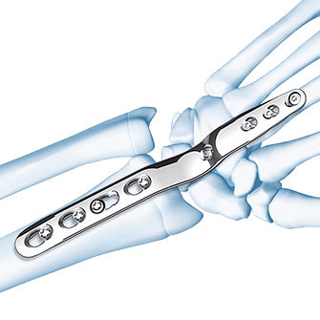

Figure 3. Manufactures diagram of the Synthes wrist fusion plate that bridges the 3 CMCJ.

An image intensifier will be used in both cases to ensure proper plate placement. Wounds will be closed in layers and a short arm back slab will be applied for 2 weeks.

**Post-operative review**

At 2 weeks, all patients will undergo a wound check and be placed in a thermoplastic removal splint.

Patients will then be assessed at 12 weeks with a computed tomography (CT) scan to assess union of the radiocarpal, mid carpal and carpometacarpal joint (if fused).

Clinical assessment will occur on an as needed basis for patients with ongoing pain or complication.

Follow-up for research purposes will occur at 12 months, 2 and 5 years. At this appointment and the assessor will readminister the patient reported outcome instruments, (Disabilities of the Arm Shoulder and Hand (DASH) and Patient Rated Wrist Evaluation (PRWE) score), reassess grip strength and interview the patient about complications.

Physiotherapy

Usual physiotherapy will be undertaken. This will include full shoulder, elbow and finger range of motion exercises will be encouraged from post-operative day 1. All patients will be review by a qualified hand therapist and provided with standardized exercise program.

Assessment

Time points

Participants will have baseline data collected at the time of consent for admission into the study. This will be done using a standard form (Initial patient data form - IPDF). A preoperative DASH, PRWE and grip strength will also be collected.

Perioperative complications will be documented by the treating surgical team at 2 weeks when a check of the surgical wound is performed.

Imaging Review at 12 weeks will be performed to assess union.

DASH, PRWE and complications (Patient review data form - PRDF) and grip strength will be collected at 12 months.

DASH, PRWE and complications (Patient review data form - PRDF) and will be collected at 2 and 5 years.

Complications will be reviewed and checked with individual operating surgeons using standard data form (Surgeon review data form – SRDF). Union will be determined by the treating surgeon at the time of review.

Table X. Assessment activities by timepoint

|  |  |  |  |  |  |
| --- | --- | --- | --- | --- | --- |
|  | Baseline | 12 weeks | **1 year** | 2 years | 5 years |
| Demographics | ✓ |  |  |  |  |
| PROMs (DASH and PRWE) | ✓ |  | ✓ | ✓ | ✓ |
| Grip Strength | ✓ |  | ✓ | ✓ | ✓ |
| Complications |  | ✓ | ✓ | ✓ | ✓ |
| X-ray |  | ✓ |  |  |  |
| CT scan to assess for union of fused joints |  | ✓ |  |  |  |

Baseline assessment

Baseline assessment will include assessment major medical commodities, including

Age

Sex

Diabetes

Smoking

Osteoporosis

Glucocorticoid use

Immunosuppressant use

History of inflammatory arthritis

Indication for total wrist fusion

Number of operations prior to total wrist fusion

Vocational status

Assessment of handedness and limb function

Left/right

Pathology affecting contralateral wrist, either elbow, shoulder

Neurological injury

Grip strength

3 attempts both hands

Patient reported outcomes measures

DASH

PRWE

Primary outcome

The primary outcome will be measure at 12 months and include assessment of complications and union.

Complications

Complications recorded will include

Wound dehiscence

Infection: superficial (treated with antibiotics alone) and deep (requiring surgical debridement and antibiotics

Fracture: in the perioperative period and in the follow up period

Non-union: recorded radiocarpal, midcarpal and carpometacarpal joint and defined as absence of bridging bony trabeculae with no interval change over 3 months

Hardware breakage: plate or screw, managed operative or non-operatively

Tendon rupture

Tendon irritation: requiring treatment

Complex regional pain syndrome: defined according to Budapest criteria

Nerve injury: operatively or not operatively managed

Other: medical and surgical

Union

Union will be defined as radiographic evidence of bridging bony trabeculae in the absence pain on palpation.

Non-union will be defined as the absence of bridging trabeculae, with no documented interval change over a 3-month period.

A CT scan at 12 weeks will be used to assess union of the radiocarpal joint, midcarpal joint and carpometacarpal joint if is fused.

Secondary outcomes

Secondary outcomes will include the DASH, PRWE and clinical data collection at 1, 2 and 5 years.

PRWE, DASH and vocation status (return to work) will also be documented. Both the PRWE and DASH have been used assess function after wrist arthrodesis.

Grip strength will be recorded using three attempts from each hand using a Jamar Digital Dynamometer.

Late complications such as fracture, hardware breakage and the development of CMCJ pain will also be assessed at 2 and 5 years.

Sample size

Nagy reported 20 non unions in 47 attempted wrist fusions with attempted CMCJ fusion and 1 incidence of CMCJ pain in 34 wrist fusion in which the CMCJ was spanned. Berling reported 13 complications in 67 spanned wrist fusions and 7 complications in 55 wrist fusions with attempted CMCJ fusion. Rancy reported 3 complications in 11 spanned wrist fusions and 3 complications in 15 wrist fusions performed with a non-spanning T-plate. Based on these numbers and assuming alpha = 0.05, beta = 0.2, the participants need for this study are 26, 940 and 1062 respectively. Based on these estimates we expect that 100 wrists will be needed to adequately discriminate between these two techniques in terms of complications.

We previously reported a DASH of 19 and PRWE of 13 of in a series of 77 wrist fusions in which the CMCJ was fused. Hernekamp reported a DASH score of 40.5 in 10 non-spanning wrist fusions, compared to 42.8 in 10 spanning wrist fusions(Hernekamp, Schönle, Kremer, Kneser, & Bickert, 2020). Rancy report of PRWE of ﻿25.9 in non-spanning wrist fusion(Rancy et al., 2018). Based on the fact that many studies have been unable to separate CMCJ fusion, non-spanning and spanning using these instruments, and that the MCID for the DASH is estimated as ranging between 10 and 11 (Angst, Schwyzer, Aeschlimann, Simmen, & Goldhahn, 2011; Franchignoni et al., 2014; Schmitt & Di Fabio, 2004), and 10-14 points for PRWE (Arora et al., 2009; Walenkamp et al., 2015), we think it will be difficult for us to show a difference between these groups with only 100 participants. We will however have collect DASH and PRWE as they have been used in a number of papers, including our own series, to assess outcome following wrist arthrodesis(Owen et al., 2016).

Analysis

Data will be analysed on an intention to treat basis.

Descriptive statistical analysis will be performed on patient demographic factors and comorbidities. Randomisation will ensure that both groups are equivalent in terms of comorbidities and demographic factors. A post hoc analysis of the treatment and control group will be performed to assess and confirm this.

Complications will be tabulated and the incidence in each group compared.

Pre-operative and post-operative grip strength, DASH and PRWE will be analysed accordingly. Comparison will be made between preoperative data and post-operative data and between different techniques of wrist fusion.

A statistician will be involved if required.

Cross over

Although the procedures are very similar, it is possible that crossover may occur from the non-spanning method to the spanning technique with CMCJ fusion. This could occur because of the development of pain at the CMCJ due to additional loading or progression of arthritis. Analysis of data will be on an intention to treat basis regardless of final treatment, but the rate of crossover will be described.

Stopping/Interim analysis

There is no plan to perform an interim analysis or stop the study, as it is anticipated that the difference in the treatment and control arms will be small. Both methods assessed are widely used and there is no evidence to suggest superiority of one method over another. All adverse events will be recorded and reported.

12. Safety considerations

This study compares two treatments that at recognized as usual care. It is not anticipated that either treatment arm will be associated with adverse events, above what is expected with wrist arthrodesis surgery. Complications which will be recorded will include:

Wound dehiscence

Infection: superficial (treated with antibiotics alone) and deep (requiring surgical debridement and antibiotics

Fracture: in the perioperative period and in the follow up period

Non-union: recorded radiocarpal, midcarpal and carpometacarpal joint and defined as absence of bridging bony trabeculae with no interval change over 3 months

Hardware breakage: plate or screw, managed operative or non-operatively

Tendon rupture

Tendon irritation: requiring treatment

Complex regional pain syndrome: defined according to Budapest criteria

Nerve injury: operatively or not operatively managed

Other: medical and surgical

13. Data management

Data will be collected stored digitally (emailed or scanned when necessary) on a password protected computer in the Trauma and Orthopaedics Department at Canberra Health Services.

Raw data in de-identified form will be published in an appendix or as supplementary data to allow other researchers analyse the results.

All identifiable data will be destroyed following completion and publication of the research in accordance with local and university data governance policies.

14. Ethical considerations

Approval for this study will be obtained from the ACT Health Human Research Ethics, and other ethics committee other as required.

The study will be registered with the ANZ Clinical Trials Registry and the protocol will be published.

The investigators consider randomization of wrist arthrodesis patients to spanning and non-spanning plate to be ethical and that the potential benefits of conducting this trial outweigh the risks. This trial satisfies the requirements of the National Statement on Ethical Conduct in Human Research.

Participants will not be paid. The investigators will receive no benefits from this study and have no conflicts of interest. Dr Owen is undertaking this study as part of completing a higher research degree.

16. Feasibility

Approximately fifty total wrist fusions are performed in the Canberra region per year. Our goal is to recruit 125 patients to give approximately 100 total wrist fusions, allowing for loss to follow up. This will take approximately 2.5 years.

17. Expected outcomes

This study will provide evidence supporting spanning the CMCJ fusion or non-spanning wrist fusion or suggest that both techniques are equivalent.

If the study determines that non-spanning plates are superior or both methods are equivalent, it will provide support for wrist arthrodesis surgery that does not involve the CMCJ.

If wrist fusion with inclusion of the CMCJ is shown to be advantageous, it will support this method.

This study will provide important information for surgeons treating patient with end stage arthritis of the wrist and address one of the most debated questions in wrist arthrodesis literature.

18. Dissemination of results and publication policy

The results of this study will be published and presented at the Australian Orthopaedic Association Annual Scientific Meeting and the American Academy of Orthopaedic Surgeons Meeting. The RCT will be submitted to the Journal of Bone and Joint Surgery which is a top Q1 journal in orthopaedics.

19. Duration of the project

Recruitment will begin once institutional ethics approval has been obtained and continue until 125 patients have been entered into the study. It is anticipated that this will take up to 3 years.

20. Anticipated problems

Reduced recruitment due to poor patient uptake and higher than expected exclusion will be addressed by increasing the study period.

21. Project management

The day to day running of this study will be done by the principal investigator (assessor). This will ensure that all data is collected and appropriately stored.

The principal investigator will be available by phone and email to answer questions that may arise from the study participants.

Surgeons will be involved in the initial recruitment of patients and the provision of an information sheet as well as usual clinical care including assessment of union and complications.

22. References

Angst, F., Schwyzer, H. K., Aeschlimann, A., Simmen, B. R., & Goldhahn, J. (2011). Measures of adult shoulder function: Disabilities of the Arm, Shoulder, and Hand Questionnaire (DASH) and Its Short Version (QuickDASH), Shoulder Pain and Disability Index (SPADI), American Shoulder and Elbow Surgeons (ASES) Society Standardized Shoulder . *Arthritis Care and Research*. https://doi.org/10.1002/acr.20630

Arora, R., Gabl, M., Gschwentner, M., Deml, C., Krappinger, D., & Lutz, M. (2009). A comparative study of clinical and radiologic outcomes of unstable Colles type distal radius fractures in patients older than 70 years: Nonoperative treatment versus volar locking plating. *Journal of Orthopaedic Trauma*. https://doi.org/10.1097/BOT.0b013e31819b24e9

Berling, S. E., Kiefhaber, T. R., & Stern, P. J. (2015). Hardware-related complications following radiocarpal arthrodesis using a dorsal plate. *Journal of Wrist Surgery*, *4*(1), 56–60. https://doi.org/10.1055/s-0034-1400069

Bolano, L. E., & Green, D. P. (1993). Wrist arthrodesis in post-traumatic arthritis: A comparison of two methods. *Journal of Hand Surgery*, *18*(5), 786–791. Retrieved from http://ovidsp.ovid.com/ovidweb.cgi?T=JS&PAGE=reference&D=med3&NEWS=N&AN=8228047

Butler, A. A. (1949). Arthrodesis of the wrist joint; graft from inner table of the ilium. *American Journal of Surgery*, *78*(5), 625–651. https://doi.org/10.1016/0002-9610(49)90299-8

Clendenin, M. B., & Green, D. P. (1981). Arthrodesis of the wrist—Complications and their management. *Journal of Hand Surgery*, *6*(3), 253–257. https://doi.org/10.1016/S0363-5023(81)80080-9

Franchignoni, F., Vercelli, S., Giordano, A., Sartorio, F., Bravini, E., & Ferriero, G. (2014). Minimal clinically important difference of the disabilities of the arm, shoulder and hand outcome measure (DASH) and its shortened version (quickDASH). *Journal of Orthopaedic and Sports Physical Therapy*. https://doi.org/10.2519/jospt.2014.4893

Hastings, H. 2nd, Weiss, A.-P. P. C., Quenzer, D., Wiedeman, G. P., Hanington, K. R., & Strickland, J. W. (1996). Arthrodesis of the wrist for post-traumatic disorders. *The Journal of Bone and Joint Surgery. American Volume*, *78*(6), 897–902. https://doi.org/http://dx.doi.org/10.2106/00004623-199606000-00013

Hernekamp, J. F., Schönle, P., Kremer, T., Kneser, U., & Bickert, B. (2020). Low-profile locking-plate vs. the conventional AO system: early comparative results in wrist arthrodesis. *Archives of Orthopaedic and Trauma Surgery*, *140*(3), 433–439. https://doi.org/http://dx.doi.org/10.1007/s00402-019-03314-4

Houshian, S., & SchrØder, H. A. (2001). Wrist arthrodesis with the AO titanium wrist fusion plate: A consecutive series of 42 cases. *Journal of Hand Surgery (Edinburgh, Scotland)*, *26 B*(4), 355–359. https://doi.org/10.1054/jhsb.2001.0600

Köhler, S., Koch, K., Arsalan-Werner, A., Mehling, I. M., Seegmüller, J., Krimmer, H., … Sauerbier, M. (2017). Handgelenkarthrodese mit winkelstabiler „Low-profile “-Platte ohne karpometakarpale Fusion. *Operative Orthopädie und Traumatologie*, *29*(5), 416–430. https://doi.org/10.1007/s00064-017-0517-5

Larsson, S. E. (1974). Compression arthrodesis of the wrist. A consecutive series of 23 cases. *Clinical Orthopaedics and Related Research*, (99), 146–153. Retrieved from http://ovidsp.ovid.com/ovidweb.cgi?T=JS&PAGE=reference&D=med1&NEWS=N&AN=4596684

Millender, L. H., & Nalebuff, E. A. (1973). Arthrodesis of the rheumatoid wrist: An evaluation of sixty patients and a description of a different surgical technique. *The Journal of Bone and Joint Surgery. American Volume*, *55A*(5), 1026–1034.

Nagy, L., & Büchler, U. (2002). AO-wrist arthrodesis: With and without arthrodesis of the third carpometacarpal joint. *Journal of Hand Surgery*, *27*(6), 940–947. https://doi.org/10.1053/jhsu.2002.35885

Owen, D. H., Agius, P. A., Nair, A., Perriman, D. M., Smith, P. N., & Roberts, C. J. (2016). Factors predictive of patient outcome following total wrist arthrodesis. *Bone and Joint Journal*, *98*(5), 647–653. https://doi.org/http://dx.doi.org/10.1302/0301-620X.98B5.35638

Rancy, S. K., Ek, E. T., Paul, S., Hotchkiss, R. N., & Wolfe, S. W. (2018). Nonspanning Total Wrist Arthrodesis with a Low-Profile Locking Plate. *Journal of Wrist Surgery*, *7*(02), 127–132. https://doi.org/http://dx.doi.org/10.1055/s-0037-1606257

Schmitt, J. S., & Di Fabio, R. P. (2004). Reliable change and minimum important difference (MID) proportions facilitated group responsiveness comparisons using individual threshold criteria. *Journal of Clinical Epidemiology*. https://doi.org/10.1016/j.jclinepi.2004.02.007

Tu, C., & Benn, E. K. T. (2017). RRApp, a robust randomization app, for clinical and translational research. *Journal of Clinical and Translational Science*, *1*, 323–327. https://doi.org/10.1017/cts.2017.310

Walenkamp, M. M. J., de Muinck Keizer, R. J., Goslings, J. C., Vos, L. M., Rosenwasser, M. P., & Schep, N. W. L. (2015). The Minimum Clinically Important Difference of the Patient-rated Wrist Evaluation Score for Patients With Distal Radius Fractures. *Clinical Orthopaedics and Related Research*. https://doi.org/10.1007/s11999-015-4376-9