**Modifiable Physical Factors that   
Predict Physical Functioning for   
Patients Receiving Peritoneal Dialysis**

**PARTICIPANT INFORMATION SHEET**

1. **Introduction**

You are invited to participate in a research study that is exploring the modifiable physical factors that predict physical functioning for patients receiving peritoneal dialysis (PD).

1. **What is the purpose of the study?**

Little is known surrounding the modifiable physical factors that influence physical function for patients receiving peritoneal dialysis. Muscle strength, cardiorespiratory fitness and physical activity levels are physical factors that have been shown to be positively modified through exercise-based intervention in haemodialysis populations with a paucity of data for patients receiving PD. This study will be one of only a few to determine the key specific modifiable predictors of physical function in patients receiving PD. Knowledge of the key modifiable physical factors may lead to tailored exercise-based interventions to improve quality of life for patients receiving PD.

1. **What does the study involve?**

If you agree to participate in the study you will require medical clearance from a Nephrologist initially before being asked to complete a questionnaire and several physical assessments (see attached summary of assessments) at the beginning of the study, at six months and again at twelve months after commencement. You have the choice of completing these assessments at a routine medical visit in-clinic or at your home. You’re not required to do anything in between testing timepoints. The study is twelve months in duration and you will be free to withdraw at any point.

1. **Who is undertaking this research?**

This research is being carried by researchers attached to the University of South Australia School of Health Sciences (UniSA) and Central Northern Adelaide Renal and Transplantation Service (CNARTS).

Primary Investigator: Mr Brett Tarca

Accredited Exercise Physiologist / Masters by Research Student

School of Health Sciences, University of South Australia (UniSA)  
Phone: +61 8302 2078

Email: Brett.Tarca@mymail.unisa.edu.au

Associate Investigator: Dr Katia Ferrar  
Principle Supervisor / Adjunct Senior Lecturer

School of Health Sciences, University of South Australia (UniSA)   
Phone: +61 8302 2554

Email: Katia.Ferrar@unisa.edu.au

Associate Investigator: Dr Tom Wycherley  
Co-Supervisor / Academic Lecturer in Exercise Science

School of Health Sciences, University of South Australia (UniSA)  
Email: Tom.Wycherley@unisa.edu.au

Phone: +61 8302 1834

Associate Investigator: Prof Paul Bennett

Associate Supervisor / Project Officer  
Central and Northern Adelaide Renal and Transplantation Service (CNARTS)

Email: Paul.Bennett2@sa.gov.au

Phone: +61 8 8222 0984

Associate Investigator: Anthony Meade

Co-Supervisor / Principal Renal Dietitian

Central and Northern Adelaide Renal and Transplantation Service (CNARTS)  
Phone: +61 8 8222 0984

Email: [Anthony.Meade@sa.gov.au](mailto:Anthony.Meade@sa.gov.au)

Associate Investigator: A/Prof. Shilpa Jesudason

Staff Specialist Nephrologist, Central and Northern Adelaide Renal and Transplantation Service (CNARTS),   
Royal Adelaide Hospital Chair, CNARTS Clinical Research Group  
Phone: +61 8 7074 0000

Email: Shilpa.Jesudason@sa.gov.au

1. **What changes will be made to my treatment if I decide to enter the study?**

Your clinical care will continue as normal. The study will be assessing your physical function,   
sedentary behaviour and physical activity levels, cardiorespiratory fitness and muscular strength   
at three timepoints (baseline, six months, twelve months) but will not influence your usual care.

1. **What if I choose not to enter the study?**

This is a research project and you do not have to be involved. If you do not wish to participate, your medical care will not be affected in any way.

1. **What if I choose to enter the study and then change my mind?**

You may withdraw from the project at any time after you have commenced. Again, this will not affect your medical care in any way.

1. **What benefits will the study have to me?**

The study will not change your clinical management but may inform future research trials involving exercise-based interventions. It may further provide information into your current sedentary behaviour and physical activity levels. cardiorespiratory fitness and muscular strength. You will be provided with a report of your results at the conclusion of your participation.

1. **Will I be inconvenienced in any way by being in the study?**

All assessments are completed by home visits from the primary investigator (Mr Brett Tarca) at a convenient time for you. This is repeated three times over a twelve-month period. The assessment may take between 60-90 minutes to complete.

1. **Are there any foreseeable risks associated with being in the study?**

There may be minimal risk involved, however you will be under the supervision of an Accredited Exercise Physiologist (AEP) at all times of the assessments. The AEP will will employ clinical guidelines and practices. You will be able to refuse any aspect of the assessment battery should you wish too.

1. **Confidentiality and Data Security**

All data collected will be de-identified (your name will be replaced by a number) to ensure confidentiality is maintained. You will not be identified in any publication or presentation.

Only information relevant to the study will be collected. Only researchers/investigators involved in the study data collection, analysis and reporting of results will have access to the data.

All data collected in paper form will be stored securely at UniSA, School of Health Sciences in a locked filling cabinet in a locked office. All data collected in electronic form will be stored on the UniSA database or a password protected USB which will be locked in a filing cabinet in a locked room when not in use. All data will be stored for 15 years then destroyed.

In addition to the processes described above, data may otherwise be discoverable through processes of law or for assessing compliance with research procedures. You have a right to access the information collected and stored by researchers about you. You also have a right to request that any information with which you disagree be corrected. You have a right to ask that any stored specimens be destroyed but should be aware that data which has already been derived from those specimens may not be able to be destroyed

**12. Who can I contact if I have concerns?**

The research will be conducted according to the NHMRC National Statement on Ethical Conduct in Human Research, 2007. This project has been approved by the Royal Adelaide Hospital Human Research Ethics Committee. If you have any concerns about the conduct of this study, please do not hesitate to discuss them with:

Mr Brett Tarca (08 8302 2078; email [Brett.Tarca@mymail.unisa.edu.au](mailto:Claire.Trimingham@sa.gov.au)),

Dr Katia Ferrar (08 8302 2554; email [Katia.Ferrar@unisa.edu.au](mailto:Anthony.Meade@sa.gov.au))

Dr Tom Wycherley (08 8302 1834; email [Tom.Wycherley@unisa.edu.au](mailto:shilpa.jesudason@.sa.gov.au)).

If you wish to speak to someone not directly involved in the study about your rights as a volunteer, or about the conduct of the study, you may also contact the Chairperson, Research Ethics Committee, Royal Adelaide Hospital on (08) 7117 2209

**SUMMARY OF ASSESSMENTS**

**Initial Questionnaire:** This a short questionnaire (completed only at the initial   
assessment) which collects demographic details (age, gender, contact details, employment status etc.), dialysis history, recent hospitalizations, current injuries and medical conditions.

**Anthropometric Data:** Participants will have their height, weight, waist and hip girth measurements manually taken.

**Short Physical Performance Battery:** The battery is made up of three components,   
balance through various stances, walking speed over four metres, and the ability to   
rise and sit from a chair five times.

**SF-36:** The SF-36 is a short questionnaire used to determine how individuals perceive and rate their own physical function.

**Accelerometry:** Participants will be asked to wear a watch and pedometer for seven days. The watch doesn’t have a face but will be recording minutes of physical activity per day. The pedometer is worn on your hip which will record the number of steps per day.

**Inclinometry:** Participants will be asked to wear a small rectangular device (size of a matchbox car) which will be taped to their thigh for a period of seven days. This device will record how much time is spent sitting, reclining and lying per day.

**Six-Minute Walk Test:** This assessment involveswalking continuously on a marked out track for a period of six minutes at a self-selected speed. The total distance walked will be recorded.

**Hand Grip Strength Assessment:** This assessment involves the participant holding a dynamometer and squeezing the handle with a maximal effort. This is repeated three times on each hand.

**Quadriceps Strength Assessment:** This assessment involves the participant in a seated position with their legs at 90°. The participant will extend their leg with the tester holding a hand-held dynamometer against their lower ankle.

**Bicep Strength Test:** This assessment involves the participant holding the elbow at 90°. The participant will flex their elbow (like a bicep curl) the tester holding a hand-held dynamometer against their hand or wrist.

**Abdominal Flexion Test:** This assessment involves the participant standing or seated upright. The participant will flex (bend) their upper body with the tester holding a hand-held dynamometer against their chest.

Accelerometer Inclinometer Hand Grip Dynamometer Hand-Held Dynamometer

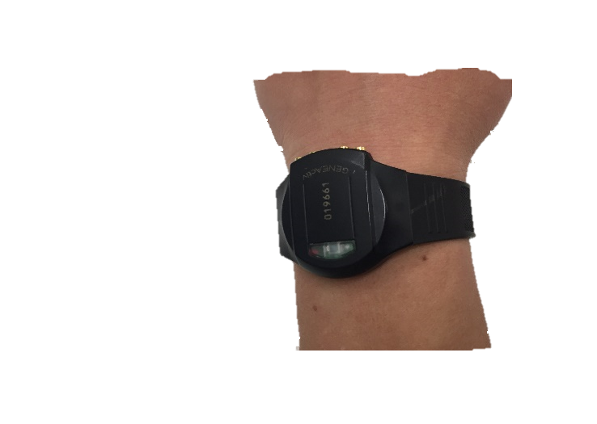 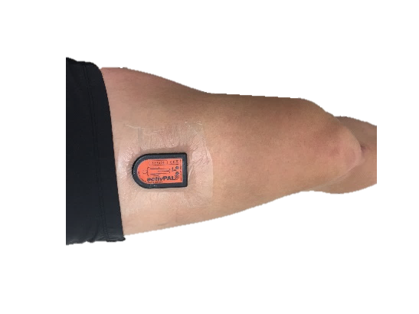 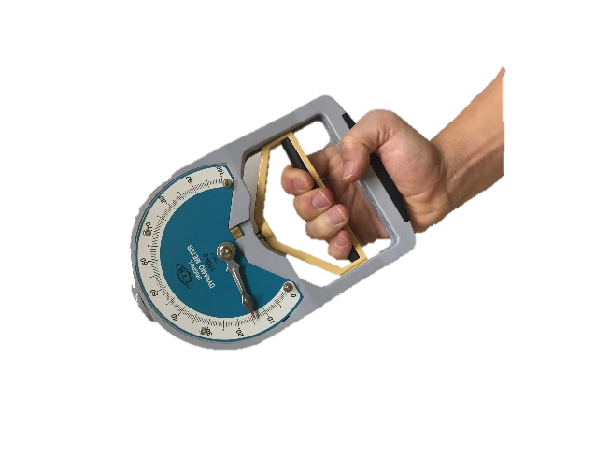 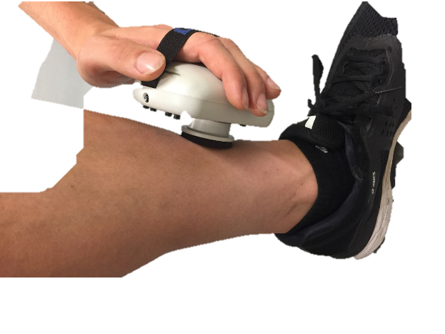

**PARTICIPANT CONSENT FORM**

**PROTOCOL NAME:** Modifiable physical factors that predict physical function for patients receiving   
 peritoneal dialysis.

HREC REFERENCE #: HREC/18/CALHN/538

**INVESTIGATORS**: Mr Brett Tarca, Dr Katia Ferrar, Dr Tom Wycherley, Prof Paul Bennett, Mr Anthony Meade

LOCATION: Home visits or at a routine medical visit in clinic.

***If you consent to being involved in the study please sign and date below***

* I give permission for nursing staff to release my contact details (phone number / e-mail) to the research team for the purpose of discussing the project and / or arranging time and location for assessments to be completed.
* The nature, purpose and risks of the research project have been explained to me. I have read the Participant Information Sheet or that someone has read it to me in a language that I understand. I understand it and agree to take part.
* I understand that I may not benefit from taking part in the trial.
* I understand that, while information gained during the study may be published, I will not be identified and my personal results will remain confidential.
* I understand that any research data is potentially subject to disclosure through processes of law
* I understand that I can withdraw from the study at any stage and that this will not affect my medical care, now or in the future.
* I have had the opportunity to discuss taking part in this investigation with a family member or friend.
* I understand that it is a requirement to have received medical clearance from a Nephrologist to participate in this study prior to any assessment.
* I understand the data from this study will be stored in electronic and audio files for a period of 15 years in a password protected computer at the University of South Australia, Adelaide.
* I understand I should retain a copy of this Consent Form and Participant Information Sheet for future reference.

I would prefer assessments performed at: Hampstead Clinic □ At home □ Either □

Participant Name:

Signed:

Dated:

______________________________________________________________________________________________

***Investigator to complete***

I certify that I have explained the study to the participant/volunteer and consider that he/she understands what is involved.

Signed:

Dated:

______________________________________________________________________________________________