# Research Protocol: Field Testing a Māori/Pacific Version of a Japanese iPad App to Support Culturally Responsive Goal Setting in Clinical Rehabilitation: A Qualitative Study

|  |  |
| --- | --- |
| **Principal Investigator:**  BMedSci (Hons) Student Kato McDonald (Ngāpuhi; Te Aupouri)  Department of Medicine, University of Otago (Wellington) 027 284 0605 mcdka034@student.otago.nz.ac | **Supervisors:**  Prof William Levack Department of Medicine, University of Otago (Wellington) 021 918 627 [william.levack@otago.ac.nz](mailto:william.levack@otago.ac.nz)  Dr Tristram Ingham (Ngāti Kahungunu ki Heretaunga; Ngāti Porou)  Department of Medicine, University of Otago (Wellington) [tristram.ingham@otago.ac.nz](mailto:tristram.ingham@otago.ac.nz)  Bernadette Jones (Ngāti Apa; Ngā Wairiki) Department of Medicine, University of Otago (Wellington) [bernadette.jones@otago.ac.nz](mailto:bernadette.jones@otago.ac.nz) |
| **Affiliates:**  A/Prof Kounosuke Tomori Tokyo University of Technology, Tokyo, Japan [tomorinkoo@gmail.com](mailto:tomorinkoo@gmail.com)  Prof Kayoko Takahashi Kitasato University, Tokyo, Japan kayo.ot@kitasato-u.ac.jp |

## Background

Goal Setting in Rehabilitation

Goal setting is considered an essential component of person-centred rehabilitation. It guides the formation of an appropriate rehabilitation plan for the patient. Goals are built on the unique values, beliefs, and circumstances of an individual patient or client. (1)

Patient involvement in goal selection is a key element of the rehabilitation planning process. The current best research on goal setting in rehabilitation has indicated that there may be some benefit for patients from participation in goal setting, though evidence supporting this is of low quality. (2) Levack et al.’s Cochrane review suggested that structured goal setting practices may lead to an increase in quality of life for patients at the end of their rehabilitation programme (standard mean difference 0.53, 95% confidence interval 0.17 to 0.88.) (1)

Past research, however, has demonstrated that health professionals tend to dominate the goal setting process despite their best intentions, and that there are number of barriers to patient involvement in goal setting. A lack of knowledge about the rehabilitation process or problems with communication of the patient’s interests can lead to this process being dominated by the healthcare team. (3) The patient may also feel overwhelmed or disempowered by the rehabilitation process and become less forthcoming with information as a result. (4) Furthermore, cognitive and communicative impairments create obstacles to robust patient involvement. In cases where direct communication is not possible or too distressing for the patient, family/whānau members may collaborate with the clinician to set goals instead. (5)

Clinicians tend to view rehabilitation goals from a biomedical perspective, to be achieved within a set timeframe, while patients and their family/whānau are more likely to view goals being about activities they want to be able to do or lifestyles they want to return to. (3, 6) Personal characteristics and beliefs of both the patient and the clinician can affect the goal setting process. Health professionals’ views on what should be goals of rehabilitation are limited by their own life experience. This is particularly problematic when the patient and clinician come from different cultural backgrounds.

The importance of facilitating participation in clinical decision-making with Māori and Pacific people

Māori and Pacific people have a particularly high need for quality rehabilitation services as they experience disabling health conditions more frequently than NZ European people, and worse health outcomes. (7) Māori and Pacific groups have been historically oppressed leading to a lower average age of death compared to non-Māori, non-Pacific people, (8) and to them occupying a higher proportion of the most deprived socioeconomic deciles. (9) Māori and Pacific people are young populations compared to non-Māori, non-Pacific people in New Zealand, (9, 10) yet Māori people experience disability at a higher rate than NZ Europeans in all age groups. (11, 12)

Māori and Pacific people also assumed to experience more disability than NZ Europeans, because they have a higher prevalence of common disabling conditions. The Ministry of Health 2018/2019 survey found the prevalence of stroke and ischaemic heart disease to be higher in Māori than non-Māori. (13) Additionally, stroke occurs at a younger age in Māori and Pacific people compared to NZ Europeans. (14) Māori women are a particularly disadvantaged group with a significantly high prevalence of stroke and ischaemic heart disease compared to non-Māori women. (13) Diabetes is twice as prevalent in Māori and three times as prevalent in Pacific people compared to non-Māori, non-pacific people. (13) Complications due to diabetes are 7 times more prevalent in Māori diabetics than non-Māori diabetics. (15) Furthermore, limited data suggests a greater prevalence of spinal cord injury in Māori and Pacific compared to other ethnicities. (16) In the future, as the average age of mortality increases we can expect a greater burden of illness and disability for Māori and Pacific groups, which needs to be addressed.

In formulating an appropriate response for Māori and Pacific it is important to acknowledge the historical oppression of these groups. Unequal distribution of health determinants has contributed to the health disparities between indigenous and non-indigenous populations, which further perpetuates a groups responsiveness (or lack thereof) to certain interventions. (17, 18) Groups with a higher health status are more likely to benefit from general healthy lifestyle promotion as they have more liberty to make the necessary changes in their lives. For disadvantaged indigenous groups where this is less feasible, a more specified approach has been shown to be beneficial. (18) There can also be an increased health burden on Māori and Pacific groups due to wider health determinants, such as poor housing or less access to education.

Health professionals are obliged to meet the principles of Te Tiriti o Waitangi through the delivery of their services. To honour Te Tiriti o Waitangi – particularly the concepts of kāwanatanga (governance) and tino rangatiratanga (authority,) Māori individuals and their whānau need to be empowered with an active role in a partnership during clinical decision-making. (17) Whānau are an important consideration for Māori individuals and thus a key component of culturally safe practice. In a similar fashion, family members will often accompany Pacific patients in clinical settings for both emotional support and for decision-making. (19) Māori culture, including Te Reo Māori must be respected and embedded in healthcare available for Māori patients. (18) He Korowai Oranga declares that Māori groups are entitled to high quality, culturally safe healthcare based on robust research. (17, 20)

Health professionals have a moral obligation to actively improve the outcomes of their clients in their care to the best of their ability. However, presently there are limitations for clinicians around the delivery of this care to Māori and Pacific patients. There are cultural and communication barriers which can hinder the clinician’s understanding of their patient’s life context. In rehabilitation for instance, goals relevant to patient’s life may be rejected or not considered by a clinician if they are deemed to be outside of the scope of the rehabilitation service. (6, 17) Health professionals may not even think to ask about important aspects of a patient’s life if those aspect are not within the health professional’s own life experience. This can create a barrier to culturally responsive, person or whānau-centred rehabilitation if the interests of the patient and the capabilities of the service are not adequately discussed during collaborative goal setting.

“Aid for Decision-making in Occupation Choice” (ADOC)

The Aid for Decision-making in Occupation Choice (ADOC) was created in Japan to address barriers to patient involvement in goal setting. ADOC is a Japanese iPad app developed to aid occupational therapists to collaboratively set goals with their patients based on a shared decision-making model. (21) The app features 94 images of various activities of daily life ranging from basic tasks, such as toileting, to complex, social activities, such as intimate relationships. A client can pick out which activities they would like to work towards during rehabilitation, and they can also rate their satisfaction with their engagement in these individual activities. (21) ADOC achieves greater patient involvement in goal setting by: a) providing more structure to the goal setting process; b) separating the patient’s initial goal selection from the health professional’s initial goal selection prior to more in-depth discussion of priorities; c) presenting patients with a wide variety of possible activities and social roles to indicate the breadth of possible goals they could consider; and d) using images to stimulate patients’ thinking around possible goals to consider and facilitating communication of their preferences. (21) In a test of ADOC involving 116 older adults in Japan, Tomori et al. (co-applicants on this grant) found that even people with a Mini-Mental State Exam (MMSE) score as low as 8 (indicating severe cognitive impairment) (22) could meaningfully participate in goal setting using ADOC. (23)

An English language version of ADOC was created for general use with English speaking patients. This English-language version was developed from a series of Delphi-style consensus meetings involving expert occupational therapists from four countries (New Zealand, Australia, United Kingdom, United States of America.) The images for ADOC-E were based closely off the original designs for ADOC. These images were thought to have good international applicability (See Figure 1 for screenshots from ADOC-E) but lacked content specific to the lives of Māori and Pacific. (24)

A prototype of a Māori/Pacific version of ADOC has recently been created (ADOC-M/P.) This version of ADOC may facilitate greater patients and family/whānau involvement in goal setting, making rehabilitation both more person-centred and more culturally responsive. ADOC-M/P may help health professionals consider culturally relevant goals more often when engaging in goal setting with patients. The ADOC-M/P version specifically features images depicting Māori and Pacific characters with the aim of better depicting Māori and/or Pacific lifestyles. In the development of the prototype for ADOC-M/P, we employed a Māori design company to create new images for this version of ADOC-M/P. Some activities from the original ADOC have been removed and replaced with unique, culturally valued activities such as Ki o Rahi. We consulted with Māori and Pacific representatives (Kaitiakitanga) for feedback on the initial images. One key area that was developed as a result of this feedback was a greater focus in the imagery on the inclusion of whānau and community. (See figure 2 for images that have been developed for ADOC-M/P.)

Our aim: Field testing ADOC-M/P

The aim of this study is to explore the following research questions, from the perspective of rehabilitation professionals and their clients:   
1) What is ADOC-M/P’s potential value to support culturally responsive goal setting in rehabilitation?   
2) How could this technology be improved for future use in New Zealand Health services?

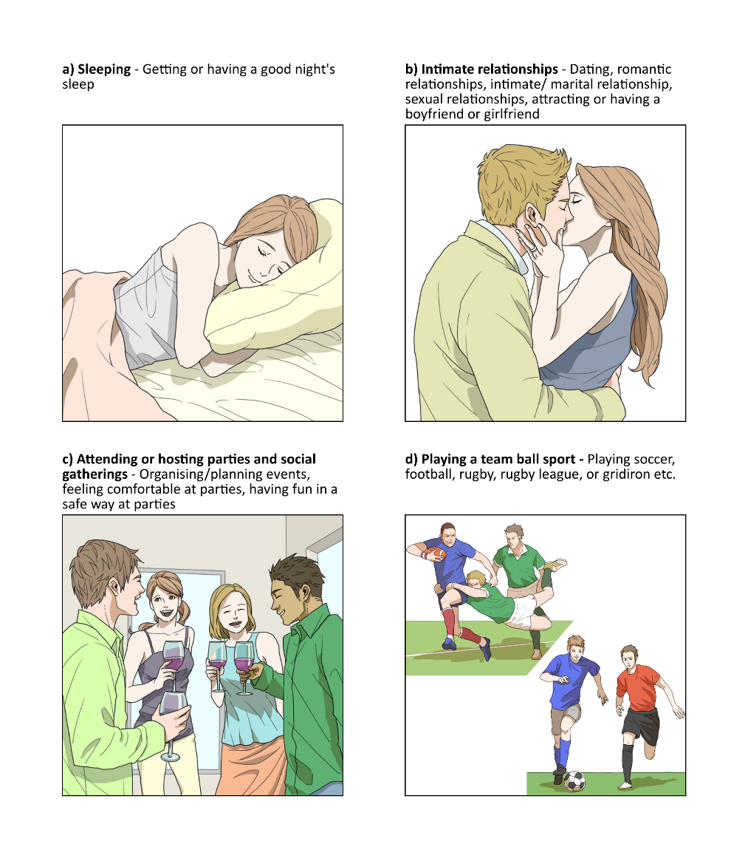

**Figure 1: Examples of images from ADOC-E**

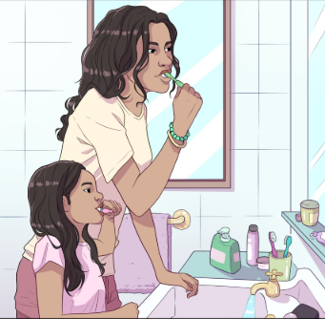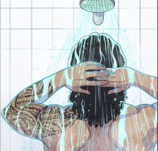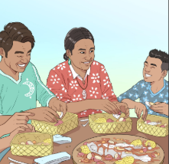

**Figure 2: Examples of draft images from ADOC-M/P currently in development**

## Methods

Methodology

The study will be a qualitative descriptive analysis from individual and whanau-based interviews, nested within kaupapa principles.

Participant recruitment

We are aiming to recruit between 6 to 12 health professionals and 6 to 12 Māori or Pacific clients. We will utilise purposeful sampling to select health professionals from different clinical backgrounds. Furthermore, we will ask these health professionals to aid in the recruitment of the Māori and Pacific clients. For a patient to be included in the study, the clients must identify as Māori and/or Pacific, be a patient in a Whanganui DHB rehabilitation service, be assessed as medically stable, be over 16 years old, be able to see with or without corrective lenses, be able to communicate in English, and score above 8 on the Mini-Mental State Exam (MMSE) as this is the minimum level of cognitive functioning found to be required for meaningful participation in the original, Japanese version of ADOC. (25) For health professionals to be included in the study, they will need to be staff in the rehabilitation services at Whanganui DHB who are usually involved in goal setting as part of their clinical responsibilities.

The primary investigator will invite the health professionals to join the study, providing them with a copy of ADOC-M/P and a small, printed tutorial. The health professionals in the study will use ADOC-M/P with as many patients as they wish, and will approach a selection of patients to ask if they would be interested in being interviewed for the study as well, providing them with the patient’s version of the participant information sheet. Patients who agree will approached by the primary investigator, who will provide them with an opportunity to ask any questions they might have before signing informed consent.

Implementation of ADOC-M/P

Prior to data collection, we will provide rehabilitation clinicians at Whanganui DHB with a copy of ADOC-M/P and information on how to use the technology to support person-centred goal setting. We will ask clinicians to invite Māori and Pacific clients to test the app with them, using it to help set goals for therapy.

Data collection

Data collection will involve interviews with the health professional who have trialled ADOC-M/P and with a selection of patients who have been involved in goal setting using ADOC-M/P. We will conduct interviews with patients in an inpatient setting within a few days of using ADOC-M/P to explore their views and experience of the app. All interviews will be conducted by the principal investigator. The interviews will be semi-structured and 30 to 90 minutes long. This may occur as a single session or as multiple, smaller sessions if the participant prefers. The interviews will be audio-recorded and later transcribed for analysis.

Patients will be interviewed at Whanganui hospital within a few days of using ADOC-M/P. Patients may opt for an individual one-on-one interview or for a whānau-based interview. Health professionals will be interviewed after they have gained 1-2 months’ experience of using ADOC-M/P. These interviews will all be one-on-one and conducted at Whanganui hospital. All participants will be asked for their preferences regarding any customs (Tikanga Māori) to be observed during the meetings.

The interviews will focus on the on the participant’s thoughts, experiences, and views on the use of ADOC-M/P in clinical practice. We will gather demographic data on all participants (age, gender, ethnicity.) We will record years of clinical experience for the health professionals, information about the patients’ presenting health conditions, and contextual information about the rehabilitation service.

After the interview, the participating patients will be given a $20 koha to thank them for their involvement in the study. Participating health professional will be able to keep a copy of ADOC-M/P for future use in their rehabilitation services.

Audio recordings of the interviews will be sent to a hired typist for transcription. This typist has signed an agreement to maintain confidentiality and to store the audio files into a secure location. After she has finished transcription, she will destroy the audio files.

Participant names and contact details will be stored separately from the interview data. Identifiable information such as names or places will be removed from the transcripts. The participants will be referred to under pseudonyms in the published results.

Data analysis

Data analysis will occur concurrently with data collection. We will use NVivo to manage the data and its analysis. Data analysis will involve thematic analysis and the constant comparative method, with each transcript being read and reread, to incorporate findings from additional interviews as the study progresses. Initial coding (open coding) will be undertaken on a line-by-line basis, with subsequent analysis exploring overlap between codes in order to develop a conceptual understanding of the relationships between themes and ideas emerging from the data. We will keep analysis of data from patients/whanau separate from analysis of data from the health professional participants.

A preliminary summary of the study findings will be sent to all participants as feedback (by mail or email, as preferred by them). All participants will be invited to comment on these findings if they choose in a follow up phone call.

## References

1. Levack WMM, Weatherall M, Hay-Smith E, Dean S, McPherson K, Siegert RJ. Goal Setting and Strategies to Enhance Goal Pursuit for Adults with Acquired Disability Participating in Rehabilitation (Review). The Cochrane Library. 2015(7).

2. Levack WMMS, Richard J. Challenges in Theory, Practice and Evidence. In: Levack WMM, editor. Rehabilitation Goal Setting Theory, Practice and Evidence. Baton Rouge2014. p. 3-19.

3. Playford E, Dawson L, Limbert V, Smith M, Ward C, Wells R. Goal-setting in rehabilitation: report of a workshop to explore professionals' perceptions of goal-setting. Clinical rehabilitation. 2000;14(5):491-6.

4. Barnard RA, Cruice MN, Playford ED. Strategies Used in the Pursuit of Achievability During Goal Setting in Rehabilitation. Qualitative Health Research. 2010;20(2):239-50.

5. Levack WMM, Siegert RJ, Dean SG, McPherson KM. Goal planning for adults with acquired brain injury: How clinicians talk about involving family. Brain Injury. 2009;23(3):192-202.

6. Levack WMM, Dean SG, Siegert RJ, McPherson KM. Navigating patient-centered goal setting in inpatient stroke rehabilitation: how clinicians control the process to meet perceived professional responsibilities. Patient education and counseling. 2011;85(2):206-13.

7. Bloomfield A. Health and Independence Report 2017. 2017.

8. Jansen P, Bacal K, Crengle S. He Ritenga Whakaaro: Māori experiences of health services. Auckland; 2008. p. 30.7.

9. Ministry of Health. Wai 2575 Māori Health Trends Report. Wellington: Ministry of Health.; 2019.

10. Ministry of Health. Position Paper on Māori Health Analytics – Age standardisation. Wellington: Ministry of Health; 2018.

11. Statistics New Zealand. Disability Survey, 2013. Wellington2014.

12. King PT. Māori With Lived Experience of Disability Part I Wellington: Ministry of Justice; 2019.

13. Ministry of Health. Annual Data Explorer 2018/19: New Zealand Health Survey [Data File]. In: Health Mo, editor. Wellington2019.

14. Feigin VL, Krishnamurthi RV, Barker-Collo S, McPherson KM, Barber PA, Parag V, et al. 30-Year trends in stroke rates and outcome in Auckland, New Zealand (1981-2012): a multi-ethnic population-based series of studies. PloS one. 2015;10(8).

15. Baxter J. Māori and Type II Diabetes [Internet]. Dunedin: University of Otago; 2019. Podcast

16. van den Heuvel M, Jansz L, Xiong X, Singhal B. People with spinal cord injury in New Zealand. American journal of physical medicine & rehabilitation. 2017;96(2):S96-S8.

17. Harwood M. Rehabilitation and indigenous peoples: the Māori experience. Disability and Rehabilitation. 2010;32(12):972-7.

18. Berghan G, Came H, Coupe N, Doole C, Fay J, McCreanor T, et al. Tiriti-based health promotion practice. STIR: Stop Institutional Racism. 2017.

19. Associates. MO. Best Health Outcomes for Pacific Peoples: Practice Implications. 2010.

20. Ministry of Health. He Korowai Oranga: Māori Health Strategy. Wellington: Ministry of Health; 2002.

21. Tomori K, Uezu S, Kinjo S, Ogahara K, Nagatani R, Higashi T. Utilization of the iPad application: Aid for Decision-making in Occupation Choice. Occupational Therapy International. 2012;19(2):88-97.

22. Tombaugh TN, McIntyre NJ. The mini‐mental state examination: a comprehensive review. Journal of the American Geriatrics Society. 1992;40(9):922-35.

23. Tomori K, Nagayama H, Saito Y, Ohno K, Nagatani R, Higashi T. Examination of a cut-off score to express the meaningful activity of people with dementia using iPad application (ADOC). Disability and Rehabilitation: Assistive Technology. 2015;10(2):126-31.

24. Levack WMM, Tomori K, Takahashi K, Sherrington AJ. Development of an English-language version of a Japanese iPad application to facilitate collaborative goal setting in rehabilitation: a Delphi study and field test. BMJ Open. 2018;8(3):e018908.

25. Levack WM, Dean SG, Siegert RJ, McPherson KM. Navigating patient-centered goal setting in inpatient stroke rehabilitation: how clinicians control the process to meet perceived professional responsibilities. Patient Education and Counselling. 2011;85(2):206-13.