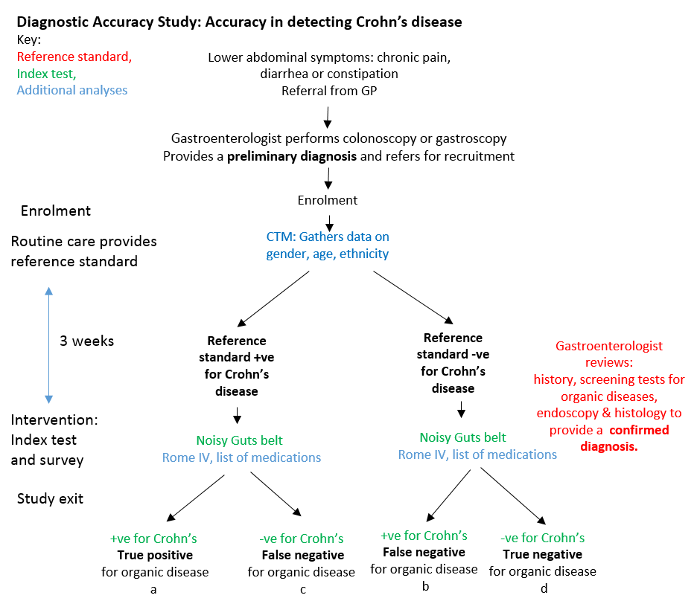

Sensitivity is calculated as the rate of true positive test results for all the individuals with the condition, i.e., a / (a+c)

Specificity is calculated as the rate of true negative test results for all the individuals free of thee condition or d / (b+d)

Accuracy is calculated as (a+d) / (a+b+c+d)