Research Plan

“What is the functional outcome of ICU survivors assessed by the Acute Care Index of Function (ACIF)?”

- Vince Marzano^{1,2}
- Sally Laughton¹
- Sumeet Rai^{1,2}
- Bernie Bissett³
- Carol Hodgson⁴
- Ekavi Georgousopoulou¹
- Hwan-Jin Yoon⁵
- Frank van Haren^{1,2,3}

¹ Medical School, Australian National University, Canberra
²Canberra Health Services, Canberra
³Faculty of Health, University of Canberra, Canberra
⁴Monash University, Melbourne
⁵Statistical Consulting Unit, Australian National University, Canberra

Synopsis
An increasing number of patients are surviving critical illness. Despite survival, cohort studies demonstrate that critical illness survivors have poor long-term functional outcomes resulting in a reduced quality of life. Current research is focusing on interventions that reduce or reverse this phenomenon. It has been recommended that a better understanding of subgroups within ICU survivors is required to develop interventions that improve long term outcomes in critical care survivors.

The primary objectives of this study are to describe the functional outcome of ICU survivors with the Acute Care Index of Function (ACIF) and to identify factors associated with the functional outcome of ICU survivors at hospital discharge. Factors associated with functional outcome of ICU survivors, including demographic factors, disease severity, interventions required during critical illness and pre-admission frailty will also be explored. We will also aim to validate the ACIF against the Functional Independence Measure (FIM).

We propose a retrospective observational cohort study examining the functional outcomes of a critical illness survivor group. Patients admitted to the ICU at Canberra Hospital between 1 July 2018 and 30 June December 2019, who were at least 18 years of age and required 72 hours of intensive care, will be included. Patients will be excluded if they died in ICU, were discharged from ICU for palliation, re-admitted to ICU during the current hospital admission or transferred to another ICU. Global rating scale of change will be collected prospectively in a separate data collection period to establish the minimal important difference of the ACIF with both an anchor method and two distribution methods.

Patient data will be extracted from the ANZICS data base and the medical file, including patient demographics, disease severity, clinical frailty and interventions required in ICU. Outcome measures will include, ICU length of stay, hospital length of stay, presence of ICU delirium, ACIF at ICU and hospital discharge, and discharge destination. Patient outcomes will be reported with descriptive statistics. Analysis of variance will be used to describe the differences between groups. A multiple regression model and survival analysis will be used will be utilized to determine any relationship between variables. ACIF validation will be conducted with classification statistics and area under curve analysis.

Abbreviations and Acronyms
ACIF: Acute Care Index of Function
ACTPAS: ACT Health Patient Administrations System
ANZICS: Australia and New Zealand Intensive Care Society
APACHE II: Acute Physiology and Chronic Health Evaluation II
CAM-ICU: Confusion Assessment Method-ICU
CPF: Clinical Patient Folder System
DOCCR: Division of Critical Care Research committee
FIM: Functional Independence Measure
ICU: Intensive Care Unit
ICU REX: ICU Research Executive Committee
IMS: ICU Mobility Scale
RSDU: Division of Critical Care, Research and Service Development Unit
SOFA: Sequential Organ Failure Assessment Score
SNAP: Subacute and non-acute patients

Introduction / Background
An increased proportion of patients survive critical illness[1-6]. Although this is a positive trend for Intensive Care Units (ICU), survivors often experience poor long-term outcomes such as reduced cognitive function and ICU acquired weakness. This leads to a reduced physical function and poor quality of life[7-12]. Factors that increase the risk of ICU acquired weakness have been examined in research however it is yet to be established how these factors influence long-term functional outcomes[13, 14].It has been suggested that patient heterogeneity may influence functional recovery in an ICU population although it is likely there are many factors that impact on function following ICU survival [15]. Poor hospital outcomes are also frequently reported in this population including protracted length of stay, and discharge to destinations other than home[6, 16, 17].This represents a significant burden on healthcare resources incurring major economic costs[18, 19]. Understanding the functional outcome and trajectory of ICU survivors, as well as the ICU factors that influence them, is critical if we are to develop and target interventions to mitigate them.
To fully understand the functional outcomes for ICU survivors, valid outcomes measures are required. A challenge in validating outcome measurement tools in this population is the heterogenicity of patients and the absence of a gold standard comparator in the literature[20, 21]. A variety of tools have been used in research to measure function in critical care patients with varying clinometric properties[22, 23]. To date, there is no consensus on the most appropriate functional outcome measure to use in clinical practice[24]. Diversity in outcome measures has precluded meta-analysis of systematic reviews limiting the ability to draw conclusions from evidence[25, 26].Therefore, further evaluation of functional outcome measurement tools in ICU populations is warranted. We propose the Acute Care Index of Function (ACIF) as a candidate for further investigation.
The ACIF is a functional outcome measure developed in 1988 used extensively in neurological, medical, and more recently ICU populations[27-29]. It has recently been validated for use in an intensive care unit and has demonstrated excellent inter-rater reliability (ICC 0.94) without demonstrating a floor or ceiling effect[30]. To date this is the only such study evaluating it clinometric properties in an ICU population. However, there are limitations in the methodology used to validate the ACIF. This includes a small overall patient population (43 patients). The previous study also validated the ACIF against the ICU Mobility Scale. While this outcome measure has been validated to describe the highest level of mobility in ICU patients[31], it is not a measure of overall function. The Functional Independence Measure (FIM) has been used extensively the rehabilitation population[32, 33] and in the ICU population[34, 35]. It is also currently used as the gold standard outcome measure in the Australian health care system for activity-based funding[36]. There are several limitations in utilizing the FIM in everyday clinical practice. These include the instrument requiring a license and specialized training. Some benefits of pursuing the ACIF against other outcome measures is that it is freely available, efficient, easy to learn and administer during regular clinical practices and it encompasses a cognitive component within its four domains.
Due to the complexity of ICU patients and environment, it is likely multiple factors contribute to the functional outcome of a patient. This has become an area of interest for contemporary researchers and previously explored[6, 37, 38]. These variables have included patient demographics, disease severity and exposure to individual life sustaining therapies. To date, studies have concentrated on either survivors of Acute Respiratory Distress Syndrome (ARDS)[12, 39], respiratory failure or sepsis[40, 41]. Large numbers of ICU survivors have been excluded from these studies, thus the relationship between these variables and outcome is not reflective of the wider ICU population. We assert that, in describing the relationship between ICU variables and patient function in a heterogeneous group of ICU patients, we may be able to identify patients who are at risk of poor functional recovery. Identification of associated factors may have implications for the allocation of rehabilitation resources in the ICU and beyond. Further investigation and validation of the ACIF in an ICU population will add to better understanding of its clinometric properties and will also help to describe the functional trajectory of ICU patients. We perceive that it is a valuable pursuit in a clinical area that lacks consensus on functional outcome measures.

Objectives
The primary objectives of this study are:
- To describe the functional outcome of ICU survivors assessed by the Acute Care Index of Function (ACIF).
- To identify factors associated with the functional outcome of ICU survivors at hospital discharge
- To determine if ACIF is a valid tool of physical function in a heterogenous ICU population.
The secondary objectives of this study are:
- To describe the difference in ACIF scores between ICU discharge and hospital discharge in a heterogenous ICU population
- To determine if there is a difference in ACIF scores observed in distinct ICU populations
- To determine the criterion and construct validity of the ACIF in comparison to the FIM for ICU survivors
- To determine the predictive validity of the ACIF on ICU discharge in relation to discharge destination, hospital LOS and hospital survival
- To determine the responsiveness of the ACIF over time from ICU dc to hospital dc.
- To determine the floor and ceiling effect of the ACIF in the ICU population
- To determine if there is a relationship between ACIF at ICU discharge, hospital discharge and discharge destination
- To determine if there is a relationship between ACIF at ICU discharge, hospital discharge and hospital length of stay
- To determine if there are antecedent factors or severity of illness factors that determine functional outcome as measured by the ACIF

Hypothesis
- That ACIF scores at ICU discharge will predict physical function and discharge destination at hospital discharge
- That a relationship exists between patient factors and severity off illness on functional outcome measured by the ACIF at hospital discharge
- That the ACIF is a valid tool to measure the functional outcome of ICU survivors

Study Methodology
We propose a retrospective observational cohort study of all admissions to the Canberra Hospital ICU from the 1 July 2018 through to the 31 June 2019 who meet the inclusion criteria. Data will be either be extracted or calculated from the ANZICS data base, the patient’s medical file or ACTPAS by the researchers. Please refer to appendix 1 for full details of data collection. All data will be inputted into a purpose-developed data base and statistical analysis completed.

Study population
Participants will be sourced from the ICU admission data from the ANZICs database. Participants will be recruited if they were admitted to the ICU at Canberra Hospital between the 1 July 2018 and 30 June 2019. Participants will be included if they were 18 years of age at the time of admission to ICU and required ICU care for 72 hours or more. Patients will be excluded if they did not survive to ICU discharge, were discharged to the ward for active palliation, transferred to another ICU for ongoing care, or if there is insufficient data in the clinical file to calculate ACIF score on both ICU and hospital discharge. Data will only be collected for the first ICU admission that meets the inclusion criteria.
To describe the functional outcome of the selected cohort (primary outcome), we anticipate approximately 600 participants will meet the inclusion criteria based on previous studies with similar inclusion criteria at the ICU at Canberra Hospital and current admission rates. We do not anticipate requiring power calculations as the primary outcome will be reported with descriptive statistics and secondary outcomes are exploring linear relationships between variables.

Study procedure
We will seek a waiver of consent as there will be no intervention or interaction with participants. Outcome measures will be retrieved from already existing databases or calculated from information detailed in the clinical file

The primary functional outcome measure will be ACIF score at ICU discharge and hospital discharge. The ACIF was developed for use in a neurological population[42] and has been validated for use in an ICU population[30]. It assesses 20 functional items in four domains (mental status, bed mobility, transfers and mobility). For detailed scoring and administration instructions, refer to appendix 2 and 3).

The FIM is an 18-item scale used extensively in the rehabilitation setting[32] as well as in previous ICU studies measuring physical function[34]. It has demonstrated high construct validity, as well as inter and intra-rater reliability and the ability to measure change over time[43]. Please refer to appendix 4 for detailed information regarding scoring of the FIM. It is currently considered the gold standard in the Australian rehabilitation sector and utilised in activity-based funding. It is routinely collected for all patients at the point of care type change and at admission to a rehabilitation facility at the Canberra Hospital by the SNAP team and scores recorded in ACTPAS. Care type change is defined as the point in an inpatients care where they are considered medically stable and have transitioned to a subacute status.

The other secondary outcome measures will be: ICU length of stay; hospital length of stay; ICU readmission, and discharge destination. Discharge destination will be categorised as death, discharge home, discharge to another acute facility, discharge to an inpatient rehabilitation facility, or discharge to care facility.

The variables to be collected are outlined in Table 1. More details of drug dosages and names is outlined in appendix 5.

Table 1: Data Variables
Patient factors | Disease Severity | ICU Interventions | Other
Age | APACHE II | Total mechanical ventilation time | IMS score (appendix 6)
Sex | SOFA Score (appendix 7) | Total non-invasive ventilation time | CAM-ICU  (appendix 8)
Comorbidity Index | ICU admission diagnosis | Number of Continual renal replacement days
Clinical Frailty Index  (appendix 10) |  | Cumulative opioid dosage
 |  | Cumulative vasoactive infusions
 |  | Cumulative corticosteroid dosage
 |  | Cumulative neuromuscular blocking agent dosage
 |  | Cumulative benzodiazepine dosage
 |  | Cumulative anti-psychotic dosage

Procedure:
All patients admitted to the ICU at the Canberra Hospital during the data collection period will be screened for eligibility from the ANZICS data base. All patients who meet the inclusion criteria will have data extracted or calculated from the ANZICS data base, clinical file (CPF and METAVISION and ACTAS) as outlined in appendix 1.

On ICU admission, patients’ age, sex, comorbidity index, ICU admission diagnosis and, APACHE II will be extracted. Clinical frailty and SOFA score will be calculated by the researchers. Patients will be stratified for subgroup analysis as per appendix 10. SOFA score will be recalculated on day 3 of admission. On ICU discharge, patients’ highest IMS or presence of ICU delirium (positive CAM-ICU) will be recorded. ICU interventions (refer to Table 1) and ICU LOS will be calculated. ACIF score on the day of ICU discharge for each participant will be extracted from the physiotherapy entries in METAVISION. If no ACIF score has been recorded on the day of discharge, ACIF score will be calculated by the researchers (SL or VM) from the physiotherapy and nursing entries recorded in the medical file.

All patients who have had a care type change from acute to subacute during their inpatient stay will have an ACIF calculated from the nursing and physiotherapy entries in the medical file on the day of care type change. This will be determined from ACTPAS data reports. FIM scores are calculated by SNAP team members as routine practice separate to this study and entered into the ACTPAS system. FIM scores will be extracted from ACTPAS after ACIF scores have been recorded for this group of participants. FIM data will be extracted after ACIF scores have been calculated to ensure blinding of the researchers to results.

ACIF on hospital discharge will be calculated by the researcher (SL or VM) from the nursing and physiotherapy entries in the medical file retrieved from the CPF system.
Discharge destination data will be sourced from ACTPAS data base. All patients who are discharged to rehabilitation facility will have FIM scores extracted from the ACTPAS data base.

Retrospective Timeline
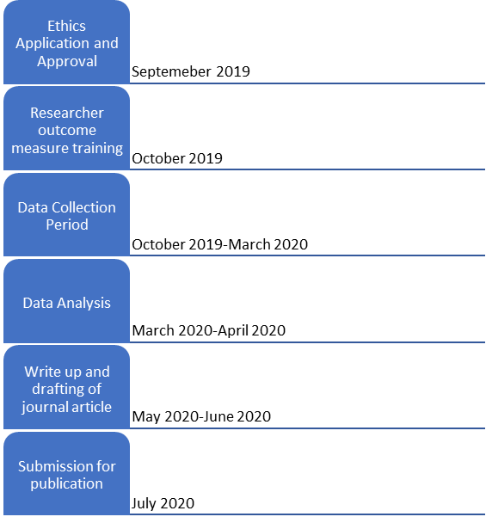

This research will allow clinicians to better understand and anticipate the expected trajectory of recovery for critical illness survivors across the spectrum of recovery. This information will also allow clinicians to better commence timely discharge planning at ICU discharge to improve patient outcomes.

By including a large patient cohort, we anticipate we will be able to stratify patients into subgroups based on clinical diagnosis and patient demographics. The findings of this research will provide information to better understand how these subgroups respond to critical illness in relation to physical function and guide future research into early mobility and physical activity in critical care patients.

One of the aims of this study is to further validate the ACIF as a functional assessment tool of critical care patients. This tool has been previously validated in this population, however this was in a smaller patient cohort and in a less heterogenous ICU population than is anticipated from the proposed study. The utility of this tool is that it is quick to administer as part of routine care. This validation may also increase the utility of the ACIF in future research. We do not anticipate any risk or burden to participants.

Data Analysis
The statistics will be undertaken by the researchers in collaboration with a statistician from the statistical consulting unit at the ANU.
Data will be extracted and organized in excel spreadsheets with all variables defined and a data dictionary established. Patient outcomes will be reported with descriptive statistics. Multiple regression models will be used to explore the relationships between functional measures (ACIF) (dependent variable) and length of stay, discharge destination, clinical subpopulations. Survival analysis will be used if time to event data can by analysed. Comparisons between groups will be performed with Pearsons’ Chi-square, t-test, ANOVA and their non-parametric equivalents. These models will be adjusted for demographic factors such as age, sex, clinical frailty and comorbidity. Medical interventions will be categorized, and their effect will be modelled with ACIF and length of stay as the dependent variables. At this point significance will be accepted where p < 0.05 inline with current research practices.
To determine the validity of the ACIF, spearman rank correlation will be used to determine criterion and construct validity between FIM and ACIF. Demming regression will be used to logistic regression to establish any predictive properties of the ACIF if a relatitionship between ACIF and FIM is found. Multinomial regression will be used if no relationship is able to be established. The percentage of participants who score highest and lowest scores will establish the floor and ceiliing effect of the ACIF. A paired t-test for parametric data and regression model will be used to establish the ACIFs responsiveness over time. A multiple regression model will be used to determine whether antecedent factors, severity of illness or particular ICU interventions predict function as measured by the ACIF
This study will be reviewed and overseen by the ICU-REX and DOCCR committees of Canberra Health Services.

Ethical Issues
Consent by participants will not be required as this is a non-interventional study and there will be no interaction with participants. All data will be accessed or calculate from already existing sources (ANZICS Database, METAVISION, medical file or ACTPAS). Participants will be de-identified and coded using a numerical numbering system. No individual patient characteristics will be reported to prevent identification. Data will be stored in a password protected file on a secure network accessible only by the research team. There will be no risk of coercion or influence on outcome measures by the principal investigators due to the retrospective nature of the study. There is a risk of dual relationships if participants are readmitted to the ICU at Canberra Hospital during the data collection period as the researchers may be involved in patient care. Due to the nature of this study, we do not anticipate data collected as part will impact future interactions with participants as all data is available to clinicians

This project will require approval from the ACT Health Human Ethics Committee and the Australian National University Human Ethics Committee.

Finance and resource use
This project forms part of the lead researches’ (VM) PhD candidacy and is fully funded by an ANU scholarship. The project will also be supported by an ANU medical student (SL), who will assist with data collection and analysis. There is no conflict of interest to declare. There are no direct costs associated with this study. Indirect costs will be associated with data reports required by RSDU.

Dissemination of Results and Publication policy
The findings of this research will be disseminated via publication in a peer reviewed journal and will be submitted for presentation at CHARM 2020 and ANZICs 2020. The findings will also be presented to the Canberra Hospital ICU multidisciplinary in-service program. We will follow Canberra Health Services policy requirements at the time for dissemination and publication of data.

References

1. Valles, J., et al., Trends in the incidence and mortality of patients with community-acquired septic shock 2003–2016. Journal of Critical Care, 2019. 53: p. 46-52.
2. Abdelkarim, H., et al., A comparison of characteristics and outcomes of patients admitted to the ICU with asthma in Australia and New Zealand and United states. Journal of Asthma, 2019: p. 1-7.
3. Casamento, A., et al., Patient characteristics, incidence, technique, outcomes and early prediction of tracheostomy in the state of Victoria, Australia. Journal of critical care, 2018. 44: p. 278-284.
4. Majumdar, A., et al., Declining mortality in critically ill patients with cirrhosis in Australia and New Zealand between 2000 and 2015. Journal of hepatology, 2017. 67(6): p. 1185-1193.
5. ANZICS, C., Centre for outcome and resource evaluation annual report 2011–2012. Australian and New Zealand Intensive Care Society, Melbourne, 2013.
6. Detsky, M.E., et al., Six-month morbidity and mortality among intensive care unit patients receiving life-sustaining therapy: A prospective cohort study. Annals of the American Thoracic Society, 2017. 14(10): p. 1562-1570.
7. Herridge, M.S., et al., Functional disability 5 years after acute respiratory distress syndrome. New England Journal of Medicine, 2011. 364(14): p. 1293-1304.
8. Cheung, A.M., et al., Two-year outcomes, health care use, and costs of survivors of acute respiratory distress syndrome. American journal of respiratory and critical care medicine, 2006. 174(5): p. 538-544.
9. Garland, A., et al., A Population-Based Observational Study of Intensive Care Unit–Related Outcomes. With Emphasis on Post-Hospital Outcomes. Annals of the American Thoracic Society, 2015. 12(2): p. 202-208.
10. Chu, L., et al., The RECOVER program: one-year disability in critically ill patients mechanically ventilated (MV) for 7 days. Am J Respir Crit Care Med, 2015. 191: p. A5123.
11. Pandharipande, P.P., et al., Long-term cognitive impairment after critical illness. New England Journal of Medicine, 2013. 369(14): p. 1306-1316.
12. Fan, E., et al., Physical complications in acute lung injury survivors: A two-year longitudinal prospective study. Critical Care Medicine, 2014. 42(4): p. 849-859.
13. Wolfe, K.S., et al., Impact of Vasoactive Medications on ICU-Acquired Weakness in Mechanically Ventilated Patients. Chest, 2018. 154(4): p. 781-787.
14. Stevens, R.D., et al., Neuromuscular dysfunction acquired in critical illness: a systematic review. Intensive care medicine, 2007. 33(11): p. 1876-1891.
15. Neumeier, A., et al., Prolonged acute care and post-acute care admission and recovery of physical function in survivors of acute respiratory failure: A secondary analysis of a randomized controlled trial. Critical Care, 2017. 21(1).
16. Thompson, K., et al., Health-related outcomes of critically ill patients with and without sepsis. Intensive care medicine, 2018. 44(8): p. 1249-1257.
17. Brandstetter, S., et al., Ambulatory and stationary healthcare use in survivors of ARDS during the first year after discharge from ICU: findings from the DACAPO cohort. Annals of intensive care, 2019. 9(1): p. 70.
18. van Beusekom, I., et al., Healthcare costs of ICU survivors are higher before and after ICU admission compared to a population based control group: A descriptive study combining healthcare insurance data and data from a Dutch national quality registry. Journal of critical care, 2018. 44: p. 345-351.
19. Secombe, P.J. and P. Stewart, Long-term morbidity and mortality in survivors of critical illness: a 5-year observational follow-up study. Rural & Remote Health, 2017. 17.
20. Corner, E.J., Intensive care unit acquired weakness: measuring recovery from critical illness. Journal of the Intensive Care Society, 2012. 13(3): p. 216-220.
21. Elliott, D., et al., Assessing physical function and activity for survivors of a critical illness: a review of instruments. Australian Critical Care, 2011. 24(3): p. 155-166.
22. Parry, S.M., et al., Functional outcomes in ICU–what should we be using?-an observational study. Critical Care, 2015. 19(1): p. 127.
23. Parry, S.M., et al., Assessment of impairment and activity limitations in the critically ill: a systematic review of measurement instruments and their clinimetric properties. Intensive care medicine, 2015. 41(5): p. 744-762.
24. Connolly, B., et al., Physical Rehabilitation Core Outcomes In Critical illness (PRACTICE): Protocol for development of a core outcome set. Trials, 2018. 19(1).
25. Stiller, K., Physiotherapy in intensive care: An updated systematic review. Chest, 2013. 144(3): p. 825-847.
26. Li, Z., et al., Active mobilization for mechanically ventilated patients: A systematic review. Archives of Physical Medicine and Rehabilitation, 2013. 94(3): p. 551-561.
27. Kayambu, G., R. Boots, and J. Paratz, Early physical rehabilitation in intensive care patients with sepsis syndromes: a pilot randomised controlled trial. Intensive Care Medicine, 2015. 41(5): p. 865-874.
28. Scherer, S.A. and A.S. Hammerich, Outcomes in cardiopulmonary physical therapy: Acute care index of function. Cardiopulm Phys Ther J, 2008. 19(3): p. 94-97.
29. Van Dillen, L.R. and K.E. Roach, Reliability and validity of the Acute Care Index of Function for patients with neurologic impairment. Physical Therapy, 1988. 68(7): p. 1098-1101.
30. Bissett, B., et al., Reliability and utility of the Acute Care Index of Function in intensive care patients: An observational study. Heart and Lung: Journal of Acute and Critical Care, 2016. 45(1): p. 10-14.
31. Tipping, C.J., et al., The ICU mobility scale has construct and predictive validity and is responsive. A multicenter observational study. Annals of the American Thoracic Society, 2016. 13(6): p. 887-893.
32. Oczkowski, W.J. and S. Barreca, The functional independence measure: its use to identify rehabilitation needs in stroke survivors. Archives of Physical Medicine and Rehabilitation, 1993. 74(12): p. 1291-1294.
33. Ring, H., et al., Functional measures of first-stroke rehabilitation inpatients: usefulness of the Functional Independence Measure total score with a clinical rationale. Archives of physical medicine and rehabilitation, 1997. 78(6): p. 630-635.
34. Dennis, D.M., et al., How do Australian ICU survivors fare functionally 6 months after admission? Critical Care and Resuscitation, 2011. 13(1): p. 9.
35. Sidiras, G., et al., Short and long term outcomes of ICU acquired weakness. Health Science Journal, 2013. 7(2).
36. Darzins, S.W., C. Imms, and M. Di Stefano, Measurement of activity limitations and participation restrictions: examination of ICF-linked content and scale properties of the FIM and PC-PART instruments. Disability and rehabilitation, 2017. 39(10): p. 1025-1038.
37. Gandotra, S., et al., Physical function trajectories in survivors of acute respiratory failure. Annals of the American Thoracic Society, 2019. 16(4): p. 471-477.
38. Rydingsward, J.E., et al., Functional status in ICU survivors and out of hospital outcomes: A cohort study. Critical Care Medicine, 2016. 44(5): p. 869-879.
39. Brown, S.M., et al., Predictors of 6-month health utility outcomes in survivors of acute respiratory distress syndrome. Thorax, 2017. 72(4): p. 311-317.
40. Iwashyna, T.J., et al., Long-term cognitive impairment and functional disability among survivors of severe sepsis. JAMA - Journal of the American Medical Association, 2010. 304(16): p. 1787-1794.
41. Paratz, J.D. and G. Kayambu, Early exercise and attenuation of myopathy in the patient with sepsis in ICU. Physical Therapy Reviews, 2011. 16(1): p. 58-65.
42. Roach, K.E. and L.R. van Dillen, Development of an Acute Care Index of Functional status for patients with neurologic impairment. Physical Therapy, 1988. 68(7): p. 1102-1108.
43. Kidd, D., et al., The Functional Independence Measure: a comparative validity and reliability study. Disability and rehabilitation, 1995. 17(1): p. 10-14.

Appendix 3: ACIF administration instructions
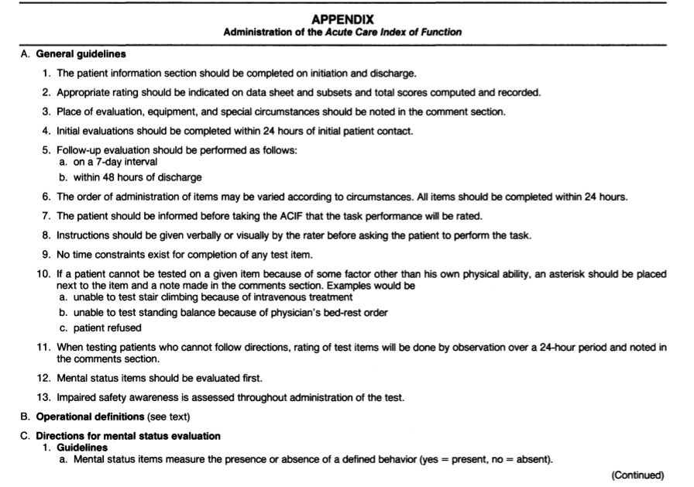

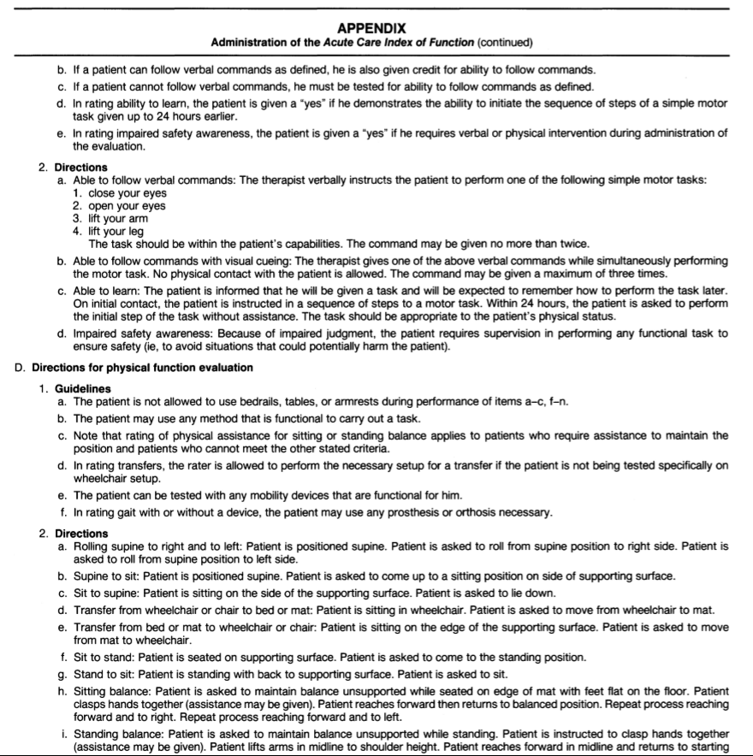
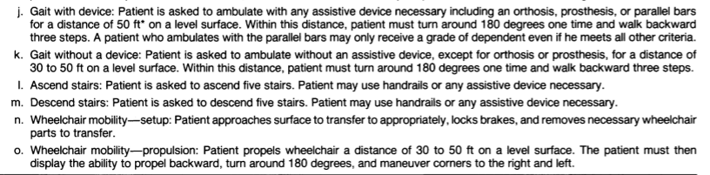

Appendix 4: FIM scoring
https://www.strokengine.ca/pdf/FIMappendixD.pdf

Appendix 5: ICU Mobility Scale
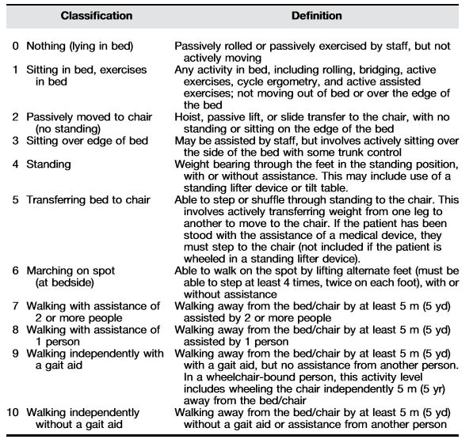

Appendix 6: SOFA scoring
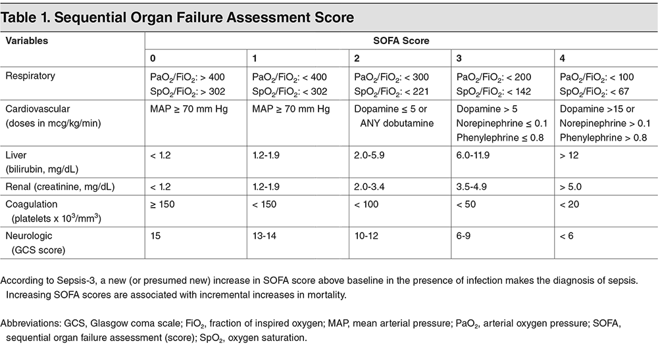

Appendix 7: Clinical Frailty Index
http://www.managingmds.com/content/Clinical_Frailty_Scale.pdf

Appendix 8: Drug names and dosages
Drug Type | Drug Names | Units of measurement
Vasoactive | Noradrenaline  Vasopressin  Adrenaline  Isoprenaline  Dobutamine  Dopamine  Phenylephrine  Milrinone | - mcg/min  - units/min  - mcg/min  - mcg/min  - mcg/kg/min  - mcg/kg/min  - mcg/min  - mcg/kg/min
Corticosteroids | Hydrocortisone  Methylprednisolone | - mg  - mg
Neuromuscular blocking agents | Cisatracurium  Atrocurium  Rocuronium  Vencuronium  Pancuronium  Mivacurium (never used) | mcg/kg/min
Opioids | Fentanyl (IV)  Alfentanyl (IV)  Morphine (IV/PO)  Ketamine (IV)  Hydromorphone (IV/PO)  Methadone (IV/PO)  Remifentanil (IV)  Pehtidine (IV)  Oxycodone (PO)  Buprenorphine (PO/Topical)  Tramadol (PO)  Tapentadol (PO)  Codeine (PO) | - mcg/hr  - mcg  - mg/hr or mg oral  - mg/hr  - mg/hr or mg oral  - mg  - mg/hr  - mg  - mg  - mcg/hr  - mg  - mg  - mg
Benzodiazapines | Midazolam (IV/PO)  Diazepam (IV stat/PO)  Clonazepam (IV/PO)  Lorazepam (IV/PO)  Alprazolam (PO)  Nitrazepam (PO)  Temazepam (PO)  Oxazepam (PO)  Flunitrazepam (PO)  Clobazam (PO) | - mg/hr  - mg -  - mg/hr or mg oral  - mg  - expressed as mcg or mg  - mg  - mg  - mg  - mg  - mg
Anti-psychotics | Quetiapine  Olanzapine  Risperidone  Haloperidol  Clozapine  Amisulpride  Aripiprazole  Zuclopenthixol  Brexipiprazole  Chlorpromazine  Droperidol  Flupentixol  Lurasidone  Paliperidone  Periciazine  Ziprasidone | - all measured in mg

Appendix 9 : CAM-ICU
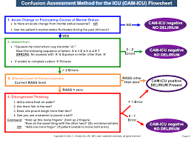

Appendix 10: Patient Stratification
- ALI/ARDS
- Sepsis
- Medical
- General surgical
- Cardiothoracic surgery
- Trauma
- Orthopaedic
- Non surgical cardiovascular
- Neurological

