**FastFX vs Optifast for Low Energy Meal Replacement prior to Intragastric Balloon Insertion: A Randomised Doubled Blinded Trial.**

**OLYMPIAN Trial**

**Dr Cameron Schauer, Mrs Catherine Patrick, Dr Michael Wang, Dr Alasdair Patrick.**

**Introduction:**

In New Zealand, it is estimated 65% of the adult population are overweight or obese (1). As this pandemic of obesity and its multitude of adverse outcomes continues to rise, implementation of non-invasive and accessible interventions are urgently needed (2). Endoscopic bariatric therapies have been developed to provide effective and sustainable weight loss that modalities other than bariatric surgery have struggled to achieve (3). Intragastric Balloons (IGB) have been developed and studied for this purpose and are thought to be efficacious (4). However, weight loss outcomes vary significantly between studies (5).

An important, and perhaps sometimes overlooked aspect of IGB procedures is participation in behavioural modification therapy, chiefly dietary modification with low energy meal replacement. It is recognised long term weight loss with IGB requires ongoing weight management strategies including diet and lifestyle modification, with patients who attend dietitian counselling appointments significantly more likely to respond (6). Meal replacements (MR) help to promote weight loss by eliminating choices, controlling portions, and providing satiation at lower calorie intakes (7, 8).

MacMurrary Clinical Centre in Auckland, New Zealand has been performing IGB insertion and BMT since 2017. Currently, this involves insertion of IGB (Orbera Austin, TX: Apollo Endosurgery, Inc. or Spatz Adjustable Balloon System, Spatz FGIA, Inc. NY, USA) followed by BMT with follow-up provided by a dietician with a special interest in obesity management and a weight loss health psychologist. 2 weeks prior to insertion, OPTIFAST; Nestlé Health Science, Bridgewater, New Jersey) meal replacement is introduced at 603 kcal/day. This is designed to optimise weight loss. Daily food and exercise logs and anthropomorphic measurements are taken at the time of balloon insertion, then 3 monthly post insertion. Further development of alternate meal replacements for optimisation of weight loss prior and during balloon insertion and following removal is required.

FastFX is a MR solution containing a range of ingredients including pea protein, which may be more satiating compared to milk based proteins (9). The mechanism is thought to be via release of the satiety hormones CCK and GLP-1 from human duodenal tissue (10). Additional benefits include predominant gastric digestion (11) and unlike milk or soy or wheat based proteins, low allergenic potential without dairy or gluten (12). We believe these differences may make this product more palatable and acceptable, possibly increasing the efficacy and weight loss.

We hypothesise that this formula as the low energy MR will be non-inferior for weight loss after 2 weeks of consumption prior to IGB insertion, as compared to the current standard of Optifast. Our secondary endpoint will be patient preference/acceptability and adherence as measured by our questionnaire, specifically superior taste, satiety and mood, with decreased cravings.

**Materials and Methods:**

**Study Design:**

This is a sponsor-initiated, single centre, prospective, double blinded 1:1 randomized trial. Consecutive consenting patients at initial dietician visit pre balloon insertion will be randomised to either Optifast (control) or FastFX (intervention) for MR. Following written informed consent and distribution of a patient information sheet, patients will be randomised. Participants will be allocated to the two treatment groups at a 1:1 ratio using randomly permutated block sizes of 4 generated by SAS version 9.4 (SAS Institute Inc, North Carolina, USA), and stratified according to baseline BMI (27.0 to 34.9 kg/m2; and 35.0 to 45.0 kg/m2). The randomisation schedule will be pre-determined prior to participant recruitment, such that the investigator involved in baseline participant assessment will have no involvement in treatment allocation. Envelopes containing randomisation group will be prepared by administration assistants, not otherwise involved in the study, according to the randomisation schedule produced by the statistician. Every envelope will be marked with a participant ID; the participant ID will be associated with the individual’s NHI and name in a dedicated spreadsheet when an envelope is handed out to an individual. Study participants and investigators involved in clinical data collection will be blinded from treatment randomisation until the end of the study period. Unblinding by research assistants will be allowed only in cases of potential allergic reaction to the ingredients. All other study personnel and subjects will be kept blinded to the treatment assignments.

Following randomisation, patients will receive 2 week’s worth of MR in single-serve plain snap lock bags (see Image 1) only labelled with instruction and randomisation code. Both products are powders (see Image 2,3). The control arm instruction will be to consume the single serve packet (53 grams) of Vanilla Flavour Optifast (as per manufacturer instruction). When reconstituted with 250mls of water, this should contain 201kcal per serve. Patients are instructed to take this 3 times per day.

The intervention arm will be identical, mixing a single serve of 60 grams of FastFX, equivalent to 201kcal when reconstituted with 400mls of water.

Additionally, both groups will be advised by dieticians to supplement this only with 2 cups of non-starch vegetables (https://www.optifast.com.au/optifast-vlcd-program/optifast-vlcd-program/allowed-vegetables-and-additional-food-allowances) and up to 2 litres of water.

This study is funded between a partnership between the MacMurray Centre and HeathFx. The owners of the MacMurray Centre (including author AP) also have a financial shareholding in HealthFx.

**Subjects/Inclusion:**

All patients presenting to the clinic and eligible for IGB insertion will be entitled to enrol in the trial. Standard patient selection for IGB insertion will apply: Adults, aged 18–65 years with obesity and a body mass index (BMI) of >27 and <45kgm2.

Patients will be excluded from this trial only if they do not consent to participation or have an allergy to the listed ingredients of the meal replacements.

**Intervention/Dietary Protocol:**

Pea protein meal replacement contains the following ingredient list:

Pea Protein Isolate, Isomaltulose, Natural Flavouring, L-Glutamine, Inulin (Chicory Root Powder), Oligofructose, Thickener [Carboxymethylcellulose], Calcium Phosphate, Magnesium Citrate, Organic Dried Vegetables, Seeds and Algae [Broccoli, Spinach, Kale, Pumpkin, Sweet Potato, Sunflower Seed, Kelp, Chlorella, Maitake Mushroom, Shiitake Mushroom]

*Allergens/Statement*

Gluten Free. Lactose Free.

Suitable for Vegetarians.

Optifast contains the following ingredient list:

Skimmed Milk Powder (31%), Milk Proteins [Calcium Caseinate (20%), Sodium Caseinate (10%)], Maltodextrin (Corn), Vegetable Oil (Canola, Sunflower), Minerals (Potassium Citrate, Magnesium Carbonate, Calcium Phosphate, Sodium Chloride, Potassium Phosphate, Ferric Pyrophosphate, Copper Gluconate, Zinc Sulphate, Manganese Sulphate, Sodium Fluoride, Potassium Iodide, Sodium Molybdate, Sodium Selenite, Chromium Chloride), Vegetable Gum (414), Fructooligosaccharide, Inulin, Medium Chain Triglycerides, Glucose Syrup (Corn), Sugar, Fish Oil, Flavour, Emulsifiers (472c, Soy Lecithin, 471), Sweeteners (Aspartame, Acesulfame Potassium), Antioxidants (301, 304, 306), Vitamins (Vitamin E Acetate, Nicotinamide, Calcium Pantothenate, Sodium Ascorbate, Pyridoxine Hydrochloride, Thiamine Hydrochloride, Vitamin A Acetate, Riboflavin, Folic Acid, Phytomenadione, Cholecalciferol, Cyanocobalamin, Biotin), Colour (Curcumin).

*Allergens/Statement*

Contains Milk, Soy and Fish. Contains Phenylalanine. May contain Egg.

Gluten Free.

Although different flavours are available, only vanilla will be provided in this study to allow for more complete blinding between groups.

**Balloon insertion:**

IGBs are saline-filled elastic balloons inserted into the stomach under endoscopic control. Balloon insertion (Orbera, Spatz) is performed by 5 endoscopist’s, with choice of balloon under the clinician’s discretion. Both balloons are made of soft silicone, designed to sit free-floating within the fundus. The procedure may be completed under conscious sedation or general anaesthesia, depending on patient preference. Standard post care instructions are provided for a 3-day liquid diet, antiemetics, antispasmodics, and a proton pump inhibitor.

**Measurements/Anthropometry**

Patient data will be collected at each visit. Patients will be weighed at initial dietician consultation, and the day they begin their Meal Replacements, 1 week prior to balloon insertion, then following their 2 weeks of MR, prior to balloon insertion (primary endpoint). Further weights will be recorded at 3 monthly scheduled follow-up appointments for 12 months. Body weight will measured using a digital balance accurate to 0.02 kg (Amtech Seca 876 Digital Floor Scales) with subjects in underwear after voiding their bladder. The same scale will be used for each recording.

Data will be recorded as: change in weight and BMI, as well as percentage excess weight loss (%EWL) and percentage total body weight loss (%TBWL). %EWL is based on weight loss divided by “excess” weight and multiplied by 100. “Excess” weight (actual weight minus “ideal weight”) is based on the 1983 Metropolitan Life Insurance Company standard height–weight tables for “medium frame” men and women.

**Questionnaires**

Questionnaire items were adapted from validated dietary questionnaires (13-15) on a 5-point Likert scale. Statements are scored from 1(Strongly Agree) to 5 (Strongly Disagree). Thus, lower scores represent greater satisfaction with the diet. The scores for the statements in each of the five factors and for the total score are averaged across the non-missing items.

Questions were sampled to suitably reflect baseline behavioural characteristics and then measure the intervention including taste, cravings, satiety and mood. These items were trialled with patients and clinicians to explore their representation of the subdomains and to compare their various perspectives. After the examination of content validity, 36 items were retained.

**Sample**

Power calculations were conducted using PASS version 11 (NCSS Statistical Software LLC, Utah, USA), with relative weight loss at 7 days being the pre-specified primary outcome for determining sample size. Sample size requirements were based on intention to treat (ITT) analysis of detecting non-inferiority the Pea-protein to Optifast MR, with an *a priori* non-inferiority margin of ∆ ≤ 1% for relative weight loss. The results show that a minimum of 56 participants (28 participants per treatment group) was required to detect non-inferiority, with 80% power (β = 0.2), at a one-sided statistical significance level of 5% (α = 0.05). The SD of relative weight loss values was estimated to be at 1.5% based on an independent, prospective cohort of 19 participants at the study centre.

**Statistical analysis plan**:

Statistical analysis will be performed using SAS version 9.4 (SAS Institute Inc, North Carolina, USA). The primary analysis will be conducted using an intention to treat (ITT) approach with baseline observation carried forward. The primary non-inferiority outcome (relative weight loss) will be analysed using the non-inferiority margin-adjusted one-tailed independent samples t-test. A sensitivity analysis for the treatment effect on relative weight loss will also be performed within a multiple linear regression model framework incorporating treatment group and baseline weight. The two-sided 90% confidence intervals for the mean difference between the two treatment groups will also be calculated to facilitate qualitative comparison with the pre-specified non-inferiority margin. Secondary superiority outcomes will be assessed using the two-tailed independent t-test for continuous measurement with normal distributions confirmed by Shapiro-Wilk testing (p > 0.05). Non-normally distributed continuous and ordinal data will be analysed using the two-tailed Mann-Whitney U-test, and categorical data using the two-tailed Fisher’s exact test. Data will be presented as mean ± SD, median (IQR), number of participants (% of participants), unless otherwise stated, and p<0.05 will be considered significant.

**References**

1. Health Mo. Annual Update of Key Results 2015/16: New Zealand Health Survey. Wellington: Ministry of Health; 2016.

2. Collaborators GBDO, Afshin A, Forouzanfar MH, Reitsma MB, Sur P, Estep K, et al. Health Effects of Overweight and Obesity in 195 Countries over 25 Years. The New England journal of medicine. 2017;377(1):13-27.

3. Force ABET, Committee AT, Abu Dayyeh BK, Edmundowicz SA, Jonnalagadda S, Kumar N, et al. Endoscopic bariatric therapies. Gastrointestinal endoscopy. 2015;81(5):1073-86.

4. Saber AA, Shoar S, Almadani MW, Zundel N, Alkuwari MJ, Bashah MM, et al. Efficacy of First-Time Intragastric Balloon in Weight Loss: a Systematic Review and Meta-analysis of Randomized Controlled Trials. Obesity surgery. 2017;27(2):277-87.

5. Tate CM, Geliebter A. Intragastric Balloon Treatment for Obesity: Review of Recent Studies. Adv Ther. 2017;34(8):1859-75.

6. Tai CM, Lin HY, Yen YC, Huang CK, Hsu WL, Huang YW, et al. Effectiveness of intragastric balloon treatment for obese patients: one-year follow-up after balloon removal. Obesity surgery. 2013;23(12):2068-74.

7. Heymsfield SB. Meal replacements and energy balance. Physiol Behav. 2010;100(1):90-4.

8. Heymsfield SB, van Mierlo CA, van der Knaap HC, Heo M, Frier HI. Weight management using a meal replacement strategy: meta and pooling analysis from six studies. Int J Obes Relat Metab Disord. 2003;27(5):537-49.

9. Diepvens K, Haberer D, Westerterp-Plantenga M. Different proteins and biopeptides differently affect satiety and anorexigenic/orexigenic hormones in healthy humans. Int J Obes (Lond). 2008;32(3):510-8.

10. Geraedts MC, Troost FJ, Tinnemans R, Soderholm JD, Brummer RJ, Saris WH. Release of satiety hormones in response to specific dietary proteins is different between human and murine small intestinal mucosa. Annals of nutrition & metabolism. 2010;56(4):308-13.

11. Eggum BO, Hansen I, Larsen T. Protein quality and digestible energy of selected foods determined in balance trials with rats. Plant Foods Hum Nutr. 1989;39(1):13-21.

12. Geraedts MC, Troost FJ, Munsters MJ, Stegen JH, de Ridder RJ, Conchillo JM, et al. Intraduodenal administration of intact pea protein effectively reduces food intake in both lean and obese male subjects. PloS one. 2011;6(9):e24878.

13. Roininen K. Evaluation of food choice behavior: development and validation of health and taste attitude scales. Helsinki University Press2001.

14. James BL, Loken E, Roe LS, Myrissa K, Lawton CL, Dye L, et al. Validation of the Diet Satisfaction Questionnaire: a new measure of satisfaction with diets for weight management. Obes Sci Pract. 2018;4(6):506-14.

15. Nakano K, Kyutoku Y, Sawa M, Matsumura S, Dan I, Fushiki T. Analyzing comprehensive palatability of cheese products by multivariate regression to its subdomains. Food Sci Nutr. 2013;1(5):369-76.

Image 1:

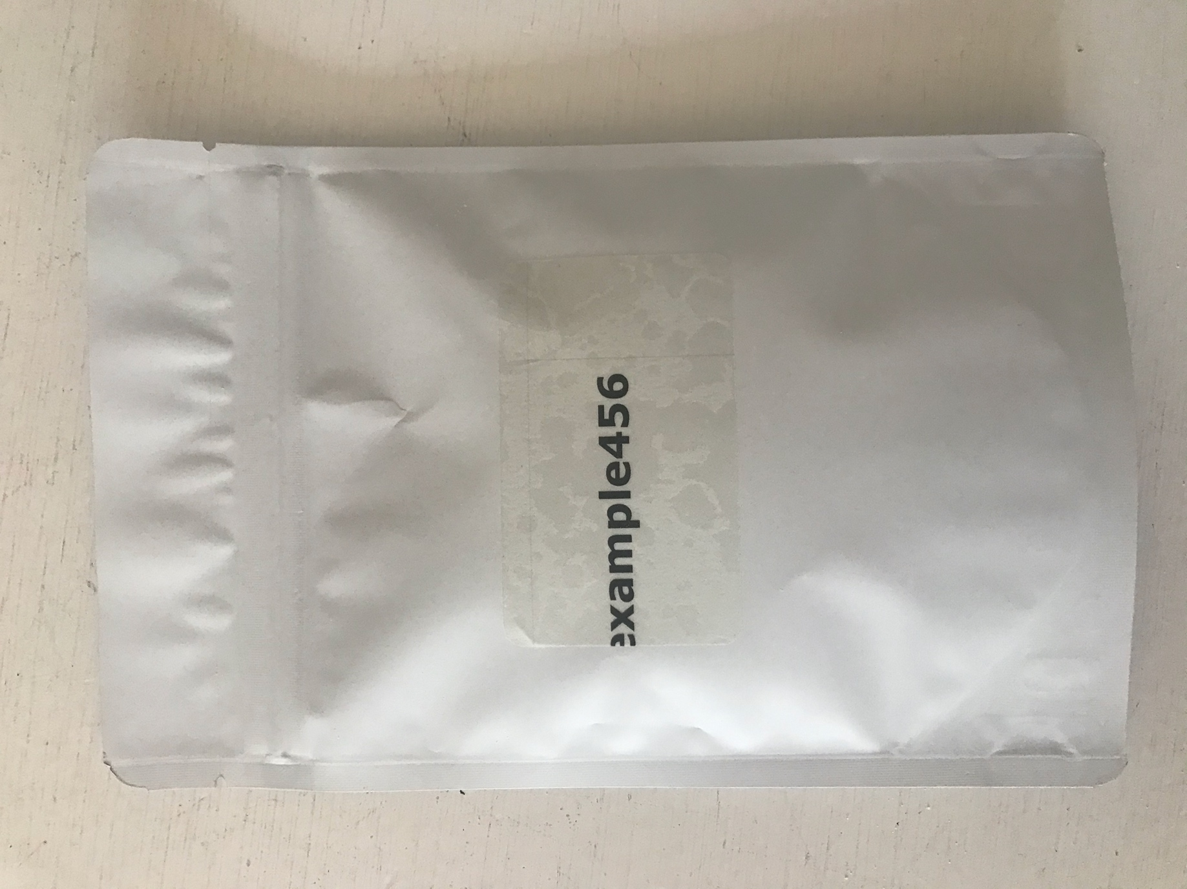

Image 2 - Optifast

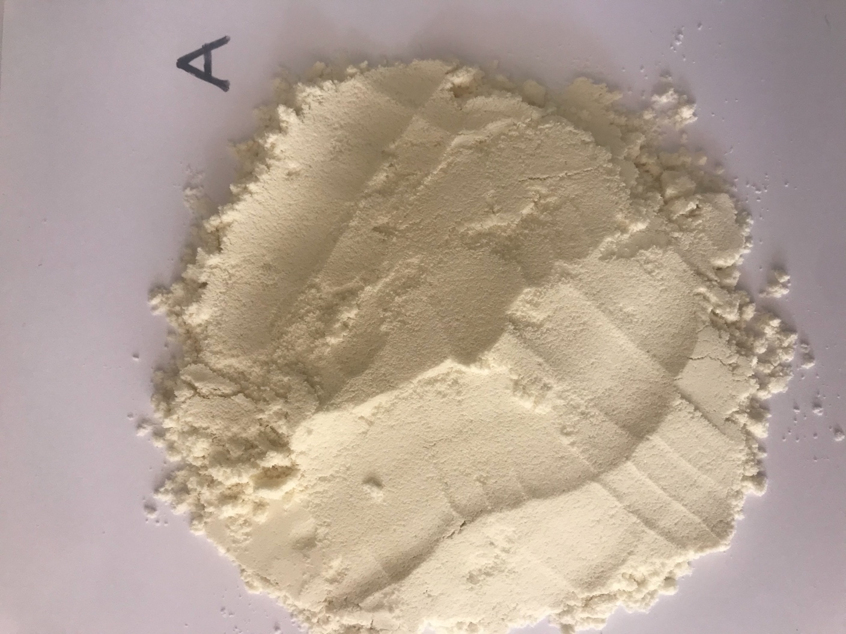

Image 3 – FastFx

