

Participant Information Sheet 

Study title: Bioavailability Of Kawakawa Tea metabolites in human volunteers (BOKA-T)

Locality: | The University of Auckland | Ethics committee ref.:
Lead investigator: | Professor Richard Mithen | Contact phone: | (0)27 201 7675

You are invited to take part in a study assessing the bioavailability of kawakawa metabolites following consumption of tea infusions prepared from commercially available kawakawa leaves. We are examining the bioavailability of kawakawa metabolites and mechanism of bioactivation in humans. Whether or not you take part is your choice. If you don’t want to take part, you don’t have to give a reason. If you do want to take part now, but change your mind later, you can pull out of the study at any time.

This Participant Information Sheet will help you decide if you would like to take part. It sets out why we are doing the study, what your participation would involve, what the benefits and risks to you might be, and what would happen after the study ends. We will go through this information with you and answer any questions you may have. You do not have to decide today whether you will participate in this study. Before you decide, you may want to talk about the study with other people, such as family, whānau, friends, or healthcare providers. Feel free to do this.

If you agree to take part in this study, you will be asked to sign the Consent Form on the last page of this document. You will be given a copy of both the Participant Information Sheet and the Consent Form to keep.

This document is eight pages long, including the Consent Form. Please make sure you have read and understood all the pages.

What is the purpose of the study?
Kawakawa is a versatile herb, endemic to New Zealand, where it is widely used for food, medicinal, and traditional ceremonial purposes by Māori. Kawakawa leaves and fruits are reported to possess medicinal properties, and are utilised for a wide range of health conditions not only limited to skin diseases but for the treatment of genitourinary, gastrointestinal as well as respiratory diseases. A previous study by Butts et al (2019) described that there is a significant number of chemical constituents present in kawakawa leaves with potential pharmacological properties. Therefore, as a candidate for potential functional food applications, examining the bioavailability of kawakawa metabolites for human consumption is required. In-vitro or mechanistic studies carried out with kawakawa leaves and fruits have discovered that they are safe for human consumption and have potential health benefits. With the advent of this, there exists a scientific need to explore the mechanisms of human metabolism and bioavailability upon ingestion of kawakawa tea.

What will my participation in the study involve?
The aim of this study is to evaluate the bioavailability of kawakawa metabolites from a commercially available kawakawa tea and its effects on other metabolites in healthy adults. You have been invited to participate because you have identified that you are a male aged between 18 and 60 years at the time of enrolment, have a BMI in the range of 18-25 kg/m², and have self-reported that you are not using any herbal supplements and do not have any major medical conditions. This study will assess changes in metabolites in your body in response to ingestion of either plain water or different doses of kawakawa tea.

If you choose to participate in this study, there will be 7 study visits in total (Table 1), including 1 screening visit and 3 intervention visits each separated by a week and 3 check-in visits each following the intervention visit . At the screening visit, we will explain the study in detail and answer any questions you may have about participation. If you are satisfied with all of the information and agree to take part, we will ask you to sign the consent form (below). This visit will take less than one hour. You are asked to record your diet for 1 full day immediately preceding the intervention visit(s).

Timeline | What will happen | Duration
Screening (Visit-1) | Description & consent | < 1hr
Intervention (Visit-2) | Height, weight & waist circumference,  Resting blood pressure. Blood & Urine samples | 6 hrs
Check-in (Visit-3) | Blood & Urine samples at 24 hrs | < 1hr
Intervention (Visit-4) | Height, weight & waist circumference  Resting blood pressure. Blood & Urine samples | 6 hrs
Check-in (Visit-5) | Blood & Urine samples at 24 hrs | < 1hr
Intervention (Visit-6) | Height, weight & waist circumference  Resting blood pressure. Blood & Urine samples | 6 hrs
Check-in (Visit-7) | Blood & Urine samples at 24 hrs | < 1hr

Table 1. Timeline of the intervention

After the screening visit, there are six visits remaining. On your intervention visits (2, 4, and 6), you will be asked to come in an overnight fasted state (at least 10 hrs) to the Nutrition and Mobility Clinic of the Liggins Institute. We will measure your height, weight, resting blood pressure and waist circumference. A fasting blood sample will be taken and you will also be asked to provide us with a fasting urine sample in a sterile container provided by us. You will then consume either hot water or different doses of kawakawa tea depending on the day of your visit. A standard breakfast will be provided after 40 mins of the intervention.

Blood and urine samples will be collected over the course of 5 hours after the intervention (either hot water or different tea doses of kawakawa). Blood will be sampled at 30, 45, 60, 90, 120, 180, 240, 300 mins, and 24 hours from an arm vein (total 220ml blood). Urine samples will be collected for 24 hours with a time frame of 0, 0-2, 2-4, 4-5, 5-24 hours after the consumption of intervention (either hot water or different tea doses of kawakawa) (Figure-1).

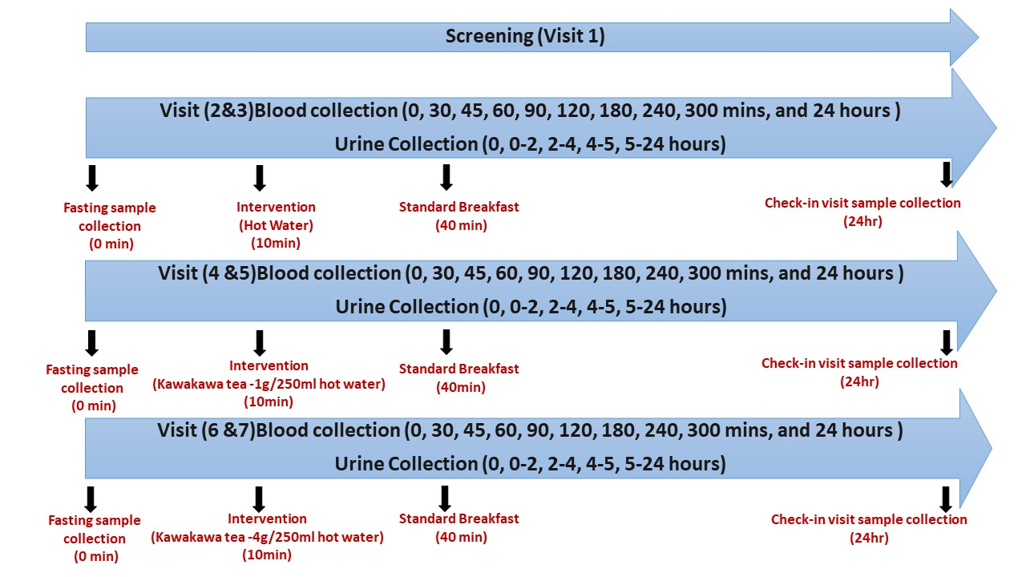
Figure 1. Sampling Schedule

These blood samples will assess metabolic changes by measuring Kawakawa metabolites in both blood as well as urine samples. Biochemical markers of metabolic processes including lipids (the digested products of fats), amino acids (the digested products of proteins), sugars such as glucose (digestion products of carbohydrates), and hormones involved in digestion such as insulin will also be measured.

You will be provided with a standard lunch during the visit and also given a light dinner to have at home. You will be provided with a sterile container to take with you in order to continue to collect urine over the remainder of the 24 hr period. You will be asked to come back in a fasted state to give urine and blood sample for check-in visits 3, 5, and 7.

What are the possible benefits and risks of this study?
This study will involve the sampling of blood by inserting a cannula (tube) in the arm vein. A blood sample taken may hurt a little, and some people get a small bruise where the needle goes in. Occasionally the needle hole can become infected, but this is very rare. Most people have no problems. If you ever faint with blood samples or when you see blood, please let the research assistant know beforehand and we will take the sample while you are lying down. After almost 6 hours, the cannula will be removed; this may cause mild discomfort.

Who pays for the study?
Participation in this study is free. We will cover all costs related to sample analysis.

We appreciate that our study requires at least 7 visits to our research centre, with each of the intervention visits (2, 4, and 6) lasting 6 hours; and we therefore will offer all participants a $50 gift voucher on each of the intervention visit days ($150 total) to reimburse you for your time and efforts. All participants will be provided with a light breakfast, lunch and dinner for the intervention day visits (2, 4 and 6).

What if something goes wrong?
If you were injured in this study, which is unlikely, you would be eligible to apply for compensation from ACC just as you would be if you were injured in an accident at work or at home. This does not mean that your claim will automatically be accepted. You will have to lodge a claim with ACC, which may take some time to assess. If your claim is accepted, you will receive funding to assist in your recovery.

If you have private health or life insurance, you may wish to check with your insurer that taking part in this study will not affect your cover.

What are my rights?
Your participation in our study is entirely voluntary. If you do agree to take part in the study, you have the right to withdraw from the study at any time without having to give a reason and any samples, however data or samples that have already been collected and processed will continue to be used.

Some blood markers analysed in this study can be early indicators of diseases such as diabetes and heart disease. Any abnormal blood results (outside of the normal healthy range) that may have implications for future health will be provided to you, and with your permission, we will inform your doctor.

All results from this study will be confidential, with all the samples and measurements coded. Coding will be numerical and you will not be identifiable by this code. Study records will be confidential and stored securely When the analysis of the data is completed the researchers will analyse the whole group’s data and report on average results. This data will be used for scientific publication and presentations. No person will be identifiable from the analysis.

With your consent, a sample of the blood or urine will be stored for up to ten years after the study and may be used to measure other markers of health. These samples will be stored at the laboratory of Professor Richard Mithen at the Liggins Institute at the University of Auckland, in a secure freezer. Samples will be accessible by the study investigators and may be used for other related studies with ethical approval. This may involve sending the samples to a laboratory overseas for testing. In this situation, these samples will be disposed of using established guidelines for discarding biohazard waste.

What happens after the study or if I change my mind?
Your study records will be stored securely for 10 years after the study is completed and then destroyed. Your samples will be stored until the end of the analysis. At the end of this time, a medical waste contactor will dispose of your tissue. If you would like a karakia said at this time, please indicate so in the consent portion of this form. Cremation and karakia ceremonies take place through the Auckland District Health Board and occur every 2 months during the year.

We are happy to give you information about the progress of the project and about future projects at your request at any time. We will also keep you informed of the results of the study. This data will be used for scientific publication and presentations. Please note that there will be a delay between your study participation and publication of the results.

Who do I contact for more information or if I have concerns?
If you have any questions, concerns or complaints about the study at any stage, you can contact:

Prof Richard Mithen
Principal investigator
Liggins Institute, the University of Auckland,
Phone: +64 (0)27 201 7675
Email: r.mithen@auckland.ac.nz

Farha Ramzan
Co-Principal investigator
Liggins Institute, the University of Auckland,
Phone: +64 224505345
Email: f.ramzan@auckland.ac.nz

If you want to talk to someone who is not involved with the study, you can contact an independent health and disability advocate on:
Phone: 0800555050
Fax: 08002
SUPPORT 080027877678)
Email: advocacy@advocacy.org.nz
Website: https://www.advocacy.org.nz/

You can also contact the health and disability ethics committee (HDEC) that approved this study on:

Phone: 0800 4 ETHICS
Email: hdecs@moh.govt.nz

Consent Form

Please read the following carefully before signing and dating this Consent Form

Please tick to indicate you consent to the following

I have read, or have had read to me in my first language, and I understand the Participant Information Sheet.

I have been given sufficient time to consider whether or not to participate in this study.
I have had the opportunity to use a legal representative, whānau/ family support or a friend to help me ask questions and understand the study.

I am satisfied with the answers I have been given regarding the study and I have a copy of this consent form and information sheet.

I understand that taking part in this study is voluntary (my choice) and that I may withdraw from the study at any time without this affecting my medical care.

I consent to the research staff collecting and processing my information,
Including information about my health.

I understand my responsibilities as a study participant.
If I decide to withdraw from the study, I agree that the information collected about me up to the point when I withdraw may continue to be processed. | Yes □ | No □
I consent to my GP or current provider being informed about my participation in the study and of any significant abnormal results obtained during the study. | Yes □ | No □
I agree to my blood and urine samples being sent overseas and I am aware that these samples will be disposed of using established guidelines for discarding biohazard waste. | Yes □ | No □
I agree to an approved auditor appointed by the New Zealand Health and Disability Ethic Committees, or any relevant regulatory authority or their approved representative reviewing my relevant medical records for the sole purpose of checking the accuracy of the information recorded for the study. | Yes □ | No □
I understand that my participation in this study is confidential and that no material that could identify me personally will be used in any reports on this study. | Yes □ | No □
I understand the compensation provisions in case of injury during the study. | Yes □ | No □
I do not wish for a karakia said at the time of my tissue disposal | Yes □ | No please perform □
I know whom to contact if I have any questions about the study in general. | Yes □ | No □
I wish to receive a summary of the results from the study. | Yes □ | No □

Declaration by participant:
I hereby consent to take part in this study.

Participant’s name:
Signature: | Date:

Declaration by member of research team:

I have given a verbal explanation of the research project to the participant, and have answered the participant’s questions about it.

I believe that the participant understands the study and has given informed consent to participate.

Researcher’s name:
Signature: | Date:

