**User-centred Design of a Theory-based, Ontology-driven Mobile Health Coaching App to Improve Fitness for Surgery in Obese Patient: A Study Protocol**

# Abstract

**Background**: Obesity is one of the most common and severe global public health challenges. Over half of the patients who undergo elective surgery in our local hospital, Wollongong Hospital, are obese. It is critical to improve the fitness of these patients before their surgery as research has shown that healthier patients experience fewer last-minute cancellations and better postoperative outcomes. Despite the promising potential of mobile applications to assist these patients with weight loss and health improvement, the utilisation of this technology for surgical preparation is still in infancy. This study aims to co-develop with obese patients a theory-based, ontology-driven mobile health coaching app to improve their fitness for surgery, implement the solution and evaluate its effectiveness.

**Methods**: Guided by the Social Cognitive Theory, a multidisciplinary clinical and research team was formed, together with obese patients to co-design the app. The functionality of the app includes automatic messaging to the patients to encourage them in exercise, building healthy body, healthy mind and healthy eating before their surgery. The messages are designed in accordance with a patient’s risk level as determined by the built-in health assessment in the app. A prospective, longitudinal pilot trial will be conducted to evaluate the effectiveness of the app after three months of use or up to the time of surgery, whichever comes first. Objective measures such as weight, waist circumference, body mass index, and cardiorespiratory fitness will be measured at the beginning and end of the study. Psychological well-being, attitudes to weight, understanding of nutrition, and satisfaction and engagement with the program will also be evaluated.

**Discussion**: Mobile health interventions have the potential to improve the fitness of patients with obesity before their surgery. Using a multi-disciplinary approach, a theory-based, ontology-driven mobile app will be developed and tested. The outcome of this study will be beneficial for future research in both mobile health intervention development methods and output. It will also shed light on new approaches for community-based interventions for obesity management, leveraging the power of ubiquitous mobile technology.

**Trial registration**: ?

**Keywords**: mHealth, preoperative, obesity, Social Cognitive Theory, mobile app

# Background

Obesity, a body mass index (BMI) greater than or equal to 30kg/m2, is among the most common and serious global public health challenges of the 21st century. In 2016, more than 650 million adults were obese, which is three folds of that in 1975 [1]. In Australia, 8.4% of the total burden of disease was attributed to obesity in 2015 [2]. An actuarial report in the country found that the sum of direct and indirect costs of obesity amount to at least 8.6 billion dollars annually [3]. Once onset, excessive fat accumulation can accelerate the dysfunction of physiological systems, impairing both short-term and long-term health. Obese patients are at the increased risk of non-communicable diseases such as cardiovascular disease, type-2 diabetes, sleep apnoea, musculoskeletal disorders and cancer. Over time, it may impede a patient’s ability to self-control or self-manage these chronic diseases [4], lead to further distress and impairment, and even premature death [5].

The challenge of obesity is particularly felt in the Illawarra and Shoalhaven Local Health District (ISLHD), New South Wales, Australia. In this region, 36% of adults are obese, much higher than the national prevalence rate of 28% [6]. Approximately 55% of the 6,000 patients who undergo elective surgery at the only local tertiary hospital - Wollongong Hospital - each year are obese, including 50% of those undergoing gallbladder removal or minor gynaecological surgery in 2016. The hospital contains more than 500 beds, providing a comprehensive range of referral services in surgery, medicine, maternal, neonatal, paediatric, intensive care, emergency and cancer care for patients [7].

As many patients with obesity are not able to get the benefit of surgery due to obesity-induced rejection, the importance of pre-operative cardiorespiratory fitness is gaining increasing attention [8, 9]. In the UK, the Perioperative Exercise Testing and Training Society is reinforcing the importance of focusing on improving the patient’s fitness before surgery. An important strategy is to encourage these patients to lose weight and gain aerobic capacity so as to improve their physiological reserves and fitness for surgery [10]. There is also plenty of evidence to suggest that healthier patients who present for surgery will experience fewer last-minute cancellations and better postoperative outcomes [11, 12].

Despite many confounding factors, such as age and genetic built, lifestyle, mainly excessive calory intake and insufficient calory consumption are the recognised fundamental causes for obesity. Obesity treatment thus should be designed to promote self-management on these two aspects [1, 13]. In other words, a person could become slimmer and healthier if he/she eats less and does more exercise. But this is often difficult to achieve because the bigger people are, the more they want to eat and the less they want to exercise [14]. Therefore, it is essential to motivate patients to be proactive about weight loss. This calls upon the innovative methods to keep patients’ motivation to fight against obesity.

According to the local audit data, in ISLHD, the waiting time for one-third of patients undergoing common operations is three months or more from booking to execution. Approximately 50% of these surgical patients gained weight while on the waiting list. The current healthcare system has no means nor resources to provide guidance to these patients on ways to improve their fitness for surgery during their prolonged surgical waiting period.

Almost everyone in Australia carries a ‘smart’ mobile phone. This affords a new opportunity for the introduction of mobile health (mHealth) interventions, such as text messages and mobile apps, to address the healthcare service gap [15]. The portable mobile phones enable ubiquitous recording, monitoring and interaction with patients anytime, anywhere; which will enable the community-dwelling patients to access health guidance and service with lower costs [16]. Therefore, mHealth interventions have emerged in delivering healthcare services to support the management of chronic conditions such as diabetes, hypertension, depression, smoking or alcohol abuse [17-21].

Despite their increasing popularity, the reported effectiveness of mHealth is mixed [22]. Only a few mobile interventions have been shown to improve health outcomes in patients with chronic diseases, other interventions have led to unsatisfactory results. One important reason is the lack of behavioural change theory to guide the design and implementation of these interventions [23-25]. This results in these interventions being used only as data collection tools instead of comprehensive interventions that can lead to positive changes in healthy behaviour [26]. Behavioural theories and behaviour change models, such as the Health Belief Model and Social Cognitive Theory (SCT), are mainly drawn from psychology and sociology. They focus on predicting and explaining human behaviours and a wide range of potential factors such as emotions, habits and daily routines that affect these behaviours [27-29]. Theory-based mHealth interventions may increase the likelihood of supporting change towards healthy behaviour through a full application of behavioural change techniques into the interventions [30]. For example, an effective intervention was guided by behavioural theory to prompt physical activity and healthy dietary [24]. The behavioural change techniques include self-monitoring, intention building, goal setting, progress reflecting and performance reporting [31]. Riley et al. also suggests that it is vital to add more interactive and dynamic functionalities to the mHealth app, maximising patients’ needs for changing their behaviour [26].

To date, there is a lack of ability in designed mHealth interventions to manage and reuse large amounts of information about chronic disease management in a rational and meaningful way [32]. Therefore, it is vital to design innovative mHealth methods and approach for effective data capture, storage and re-use to deliver effective interventions that will lead to tangible health outcomes. Ontology can provide a unique opportunity to achieve this goal [33]. As a formal, explicit specification of shares conceptualisation, the ontology provides a powerful taxonomic tool to model existing information by integrating and computerising behavioural change theory into the relevant strategies on managing obesity [34]. Using ontology can enable the connection of multiple, complex health knowledge base with a patient’s health status and modifiable factors to improve the person’s health outcomes [33]. Thus, it can provide an evidence-based and theory-based source of knowledge for mHealth based obesity interventions.

Despite the proven efficacy of a range of telemedicine methods for weight loss [35-37], or cardiac rehabilitation [38-42], it is still in the early development stage for the digital rehabilitation platforms that integrate mobile apps, wearable activity trackers or clinical Web portals to engage patients in self-management tasks to build cardiorespiratory fitness for surgery. Furthermore, although almost everyone in Australia owns a mobile phone, it is not yet common to deliver patient education programs using a mobile app. The efficacy of this mode of patient education delivery is yet to be proven, as suggested by a systematic literature review [38], which calls for further research on the effect of embedding the relevant behaviour theory within the mHealth app and improved study design. Therefore, the goal of this project is to use innovative mHealth methods to coach patients with obesity to improve their health and fitness for surgical operation, during their time on surgical waiting lists that are often three months or longer.

# Methods

## Aim and objectives

This study aims to design and deliver a theory-based, ontology-driven, mHealth coaching app to promote healthy living and weight loss. The following three objectives will be achieved:

1. To embed SCT into mHealth interventions;
2. To co-develop with obese patients the mHealth coaching app to improve their fitness for surgery;
3. To evaluate the effectiveness of this mHealth innovation.

## Study design

This practice-based, mHealth research will be completed in two phases: development phase and evaluation phase (see Figure 1). The researchers will extensively collaborate with two groups of end-users in these two phases.

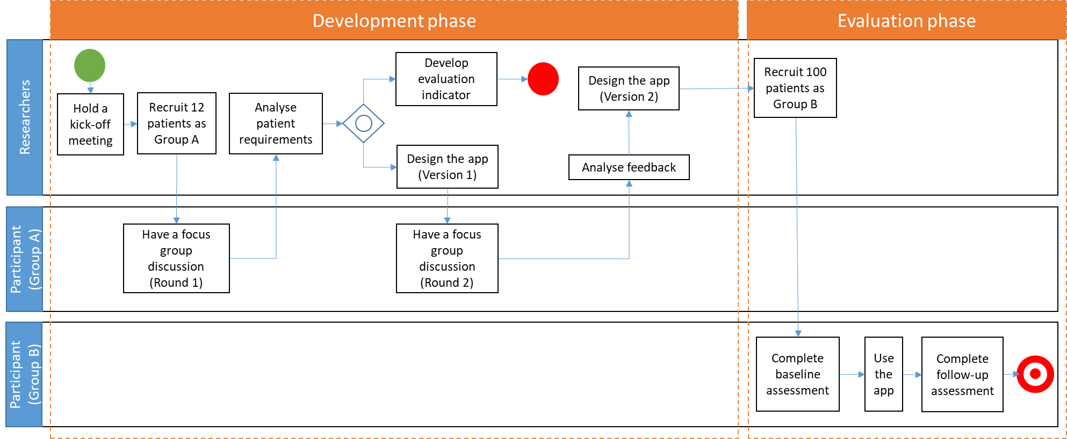

Figure 1 Flow chart of the research

### Development phase

In this phase, a multidisciplinary clinical and research team will be formed, which includes a clinical anaesthetist and academic researchers in psychology, nutrition, exercise science, e-health development, information systems and software engineering. The aim is to develop a mHealth coaching app to improve the obese patient’s fitness for surgery. The SCT will be applied to guide app development [43].

An incremental, agile development methodology will be applied to build this app. As the involvement of end-users in system development is essential for acquiring valuable feedback [44], we will also form open, interactive collaboration with the obese patients and empower them to discuss their experiences and feelings of using the app through two-round focus group discussions. This will enable the researchers to understand the target patient users’ requirements and test the acceptability, usability and feasibility of the app (see Figure 2).

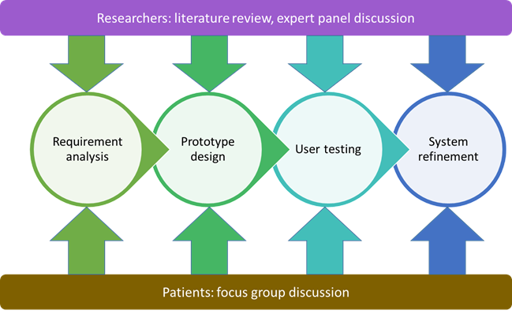

Figure 2 The co-development of the mHealth coaching app

### Evaluation phase

In the evaluation phase, a prospective, longitudinal pilot trial will be conducted to evaluate the initial effectiveness of the app for patients after using the app for three months or up to the time of surgery, whichever comes first. This app will automatically send regular messages to the patients to encourage them to engage in exercise, healthy body, healthy mind and healthy eating before their surgery. These messages will be developed by the research team and be sent to the patients according to their health risk level as being assessed by the built-in assessment form in the app.

This study will be conducted and reported in strict compliance with the requirements of the Transparent Reporting of Evaluations with Nonrandomised Designs statement [45], which is widely used to improve the reporting standards of nonrandomised evaluation of behavioural and public health interventions.

## Study setting

The app development will be conducted in the Centre for Digital Transformation, School of Computing and Information Technology, University of Wollongong, Australia. It will be implemented and evaluated in the Department of Surgery, the Wollongong Hospital.

## Participants and recruitment

Two groups of participants will be recruited into this study. Participants in Group A will be recruited for focus group discussions to co-develop the app. Group B will be recruited to evaluate the effectiveness of the app in implementation. All participants in the two groups will be identified when they book for surgery at the Wollongong Hospital. The inclusion criteria are patients (1) who are 18 years and over; (2) whose BMI is greater than or equals to 30kg/m2; (3) who owns an iPhone or an Android smartphone and know how to use it; (4) who is English-speaking with self-elected adequate reading skills; (5) consent to participation in the study.

Eligible patients will be given an information sheet about the project. After booking, a research nurse will ring them to further discuss the project and seek their consent to participate in the focus group discussion (for Group A) and the trial (for Group B). One week later, patients will be sent an SMS text message asking them to confirm their consent to participate. We aim to recruit 12 patients for focus group discussions and 100 patients for the pilot trial over three months.

## Interventions

Figure 3 presents the conceptual framework of the mHealth coaching app. Patients will be contacted regularly throughout their waiting period by the app. We aim to encourage them to participate in healthy behaviours and become more actively involved in improving their own health status.

The central to the SCT is self-efficacy. On the one hand, self-efficacy plays a vital role in goal setting and related outcomes before an individual thinks about changing a particular behaviour. This is because a strong sense of self-efficacy is needed to monitor and maintain task orientation when faced with failure [46]. Therefore, personal goal-setting and self-monitoring of weight change, diet and physical activity combined with feedback will be the key features of the app. On the other hand, SCT is a comprehensive model of how cognitions, behaviours, and environments interact, providing social support via using observational learning and additional reinforcements to achieve behavioural change [47]. The app will thus send short messages to eligible patients regularly. The content of the messages will be developed by the clinical psychologist, dietitian and exercise physiologist in the team to provide psychological counselling, dietary and exercise suggestions to the patients. These messages will boost self-efficacy on behavioural change. Considering reinforcements, a key component in SCT, the patients will be reminded to input their data such as weight, diet, emotion on regular bases. Their walking steps will be recorded automatically in the app. These will be used as prompts for the personalised text messages. We will also provide a number of resources that patients can use, and check on patient’s access to this information. Interaction with individual patients will conclude after three months or upon surgery, whichever comes first.

To enable intelligent reasoning of the assessment results and the automatic selection of messages, both the assessment items and the messages have been represented as an ontology which forms the logic layer of the mobile app. The ontology will be built following the Integrated Definition for Ontology Description Capture Method using Protégé 5.2 [48]. We will first conduct requirement analysis to understand the domain, application and use case. Based on the analysis, we will determine the scope of the ontology and consider if we could reuse some existing and validated ontologies with consensus among all researchers. Afterwards, we will start to build our ontology based on a patient-centred approach. Taking patients as the hub, relevant terms will be enumerated by brainstorming, as well as the feedback from the focus group discussion. Next, we can define the hierarchical affiliation of these terms, identify the classes, and further discover the relationships and constraints between them. At last, we will put all the messages and assessment items into the ontology as individuals. Due to security concerns, an authentication system and NoSQL database will also be deployed on Google cloud services.

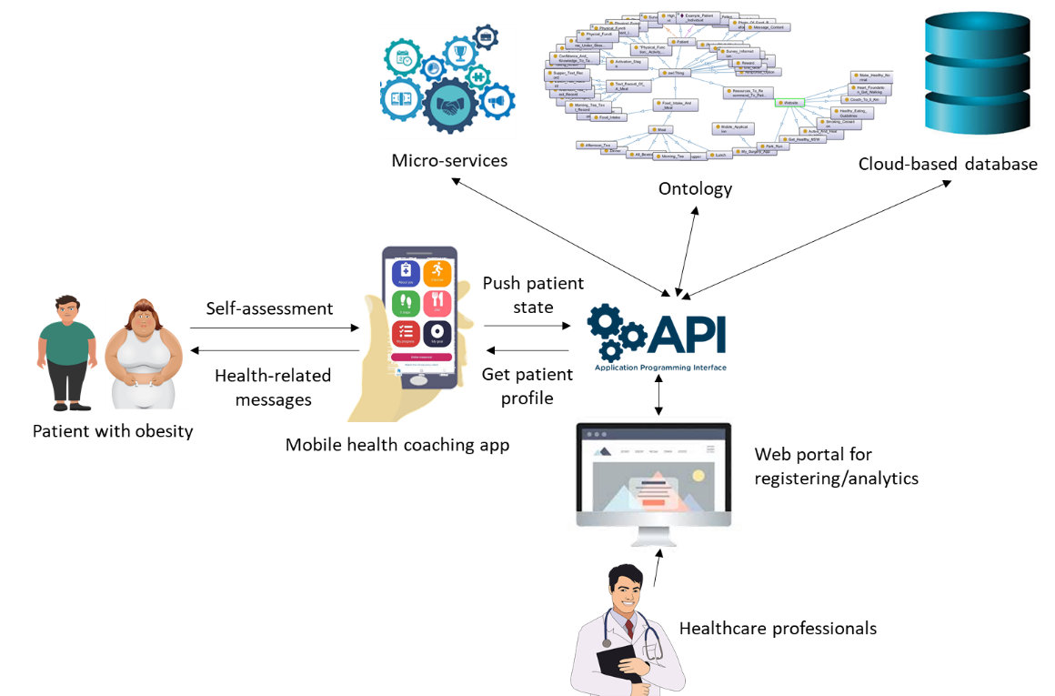

Figure 3 Conceptual framework of the mHealth coaching app

## Data collection

The evaluation data will be collected at two timepoints: baseline (T0) and three months after the intervention or up to the time of surgery, whichever comes first (T1). The primary outcomes measured at three months are (1) change in weight, waist circumference, and BMI; (2) exercise capacity as measured via the app and self-report; and (3) change in standard perioperative risk calculation scores. The secondary outcomes are patients’ subjective acceptance, experience/enjoyment of the app and overall program using a range of standard measures of psychological well-being. These include EuroQol five-dimensional five-level (EQ 5D 5L) to assess the general quality of life of the patients [49], Patient Activation Measure to assess patients’ engagement with their health improvement [50], International Physical Activity Questionnaire to assess their physical activities [51] and Australian Health Survey Short Questions on nutrition to assess their food habit [6]. Demographic data such as age, gender will also be collected as covariates. All these measurements will be built in the app for data collection. Data will be automatically transferred and stored in a researcher’s password-protected desktop. Each participant will be tracked using a given patient ID.

## Statistical analysis

All statistical analyses will be conducted using SPSS software (Version 25). We will use descriptive statistics, expressed as means ± standard deviation, to summarise the baseline demographics of the study participants. Changes in weight, waist circumference, and BMI will be calculated using a paired t-test. Nominal variables will be measured using the Chi-squared test. Changes in preoperative risk stratification scores will be calculated using a Wilcoxon Signed Rank Test. The missing data will be estimated using the expectation-maximization method, achieved by the Missing Value Analysis function in SPSS. We consider P<0.05 to be statistically significant.

# Discussion

To date, very few evidence exists regarding the effectiveness of mHealth interventions for obesity treatment and control, especially for the patients who are waiting for their surgery. This multi-disciplinary study will develop a user-centred mobile app to enable the research team to interact with patients to guide them to improve physiological reserves and fitness for surgery. We aim to test the acceptability, usability, feasibility, and efficacy of this mHealth coaching approach in prehabilitation in patients with obesity, utilising the time they spend on a waiting list to improve their health status.

The strengths of the study will be manifested in both project development methods and output. The project development method is innovative in the theory-guided message design, co-development with the obese patients, following an incremental, user-centred design methodology. The multi-disciplinary research team will form an open, interactive collaboration with patients and empowering them to improve their own health. The project output, a mobile health coaching program and app, is innovative in providing just-in-time support for patients at a tie of health vulnerability with a better chance of program success than otherwise [52]. Another innovation is a multi-disciplinary approach to weight loss; including the appropriate psychological, nutrition and exercise support to improve fitness for surgery for patients with obesity. The explicit preoperative prehabilitation focus of our study design is also relatively new.

The project is significant in piloting a new method of cost-effective patient care in the community setting. This model can also be more readily used with patients in rural or remote communities than traditional face-to-face approaches.

Once demonstrating the effectiveness of this mobile coaching app, we will have improved patient health and satisfaction as well as perioperative efficiency in the short term. We will also have produced a tool that can be used with minimal resources into the future to continue to do so in the post-operative care stage. We will take feedback from this pilot trial on the content, usability, and capability of the app, to develop into a future product that can be tested more extensively.

# List of abbreviations

BMI: body mass index; EQ 5D 5L: EuroQol five-dimensional five-level; ISLHD: Illawarra and Shoalhaven Local Health District; mHealth: mobile health; SCT: Social Cognitive Theory

# Ethics approval and consent to participate

This study has been approved by the University of Wollongong and Illawarra and Shoalhaven Local Health District Health and Medical Human Research Ethics Committee (AuRed Number: HREC/18/WGONG/64).

# Consent for publication

Not applicable.

# Availability of data and materials

The study is currently enrolling; therefore, data collection is ongoing. The principal investigator can be contacted for data and for material requests.

# Competing interests

The authors declare that they have no competing interests.

# Funding

This research was supported by the 2018 Illawarra Health and Medical Research Institute Clinical Translation Grant Scheme.

# Authors' contributions

PY and NS led this collaboration project and secured funding for the study. PY conceived the mHealth intervention concept. PY and NS guided the design and piloting of the intervention. VB, YP and GP designed the content of push notifications and built-in assessment questions in the app. SQ built the concept map and ontology of the app. MA designed the architecture of the app. TS drafted the first manuscript of the protocol. XX, XX, XX critically revised the manuscript. All authors have read and approved the final manuscript.

# Acknowledgements

The authors wish to thank the ?

# References

1. (WHO), W.H.O. *Obesity and overweight*. 2018; Available from: <https://www.who.int/en/news-room/fact-sheets/detail/obesity-and-overweight>.

2. AIHW. *Australian Burden of Disease Study 2015: Interactive data on risk factor burden*. 2019; Available from: <https://www.aihw.gov.au/reports/burden-of-disease/interactive-data-risk-factor-burden/contents/overweight-and-obesity>.

3. PricewaterhouseCoopers. *Weighing the Cost of Obesity: A Case for Action*. 2015. PwC Sydney (AUST).

4. Pi-Sunyer, X., *The medical risks of obesity.* Postgraduate medicine, 2009. **121**(6): p. 21-33.

5. Borrell, L.N. and L. Samuel, *Body mass index categories and mortality risk in US adults: the effect of overweight and obesity on advancing death.* American journal of public health, 2014. **104**(3): p. 512-519.

6. *National Health Survey, First Results, Australia 2014/15*, A.B.O. STATISTICS, Editor. 2016.

7. *Wollongong Hospital*. 2018; Available from: <https://www.islhd.health.nsw.gov.au/hospitals/wollongong-hospital>.

8. Smith, S.M., *Measuring distress in patients with morbid obesity in the United States of America: A replication of the Obesity Adjustment Survey using online patients who are involved with bariatric surgery*. 2006, Capella University.

9. Lemanu, D.P., et al., *Effect of preoperative exercise on cardiorespiratory function and recovery after surgery: a systematic review.* World journal of surgery, 2013. **37**(4): p. 711-720.

10. Levett, D., et al., *Perioperative cardiopulmonary exercise testing (CPET): consensus clinical guidelines on indications, organization, conduct, and physiological interpretation.* British journal of anaesthesia, 2018. **120**(3): p. 484-500.

11. Cui, H.W., B.W. Turney, and J. Griffiths, *The preoperative assessment and optimization of patients undergoing major urological surgery.* Current urology reports, 2017. **18**(7): p. 54.

12. Gao, K., et al., *Cardiopulmonary exercise testing screening and pre‐operative pulmonary rehabilitation reduce postoperative complications and improve fast‐track recovery after lung cancer surgery: A study for 342 cases.* Thoracic cancer, 2015. **6**(4): p. 443-449.

13. Jensen, M.D., et al., *2013 AHA/ACC/TOS guideline for the management of overweight and obesity in adults: a report of the American College of Cardiology/American Heart Association Task Force on Practice Guidelines and The Obesity Society.* Journal of the American college of cardiology, 2014. **63**(25 Part B): p. 2985-3023.

14. Forbes, G., *Do obese individuals gain weight more easily than nonobese individuals?* The American journal of clinical nutrition, 1990. **52**(2): p. 224.

15. Kay, M., J. Santos, and M. Takane, *mHealth: New horizons for health through mobile technologies.* World Health Organization, 2011. **64**(7): p. 66-71.

16. Yu, P., et al. *The challenges for the adoption of m-health*. in *2006 IEEE International Conference on Service Operations and Logistics, and Informatics*. 2006. IEEE.

17. Arora, S., et al., *Trial to examine text message–based mHealth in emergency department patients with diabetes (TExT-MED): A randomized controlled trial.* Annals of emergency medicine, 2014. **63**(6): p. 745-754. e6.

18. Dou, K., et al., *Patients’ Acceptance of Smartphone Health Technology for Chronic Disease Management: A Theoretical Model and Empirical Test.* JMIR mHealth and uHealth, 2017. **5**(12): p. e177.

19. Shen, N., et al., *Finding a depression app: a review and content analysis of the depression app marketplace.* JMIR mHealth and uHealth, 2015. **3**(1): p. e16.

20. Ghorai, K., et al., *mHealth for smoking cessation programs: a systematic review.* Journal of personalized medicine, 2014. **4**(3): p. 412-423.

21. Song, T., S. Qian, and P. Yu, *Mobile health interventions for self-control of unhealthy alcohol use: systematic review.* JMIR mHealth and uHealth, 2019. **7**(1): p. e10899.

22. Free, C., et al., *The effectiveness of mobile-health technology-based health behaviour change or disease management interventions for health care consumers: a systematic review.* PLoS medicine, 2013. **10**(1): p. e1001362.

23. Borrelli, B. and L.M. Ritterband, *Special issue on eHealth and mHealth: Challenges and future directions for assessment, treatment, and dissemination.* Health Psychology, 2015. **34**(S): p. 1205.

24. Bashi, N., et al., *Self-management education through mhealth: review of strategies and structures.* JMIR mHealth and uHealth, 2018. **6**(10): p. e10771.

25. Song, T., et al., *The Use of Theory in Mobile Health Interventions for Patient Self-Management of Chronic Diseases.* Studies in health technology and informatics, 2019. **264**: p. 1982-1983.

26. Riley, W.T., et al., *Health behavior models in the age of mobile interventions: are our theories up to the task?* Translational behavioral medicine, 2011. **1**(1): p. 53-71.

27. Davis, R., et al., *Theories of behaviour and behaviour change across the social and behavioural sciences: a scoping review.* Health psychology review, 2015. **9**(3): p. 323-344.

28. Michie, S., et al., *From theory to intervention: mapping theoretically derived behavioural determinants to behaviour change techniques.* Applied psychology, 2008. **57**(4): p. 660-680.

29. Darnton, A., *Practical Guide: An overview of behaviour change models and their uses*, L.G.S.R.S. (GSR), Editor. 2008.

30. Abraham, C. and S. Michie, *A taxonomy of behavior change techniques used in interventions.* Health psychology, 2008. **27**(3): p. 379.

31. Michie, S., et al., *Effective techniques in healthy eating and physical activity interventions: a meta-regression.* Health Psychology, 2009. **28**(6): p. 690.

32. Surka, S., et al., *Evaluating the use of mobile phone technology to enhance cardiovascular disease screening by community health workers.* International journal of medical informatics, 2014. **83**(9): p. 648-654.

33. Cameron, J.D., A. Ramaprasad, and T. Syn, *An ontology of and roadmap for mHealth research.* International journal of medical informatics, 2017. **100**: p. 16-25.

34. Larsen, K.R., et al., *Behavior change interventions: the potential of ontologies for advancing science and practice.* Journal of behavioral medicine, 2017. **40**(1): p. 6-22.

35. Alencar, M.K., et al., *The efficacy of a telemedicine-based weight loss program with video conference health coaching support.* Journal of Telemedicine and Telecare, 2017: p. 1357633X17745471.

36. Gerber, P., C. Anderin, and A. Thorell, *Weight loss prior to bariatric surgery: An updated review of the literature.* Scandinavian Journal of Surgery, 2014. **104**(1): p. 33-39.

37. Haggerty, A.F., et al., *A Randomized, Controlled, Multicenter Study of Technology-Based Weight Loss Interventions among Endometrial Cancer Survivors.* Obesity, 2017. **25**: p. S102-S108.

38. Cook, D.J., et al., *Functional Recovery in the Elderly After Major Surgery: Assessment of Mobility Recovery Using Wireless Technology.* Annals of Thoracic Surgery, 2013. **96**(3): p. 1057-1061.

39. Gao, K., et al., *Cardiopulmonary exercise testing screening and pre-operative pulmonary rehabilitation reduce postoperative complications and improve fast-track recovery after lung cancer surgery: A study for 342 cases.* Thorac Cancer, 2015. **6**(4): p. 443-9.

40. Hussain, M.S., et al., *Supporting the Delivery of Total Knee Replacements Care for Both Patients and Their Clinicians With a Mobile App and Web-Based Tool: Randomized Controlled Trial Protocol.* JMIR Research Protocols, 2017. **6**(3): p. e32.

41. Jaensson, M., et al., *Evaluation of postoperative recovery in day surgery patients using a mobile phone application: a multicentre randomized trial.* British Journal of Anaesthesia, 2017. **119**(5): p. 1030-1038.

42. Varnfield, M., et al., *Smartphone-based home care model improved use of cardiac rehabilitation in postmyocardial infarction patients: results from a randomised controlled trial.* Heart, 2014.

43. Bandura, A., *Health promotion from the perspective of social cognitive theory.* Psychology and health, 1998. **13**(4): p. 623-649.

44. Wagner, E.L. and G. Piccoli, *Moving beyond user participation to achieve successful IS design.* Communications of the ACM, 2007. **50**(12): p. 51-55.

45. Vlahov, D., *Transparent reporting of evaluations with nonrandomized designs (TREND).* Journal of urban health: bulletin of the New York Academy of Medicine, 2004. **81**(2): p. 163.

46. Schunk, D.H., *Goal setting and self-efficacy during self-regulated learning.* Educational psychologist, 1990. **25**(1): p. 71-86.

47. Bandura, A., *The evolution of social cognitive theory.* Great minds in management, 2005: p. 9-35.

48. Menzel, C.P. and R.J. Mayer, *IDEF5 ontology description capture method: Concept paper.* 1990.

49. Herdman, M., et al., *Development and preliminary testing of the new five-level version of EQ-5D (EQ-5D-5L).* Quality of life research, 2011. **20**(10): p. 1727-1736.

50. Hibbard, J.H., et al., *Development of the Patient Activation Measure (PAM): conceptualizing and measuring activation in patients and consumers.* Health services research, 2004. **39**(4p1): p. 1005-1026.

51. Fogelholm, M., et al., *International physical activity questionnaire: Validity against fitness.* Medicine & Science in Sports & Exercise, 2006. **38**(4): p. 753-760.

52. Silva, B.M., et al., *Mobile-health: A review of current state in 2015.* Journal of biomedical informatics, 2015. **56**: p. 265-272.