**Comparison between freehand and needle guide techniques for the teaching of percutaneous renal biopsy: a randomised control trial**

Dr Elizabeth Downie, Nephrology Advanced Trainee, Renal Unit, Liverpool Hospital, SWSLHD, NSW 2170 Australia

Dr Govind Narayanan, Staff Specialist, Renal Unit, SWSLHD Liverpool Hospital, NSW 2170 Australia

Dr Ananthakrishnapuram Aravindan, Staff Specialist, Renal Unit, SWSLHD Liverpool Hospital, NSW 2170 Australia

Dr Stephen Spicer, Director of Renal Services and Staff Specialist, Renal Unit, SWSLHD Liverpool Hospital, NSW 2170 Australia

Dr Hareeshan Nandakoban, Staff Specialist, Renal Unit, SWSLHD Liverpool Hospital, NSW 2170 Australia

Professor Angela Makris, Staff Specialist, Renal Unit, SWSLHD Liverpool Hospital, NSW 2170 Australia

Dr Jeffrey Wong, Staff Specialist, Renal Unit, SWSLHD Liverpool Hospital, NSW 2170 Australia

Contents

Synopsis 3

Rationale/Background 4

Aims/Objectives/Hypotheses 5

Participating Sites 6

Research Plan/Study design 6

Type of study 6

Data sources/collection 6

Population/Sample size 9

Expected duration of study and start times 9

Statistical analyses 9

Funding 10

Ethical Considerations 10

Recruitment and selection of participants 10

Inclusion and exclusion criteria 10

Informed consent 10

Confidentiality and privacy 10

Data storage and record retention 11

Outcomes and significance 11

Timelines/Milestones 12

Publication policy 12

References 12

# Synopsis

Percutaneous renal biopsy is an essential diagnostic tool in the specialty of nephrology. Currently, it is generally performed under real-time ultrasound imaging because of the ubiquity and availability of ultrasound, and its ability to provide real time simultaneous views of the kidney and biopsy needle. There are 2 common variations:

1. The “freehand technique” where the operator uses one hand to manoeuvre the ultrasound probe and the other to manipulate the biopsy needle in an independent manner, or
2. The “needle guide method” where the biopsy needle is passed through a guide fixed to the ultrasound probe so the probe and needle remain in the same 2 dimensional plane at all times. This optimises the imaging and provides a predetermined needle course.

Whilst there is mixed evidence regarding the differences in safety and adequacy between techniques in the hands of experienced operators, there is little literature regarding the optimal method of teaching ultrasound guided percutaneous renal biopsy to junior doctors.

This prospective randomised trial aims to ascertain the safest and most efficient method for novice operators (medical students and junior doctors) to perform real-time ultrasound guided percutaneous renal. This will be simulated on a “Blue Phantom” renal biopsy ultrasound training model. We will compare the two methods in the domains of: adequacy, determined by macroscopic examination of tissue obtained, and safety, determined by continuous visualisation of both the biopsy needle and kidney as well as passage of the needle into the safe zone of the lower pole of the kidney.

# Rationale/Background

The procedure of percutaneous renal biopsy is an integral tool in nephrology as it provides the gold standard for diagnosis and prognosis of many renal diseases. Current practice involves the introduction of an automated biopsy needle through the skin, subcutaneous tissue, muscle and fascia to the renal capsule, where the needle is deployed and a tissue sample obtained. This occurs under real time ultrasound guidance. In order for this procedure to be undertaken efficiently and safely, certain steps are essential. Firstly, the kidney and needle need to be simultaneously visualised, which involves keeping the biopsy needle in the same 2-dimensional plane as the ultrasound probe. Secondly, the biopsy needs to be taken from the inferior pole of the kidney to maximise cortical tissue and to avoid the major renal blood vessels and medulla.

There are two main methods by which this procedure is undertaken - the freehand method and the ultrasound needle guide method. Using the freehand method, the operator uses one hand to hold the ultrasound probe, and the other hand to manoeuvre the biopsy needle. The operator’s hands move independently in an attempt to achieve the correct angle required to allow the needle to remain in the same 2 dimensional plane as the ultrasound probe. The ultrasound needle guide method involves clipping a device onto the ultrasound probe through which the biopsy needle is introduced, thus fixing the needle in the same plane as the ultrasound probe itself, allowing for continuous visualisation of both the kidney and needle. When learning how to perform a renal biopsy, one of the most troubling elements for junior doctors is the coordination of their two hands, and we hypothesise the use of a needle guide will minimise this.

Bleeding is one of the more common complications encountered when performing renal biopsy. This may be in the form of a perinephric haematoma or macroscopic haematuria. Whilst the bleeding may spontaneously resolve, on occasion the patient may require intervention including blood transfusion, angiographic intervention or even nephrectomy (Tondel et al., 2012). Continuous visualisation of the biopsy needle and kidney, as well as taking biopsies from the inferior pole, minimises the chances of inadvertently injuring a major vessel leading to significant bleeding.

There is minimal research currently available comparing the two techniques of renal biopsy, and the results are mixed. Prasad et al (2015) favoured the use of the ultrasound needle guide, finding it was associated with significantly fewer major complications, significantly higher yields and fewer attempts to achieve an adequate tissue sample. Ali et al (2015) compared the two methods as well as the needle size in regards to biopsy adequacy and complications. The only statistically significant difference was between the ultrasound needle guide and freehand technique when using a 14 gauge needle - a larger needle size that is less commonly used today, and is not used at all in our centre for renal biopsy. Lastly, Rao et al (2018) demonstrated no difference in yield or major complications between the two groups, but found the ultrasound needle guide method was associated with a lower risk of minor complications. Of note, all these studies are retrospective and involve experienced nephrologists or radiologists performing the biopsy. Currently, there are no prospective trials, and no evidence as to how these techniques apply to inexperienced operators learning the skill of renal biopsy.

The proposed study aims to compare the two methods for teaching percutaneous renal biopsy under real time ultrasound guidance to novice operators (junior doctors and medical students). The participants will be randomly allocated to learn the skill of percutaneous renal biopsy using either the freehand method or the needle guide method. The participants will view one of two standardised video demonstrations that will differ only with the addition of the needle guide and the associated software on the ultrasound machine (i.e. projected course of the needle on the ultrasound screen) in the ultrasound guide group.

Each participant is allowed to perform 3 needle passes using identical 18 gauge needles, identical ultrasound machines with identical optimised settings with the only difference being the presence/absence of the ultrasound needle guide and associated software. The procedure will be performed on a “Blue Phantom” renal biopsy ultrasound training model in the presence of a trained observer. Adequacy will be assessed by the number of times a core of renal tissue is obtained from the 3 needle passes. Safety will be assessed by examination of the continuous ultrasound video of each biopsy attempt to ensure simultaneous visualisation of kidney and needle and the passage of the needle into the lower pole of the target kidney. The subjects will be timed performing their attempts, and each participant will complete a questionnaire regarding their renal biopsy teaching experience. The assessor will also rate the difficulty of each participant performing the biopsy.

We anticipate that the results of this study will allow for evidence based practice change in the teaching of novice doctors the procedure of real time ultrasound guided percutaneous renal biopsy.

# Aims/Objectives/Hypotheses

Hypothesis:

The use of needle guide will be associated with a higher proportion of safe biopsies (taken from the inferior pole and with simultaneous visualisation of both the needle and kidney) as well as a higher proportion of adequate biopsies. Additionally, we hypothesise the participants will rate the needle guide method as an easier method to acquire the skill of performing a percutaneous renal biopsy under real-time ultrasound guidance.

Primary outcome

* To compare the needle guide technique and freehand technique in the domains of safety and adequacy for teaching novice operators the procedure of real-time ultrasound guided renal biopsy. This will be a composite endpoint comprising of
  + Proportion of passes in which the core is taken of the lower pole (must be 100% to be deemed safe),
  + Proportion of passes in which the biopsy needle and ultrasound are simultaneously visualised at time of biopsy (must be 100% to be deemed safe),
  + Proportion of passes that successfully obtain a core of renal tissue (determined macroscopically) (must successfully biopsy kidney in at least 2 of 3 passes)

Secondary outcomes

* To compare between freehand and needle guide groups:
  + The proportion of passes that successfully biopsied kidney between the two groups
  + The number of biopsies through the inferior pole in the two groups
  + The continuous visualisation of both the kidney and biopsy needle in both groups
  + The time taken to complete 3 cores
  + The time taken to adequately visualise the kidney
  + The subjective difficulty as graded by the participant of learning the skill of percutaneous renal biopsy using freehand or ultrasound needle guide
  + The subjective difficulty as graded by the assessor of performing percutaneous renal biopsy using freehand or ultrasound needle guide

# Participating Sites

Liverpool Hospital

There is also the potential for expanding this study to become a multi-centre study to include Royal Prince Alfred Hospital.

# Research Plan/Study design

## Type of study

The proposed study is a prospective stratified randomisation control trial. The participants will be allocated (stratified by gender, level of training and previous US proficiency) into either the freehand or needle guide group. Due to the nature of the intervention, blinding of the participant and assessor is not possible. The investigators independently reviewing the recording of the biopsies to determine safety and timing also cannot be blinded as the anticipated needle throw lines on the ultrasound screen in the needle guide group will be visible. Removal of these throw lines provided by the accompanying software is possible but we anticipate most operators employing a needle guide will also use employ the associated software.

This trial will also be registered on the Australian Clinical Trials site.

## Data sources/collection

Baseline characteristics

Each participant will complete a form of their baseline characteristics. This form will collect the following data: age, gender, postgraduate year, any specialty training they are enrolled in, any previous experience with ultrasound and dominant hand.

Biopsy data

After completing the baseline characteristics, each participant will be allocated to either the freehand or ultrasound needle guide arm. The randomisation will be stratified according to gender, previous ultrasound experience and duration of medical training to date (ie medical student or junior doctor). Each arm will have 1 participant enter it at a time. They begin by watching a recorded presentation and video that differs depending on the arm of the study to which they are allocated. They will only be exposed to the video relevant to their randomisation, and will not see or hear the other group’s presentation. The video explains the indication, process and possible complications of renal biopsy, emphasising safety elements including being able to see the biopsy needle and kidney at all times, and only taking cores of tissue from the inferior pole. It will include a demonstration of the method for performing a renal biopsy. Each participant will then enter a bay with a dedicated assessor, ultrasound machine and synthetic biopsy model. The assessor will only be able to help with technical aspects of the ultrasound machine. The assessor will have a standardised assessor’s marking sheet on which they will record data. The participant will use the ultrasound to obtain an adequate view of the synthetic kidney. They will then attempt to perform a biopsy of the synthetic kidney. They will be allowed to perform 3 passes in total. Each core will be macroscopically examined and recorded as “adequate” if it is synthetic renal tissue, or “inadequate” if it is not. Each pass is also assessed for safety - whether the needle and kidney are simultaneously visualised continuously, and whether the inferior pole of the kidney was biopsied. Key information recorded will be time to each pass being performed, adequacy of each pass, where in the kidney the pass was taken from and whether the needle could be seen throughout the procedure.

Participant evaluation

After each participant has completed the biopsy, we will provide them with a visual analogue scale and the question “How difficult did you find obtaining 2 adequate samples of synthetic renal tissue by percutaneous renal biopsy?” Each participant will mark on the scale an answer to this question. Further visual analogue scales will be used to ascertain

* How hard was it to use the ultrasound to visualise the kidney?
* How hard was it to clip on the needle guide?
* How hard was it to keep the needle and kidney in the same plane on ultrasound?

Assessor evaluation

As part of the standardised assessor’s marking sheet, they will be asked “how difficult did you think it was for this participant to obtain 2 adequate cores of synthetic renal tissue?” Again, this will be assessed using a visual analogue scale.

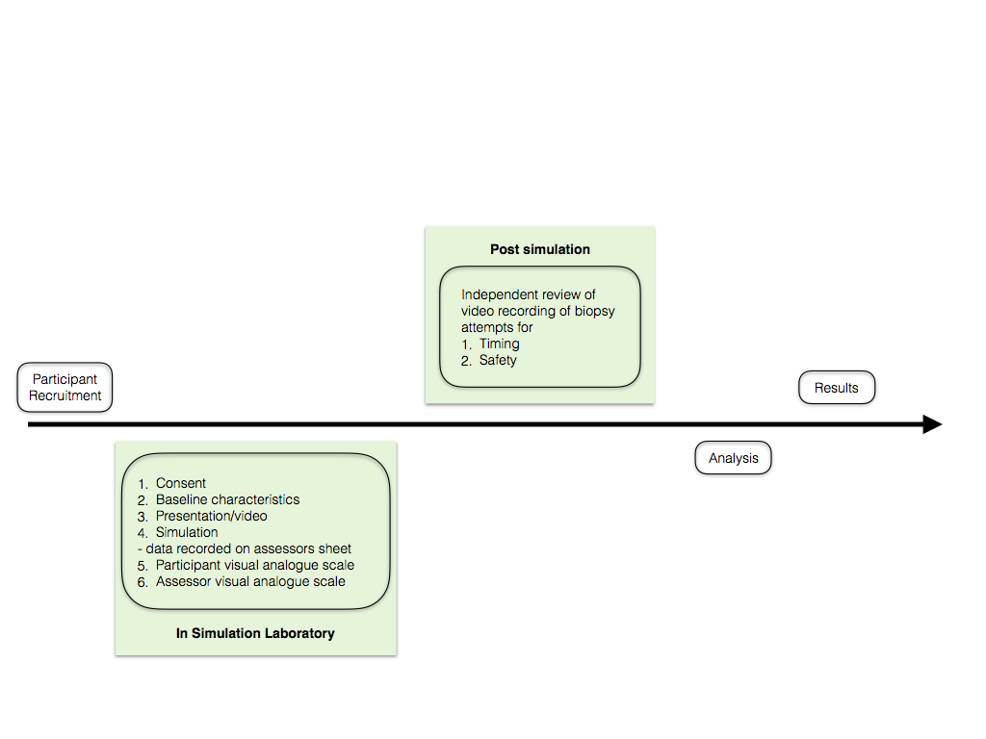

## Population/Sample size

The study population will be all junior doctors or medical students working in or based at Liverpool Hospital.

Difficulty exists in estimating numbers required for this study, as no similar study has been performed previously. Using a composite primary outcome of adequacy and safety, and assuming that there will be a 60% event rate in the freehand technique group and 30% in the ultrasound needle guide group, we will need at least 84 participants (42 in each group) to be able to reject the null hypothesis (significance 0.05, allowing for two sided testing) with 80% power.

Therefore, we will approach all medical students and junior doctors eligible for participation, and aim for a sample size of 84 (exclusive of dropouts). All participants will provide written informed consent.

## Expected duration of study and start times

The expected duration of participant recruitment, data collection and analysis would be 12 months. We will aim to star the study as soon as possible. We anticipate the following timeline:

* Participant recruitment and consent: 1 month
* Collection of data : 2 months
* Analysis: 2 months
* Write up: 3 months

|  |  |  |  |  |  |  |  |  |
| --- | --- | --- | --- | --- | --- | --- | --- | --- |
|  | Feb 2020 | March  2020 | April  2020 | May  2020 | June 2020 | July 2020 | Aug  2020 | Sept 2020 |
| Recruitment |  |  |  |  |  |  |  |  |
| Collection data |  |  |  |  |  |  |  |  |
| Analysis |  |  |  |  |  |  |  |  |
| Write up |  |  |  |  |  |  |  |  |

## Statistical analyses

Statistical analyses will be carried out using SPSS v25. This trial will be analysed as an intention to treat analysis. Given the primary outcome is dichotomous, chi squared or binomial logistic regression will be used depending on the variability of the remainder of the data.

Other categorical data will be compared using Persons chi quared. Data that is normally distributed will be analysed with parametric tests and non-normally distributed data will be analysed with non-parametric tests. Significance will be set at 0.05 and adjustments for multiple comparisons will be made where comparing several groups.

## Funding

There will be no cost implications for the participants or hospital. Education grants and departmental research funds will pay for the synthetic renal biopsy ultrasound models, needle guides, biopsy needles and other consumables (eg gloves, hand wash etc.) The ultrasound machines will be pre-owned by the hospital or borrowed from GE.

# Ethical Considerations

## Recruitment and selection of participants

The study population will include all junior doctors and medical students at Liverpool Hospital who have no previous experience with performing or simulation of renal biopsies. They will be approached during their mandatory education session. They will be provided with an information sheet/brief presentation. At this time it will be emphasised that participation is voluntary, and not participating will have no effect on their training. This will explain the necessary level of involvement as well as associated risks. It will be emphasised at this stage that the biopsy attempts will be recorded on video, but that no identifying features of the participant will be recorded. This will be used for a second independent evaluation of safety of the attempt as well as to more accurately document timing. If each trainee is happy to participate, then written consent will be obtained at the end of the presentation. Consent can be withdrawn at any stage, and will be revisited on the day of the trial.

The risk of injury or adverse outcome involving the participants is very low. The main possible risk to participants include needle stick injury either with hollow bore needle or scalpel. During the introduction video we will emphasise the risk that working with sharps includes, and encourage good clinical technique including placing all sharps in the sterile field within a kidney dish, and the prompt and safe disposal of sharps. We will also have a senior doctor present supervising each biopsy who will be able to stop any practice deemed dangerous. The use of synthetic models and a new biopsy needle for each participant means that there is no risk of transmission of blood borne infections.

## Inclusion and exclusion criteria

Inclusion criteria

* Over the age of 18 years
* Current medical student, intern, RMO or Basic Physician Trainee

Exclusion criteria

* Unwilling to consent
* Previous significant experience in performing or simulation of renal biopsy

## Informed consent

Junior doctors and medical students will be informed about the study during their regular education sessions. In these session, we will provide information regarding the trial. If the junior staff are happy to participate they will provide written consent at this time.

## Confidentiality and privacy

Participants names will only be recorded for ethics and on a master password protected Microsoft Excel spreadsheet which will have participant names and an allocated candidate number. Only study investigators will have access to the password. All other data will be stored on a separate Excel spreadsheet with the candidate number, not identifiable details.

Baseline demographics (age, gender, postgraduate year and previous experience with ultrasound) will be collected at the commencement of the study period. This will be for the purpose of multivariable analysis in order to exclude potential confounders to findings. Participant information will be de-identified at this stage of data collection. All data that will be presented will be grouped data and non-identifiable.

## Data storage and record retention

Data will be recorded by investigators onto a standardised assessors sheet which will be labelled with the candidates “candidate number”. This data will then be entered into a Microscope Excel spreadsheet. A master spreadsheet will contain the participants name and code number. A separate de-identified spreadsheet will have code numbers and all other collected data for the study. This spreadsheet will be password protected and stored on the hospital network only. Data will be regularly backed up on a password protected USB drive which will be stored in a locked office within hospital grounds. Passwords will only be known to the investigators. Following study completion, stored data will be kept for 7 years and then destroyed.

# Outcomes and significance

The primary outcome of the trial will be a composite outcome of adequacy and safety of each participant performing 3 passes. This is defined by:

* Adequacy: determined by macroscopic examination of each of the 3 cores obtained by the participant. If 2 of the 3 cores obtained by one individual participant are determined to be synthetic renal tissue by the assessor, this is considered an adequate biopsy. Conversely, if more than one core of the three obtained is not synthetic renal tissue, this is considered an inadequate biopsy.
* Safety: During each attempt at renal biopsy, 2 conditions must be met for that attempt to be considered safe. The core must be obtained from the inferior pole of the kidney, and concurrently the biopsy needle and kidney must be simultaneously seen at the time of biopsy. If either of these conditions are not met for any one pass, it is considered an unsafe biopsy.

Secondary outcomes will include

* Compare the proportion of passes that successfully biopsied kidney between the two groups
* Compare the number of biopsies through the inferior pole in the two groups
* Compare the continuous visualisation of both the kidney and biopsy needle in both groups
* Compare the time taken to complete 3 cores
* Compare the time taken to adequately visualise the kidney
* To compare the subjective difficulty as graded by the participant of learning the skill of percutaneous renal biopsy using freehand or ultrasound needle guide
* To compare the subjective difficulty as graded by the assessor of performing percutaneous renal biopsy using freehand or ultrasound needle guide

Significant result will be indicated by a p value of <0.05 signifying a difference between the two groups.

# Timelines/Milestones

We anticipate the following timeline:

* Participant recruitment and consent: 1 month
* Collection of data : 2 months
* Analysis: 2 months
* Write up: 3 months

# Publication policy

We aim to present this study locally, at national nephrology meetings and also to publish in a peer reviewed journal. Data will be grouped data and non-identifiable at all times. Authors will only include those who have substantially contributed to the study. All investigators will have access to the data and will approve the final submissions for dissemination. The trial protocol will be registered on the Australian Clinical Trials website. Where available, based on location of peer-reviewed publication, we will participate in data sharing.

# References

1. Tondel C et al. (2012) Safety and Complications of Percutaneous Kidney Biopsies in 715 Children and 8573 Adults in Norway 1988–2010. J Am Soc Nephrol 2012;7:1591-7
2. Prasad N, Kumar S, Manjunath R, et al. Real-time ultrasound-guided percutaneous renal biopsy with needle guide by nephrologists decreases post-biopsy complications. Clin Kidney J. 2015;8(2):151–156. doi:10.1093/ckj/sfv012
3. Ali H, Murtaza A, Anderton J, Ahmed A (2015). Post renal biopsy complication rate and diagnostic yield comparing hands free (ultrasound-assisted) and ultrasound-guided biopsy techniques of renal allografts and native kidneys [published correction appears in Springerplus. 2016;5(1):963]. Springerplus. 2015;4(1):491. Published 2015 Sep 12. doi:10.1186/s40064-015-1292-0
4. Rao NS, Chandra A. Needle guides enhance tissue adequacy and safety of ultrasound-guided renal biopsies. Kidney Res Clin Pract. 2018;37(1):41–48. doi:10.23876/j.krcp.2018.37.1.41