**Clinical Research Proposal - “Acupuncture and Paediatric Post-Tonsillectomy Analgesia”**

Dr David Ho, MBBS, FANZCA, Visiting Anaesthetist, Northside Anaesthesia

Dr Hannah Burns, MBBS, FRACS, Visiting ENT Surgeon, Northside ENT

Dr David McCrystal, MBBS, FRACS, Visiting ENT Surgeon, Northside ENT

Dr Paul Canty, MBBS, FRACS, Visiting ENT Surgeon, Northside ENT

Dr Richard Barr, MBBS, FRACS, Visiting ENT Surgeon, Northside ENT

**Correspondence:**

Dr David Ho

Northside Anaesthesia

Level 1 Education Centre,

Holy Spirit Northside Hospital,

627 Rode Rd,

Chermside 4032.

Phone: 07 3359 7011

Fax: 07 3359 7022

Mobile: 0402 898781

Email: david@hohoho.net.au

**Introduction**

Tonsillectomy is one of the most commonly performed surgical procedures in children and is usually accompanied by significant morbidity, such as postoperative bleeding, pain, nausea, vomiting, poor oral intake and dehydration. In Australia, pain relief post-tonsillectomy in children is commonly managed with Paracetamol, Non-steroidal anti-inflammatory drugs (NSAID), and narcotics such as oral Oxycodone. Although such regimens are usually highly effective, the use of opioid medications can precipitate or exacerbate nausea, vomiting, respiratory suppression, and — as seen in some well-publicized cases — result in death.

Recent evidences indicate that acupuncture may have a role in reducing post-operative pain and vomiting for tonsillectomy in children aged 1-5. This would then reduce their opioid requirement and, in turn, reduce undesirable drug side effects.

In a study of 143 adult patients, Sertel et al showed that acupuncture significantly reduced odynophagia after tonsillectomy; however, this study employed only post-procedure inpatient acupuncture that was timed with NSAID administration (1). It suggests that acupuncture may serve as an alternative pain treatment to NSAID following tonsillectomy.

In a similarly designed study of 60 children Gilbet et al showed that, in the study group, there was less pain, less analgesic drug consumption, and higher patient/parent satisfaction with analgesic treatment scores (2). No adverse effects were recorded. They concluded that acupuncture, in addition to conventional analgesic treatment, is an effective treatment for post-tonsillectomy pain. They also noted that acupuncture is safe and well received by children and their parents.

Both these studies suggest that acupuncture may have a significant role in reducing post-operative tonsillectomy pain. However, performance of acupuncture in children who are awake is unlikely to gain wide acceptance.

In an alternatively designed study of intra-operative acupuncture and post-tonsillectomy pain in 59 children, Tsao et al found there were no significant differences in opioid dose administered or total post-anesthesia care unit time between the control and treatment groups (3). Home surveys (of patients, not of parents) revealed significant improvements in pain control in the acupuncture treatment group postoperatively (P = 0.0065 and 0.051, respectively), and oral intake improved significantly earlier in the acupuncture treatment group (P = 0.01). However, the clinical trends were suggestive of improvements in the treatment group and the authors suggest the study was insufficiently powered to detect a statistical difference.

Similarly, in a retrospective study of 57 children with post-operative tonsillectomy pain, Occhi found that intra-operative acupuncture significantly decreased pain for up to 72 hours after treatment (4). In separate study of 60 children, Lin et al found that intra-operative acupuncture reduced pain and agitation after myringotomy (5). These studies suggest that intra-operative acupuncture may have significant benefits for up to 72 hours following treatment.

Finally, in a recent meta-analysis, Cho et al noted that the pain score reported by patients during the first 48 postoperative hours and the postoperative analgesic requirement were significantly lower in the acupuncture group versus the control group (6). Additionally, the incidence of postoperative nausea and vomiting was significantly lower in the acupuncture group than in the control group. No major adverse effects of perioperative acupuncture were reported in the enrolled studies. They conclude that perioperative acupuncture may provide pain relief without side effects in patients undergoing tonsillectomy. However, there were high levels of heterogeneity in several of the measured parameters, and the authors suggested that additional well-designed trials are required to further support the results of this meta-analysis.

These studies suggest that the use of intra-operative acupuncture to supplement general anaesthesia may be able to reduce the narcotic requirement for children undergoing tonsillectomy and hence improve their post-operative outcomes by reducing post-operative pain, reducing vomiting, and increasing oral intake at an earlier stage. Furthermore, this can readily be performed on the anaesthetised child. We propose this clinical trial to determine the effects of intra-operative acupuncture on analgesic requirements and vomiting in children undergoing tonsillectomy.

**Method**

Subject to the ethics committee approval, we propose to enrol two hundred and fifty (250) children, ASA grade 1 or 2, aged from 2 to 12 years, undergoing adenotonsillectomy in a double-blinded randomised controlled clinical trial.

Inclusion criteria:

* Age : 2-12
* ASA grade : 1-2
* Healthy otherwise
* No significant medical disease

Exclusion criteria:

* Any significant allergy
* Known bleeding tendency
* Known or likely airway difficulty
* Children who had received analgesics and sedatives within 36 hours prior to surgery.

All parents of respective patients will receive written informed consent prior to surgery. All parents will be interviewed and consented by the anaesthetist before or on the day of surgery. They will all be given a chance to ask questions, and any further queries will be addressed prior to the procedure.

The patients will be randomised assigned by a computer-generated programme to either the control or the acupuncture group.

In the control group, each child will be accompanied by their parent into the operating room for induction. General anaesthesia will be induced by oxygen, nitrous oxide and 8% Sevoflurane until loss of consciousness. The parent will then be escorted out from the operation room. An intravenous cannula will then be inserted and the child will be administered Morphine 0.1mg/kg, Granisetron 20mcg/kg, Dexamethasone 0.1mg/kg, and Clonidine 1mcg/kg. A flexible laryngeal mask (LMA) will then be inserted to maintain the airway for the duration of surgery and recovery. Anaesthesia will be maintained with oxygen 100% and end-tidal Sevoflurane of 2-6% with spontaneous ventilation. An intravenous fluid bolus of 20ml/kg will be given intra-operatively and followed by 2ml/kg in the ward. The adeno-tonsillectomy procedure will then be performed by electrocautery. At end of surgery, the child will be transferred onto a ward bed and taken to recovery with the LMA in situ. The LMA will be removed when the child is awake and able to maintain his/her own airway in recovery.

In the acupuncture group an identical procedure to that described above will be followed, with the addition of the insertion of ten (10) acupuncture needles after LMA insertion and prior to surgical stimulation. All acupunctures will be performed by Dr Ho, who is also a qualified acupuncturist with the Australian College of Medical Acupuncturist (AMAC). Stainless steel acupuncture needles, 15 mm in length and 0.18 mm in diameter (Serin Co, Shizuoka, Japan), will be used for the acupuncture. The positions for the needles inserted, according to Chinese Medicine standards, are: LI4x2, LI20/Bitongx2, CV(REN)22, GV(DU)20, LI1, PC6, ST44, SP6 (see Appendix 1). These particular acupuncture points are selected for their local analgesic property in the pharyngeal region, or for their general analgesic/anti-inflammatory property, or for their anti-emetic property. No electrical stimulation will be applied to the acupuncture needles. The surgical intervention will then commence immediately following acupuncture needle insertion. The needles will be left in situ for the duration of surgery, and immediately removed at the completion of surgery prior to the patient waking up.

In recovery and the ward, the patient will be assessed for pain using the CHEOPS scale by the recovery nurses at the following intervals: on awakening and at 5, 10, 15, 20, 30, and 60 minutes. All patients will be given Paracetamol 15mg/kg intravenously in recovery, and this will be continued orally on the ward every 6-hourly. When simple comfort measures, such as the presence of parents physically holding the child and/or offering oral fluids, do not console the patient and the child shows evidences of significant pain, with a pain score of > 7 on the CHEOPS scale, he/she will be treated with a Morphine bolus of 50mcg/kg in recovery. The patient will also be assessed for nausea and vomiting, and will be treated with Droperidol 10mcg/kg if required. All doses of Morphine bolus will be recorded as well as the time at which they are given.

On the ward, oxycodone liquid 0.1 mg/kg will be given 4-hourly postoperatively as required for analgesia, if the pain score is > 7, at the discretion of the ward nurse. All patients are encouraged to eat and drink as tolerated. All observations, including pulse oximetry and pain score, are recorded at 2-hourly intervals as well as the time and dose of Oxycodone given during their post-operative stay by the ward nurse. Patients are given another dose of Dexamethasone 10mcg/kg intravenously or orally on the first postoperative morning. Patients are discharged on the first postoperative morning if they are able to tolerate an oral intake. If the patient is still in significant pain, or not tolerating oral intake, then he/she remains in hospital until these issues are overcome.

All patients will be interviewed on day 1, 3 and 7 after discharge from hospital by telephone, and an assessment of pain and oral intake will be recorded by a blinded, independent research nurse.

**Null hypothesis**

Our null hypothesis is that there is no difference between the control group and the acupuncture group. The patients and parents will be blinded in both groups, as they will not be advised to which group they have been assigned and acupuncture will only be performed after patients are fully anaesthetised and the parents have been escorted from the operating room. Staff in recovery and on the ward will be also blinded, as they will not be told to which group the child belongs and acupuncture needles are removed prior to patients leaving the operating room. By necessity, the anaesthetist and surgeon will not be blinded, as they will be in the operating room during insertion of the acupuncture needles. However, we felt that our study structure will be rigorous enough to minimise the potential for bias.

**Power analysis**

During our ascertainment period in the first nine months of 2015, we observed that by using supplemental acupuncture intra-operatively there appears to be a 20-30% reduction in the amount of intra-operative Morphine required for patient comfort in recovery, as well as a similar reduction in total amount of Oxycodone required on the ward during their post-operative stay. Based on these observations we estimate that 45 patients are required in each group to achieve a level of statistical significance of p < 0.05. To allow for possible exclusions and drop-outs due to complications we have rounded this number up to 50 patients in each group. We note that an earlier study with similar design to ours used an initial 35% difference to arrive at a sample size of 30 for each group, but was subsequently found to be underpowered. We estimate that it would take approximately 3 to 6 months to complete the trial.

**Potential benefits**

We feel that acupuncture has the potential to improve outcomes in children undergoing adeno-tonsillectomy as it can lower the overall narcotic requirement and, in turn, lead to better post-operative pain relief. More importantly, we believe it may lessen the risk of serious complications including respiratory depression, post-operative apnoea, and oxygen desaturations. Evidence to date suggest that acupuncture also helps to minimise nausea and vomiting in children following tonsillectomy, which enables patients to better tolerate an oral intake and reduce the need for extended hospital stays.

**Potential complications**

As both groups receive the same identical general anaesthesia and surgery, the only additional potential complications will be from the acupuncture needling itself, which includes minor bleeding and nerve injury. The incidences of these complications are unknown but estimated to be extremely low, at 1:10,000 for minor bleeding and <1:100,000 for nerve injury. These injuries are self-limiting and not likely to require any active treatment. In a review of worldwide literature, White finds that the rate of serious adverse events is estimated to be 0.05 per 10,000 patients undergoing acupuncture treatment. He concludes that acupuncture incurs a ‘very low’ risk in term of medical interventions and that acupuncture is deemed as ‘a very safe intervention in the hands of a competent practitioner’ (8).

A recent article in the Medical Journal of Australia suggests that a possible infection and abscess in the neck was related to an acupuncture needle (7). However, as the authors pointed out, the acupuncture treatment in this case was unconventional, as the needle was left in-situ in the patient’s neck for more than 24 hours. In this study, all needles will be removed at end of surgery, which is usually of less than 1 hour in duration and thus minimise the chance of infection.

**References**

1) Sertel S, Herrmann S, Greten HJ, Haxsen V, El-Bitar S, Simon CH, Baumann I, Plinkert PK. Additional use of acupuncture to NSAID effectively reduces post-tonsillectomy pain. Eur Arch Otorhinolaryngol 2009; 266:919–925.

2) Tsao GJ , Messner AH , Seybold J , Sayyid ZN , Cheng AG , Golianu B . Intraoperative acupuncture for post-tonsillectomy pain: a randomized,

double-blind, placebo-controlled trial. Laryngoscope 2015; Aug 125(8):1972-8.

3) Gilbey P, Bretler S, Avraham Y, Sharabi-Nov A, Ibrgimov S, Luder A. Acupuncture for posttonsillectomy pain in children: a randomized, controlled study. Pediatric Anesthesia 2015; 25: 603–609.

4) Ochi JW. Acupuncture instead of codeine for tonsillectomy pain in children. International Journal of Pediatric Otorhinolaryngology 2013; 77:2058–2062.

5) Lin YC, Tassone R, Jahng S, Rahbar R, Holzman RS, Zurakowski D, Sethna N. Acupuncture management of pain and emergence agitation in children after bilateral myringotomy and tympanostomy tube insertion. Pediatric Anesthesia 2009; 19: 1096–1101.

6) Cho HK , Park IJ , Jeong YM , Lee YJ , Hwang SH. Can perioperative acupuncture reduce the pain and vomiting experienced after tonsillectomy? A meta-analysis. Laryngoscope 2015; Oct 20: 2055-2023.

7) Dlaska CE, Temple S, Schuetz MA. Disseminated methicillin-sensitive Staphylococcus aureus infection resulting from a paracervical abscess after acupuncture. Med J Aust 2015; 203 (10): 408-409.

8) White A. A cumulative review of the range and incidence of significant adverse events associated with acupuncture. Acupuncture Med 2004;22(3):122-133.

**Appendix 1. Acupuncture Points**

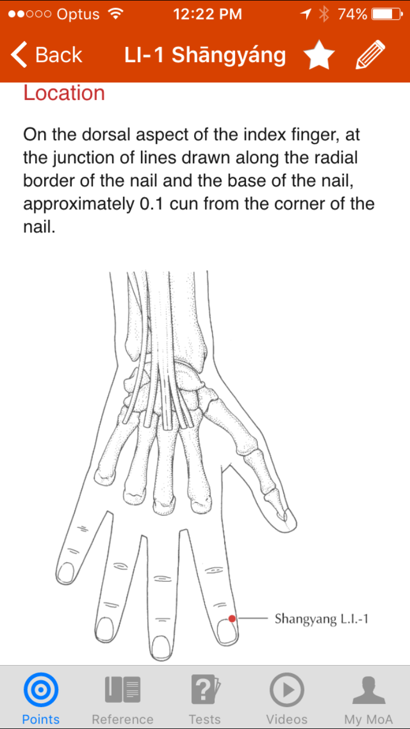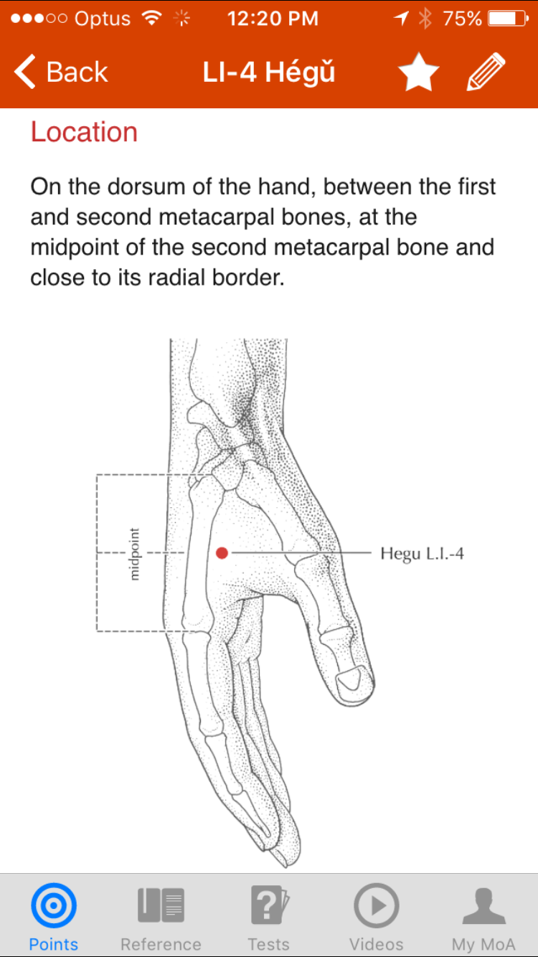

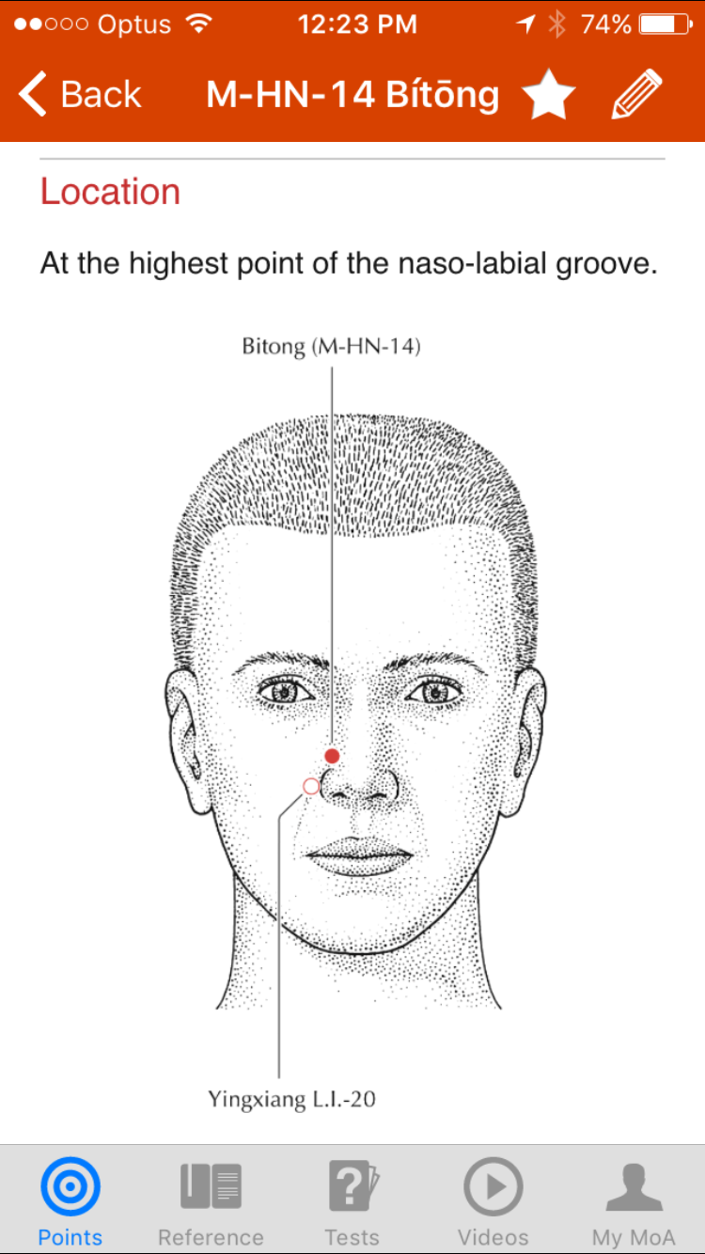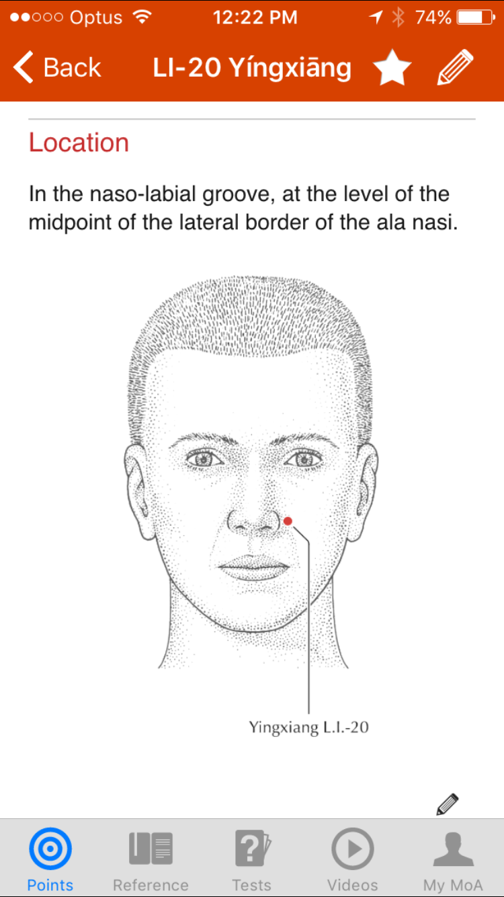

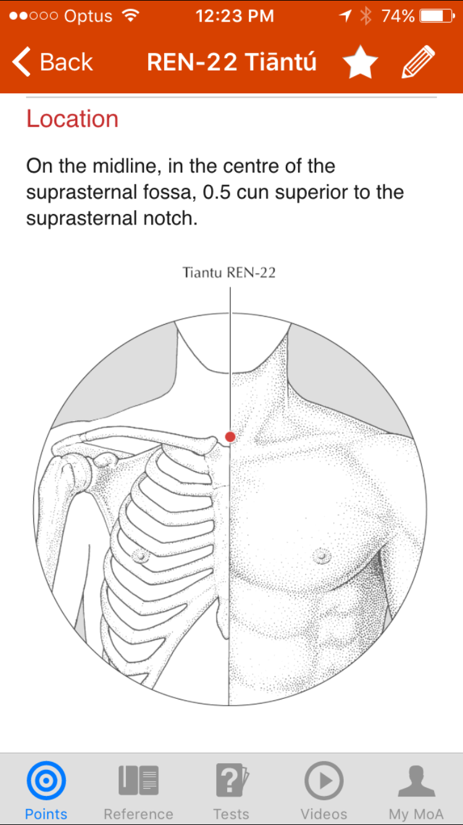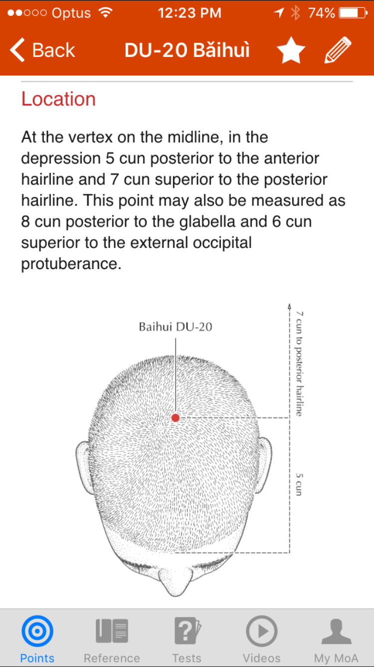

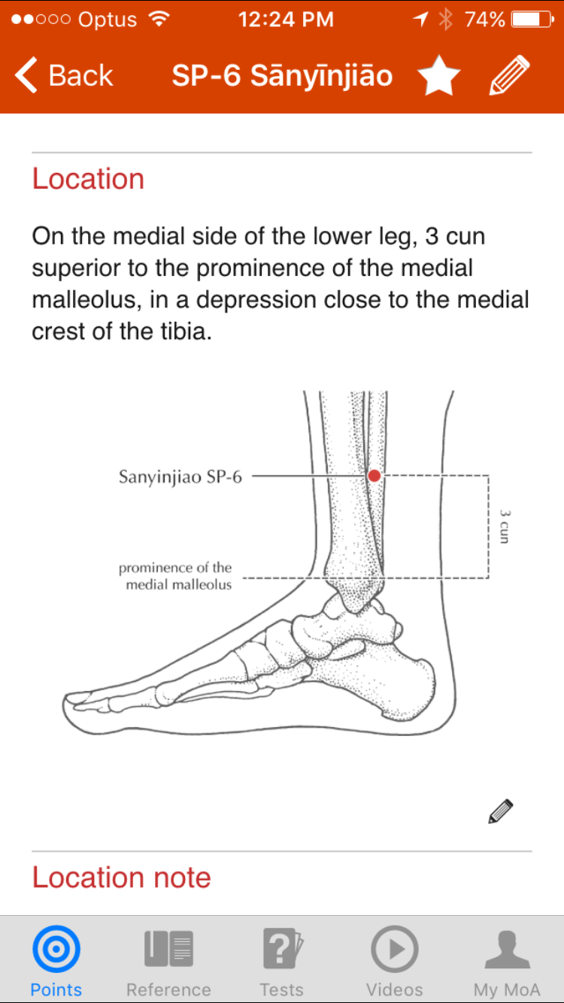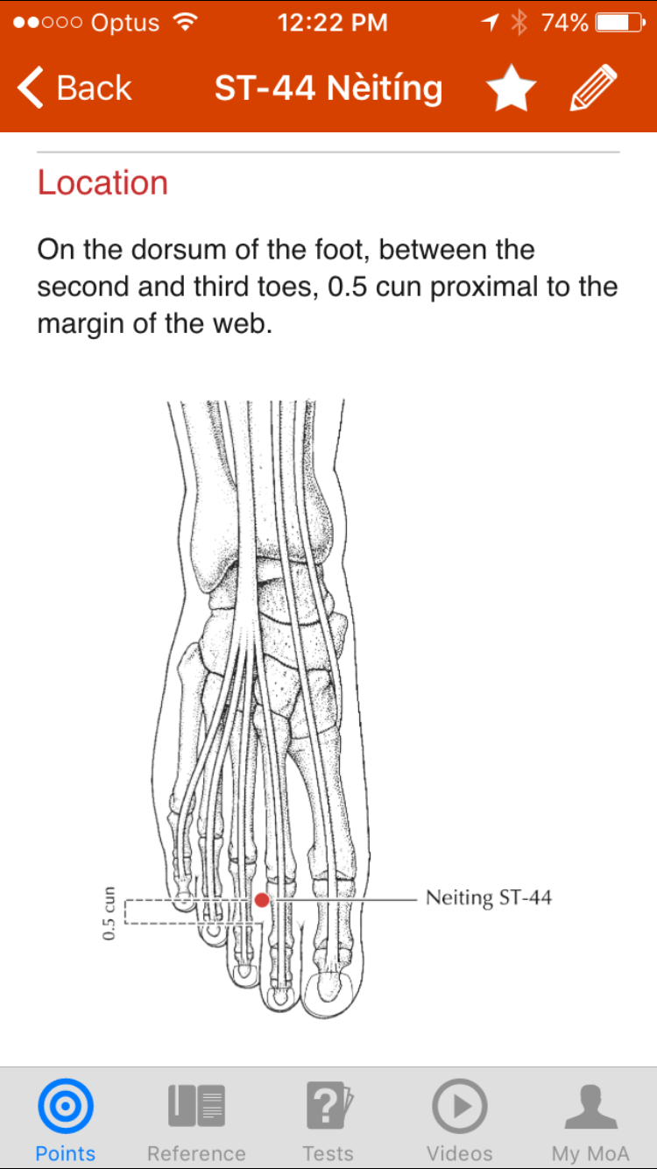

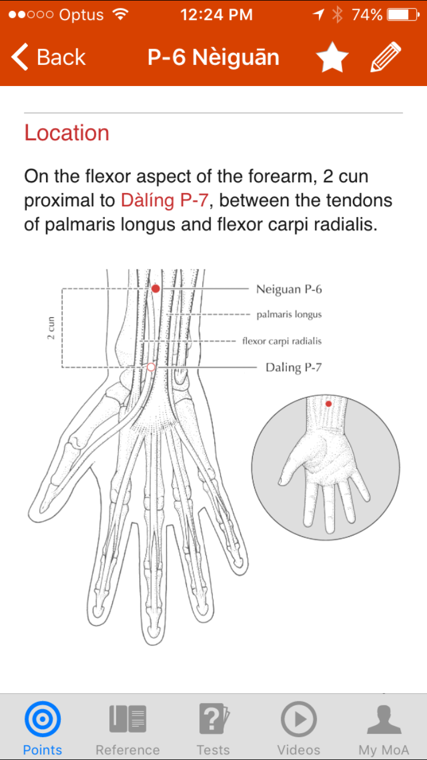

**Appendix 2 – CHEOPS Pain Scale**

**Children's Hospital Eastern Ontario Pain Scale (CHEOPS)**

(Recommended for children 1-7 years old) - A score greater than 4 indicates pain

|  |  |  |  |  |
| --- | --- | --- | --- | --- |
| **Item** | **Behavioral** |  | **Definition** | **Score** |
| **Cry** | No cry | 1 | Child is not crying. |  |
| Moaning | 2 | Child is moaning or quietly vocalizing silent cry. |  |
| Crying | 2 | Child is crying, but the cry is gentle or whimpering. |  |
| Scream | 3 | Child is in a full-lunged cry; sobbing; may be scored with complaint or without complaint. |  |
| **Facial** | Composed | 1 | Neutral facial expression. |  |
| Grimace | 2 | Score only if definite negative facial expression. |  |
| Smiling | 0 | Score only if definite positive facial expression. |  |
| **Child**  **Verbal** | None | 1 | Child not talking. |  |
| Other complaints | 1 | Child complains, but not about pain, e.g., “I want to see mommy” or “I am thirsty”. |  |
| Pain complaints | 2 | Child complains about pain. |  |
| Both complaints | 2 | Child complains about pain and about other things, e.g., “It hurts; I want my mommy”. |  |
| Positive | 0 | Child makes any positive statement or talks about others things without complaint. |  |
| **Torso** | Neutral | 1 | Body (not limbs) is at rest; torso is inactive. |  |
| Shifting | 2 | Body is in motion in a shifting or serpentine fashion. |  |
| Tense | 2 | Body is arched or rigid. |  |
| Shivering | 2 | Body is shuddering or shaking involuntarily. |  |
| Upright | 2 | Child is in a vertical or upright position. |  |
| Restrained | 2 | Body is restrained. |  |
| **Touch** | Not touching | 1 | Child is not touching or grabbing at wound. |  |
| Reach | 2 | Child is reaching for but not touching wound. |  |
| Touch | 2 | Child is gently touching wound or wound area. |  |
| Grab | 2 | Child is grabbing vigorously at wound. |  |
| Restrained | 2 | Child's arms are restrained. |  |
| **Legs** | Neutral | 1 | Legs may be in any position but are relaxed; includes gentle swimming or separate-like movements. |  |
| Squirm/kicking | 2 | Definitive uneasy or restless movements in the legs and/or striking out with foot or feet. |  |
| Drawn up/tensed | 2 | Legs tensed and/or pulled up tightly to body and kept there. |  |
| Standing | 2 | Standing, crouching or kneeling. |  |
| Restrained | 2 | Child's legs are being held down. |  |

**Appendix 3 - Information Sheet and Consent Form for Parents**

Your child will be having a surgical operation to remove his/her tonsils and adenoids under general anaesthesia. On the day of surgery, your child will be admitted to the hospital by the nurse on the surgical ward. You may be contacted by your anaesthetist by telephone before the day of surgery to discuss your child’s procedure. Otherwise, your anaesthetist will see you and your child before the operation to discuss the plan for general anaesthesia and pain management following surgery.

When your child is brought to the operating room, you will be able to accompany your child until he/she goes to sleep. The anaesthetist will use a mask with anaesthetic gas to put your child to sleep, and once your child is asleep you will be escorted from the operating room. An intravenous cannula will be inserted into your child’s hand or arm, and this will generally remain in place until the following day. The surgery will then proceed, and generally will take about 30-60 minutes. When the surgery is finished, your child will be transferred to the recovery room and allowed to wake slowly from the anaesthetic. When he/she is awake, you will be able to come to see him/her in recovery, and you will stay with your child until they are transferred back to the surgical ward.

This operation is well known to be associated with significant pain and possible vomiting after the surgery. Our standard pain management after tonsillectomy surgery is regular oral Panadol, with Oxynorm liquid for breakthrough pain between doses of Panadol. Oxynorm is a narcotic-based drug that has very effective pain relieving properties, but can impair breathing if large doses are given. Our aim is not to take away all pain, but to reduce pain enough to enable your child to eat and drink while minimising the risk of respiratory depression. Most children tolerate this pain relief regimen very well, experience manageable levels of discomfort, and should be able to go home after breakfast the next day.

Recent scientific evidence suggests that the use of acupuncture may help to improve pain control and dietary intake in children after tonsillectomy. We would like to enrol your child in a trial to help establish whether acupuncture does indeed significantly improve such outcomes in children after tonsil surgery. If you agree to enrol in this study, your child will be randomly assigned to one of two groups – a control group, or a treatment group. If he/she is in the control group, he/she will receive the same standard regimen that we have been using at this hospital as outlined above. If he/she is in the treatment group, he/she will receive the standard regimen as above but with the addition of acupuncture treatment. The acupuncture will only be performed after your child is under general anaesthesia, and he/she will not be aware whether he/she has had acupuncture or not. He/she will not feel any pain from the needle insertion. All needles will be removed before he/she wakes up. The nurses in recovery and on the surgical ward will use a pain scale to assess your child’s pain level in both control and treatment groups; this will be used to compare the two groups to see if there is any difference. Our pain management after surgery is identical in both groups, and your child will otherwise be given the same treatment (as outlined above), regardless of which trial group he/she is assigned to.

**Benefits:**

By participating in this study, you will help us to determine whether acupuncture will benefit other children having the same procedure in future.

If your child is in the control group, he/she can be expected to have the same outcome following surgery as has always been the case. If your child is in the treatment (ie acupuncture) group, then he/she may or may not experience additional benefits as a result of the acupuncture.

**Risks:**

If your child is in the control group, then there is no additional risk. If your child is in the treatment group, there may be risks related to the acupuncture procedure. These risks are very small, and as described in the scientific literature, include minor bleeding (<1:100,000), nerve injury (<1:1,000,000), and infection of the acupuncture site (<1:500,000). Minor bleeding from acupuncture can generally be stopped with gentle pressure. The risk of infection is minimised by using sterile needles and by removing needles as soon as the surgery is finished.

**Consent form**

I, ,

of ,

hereby consent to my child, ,

participating in the study “ Acupuncture and Paediatric Post-operative Tonsillectomy Analgesia”.

I have read the information provided about this study, and understand the potential risks and benefits. I have had the opportunity to ask questions regarding the details and the conduct of the study.

Signed

Date / /