Klinik Lanjutan Strok Klinik Primer Cheras stroke patient and their caregiver

Screen for possible depression with TQWHQ

No

Yes

Exclude and alert primary care team for further assessment and treatment if required

Recruit and randomize

Intervention

Control

Risk of stroke calculated with Riskometer in percentage

Risk of stroke calculated with Riskometer in percentage

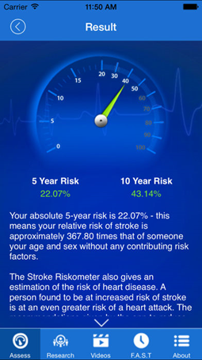

Assess Life’s Simple 7 score and given general advice

Assess Life’s Simple 7 score and given general advice

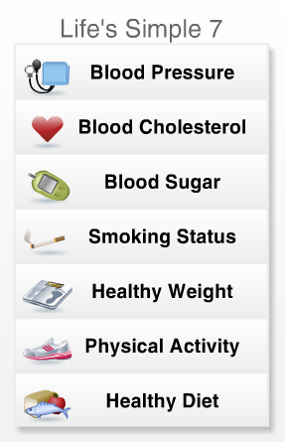

Stroke Riskometer downloaded, teach how to use

No application downloaded

Review in 3 months and reassess stroke risk and LS7

Review in 3 months and reassess stroke risk and LS7

Identify risk and refer, exit trial and analyse

Refer patients who require stroke risk factor intervention / symptomatic

Participants are identified from KLS appointment list from June to Sept 2018 (n=190)