|  |  |
| --- | --- |
|  | **Effects of Dance for Parkinson’s on gait and cognitive skills in Parkinson's disease** |

***Would you like to take part in a study to measure the impact of dance on people with Parkinson’s disease?***

**We are looking for:**

Independently living, ambulatory, men or women, who are diagnosed as having idiopathic Parkinson’s disease; aged between 30 to 85 years; and, who have not participated in a dance programme in the past six months.

**Your participation would include:**

Being allocated randomly to a dance group or a control group. Please note that depending on your allocation you may be in the Dance for Parkinson’s (DfP) group or the control group. The results of the study will be shared after completion and it is expected that your knowledge of Parkinson’s disease will be extended. Both groups will receive a useful series of assessments which will help to understand Parkinson’s by obtaining some information about performance regarding walking style, cognitive function and some other outcomes.

**What will you be asked to do?**

|  |  |
| --- | --- |
| **If you are allocated into the dance group,**  **you will have the opportunity to:** | **If you are allocated into the control group,**  **you will have the opportunity to:** |
| * Attend 2 assessment sessions before the series of dance classes. * ***Participate in DfP classes twice a week for 12 weeks.*** * Attend 2 assessment sessions after the series of dance classes. * Attend two follow up assessment sessions in the 12th week after completing the dance class. | * Attend 2 assessment sessions before the 12 week research period. * Follow the usual exercise and medication routine for the duration of the 12 weeks. * Attend 2 assessment sessions after the 12 week research period. * ***Participate in a free complimentary dance class*** after the 12th week follow up assessment session. |

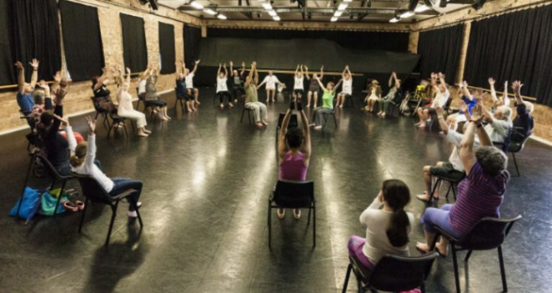**The DfP classes will be:**

* ***Free of charge***
* 75-minute classes
* Held at QUT Kelvin Grove Campus
* Modelled on the internationally recognized Dance for Parkinson’s disease (DfPD®) programme
* Conducted by two DfPD® trained instructors who are routinely conducting DfP classes at Queensland Ballet

Please note that free parking is provided during visits to QUT for assessment. However, you are required to cover your own parking expenses for your visits to any of the dance classes.

**What is DfP?**

If you are interested in learning more about Dance for Parkinson’s go to:

[**https://www.queenslandballet.com.au/learn/fitness-and-wellbeing/dance-for-parkinson-s**](https://www.queenslandballet.com.au/learn/fitness-and-wellbeing/dance-for-parkinson-s)

**If you would like to participate please contact:**

**Ms Nadeesha Kalyani 07 3138 6426** [**nadeesha.haputhanthirige@hdr.qut.edu.au**](mailto:nadeesha.haputhanthirige@hdr.qut.edu.au)

**Professor Graham Kerr** 07 3138 6303 [g.kerr@qut.edu.au](mailto:g.kerr@qut.edu.au)

**Erica Rose Jeffrey** 0412 260 040 [ericarose@danceforparkinsonsaustralia.org](mailto:ericarose@danceforparkinsonsaustralia.org)

QUT Human Research Ethics Committee, approval number 1700000005.