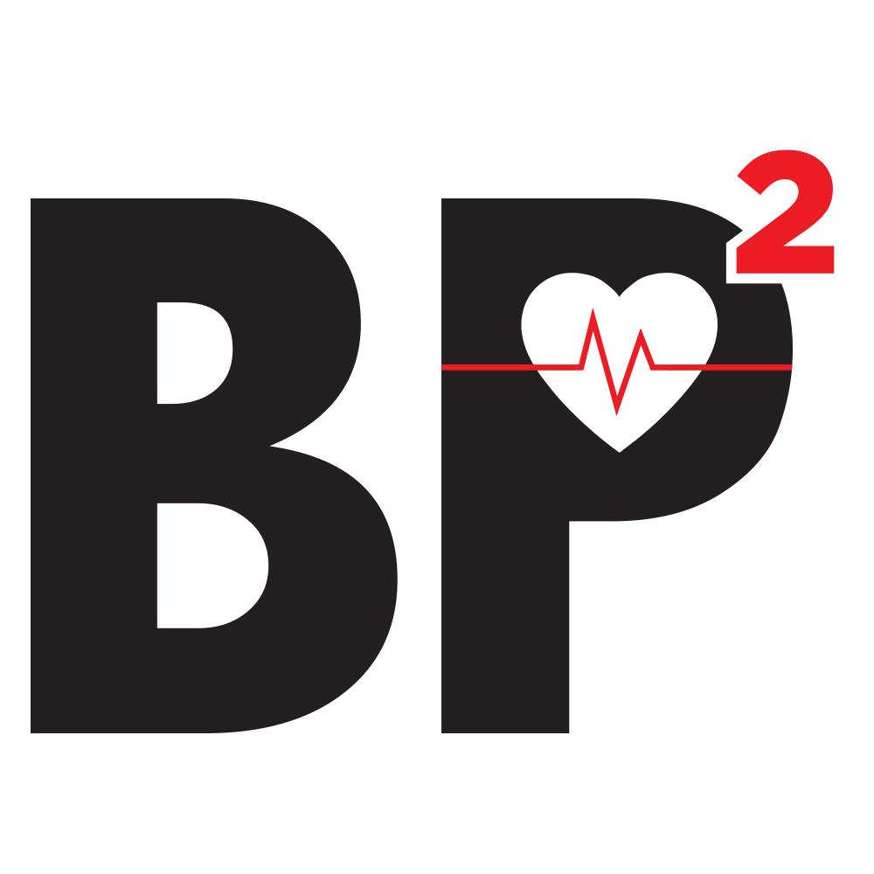[Insert institutional letterhead]
[insert name of local institution/s where research is being conducted]

PARTICIPANT INFORMATION SHEET AND CONSENT FORM

CLINICAL TRIAL/CLINICAL RESEARCH
(EXCLUDING GENETIC TESTING AND COLLECTION/STORAGE OF HUMAN TISSUE)

The BP² (Blood Pressure Postpartum) study: a 3-arm, randomised trial of follow-up and lifestyle behaviour change strategies in the first 12 months after hypertensive disorders of pregnancy

Invitation
You are invited to participate in a research study into follow-up and healthy lifestyle for women who have recently had a pregnancy complicated by high blood pressure (“gestational hypertension”, “preeclampsia” or “chronic hypertension”).

The study is being conducted by
[Insert investigator names]

in several hospitals across the [insert LHD here] Local Health Districts

Before you decide whether or not you wish to participate in this study, it is important for you to understand why the research is being done and what it will involve. Please take the time to read the following information carefully and discuss it with others if you wish.

- What is the purpose of this study?
The purpose is to investigate different ways to follow-up women after they have had a pregnancy complicated by one of the hypertensive (high blood pressure) disorders of pregnancy. The technical names of these disorders are preeclampsia, gestational hypertension, and chronic (or “essential”) hypertension. It is known that women who have had a pregnancy complicated by high blood pressure are at increased long-term risk of health problems, such as chronic high blood pressure and heart disease.
However, it is unknown whether any monitoring or treatments in the first few years after a hypertensive pregnancy improve health risks or outcomes for either a mother or her baby. In other words, we do not yet know the best way to follow-up mothers and babies after a pregnancy complicated by high blood pressure. This research is aiming to help answer that question, by studying three different methods of follow-up and encouraging a healthy lifestyle (also known as “lifestyle behaviour change strategies”) in the first 3 years after hypertensive pregnancy.

- Why have I been invited to participate in this study?
You are eligible to participate in this study because you had a high blood pressure (hypertensive) disorder of pregnancy (preeclampsia, gestational hypertension, or chronic hypertension with or without preeclampsia) at one of the study hospitals, and your baby is six months old or younger.

- What if I don’t want to take part in this study, or if I want to withdraw later?
Participation in this study is voluntary. It is completely up to you whether or not you participate. If you decide not to participate, it will not affect the treatment you receive now or in the future. Whatever your decision, it will not affect your relationship with the staff caring for you.

New information about the treatment being studied may become available during the course of the study. You will be kept informed of any significant new findings that may affect your willingness to continue in the study.

If you wish to withdraw from the study once it has started, you can do so at any time without having to give a reason.

- What does this study involve?
If you agree to participate in this study, you will be asked to sign the Participant Consent Form.

The main involvement for you and your baby will be from approximately 5-6 months after your baby is born, to when your baby is about 1 year of age, with further follow up visits when your baby is 2 years old and 3 years old if ongoing funding allows. This study will be initially conducted over 2 years (time to enter all mothers and babies into the study and perform 6 month after birth and 12 month after birth visits), with follow-up for a further 2 years (further visits when children are age 2 and age 3) if ongoing funding allows. Approximately 500 mothers and their babies will be involved in the study.

The treatment (follow-up methods) being investigated in this study differ from the standard treatment offered after a woman has high blood pressure in pregnancy because they include structured, consistent information packages, education tools and a specific hospital postpartum clinic for study women. Currently, women after hypertensive pregnancy receive a variety of different follow-up methods and advice, particularly regarding their long-term health.

This study is a randomised trial. Sometimes doctors don’t know the best way of treating patients with a particular condition, so comparisons need to be made between different treatments. This is the case with treatment after hypertensive (high blood pressure) disorders of pregnancy. To do this, study participants are put into groups and given different treatments, and the results are compared to see whether one treatment is better. To ensure the groups are similar to start with, a computer allocates each study participant into a group randomly, like the flip of a coin. Neither the doctor nor the study participant can decide which treatment the participant receives.

If you agree to participate in this trial, including being randomly allocated to one of the 3 study treatments, you will then be asked to undergo the following procedures:
- At about six months (between 5 and 7 months) after the birth of your baby
- Fill in questionnaires which ask details about your current and past physical and mental health, the health of your baby, the eating patterns of yourself and your baby, and some other factors in your lifestyle such as exercise patterns, smoking, and alcohol use. Some questions will be asked of you directly by the study nurse/midwife over the phone, and some will be emailed (or mailed if that is your preference) to you to fill in and return.
- Have a blood and urine test (mothers only, not babies)
- Have a visit for you and your baby, with either your general practitioner (GP) if you are allocated to study Group 1, or at your study hospital Postpartum Clinic if you are in Group 2 or Group 3. At that visit, some physical measurements will be taken of yourself (including your blood pressure, weight, and waist circumference) and your baby (including height, weight, and head circumference). You will also speak to either your GP (Group 1) or study staff (doctors, nurses/midwives, and dieticians) at the Postpartum Clinic (Groups 2 and 3) about health after hypertensive pregnancy, including healthy lifestyle. For women in Group 1 who are seeing their GP, you may wish to have this visit at the same time as your baby’s six months vaccinations are due, or you may wish to have a separate visit with your GP – whatever is most convenient for you. For Group 1 women, as the hospital study staff are not taking your physical measurements or that of your baby at the six month visit, we will also ask your written permission to contact your GP and obtain those measurements.
- [include for following sites: Royal Prince Alfred Hospital] An appointment at your study hospital (which can be on the same day as your Postpartum Clinic visit) to perform testing of your blood vessel (endothelial) function. This involves 1) An ultrasound of the arteries in your neck (carotid arteries) with light pressure applied via a small probe and pictures taken over 10 minutes 2) An ultrasound of your arm whereby you are required to lie still for approximately 20 minutes on a bed. A standard blood pressure cuff will be inflated around your forearm for 5 minutes and then released and a scan will be performed on your arm.

- After your six months postpartum visit (between 6 and 12 months after birth)
- Women in all groups may have further follow-up organised, if the six month blood and urine test results, physical measurements, or the consultation with your GP or Postpartum Clinic suggests that this is appropriate
- Between 6 and 12 months postpartum, women in Group 3 will participate in a telephone-based healthy lifestyle (lifestyle behaviour change) program. This includes setting goals regarding lifestyle areas women wish to improve (e.g. diet, exercise, weight) and receiving coaching calls to help them achieve these goals
- Women who indicate on their six month questionnaire that they are interested in participating in a more in-depth interview, about their experiences of looking after their health after having a baby, and about the experience of participating in the BP² study, may be contacted and invited in for an interview. The interview is entirely voluntary, and it is up to you to decide whether or not to participate. If you choose not to, this will not affect the care you receive. If you agree to the interview, it will be conducted by telephone at a time that is convenient to you, when your baby is around 10 months old. It will take approximately 40-60 minutes. The interview will be audio recorded and professionally transcribed, with your consent. The recording will be deleted from the audio recorder once the typed transcript has been received and verified. The written transcript of your interview will only have a BP² code number on it and no information that can identify you. The transcript will be stored on a secure network at the University of Sydney, accessible only via a password-protected computer. The transcript will be removed from the system and destroyed after five years.

- At about 12 months after the birth of your baby (between 11 and 13 months), all women and their babies will come to their study hospital to have follow-up physical measures performed, fill in follow-up questionnaires, have the study blood and urine tests (mothers only) repeated, [include for following sites: Royal Prince Alfred Hospital] have the blood vessel ultrasounds repeated, and have a visit with the study nurse/midwife.
- When your baby is 2 years old and 3 years old, we would like to have further follow-up visits with you and your baby to repeat these measures, provided that ongoing funding is secured to allow us to continue this follow-up. At the 3 year visit, we will also request your permission to take a blood sample from your child as well as yourself, although please note that all tests are optional and you can still participate in the overall study without giving permission for future blood tests on your child.

Regarding the blood tests on mothers (at 6 and 12 months after pregnancy, and planned 2 and 3 year follow-up), samples of blood taken from a vein will be required. The blood samples should be performed in the morning after a fast, i.e. after you have had nothing to eat and drink overnight, the blood sample should be taken before you have anything to eat or drink. The amount of blood taken will be equivalent to 8 teaspoons on each occasion (approximately the same amount of blood that would have been taken early in your pregnancy when you had your “booking” blood tests). Six of the 8 teaspoons will be immediately used to perform tests that are known to be useful in estimating health risks (such as your blood sugar and cholesterol levels). Two teaspoons will be used by the study research team to perform research tests. These tests are looking for blood factors that may in future be useful in estimating heart disease and/or blood vessel disease risks, but are not currently used for this as their usefulness is not proven.

In addition, the researchers would like to have access to your medical record, including the details of your hypertensive pregnancy, to obtain information relevant to the study. We will also, where relevant, obtain information from your GP about your 6 month visit, and from the healthy lifestyle program providers about your participation in the program.

The researchers would also like to have access to your PBS, Medicare and NSW hospital admission data for both yourself and your child/ren. This is optional and you will be provided with an additional Information Sheet and Consent Form to sign for this. If you have not been given this additional information today, it will be provided in the future. The researchers will not access the PBS, Medicare or NSW hospital admission data for yourself or your child/ren unless you specifically consent to this.

- How is this study being paid for?
The study is being sponsored by the New South Wales Department of Health Translational Research Grants Scheme.

All of the money being paid by the sponsor to run the trial will be deposited into an account managed by the South-Eastern Sydney Local Health District. No money is paid directly to individual researchers.

Study Chief Investigator Dr Amanda Henry also receives salary support from the National Health and Medical Research Council in the form of an Early Career Fellowship (APP1141570), which partially pays for her salary and therefore her involvement in the study.

- Are there risks to me in taking part in this study?
All medical procedures involve some risk of injury. In addition, there may be risks associated with this study that are presently unknown or unforeseeable. In spite of all reasonable precautions, you might develop medical complications from participating in this study. The known risks of this study are:
- Mild discomfort that most women would experience from blood testing. About 1 in 10 women would have bruising or more than mild discomfort after blood testing, and about 1 in 20 feel dizzy/faint at the time of blood testing. Serious or longer-lasting injury after blood tests are very rare.
- Inconvenience of extra medical visits due to study participation
- For some women, study questionnaires and/or visits might cause distress either due to recall of traumatic events from your pregnancy and birth, or anxiety about your ongoing health. Please inform study staff promptly if you have any feelings of distress so that we can arrange appropriate counselling and ongoing follow-up

There may also be risks associated with this trial that are presently unknown or unforeseeable.

- What are the alternatives to participation?

You do not have to take part in this research project to receive standard treatment at this hospital. After hypertensive pregnancy, your treating doctors decide what immediate treatment and follow-up for your health is appropriate, which may include medication and either follow-up with your GP or at the hospital where you have given birth. You will still receive this treatment regardless of whether or not you choose to participate in the research project. This research project is additional to your immediate post-birth treatment and follow-up.

- What happens if I suffer injury or complications as a result of the study?
If you suffer any injuries or complications as a result of this study, you should contact the study doctor as soon as possible, who will assist you in arranging appropriate medical treatment.

You may have a right to take legal action to obtain compensation for any injuries or complications resulting from the study. Compensation may be available if your injury or complication is caused by procedures, or by the negligence of any of the parties involved in the study. If you receive compensation that includes an amount for medical expenses, you will be required to pay for your medical treatment from those compensation monies.

If you are not eligible for compensation for your injury or complication under the law, but are eligible for Medicare, then you can receive any medical treatment required for your injury or complication free of charge as a public patient in any Australian public hospital.

- Will I benefit from the study?
This study aims to further medical knowledge and may improve future treatment of women and their babies after hypertensive disorders of pregnancy, however it may not directly benefit you. Although it is expected that the health of participants overall could be improved through the study interventions, there is no guarantee of benefit to any individual mother or her baby through study participation. Where there are benefits, these may be quite small on an individual basis e.g. slight decrease in weight or blood pressure.

- Will taking part in this study cost me anything, and will I be paid?
Participation in this study will not cost you anything. You will be reimbursed for reasonable travel/parking expenses to the amount of $30 per hospital visit. If you agree to the phone interview when your baby is around ten months old, we will send you a $30 supermarket gift card with our thanks, in recognition of your time taken for the interview.

- What will happen to my tissue (blood) sample after it has been used?
The blood samples you provide during the study will be destroyed at the completion of the study.

- How will my confidentiality be protected?
Of the people treating you, only the study investigators at your study hospital, study staff at your hospital (e.g. research nurse/midwife) and your GP/local doctor will know whether or not you are participating in this study. Any identifiable information that is collected about you in connection with this study will remain confidential and will be disclosed only with your permission, or except as required by law. Only the researchers named above and employed study staff (e.g. research nurse/midwife) will have access to your details and results that will be held securely at [institution].

- What happens with the results?
If you give us your permission by signing the consent document, we plan to discuss/publish the results at scientific conferences, in appropriate seminars e.g. GP and/or consumer education sessions, and in peer-reviewed journals. Results may also be disclosed to the HREC and NSW Health Translational Research Grants Scheme for monitoring purposes.

In any publication, information will be provided in such a way that you cannot be identified. Results of the study will be provided to you, if you wish.

- What happens to my treatment when the study is finished?
If one of the study interventions is found to be of benefit as a result of this trial, then the study hospitals are committed to providing this model of care on an ongoing basis as a condition of the Translational Research Grants Scheme funding. Therefore, you may be able to access further follow-up at the conclusion of the trial. The study research nurse/midwife (and doctor if appropriate) will discuss further follow-up options in consultation with you at the time of your 12 months after birth visit. Your GP will also, with your permission, receive copies of all blood tests (e.g. blood sugar, cholesterol) relevant to your health and ongoing healthcare that are performed during the study, as well as consultation letters as applicable.

- What should I do if I want to discuss this study further before I decide?
When you have read this information, the researcher [name] will discuss it with you and any queries you may have. If you would like to know more at any stage, please do not hesitate to contact him/her on [study phone number].

- Who should I contact if I have concerns about the conduct of this study?
This study has been approved by the South Eastern Sydney Local Health District Human Research Ethics Committee. Any person with concerns or complaints about the conduct of this study should contact the Research Support Office which is nominated to receive complaints from research participants. You should contact them on 02 9382 3587, or email SESLHD-RSO@health.nsw.gov.au and quote 2019/ETH04732.

The conduct of this study at the [name of site] has been authorised by the [name of health district]. Any person with concerns or complaints about the conduct of this study may also contact the [details of the Research Governance Officer of the health district].

Thank you for taking the time to consider this study.
If you wish to take part in it, please sign the attached consent form.
This information sheet is for you to keep.
[Insert institutional letterhead]
[name of local institution/s where research is being conducted]

CONSENT FORM
The BP² (Blood Pressure Postpartum) study: a 3-arm, randomised trial of follow-up and lifestyle behaviour change strategies in the first 12 months after hypertensive disorders of pregnancy

1. I,................................................................................................................. of................................................................................................................
agree to participate in the study described in the participant information statement set out above.
2. I acknowledge that I have read the participant information statement, which explains why I have been selected, the aims of the study and the nature and the possible risks of the investigation, and the statement has been explained to me to my satisfaction.
3. Before signing this consent form, I have been given the opportunity of asking any questions relating to any possible physical and mental harm I might suffer as a result of my participation and I have received satisfactory answers.
4. I understand that I can withdraw from the study at any time without prejudice to my relationship to the [name of Hospital].
5. I agree that research data gathered from the results of the study may be published, provided that I cannot be identified.
6. I further agree to my child, ………………………, participating in the study as described in the participant information statement set out above. I understand that I can withdraw my child’s participation from the study at any time without prejudice to my relationship, or my child’s relationship, to the [name of Hospital].
7. I agree that my medical record may be accessed to provide data relevant to the study. Where applicable, I also agree that my general practitioner (GP)/local doctor records of my and my child’s six months postpartum consultation with my GP may be accessed to provide data relevant to the study as outlined in the participant information statement set out above.
8. I understand that if I have any questions relating to my participation in this research, I may contact Dr Amanda Henry on telephone [study phone] or Amanda.Henry@unsw.edu.au , who will be happy to answer them.
9. I acknowledge receipt of a copy of this Consent Form and the Participant Information Statement.

Complaints may be directed to the Research Ethics Secretariat, South Eastern Sydney Local Health District, Prince of Wales Hospital, Randwick NSW 2031 Australia (phone 02-9382 3587, fax 02-9382 2813, email SESLHD-RSO@health.nsw.gov.au .

Signature of participant Please PRINT name Date

_________________________ _______________________ _______________

Signature of witness Please PRINT name Date

_________________________ _______________________ _______________

Signature of investigator Please PRINT name Date

_________________________ _______________________ _______________

[Institutional letterhead]

[Insert name of local institution where research is being conducted]

The BP² (Blood Pressure Postpartum) study: a 3-arm, randomised trial of follow-up and lifestyle behaviour change strategies in the first 12 months after hypertensive disorders of pregnancy

WITHDRAWAL OF CONSENT

I hereby wish to WITHDRAW my/my child’s consent to participate in the study described above and understand that such withdrawal WILL NOT jeopardise any treatment or my relationship with the [name of Hospital] or my medical attendants.

Signature of participant Please PRINT name Date

_________________________ _______________________ _______________

The section for Revocation of Consent should be forwarded to Dr Amanda Henry, Department of Women’s and Children’s Health, Level 2 Prichard Wing, St George Hospital.

