

**Project Title**

***Do Shoe Inserts Affect Walking and Provide Pain Relief in Individuals***

***with Greater Trochanteric Pain Syndrome?***

**Researchers:**

Chief investigator: Dr Angela M Fearon  
Faculty of Health, UCRISE  
University of Canberra  
Phone: (02) 6206 8717  
Email: [Angie.Fearon@canberra.edu.au](mailto:angie.fearon@canberra.edu.au)

Research Team: Dr Wayne Spratford; Dr Jaqueline Bousie; Dr Marijke Welvaert; Ms Bhalveen Smoot, Ms Lisa Rich, Mr Jayden Hunter

**Project Aim**

Before you decide whether or not you wish to participate in this study, it is important for you to understand why the research is being done and what it will involve. Please take the time to read the following information carefully and discuss it with others if you wish.

Greater Trochanteric Pain Syndrome (GTPS - previously known as Trochanteric Bursitis) is a common cause of hip pain. It can result in difficulty and pain with walking, negotiating stairs, and pain when you lie on your side. This *clinical trial* aims to determine if using shoe inserts (orthoses) provides pain relief and/or better control of your hip movement.

**The primary aim of this project** is to determine if the use of shoe inserts (orthotics) causes a change in the way people with GTPS walk. **The secondary aim** is to determine if using orthoses reduces the discomfort or pain reported by people with GTPS.

**Benefits of the Project**

Shoe inserts may provide an alternative treatment to the use of corticosteroid injections (currently the most common treatment for GTPS). The benefits may include drug free pain relief, and improvement walking ability.

The information gained from the research will be disseminated to health professionals (e.g. physiotherapists, massage therapists, podiatrists, and doctors) via conferences, professional development and journal papers. You will not be identifiable in any publication information resulting from this research unless you specifically agree to be. If you would like a copy of a summary of the research findings, please tick the box on the consent form below.

**General Outline of the Project**

This is a randomised controlled trial of the use of shoe inserts (orthoses). Following an initial telephone screening, you may be invited to attend a clinical screening assessment where a an honours physiotherapy student, under the direct supervision of registered physiotherapist (Angie Fearon or Jaqi Bousie), will examine you to see if you are eligible to take part in the study. Details of these tests are found below. If you are found to be eligible to take part in the study, you will be invited to undertake a biomechanical walking assessment (conducted about a week later). You will also be asked to wear a shoe insert in your shoe for four weeks, and will be asked to return after that time for a further biomechanical walking assessment.

**This study will be conducted over three appointments.**

At the **first appointment (duration: up to one hour):**

1. You will undergo a clinical screening assessment (to determine if you have the right problems to participate in the study). If you do, you will be invited to participate in the study, and you will be asked to sign the attached consent form.
2. You will then be asked to undertake several research orientated clinical tests. These include moving from sitting to standing as many times as you can in 30 seconds, walking as far as you can in six (6) minutes, climbing a flight of stairs as fast as you can; walking 10 metres, 4 times; moving from sitting to standing and walking 6 metres and sitting down again; and seeing how strong your affected leg is.
3. You will be asked to complete several of questionnaires. These ask questions about how much pain you have, how you manage your life, whether you are finding life difficult, and whether you have any other health issues.
   1. The Australian Quality of Life score
   2. the VISA-G
   3. the OARSI hip pain score

Either the honours student or a registered physiotherapist will then ask you some questions about your general health, for example, do you have arthritis, diabetes, high blood pressure, or depression.

If you find any of the questionnaire up set you please either speak to the senior researcher or seek assistance from your GP, Life-line (13 11 14) or Beyond Blue (1300 22 4636/ <https://www.beyondblue.org.au/about-us/contact-us> )

1. You will then be invited to make an appointment for a “Gait (walking) analysis” in the University of Canberra Gait Laboratory.

At the **second appointment – Gait analysis (duration: 1 hour)**:

1. Prior to the assessment you will have your foot posture assessed by one of the honours students or by a registered physiotherapist.
2. You will then be asked to walk approximately 80 to 100m, perform 6 “sit to stand” tests, and 6 “step up” tests, under three (3) conditions. These conditions are:
   1. Baseline (your current shoe arrangement),
   2. Orthosis 1, (with a shoe insert in your shoe) and
   3. Orthosis 2. (with an alternative shoe insert in your shoe).

You will also be asked to rate your pain on a scale of zero to 10 (with 10 being terrible) following each “condition”. During this task you will be asked to **wear reflective markers** on your foot, leg, thigh, front of your hips, back, chest and neck. As in the pictures below, we will ask you to wear shorts (or skins/tight leggings) and a loose-fitting top, crop top or skins. In this part of the assessment you will be asked to walk between light reflective sensitive cameras. The cameras pick-up the progress of the reflection from the markers, they will not be recording your image.

**No images of your body will be captured.** **Please see Figure 1and** **Figure 2**

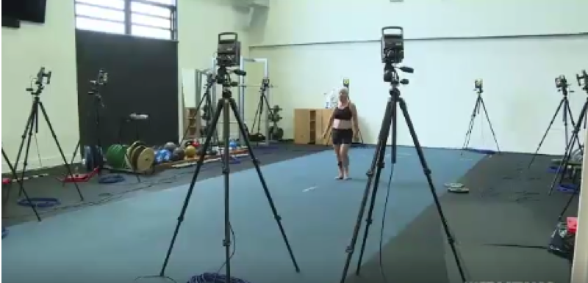 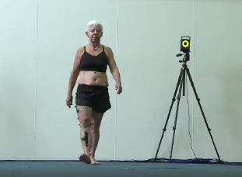

Figure 1: Walking between the cameras Figure 2: Walking with reflective ……………………………………………………………………………… markers on the leg, hips and chest

The room in which the measurements are taken is screened off from the public. There will need to be a minimum of three people in the room including a biomechanist (Dr Spratford), and two researchers.

Between using orthosis 1 and 2 you will wear your shoes as normal for 30 minutes, climb some stairs, and you will be invited to have a cup of tea or coffee. (This is called a “wash out period”).

Orthosis 1 and 2 represent an active and a sham orthosis. This is to determine if an active orthosis is more effective than a sham one. The order of the orthosis application will be randomly determined. You will not know which order you are receiving the orthosis.

We would like to take the second orthosis home with you to evaluate if it provides any form benefit over four weeks.

At the **third appointment (4 weeks after the Gait assessment. Duration 1 hour):**

You will be invited to return to undertake a modified gait analysis (in the gait lab) and to retest the research orientated clinical tests, to see if there have been any changes in these measures.

**Participant Involvement**

Participants who agree to participate in the research will be asked to:

1. Attend all three appointments
2. Place a shoe insert (orthosis) in their shoes for four weeks
3. Take part in a formal gait assessment, twice
4. Fill out the patient reported outcomes and undertake clinical assessments during the appointment 1 and appointment 3

Your participation in the research is completely voluntary. You may decline to take part or withdraw at any time, refuse to answer a questions or to undertake parts of the research, without any penalty and without providing an explanation.

**Confidentiality**

Your privacy is important. Only the researcher/s will have access to the individual information provided by participants. Privacy and confidentiality will always be assured. The research outcomes may be presented at conferences and written up for publication. In this case group information is present, with no information provided that would identify you.

**Anonymity**

All reports and publications of the research will contain no information that can identify any individual and all information will be kept in the strictest confidence.

**Data Storage**

The information collected will be stored securely on a password protected computer throughout the project and then stored at the University of Canberra for up to fifteen years, after which it will be destroyed according to university protocols.

**Ethics Committee Clearance**

The project has been approved by the Human Research Ethics Committee of the University of Canberra (HREC – XXXX).

**Queries and Concerns**

Queries or concerns regarding the research can be directed to the lead researcher. Their contact details are at the top of this form. You can also contact the University of Canberra’s Research Ethics & Integrity Unit. You can either contact Mr. Hendryk Flaegel via phone 02 6201 5220, Ms Maryanne Simpson via phone 02 6206 3916 or email [humanethicscommittee@canberra.edu.au](mailto:humanethicscommittee@canberra.edu.au).

If you would like some guidance on the questions you could ask about your participation please refer to the Participants’ Guide located at <http://www.canberra.edu.au/ucresearch/attachments/pdf/a-m/Agreeing-to-participate-in-research.pdf>

**Thank you for taking the time to consider this study. If you wish to** **take part please sign the attached consent form.**

**.**

**Project Title**

***Do Shoe Inserts Affect Walking and Provide Pain Relief in Individuals***

***with Greater Trochanteric Pain Syndrome?***

**Consent Statement**

I, __________________________________________ (name of participant)

of ________________________________________________________________

__________________________________________________________________ (Number and Street) (Suburb/town) (State/Postcode) ……………….

have been asked to consent to participation in a research project entitled:

***Evaluating Shoe Inserts for Pain Relief and Gait Correction in Individuals with Greater Trochanteric Pain Syndrome***

In relation to this project I have read the Patient Information Sheet and have been informed of the following points:

1. Approval has been given by the University of Canberra Human Research Ethics Committee.
2. The aim of the project is to evaluate if orthoses provide biomechanical changes and/or pain control in people with symptomatic Greater Trochanteric Pain Syndrome.
3. The results obtained from the study may or may not be of direct benefit to my medical management.
4. I will need to attend the University of Canberra on four occasions.
   1. To undertake the initial clinical research tests
   2. To undertake the initial gait (walking) assessments
   3. To pick up the accelerometer for the second assessment of activity
   4. To re-assess both of the above.
5. I will have my level of activity monitored for 1 week, twice. This will involve me wearing an accelerometer (at my waist) during the day.
6. To undertake the gait (walking) assessment I will need to wear shorts (or skins/tights/leggings) and a very loose (or very tight-fitting top or crop top for the cameras to capture the movement of the reflective markers placed on my legs, thighs, hips, back, chest and neck. I will need to walk 60 to 100m.
7. I will undertake a clinical assessment. This will involve number of standard walking related assessment tasks where I will need to wear light, loose fitting clothing for this.
8. I will be asked to complete several surveys.
9. There is a small possibility me experiencing an increase in my hip pain, however, the risk is believed to be very low.
10. My involvement in this project may be terminated if the research team determine that the interventions are not appropriate.
11. Should I develop a problem which I suspect may have resulted from my involvement in this project, I am aware that I may contact:

Dr Angie Fearon: Email: angie.fearon@canberra.edu.au Ph: 62068717

The University of Canberra Human Research Ethics Secretariat:

Mr. Hendryk Fleagel Ph: 601 5220, or. Maryanne Simpson Ph: 62063916, or via email: [humanethicscommittee@canberra.edu.au](mailto:humanethicscommittee@canberra.edu.au)

1. Should I have any problems or queries about the way in which the study was conducted and I do not feel comfortable contacting the research staff, I am aware that I may contact the University of Canberra Human Research Ethics Secretariat (details above).
2. I can decline to take part in this project or withdraw from it at any time without affecting my medical care.
3. Participation in this project will not result in any extra medical and hospital costs to me.
4. I understand that the results of the research will be made accessible and that my involvement and my identity will not be revealed, subject to my consent regarding being videotaped or photographed (see below).
5. I acknowledge that I **maybe** be videotaped and that I may be identifiable from the video.

Where I will be identifiable **I consent / I do not consent** to this footage being used for (please provide your initials in the appropriate column).

|  |  |  |
| --- | --- | --- |
|  | **I do consent** | **I do not consent** |
| Research |  |  |
| Teaching |  |  |
| Publication |  |  |

If you would like a summary of the results, please provide your details below:

Email: __________________________________________________

After considering all these points, I accept the invitation to participate in this project.

I also state that I have/have not participated in any other research project in the past 3 months. If I have, the details are as follows:

____________________________________________________________________________________

|  |  |  |
| --- | --- | --- |
| **Name of participant** | **Signature of Participant** | **Date** |
|  |  |  |
| **Name of witness** | **Signature of witness** | **Date** |