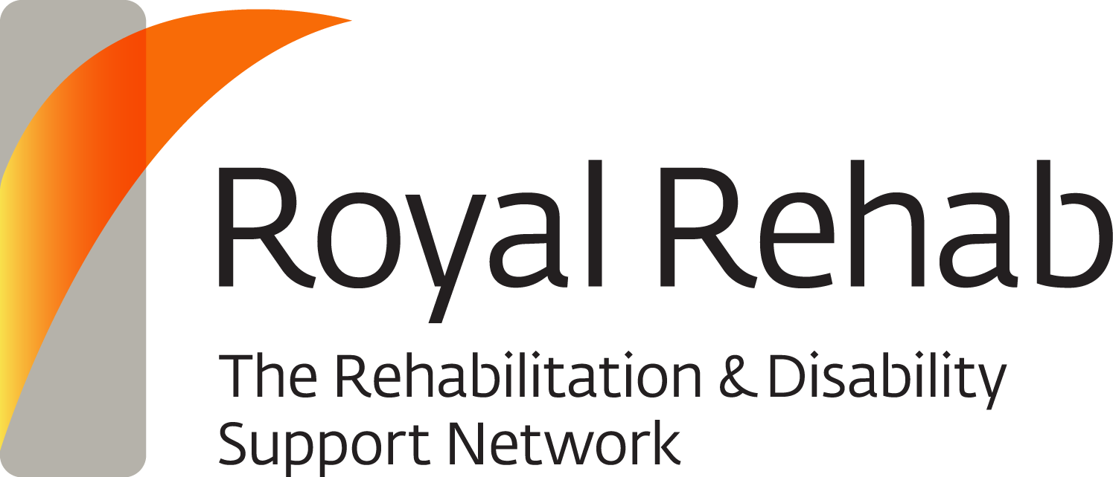 | 235 Morrison Road, Ryde NSW 2112  PO Box 6, Ryde NSW 1680 Australia  ABN 34 000 025 794 | T. +61 2 9808 9222  F. +61 2 9809 6071  E. info@royalrehab.com.au  royalrehab.com.au

Participant Information Sheet/Consent Form

Combining serial casting and Botulinum Toxin for the management of ankle contractures after traumatic brain injury

Principal Investigators: Mrs Joan Leung and Dr Clayton King

Please read this information carefully. Ask questions about anything that you don’t understand or want to know more about. Participation in this research is voluntary. If you do not wish to take part, you do not have to. Before deciding whether or not to take part, you might want to talk about it with a relative, friend or your local doctor. You will be given a copy of this Participant Information and Consent Form to keep.

1 Introduction

The research project investigates a treatment program for the management of ankle stiffness. All patients with traumatic brain injury admitted to the Brain Injury Unit of Royal Rehab with ankle stiffness will be invited to participate in the study.

2 What is the purpose of this research?

Ankle stiffness is a common problem after traumatic brain injury. The documented incidence is as high as 82% in people with severe traumatic brain injury. Ankle contractures are a concern because of its potential negative implications on motor return, functional ability and rehabilitation outcomes. This research project examines the effectiveness of a program combining serial casting and Botulinum Toxin for treatment of ankle stiffness. Serial casting is a procedure that gradually stretches the tight calf muscles by applying a series of cast over weeks with each cast stretch the ankle joint further. This treatment program is commonly used for managing ankle stiffness.

3 What does participation in this research involve?

To find out if the treatment program is effective for ankle stiffness we need to compare the treatment program with no treatment. We put people into two groups (intervention group and control group). The intervention group will receive the experimental interventions, that is, Botulinum toxin injections and serial casting. The control group will be placed on a wait list. Each participant is put into a group by chance (random) thus there is even chance of being in either group. This research design is to make sure the researchers interpret the results in a fair and appropriate way.

To ensure the participants in the control group will not be disadvantaged, the study has a cross-over component, that is, the participants in the control group will also receive the same treatment as the intervention group but this will happen 6 weeks after recruitment.

There are no additional costs associated with participating in this research project, nor will you be paid. All medication, tests and medical care required as part of the research project will be provided to you free of charge.

Participation in this study will not cost you anything.

4 What do I have to do?

If you agree to participate in this study, you will be asked to sign the Consent Form. You will be randomly assigned to one of the two treatment groups. The study will be conducted over12 to 18 weeks depending on which group you are in.

Intervention Group: Receive Botulinum Toxin injections to the calf muscles, followed by 4-week of casting of the ankle and then 2-week of ankle splinting

Control Group: On a wait list for 6 weeks, then receive same treatment as the intervention group.

You will not be able to choose which group you are in. There is an equal chance you will be in either group. The interventions investigated are commonly used in treatment of ankle stiffness. The treatment program will be administered at least over a 6-week period.

Your ankle will be assessed for flexibility, strength and function. The range of your ankle will be measured using a device which standardizes the amount of torque applied. The strength of your ankle will be assessed. You will also be asked to perform a walk test to determine walking speed if you are able to walk 10metres or more.

If you are in the intervention group, you will have five 30-minute measurement sessions during your stay at the Brain Injury Unit: before the study, after 4 weeks, 6 weeks, 12 weeks and on discharge.

If you are in the control group, you will have seven 30-minute measurement sessions during your stay at the Rehabilitation Unit: before the study, after 4 weeks, 6 weeks, 10 weeks, 12 weeks, 18 weeks and on discharge.

For both groups, where possible, a follow-up measurement session will be conducted 12 months after discharge. For your convenience, we would endeavour to arrange this session to occur on the same day as you come in for your regular medical review appointment after discharge. You will also be asked to fill in a questionnaire to provide some feedback about the interventions received and perceived effects.

In addition, the researchers would like to have access to your medical record to obtain information relevant to the study such as demographics and injury details.
Participation in the study is not going to affect your rehabilitation program. You shall continue to receive the usual multi-disciplinary rehabilitation provided by the unit including an individualised motor-training program.

5 Do I have to take part in this research project?

Participation in any research project is voluntary. If you do not wish to take part, you do not have to. If you decide to take part and later change your mind, you are free to withdraw from the project at any stage.

Your decision whether to take part or not to take part, or to take part and then withdraw, will not affect your routine treatment, your relationship with those treating you or your relationship with the Brain Injury Unit of Royal Rehab.

6 What are the alternatives to participation?

You do not have to take part in this research project to receive treatment at this hospital. You will receive the standard treatment available for your ankle stiffness. Your study doctor will discuss these options with you before you decide whether or not to take part in this research project.

7 What are the possible benefits of taking part?

We cannot guarantee that you will receive any benefits from this research; however, possible benefits include improvements of joint range in your ankle.

8 What are the possible risks and disadvantages of taking part?

You will only be invited to participate in the study if you are deemed suitable for the Botulinum Toxin injections. Botulinum Toxin has been approved for use by the Australian Therapeutic Goods Administration. For the great majority of people the known risks associated with Botulinum Toxin injections are minimal. Having a drug injected may cause some discomfort, bruising, minor infection or bleeding. If this happens, it can be easily treated. A few people feel faint for a short period with injections and this is managed with lying down and being assessed by the Doctor during the procedure.
There have been reported cases of weakness in nearby muscles and distant effects on swallowing and breathing, occurring hours to weeks after injection. The risk of symptoms is probably greatest in patients treated with high doses of Botulinum toxin. Swallowing and breathing difficulties can be life threatening and there have been rare reports of death, although the exact relationship to Botox has not been established. Should you have swallowing and breathing difficulty immediate medical attention should be sought.

There may be a small risk of pressure areas from casting or ankle splinting but you will be monitored closely to avoid this. The cast and splint will be removed, modified and changed as necessary. If a severe side effect or reaction occurs, your study doctor and therapist may need to stop your treatment. Your study doctor and therapist will discuss the best way of managing any issues that may arise.

9 What if I withdraw from this research project?

If you decide to withdraw from the project, please notify a member of the research team before you withdraw. This notice will allow that person or the research supervisor to discuss any health risks or special requirements linked to withdrawing.

If you do withdraw your consent during the research project, the study doctor and therapist will ask if you are willing to participate in a final assessment. The assessment will only take place with your agreement. You do not need to participate in this assessment if you do not want to.

10 Could this research project be stopped unexpectedly?

This research project is unlikely to be stopped unexpectedly. Possible reasons for stopping the study include slow recruitment or decisions by local / regulatory authorities.

11 What happens when the research project ends?

On completion of this study, your doctor and therapist will inform you how your ankle has responded to the treatment program. You will be given a splint to use for your ankle. Your doctor and therapist will continue to provide treatment for your ankle if further treatment is required.

Part 2 How is the research project being conducted?

12 What will happen to information about me?

Any information obtained in connection with this research project that can identify you will remain confidential. Only the researchers named above will have access to your details and results that will be held securely within their office. All your information will be coded and pooled together with that of the other participants of the study. The collective data will be analysed and the results will be presented at conferences or other professional forums and published in peer-reviewed journals. Your information will only be used for the purpose of this research project and it will only be disclosed with your permission, except as required by law. Information about your participation in this research project may be recorded in your health records.

13 Complaints and compensation

If you suffer any injuries or complications as a result of this research project, you should contact the study team as soon as possible and you will be assisted with arranging appropriate medical treatment. If you are eligible for Medicare, you can receive any medical treatment required to treat the injury or complication, free of charge, as a public patient in any Australian public hospital.

14 Who has reviewed the research project?

This research has been reviewed by the Northern Sydney Local Health District Human Research Ethics Committee.

This project will be carried out according to the National Statement on Ethical Conduct in Human Research (2007). This statement has been developed to protect the interests of people who agree to participate in human research studies.

15 Further information and who to contact

The person you may need to contact will depend on the nature of your query.

If you want any further information concerning this project or if you have any medical problems which may be related to your involvement in the project (for example, any side effects), you can contact the doctors or the principal researchers of the Brain Injury Unit.

For matters relating to research at the site at which you are participating, you can contact the Research Governance Officer of Royal Rehab, Bernadette Nicholl on (02) 9807 1144.

If you have any complaints about any aspect of the project, the way it is being conducted or any questions about being a research participant in general, then you may contact the Northern Sydney Local Health District Research Office on (02) 9926 4590.

Consent Form

Combining serial casting and Botulinum Toxin for the management of ankle contractures after traumatic brain injury

Principal Investigators: Mrs Joan Leung and Dr Clayton King

I have read the Participant Information Sheet or someone has read it to me in a language that I understand.

I understand the purposes, procedures and risks of the research described in the project.

I give permission for my doctors, other health professionals, hospitals or laboratories outside this hospital to release information to Royal Rehab concerning my disease and treatment for the purposes of this project. I understand that such information will remain confidential.

I have had an opportunity to ask questions and I am satisfied with the answers I have received.

I freely agree to participate in this research project as described and understand that I am free to withdraw at any time during the study without affecting my future health care.

I understand that I will be given a signed copy of this document to keep.

 | Name of Participant (please print)
 | Signature |  |  | Date

Declaration by Study Doctor/Senior Researcher†

I have given a verbal explanation of the research project, its procedures and risks and I believe that the participant has understood that explanation.
Name of Study Doctor/
Researcher† (please print)
 | Signature |  |  | Date

Form for Withdrawal of Participation

Combining serial casting and Botulinum Toxin for the management of ankle contractures after traumatic brain injury

Principal Investigators: Mrs Joan Leung and Dr Clayton King

I wish to withdraw from participation in the above research project and understand that such withdrawal will not affect my routine treatment, my relationship with those treating me or my relationship with Royal Rehab.

 | Name of Participant (please print)
 | Signature |  |  | Date

In the event that the participant’s decision to withdraw is communicated verbally, the Study Doctor/Senior Researcher will need to provide a description of the circumstances below.

Declaration by Study Doctor/Senior Researcher†

I have given a verbal explanation of the implications of withdrawal from the research project and I believe that the participant has understood that explanation.

Name of Study Doctor/
Researcher† (please print)
 | Signature |  |  | Date
† A senior member of the research team must provide the explanation of and information concerning withdrawal from the research project.

Note: All parties signing the consent section must date their own signature.

