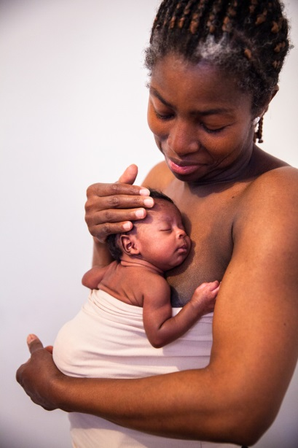 **Immediate Kangaroo Mother Care Study**

We would like to inform you that this hospital where you are attending antenatal care clinic takes part in multi-country research to study the effects of Kangaroo Mother Care (KMC) initiated immediately after birth on babies with birth weight between 1.0 kg to 1.8 kg. You have been found to have a possibility of delivering a small baby. Therefore, we would like to give you information about this research, and inform you in advance that our research assistant will approach you to ask if you are interested in participating in this study when you are admitted to the hospital for childbirth.

**What KMC means and what’s currently known about it?**

KMC means continuous skin-to-skin contact between the mother and the baby, and feeding the baby with only mother’s breast milk. KMC in stable babies with low birth weight has shown to have several advantages including better regulation of baby’s heart rate and temperature, lower stress, better breastfeeding, reduced infection, improved bonding between the mother and the baby, as well as improved survival.

**Why are we doing this study?**

Babies born with birth weight lower than 1.8 kg at are a high risk of illness and are routinely separated from their mothers and treated in a special newborn care unit. In the current research, we want to provide continuous KMC starting immediately after birth to babies born with birth weight between 1- 1.8 kg while giving them all the current care in the special newborn care unit, and study its effect on health and survival of these babies. Thus, the purpose of this study is to find out if initiating KMC immediately after birth is better than the current practice of initiating KMC only after the baby is assessed to be clinically stable by the doctor, which means that baby’s condition has improved so that the baby no longer needs special care in the unit.

**What will happen if you decide to participate in the study?**

If you agree to participate in this research study and your baby’s birth weight lies in between 1.0 to 1.8 kg, you will be assigned to one of two groups - the intervention group (initiation of continuous KMC immediately after birth) or the control group (initiation of KMC after a few days when the baby is stable) by a computerised process that is based on chance. Other than the time of initiation of KMC, babies in both groups will receive identical health care. If you are in the intervention group, you will go to the special newborn care unit with your baby and provide KMC. If you are the control group, you and your baby will receive care as is currently provided to those who don't participate in the research Research assistants will come to assess your baby every 12 hours while at the hospital, home visits will be conducted when your baby is at 7 days and 28 days old.

We are here for you. Please do not hesitate to ask if you need anything to support you. We wish you all the best.

*Name of the PI*