CONFIDENTIAL
Research Protocol

Monitoring endothelial function of children with sepsis in the paediatric intensive care unit

Protocol Version 1 dated 17 November 2017
Principal Investigators: A/Prof Mark Coulthard, Dr Debbie Long, A/Prof Trent Woodruff

Investigators
Principal Investigators

A/Prof Mark G Coulthard, Lady Cilento Children’s Hospital
Debbie Long, Lady Cilento Children’s Hospital
A/Prof Trent M Woodruff, The University of Queensland

Co-Investigators

Prof Jeff Lipman, Royal Brisbane Women’s Hospital
Emeritus Prof Andrew W Boyd, QIMR Berghofer Medical Research Institute
Prof Perry Bartlett, Queensland Brain Institute

Revision history
Date | Version. | Author | Description of revision

Statement of Compliance

This document is a protocol for a research project. This study will be conducted in compliance with all stipulation of this protocol, the conditions of the ethics committee approval, the NHMRC National Statement on ethical Conduct in Human Research (2007) and the Note for Guidance on Good Clinical Practice (CPMP/ICH-135/95).

Contents
Contents 4
1 Protocol Synopsis 6
INTRODUCTION AND BACKGROUND 8
1.1 Background and rationale 8
1.2 Aims 11
1.3 Hypothesis 11
2 TYPE OF STUDY 11
2.1 Study Setting 11
3 PARTICIPANTS AND RECRUITMENT 11
3.1 Number of Participants 11
3.2 Eligibility Criteria 12
3.2.1 Inclusion criteria 12
3.2.2 Exclusion criteria 12
3.3 Recruitment and identification of potential participants 12
3.4 Consent 12
4 STUDY VISITS AND PROCEDURES 13
4.1 Schedule of assessments (septic patients) 14
4.1.1 T1 - Baseline 14
4.1.2 T3 - Admission to PICU 15
4.1.3 T4 - 12 hours post admission to PICU 15
4.1.4 T5 - 24 hours post admission to PICU 15
4.2 Schedule of assessments (control patients) 16
4.2.1 T1 - Baseline (clinic) 16
4.2.2 T3 – In theatre 17
4.2.3 T4 – In recovery ward 17
4.3 Measures 18
1 ADVERSE EVENTS AND RISKS 19
1.1 Assessment and documentation of adverse events 19
1.2 Eliciting adverse event information 20
1.3 Serious adverse event reporting 20
1.3.1 SAEs 20
2 DATA MANAGEMENT 21
2.1 Data Collection 21
2.2 Source Data 21
2.3 Data Capture Methods 21
2.4 Data Storage 21
2.5 Sample Storage 21
2.6 Record Retention 21
3 STUDY OVERSIGHT 22
3.1 Governance structure 22
4 STATISTICAL METHODS 22
5 ETHICS AND DISSEMINATION 22
5.1 Research Ethics Approval 22
5.2 Modifications to the protocol 22
5.3 Confidentiality 22
5.4 Dissemination and translation plan 23
6 REFERENCES 24
7 APPENDICES 26
A Biological Specimens 27
C Causality and Assessment of Severity – Adverse Events 31

- Protocol Synopsis

Title | Assessing the feasibility of microdialysis to monitor vascular endothelial function in children with severe sepsis.
Objectives | To determine the feasibility of monitoring the integrity of vascular endothelium in critically ill children by;  - Microdialysis to measure interstitial protein levels including albumin and cytokines  - Plasma levels of endothelial activation markers, cytokines and Eph/ephrin proteins  - Monitoring urinary albumin (microalbuminuria)
Design | Prospective, feasibility study
Study duration | 24 months
Number of participants | 120 participants  100: severe sepsis  20: routine surgery (control group)
Population | 120 children aged 1 day-18 years admitted to Lady Cilento Children’s Hospital Paediatric Intensive Care Unit with either severe sepsis or following routine surgery.

Glossary of abbreviations

ABBREVIATION | TERM
AE | Adverse Event
CRF | Case Report Form
DMC | Data Monitoring Committee
HREC | Human Research Ethics Committee
LCCH | Lady Cilento Children’s Hospital
NHMRC | National Health and Medical Research Council
PICU | Paediatric Intensive Care Unit

INTRODUCTION AND BACKGROUND

Background and rationale
The clinical research project outlined in this proposal is an integral part of a larger research program investigating endothelial biology in critical illness. Our overall research goal is to understand, monitor and restore the integrity of the vascular endothelium to facilitate patient recovery and improve outcomes in systemic inflammation, specifically septic shock. Our research focuses on the Eph/ephrin signalling system and our program includes: evaluating Eph/ephrin signalling blocking reagents in a mouse model of sepsis, investigating the cellular and molecular signalling events involved in vascular leak in severe sepsis, and undertaking clinical studies in critically-ill children described below.
Vascular endothelium: In health, the vascular endothelium provides a non-thrombogenic barrier between the bloodstream and the tissues. However, in sepsis (and the systemic inflammatory response syndrome or SIRS), there is a change in the phenotype of the vascular endothelium, which becomes pro-coagulant (sticky) and permeable (leaky) to fluid, protein and inflammatory cells. In fact, the vascular endothelium is the common denominator of many intersecting and overlapping upstream signalling pathways triggered by the inciting (usually infectious) insults. Pathologically and clinically, a hallmark of septic shock is pervasive vascular leak throughout the circulation leading to hypovolaemia, which results in circulatory shock and contributes to multi-organ failure. In clinical practice, fluid resuscitation is a cornerstone of therapy in septic shock; however, the science supporting this practice has been questioned (Hilton and Bellomo, 2012) and recent studies have not supported early goal-directed therapy (Angus et al., 2015).
Sepsis, septic shock and vascular leak: Septic shock is a subset of sepsis, in which there are circulatory, cellular and metabolic abnormalities with a substantial increase in mortality. It is clinically diagnosed by the need for vasopressor therapy and elevated serum lactate despite adequate fluid resuscitation (Singer et al., 2016). Septic shock is caused by a dysregulated host response to infection which results in life-threatening organ dysfunction (Singer et al., 2016). Regardless of initiating factors, a disrupted inflammatory axis is the common initiating event that characterises sepsis and septic shock, involving: 1) global production of inflammatory mediators by monocytes, macrophages, polymorphonuclear leukocytes (PMNs) and endothelial cells; 2) complement activation and C5a generation, leading to increased vascular permeability and secretion of pro-inflammatory cytokines; and 3) changes in the function of microvascular endothelial cells, with increased microvascular permeability (Hotchkiss et al., 2016). The role of the immune system in the pathogenesis of sepsis and septic shock is critical (Delano and Ward, 2016). However, despite over 100 clinical trials in septic patients published over the past 20 years, no specific treatment that modulates the host response to infection has been effective in reducing mortality (Marshall, 2014). Recent evidence suggests that phenotypic changes to the vascular endothelium, which becomes pro-coagulant and permeable to fluid, protein and inflammatory cells, underpin the pathogenesis of sepsis and septic shock (Opal and van der Poll, 2015). The hypotension and circulatory failure in septic shock is partly due to vasoplegia, which causes decreased systemic vascular resistance (Sharawy, 2014), and relative hypovolaemia from vascular leak of plasma water into the interstitial space. In addition, there is upregulation of adhesion molecules on the vascular endothelium for circulating leukocytes, which allows leukocytes and circulating factors for host defence to target injured or infected tissues (Opal and van der Poll, 2015). The extravasation of albumin and the transmigration of fluid into the interstitium has been demonstrated in critically-ill medical (Cordemans et al., 2012) and surgical (Norberg et al., 2016) patients. At present there is no effective therapy specifically targeting endothelial injury and vascular leak despite evidence supporting the idea that vascular endothelial leak may be a viable therapeutic target in sepsis and septic shock (Goldenberg et al., 2011).
Eph receptors and their ephrin ligands: Eph receptor tyrosine kinases associate with a group of cell surface ligands termed ephrins. Structural features identify nine type-A Ephs which preferentially bind the six type-A ephrins, and six type-B Ephs which preferentially bind the three type-B ephrins (Lackmann and Boyd, 2008). Eph and ephrin signalling is initiated at cell–cell contacts with the formation of tetrameric receptor–ligand complexes which act as a focus for the assembly of higher order signalling clusters on the surface of opposing cells (Janes et al., 2012). Interaction of Eph receptors and ephrin ligands can induce cell–cell adhesion or detachment (Lisabeth et al., 2013). Eph receptors principally modify cell adhesion through changes in the organisation of the actin cytoskeleton. These changes influence the dynamics of cellular protrusion and cell migration and are mediated via signalling cascades that ultimately converge on targets including integrins and small Rho-family GTPases. This is in contrast to many receptor tyrosine kinases that activate signalling pathways regulating cell proliferation and/or differentiation (Pasquale, 2005). The role of the Eph/ephrin receptor ligand family in cancer has been researched extensively (Boyd et al., 2014), but evidence for a role in injury, inflammation (Coulthard et al., 2012) and atherosclerotic cardiovascular disease (Funk and Orr, 2013) has also emerged.
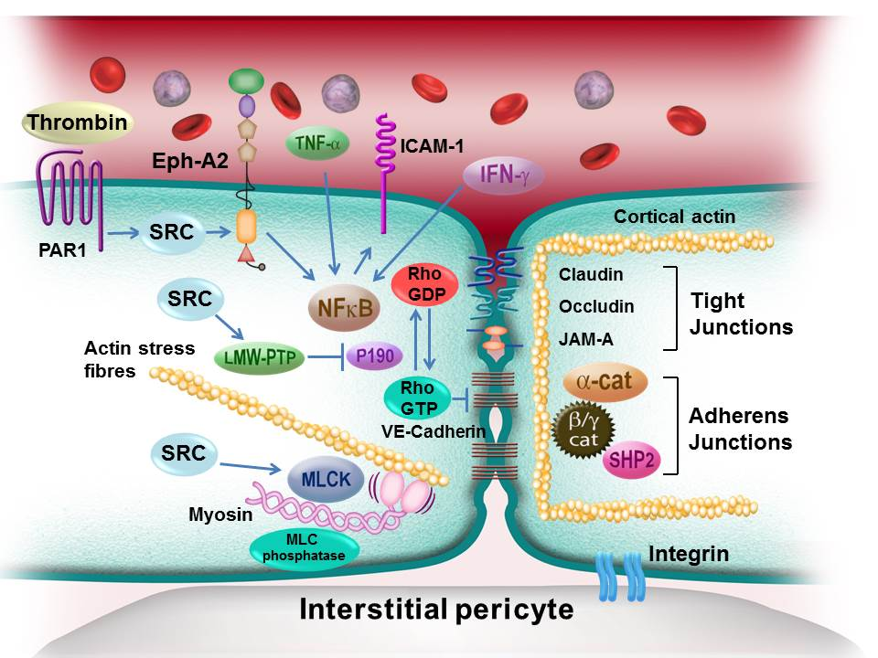
Role of EphA2 and ephrin-A1 in vascular endothelium leak and inflammation: The upregulation of various Eph/ephrin proteins in response to the pro-inflammatory cytokines suggests a role in inflammation (Coulthard et al., 2012) (Fig. 1). The initial evidence for the role of Eph/ephrin proteins in vascular biology was the identification of ephrin-A1 as a TNF-α responsive gene in endothelial cells, highlighting a potential role in inflammatory responses (Dixit et al., 1990). The vascular endothelium controls the passage of fluid, proteins and inflammatory cells from the blood into the interstitium via paracellular spaces between endothelial cells. The distortion of endothelial cell shape allows the development of gaps in the monolayer, permitting the passage of fluid, proteins, and inflammatory cells from the blood into the interstitial tissues (Opal and van der Poll, 2015).
Figure 1. Mechanism of EphA2 signalling in the endothelium. The passage of fluid and inflammatory cells across the endothelium is regulated by both the shape of the endothelial cells and the permeability of the endothelial gap junctions. The actinomyosin contractile elements which control cell shape are regulated by signalling pathways acting through the myosin light chain kinase. Ephrin-A1, the ligand for EphA2, is upregulated by TNF-α, and EphA2 upregulates NF-κB. Thus, EphA2 may have a central role in endothelial cell permeability in inflammation (Coulthard et al., 2012).

The endothelial cell–cell junctional structures are large macromolecular complexes, functionally regulated by several key signalling pathways, which determine the barrier function of the cell–cell junctions regulating the paracellular space. The adherens junctions are particularly important in the post-capillary venule, which also expresses the receptors for inflammatory mediators including TNF-α, IL-1β and vascular endothelial growth factor (VEGF). The predominant structural protein of the adherens junction is vascular endothelial cadherin (VE-cadherin), which interacts with the p120 catenin and β-catenin proteins, thereby allowing connection of VE-cadherin with the actin cytoskeleton (Giannotta et al., 2013). Other signalling pathways that control vascular endothelial permeability, including vascular endothelial growth factor (Jeong et al., 2013), Slit/Robo (London and Li, 2011) and angiopoietin/Tie2 (Milam and Parikh, 2015) are under investigation, but to date no effective therapeutic intervention has emerged from these studies. There is a need for additional detailed information about the molecular and cellular events controlling the flux of fluid, albumin and inflammatory cytokines and cells into the interstitium during sepsis and how this contributes to shock, SIRS, multiple organ failure and death.
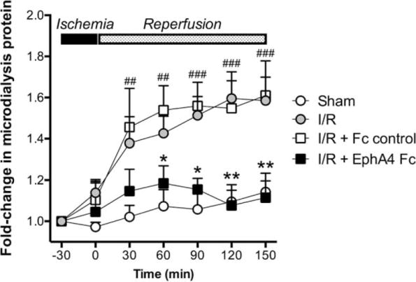
In the mouse gut ischaemia/reperfusion (I/R) model of systemic inflammation, we pre-treated mice with EphA4-Fc to block Eph/ephrin signalling and compared them with mice pre-treated with a control Fc (EphA4-Fc-ΔLBD), which does not bind ephrins. There was significantly reduced intestinal injury and neutrophil infiltration in EphA4-Fc pre-treated mice. Further, we showed that systemic vascular leakage, measured using microdialysis to quantify the interstitial protein level, was completely abrogated by EphA4-Fc (Fig. 2). Our recently published results demonstrate that Eph/ephrin signalling is a key modulator of inflammatory vascular leak, and provides a new and compelling molecular target for the control of vascular leak in septic shock (Woodruff et al., 2016).
Figure 2. EphA4-Fc antibody blockade of EphA2/ephrin-A1 signalling inhibits I/R-induced systemic vascular leak of protein into the interstitium, as measured by microdialysis, (##) P < 0.01, (###) P < 0.001 (sham versus I/R); (*) P < 0.05, (**) P < 0.01 (I/R+Fc control versus I/R+EphA4-Fc); n = 6/group.
In summary, our research program focuses on understanding vascular endothelial dysfunction in critical illness. Specifically, we are exploring a novel signalling mechanism which may be critically involved with regulating vascular leak in sepsis. Overall, our evidence suggests that EphA2/ephrin-A1 signalling may be a key link between inflammatory cytokines released in response to an inflammatory stimulus and the increase in endothelial permeability mediated by signalling pathways which modulate the endothelial junctional structures resulting in vascular leak. Our laboratory has developed new reagents (Eph/ephrin receptor signalling blockers) which inhibit vascular leak and tissue damage in a murine model of systemic inflammation similar to sepsis and septic shock in humans. We propose that inhibition of Eph/ephrin receptor signalling using our unique and specific reagents will provide substantial reductions in vascular leak and pathology including multiple organ failure. This has major clinical significance and has the potential to improve patient outcomes in sepsis and septic shock. Current best practice provides sophisticated supportive care for sepsis and septic shock (Rhodes et al., 2017), but does not target causal pathogenic factors, and clinical care is largely symptomatic and is not based on high quality experimental evidence (Hilton and Bellomo, 2012).
The clinical studies described below will determine the feasibility of monitoring interstitial albumin flux by microdialysis, as we did in mice, and whether EphA2 is a potential biomarker of vascular endothelial health and integrity.

Aims
To conduct a prospective study of vascular endothelial function in critically-ill infants and children with septic shock and/or systemic inflammation by: a) monitoring the flux of fluid, albumin and inflammatory cytokines into the interstitium with microdialysis, and b) measuring plasma Eph/ephrin proteins and cytokine levels as potential biomarkers of endothelial activation.

Hypothesis
Vascular endothelial activation can be monitored in the intensive care unit by measuring plasma levels of Eph/ephrins.

- TYPE OF STUDY
This is a single-centre, prospective study examining the feasibility of assessment of vascular endothelial activation by measuring plasma Ephs/ephrins using microdialysis. Vascular endothelial activation will be examined in a sample of 100 children admitted to the Paediatric Intensive Care Unit with severe sepsis and a control group of 20 children undergoing elective surgery.

Study Setting
The study will be conducted in a paediatric intensive care unit in a single, tertiary paediatric hospital in Brisbane, Australia.

- PARTICIPANTS AND RECRUITMENT

Number of Participants
A total of 120 participants will be recruited into the study. Participants will include children aged 0-18 years admitted to Lady Cilento Children’s Hospital for;
- 100 patients admitted to PICU with severe sepsis;
- 20 patients admitted for elective surgery.

Eligibility Criteria

Inclusion criteria
Each patient must meet all of the following criteria to be enrolled in this study:
- Is between the ages of 1 day and 18 years at time of recruitment.
- Either admitted to PICU with confirmed sepsis (tachycardia, tachypnoea and suspicion of infection) confirmed using established guidelines (Randolph and McCulloh, 2014) and microbiology (n=100).
- Planned PICU admission following elective surgery (n=20).
- Has a legally acceptable representative capable of understanding the informed consent document and providing consent on the participant’s behalf.

Exclusion criteria
Patients meeting any of the following criteria will be excluded from the study:
- Inability or unwillingness of participant or legally acceptable representative to give written informed consent.

Recruitment and identification of potential participants
Septic patients will be identified by the research nurse who will identify potential participants based on admission to PICU. The nurse will subsequently enrol patients in the study. The control group will be identified from the routine surgical booking list. Eligible participants will be identified by the care coordinators and details of participants will be passed on to the study team. A research nurse will subsequently enrol patients in the study. Initial contact with potential patients will be made by email prior to the planned procedure date. This is to allow the parents to read over the material and take time to understand the study. Should the family indicate they are interested in participating, the research team will organise to meet with the family in person at pre-admission clinic prior to surgery to obtain full written consent (see detailed procedure below).

Consent
Prior to performing any study specific procedure (including screening procedures to determine eligibility), a signed consent form will be obtained for each participant by the study research nurse from a parent, legal guardian, or person with power of attorney. Consent will also be sought from participants where appropriate. Capacity to consent will be assessed by discussion plan with the child > 8 years of age and using MacArthur Competence Assessment Tool for Clinical Research. The consent form will describe the purpose of the study, the procedures to be followed, and the risks and benefits of participation. The research nurse will conduct the informed consent discussion and will check that the participant and their legally acceptable representative comprehend the information provided and answer any questions about the study. Consent will be voluntary and free from coercion. The research nurse that conducted the consent discussion will also sign the informed consent form. A copy of the consent form will be given to the participant or their legally acceptable representative and the fact that the participant has been consented to the study will be documented in the participant’s record. When the all the inclusion/exclusion criteria have been addressed and the eligibility of the participant confirmed, the participant may be enrolled in the study.
Withdrawal of Participants

The investigator may withdraw a patient from the study treatment and follow-up procedures if the patient:
- Is in violation of the protocol;
- Experiences a serious or intolerable adverse event
- Develops, during the course of the study, symptoms or conditions listed in the exclusion criteria
- Requires early discontinuation for any reason

The investigator will also withdraw all participants from the study treatment if the study is terminated. Patients are free to withdraw from the study at any time upon their request or the request of their legally acceptable representative. Withdrawing from the study will not affect their access to standard treatment or their relationship with the hospital and affiliated health care professionals

When a participant is withdrawn from the treatment and/or the study by the investigator, the reasons for withdrawal shall be recorded and captured in the CRF by the site research nurse. Where the participant withdraws from the treatment and/or the study themselves or is withdrawn by their parent/guardian, the site research nurse shall attempt to ascertain the reason(s) for withdrawal from the parent/legal guardian or competent participant and, where provided, record this data. Any results obtained prior to withdrawal from the treatment and/or the study will be included in the analysis, unless the participant or their parent/guardian withdraws consent to use any of the participant’s data.

- STUDY VISITS AND PROCEDURES
Baseline variables, primary end points, secondary end points, pre-determined physiological variables of interest, and process of care measures will be prospectively recorded into a study RECcap online database.

Schedule of assessments (septic patients)
 | Baseline | Admission PICU | 12H post adm PICU | 24H post adm PICU
ENROLMENT:
Eligibility screen | X
Informed consent | X
INTERVENTIONS:
Placement microdialysis catheter |  | X
ASSESSMENTS:
Bloods** |  | X | X | X
Microdialysate Q2H |  | X | X | X
Urine Q2H |  | X | X | X
Patient status/microdialysis site check Q2H |  | X | X | X
Parent satisfaction questionnaire |  |  |  | X
**Plasma from routine blood tests taken in PICU will be used for assessment of EphA2 and inflammatory markers.

T1 - Baseline
The research nurse will collect/conduct the following assessments at the baseline visit (this may coincide with admission to PICU);
- Obtain and document consent from potential participant/parent/carer.
- Review medical history to determine eligibility based on inclusion/exclusion criteria.
- Obtain demographic information, medical, surgical, immunisation history and allergies.

T3 - Admission to PICU
On admission to PICU, while the child is anaesthetised the microdialysis catheter will be inserted by authorised research personnel.
The research nurse will also arrange for collection of the following samples second hourly following either discharge from PICU or 48 hours post admission to PICU.
- 0.5 mL microdialysate
- Urine specimen collection
- Monitoring of microdialysate catheter site
The research nurse will also arrange for the collection of the following assessments on patient admission to PICU using using the existing arterial line; a central venous line sample is acceptable if no arterial access is present;
- 2.5 mL of PAXgene tube blood (for gene expression markers);
- 1–2 mL of serum.

T4 - 12 hours post admission to PICU
The research nurse will arrange for the collection of the following assessments 12 hours following admission to PICU using the existing arterial line; a central venous line sample is acceptable if no arterial access is present;
- 1–2 mL of serum.

T5 - 24 hours post admission to PICU
The research nurse will arrange for the collection of the following assessments 24 hours following admission to PICU using the existing arterial line; a central venous line sample is acceptable if no arterial access is present;
- 1–2 mL of serum.
- Parent satisfaction questionnaire.

Schedule of assessments (control patients)
 | Baseline | In theatre | In recovery ward
ENROLMENT:
Eligibility screen | X
Informed consent | X
INTERVENTIONS:
Placement microdialysis catheter |  | X
Removal microdialysis catheter |  |  | X
ASSESSMENTS:
Bloods** |  | X
Microdialysate* |  | X
Urine Q2H |  | X
Patient status/microdialysis site check Q2H |  | X | X
Parent satisfaction questionnaire |  |  | X
**Plasma from routine blood tests taken in PICU will be used for assessment of EphA2 and inflammatory markers.
*Microdialysate will be collected during the surgical procedure and the microdialysis catheter will be removed in the recovery ward.

T1 - Baseline (clinic)
The research nurse will collect/conduct the following assessments at the baseline visit;
- Obtain and document consent from potential participant/parent/carer.
- Review medical history to determine eligibility based on inclusion/exclusion criteria.
- Obtain demographic information, medical, surgical, immunisation history and allergies.

T3 – In theatre
In theatre, while the child is anaesthetised the microdialysis catheter will be inserted by authorised research personnel. The research nurse will arrange collection of the following samples immediately following insertion of the arterial line.
- 1–2 mL of EDTA blood (for DNA);
- 2.5 mL of PAXgene tube blood;
- 1–2 mL of serum.

The research nurse will also arrange for collection of the following samples second hourly during the procedure (if procedure extends longer than 2 hours).
- 0.5 mL microdialysate
- Urine specimen collection
- Monitoring of microdialysate catheter site

T4 – In recovery ward
The research nurse will remove the microdialysis catheter. They will also take a final specimen before removal of the tube and will arrange parental completion of the satisfaction survey;
- 0.5 mL microdialysate
- Parent satisfaction questionnaire.

Measures
    - Baseline variables
Patient demographics, medical and surgical history, allergies, immunisations and paediatric history will be collected from the patient at the baseline visit by the research nurse.

    - Microdialysis insertion and sampling
A 66 Linear Microdialysis Catheter (AshMed Medical Pty Ltd) will be inserted under the skin of the forearm in anaesthetised children by the research personnel under the supervision of the anaesthetist. The microdialysis catheter will be perfused with sterile saline (0.9% NaCl) solution. The microdialysis pump will run at 1 microliter per minute.

Dialysate samples will be collected every 2 ± 1 hours in 0.5 mL Eppendorf tubes. The tubes will be placed on ice and transferred to the laboratory. The microdialysate will be analysed for protein and inflammatory markers.
    - Urine
Second hourly urine samples from the indwelling urinary catheter will be collected for the first 48 hours of the PICU stay.
    - Bloods
As per the paediatric intensive care unit (PICU) protocol, all patients will have routine post-operative blood taken for blood gas analysis (including lactate and central venous oxygen saturations), full blood count, plasma electrolytes, renal and liver functions tests and coagulation profiles. At this time researchers will organise the collection of an additional 1.0-2.0 mL of blood. In this sample 200 μL of plasma will be used to measure levels of EphA2 (Human Magnetic Luminex® Screening Assay kit, R&D Systems, Inc.), EphA4, EphB4, ephrin-A1 and ephrin-B2 (ELISA, R&D Systems Inc.). We will also measure inflammatory markers (CRP, procalcitonin), complement (C5a), endothelial markers (endocans, VEGF, Ang-1, Ang-2) and cytokines (TNF-α, IL-1β, IL-6, IL-8, IL-10 and IFN-γ) using standard Bio-RAD ELISA kits as per the manufacturers’ instructions.
    - Patient status
Children will have severity of illness data monitored as per standard care whilst in the Paediatric Intensive Care Unit, including vital signs (BP, heart rate, respiratory rate).
    - Parent questionnaire
Parents of participating children will be requested to complete a satisfaction questionnaire prior to discharge from PICU. The questionnaire involves seven questions regarding the research process and parent satisfaction with their child’s participation in the study. The questionnaire should take approximately 5 minutes at maximum for the parent to complete.

- ADVERSE EVENTS AND RISKS

Unanticipated problems involving risks to participants or others to include, in general, any incident, experience, or outcome that meets all of the following criteria:
- unexpected in terms of nature, severity, or frequency given (a) the research procedures that are described in the protocol-related documents, and (b) the characteristics of the participant population being studied;
- related or possibly related to participation in the research; and
- suggests that the research places participants or others at a greater risk of harm (including physical, psychological, economic, or social harm) than was previously known or recognised."
Adverse Event (AE): Any untoward medical occurrence in a patient enrolled into this study regardless of its causal relationship to study/interventions.
Serious Adverse Event (SAE)
Adverse events are classified as serious or non-serious.
An SAE is defined as any AE that:
- results in death; or
- is immediately life threatening; or
- requires inpatient hospitalisation; or
- requires prolongation of existing hospitalisation; or
- results in persistent or significant disability/incapacity; or
- is a congenital anomaly/birth defect.

Important medical events will be considered an SAE when, based upon appropriate medical judgement, they may jeopardise the patient and may require medical or surgical intervention to prevent one of the outcomes listed in this definition.

Assessment and documentation of adverse events
For the purposes of this study the investigator is responsible for recording all Adverse Events, regardless of their relationship to study intervention, with the following exceptions:
- Conditions that are present at screening and do not deteriorate will not be considered adverse events.

The description of each AE on the CRF will include:
- A description of the AE;
- The onset date, duration, date of resolution;
- Severity (mild, moderate or severe);
- Seriousness (i.e. is it an SAE?);
- Any action taken, (e.g. treatment, follow-up tests);
- The outcome (recovery, death, continuing, worsening);
- The likelihood of the relationship of the AE to the study intervention (Unrelated, Possible, Probable, Definite).
The seriousness of an AE will be assessed by an investigator according to the definition in section 7.1, with the following exception:
- Hospitalisation due to progression of disease will not be considered an SAE for the purposes of this study.
Changes in the severity of an AE will be reported. AEs characterised as intermittent will be documented for each episode. All AEs will be followed to adequate resolution, where possible.

Eliciting adverse event information
Safety events will be recorded from the time the participant signs the informed consent form until 48 hours after the discharge from the PICU. At every study visit participants will be asked “How have you felt since your last visit?” in order to elicit any changes in their well-being.”

Serious adverse event reporting

SAEs
Any SAE occurring in a study participant will be reported to the HREC within 24-72 hours of occurrence, in accordance with the safety reporting policy of the HREC. The HREC safety reporting form will be completed, signed and submitted by an investigator.

- DATA MANAGEMENT

Data Collection
The investigators are responsible for ensuring the accuracy, completeness, legibility, and timeliness of the data reported. All source documents should be completed in a neat, legible manner to ensure accurate interpretation of data. The investigators will maintain adequate case histories of study participants, including accurate case report forms (CRFs), and source documentation."

Source Data
Source data will be entered directly onto pre-printed CRFs where practical, where this cannot occur in real time, data will be retrospectively entered onto CRFs from hospital records, observation charts and resuscitation flow sheets to complete the required data set.

Data Capture Methods
Data will be prospectively entered into a secure web-based database (REDCap https://redcap.health.uq.edu.au/), hosted by the University of Queensland. Printed paper CRFs will be available if required.

Data Storage
Hard copy data will be securely stored by the investigating site in a locked cupboard in a secured location. Electronic data will be securely stored on the RedCAP database, hosted by The University of Queensland.

Sample Storage
Biological sample processing and storage will follow standard operating procedures. Samples will be labelled with the patients’ hospital label for identification by the Lady Cilento Children’s Hospital laboratory. The blood will be centrifuged to separate the plasma, which will then be transferred to de-identified tubes with study labels and stored at -20ºC prior to secure transfer to the Centre for Children’s Health Research 80ºC freezer. The dialysate and urine samples will be stored at -80ºC prior to protein estimation by the Pierce™ BCA Protein assay method.

The de-identified samples will then be transferred to the Neuroinflammation Laboratory (Skerman Building at St Lucia and stored in a secure -80ºC freezer prior to processing. The Neuroinflammation Laboratory is currently involved in similar research studies and the staff has experience in storing and handling specimens. The samples will be kept for 10 years after study completion and will be destroyed thereafter. Any use of the participants’ blood other than what is approved for this study will require further review by our ethics committee and approval. An aliquot of plasma will be transferred to the QIMR Berghofer Research Institute for Eph/ephrin protein analysis.

Record Retention
As required by the Queensland State Archivist, all study information and documentation will be securely stored for a period of 15 years.

- STUDY OVERSIGHT

Governance structure
The chief investigator (Assoc Prof Mark G Coulthard) is responsible for the clinical trial to be performed in accordance with the protocol and the applicable regulatory requirements. Study principal investigators will meet weekly to review adverse outcomes. Adverse outcomes will be collated and distributed to an independent panel for review. The panel will consist of two experienced PICU specialists, one ICU specialist and a statistician.

- STATISTICAL METHODS
We have access to expert biomedical statistical advice and assistance. In the septic children, based on similar studies of biomarkers (Ricciuto et al., 2011), we estimate that our sample size (~100) will allow us to analyse the association between in vivo measurements of vascular leak, plasma Eph/ephrin proteins and cytokine levels between patients with and without septic shock using logistic regression to calculate diagnostic statistics. We will use receiver operating characteristic (ROC) curve analyses, where appropriate, to determine optimal cut-off values for continuous variables.
- ETHICS AND DISSEMINATION

Research Ethics Approval
This protocol and the informed consent document and any subsequent modifications will be reviewed and approved by the human research ethics committee (HREC). A letter of protocol approval by HREC will be obtained prior to the commencement of the study, as well as approval for other study documents participant to HREC review.”

Modifications to the protocol
This study will be conducted in compliance with the current version of the protocol. Any change to the protocol document or Informed Consent Form that affects the scientific intent, study design, patient safety, or may affect a participants willingness to continue participation in the study is considered an amendment, and therefore will be written and filed as an amendment to this protocol and/or informed consent form. All such amendments will be submitted to the HREC, for approval prior to becoming effective.

Confidentiality
Participant confidentiality is strictly held in trust by the participating investigators, research staff, and the sponsoring institution and their agents. This confidentiality is extended to cover testing of biological samples and genetic tests in addition to the clinical information relating to participating participants. The study protocol, documentation, data and all other information generated will be held in strict confidence. No information concerning the study or the data will be released to any unauthorised third party, without prior written approval of the sponsoring institution. Authorised representatives of the sponsoring institution may inspect all documents and records required to be maintained by the Investigator, including but not limited to, medical records (office, clinic or hospital) and pharmacy records for the participants in this study. The clinical study site will permit access to such records. All laboratory specimens, evaluation forms, reports and other records that leave the site will be identified only by the Participant Identification Number (SID) to maintain participant confidentiality. Clinical information will not be released without written permission of the participant, except as necessary for monitoring by HREC or regulatory agencies.

Dissemination and translation plan
Results from the study will be presented at weekly departmental research meetings. Publication in high impact peer-reviewed journals will be sought and presentation at local, national and international conferences is anticipated.

- REFERENCES
- Angus, D C, Barnato, A E, Bell, D, et al. 2015. A systematic review and meta-analysis of early goal-directed therapy for septic shock: The arise, process and promise investigators. Intensive Care Medicine, 41, 1549-1560.
- Beauchamp, A & Debinski, W 2012. Ephs and ephrins in cancer: Ephrin-a1 signaling. Seminars in cell & developmental biology, 23, 109-115.
- Biron, B M, Ayala, A & Lomas-Neira, J L 2015. Biomarkers for sepsis: What is and what might be? Biomark Insights, 10, 7-17.
- Boyd, A W, Bartlett, P F & Lackmann, M 2014. Therapeutic targeting of eph receptors and their ligands. Nat Rev Drug Discov, 13, 39-62.
- Chung, K S, Kim, C Y, Lee, S H, et al. 2016. 1366: Clinical implications of the plasma epha2 receptor level in patients with sepsis. Critical Care Medicine, 44(12) Supplement, 417.
- Cordemans, C, De Laet, I, Van Regenmortel, N, et al. 2012. Fluid management in critically ill patients: The role of extravascular lung water, abdominal hypertension, capillary leak, and fluid balance. Annals of Intensive Care, 2, S1-S1.
- Coulthard, M G, Morgan, M, Woodruff, T M, et al. 2012. Eph/ephrin signaling in injury and inflammation. Am J Pathol, 181, 1493-503.
- Delano, M J & Ward, P A 2016. The immune system's role in sepsis progression, resolution, and long-term outcome. Immunological Reviews, 274, 330-353.
- Dellinger, R P, Levy, M M, Rhodes, A, et al. 2013. Surviving sepsis campaign: International guidelines for management of severe sepsis and septic shock: 2012. Crit Care Med, 41, 580-637.
- Dixit, V M, Green, S, Sarma, V, et al. 1990. Tumor necrosis factor-alpha induction of novel gene products in human endothelial cells including a macrophage-specific chemotaxin. Journal of Biological Chemistry, 265, 2973-2978.
- Funk, S D & Orr, A W 2013. Ephs and ephrins resurface in inflammation, immunity, and atherosclerosis. Pharmacol Res, 67, 42-52.
- Genga, K & Russell, J A 2016. Early liberal fluids for sepsis patients are harmful. Crit Care Med, 44, 2258-2262.
- Giannotta, M, Trani, M & Dejana, E 2013. Ve-cadherin and endothelial adherens junctions: Active guardians of vascular integrity. Developmental Cell, 26, 441-454.
- Goldenberg, N M, Steinberg, B E, Slutsky, A S, et al. 2011. Broken barriers: A new take on sepsis pathogenesis. Sci Transl Med, 3, 88ps25.
- Hilton, A K & Bellomo, R 2012. A critique of fluid bolus resuscitation in severe sepsis. Crit Care, 16, 302.
- Hotchkiss, R S, Moldawer, L L, Opal, S M, et al. 2016. Sepsis and septic shock. Nature Reviews Disease Primers, 2, 16045.
- Jaehne, A K & Rivers, E P 2016. Early liberal fluid therapy for sepsis patients is not harmful: Hydrophobia is unwarranted but drink responsibly. Crit Care Med, 44, 2263-2269.
- Janes, P W, Nievergall, E & Lackmann, M 2012. Concepts and consequences of eph receptor clustering. Semin Cell Dev Biol, 23, 43-50.
- Jeong, S J, Han, S H, Kim, C O, et al. 2013. Anti-vascular endothelial growth factor antibody attenuates inflammation and decreases mortality in an experimental model of severe sepsis. Critical Care, 17, R97-R97.
- Kumar, A, Haery, C, Paladugu, B, et al. 2006. The duration of hypotension before the initiation of antibiotic treatment is a critical determinant of survival in a murine model of escherichia coli septic shock: Association with serum lactate and inflammatory cytokine levels. J Infect Dis, 193, 251-8.
- Lackmann, M & Boyd, A W 2008. Eph, a protein family coming of age: More confusion, insight, or complexity? Sci. Signal., 1, re2-.
- Lisabeth, E M, Falivelli, G & Pasquale, E B 2013. Eph receptor signaling and ephrins. Cold Spring Harb Perspect Biol, 5.
- London, N R & Li, D Y 2011. Robo4-dependent slit signaling stabilizes the vasculature during pathologic angiogenesis and cytokine storm. Curr Opin Hematol, 18, 186-90.
- Marshall, J C 2014. Why have clinical trials in sepsis failed? Trends Mol Med, 20, 195-203.
- Milam, K E & Parikh, S M 2015. The angiopoietin-tie2 signaling axis in the vascular leakage of systemic inflammation. Tissue Barriers, 3, e957508.
- Millar, J E, Fanning, J P, Mcdonald, C I, et al. 2016. The inflammatory response to extracorporeal membrane oxygenation (ecmo): A review of the pathophysiology. Critical Care, 20, 387.
- Mutunga, M, Fulton, B, Bullock, R, et al. 2001. Circulating endothelial cells in patients with septic shock. Am J Respir Crit Care Med, 163, 195-200.
- Norberg, A, Rooyackers, O, Segersvard, R, et al. 2016. Leakage of albumin in major abdominal surgery. Crit Care, 20, 113.
- Opal, S M & Van Der Poll, T 2015. Endothelial barrier dysfunction in septic shock. J Intern Med, 277, 277-93.
- Pasquale, E B 2005. Eph receptor signalling casts a wide net on cell behaviour. Nat Rev Mol Cell Biol, 6, 462-75.
- Proulx, F, Joyal, J S, Mariscalco, M M, et al. 2009. The pediatric multiple organ dysfunction syndrome. Pediatr Crit Care Med, 10, 12-22.
- Randolph, A G & Mcculloh, R J 2014. Pediatric sepsis: Important considerations for diagnosing and managing severe infections in infants, children, and adolescents. Virulence, 5, 179-189.
- Rhodes, A, Evans, L E, Alhazzani, W, et al. 2017. Surviving sepsis campaign: International guidelines for management of sepsis and septic shock: 2016. Crit Care Med.
- Ricciuto, D R, Dos Santos, C C, Hawkes, M, et al. 2011. Angiopoietin-1 and angiopoietin-2 as clinically informative prognostic biomarkers of morbidity and mortality in severe sepsis. Crit Care Med, 39, 702-10.
- Roberts, J A, Roberts, M S, Robertson, T A, et al. 2009. Piperacillin penetration into tissue of critically ill patients with sepsis--bolus versus continuous administration? Crit Care Med, 37, 926-33.
- Sharawy, N 2014. Vasoplegia in septic shock: Do we really fight the right enemy? Journal of Critical Care, 29, 83-87.
- Singer, M, Deutschman, C S, Seymour, C W, et al. 2016. The third international consensus definitions for sepsis and septic shock (sepsis-3). JAMA, 315, 801-10.
- Sinnollareddy, M G, Roberts, M S, Lipman, J, et al. 2016. In vivo microdialysis to determine subcutaneous interstitial fluid penetration and pharmacokinetics of fluconazole in intensive care unit patients with sepsis. Antimicrob Agents Chemother, 60, 827-32.
- Wang, Y, Wong, S L & Sawchuk, R J 1993. Microdialysis calibration using retrodialysis and zero-net flux: Application to a study of the distribution of zidovudine to rabbit cerebrospinal fluid and thalamus. Pharm Res, 10, 1411-9.
- Woodruff, T M, Wu, M C, Morgan, M, et al. 2016. Epha4-Fc treatment reduces ischemia/reperfusion-induced intestinal injury by inhibiting vascular permeability. Shock, 45, 184-191.

- APPENDICES

A Biological Specimens
Specimen tubes and timing
Please use the following tubes:
- 2.5 mL PAXgene tubes: http://www.preanalytix.com/products/blood/RNA/paxgene-blood-rna-tube
- EDTA tubes: 4 mL Purple top BD Vacutainer (see picture below)
- Serum tubes: 3.5 mL Yellow top BD Vacutainer (see picture below)

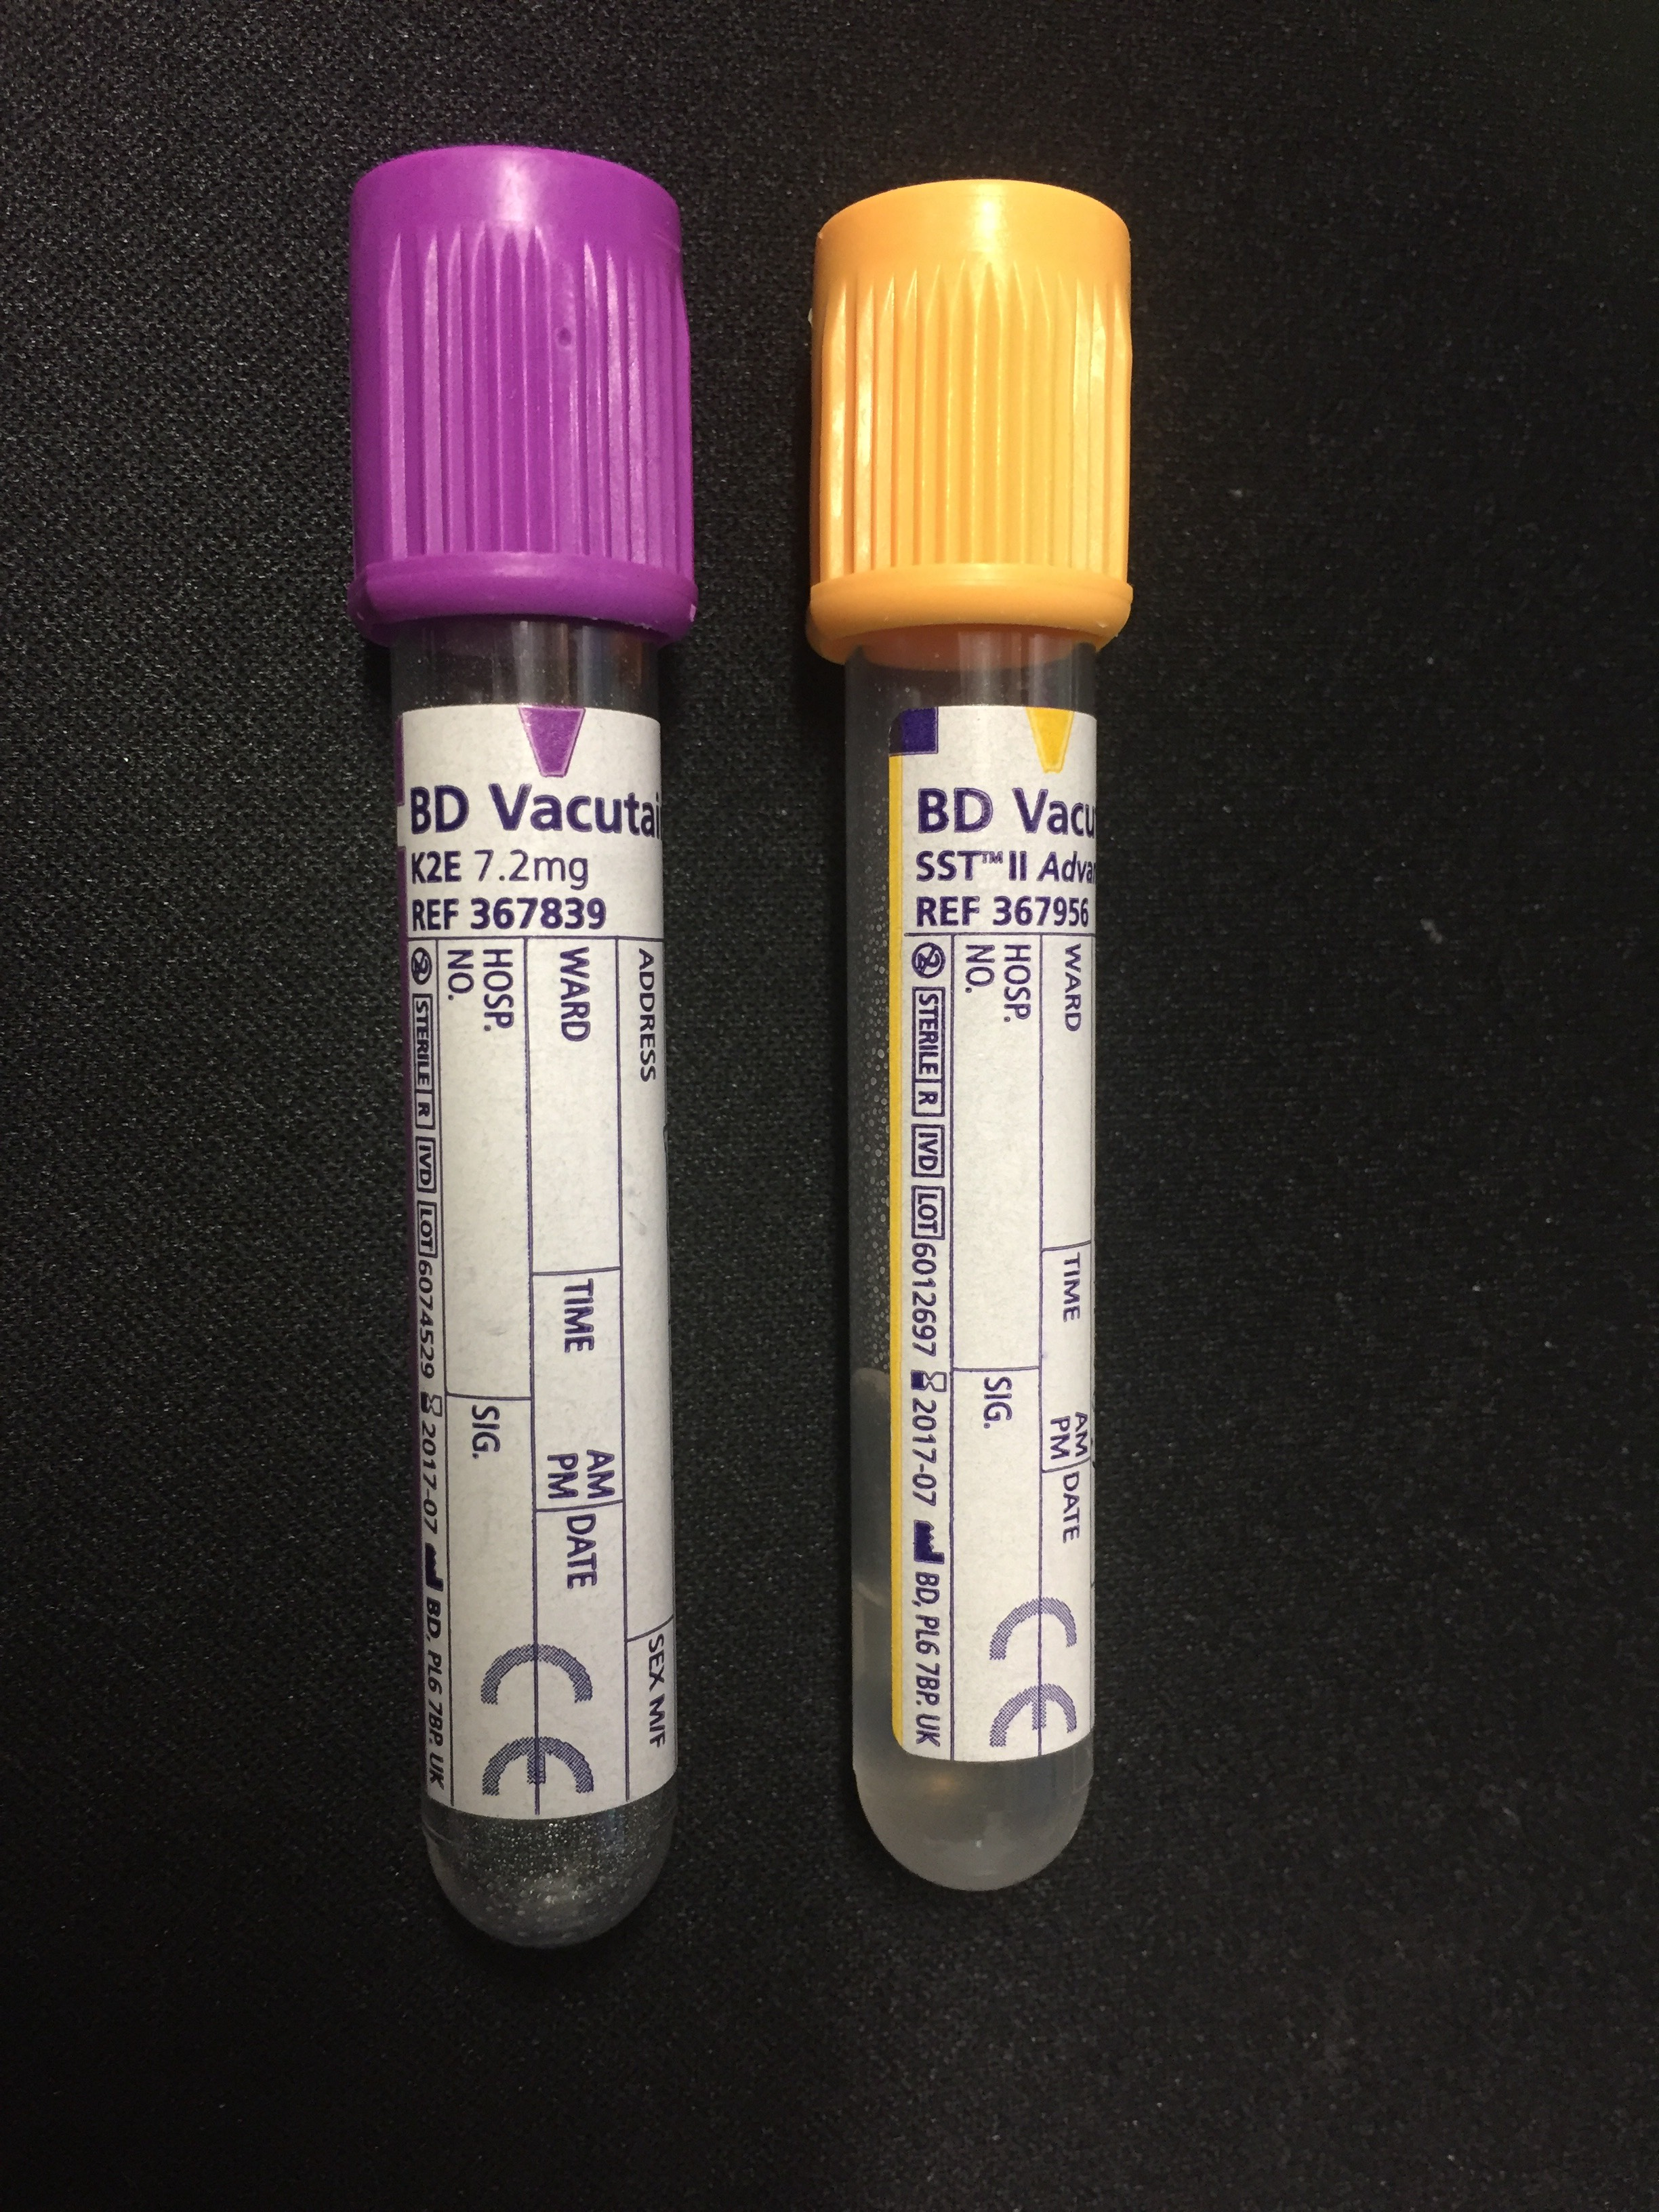

- On admission to PICU (or in theatre or recovery for control patients), taken by research nurse using the existing arterial line; a central venous line sample is acceptable if no arterial access is present): 2.5 mL of PAXgene tube blood, 1–2 mL of serum.
- 12 hours post admission to PICU, taken by research nurse using the existing arterial line; a central venous line sample is acceptable if no arterial access is present): 1–2 mL of serum.
- 24 hours post admission to PICU, or pre-discharge from PICU, whichever occurs first (in PICU, taken by PICU using the existing arterial line; a central venous line sample is acceptable if no arterial access is present): 1–2 mL of serum.
Blood Sampling instructions
PAXgene: 2.5 mL, see:
http://www.preanalytix.com/sites/default/files/brochures/PAXgene%20Blood%20RNA%20Tube_How%20to%20collect%20blood.pdf
- Once the blood has been collected, gently invert the PAXgene Blood RNA tube 8 to 10 times.
- EDTA: at least 1 mL (ideally 2 mL), follow standard institutional sampling instructions.
- Serum: at least 1 mL (ideally 2 mL), follow standard institutional sampling instructions.

Preparation of blood tubes to be taken at each time point
- Study nurse to supply PAXgene, EDTA, and serum tubes.
- Handover of tubes and labels (where appropriate) to PICU as part of handover checklist.
- Study flyer/checklist for every patient to ensure correct tubes are taken at correct time point.
- Specific instructions for PAXgene filling (2.5 mL exactly).
- Patient etiquette: contain study number with barcode, label/sticker that is resistant to prolonged -70°C freezing.

Shipment of blood tubes from collection to lab (same instructions are for each time point)
Samples to be labelled with standard clinical patient labels and shipped immediately upon collection using institutional urgent shipment procedure (i.e. four separate shipments to the lab for every patient) as inflammatory markers rapidly degrade under ambient temperature. The in-house process has to be set up to ensure that shipment is not delayed and the lab will immediately process.

Processing of blood tubes at lab (same instructions are valid for each time point)
PAXgene tubes (2.5 mL): pre-bypass, and time 0:
- Store the PAXgene Blood RNA tube upright at room temperature (18°C–25ºC) for a minimum of 2 hours and a maximum of 72 hours before processing or transferring to refrigerator (2–8°C) or freezer (−20°C).*
- Stand the PAXgene Blood RNA tube upright in a wire rack. Do not freeze tubes upright in a styrofoam tray as this may cause the tubes to crack.
- The PAXgene Blood RNA tubes must be frozen first at -20ºC for at least 24 hours, then transferred to -70ºC or -80ºC. Samples can remain at -20ºC at LCCH for up to 5 days. The Research Team will collect and transfer samples to -80ºC CCHR storage facility every Tuesday and Friday.

Serum tubes (1–2 mL): pre-bypass, and time 0, 12 h, 24 h:
- Centrifuge at 1000 g for 15 minutes
- Aliquot into 5 aliquots (aim for > 200 microlitres each)
- Freeze at -20°C. Samples can remain in -20ºC at LCCH for up to 5 days. The Research Team will collect and transfer samples to -80ºC CCHR storage facility every Tuesday and Friday.

EDTA tubes (1–2 mL): pre-bypass
- Aliquot into 5 aliquots (aim for > 200 microlitres each). Then freeze at -20ºC. Samples can remain in -20ºC at LCCH for up to 5 days. The Research Team will collect and transfer samples to -80ºC CCHR storage facility every Tuesday and Friday.

The laboratory has to use study labels for PAXgene tubes, and for serum and EDTA aliquots. These labels contain the study ID and barcode.

Study ID definition for labels
- 4 letters: study site (LCCH) – 3 digit number: patient number (1 to 999 for each site) – 1 digit number: timing (0, pre-op; 1, PICU admission; 2, 12 h; 3, 24 h) – 1 letter: sample type (P, PAXgene; E, EDTA; S, Serum) – 1 digit number: aliquot number (1,2,3,4 etc.)
- Samples must be processed within 30 minutes to avoid degradation of the inflammatory markers.
- For auditing purposes, we request a periodical temperature log.
We will batch transfer frozen samples from CCHR to the biobank. Samples will be transferred at regular intervals for analysis.

Procedure at University of Queensland / QIMR Berghofer
- Blood samples will be monitored using the same study ID labels.
- Specific procedures for RNA sequencing, DNA isolation, and multiplex serum biomarker testing will be followed and updated depending on the available methodology.
- Please use the following tubes:
- 2.5 mL PAXgene tubes: http://www.preanalytix.com/products/blood/RNA/paxgene-blood-rna-tube
- EDTA tubes: 4 mL Purple top BD Vacutainer (see picture below)
B Laboratory Instructions

Microdialysis to monitor endothelial function in Sepsis Study - LCCH – XX_YYYY
-------------------------------------------------------------------------------------------------------
Processing of tubes:
- PAXgene tube (2.5 mL)
- Store tube upright at room temperature for minimum of 2 hours, up to 24 hours
- De-identify tube using labels provided
- Freeze tube upright in -20°C freezer in a wire rack, located on shelf labelled MICRODIALYSIS SEPTIC STUDY
- Store in -20°C freezer for at least 24 hrs
- Twice each week, research team will collect frozen tube for storage at -80°C in CCHR
- Serum tube (1–2 mL, Gold top)
- Centrifuge tube at 1000 g for 15 minutes
- Aliquot serum into 5 cryotubes (place 200 µL into each cryotube)
- In the event of inadequate sample volume, equally divide sample into 5 cryotubes
- Label cryotubes with labels provided
- Freeze the cryotubes in -20°C freezer in storage boxes, located on shelf labelled MICRODIALYSIS SEPTIC STUDY
- Twice each week, research team will collect frozen cryotubes for storage at -80°C in CCHR
- EDTA tube (1–2 mL Purple top)
- Ensure the EDTA tube is well mixed
- Aliquot the whole blood into 5 cryotubes (place 200 µL into each cryotube)
- In the event of inadequate sample volume, equally divide sample into 5 cryotubes
- Label cryotubes with labels provided
- Freeze the cryotubes in -20°C freezer in storage boxes, located on shelf labelled MICRODIALYSIS SEPSIS STUDY
- Twice each week, research team will collect frozen cryotubes for storage at -80°C in CCHR
-- ---------------------------------------------------------------------------------------------------------------------------
*Note: Urgent processing of samples is required as inflammatory markers degrade after 30 minutes of collection.
-------------------------------------------------------------------------------------------------------------------------------

C Causality and Assessment of Severity – Adverse Events
The severity of an Adverse Event will be assessed as follows:
- Mild: Events that require minimal or no treatment and do not interfere with the patient’s daily activities.
- Moderate: Events that cause sufficient discomfort to interfere with daily activity and/or require a simple dose of medication.
- Severe: Events that prevent usual daily activity or require complex treatment.

The relationship of the event to the study intervention will be assessed as follows:
- Unrelated: There is no association between the study intervention and the reported event. AEs in this category do not have a reasonable temporal relationship to exposure to the test product, or can be explained by a commonly occurring alternative aetiology.
- Possible: The event could have cause or contributed to the AE. AEs in this category follow a reasonable temporal sequence from the time of exposure to the test product and/or follow a known response pattern to the test article, but could also have been produced by other factors.
- Probable: The association of the event with the study medication seems likely. AEs in this category follow a reasonable temporal sequence from the time of exposure to the test product and are consistent with the known pharmacological action of the intervention, known or previously reported adverse reactions to the intervention or judgement based on the investigators clinical experience.
- Definite: The AE is a consequence of administration of the test product. AEs in the category cannot be explained by concurrent illness, progression of disease state or concurrent medication reaction. Such events may be widely documented as having an association with the test product or that they occur after rechallenge.

