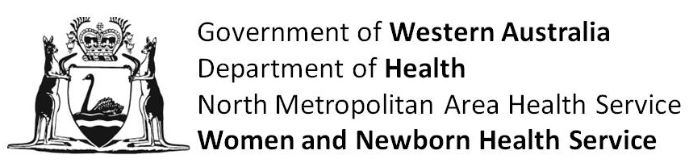

FORM OF CONSENT

PLEASE NOTE THAT PARTICIPATION IN RESEARCH STUDIES IS VOLUNTARY AND SUBJECTS CAN WITHDRAW AT ANY TIME WITH NO IMPACT ON CURRENT OR FUTURE CARE.

I ................................................................................................................................. have read
Given Names Surname

the information explaining the study entitled:

Maternal pre caesarean Section Carbohydrate and Neonatal Glycaemia Trial

I have read and understood the information given to me. Any questions I have asked have been answered to my satisfaction.

I understand I may withdraw from the study at any stage and withdrawal will not interfere with routine care.

I agree that research data gathered from the results of this study may be published, provided that names are not used.

Dated ................................. day of ............................................................ 20 ..........

Signature ....................................................

I, ........................................................................... have explained the above to the
(Investigator’s full name)

signatory who stated that he/she understood the same.

Signature .............................................................................................

