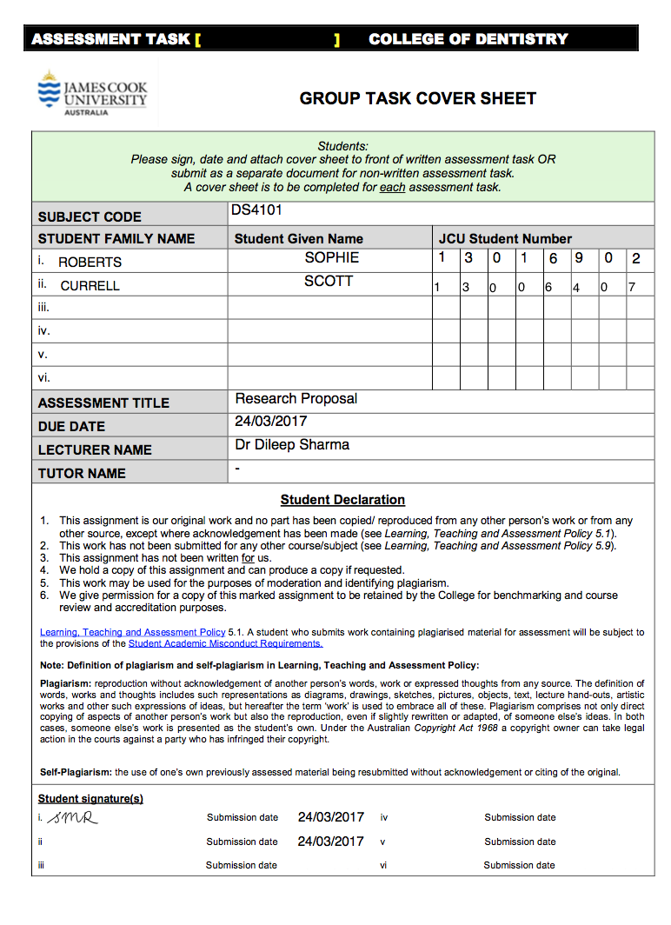

RESEARCH PROPOSAL

*Research Question*

Is the lateral cephalometric radiograph necessary for orthodontic diagnosis and treatment planning of malocclusions?

*Proposed Project Title*

Australian orthodontists’ diagnosis and treatment planning with lateral cephalometric radiographs. A double blind, clinical randomised equivalence trial

*Supervisor*

Dr Carmen Karadeniz

Professor Adrian Esterman

Professor Neil Meredith

*Group Members*

Scott Currell

Sophie Roberts

Table of Contents

Introduction 2

Consultation with colleagues/external agencies 2

Focused clinically relevant question and hypothesis 3

Search strategy 3

Identifying existing literature related to the focused clinical question 3

Problem Statement, aim of study, objectives, research question 4

Research Methodology 5

Methods of data collection and analysis 6

Ethical Considerations 8

Timeline, budget justification and dissemination plan 9

Conclusion 10

Appendix 11

References 11

# Introduction

Lateral cephalometric radiographs are routinely prescribed to every patient who is willing to have orthodontic treatment to correct their malocclusion.1,2 The focus of this research is to investigate the effect of a lateral cephalometric radiograph on Australian Orthodontists’ diagnosis and treatment planning. This proposal clearly outlines the consultation requirements, and overall clinical relevance, aims and outcomes of the research project. A detailed explanation of the research methodology and associated ethical considerations is provided. The feasibility of the research project given the time-frame and budget allocation is demonstrated via a GANTT chart, budget table and dissemination plan.

## Consultation with colleagues/external agencies

The following key stakeholders were identified to provide knowledge and expertise in their fields. They will be contacted via email, mobile phone and if required, a face-to-face meeting will be arranged.

Knowledge of Orthodontics

*Dr Carmen Karadeniz* Will oversee the research project, guide the research design, ethics approval, development of the questionnaire and data analysis.

Research Design

*Professor Adrian Esterman* Assist in the formulation of the research methodology, sample size calculation and data analysis.

*Professor Neil Meredith* Head of the JCU Dental School, consulted in regards to the feasibility of the project.

Designing Questionnaire

*JCU IT Staff* Assist in gaining access to the program, Dolphin

*Practice Manager, JCU Dental* Assist in the location of previous patient records

*Secretaries, JCU Dental* Assist in the location of previous patient records

*Kay Butcher* Assist in the location of previous patient records and assist in the randomisation process.

Ethics

*JCU Human Research Ethics Committee (HREC)*

Provide necessary authorisation to safely conduct the

proposed study

Participants and Dissemination

*Six Heads of Australian Dental Council Accredited Orthodontic Programmes*

*Prof. Mauro Farella (Otago), Prof. M.Ali Darendeliler (Sydney), Prof. Paul M Schneider,*

*(Melbourne), Prof. Mithran Goonewardene (Perth, Western Australia), Prof. David Healey*

*(Brisbane, Queensland), Prof. Craig Dreyer (Adelaide)*

Will be contacted via personal email as provided on their respective university website.

Australian Orthodontists Will be contacted via personal email as provided by AHPRA, ASO or AOB public databases or from their dental practice’s public website.

## Focused clinically relevant question and hypotheses

Is the lateral cephalometric radiograph necessary for orthodontic diagnosis and treatment planning of malocclusions?

Null hypothesis:

Lateral cephalometric radiographs will significantly alter Australian Orthodontists’ diagnosis and treatment planning decisions.

Alternate hypothesis:

Lateral cephalometric radiographs will not significantly alter Australian Orthodontists’ diagnosis and treatment planning decisions.

# Search strategy

## Identifying existing literature related to the focused clinical question

Several search strategies will be employed to identify existing literature related to the focused clinically relevant question: Is the lateral cephalometric radiograph necessary for orthodontic diagnosis of malocclusions? The literature review will aim to explore articles published between January 2007 and February 2017, to determine use of lateral cephalometric radiographs as diagnostic aids in orthodontics, and their effect on the accuracy of diagnosis. Descendant and ancestry searches will be undertaken to identify additional sources of literature if required.

The literature search will be conducted using orthodontic textbooks and online databases: JCU One Search, PubMed, MEDLINE and online orthodontic journals such as Angle Orthodontist. The primary research will be extrapolated from full text, peer review journal articles in English using the key words as listed in Table 1.

Table 1: Search Terms

|  |  |
| --- | --- |
| **Key Words** | **Synonyms/Related Terms** |
| Lateral Cephalometric | Radiograph, lateral head, dosimetry, X-ray, cephalogram |
| Orthodontics | Orthodontists |
| Diagnosis | Decisions, aid, cases |
| Malocclusion | Teeth position, abnormal, unnatural |
| Treatment | Corrective, consultation, new patient, cases |
| Australian Practices | Activity, clinic, clinical |

The literature obtained will be refined as per criteria outlined in Table 2. Additional literature will be sourced as required by searching reference lists or authors of key articles, and conducting descendant or ancestry searches. Boolean operators (AND/NOT/OR commands) will also be used to combine terms and increase the likelihood of finding relevant literature.

Table 2: Inclusion and Exclusion Criteria

|  |  |
| --- | --- |
| **Inclusion Criteria**  Articles will be included if they: | **Exclusion Criteria**  Articles will be excluded if they: |
| Published after January 2007 | Irrelevant articles not addressing the key areas identified |
| Published in English | Articles aimed at addressing skeletal syndromes |
| Full text articles available | Articles aimed at addressing aberrations of dental number and morphology |
| Adequate sample size |  |
| Peer-reviewed articles |
| Electronic journal articles |
| Electronic text books |

The search will be conducted systematically, and a list of articles collated using a shared library on EndNote. Changes to the proposed search strategy may occur whilst conducting the integrated literature review, and these will be outlined in detail in the literature review.

# Problem Statement, aims of study, objectives

**Problem Statement**

Lateral cephalometric radiographs are routinely prescribed to every patient who undergoes orthodontic treatment.1,2 However, the information gathered during a clinical examination of the patient is fundamental to determine the diagnosis for a given malocclusion. Most recently in 2013 a systematic review deduced that amongst contemporary orthodontics, ‘the usefulness of this radiographic technique in orthodontics is still lacking, with contradictory results.’3 In 2015, the British Orthodontic Society published a document entailing specific indications and guidelines for the prescription of lateral cephalometric radiographs.8 However, no such framework exists in Australia, and the decision expose a patient to ionising radiation is at individual orthodontists’ discretion.9 Overall, authors suggest reconsidering the necessity of lateral cephalograms in orthodontic treatment to reduce the amount of ionising radiation a patient is exposed to.2,5

From our proposed research project, if we determine that lateral cephalograms do not alter orthodontists’ diagnosis and treatment planning, we can deem this diagnostic record irrelevant. Therefore, patients should not be exposed to radiation unnecessarily. This is in keeping with the principle that radiation exposure be kept as low as reasonably achievable, whereby the balance between benefit and associated risk of subjecting patients to ionising radiation is determined.10 Exposure is dangerous, and has the potential to damage human cells and tissues, including fatal malignant (cancerous) change. The extent of damage is dependent upon the dose of ionising radiation received and one of the many conditions described is thyroid cancer.11 Orthodontic treatment (including the diagnostic radiographs) usually start at age 10 or 11 following the eruption of permanent dentition. The thyroid gland serves a very important role in growth and development, particularly in children, and is shown to be exposed in lateral cephalometric radiograph techniques. With the thyroid gland alone absorbing 13.1μSv of radiation during lateral cephalometric radiography, the omission of the radiograph will be deemed as a significant reduction in ionising radiation exposure.12

If the results are consistent and we find that lateral cephalograms provide no relevant information and are not a ***‘must have’*** diagnostic record in Orthodontics, we can suggest that they should not be prescribed routinely to all patients.

**Aims and Objectives**

The aim of this study is to determine the usefulness of the lateral cephalometric radiograph in orthodontists’ diagnosis and treatment planning of typical malocclusions. The objectives of this study are twofold:

1° aim: To determine if there is a difference in accuracy of diagnosis of typical orthodontic cases between two randomised groups of Australian orthodontists, with only one receiving a lateral cephalometric radiograph and the other having the radiograph omitted.

2° aim: To determine if there is a difference in accuracy of treatment planning decisions of typical orthodontic cases between two randomised groups of Australian orthodontists, with only one receiving a lateral cephalometric radiograph and the other having the radiograph omitted.

# Research Methodology

The design of this study is a quantitative, analytical, experimental, randomised equivalence control trial. Questionnaires will be used to generate and collect data. The study factor altered to produce a specific outcome is the inclusion or exclusion of a lateral cephalometric radiograph as a diagnostic aid in the questionnaires.

# Methods of data collection and analysis

**Study Population and Setting**

The target population for this study is all currently Australian Health Practitioners Regulation Agency (AHPRA) registered Orthodontists. The setting of this research is also Australia.

**Participant Allocation**

The Orthodontists who are willing to join this study will be randomly allocated into two groups. One control group and one intervention group. Those in the control group will receive a questionnaire of a random orthodontic case, with all diagnostic material, including a lateral cephalometric radiograph. Whereas those in the intervention will receive the same random sample without the lateral cephalometric radiograph.

**Intervention/Questionnaires**

The questionnaire will be prepared in an online format using a web-based survey generator, *Survey Monkey*. Five patient’s records will be attained from those of James Cook University Dental Clinic, representative of different typical malocclusions as per expert opinion:

* Class I
* Class II Division 1
* Class II Division 2
* Class III
* Extra case of the aforementioned with a vertical or transverse discrepancy.

Such patients had full pre-treatment orthodontic records (facial and intra-oral photographs, study models and radiographs) and have since completed orthodontic treatment. A sample of patients will be determined, and their records de-identified, prior to the design of the questionnaire and dissemination to the participating specialist orthodontists. All patients (or parents/guardians) signed a consent form for the photographs, dental casts, and radiographs to be used for teaching/academic purposes. The consent forms are included in the patients’ files and kept at JCU Dental Clinic (Appendix 1).

Eligibility criteria for inclusion in the questionnaire included patient with:

* Presence of permanent dentition
* Absence of craniofacial syndromes or dental abnormalities
* Absence of missing or non-erupted teeth (excluding wisdom teeth)
* High quality intra and extra oral photographs
* Study casts, cephalometric radiographs available

**Study Design**

Prior to dissemination of the questionnaires to participants, the Head of Orthodontics at each of the six Australian Dental Council accredited orthodontic programmes (University of Adelaide, University of Melbourne, University of Sydney, University of Western Australia, University of Queensland and University of Otago) will be contacted, requesting their participation in the study. If they agree to participate, they will receive one questionnaire containing 5 selected cases, with complete records including lateral cephalometric radiograph. Their responses would create, what is deemed by an esteemed panel of experts, the correct diagnosis and treatment plan.

A control and intervention version of the survey will then be created for each of these 5 patients, and randomly assigned to an Australian Orthodontist, as illustrated in Figure 1. Each questionnaire in the control group contains a single patients’ diagnostic records consisting of facial photographs, intraoral photographs, photographs of dental casts and radiographs (OPG and lateral cephalometric radiograph). The intervention group will also receive the same patient records, without the lateral cephalometric radiograph.

Figure : Flowchart of Study Design

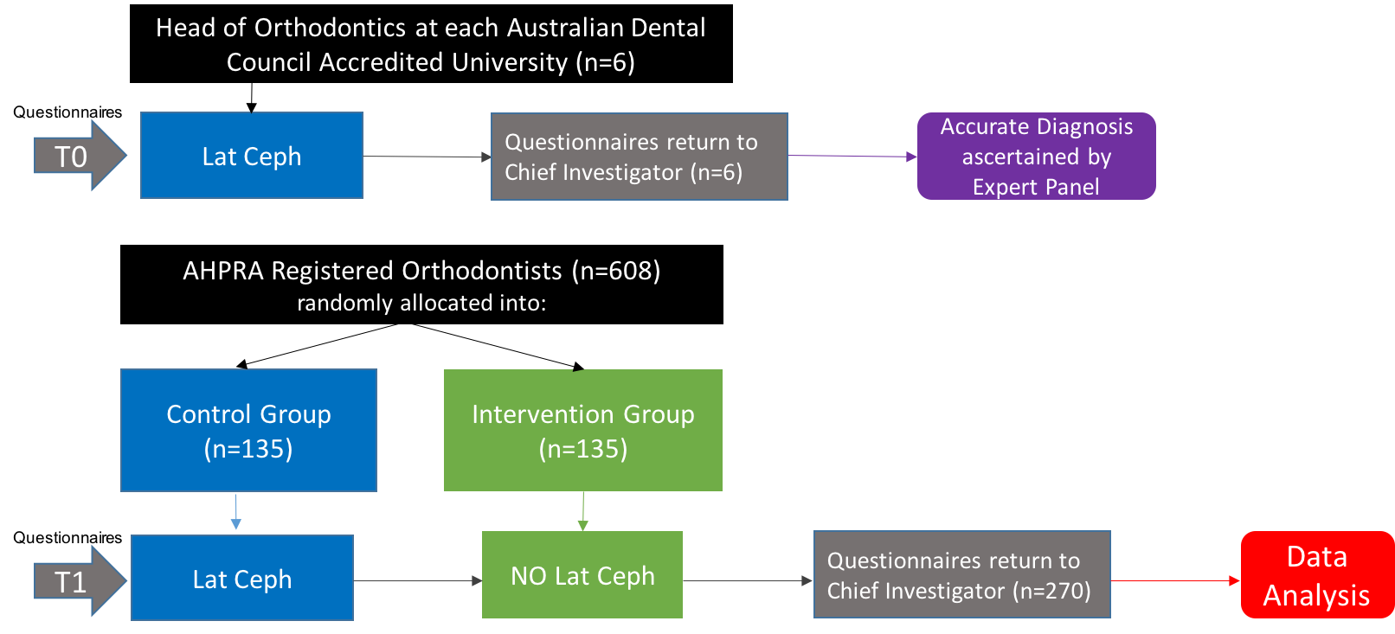

An information sheet and link to the corresponding questionnaire (control or intervention, one of five potential cases) will be sent out via email to the randomly assigned orthodontists inviting them to join this research project. Those interested can follow the link to the questionnaire, and their responses will be automatically recorded and de-identified. Each questionnaire will take approximately 15 minutes to complete in the orthodontist’s own time. A reminder letter will be sent out 3 weeks after the initial correspondence, and a final reminder after 6 weeks.

**Outcomes**

The questionnaires to be sent to the Heads of Orthodontics at Australian Universities and Australian orthodontists will be created using online computer software such as Survey Monkey or Google Forms. The validity of the questionnaires will be proven following the analysis of the Heads of Orthodontics’ results, and determining the correct diagnosis for each of the cases.

The data received from the questionnaires will be compiled and analysed as per the study design to determine the percentage of correct diagnosis by participants with and without the lateral cephalometric radiographs. Therefore, the primary outcome measure will be the percentage of orthodontists who achieved the correct diagnosis in both intervention and control groups. The secondary outcome measure will be the variation in treatment planning decision-making (based on diagnosis) from the intervention and control groups. This data may then be stratified to determine if there is an association between years of orthodontic experience and accuracy of diagnosis, with and without a lateral cephalometric radiograph.

**Sample Size Calculations**

Convenience sampling will be used to recruit participants. The parameters used to calculate sample size were as per an equivalence trial, as shown in Table 3. Interim analyses may be performed during the trial to test the levels of significance. Ideally, these will be performed when 50% and 75% of the data has been collected.

Table : Sample size calculations as per an equivalence trial.

|  |  |
| --- | --- |
| **Factor** | **Number** |
| AHPRA Registered Orthodontists | 608 (n) |
| Type 1 Error | 0.5 |
| Power | 0.8 |
| Expected Proportion | 0.9 |
| Equivalence Difference | 0.05 |
| Sample Size | 135 per group, 270 in total (n) |

**Recruitment Strategy**

Firstly, approval will be sought to circulate invitations to participate in our research from the following dental organisations internal member’s mailing list:

* Australian Health Practitioners Regulation Agency (AHPRA)
* Australian Society of Orthodontists (ASO)
* Australian Orthodontic Board (AOB)

If approval is not granted, participants will be recruited in the following 3 ways:

1. The contact details (i.e. names) of the potential participants (all Australian registered Orthodontists) will be attained from the AHPRA, ASO and AOB public databases.
2. Participants may be contacted by email or phone (from their dental practice websites)
3. Alternatively, participants may be contacted in person at orthodontic conferences/meetings. Those interested will receive the questionnaire via their nominated email address.

**Randomisation and Implementation**

Microsoft Excel will be used to create a list of participating orthodontists. Each orthodontist will then be randomly assigned into the control or intervention group, and one of 5 potential patient cases to diagnose, using a computer-generated list of random numbers and letters. This randomisation procedure will be carried out by a third party: a member of JCU administration staff who has no clinical involvement in the trial. The questionnaires will be created by the research team members, and given to the staff member for distribution. An individual email account ([orthodonticresearch@jcu.edu.au)](mailto:orthodonticresearch@jcu.edu.au)) for the research project has been created and only the staff member will be able to access this. The allocation sequence will be concealed from the investigators assessing the results of the questionnaire, and all questionnaire responses will be de-identified.

**Blinding**

All investigators, outcome assessors and data analysts will be blinded to the randomisation process and individual participants’ responses.

**Data Collection, Management and Storage**

Data will be collated from the survey results and directly inputted into a statistical computer software package. Investigators will then sort, clean and check the data, in preparation for analyses. All data generated in this project will be stored in accordance with the NHRMC/Universities Australia guidelines and JCU’s research data policies.13,14 Specifically:

* Raw data for this project will be retained for at least 5 years
* Any data stored on computer/CD/DVD will be de-identified, and password protected
* Signed informed consent forms from this study will be retained for 15 years
* Upon completion of the project, raw data will be stored in the Principal Investigator’s School at James Cook University, in a locked box or cupboard.

**Statistical Method**

Statistical methods will be used to compare control and intervention groups for primary and secondary outcomes. Methods for additional analyses, such as subgroup analyses and adjusted analyses will also be carried out. The response rate of the surveys will be calculated depending upon the sample size calculation, the surveys received after one reminder and two reminders, and those who did not respond at all. A more detailed description of the statistical methods will be provided in the final report.

**Statistical inference**

* If more than 95% of Orthodontists reach the correct diagnosis with the lateral cephalometric radiograph (control), then it is superior, the null hypothesis is accepted.
* If less than 85% of Orthodontists reach the correct diagnosis with the lateral cephalometric radiograph (control), then it is inferior, the null hypothesis is accepted.
* If the percentage of Orthodontists who reach the correct diagnosis with the lateral cephalometric radiograph is between 85<90<95, then it is then it is deemed equivalent, and the null hypothesis can be rejected in favour of the alternate hypothesis.

# Ethical Considerations

The risk of this project is considered negligible as the only foreseeable risk is no more than inconvenience (giving up time to participate in a survey). There is no foreseeable risk of harm or discomfort to participants or researchers. Information about the study will be included in the email sent out to AHPRA registered orthodontists (Appendix 2), and participants will be required to read this and tick a box on the online survey form prior to beginning the questionnaire. Informed consent will therefore be obtained, and responses will only be considered in the project if this box has been checked. Participant recruitment is likely to be successful as we will be contacting orthodontists who are members of the ASO and AOB and are thus interested in education, research and the continuation of the profession, and are not in need of an external incentive.

The dental records of the patients included in the questionnaires have signed prior consent forms for the use of their de-identified information for academic/teaching purposes (Appendix 1).

A JCU ethics approval application form has been filled out, and sent for approval from the JCU Health Research Ethics Committee (HREC). Should any amendments be required, a JCU ethics amendment form will be filled out and re-sent for approval.

The data collected will be automatically de-identified to blind the researchers to individual participants’ responses and enable comparison of responses longitudinally. Participants will be given their individual data if requested for personal feedback, and a copy of the final report will also be made available. To facilitate feedback, each orthodontist will be assigned a unique identification number and this will be included as a question in the questionnaire. Only the member of JCU administration staff who carried out the randomisation process will be able to provide feedback for individuals.

# Timeline, budget justification and dissemination plan

**Timeline/GANTT Chart**

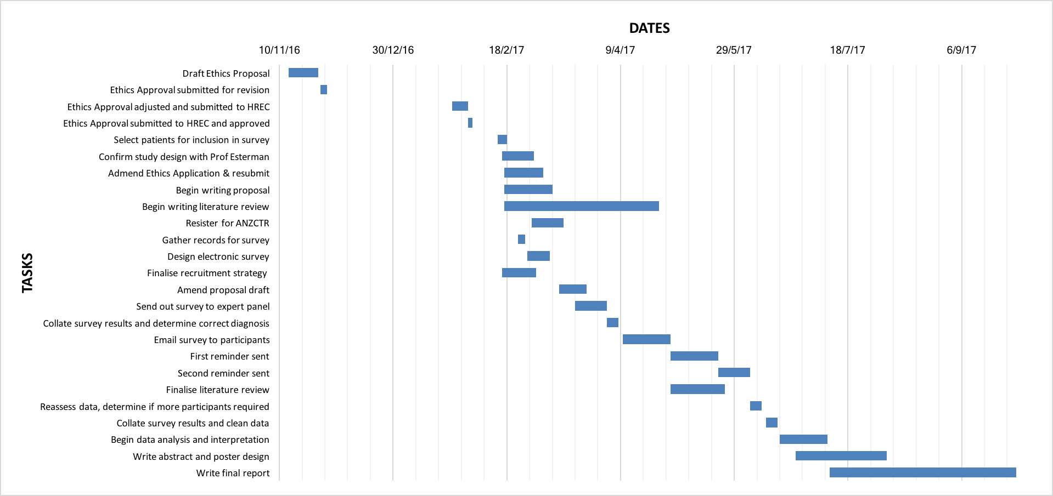

**Budget**

|  |  |  |
| --- | --- | --- |
| **Item** | **Cost** | **Justification** |
| Subscription to Survey Monkey for Survey | $29 per month, 7 months therefore $203 | Required to reach and recruit the maximum number of participants |
| Poster | $30-$50, depending on material | Poster for presentation at the end of the year at JCU Cairns |

**Dissemination**

The results of this research will be presented as an original research article. This journal article will then be submitted to the American Journal of Orthodontics for their publication consideration. A poster will also be created and presented to fellow colleagues, health professionals, staff and students at JCU Cairns at the end of 2017.

# Conclusion

If the results are consistent and we find that lateral cephalometric radiographs provide no relevant information and are not a ‘must have’ diagnostic record in Orthodontics, we can suggest that they should not be prescribed routinely to all patients. This would alter the conventional prescription of radiographs required for orthodontic diagnosis. The omission of the lateral cephalometric radiograph from a susceptible age group would limit the amount of ionising radiation exposure. Within this proposal, the research question, methodology and ethical considerations of this project are clearly specified. The feasibility of this research will be greatly dependent upon support from key stakeholders and supervisors.

# Appendix

Appendix 1: Patient Consent Form

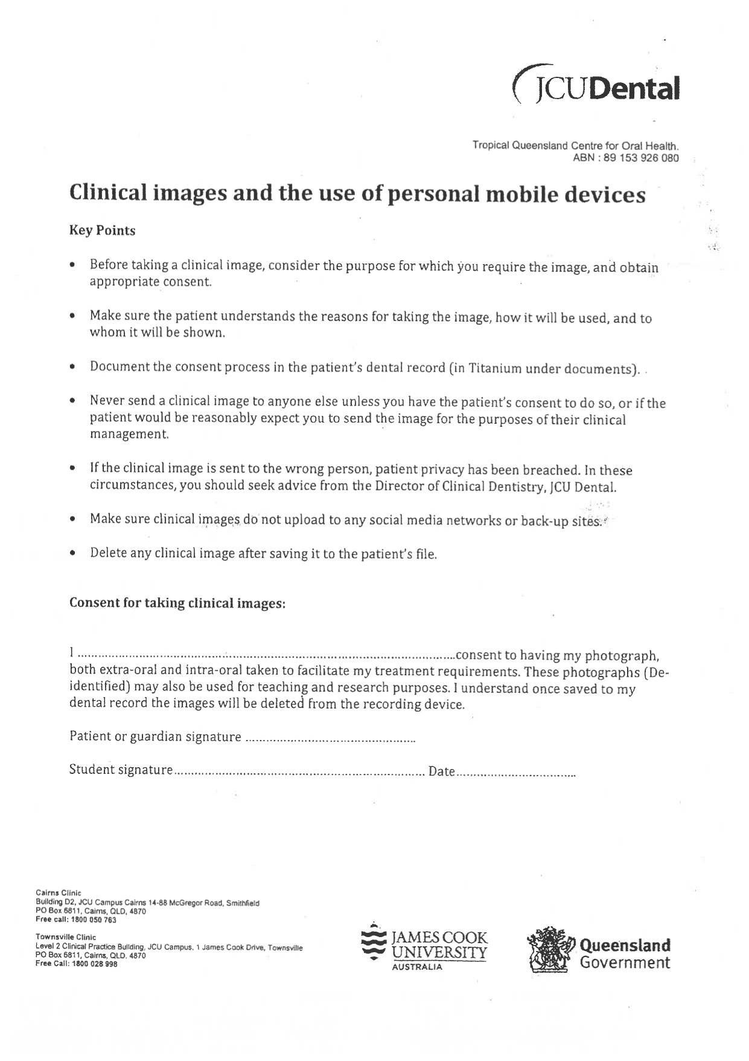

Appendix 2: Informed Consent Form for Participants

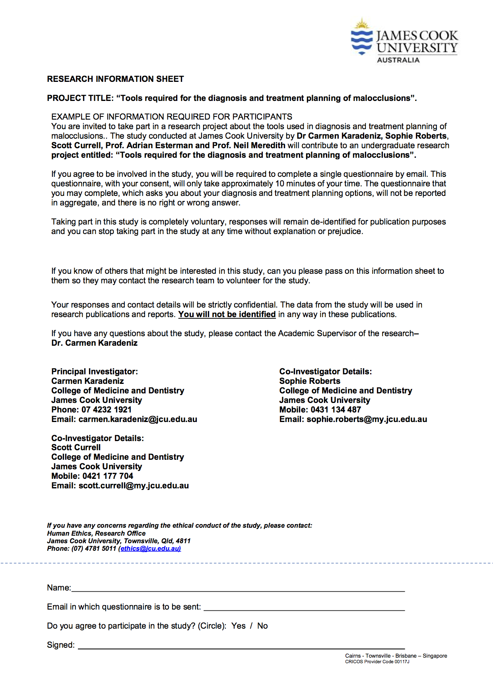

# References

1. Cobourne MT, DiBiase AT. *Handbook of Orthodontics.* Philadelphia: Mosby Elsvier; 2011.

2. Rischen R, Breuning K, Bronkhorst E, Kuijpers-Jagtman A. Records Needed for Orthodontic Diagnosis and Treatment Planning: A Systematic Review. 2013.

3. Durão AR, Pittayapat P, Rockenbach MIB, et al. Validity of 2D lateral cephalometry in orthodontics: a systematic review. *Progress in Orthodontics.* 2013;14(1):1-11.

4. Dincer B, Yetkiner E, Aras I, Attin T, Attin R. Influence of lateral cephalometric radiographs on extraction decision in skeletal class I patients. *HEAD & FACE MEDICINE.* 2013;9(1):36-36.

5. Devereux L, Moles D, Cunningham SJ, McKnight M. How important are lateral cephalometric radiographs in orthodontic treatment planning? *American Journal of Orthodontics & Dentofacial Orthopedics.* 2011;139(2):e175-e181.

6. Durao AR, Alqerban A, Ferreira AP, Jacobs R. Influence of lateral cephalometric radiography in orthodontic diagnosis and treatment planning. *ANGLE ORTHODONTIST.* 2015;85(2):206-210.

7. Nijkamp PG, Habets LLMH, Aartman IHA, Zentner A. The influence of cephalometrics on orthodontic treatment planning. *European Journal of Orthodontics.* 2008;30(6):630-635.

8. Isaacson KG TA, Atack NE, Horner K, Whaites E , Jones M. *Orthodontic radiographs: guidelines for the use of radiographs in clinical orthodontics.* 4th ed. London, United Kingdom: British Orthodontic Society; 2015.

9. Committee RH. Code of Practice and Safety Guide for Radiation Protection in Dentistry. In: Agency ARPaNS, ed. 10 ed. Canberra: Australian Radiation Protection and Nuclear Safety Agency (ARPANSA); 2005.

10. Council NR. *Health risks from exposures to low levels of ionising radiation:BEIR VII Phase 2.* Washington DC: : National Academy Press;2006.

11. Silva M, Wolf U, Heinicke F, Bumann A, Visser H, Hirsch E. Cone-beam computed tomography for routine orthodontic treatment planning: A radiation dose evaluation. *Am J Orthod Dentofacial Orthop.* 2008;133(640):e1-640.e645.

12. Council NHaMR. Australian Code for the Responsible Conduct of Research. 2007. <https://www.nhmrc.gov.au/_files_nhmrc/file/research/research-integrity/r39_australian_code_responsible_conduct_research_150811.pdf>. Accessed March 7, 2017.

13. University JC. Code for the Responsible Conduct of Research. 2007. <https://www.jcu.edu.au/policy/research-management/code-for-the-responsible-conduct-of-research>. Accessed March 7, 2017.