Department of Psychological Medicine

Faculty of Medical and Health Sciences

The University Of Auckland

Private Bag 92019

Auckland 1142, New Zealand

**STUDY PROTOCOL**

|  |  |
| --- | --- |
| **Project Title:** | The use of a visualisation intervention to improve exercise during recovery from colorectal cancer surgery. |
| **Public Title:** | Improving outcomes from colorectal cancer surgery. |
| **Universal Trial Number:** | U1111-1193-1685 |
| **Principal Investigator:** | Professor Keith Petrie  Department of Psychological Medicine  Faculty of Medical and Health Sciences  University of Auckland  [Kj.petrie@auckland.ac.nz](mailto:Kj.petrie@auckland.ac.nz) |
| **Student Researcher:** | Annie Jones  PhD Student in Health Psychology  Department of Psychological Medicine  Faculty of Medical and Health Sciences  University of Auckland  [Annie.jones@auckland.ac.nz](mailto:Annie.jones@auckland.ac.nz) |
| **Co-Investigators:** | Dr Arend Merrie  Colorectal Surgeon  Department of General Surgery  Auckland City Hospital  [ArendM@adhb.govt.nz](mailto:ArendM@adhb.govt.nz)  Annelies Mittendorf  Colorectal and Enhanced Recover After Surgery Nurse Specialist  Department of Surgery  Auckland City Hospital  [AnneliesM@adhb.govt.nz](mailto:AnneliesM@adhb.govt.nz)  Dr Justin Fernandez  Senior Lecturer  Auckland Bioengineering Institute  University of Auckland  [j.fernandez@auckland.ac.nz](mailto:j.fernandez@auckland.ac.nz) |

**Introduction**

The use of visualisation to improve understanding regarding medical conditions and health behaviours is a new area of research in health psychology. Visualising the inner bodily processes of an illness or medication through animations or 3-Dimensional models has been found to help improve adherence to HIV treatment (Perera, Thomas, Moore, Faasse, & Petrie, 2014), to improve recovery in patients with acute coronary syndrome (Jones, Ellis, Nash, Stanfield, & Broadbent, 2016), and to improve understanding in newly diagnosed patients with osteoporosis (Stephens et al., 2016). To our knowledge however, there is no prior visualisation study which attempts to visualise the purpose of recovery health behaviours, rather than a medication.

Over the last 10 years, Enhanced Recovery After Surgery (ERAS) programmes have been introduced into hospitals worldwide for a number of procedures, including colorectal cancer surgery (Gustafsson et al., 2013). Patients included in ERAS programmes in comparison to standard care are discharged from hospital twice as quickly and have fewer illness-related complications, while experiencing no increased rates of hospital re-admission or mortality. For this reason, ERAS programmes have been adopted in hospitals worldwide, including New Zealand.

The ERAS programme consists of a number of modules, two of which concern early mobilisation and the early re-introduction of food and drink following surgery. Performing these behaviours enables patients to recover faster and be discharged from hospital sooner, but both behaviours could be anxiety provoking if they contrast patients’ views regarding what recovery should be in hospital. Patients may believe that bed-rest, minimal physical exertion and intravenous fluids are likely to ensure optimal recovery from surgery such as colorectal resection. The ERAS programme will therefore challenge such ideas and possibly discourage such behaviour.

For the current study, we want to employ a visualisation intervention to explain to patients the purpose of the recovery behaviours of early oral nutrition and mobilisation as part of the ERAS programme. The intervention will use animations to show patients how mobilisation and eating and drinking actually help their body to recover faster by demonstrating the anatomical processes occurring inside the body when these behaviours are performed. The intervention will be shown to patients on an iPad computer tablet at their bedside, day one following their surgery.

**Objectives**

The objective of the study is to determine the efficacy of a visualisation intervention in improving adherence to the recovery behaviour of exercise in patients following surgery for colorectal cancer. The study also aims to investigate the utility of using visualisation versus standard forms of information (such as verbal).

**Research Design**

This research is a parallel design, 3-arm randomised controlled intervention. The intervention will involve three different conditions, standard care, standard care plus the visualisation intervention, and standard care plus verbal information (detail about each condition is given below).

**Participants**

Participants in the study will be patients undergoing colorectal resection at Auckland City Hospital during our recruitment period of March to December 2017, aged between 18 to 80 years of age. Participants will be excluded if they feel unable to fill out the questionnaires and participate, and/or cannot understand English.

Initial contact with patients will occur at Greenlane Clinical Centre in Auckland. Patients attend a pre-admission clinic here anywhere from 2 weeks to 1 day prior to their surgery. During this pre-admission visit, the colorectal nurse specialist (Annelies Mittendorf) will inform the patients about the study. Patients who are interested in taking part will be referred on to visit the student researcher who will then discuss the participant information sheet (Appendix A) and gain written informed consent for participation (Appendix B). Following the receipt of written informed consent the participant will be asked to complete the baseline questionnaire.

The day following each participant’s surgery, the student researcher will visit the patient at their bedside. The randomisation envelope will be opened and the participant will be informed of which study group they are in. If the participant is in the intervention or the active control group, they will receive their information session from the study researcher. Following this, participants in these groups will complete a post-procedure questionnaire, with a separate version given to participants of each group. If the participant is in the control group, they will complete the control group post-procedure questionnaire. The post-procedure questionnaires will be administered by an independent researcher, not the student researcher who delivers the intervention, recruits the participant, and administers the baseline questionnaire.

After completing the post-procedure questionnaire in-hospital, the independent researcher will give all participants a fitness tracker watch. Participants will be asked to wear this watch on their person for the duration of their time in hospital and also for one week following their discharge from hospital. This fitness tracker watch will be used to collect data on the participant’s step count. Participants will also be given a pre-paid courier bag to post their fitness tracker back to the department at the end of the week, and will be informed that at the end of the seven days post-discharge they will complete a final 5-minute phone questionnaire. Following the receipt of the fitness tracker back (and the completion of the follow-up questionnaire) participants will be sent a $20 Westfield voucher to thank them for their participation.

**Sampling**

Participants will be recruited from patients having colorectal cancer surgery scheduled during our recruitment period (commencing April to December 2017) at Auckland City Hospital. Each participant will be randomly allocated into one of the three study conditions before completing the second questionnaire assessment. This randomisation will be completed by someone independent of the study and sealed in opaque, numbered envelopes.

**Blinding**

The student researcher will recruit the participants, administer the baseline questionnaire and deliver the intervention. The post-procedure and follow-up questionnaires will be completed by an individual independent of the study. Participants will not be informed about the study hypothesis. The data will be linked to each participant’s unique 3 digit code to ensure anonymity in the data set.

**Intervention**

The current study includes 3 conditions, the intervention group, an active control group, and a standard care group. The intervention group will receive the animated intervention displayed on an iPad at their bedside day 1 following their surgery. The intervention will be administered by the student researcher (Annie Jones). The intervention will provide information about how behaviours part of the ERAS programme will help the patient to recover well from their surgery. There are two versions of the intervention where either a male or female actor patient is used. The version of the intervention the patient sees will be their gender match. The intervention will begin by highlighting common beliefs that patients have about recovering from a surgical procedure, such as ideas around bed rest being the fastest way to heal. These ideas will be challenged by providing information about the ERAS programme including evidence supporting their efficacy from previous clinical trials. The intervention then explains the recovery behaviour of early mobilisation. The presentation incorporates real life footage of an ‘actor’ with animations depicting the internal bodily processes occurring while either resting, or when mobile. The animations show the heart, the lungs, and bodily circulation. The second part of the intervention shows the importance of the early re-introduction of food and drink following surgery. An animation explaining the digestive system is used here. Figure 1 shows selected screen grabs from the intervention. The intervention also outlines to patients their daily goals for each of the behaviours. These are pre-existing goals that are given to all patients in their information booklet. Finally, the intervention ends with an elaborative reasoning task, which tries to get the patient to contextualise their ideas about exercising with their own life. The patient is asked to discuss two questions: “In what ways could you incorporate exercise into something specific that you might do on the ward while in hospital?” and “In what specific ways can you try and incorporate daily exercise into your routine once you are discharged and back home?”.

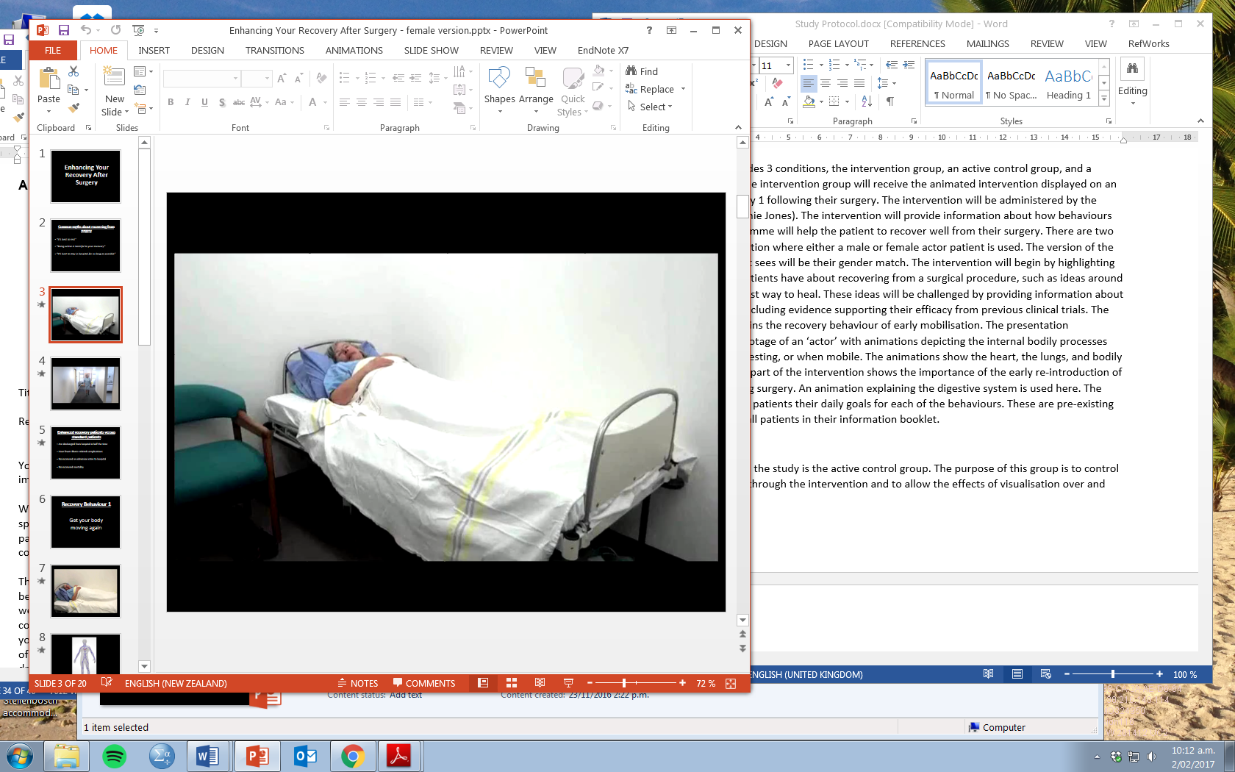 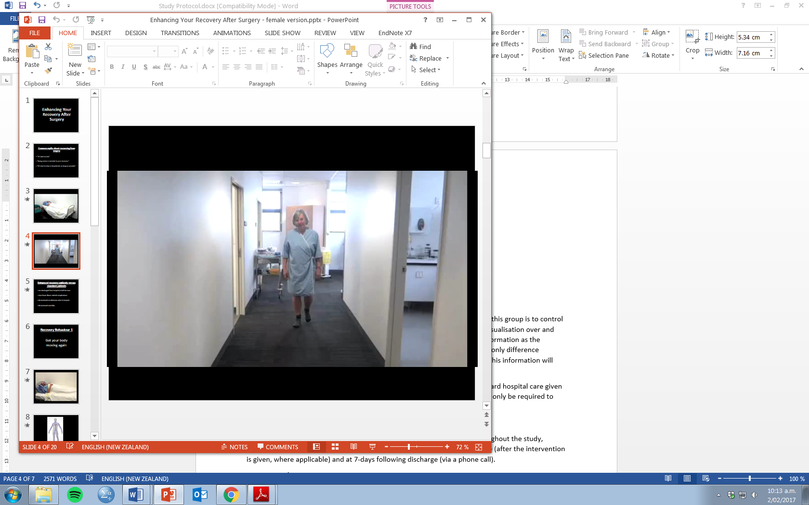

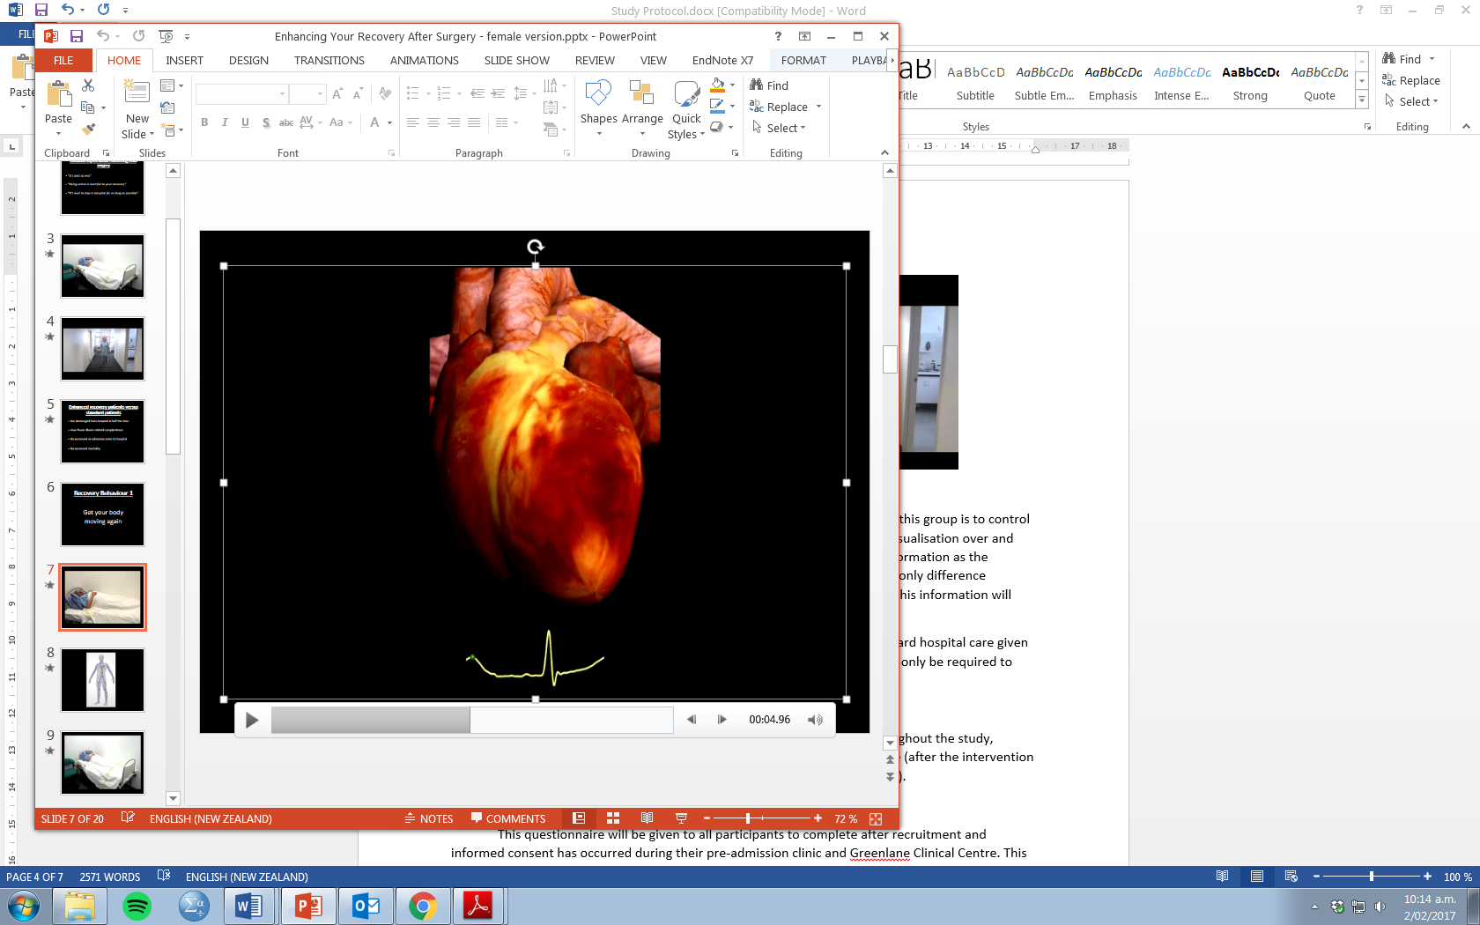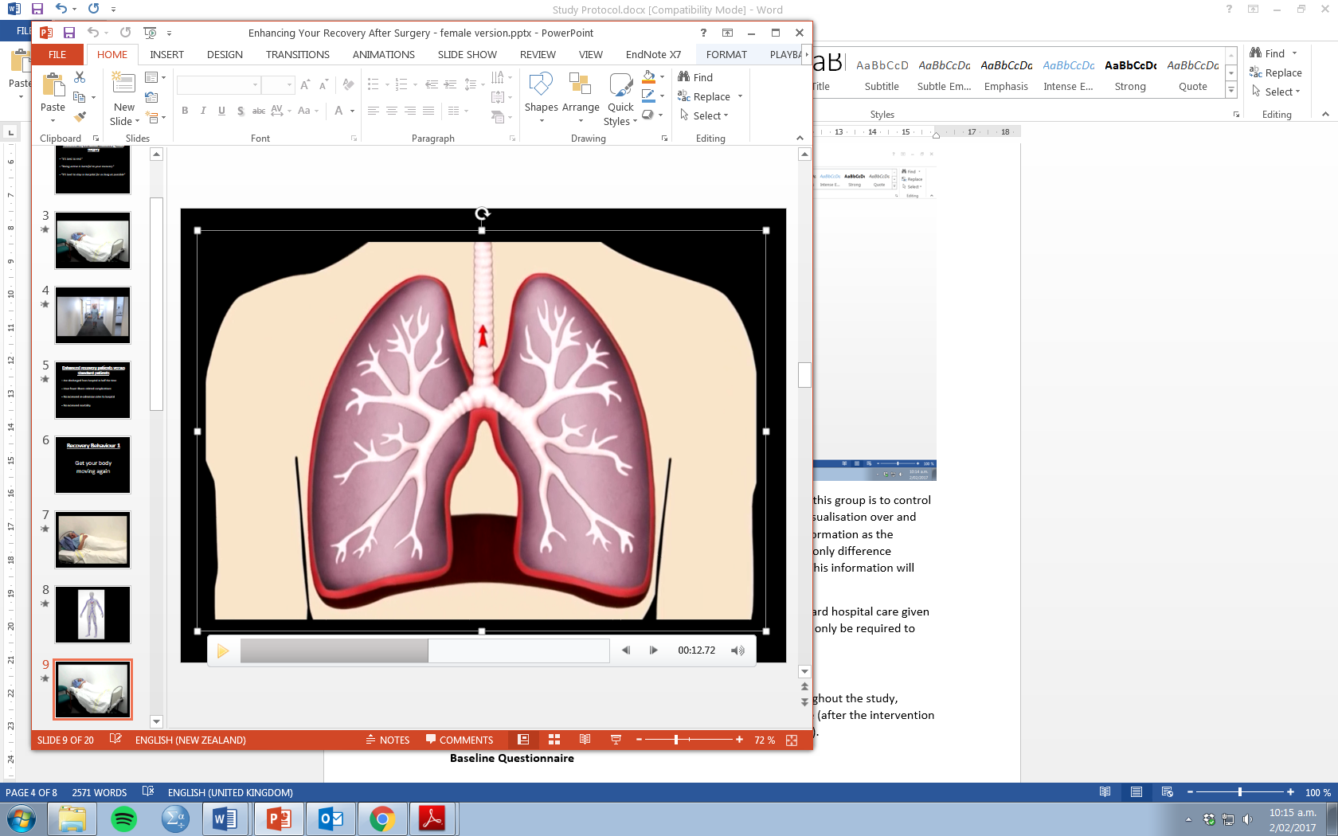

*Figure 1*. Selected screen grabs from the female version of the visualisation intervention. Top two images show the female actor patient resting and walking. The bottom two images show the two of the animations, the heart animation (bottom left) and the lung animation (bottom right).

The second condition in the study is the active control group. The purpose of this group is to control for the attention given through the intervention and to allow the effects of visualisation over and above this to be examined. The active control group will receive the same information as the visualisation group, however this will only be the verbal script. Therefore the only difference between the intervention and the active control group is visualisation itself. This information will also be delivered by the student researcher (Annie Jones). The script used in both the visualisation intervention and the active control group is identical and also includes the final elaborative reasoning task (see Appendix C).

The final condition is a standard care group. These patients will receive standard hospital care given to all patients undergoing this procedure and the ERAS programme. They will only be required to complete the measures at teach time point.

**Outcome Measures**

Participants will complete questionnaires at three separate time points throughout the study, baseline (prior to admission and procedure), day one following the procedure (after the intervention is given, where applicable) and at 7-days following discharge (via a phone call). Each questionnaire can be seen in Appendix D.

**Baseline Questionnaire**

This questionnaire will be given to all participants to complete after recruitment and informed consent has been received during their pre-admission clinic at Greenlane Clinical Centre. This questionnaire will include demographic questions, a self-report item about the current week’s exercise levels, questions from the Brief Illness Perception Questionnaire (Broadbent, Petrie, Main, & Weinman, 2006) adapted to ask about surgery and recovery, questions regarding understanding, anxiety, and motivation to perform the recovery behaviours, and some questions regarding their beliefs about recovery from surgery.

**Post-Procedure Questionnaire**

This will be completed by participants the day after surgery and the intervention (where applicable). A person independent of the study will administer this questionnaire to participants. All three groups will answer the same measures as those in the baseline questionnaire (minus the demographic questions), as well as the Quality of Recovery 15-item scale (Stark, Myles, & Burke, 2013). Participants in the active control and visualisation intervention groups will answer additional questions rating the information they received.

**One-Week Post-Discharge Questionnaire**

All participants will complete the same follow-up questionnaire, one-week following their discharge from hospital. This will be completed on the phone by a person independent of the study. This questionnaire asks participants the same items about their recovery behaviours from the baseline and post-procedure questionnaire, the Quality of Recovery scale, and to self-report their current week’s exercise levels (as in the baseline questionnaire).

**Objective Measures**

As well as completing the three questionnaires, there will also be some objective measures for all participants. Step count will be measured in all participants using a moov NOW fitness tracker watch. Step count will be recorded during the participants hospital stay (following the day 1 study session) and the participant will be asked to continue to wear this fitness tracker through the first week following their recovery. Data will be collected using the moov smartphone application on the study iPad.

Clinical data will also be recorded from patients’ clinical notes. Length of hospital stay and any re-hospitalisation will be recorded from participant’s hospital notes following their discharge.

**Sample Size and power calculation**

We are aiming to recruit 90 participants for the current study (30 participant in each study arm). This is based off a G*Power calculation which suggested that 81 participants would be required using a repeated measures between-within ANOVA to measure differences with 80% power at a significance level of p= .05 with a small to medium effect size (f= 0.18). This effect size was taken from a previous study for testing differences between groups over time in levels of Brief IPQ understanding (Jones, Fernandez, Grey, & Petrie, In Submission). We are aiming for 90 participants to account for a possible 10% attrition rate.

**Statistical Analysis**

Repeated-measures between-within ANOVA will be used to assess differences between study groups, from baseline to post-surgery (and 1-week follow-up where applicable), in recovery beliefs, illness perceptions and anxiety and motivations to perform recovery behaviours. Repeated measures ANOVA will be used to assess differences in self-reported exercise levels between study groups from baseline to 1-week follow-up. A one-way ANOVA will be used to assess differences in total step count between the two groups. Independent samples t-tests and Chi-Square tests for independence will be used to assess difference between groups in demographic variables and baseline measures.

**Ethical considerations**

Ethical approval will be obtained from the Health and Disability Ethics Committee in Auckland, New Zealand, as well as the Auckland District Health Board Ethics Committee prior to study commencement.

It is important to consider that this is a patient sample. This trial will pose minimal risks to the participant. The intervention is only information based and behaviour is only being self-reported or measured through an objective fitness tracker. The behaviour encouraged in the intervention follows the advice that all participants are given prior to and following their surgery as part of standard care.

Participants will be informed that they are able to withdraw from their participation in the study at any time and they will be able to withdraw any data traceable to them up to one week following their participation in the research. Participants will provide written informed consent prior to participating in the study. Confidentiality will be protected at all times. A three-numbered coding system will be used on all study documents, with only one document linking the participant’s details to this unique code (the consent form). All consent forms and questionnaires will be kept in a locked filing cabinet in the study researcher’s office. The electronic participant information file will be password protected with only the student researcher and principal investigator (Professor Keith Petrie) having access to this.

Participants are likely to experience some direct benefits from the intervention. It is hypothesised that both the visualisation and active control groups may report greater levels of exercise and recovery following their surgery.

**Feedback of findings**

This study is being completed as part of Annie Jones’ PhD in Health Psychology thesis. The findings from this study will feature in the thesis. The authors also hope to publish the results in a peer-reviewed journal article. The results will also potentially be discussed at conferences and seminar presentations.

Findings will be disseminated to participants who are interested by a results summary. On the consent form that participants complete prior to participation, participants will be asked if they would like to receive a copy of the study results once available. Participants can also select here if they would like this results summary to be sent to them by post or email.

**Budget**

The study will be of no cost to the hospital or departmental staff. The costs of the study in terms of buying the fitness trackers, questionnaire printing and vouchers will all be covered by the University of Auckland. The study will also no impact resources for ADHB. The student researcher alongside the clinical staff (Dr Arend Merrie and Annelies Mittendorf) will ensure that the study procedures do not interfere with clinical practice and staff.

**Timeline**

**Ethics application –** February-March 2017

**Study development –** March 2017

**Recruitment begins –** April 2017

**Recruitment ends –** December 2017

**Analysis of data and write-up for publication –** December 2017

References

Broadbent, E., Petrie, K. J., Main, J., & Weinman, J. (2006). The brief illness perception questionnaire. *Journal of Psychosomatic Research, 60*(6), 631-637. doi:<http://dx.doi.org.ezproxy.auckland.ac.nz/10.1016/j.jpsychores.2005.10.020>

Gustafsson, U., Scott, M., Schwenk, W., Demartines, N., Roulin, D., Francis, N., . . . Soop, M. (2013). Guidelines for perioperative care in elective colonic surgery: Enhanced recovery after surgery (ERAS®) society recommendations. *World Journal of Surgery, 37*(2), 259-284. doi:10.1007/s00268-012-1787-6

Jones, A. S. K., Fernandez, J., Grey, A., & Petrie, K. J. (In Submission). The impact of 3-D models versus animations on perceptions of osteoporosis and treatment motivation: A randomised trial.

Jones, A. S. K., Ellis, C. J., Nash, M., Stanfield, B., & Broadbent, E. (2016). Using animation to improve recovery from acute coronary syndrome: A randomized trial. *Annals of Behavioral Medicine, 50*(1), 108-118. doi:10.1007/s12160-015-9736-x

Perera, A. I., Thomas, M. G., Moore, J. O., Faasse, K., & Petrie, K. J. (2014). Effect of a smartphone application incorporating personalized health-related imagery on adherence to antiretroviral therapy: A randomized clinical trial. *AIDS Patient Care and STDs, 28*(11), 579-586. doi:10.1089/apc.2014.0156

Stark, P. A., Myles, P. S., & Burke, J. A. (2013). Development and psychometric evaluation of a postoperative quality of recovery ScoreThe QoR-15. *Anesthesiology, 118*(6), 1332-1340. doi:10.1097/ALN.0b013e318289b84b

Stephens, M. H., Grey, A., Fernandez, J., Kalluru, R., Faasse, K., Horne, A., & Petrie, K. J. (2016). 3-D bone models to improve treatment initiation among patients with osteoporosis: A randomised controlled pilot trial. *Psychology & Health, 31*(4), 487-497. doi:10.1080/08870446.2015.1112389

**APPENDIX A – PARTICIPANT INFORMATION SHEET**

Department of Psychological Medicine

Faculty of Medical and Health Sciences

The University Of Auckland

Auckland 1142, New Zealand

Private Bag 92019

**PARTICIPANT INFORMATION SHEET**

Title: Improving outcomes from CRC Surgery Study

Researchers: Professor Keith Petrie, Annie Jones (PhD student), Dr Arend Merrie (Colorectal Surgeon), Annelies Mittendorf (Colorectal Nurse Specialist) and Dr Justin Fernandez.

You are invited to take part in a study investigating how recovery outcomes can be improved following colorectal cancer surgery.

We are recruiting patients who are scheduled to have elective colorectal cancer surgery at Auckland City Hospital. Your participation would require three points of contact. During the initial meeting at Greenlane Clinical Centre, you will complete a consent form and a 10-minute baseline questionnaire which will ask you some demographic questions and questions about your surgery and beliefs around your recovery.

The day after surgery you will be visited in Auckland City Hospital, where you will be randomly assigned to one of three study groups. You will either only complete a 15-minute questionnaire or you will additionally receive a brief, 10-minute information session. After completing this, all participants will be given a fitness tracker watch and asked to wear this from this point until 7 days post-discharge from hospital. Wearing the fitness tracker will not interfere with the participant’s everyday life and you will not be asked to complete any additional tasks.

At 7-days post-discharge you will complete a final 5-minute phone questionnaire and be asked to post the fitness tracker back in a pre-paid, courier envelope. Upon receiving the fitness tracker back, you will be sent a $20 Westfield voucher to thank you for your participation in the study.

The data obtained from this research will be stored securely at the Department of Psychological Medicine, Faculty of Medical and Health Sciences, at the University of Auckland. Participation in this study is confidential and no material that could identify participants will be used in any reports on this study. An electronic file of the study data will include your unique participant code. This file will be password protected, with only the principal investigator (Professor Keith Petrie) and the student researcher (Annie Jones) having access to this file. Hard copies will be stored in a locked cabinet. The data will be destroyed after a period of six years. This will be done by shredding or deleting according to whether the data has been stored electronically or as a hard copy.

Please indicate on the consent form if you would like a summary of study results once available.

Thank you very much for your time and effort in making this study possible. Please feel free to contact Annie Jones or Professor Keith Petrie if you wish to know more about the study, or if you have any queries.

|  |  |
| --- | --- |
| Annie Jones  PhD student  Department of Psychological Medicine  The University of Auckland  Private Bag 92019  Auckland 1142  +64 9 373 7599 ext. 84687  [annie.jones@aucklanduni.ac.nz](mailto:annie.jones@aucklanduni.ac.nz) | Professor Keith Petrie  Professor of Health Psychology  Department of Psychological Medicine  The University of Auckland  Private Bag 92019  Auckland 1142  +64 9 923 6564  [kj.petrie@auckland.ac.nz](mailto:kj.petrie@auckland.ac.nz) |
| Dr Arend Merrie  Colorectal Surgeon  Department of General Surgery  Auckland City Hospital  +6421774637  [ArendM@adhb.govt.nz](mailto:ArendM@adhb.govt.nz) | Annelies Mittendorf  Colorectal and Enhanced Recover After Surgery Nurse Specialist  Department of Surgery  Auckland City Hospital  + 64 9 307 4949 ext 23302  [AnneliesM@adhb.govt.nz](mailto:AnneliesM@adhb.govt.nz) |
| Justin Fernandez  Senior Lecturer  Auckland Bioengineering Institute  The University of Auckland  Private Bag 92019  Auckland 1142  +64 9 923 9196  [j.fernandez@auckland.ac.nz](mailto:j.fernandez@auckland.ac.nz) | Head of Department: Associate Professor Sally Merry  Department of Psychological Medicine  The University of Auckland  Private Bag 92019  Auckland 1142  +64 9 373 7599; extn. 86531  [s.merry@auckland.ac.nz](mailto:r.kydd@auckland.ac.nz) |

For any concerns regarding ethical issues you may contact the Chair, the University of Auckland Human Participants Ethics Committee, at the University of Auckland, Research Office, Private Bag 92019, Auckland 1142. Telephone 09 373-7599 ext. 83711. Email: [ro-ethics@auckland.ac.nz](mailto:ro-ethics@auckland.ac.nz)

APPROVED BY THE UNIVERSITY OF AUCKLAND HUMAN PARTICIPANTS ETHICS COMMITTEE ON XX/XX/XXXX FOR (X) YEARS REFERENCE NUMBER XXXXXX

**APPENDIX B – CONSENT FORM**

|  |  |  |  |
| --- | --- | --- | --- |
| CODE |  |  |  |

Department of Psychological Medicine

Faculty of Medical and Health Sciences

The University Of Auckland

Private Bag 92019

Auckland 1142, New Zealand

**CONSENT FORM**

This form will be kept for a period of 6 years

Title: Improving outcomes from CRC Surgery Study

Researchers: Professor Keith Petrie, Annie Jones (PhD student), Dr Arend Merrie (Colorectal Surgeon), Annelies Mittendorf (Colorectal Nurse Specialist) and Dr Justin Fernandez.

* I have read the Participant Information Sheet and understand the nature of the research and why I have been selected. I have had the opportunity to ask questions and have them answered to my satisfaction.
* I agree to take part in this research and understand that taking part is voluntary (my choice).
* I understand that my involvement in the study includes three points of contact. I will fill out three short questionnaires, wear a fitness tracker while in hospital and one week following discharge, and be asked to post this back in a pre-paid courier bag. I may also be randomly allocated to receive a brief, 10-minute informational session while in hospital.
* I understand that I can withdraw participation at any time during the session and withdraw any data traceable to me up to one week following my participation in the research.
* I understand that participation in this study is confidential and that no material that could identify me will be used in any reports on this study.
* I understand that I will receive a $20 Westfield gift voucher after completing the study.
* I understand that the research data will be stored securely in the Department of Psychological Medicine, University of Auckland for 6 years, after which it will be destroyed by shredding/deleting according to whether it is in a hard copy or electronic format.
* Please indicate if you would like to receive a copy of the study results once available:

YES NO

Full Name: ...............................................................................

Telephone: .................................................. Mobile: ………………………………………………………

Email address:..........................................................................

Signed …………………………………………………………………………………

APPROVED BY THE UNIVERSITY OF AUCKLAND HUMAN PARTICIPANTS ETHICS COMMITTEE ON XX/XX/XXXX FOR (X) YEARS REFERENCE NUMBER XXXXXX

**APPENDIX C – INTERVENTION SCRIPT**

|  |
| --- |
| **SCRIPT** |
| I’m going to show a short presentation that gives you some information about specific behaviours you can do while you are in hospital to help your body recover faster from your surgery. |
| After having a procedure such as colorectal surgery, there are common myths that some patients believe about what is best for their recovery:   * Firstly, that it is best to rest your body completely afterwards. * That being active can aggravate the body and slow down recovery. * And that it is best to stay in hospital care for as long as possible. |
| What research has actually proven over the last 10 years is that getting our bodies and bodily systems back up and working again immediately following surgery can help to speed up recovery and reduce complications.  This includes patients who have had colorectal surgery. |
| Research studies have shown that colorectal surgery patients who go through an ERAS or ‘Enhanced Recovery After Surgery’ programme, such as yourself, are discharged from hospital in half the time of a normal patient, have fewer illness-related complications and do not have increased rates of being readmitted to hospital.  These studies have also revealed that patients in enhanced recovery programmes do not have increased mortality rates. This is the reason that these programmes are now used worldwide to give patients the best outcomes following their surgery.  Your nurse specialist talked to you at Greenlane before your procedure about certain behaviours that you need to do in the days following your surgery.  I’m going to explain to you why doing these behaviours is important by showing you how they work inside your body to help speed up your recovery. |
| An important behaviour which your nurse specialist would have told you about is to get your body moving again after surgery.  Movement and mobility following surgery are important for a number of reasons, most of which lead back to the fact that we need to stimulate our system to get blood flow, circulation and breathing occurring at a healthy rate. |
| As I mentioned earlier, it is common for patients to think that the best thing that they can do after having surgery is to lie down and rest for as long as possible, which is false. [CLICK ANIMATION TO START]  If we spend too much time lying down in bed, our heart does not have to work as hard and our heart rate decreases. |
| This means that our heart pumps blood around our body at a much slower rate.  This is why lying down in bed and not moving for a long time can cause our blood to thicken and stick together, which in severe cases can cause blood clots to form. |
| A lack of movement for too long can also affect our lung function. When we are resting or lying down, our lungs do not work as hard. If we are immobile and have extended bed rest following surgery, this increases the risk of experiencing pulmonary depression – a state where our lungs do not expand as much, so therefore our body does not receive enough oxygen. |
| However, when we move from a lying down to a seated position, and even more so when we get up and walk, our heart rate increases. |
| This increased blood flow circulates more blood to our muscles. A better flowing bloodstream means that vital nutrients that are essential for recovery can be easily transported around our body. |
| Being active also helps our lung function to get back to normal.  When we move, our body requires more oxygen. Our lungs therefore expand to allow for larger intakes of oxygen which also increases our blood circulation.  When our lungs are functioning normally, this also puts us at a much lower risk of having related complications following surgery, such as chest infections.  Steady exercise is therefore a crucial recovery behaviour. It allows our bodily systems to get back to working normally again, which speeds up the recovery process and reduces complications. Being mobile during recovery also helps to keep our body strong by preventing the loss of muscle and strength. |
| To help improve your recovery during hospital you have a plan to follow to keep your body active:  On the day of your surgery, you are expected to sit up out of bed for two hours.  On day 1 and day 2 following surgery, you will be out of bed for 8 hours, taking regular walks around the wards and sitting up in a chair with assistance from the nursing team. Aim to take 4x 10 minute walks throughout the day.  By day 3, although you may be slightly slower than normal, you should feel you’re able to move around rather well.  Once home, it’s important to keep up this movement and gradually increase each day to improve your strength and fitness. Aim for 3 or 4 short walks a day. |
| Another important recovery behaviour is re-introducing food and drink back into your body. |
| After your surgery, eating and drinking normally again is important.  Eating and drinking early provides essential nutrients your body needs to re-build its strength again and assist with recovery. [CLICK TO PLAY ANIMATION}.  As you can see, when we ingest food it travels from our stomach into our small intestine. In here, the Villi absorb vital nutrients from that food and transport them into the bloodstream. |
| When we combine this with exercise, these nutrients become easily transported around our body by the increased blood flow which aids in the healing process. |
| Again, you have a plan to try and reintroduce food and drink slowly as you recover from your surgery:  You will begin drinking soon after your surgery. This will include water, hot drinks and two high protein drinks in the evening.  On days 1 and 2 following surgery, you will aim to eat some food and drink 3-4 glasses of water or a preferred drink, plus 3 high protein drinks.  By day 3, you should be eating and drinking a normal diet. You will encouraged to drink a lot of fluid including 3 high protein drinks.  Once home, it’s important to keep up eating and drinking a healthy diet. |
| The key points to remember are that both getting your body moving again, and eating and drinking regularly are important behaviours to help speed up your recovery from surgery.   * Becoming mobile again increases our heart rate and therefore blood flow. This increased blood flow transports vital nutrients around the body that promote healing.   + Exercise also helps our lungs to function normally which keeps the body oxygenated, and prevents the loss of muscle and strength. * Early eating and drinking provides the body with essential nutrients and promotes the normal function of your digestive system.   Both behaviours also reduce the chance of complications occurring after surgery.  Remember the staff are here to safely assist you in this journey by helping you to perform these behaviours. You may be surprised at how quickly you are eating and drinking and getting up out of bed. |
| Not only are these behaviours essential to help speed up your recovery from surgery, but they are also part of the checklist which you must complete before you are able to be discharged from hospital.  As well as eating and drinking and being able to independently move, other things on the checklist include:   * Experiencing good pain relief with tablets. * Passing wind regularly * Being able to independently care for stoma (if applicable) * Having no fever or other issues that may require observation in hospital. |
| Once you are discharged, it is important to keep up these behaviours. You should continue to maintain a healthy diet and to slowly build up into regular exercise. These behaviours are important for your long-term recovery and wellbeing.  So remember, getting up and moving and eating and drinking are going to help you to have an enhanced recovery following your surgery and get you back int o enjoying everyday life. |

|  |  |
| --- | --- |
| **Elaborative Reasoning Task** | |
| *Researcher to ask participant:* | In what ways could you incorporate exercise into something specific that you might do on the ward while in hospital?  In what specific ways can you try and incorporate daily exercise into your routine once you are discharged and back home? |

**APPENDIX D – QUESTIONNAIRES**

|  |  |  |  |
| --- | --- | --- | --- |
| CODE |  |  |  |

|  |  |  |  |
| --- | --- | --- | --- |
| DATE |  |  |  |



**Improving Outcomes from CRC Surgery Study**

**Baseline Questionnaire**

This questionnaire asks you some questions about your demographics, your upcoming surgery, and your recovery.

Many questions will ask about your attitudes. There are no right or wrong answers for these questions – a correct answer is one that is true for you.

All of the information you provide to us is in confidence and will only be used for the purposes of this study. Please read the instructions carefully before answering each set of questions.

**Thank you for your participation.**

Could you please answer the following questions by ticking the appropriate spaces or stating the answer:

**1. Gender:**

_____ Female _____ Male

**2.** **Age:** ________ (years)

**3. Which Ethnic Group do you belong to? (Mark the options that apply to you)**

|  |  |
| --- | --- |
| New Zealand European |  |
| Maori |  |
| Samoan |  |
| Cook Island Maori |  |
| Tongan |  |
| Niuean |  |
| Chinese |  |
| Indian |  |

Other (please state) ………………………………………..

**4. What is your current work status?** **(Please tick the appropriate box)**

|  |  |
| --- | --- |
| Employed full time |  |
| Employed part time |  |
| Unemployed |  |
| Retired |  |
| A student |  |
| A sickness beneficiary |  |

Other (please describe) ………………………………………..

**6. What are your current living arrangements?**

|  |  |
| --- | --- |
| Living with partner or spouse and children |  |
| Living with partner or spouse and no children |  |
| Sole adult with children |  |
| Living alone |  |
| Living with other adults (e.g. relative, friends) |  |
| Living with others in supportive care (e.g. retirement home) |  |

Other (please describe) ………………………………………..

**7. What is your highest level of education?** **(Please tick ONE box only)**

|  |  |
| --- | --- |
| Primary |  |
| Secondary (e.g.. School cert, NCEA) |  |
| Tertiary (e.g. Diploma, undergraduate degree) |  |
| Post-graduate (e.g. Master’s degree or PhD) |  |

**Exercise:**

|  |  |
| --- | --- |
| **In the past 7 days, how many minutes did you spend doing moderate exercise (e.g. going for a walk)?** | ________ minutes per week |

The following questions are about your ***upcoming surgery***.

**Please answer the following by circling a number for each question:**

|  |  |  |  |  |  |  |  |  |  |  |  |
| --- | --- | --- | --- | --- | --- | --- | --- | --- | --- | --- | --- |
| **How much do you think your surgery will help your medical condition?** | | | | | | | | | | | |
| 0 | 1 | 2 | 3 | 4 | 5 | | 6 | 7 | 8 | 9 | 10 |
| Not at  all | | | | | | Extremely  helpful | | | | | |
| **How much do you think you will experience post-operative symptoms (fatigue, pain etc)?** | | | | | | | | | | | |
| 0 | 1 | 2 | 3 | 4 | 5 | | 6 | 7 | 8 | 9 | 10 |
| No symptoms  at all | | | | | | Many severe  symptoms | | | | | |
| **How concerned are you about your upcoming surgery?** | | | | | | | | | | | |
| 0 | 1 | 2 | 3 | 4 | 5 | | 6 | 7 | 8 | 9 | 10 |
| Not  at all  concerned | | | | | | Extremely  concerned | | | | | |
| **How much does your upcoming surgery affect you emotionally? (E.g. does it make you angry, scared, upset or depressed?)** | | | | | | | | | | | |
| 0 | 1 | 2 | 3 | 4 | 5 | | 6 | 7 | 8 | 9 | 10 |
| Not at  all affected  emotionally | | | | | | Extremely  affected  emotionally | | | | | |

The following questions are about your ***recovery*** from your upcoming surgery.

**Please answer the following by circling a number for each question:**

|  |  |  |  |  |  |  |  |  |  |  |  |
| --- | --- | --- | --- | --- | --- | --- | --- | --- | --- | --- | --- |
| **How much do you think your life will be affected during your recovery from surgery?** | | | | | | | | | | | |
| 0 | 1 | 2 | 3 | 4 | 5 | | 6 | 7 | 8 | 9 | 10 |
| Not affected  at all | | | | | | Severely  affected | | | | | |
| **How long do you think it will take you to recover from your surgery?** | | | | | | | | | | | |
| 0 | 1 | 2 | 3 | 4 | 5 | | 6 | 7 | 8 | 9 | 10 |
| A very  short time | | | | | | Forever | | | | | |
| **How much control do you feel you will have over your recovery from surgery?** | | | | | | | | | | | |
| 0 | 1 | 2 | 3 | 4 | 5 | | 6 | 7 | 8 | 9 | 10 |
| Absolutely  no control | | | | | | Extreme  amount of  control | | | | | |
| **How concerned are you about the recovery from your surgery?** | | | | | | | | | | | |
| 0 | 1 | 2 | 3 | 4 | 5 | | 6 | 7 | 8 | 9 | 10 |
| Not at  all concerned | | | | | | Extremely  concerned | | | | | |

The following questions ask about the ***recovery behaviours*** of being active and re-introducing food and drink early following surgery.

**Please answer the following by circling a number for each question:**

|  |  |  |  |  |  |  |  |  |  |  |  |
| --- | --- | --- | --- | --- | --- | --- | --- | --- | --- | --- | --- |
| **How well do you feel you understand the value of being active early following your surgery?** | | | | | | | | | | | |
| 0 | 1 | 2 | 3 | 4 | 5 | | 6 | 7 | 8 | 9 | 10 |
| Don’t understand  at all | | | | | | Understand  very clearly | | | | | |
| **How well do you feel you understand the value of re-introducing food and drink early following your surgery?** | | | | | | | | | | | |
| 0 | 1 | 2 | 3 | 4 | 5 | | 6 | 7 | 8 | 9 | 10 |
| Don’t understand  at all | | | | | | Understand  very clearly | | | | | |
| **How motivated are you to be active immediately following your surgery?** | | | | | | | | | | | |
| 0 | 1 | 2 | 3 | 4 | 5 | | 6 | 7 | 8 | 9 | 10 |
| Not at all  motivated | | | | | | Extremely  motivated | | | | | |
| **How motivated are you to re-introduce food and drink immediately following your surgery?** | | | | | | | | | | | |
| 0 | 1 | 2 | 3 | 4 | 5 | | 6 | 7 | 8 | 9 | 10 |
| Not at all  motivated | | | | | | Extremely  motivated | | | | | |
| **How anxious do you feel about being mobile immediately following your surgery?** | | | | | | | | | | | |
| 0 | 1 | 2 | 3 | 4 | 5 | | 6 | 7 | 8 | 9 | 10 |
| Not at all  anxious | | | | | | Extremely  anxious | | | | | |
| **How anxious do you feel about re-introducing food and drink immediately following your surgery?** | | | | | | | | | | | |
| 0 | 1 | 2 | 3 | 4 | 5 | | 6 | 7 | 8 | 9 | 10 |
| Not at all  anxious | | | | | | Extremely  anxious | | | | | |

The following questions ask you about your ***beliefs about recovering from surgery***.

**Please answer the following by circling a number for each question:**

|  |  |  |  |  |  |  |  |  |  |  |  |
| --- | --- | --- | --- | --- | --- | --- | --- | --- | --- | --- | --- |
| **To what extent do you believe it is important to have complete bed rest (i.e. minimum physical movement) following surgery?** | | | | | | | | | | | |
| 0 | 1 | 2 | 3 | 4 | 5 | | 6 | 7 | 8 | 9 | 10 |
| Not at  all important | | | | | | Extremely  important | | | | | |
| **To what extent do you believe it is important to stay in hospital for as long as possible following surgery?** | | | | | | | | | | | |
| 0 | 1 | 2 | 3 | 4 | 5 | | 6 | 7 | 8 | 9 | 10 |
| Not at  all important | | | | | | Extremely  important | | | | | |
| **To what extent do you believe it is important to keep on intravenous fluids instead of eating regular food following surgery?** | | | | | | | | | | | |
| 0 | 1 | 2 | 3 | 4 | 5 | | 6 | 7 | 8 | 9 | 10 |
| Not at  all important | | | | | | Extremely  important | | | | | |

|  |  |  |  |
| --- | --- | --- | --- |
| CODE |  |  |  |

|  |  |  |  |
| --- | --- | --- | --- |
| DATE |  |  |  |



**Improving Outcomes from CRC Surgery Study**

**Post-Procedure Questionnaire**

This questionnaire asks you some questions about your recovery from surgery.

Some questions may sound similar to those which you answered before your procedure. We are asking these questions again to see if you beliefs have changed.

Many questions will ask about your attitudes. There are no right or wrong answers for these questions – a correct answer is one that is true for you.

All of the information you provide to us is in confidence and will only be used for the purposes of this study. Please read the instructions carefully before answering each set of questions.

**Thank you for your participation.**

The following questions are about your ***surgery***.

**Please answer the following by circling a number for each question:**

|  |  |  |  |  |  |  |  |  |  |  |  |
| --- | --- | --- | --- | --- | --- | --- | --- | --- | --- | --- | --- |
| **How much do you think this surgery will help your medical condition?** | | | | | | | | | | | |
| 0 | 1 | 2 | 3 | 4 | 5 | | 6 | 7 | 8 | 9 | 10 |
| *Not at*  *all* | | | | | | *Extremely*  *helpful* | | | | | |
| **How much have you experienced post-operative symptoms (fatigue, pain etc)?** | | | | | | | | | | | |
| 0 | 1 | 2 | 3 | 4 | 5 | | 6 | 7 | 8 | 9 | 10 |
| *No*  *symptoms*  *at all* | | | | | | *Many*  *severe*  *symptoms* | | | | | |
| **How much has your surgery affected you emotionally? (E.g. does it make you angry, scared, upset or depressed?)** | | | | | | | | | | | |
| 0 | 1 | 2 | 3 | 4 | 5 | | 6 | 7 | 8 | 9 | 10 |
| *Not at*  *all affected*  *emotionally* | | | | | | *Extremely*  *affected*  *emotionally* | | | | | |

The following questions are about your ***recovery*** from surgery.

**Please answer the following by circling a number for each question:**

|  |  |  |  |  |  |  |  |  |  |  |  |
| --- | --- | --- | --- | --- | --- | --- | --- | --- | --- | --- | --- |
| **How much do you think your life will be affected during your recovery from surgery?** | | | | | | | | | | | |
| 0 | 1 | 2 | 3 | 4 | 5 | | 6 | 7 | 8 | 9 | 10 |
| *Not affected*  *at all* | | | | | | *Severely*  *affected* | | | | | |
| **How long do you think it will take you to recover from your surgery?** | | | | | | | | | | | |
| 0 | 1 | 2 | 3 | 4 | 5 | | 6 | 7 | 8 | 9 | 10 |
| *A very*  *short time* | | | | | | *Forever* | | | | | |
| **How much control do you feel you will have over your recovery from surgery?** | | | | | | | | | | | |
| 0 | 1 | 2 | 3 | 4 | 5 | | 6 | 7 | 8 | 9 | 10 |
| *Absolutely*  *no control* | | | | | | *Extreme*  *amount of*  *control* | | | | | |
| **How concerned are you about the recovery from your surgery?** | | | | | | | | | | | |
| 0 | 1 | 2 | 3 | 4 | 5 | | 6 | 7 | 8 | 9 | 10 |
| *Not at*  *all concerned* | | | | | | *Extremely*  *concerned* | | | | | |

The following questions ask about the ***recovery behaviours*** of being active and re-introducing food and drink early following surgery.

**Please answer the following by circling a number for each question:**

|  |  |  |  |  |  |  |  |  |  |  |  |
| --- | --- | --- | --- | --- | --- | --- | --- | --- | --- | --- | --- |
| **How well do you feel you understand the value of being active early following your surgery?** | | | | | | | | | | | |
| 0 | 1 | 2 | 3 | 4 | 5 | | 6 | 7 | 8 | 9 | 10 |
| *Don’t understand*  *at all* | | | | | | *Understand*  *very clearly* | | | | | |
| **How well do you feel you understand the value of re-introducing food and drink early following your surgery?** | | | | | | | | | | | |
| 0 | 1 | 2 | 3 | 4 | 5 | | 6 | 7 | 8 | 9 | 10 |
| *Don’t understand*  *at all* | | | | | | *Understand*  *very clearly* | | | | | |
| **How motivated are you to be active now while in hospital?** | | | | | | | | | | | |
| 0 | 1 | 2 | 3 | 4 | 5 | | 6 | 7 | 8 | 9 | 10 |
| *Not at all*  *motivated* | | | | | | *Extremely*  *motivated* | | | | | |
| **How motivated are you to re-introduce food and drink now while in hospital?** | | | | | | | | | | | |
| 0 | 1 | 2 | 3 | 4 | 5 | | 6 | 7 | 8 | 9 | 10 |
| *Not at all*  *motivated* | | | | | | *Extremely*  *motivated* | | | | | |
| **How anxious do you feel about being mobile in hospital?** | | | | | | | | | | | |
| 0 | 1 | 2 | 3 | 4 | 5 | | 6 | 7 | 8 | 9 | 10 |
| *Not at all*  *anxious* | | | | | | *Extremely*  *anxious* | | | | | |
| **How anxious do you feel about re-introducing food and drink in hospital?** | | | | | | | | | | | |
| 0 | 1 | 2 | 3 | 4 | 5 | | 6 | 7 | 8 | 9 | 10 |
| *Not at all*  *anxious* | | | | | | *Extremely*  *anxious* | | | | | |
| **Overall, how difficult do you feel it is to be mobile immediately following your surgery?** | | | | | | | | | | | |
| 0 | 1 | 2 | 3 | 4 | 5 | | 6 | 7 | 8 | 9 | 10 |
| *Not at all*  *difficult* | | | | | | *Extremely*  *difficult* | | | | | |
| **Overall, how difficult do you feel it is to re-introduce food and drink immediately following your surgery?** | | | | | | | | | | | |
| 0 | 1 | 2 | 3 | 4 | 5 | | 6 | 7 | 8 | 9 | 10 |
| *Not at all*  *difficult* | | | | | | *Extremely*  *difficult* | | | | | |

The following questions ask you about your ***beliefs about recovering from surgery***.

**Please answer the following by circling a number for each question:**

|  |  |  |  |  |  |  |  |  |  |  |  |
| --- | --- | --- | --- | --- | --- | --- | --- | --- | --- | --- | --- |
| **To what extent do you believe it is important to have complete bed rest (i.e. minimum physical movement) following surgery?** | | | | | | | | | | | |
| 0 | 1 | 2 | 3 | 4 | 5 | | 6 | 7 | 8 | 9 | 10 |
| *Not at*  *all important* | | | | | | *Extremely*  *important* | | | | | |
| **To what extent do you believe it is important to stay in hospital for as long as possible following surgery?** | | | | | | | | | | | |
| 0 | 1 | 2 | 3 | 4 | 5 | | 6 | 7 | 8 | 9 | 10 |
| *Not at*  *all important* | | | | | | *Extremely*  *important* | | | | | |
| **To what extent do you believe it is important to keep on intravenous fluids instead of eating regular food following surgery?** | | | | | | | | | | | |
| 0 | 1 | 2 | 3 | 4 | 5 | | 6 | 7 | 8 | 9 | 10 |
| *Not at*  *all important* | | | | | | *Extremely*  *important* | | | | | |

The following questions are about how you have been feeling after your surgery. Please answer these by circling a number for each item.

**How have you been feeling in the last 24 hours?**

|  |  |  |  |  |  |  |  |  |  |  |  |
| --- | --- | --- | --- | --- | --- | --- | --- | --- | --- | --- | --- |
| **Able to breathe easily** | | | | | | | | | | | |
| 0 | 1 | 2 | 3 | 4 | 5 | | 6 | 7 | 8 | 9 | 10 |
| *None of*  *the time* | | | | | | *All of*  *the time* | | | | | |
| **Been able to enjoy food** | | | | | | | | | | | |
| 0 | 1 | 2 | 3 | 4 | 5 | | 6 | 7 | 8 | 9 | 10 |
| *None of*  *the time* | | | | | | *All of*  *the time* | | | | | |
| **Feeling rested** | | | | | | | | | | | |
| 0 | 1 | 2 | 3 | 4 | 5 | | 6 | 7 | 8 | 9 | 10 |
| *None of*  *the time* | | | | | | *All of*  *the time* | | | | | |
| **Have had a good sleep** | | | | | | | | | | | |
| 0 | 1 | 2 | 3 | 4 | 5 | | 6 | 7 | 8 | 9 | 10 |
| *None of*  *the time* | | | | | | *All of*  *the time* | | | | | |
| **Able to look after personal toilet and hygiene unaided** | | | | | | | | | | | |
| 0 | 1 | 2 | 3 | 4 | 5 | | 6 | 7 | 8 | 9 | 10 |
| *None of*  *the time* | | | | | | *All of*  *the time* | | | | | |
| **Able to communicate with family or friends** | | | | | | | | | | | |
| 0 | 1 | 2 | 3 | 4 | 5 | | 6 | 7 | 8 | 9 | 10 |
| *None of*  *the time* | | | | | | *All of*  *the time* | | | | | |
| **Getting support from hospital doctors and nurses** | | | | | | | | | | | |
| 0 | 1 | 2 | 3 | 4 | 5 | | 6 | 7 | 8 | 9 | 10 |
| *None of*  *the time* | | | | | | *All of*  *the time* | | | | | |
| **Feeling comfortable and in control** | | | | | | | | | | | |
| 0 | 1 | 2 | 3 | 4 | 5 | | 6 | 7 | 8 | 9 | 10 |
| *None of*  *the time* | | | | | | *All of*  *the time* | | | | | |
| **Having a feeling of general well-being** | | | | | | | | | | | |
| 0 | 1 | 2 | 3 | 4 | 5 | | 6 | 7 | 8 | 9 | 10 |
| *None of*  *the time* | | | | | | *All of*  *the time* | | | | | |

**Have you had any of the following in the last 24 hours?**

|  |  |  |  |  |  |  |  |  |  |  |  |
| --- | --- | --- | --- | --- | --- | --- | --- | --- | --- | --- | --- |
| **Moderate pain** | | | | | | | | | | | |
| 0 | 1 | 2 | 3 | 4 | 5 | | 6 | 7 | 8 | 9 | 10 |
| *None of*  *the time* | | | | | | *All of*  *the time* | | | | | |
| **Severe pain** | | | | | | | | | | | |
| 0 | 1 | 2 | 3 | 4 | 5 | | 6 | 7 | 8 | 9 | 10 |
| *None of*  *the time* | | | | | | *All of*  *the time* | | | | | |
| **Nausea or vomiting** | | | | | | | | | | | |
| 0 | 1 | 2 | 3 | 4 | 5 | | 6 | 7 | 8 | 9 | 10 |
| *None of*  *the time* | | | | | | *All of*  *the time* | | | | | |
| **Feeling worried or anxious** | | | | | | | | | | | |
| 0 | 1 | 2 | 3 | 4 | 5 | | 6 | 7 | 8 | 9 | 10 |
| *None of*  *the time* | | | | | | *All of*  *the time* | | | | | |
| **Feeling sad or depressed** | | | | | | | | | | | |
| 0 | 1 | 2 | 3 | 4 | 5 | | 6 | 7 | 8 | 9 | 10 |
| *None of*  *the time* | | | | | | *All of*  *the time* | | | | | |

**VISUALISATION INTERVENTION GROUP ONLY:**

We are interested in how effective you found the presentation which explained the purpose of your recovery behaviours.

***Please answer the following by circling a number for each question:***

|  |  |  |  |  |  |  |  |  |  |  |  |
| --- | --- | --- | --- | --- | --- | --- | --- | --- | --- | --- | --- |
| **How helpful was the presentation in helping you to understand the purpose of being active immediately following surgery?** | | | | | | | | | | | |
| 0 | 1 | 2 | 3 | 4 | 5 | | 6 | 7 | 8 | 9 | 10 |
| *Not at*  *all helpful* | | | | | | *Extremely*  *helpful* | | | | | |
| **How helpful was the presentation in helping you to understand the purpose of re-introducing food and drink immediately following surgery?** | | | | | | | | | | | |
| 0 | 1 | 2 | 3 | 4 | 5 | | 6 | 7 | 8 | 9 | 10 |
| *Not at*  *all helpful* | | | | | | *Extremely*  *helpful* | | | | | |
| **Did seeing the animations make you anxious about being active immediately following surgery?** | | | | | | | | | | | |
| 0 | 1 | 2 | 3 | 4 | 5 | | 6 | 7 | 8 | 9 | 10 |
| *Not at*  *all anxious* | | | | | | *Extremely*  *anxious* | | | | | |
| **Did seeing the animations make you anxious about eating and drinking immediately after surgery?** | | | | | | | | | | | |
| 0 | 1 | 2 | 3 | 4 | 5 | | 6 | 7 | 8 | 9 | 10 |
| *Not at*  *all anxious* | | | | | | *Extremely*  *anxious* | | | | | |
| **How interesting did you find the presentation?** | | | | | | | | | | | |
| 0 | 1 | 2 | 3 | 4 | 5 | | 6 | 7 | 8 | 9 | 10 |
| *Not*  *at all*  *interesting* | | | | | | *Extremely*  *Interesting* | | | | | |
| **How much did seeing the presentation motivate you to be mobile during your recovery?** | | | | | | | | | | | |
| 0 | 1 | 2 | 3 | 4 | 5 | | 6 | 7 | 8 | 9 | 10 |
| *Not*  *at all*  *motivated* | | | | | | *Highly*  *motivated* | | | | | |
| **How much did seeing the presentation motivate you to eat and drink a healthy diet during your recovery?** | | | | | | | | | | | |
| 0 | 1 | 2 | 3 | 4 | 5 | | 6 | 7 | 8 | 9 | 10 |
| *Not*  *at all*  *motivated* | | | | | | *Highly*  *motivated* | | | | | |

**ACTIVE CONTROL GROUP ONLY:**

We are interested in how effective you found the information which explained the purpose of your recovery behaviours.

***Please answer the following by circling a number for each question:***

|  |  |  |  |  |  |  |  |  |  |  |  |
| --- | --- | --- | --- | --- | --- | --- | --- | --- | --- | --- | --- |
| **How helpful was the information in helping you to understand the purpose of being active immediately following surgery?** | | | | | | | | | | | |
| 0 | 1 | 2 | 3 | 4 | 5 | | 6 | 7 | 8 | 9 | 10 |
| *Not at*  *all helpful* | | | | | | *Extremely*  *helpful* | | | | | |
| **How helpful was the information in helping you to understand the purpose of re-introducing food and drink immediately following surgery?** | | | | | | | | | | | |
| 0 | 1 | 2 | 3 | 4 | 5 | | 6 | 7 | 8 | 9 | 10 |
| *Not at*  *all helpful* | | | | | | *Extremely*  *helpful* | | | | | |
| **Did the information make you anxious about being active immediately following surgery?** | | | | | | | | | | | |
| 0 | 1 | 2 | 3 | 4 | 5 | | 6 | 7 | 8 | 9 | 10 |
| *Not at*  *all anxious* | | | | | | *Extremely*  *anxious* | | | | | |
| **Did the information make you anxious about eating and drinking immediately after surgery?** | | | | | | | | | | | |
| 0 | 1 | 2 | 3 | 4 | 5 | | 6 | 7 | 8 | 9 | 10 |
| *Not at*  *all anxious* | | | | | | *Extremely*  *anxious* | | | | | |
| **How interesting did you find the information?** | | | | | | | | | | | |
| 0 | 1 | 2 | 3 | 4 | 5 | | 6 | 7 | 8 | 9 | 10 |
| *Not*  *at all*  *interesting* | | | | | | *Extremely*  *Interesting* | | | | | |
| **How much did the information motivate you to be mobile during your recovery?** | | | | | | | | | | | |
| 0 | 1 | 2 | 3 | 4 | 5 | | 6 | 7 | 8 | 9 | 10 |
| *Not*  *at all*  *motivated* | | | | | | *Highly*  *motivated* | | | | | |
| **How much did the information motivate you to eat and drink a healthy diet during your recovery?** | | | | | | | | | | | |
| 0 | 1 | 2 | 3 | 4 | 5 | | 6 | 7 | 8 | 9 | 10 |
| *Not*  *at all*  *motivated* | | | | | | *Highly*  *motivated* | | | | | |

|  |  |  |  |
| --- | --- | --- | --- |
| CODE |  |  |  |

|  |  |  |  |
| --- | --- | --- | --- |
| DATE |  |  |  |



**Improving Outcomes from CRC Surgery Study**

**Follow-up questionnaire [completed by research assistant]**

This questionnaire asks you some questions about your recovery from surgery.

Some questions may sound similar to those which you answered before your procedure. We are asking these questions again to see if you beliefs have changed.

Many questions will ask about your attitudes. There are no right or wrong answers for these questions – a correct answer is one that is true for you.

All of the information you provide to us is in confidence and will only be used for the purposes of this study. Please listen to the instructions carefully before answering each set of questions.

**Thank you for your participation.**

The following questions ask about the ***recovery behaviours*** of being active and re-introducing food and drink early following surgery.

**Please answer the following by circling a number for each question:**

|  |  |  |  |  |  |  |  |  |  |  |  |
| --- | --- | --- | --- | --- | --- | --- | --- | --- | --- | --- | --- |
| **How well do you feel you understand the value of being active during your recovery?** | | | | | | | | | | | |
| 0 | 1 | 2 | 3 | 4 | 5 | | 6 | 7 | 8 | 9 | 10 |
| Don’t understand  at all | | | | | | Understand  very clearly | | | | | |
| **How well do you feel you understand the value of maintaining a healthy diet during your recovery?** | | | | | | | | | | | |
| 0 | 1 | 2 | 3 | 4 | 5 | | 6 | 7 | 8 | 9 | 10 |
| Don’t understand  at all | | | | | | Understand  very clearly | | | | | |
| **How motivated have you been to be active during your recovery?** | | | | | | | | | | | |
| 0 | 1 | 2 | 3 | 4 | 5 | | 6 | 7 | 8 | 9 | 10 |
| Not at all  motivated | | | | | | Extremely  motivated | | | | | |
| **How motivated have you been to maintain a healthy diet during your recovery?** | | | | | | | | | | | |
| 0 | 1 | 2 | 3 | 4 | 5 | | 6 | 7 | 8 | 9 | 10 |
| Not at all  motivated | | | | | | Extremely  motivated | | | | | |
| **How anxious have you felt about being mobile during your recovery?** | | | | | | | | | | | |
| 0 | 1 | 2 | 3 | 4 | 5 | | 6 | 7 | 8 | 9 | 10 |
| Not at all  anxious | | | | | | Extremely  anxious | | | | | |
| **How anxious have you felt about eating and drinking a healthy diet during your recovery?** | | | | | | | | | | | |
| 0 | 1 | 2 | 3 | 4 | 5 | | 6 | 7 | 8 | 9 | 10 |
| Not at all  anxious | | | | | | Extremely  anxious | | | | | |
| **Overall, how difficult do you feel it has been to be active during your recovery?** | | | | | | | | | | | |
| 0 | 1 | 2 | 3 | 4 | 5 | | 6 | 7 | 8 | 9 | 10 |
| Not at all  difficult | | | | | | Extremely  difficult | | | | | |
| **Overall, how difficult do you feel it has been to maintain a healthy diet during your recovery?** | | | | | | | | | | | |
| 0 | 1 | 2 | 3 | 4 | 5 | | 6 | 7 | 8 | 9 | 10 |
| Not at all  difficult | | | | | | Extremely  difficult | | | | | |

The following questions are about how you have been feeling after your surgery. Please answer these by circling a number for each item.

**How have you been feeling in the last 24 hours?**

|  |  |  |  |  |  |  |  |  |  |  |  |
| --- | --- | --- | --- | --- | --- | --- | --- | --- | --- | --- | --- |
| **Able to breathe easily** | | | | | | | | | | | |
| 0 | 1 | 2 | 3 | 4 | 5 | | 6 | 7 | 8 | 9 | 10 |
| *None of*  *the time* | | | | | | *All of*  *the time* | | | | | |
| **Been able to enjoy food** | | | | | | | | | | | |
| 0 | 1 | 2 | 3 | 4 | 5 | | 6 | 7 | 8 | 9 | 10 |
| *None of*  *the time* | | | | | | *All of*  *the time* | | | | | |
| **Feeling rested** | | | | | | | | | | | |
| 0 | 1 | 2 | 3 | 4 | 5 | | 6 | 7 | 8 | 9 | 10 |
| *None of*  *the time* | | | | | | *All of*  *the time* | | | | | |
| **Have had a good sleep** | | | | | | | | | | | |
| 0 | 1 | 2 | 3 | 4 | 5 | | 6 | 7 | 8 | 9 | 10 |
| *None of*  *the time* | | | | | | *All of*  *the time* | | | | | |
| **Able to look after personal toilet and hygiene unaided** | | | | | | | | | | | |
| 0 | 1 | 2 | 3 | 4 | 5 | | 6 | 7 | 8 | 9 | 10 |
| *None of*  *the time* | | | | | | *All of*  *the time* | | | | | |
| **Able to communicate with family or friends** | | | | | | | | | | | |
| 0 | 1 | 2 | 3 | 4 | 5 | | 6 | 7 | 8 | 9 | 10 |
| *None of*  *the time* | | | | | | *All of*  *the time* | | | | | |
| **Able to return to work or usual home activities** | | | | | | | | | | | |
| 0 | 1 | 2 | 3 | 4 | 5 | | 6 | 7 | 8 | 9 | 10 |
| *None of*  *the time* | | | | | | *All of*  *the time* | | | | | |
| **Feeling comfortable and in control** | | | | | | | | | | | |
| 0 | 1 | 2 | 3 | 4 | 5 | | 6 | 7 | 8 | 9 | 10 |
| *None of*  *the time* | | | | | | *All of*  *the time* | | | | | |
| **Having a feeling of general well-being** | | | | | | | | | | | |
| 0 | 1 | 2 | 3 | 4 | 5 | | 6 | 7 | 8 | 9 | 10 |
| *None of*  *the time* | | | | | | *All of*  *the time* | | | | | |

**Have you had any of the following in the last 24 hours?**

|  |  |  |  |  |  |  |  |  |  |  |  |
| --- | --- | --- | --- | --- | --- | --- | --- | --- | --- | --- | --- |
| **Moderate pain** | | | | | | | | | | | |
| 0 | 1 | 2 | 3 | 4 | 5 | | 6 | 7 | 8 | 9 | 10 |
| *None of*  *the time* | | | | | | *All of*  *the time* | | | | | |
| **Severe pain** | | | | | | | | | | | |
| 0 | 1 | 2 | 3 | 4 | 5 | | 6 | 7 | 8 | 9 | 10 |
| *None of*  *the time* | | | | | | *All of*  *the time* | | | | | |
| **Nausea or vomiting** | | | | | | | | | | | |
| 0 | 1 | 2 | 3 | 4 | 5 | | 6 | 7 | 8 | 9 | 10 |
| *None of*  *the time* | | | | | | *All of*  *the time* | | | | | |
| **Feeling worried or anxious** | | | | | | | | | | | |
| 0 | 1 | 2 | 3 | 4 | 5 | | 6 | 7 | 8 | 9 | 10 |
| *None of*  *the time* | | | | | | *All of*  *the time* | | | | | |
| **Feeling sad or depressed** | | | | | | | | | | | |
| 0 | 1 | 2 | 3 | 4 | 5 | | 6 | 7 | 8 | 9 | 10 |
| *None of*  *the time* | | | | | | *All of*  *the time* | | | | | |

|  |  |
| --- | --- |
| **In the past 7 days, how many minutes did you spend doing moderate exercise (e.g. going for a walk)?** | ________ minutes per week |

**Exercise:**