**RESEARCH PROPOSAL SUMMARY DOCUMENT:** Version 2.2

# **STUDY TITLE:** Navigated medial opening wedge high tibial osteotomy versus navigated lateral closing wedge high tibial osteotomy: A randomised controlled trial

**ABBREVIATED TITLE**

Navigated HTO MO vs LC

PROJECT SUMMARY

In patients with symptomatic medial compartment (inner side) knee osteoarthritis (OA) and associated genu varum (bowing of the lower limb) performing a high tibial osteotomy (HTO) can provide pain relief by changing the shape of the limb. The shape changes the point at which compressive load crosses the knee. This unloads the painful arthritic side of the knee and transfer load to the undamaged lateral compartment (outside) of the knee. There are two widely used HTO techniques. These are the medial opening wedge (MO) and the lateral closing wedge (LC) HTO. Intra-operative computer navigation can increase the accuracy and precision of the intended correction but has not been used for the LC technique.

It is unclear in the literature, which approach yields the highest patient satisfaction as very few studies have been done that compare the two techniques. Additionally, there are even fewer studies that have examined the changes to gait mechanics that take effect as a result of the described procedures. To detect a difference between the two procedures, patients will undergo pre-operative and post-operative radiographic (x-ray) and functional joint assessments. In addition, investigators will assess changes to the patients' gait by performing analysis at a Gait Laboratory.

Aims and Outcomes:

1) The primary aim of this study is to analyse if the same correction made by the two above-mentioned techniques (MO wedge HTO and LC wedge HTO) produce the same change to gait mechanics.

2) The secondary aim will include comparisons between groups for time to union, time to weight bear, cosmesis (scar size), change to standing coronal hip knee angle, range of motion, change in patellar (knee cap) height and change in tibial slope. Investigators will record patient reported outcome measures (PROMs) to assess subjective functional outcome of the procedures.

Research Design:

The design of this project is a single centre, multi-surgeon, prospective, randomized controlled trial. (Evidence Level: II)

Materials and Methods:

Patients planned to undergo a HTO procedure at the investigators' clinic who fit study inclusion criteria, may be approached to voluntarily participate in the study. Patients will be randomised to the MO wedge HTO group or LC wedge HTO group at time of consent. Alignment corrections associated with the procedure will be standardised to 3-5° of valgus. Patients will undergo assessments pre-operatively, and postoperatively for follow-up in clinic at six weeks, six months and yearly.

**STUDY IDENTIFICATION**

Registered with ANZCTR (Australian and New Zealand Clinical Trials Registry)

Registered by Dr Peter McEwen

**SPONSOR**

ORIQL (Orthopaedic Research Institute of Queensland)

**ADMINISTERING INSTITUTION**

ORIQL

Street Address: 7 Turner Street, Pimlico, QLD 4812

Telephone: 0413 685 331

Website: [www.oriql.com.au](http://www.oriql.com.au)

Email: research_coordinator@oriql.com.au

**Investigators and Institutions**

Dr Peter McEwen ORIQL, James Cook University

Dr Kenji Doma ORIQL, James Cook University

Dr Matthew Wilkinson ORIQL

Dr Kaushik Hazratwala ORIQL, James Cook University

Andrea Grant ORIQL

Dr Ryan Faruque ORIQL

GLOSSARY OF ABRREVIATIONS AND TERMS:

ACL – Anterior cruiciate ligament

BMI – Body mass index

Coronal alignment – alignment that is in the anterior to posterior plane

Cortex (*plural* cortices) – the outer hard bone encasing the softer trabecular/spongy bone

Contralateral – opposite side

FFD – Fixed flexion deformity

Fluoroscopy – x-ray

HKA – Hip knee ankle angle

HTO – High tibial osteotomy

KOOS – Knee Injury and Osteoarthritis Outcome Score

mMPTA – Mechanical Medial Proximal Tibial Angle

mTFA – Medial Tibiofemoral Angle

LC – Lateral closing

MW – Medial opening

Nav – Navigated

Neurovascular – nerves and blood vessels

OA – Osteoarthritis

OKS – Oxford Knee Score

Osteotomy – bone cut or resection

Periosteum - thin soft tissue covering the bone that contains bone producing cells

PROM – Patient reported outcome measure

ROM – Range of Motion

Varus- Bowing of the knee

RATIONALE AND BACKGROUND INFORMATION

Varus deformity and associated medial compartment OA can be managed with HTO by either a MO wedge and plate fixation or a LC wedge approach. Both methods can adequately correct the varus deformity, however they have other impacts on knee kinematics4. The use of computer navigation can also be applied to HTO procedures to increase accuracy and precision2. A database search of previous studies revealed four prospective clinical trials that compare traditional MO HTO vs LC HTO1 and navigated MO HTO vs traditional MO HTO3.

Nerhus et al1, performed a prospective randomised clinical trial comparing traditional MO Wedge HTO vs LC Wedge HTO where-by investigators compared final corrections to planned corrections. Radiological measurements were taken pre-operatively and at six months post-operatively. Mechanical medial proximal tibial angle comparisons' (mMPTA) showed no difference. Leg length increased by a mean 3.1 mm after MO HTOs and a decrease by mean 5.7 mm after LC. In comparison, Amzallag et al,2 conducted a multicentre, prospective, comparative, observational, non-randomised study where by patellar height modification after HTO surgery was measured (MO n=224, LC=97 HTO). Both studies showed no significant difference in Patella height (Nerhus et al used Insall-Salvati method and Amzallag et al the Caton Deschamps index). For post-operative leg length changes, both studies demonstrated a significant decrease for the LC HTO group. Nerhus et al also found there was a significant reduction in tibial slope with the LC (6.5 ±2.3mm to 3.9 ± 4.4mm) where no change was measured with MO (7.0 ± 2.6mm to 8.0 ± 3.4mm).

In 2016 Na et al3 concluded from their retrospective investigation into the use of navigation in MO HTO that compared to conventional MO HTO, navigation maintained tibial slope. Investigators compared 40 knees that underwent MW HTO surgery with assistance of navigation by one surgeon, versus 20 knees that underwent conventional MW HTO by another surgeon. According to investigators the MO HTO navigation group had reduced radiation exposure however operative times were comparable. There were however, no studies investigating the use of navigation for LC HTO for comparison of these parameters.

From the literature available there is supporting evidence to suggest, the two surgical approaches (traditional/navigation and MO/LC) yield significantly different alignment parameters post-operative. It is certain that these changes will impact patients' post-operative function and satisfaction; the extent of which could be further examined by analysing patient gait patterns. Specifically, does the same correction achieved intraoperatively produce the same correction to gait mechanics post-operatively.

Ground reaction force analysis is one method which could be used to measure the effect on gait pattern following HTO surgery. DeMeo and colleagues5 investigated adduction moment and vertical ground reaction force with gait analysis, along with the clinical and radiographic results after a MO HTO in a case series of 20 consecutive patients with isolated medial compartment osteoarthritis and varus deformity. Gait analysis was performed pre-operatively and at six months post-operatively. Their pre-operative gait analysis showed abnormal weight bearing pattern and post-operative vertical ground-reaction force revealed a return to normal double peak pattern. Pre-operative varus averaged 3.6° (range, 0°-6°) and was corrected to an average of 7.5° (range, 4°-9°) of valgus. There was a 29% reduction in the adduction moment post-operatively, indicating improved weight distribution when walking.

We are unaware of any literature comparing navigated medial opening (MO) wedge HTO versus navigated lateral closing (LC) wedge HTO.

STUDY HYPOTHESIS

**Primary Hypothesis:**

The same angle of correction achieved intra-operatively by two difference high tibial osteotomy techniques produces the same correction to gait mechanics.

**Secondary Hypothesis:**

Navigated LC wedge HTO is as accurate as navigated MO wedge HTO

AIMS

**Primary Aim:**

Investigate what effect on gait pattern, if any, MO HTO versus LC HTO based on the changes in:

1. Ground reaction force
2. Adductor moment
3. Abductor moment

**Secondary Aims:**

What are the comparisons between LC and MW HTO in regards to the radiographic parameters

1. Time to union
2. Time to weight bear
3. Scar size
4. Change in leg length
5. Change to coronal HKA (Measured radiographically)
6. Change to ROM (Measured by digital inclinometer)
7. Change in patellar height (Lateral radiographs assessed using 'Blackburn Peele' methodology)
8. Change in tibial slope (Assessment from lateral radiograph)
9. PROM (Patient Reported Outcome Measures) to assess patient subjective functional outcome

STUDY DESIGN

This is a randomised prospective, controlled trial on patients who will undergo computer navigated, MO and LC HTO surgery. Three surgeons will perform the surgery following HREC approval at the Mater Health Services North QLD Ltd, from September 2016 to September 2018.

METHODS

Setting

Mater Health Services North Queensland Ltd

Population

Selection Criteria

Inclusion criteria:

Age 30–60 years

BMI<35

Medial compartment OA with medial knee pain

Intact ACL

Varus malalignment of <10⁰

Normal lateral compartment

Clinically silent patellofemoral compartment

FFD <10⁰

Flexion range >110⁰

Exclusion criteria:

OA of the lateral compartment

Symptomatic OA of the patellofemoral joint

Rheumatoid arthritis

Previous infection in the knee

History of an angulated fracture of the lower extremity

Flexion contracture of >10°

Recruitment

Potential participants who fit the selection criteria will be approached in clinic by the investigating surgeon and provided information on the study, with an opportunity to ask questions. Willing participants will be asked to provide consent for inclusion.

Consent

All participants shall provide consent prior to participation in Gait Laboratory Assessment, they will also be required to consent for investigators to electronically capture and store information for current and future use in ORIQL research following HREC approval.

Randomisation

Randomization will be performed at the time of patient consent during the initial consult at the clinic. Randomization at this time-point will enable the surgeon to plan his surgical approach and calculate the pre-operative corrections. Sequentially numbered sealed envelopes will be used to assign treatment according to the patients’ study enrolment number, identified at recruitment.

Time points

Participants will undergo two assessments in the Gait Laboratory. One assessment will be performed at least within four weeks before the surgery and a second at least six months after the surgery to compare with the first. Patients will undergo two X-ray assessments at least within four weeks before the surgery and a second at least six months after the surgery to compare with the first. Patient reported outcomes measures will be taken before surgery, at six months after surgery and at the yearly mark.

|  |  |  |  |  |  |
| --- | --- | --- | --- | --- | --- |
|  | **Study Visits** | | | | |
|  | Pre-Surgery | Surgery | 6 weeks later | 6 months later | 12 months later |
| Informed Consent | x | Surgery |  |  |  |
| Clinical exam | x | x | x | x |
| Lab Assessment | x |  | x |  |
| Questionnaires | x | x | x | x |
| X-ray | x | x | x | x |

Patient Information and Demographic Data

Patient information and demographic data will be gathered and used to identify patients during the study. Data will be pooled for statistical analysis in its de-identifiable form.

STUDY OUTCOMES s

Gait Analysis (Primary Outcome)

The gait assessment will be performed pre-operatively and at six months post-operatively at the James Cook University Gait Laboratory under the supervision and instruction of Dr Kenji Doma. Optical gait analysis (temporal-spatial gait parameters and lower limb gait characteristics) will be captured using VICON Nexus movement analysis system (eight infrared optical cameras, four AMTI force plates and 16 channel EMG). Reflective markers will be placed on anatomical landmarks on the pelvis, legs and feet. These landmarks include upper leg, lower leg, foot, anterior and posterior iliac spine, greater trochanter, lateral knee, lateral and medial malleoli, head of the fifth metatarsal, head of the first metatarsal, and the calcaneus. Lower limb muscle activation of the front and back muscles and gluteal muscles will be recorded during testing via surface electrodes. After leg length, a standing view of the markers, and weight are recorded, biomechanical analysis will be conducted using various movement patterns including walking a set distance over level ground. Gait data will include adduction, abduction moments at the knee and the vertical ground-reaction force pattern.

Functional Outcomes (Secondary Outcome)

* Type of osteotomy
* Pre- and post- operative mobility
* ROM (measured by inclinometer)
* Time to weight bear (Defined as time, in days post operatively, that the patient was able to bear weight on the operated limb)
* Time to weight bear without crutches (Defined as time, in days post operatively, patient is comfortable to walk and gait pattern normalised, not requiring crutches as indicated by physiotherapist)
* Scar size (Length measured in centimetres)
* Reduced symptoms related to the internal fixation device

Radiological Outcome (Secondary Outcomes)

1. Hip knee ankle angle (HKA) from long leg weight bearing films – this is the angle subtended by a line through the centre of the head of femur to the highest point in the distal femoral intercondylar notch and a line between then spines of the tibia and midpoint of the talus.3

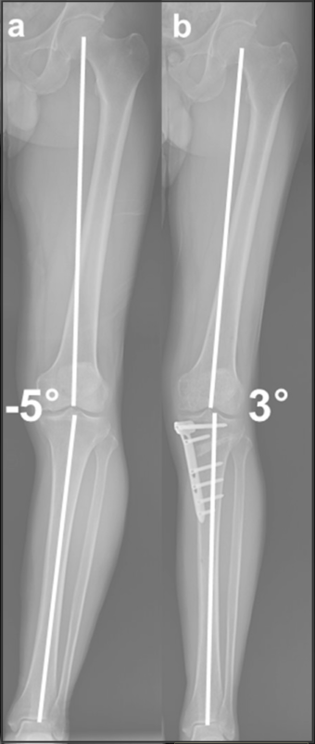

1. 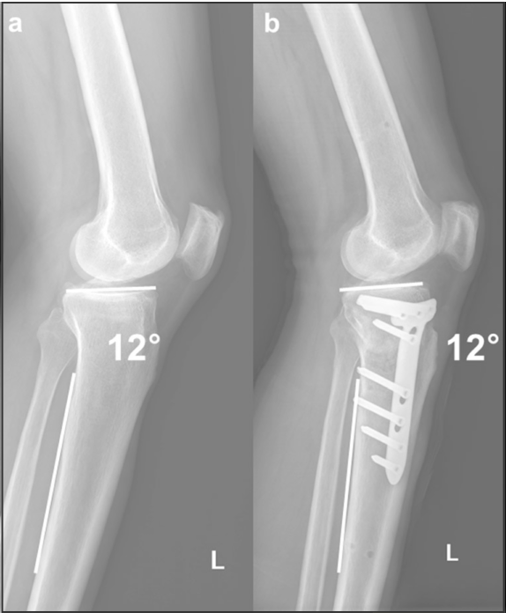Posterior tibial slope – this is measured by the angle it subtends with a line draw vertically from the posterior edge of the tibial shaft. 3
2. 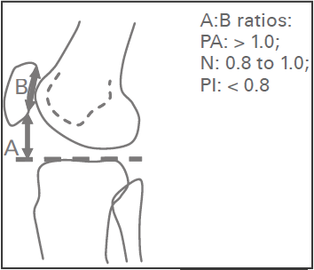Patellar height which is calculated by Blackburne-Peele method6 (PA- patella alta, N- normal, PI- patella infera)
3. Time to union which is defined as time at which there is an absence of pain upon local palpation, an absence of swelling in the limb, an ability to walk painlessly without crutches, and an evidence of a radiographic bridging callus or trabecula between fragments8

Patient Reported Outcome Measure (PROM) scores (Secondary Outcome)

There is no specific PROM that has been developed/validated for the evaluation of HTO outcomes. The following scores have been recommended by Wang et7 al after thorough investigation of their statistical effect size for osteoarthritis and general knee conditions KOOS were developed to be used in a young to middle aged athlete group thus will be suitable marker for functional outcome as the HTO cohort is usually younger and often have a history of chronic ACL deficiency due to early ACL injury. Scores that will be utilised include:

1. KOOS
2. OKS
3. Visual-analogue-scale (VAS) pain score

Surgical Procedures

Recruitment and consent of participants

*HTO Surgical Technique*

The limb will be prepped and draped in standard fashion using betadine and iBand to cover exposed skin to maintain sterility. Two pins will be placed in the femur and tibia and navigation trackers attached. Two small 2cm incisions will be made in the knee joint for arthroscopic mapping of the articular surface to the Stryker PrecisioN© Knee Navigation System. Data will be collected from the navigation system regarding pre-operative and post-operative ROM, coronal alignment, bony resections, tibial slope and internal/external rotation of the tibia.

Appropriate skin incision will be made for the corresponding osteotomy. After bone has been exposed, guide pins will be inserted under fluoroscopy (x-ray guidance). Homan retractors will be used to protect the vital posterior neurovascular structures as well as the tibial insertion of the patella tendon as the osteotomy is performed. The osteotomy will be performed under fluoroscopy guidance to ensure no breach of the contralateral cortex. Wedge chisels will be sequentially inserted to facilitate osteotomy opening. In the case of the lateral closing wedge, the proximal tibiofibilar ligament will be released with the periosteum and overlying tibial anterior compartment structures to protect the popliteal neurovascular bundle and allow better exposure of the lateral cortex. Again retractors will be used to protect appropriate structures and guide pins will be inserted under fluoroscopy and subsequent osteotomy performed in the same manner. An extra 2mm of bone will be removed as per surgical planning. The osteotomy will be held in place by an anatomic specific locking plate. All osteotomies will be standardised to be corrected to 3° of valgus angulation. Before closure, dorsalis pedis and posterior tibial peripheral pulses will be checked for any vascular compromise. The incision will be closed as per wound closure protocol with injection of local anaesthetic for acute analgesia.

Surgical Data

Data will be collected from the Stryker PrecisioN© Knee Navigation System regarding pre-operative and post-operative ROM, coronal alignment, tibial slope and internal/external rotation of the tibia.

Research Design

With respect to the Gait Assessment, kinetic and kinematic data will be simultaneously recorded and filmed to correlate with movement.

Sample Size

Sample size and statistical power

Given there is no previous study that has looked at navigated HTOs, or any surrogate that we can use to perform sample size calculation, we will initially recruit 10 patients to each arm of the study, and perform interim calculations for statistical difference, if this is insufficient we will recruit a further 10 patients to each arm, giving us a total of 40 patients in the complete study.

Statistical Analysis

All data will be analysed using the Statistical Sciences (SPSS, Version 22). Raw data will be de-identified and given to an independent statistician to perform the appropriate statistical testing.

DATA MANAGEMENT

Data may be captured and monitored by one of two methods.

1. ORIQL/FORCE DB: Data collected by Investigator, including mandatory identification data and assessments will be input directly onto the ORIQL/FORCE database. Patients will answer PROMS assessment questionnaires electronically either in practice or by email. Patients will be randomised post consent, and provided with a patient study number. (Pending HREC approval)

2. Patient Study Folders: Data will be recorded into patient study case report forms (study folders). During data monitoring phase, the data will be transcribed and entered into patient database. Patients' details will be stored on an orthopaedic specific research database at ORIQL (SOCRATES), which will include name and date of birth as mandatory identifiers. This will allow easy identification of patients to review the data collected during the research process. The database is password protected with limited access only to the named investigators.

ETHICAL CONSIDERATIONS

This study will be submitted to the Principal Investigators Ethics Committee, Mater Health Services North Queensland Ltd Human Research Ethics Committee.

The study will be registered prior to trial commencement with the ANZCTR.

Participants will be provided with carpark passes to enable participation at the Gait Laboratory which is located at the Douglas Campus at James Cook University. Gait Lab costs will be covered by the investigators not the study participants. Ethics approval will be submitted to James Cook University Ethics Review board along with supporting documentation for site approval.

FEASIBILITY

The administrating institution has conducted collaborative research utilizing the Gait Laboratory which is still undergoing patient recruitment. A contract is in place for the collaboration between JCU and ORIQL for the utilization of the Gait Laboratory Facility. The lead JCU investigator had contributed to other published ORIQL research; all investigators have extensive experience in performing and publishing clinical studies in Orthopaedics.

DISSEMINATION OF RESULTS AND PUBLICATION

The results of the study will be presented at national and international orthopaedic scientific meetings such as the Australian Orthopaedic Association (AOA) Annual Scientific Meeting. Results will be published in a high impact surgical journal and will be disseminated via various forms of media. Given the nature of this data, there is the capacity for the Sponsor to publish a White Paper in collaboration with the investigators.

Authorship will be under the name of Investigators belonging to ORIQL, and by association to James Cook University.

REFERENCES

1. Nerhus TK, Ekeland A, Solberg G, Sivertsen EA, Madsen JE, Heir S. Radiological outcomes in a randomized trial comparing opening wedge and closing wedge techniques of high tibial osteotomy. *Knee Surgery, Sport Traumatol Arthrosc*. 2015. doi:10.1007/s00167-015-3817-z.

2. Amzallag J, Pujol N, Maqdes A, Beaufils P, Judet T, Catonne Y. Patellar height modification after high tibial osteotomy by either medial opening-wedge or lateral closing-wedge osteotomies. *Knee Surgery, Sport Traumatol Arthrosc*. 2013;21(1):255-259. doi:10.1007/s00167-012-2304-z.

3. Na YG, Eom SH, Kim SJ. The use of navigation in medial opening wedge high tibial osteotomy can improve tibial slope maintenance and reduce radiation exposure. 2016:499-507. doi:10.1007/s00264-015-2880-x.

4. Ihle SSC, Döbele DWES, Ateschrang USA. Surgical accuracy in high tibial osteotomy : coronal equivalence of computer navigation and gap measurement. *Knee Surgery, Sport Traumatol Arthrosc*. 2016. doi:10.1007/s00167-016-3983-7.

5. DeMeo PJ, Johnson EM, Chiang PP, Flamm AM, Miller MC. Midterm Follow-up of Opening-Wedge High Tibial Osteotomy. *Am J Sports Med*. 2010;38(10):2077-2084. doi:10.1177/0363546510371371.

6. Phillips CL, Silver D a T, Schranz PJ, Mandalia V. The measurement of patellar height: a review of the methods of imaging. *J Bone Joint Surg Br*. 2010;92(8):1045-1053. doi:10.1302/0301-620X.92B8.23794.

7. Wang D, Jones MH, Khair MM, Miniaci A. Patient-reported outcome measures for the knee. *J Knee Surg*. 2010;23(3):137-151. doi:10.1055/s-0030-1268691.

8. Schulz KF, Grimes DA. Generation of allocation sequences in randomised trials: Chance, not choice. *Lancet*. 2002;359(9305):515-519. doi:10.1016/S0140-6736(02)07683-3.