Procedure
- Visit schedule with all procedures to be carried out at each visit
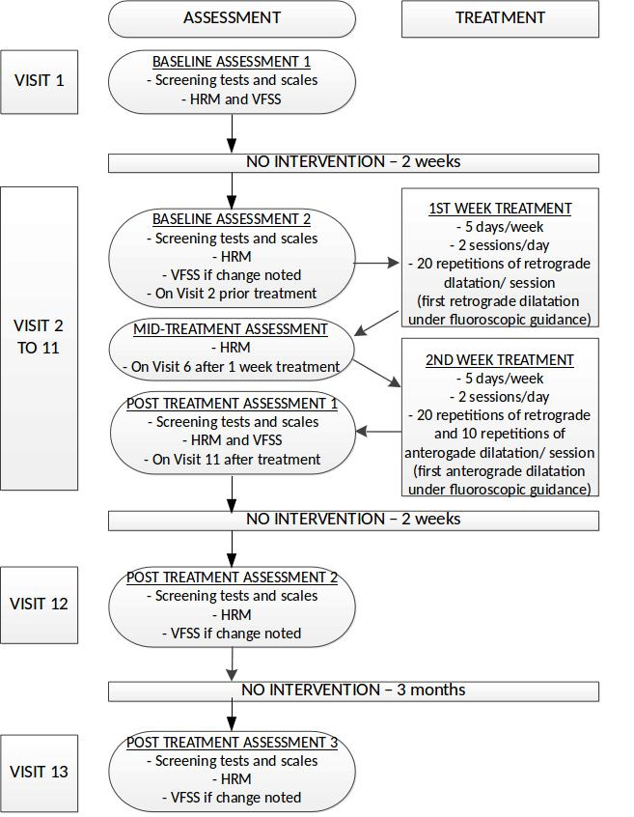
Figure 1. Summary of Study Procedures

