Main Variables

Plaque Indices
1. Plaque Index by Silness and Loe 1964
0 - No plaque

1 - A film of plaque adhering to the free gingival margin and adjacent area of the tooth, which

cannot be seen with the naked eye. But only by using disclosing solution or by using a probe.

2 - Moderate accumulation of deposits within the gingival pocket, on the gingival margin and or

adjacent tooth surface, which can be seen with the naked eye.

3 - Abundance of soft matter within the gingival pocket and/or on the tooth and gingival margin.

2. Plaque index: Rustogi et al Modified Navy Plaque Index (RMNPI)
- The RMNPI plaque is evaluated as either present or absent (1 or 0) on each of the nine areas

of the buccal and lingual tooth surfaces.

- Whole tooth, marginal, and approximal areas are defined as shown below.

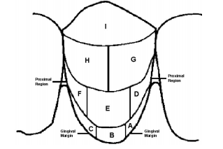

(Biesbrock R.A et al. 2007)

3. Staining index: modified Lobene stain index (Lobene 1968)

Buccal Surfaces

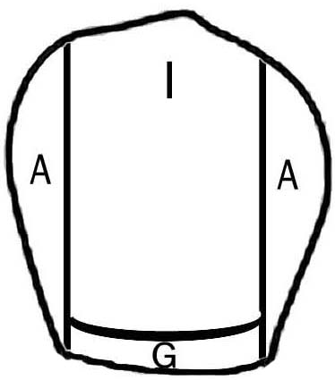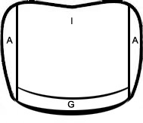
L
B
Anterior tooth
Posterior tooth

Palatal Surfaces

P
P
Posterior tooth
Anterior tooth

- Stain will be recorded on the buccal and lingual surfaces of all four teeth. Pigmentation of the

dental surface will be evaluated using a modification of the stain index (Lobene 1968).

- The tooth will be divided into six areas

Buccal surface: Anterior tooth – labial (I), approximal (A), gingival (G)

Posterior teeth - buccal (B), approximal (A), gingival (G)

Palatal surface: Anterior tooth - palatal (P), approximal (A), gingival (G)

Posterior teeth – palatal (P), approxiaml (A), gingival (G)

- When at least one area of the considered teeth in a patient was found to be pigmented that area

will be considered to be positive at the patient level
Gingival Indices

1. Gingival Index by Löe and Silness 1963.
0 – No inflammation
1 – Mild inflammation, slight change in colour, slight edema, no bleeding on probing
2 – Moderate inflammation, moderate glazing, redness, bleeding on probing.
3 – Severe inflammation, marked redness and hypertrophy, ulceration, tendency to
spontaneous bleeding.

2. Papillary Bleeding Index by Muhlemann 1977
- Papillary bleeding index is a modification of the SBI. It is based on bleeding following gentle

probing of the interdental papilla.

0 - No bleeding

1 - Only one bleeding point appearing

2 - Several isolated bleeding point

3 - Interdental triangle filled with blood soon after probing

4 - Profuse bleeding when probing, blood spreads towards the marginal gingiva

