*Patient Identification Sticker*

**Fluids in Sepsis**

CRF 1- Investigator’s Report

Enrollment # □ □ □

**Patient Information**

Age: Sex:

Weight:

Primary respiratory illness □ yes □ no

Co morbidity:

**Inclusion Criteria**

* Suspected Infection
* SIRS
  + Fever / hypothermia OR leukocytosis

AND

* + Tachycardia OR tachypnoea
* Requiring fluid bolus

**Exclusion Criteria**

* Congenital cardiac disease
* Palliative
* ESL

**Respiratory Distress (Silverman) Score**

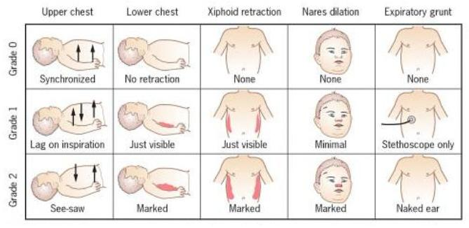

**Vital Signs for Age**

HR RR

<1mo >180 >40

1mo-1yr >180 >34

2-5yrs >140 >22

6-12yrs >130 >18

>13yrs >110 >14

**Glasgow Coma Score**

|  |  |  |  |  |  |  |
| --- | --- | --- | --- | --- | --- | --- |
|  | 1 | 2 | 3 | 4 | 5 | 6 |
| E | none | To pain | To voice | spontaneous |  |  |
| V | none | Incomprehensible / agitated | Inappropriate / inconsolable | Confused / consolable | Oriented / interacts |  |
| M | none | decerebrate | decorticate | withdraws | localises | Obeys commands/ spont mvmt |

**Pre Fluid Bolus Total Previous Volume Administered:**

HR RR CR SpO2 Temp MAP GCS

Hepatomegaly : Rales: Resp Distress Score:

VTI 1 2 3 4 5 Mean

VTI 1 2 3 4 5 Mean

B-lines 1a b 2a b 3a b

4a b 5a b 6a b

IVC collapse : y n %

GAF: hyperdynamic impaired in between FS(%)

**Post Fluid Bolus Volume: Content:**

HR RR CR SpO2 Temp MAP GCS

Hepatomegaly: Rales: Resp Distress Score:

VTI 1 2 3 4 5 Mean

B-lines 1a b 2a b 3a b

4a b 5a b 6a b

IVC Collapse: y n %

GAF: hyperdynamic impaired in between FS(%)

**60 minutes post fluid bolus**

HR RR CR SpO2 Temp MAP GCS

Hepatomegaly: Rales: Resp Distress Score:

VTI 1 2 3 4 5 Mean

B-lines 1a b 2a b 3a b

4a b 5a b 6a b

IVC Collapse y n %

GAF: hyperdynamic impaired in between FS(%)

Comments: