Appendix 1 Theoretical Frameworks
Figure 1. The Knowledge-To-Action Cycle and Study Processes (KTAC)
Reprint by permission: Straus SE, Tetroe J, Graham I. Knowledge translation in health care: moving from evidence to practice. Chichester, Wiley-Blackwell/BMJ, 2013. 318 pages.

Figure 2 Technology Acceptance Model (TAM)
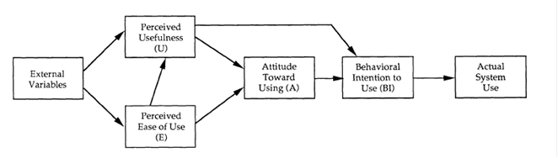

“Reprinted by permission. Copyright 1989 INFORMS. Fred D. Davis, Richard P. Bagozzi, Paul R. Warshaw (1989) User Acceptance of Computer Technology: A Comparison of Two Theoretical Models. Management Science 35(8):982-1003. The Institute for Operations Research and the Management Sciences, 5521 Research Park Drive, Suite 200, Catonsville, Maryland 21228, USA.”
Figure 3 Hypothesized Model of Effects of Self-Efficacy-Enhancing Interventions for People with Chronic Diseases HMESE
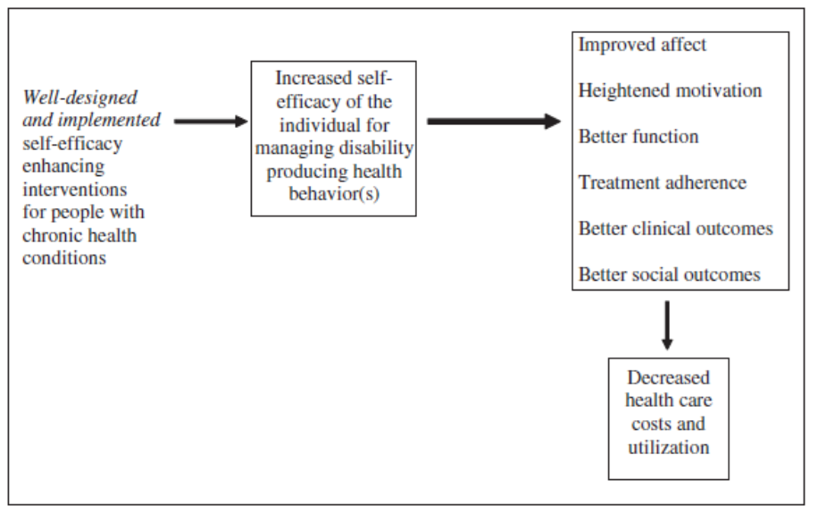

Reprint by permission: Marks R & Allegrante JP. A Review and Synthesis of Research Evidence for Self-Efficacy-Enhancing Interventions for Reducing Chronic Disability: Implications for Health Education Practice (Part II). Health Promotion Practice 6: 148-156, 2005.

Appendix 2. Specific effect of each Component in the Multifaceted/Complex Intervention Groups
Baseline 6 weeks Immediate Post Intervention 3 months Follow-Up 6 months Follow-Up
Specific effect between each component

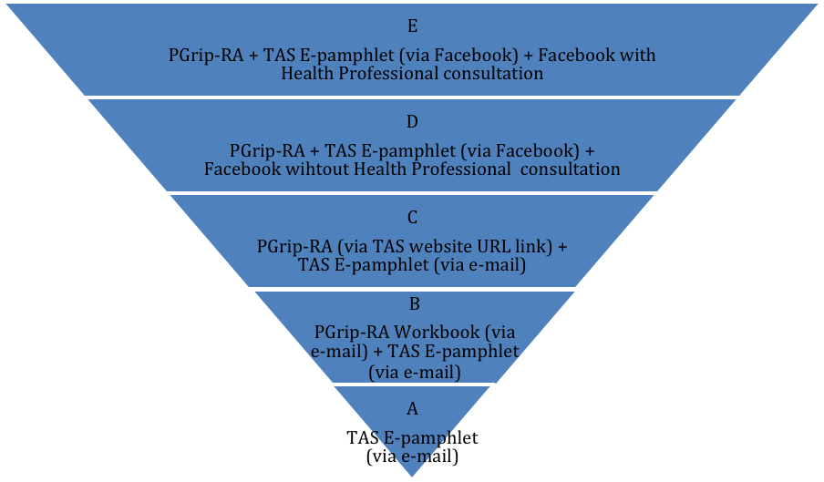
HP consultation
(specific effect between components D &E)
Facebook (specific effect between C & D components)
TAS PGrip website (specific effect between B & C components)
PGrip workbook (specific effect between A & B components)

Appendix 3 Facebook Plus (Group E) Module including Health Professionals
Module | Moderator
Physical activity and TENS interventions | Physiotherapist #1 (English)
Orthotics, insoles, ice massage interventions | Occupational therapist #1 (English)
Nutrition and Weight loss interventions | Dietician #1 (English)

Appendix 4: The Arthritis Society (TAS) E-Pamphlets

1) Rheumatoid Arthritis: Know your options (http://www.arthritis.ca/local/files/pdf%20documents/Types%20of%20Arthritis/Arthritis Society_RA_eBROCH_ENG.pdf

2) Physical Activity and Arthritis
(http://www.arthritis.ca/local/files/pdf%20documents/Printed%20Publications/physical%20activity%20&%20arthritis.pdf);

3) Nutrition and Arthritis (http://www.arthritis.ca/local/files/pdf%20documents/Printed%20Publications/ENG_Nutrition.pdf)

Appendix 5. Assessment Schedule add additional outcome measures
Assessment | Admission | Baseline | 6 weeks post intervention | 3 months follow-up | 6 months follow-up
Informed consent | X
Demographics | X
Self-reported Diagnosis of OA/RA | X
Physical Activity Readiness Questionnaire (PARQ) | X
Self-efficacy to manage pain |  | X | X | X | X
Prior Knowledge of SMIs |  | X
Attained Knowledge of SMIs |  |  | X | X | X
Intention to use SMIs |  |  | X
Actual use of SMIs |  |  |  | X
Self-efficacy (function) |  | X | X | X | X
Quality of life (EQ-5D) |  | X | X | X | X
Health Resource Utilization |  | X | X | X | X
Usability with Online Learning |  |  |  | X | X
Self-reported pain (VAS) |  | X | X | X | X
7-day Physical Activity Recall (PAR) |  | X | X | X | X
SMIs=self-management interventions

Appendix 6: Outcome measures according to selected measurement frameworks
KTAC Monitoring knowledge use
Concept | Theory-based | Operationalization | Time period | Layers
Knowledge acquisition | : Diffusion of innovation model. : Rogers (1995)  TAM (Davis et al., 1989) | - Questionnaire developed in pilot study (Brosseau et al. 2014)  - Log book including 7-Day PAR and changes report (Brosseau et al., 2012) | - Baseline  - 6 weeks  - 3&6 months | PGrip-RA
Intend to use | Diffusion of innovation model. : Rogers (1995)  TAM (Davis et al. 1989) | - Questionnaire developed in pilot study (Brosseau et al. 2014)  - Goal setting for Facebook + group only | - 6 weeks  Bi-weekly during 6 weeks  - 3&6 months | - PGrip-RA  - Facebook or e-mail  -PGrip-RA  -Facebook or e-mail
PGrip-RA: clinical layer; Facebook or E-mail: Knowledge translation (KT) layer using information communication technologies (ICT)
Appendix 7: Outcome measures according to selected measurement frameworks
KTAC Evaluated Outcomes
Concept | Theory-based | Operationalization/instrumentation | Time period | Layers
Self efficacy  (Primary outcome) | Diffusion of innovation model. : Rogers (1995)  HMESE | Arthritis self-efficacy (pain management subscale) (Lorig et al., 1989) | - Baseline  - 6 weeks  - 3 & 6 months | PGrip-RA
Actual use | Diffusion of innovation model. : Rogers (1995)  TAM  HMESE | - Questionaire developed in previous pilot study (Brosseau et al., 2014  - 7Day -PAR (Heesch et al., 2003)  - Long-term goal attainment (Stolee, 1992)  - # Log in # hits  - Facebook intensity scale (Ellison et al., 2007) | - 3 & 6 months | PGrip-RA  Facebook or e-mail
Better clinical outcomes  - Pain  - QoL  - Self-efficacy  - Motivation  - Social | Diffusion of innovation model. : Rogers (1995)  HMESE | - Pain intensity (Bjo, 2008)  - Arthritis self-efficacy (function management / other symptom subscale ) (Lorig et al., 1989)  - Euro QoL: EQ-5D-5L (Rabin et al., 2001)  - Mobility  - Self Care  - Pain  - Anxiety depression  - Goal attainment (Stolee,1992) | - Baseline  - 6 weeks / 3& 6 months  -Baseline  6 weeks / 3& 6 months | PGrip-RA
Interventions adherence | Diffusion of innovation model. : Rogers (1995)  HMESE | -7Day -PAR (Heesch et al., 2003) | - Baseline  - Each week | PGrip-RA
Usability | Diffusion of innovation model. : Rogers (1995)  TAM | System Usability Scale (Saturo, 2012) | - Baseline  - 3 & 6 months | Facebook or e-mail
Health economics | Diffusion of innovation model. : Rogers (1995)  HMESE | Health Resource Utilization questionnaire  QALY (Manca et al., 2005) | - Baseline  - - 3 & 6 months | PGrip-RA  Facebook or e-mail
PGrip-RA: clinical layer; Facebook or E-mail: Knowledge translation (KT) layer using information communication technologies (ICT)

